**Nama : Lukman al hakim**

**Kelas : XI-RPL**

**Absen : 18**

**ScannerString03**

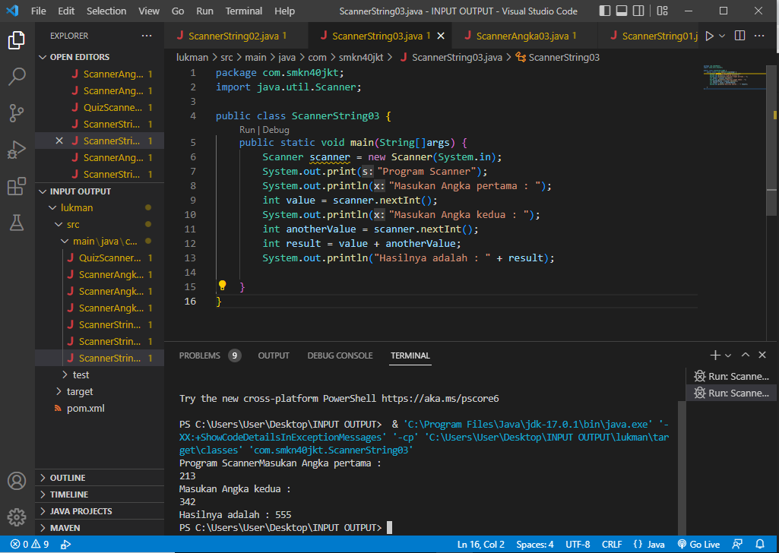

**ScannerString02**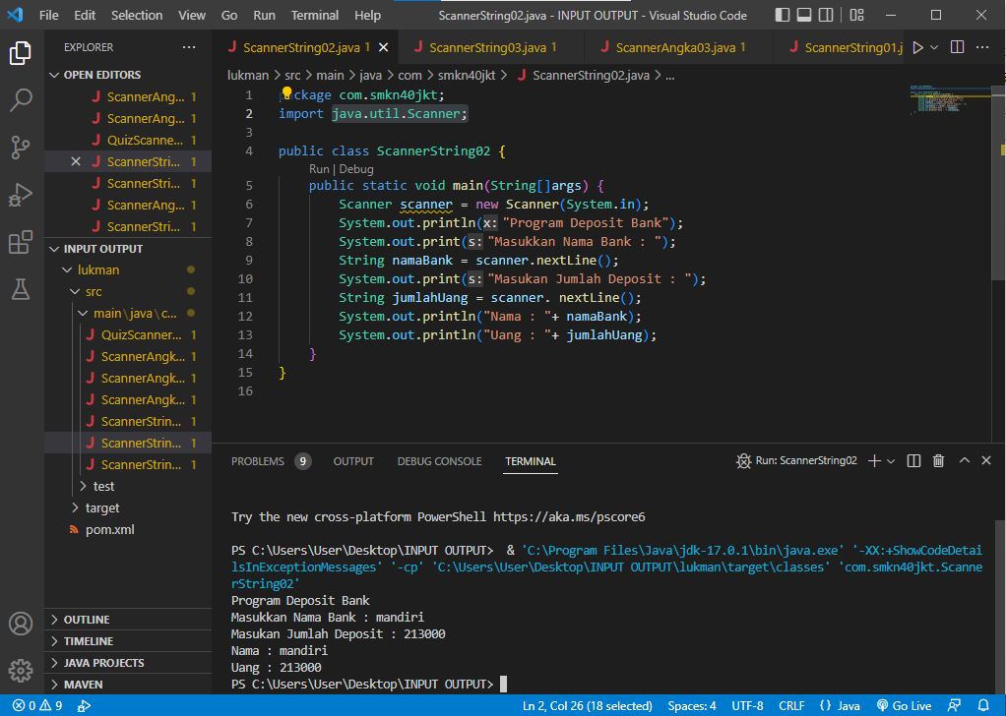

**ScannerString01**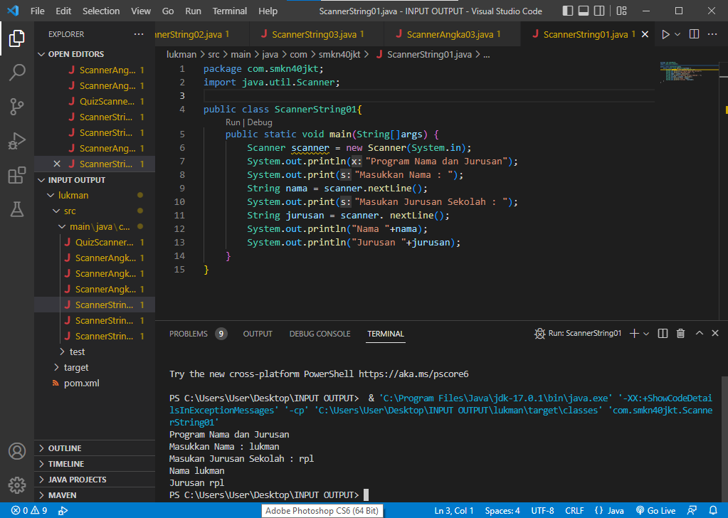

**ScannerAngka03**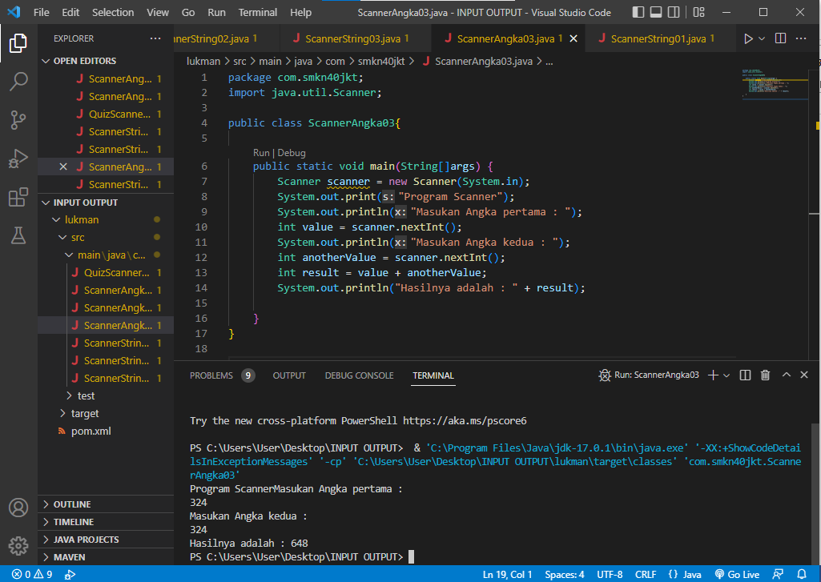

**ScannerAngka02**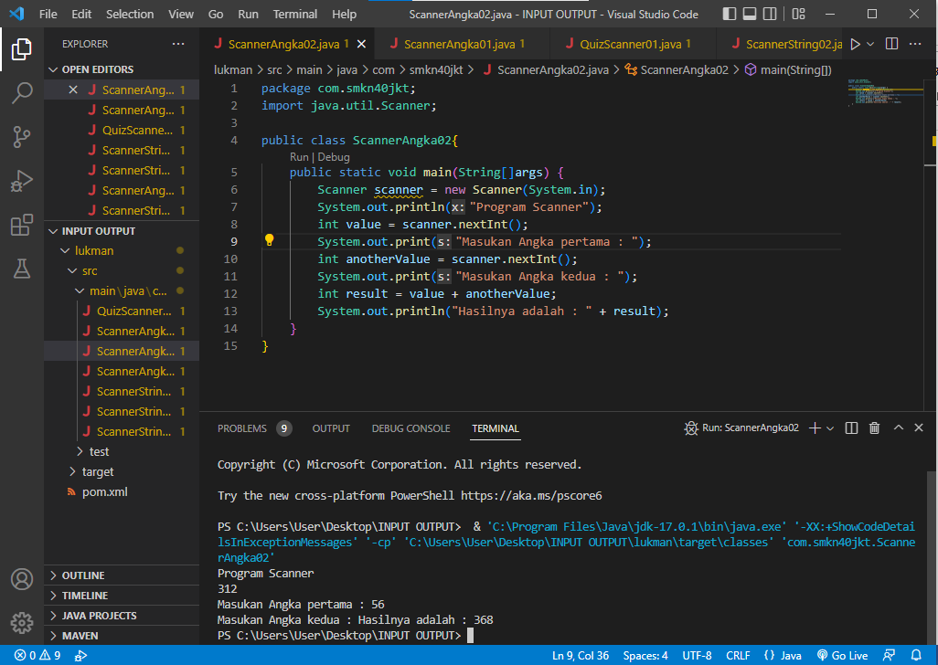

**ScannerAngka01**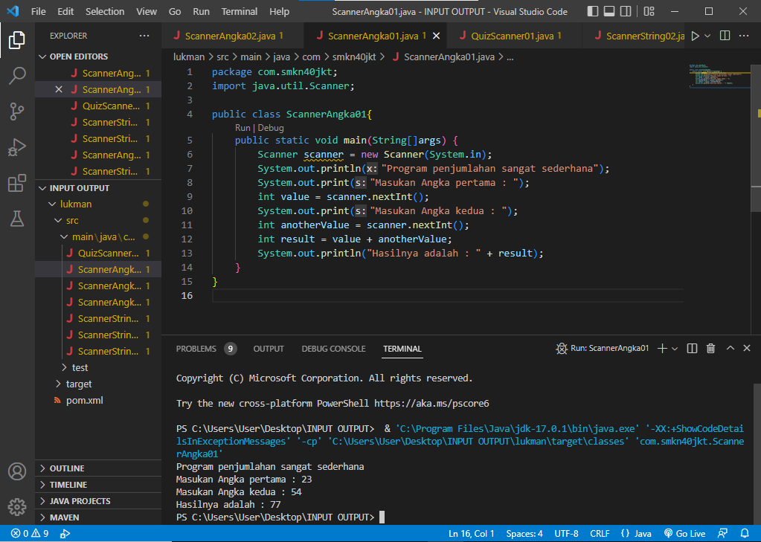

**QuizScanner01**