Business Requirements

**Expekt – Registration form**

Author: Iryna Lukovets

Creation Date: 08.04.2019

Version: 1.1

Approvals:

In this document is described the expectations from view and functionality the registration form. The work with the site is available only for registered users, therefore the procedure of registration is mandatory.

**1. Opening of the registration form**

The registration form is opened from the main page of the site.

There is an easy-to see button which is called “Register now” on the main page of the site. Clicking on this button opens a new screen with the registration form. All mandatory fields marks by “*”.

**2. The registration form's view**

The registration form should have the view as shown on screenshot 1.

All colors and fonts should match with required, all characters should be present and dispose at the right places.

Screenshot 1:

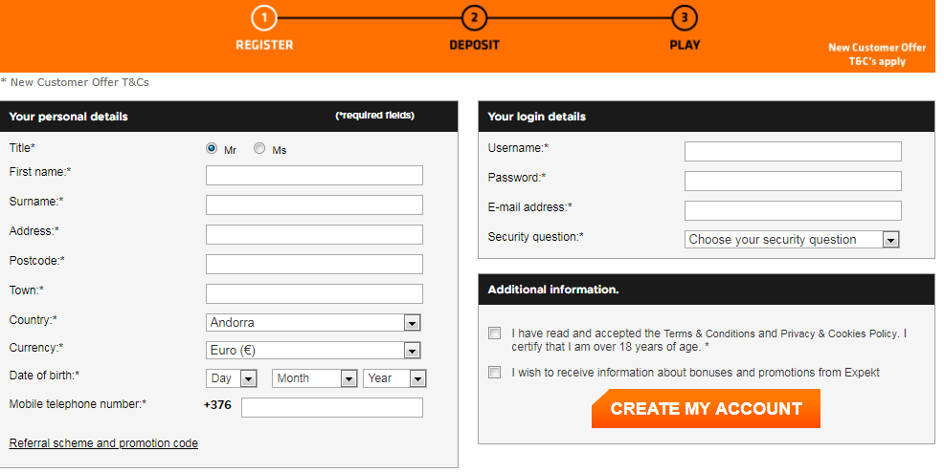

There are three blocks on this screen.

First of them is called “Your personal details” and disposed at the left side of the screen.

Second block is called “Your login details” and disposed at right from the block “Your personal details”.

Third block is called “Additional information” and disposed at right from the block “Your personal details” and below the block “Your login details”. This block has a big orange button “CREATE MY ACCOUNT”. All letters on this button is uppercase and have white color.

Also above the block “Your personal details” is lettering “ * New customer Offer T&Cs” with the hyper link, which leads to the information about terms & conditions.

At the top-right corner is languages switcher. It looks as shown at the screenshot 2.

Screenshot 2:

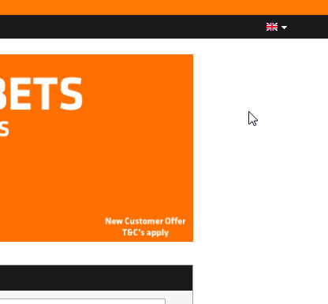

Pressing on this switcher opens accessible languages as shown at the screenshot 3.

Languages available for choice are shown on the screenshot 3.

Screenshot 3:

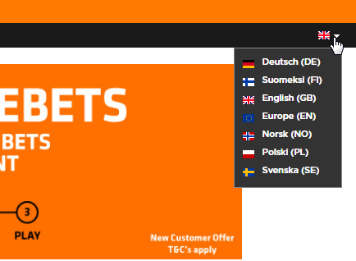

**Block “Your personal details”**

This block concerns personal customer information, like full name, address, date of birth and other.

All fields with precise names of each field and descriptions are below. The fields should be disposed in the same order as they are described in this document.

**3. Title** – mandatory field

It is necessary to check a box: “Mr” or “Ms”.

This field never will be blank – the box “Mr” is filled as a default;

**4. First name** – mandatory field

The hint “Please indicate your name” appears to the right of the field when the cursor is positioned in this field.

The red color lettering “Please enter your first name” appears below the field if this field leaves blank.

It is possible to enter only the letters from the Cyrillic alphabet or the Latin alphabet in this field. Any digits or symbols don’t allow in this field;

**5. Surname** – mandatory field

The hint “Please indicate your last name” appears to the right of the field when the cursor is positioned in this field.

The red color lettering “Please enter your last name” appears below the field if this field leaves blank.

It is possible to enter only the letters from the Cyrillic alphabet or the Latin alphabet in this field. Any digits or symbols don’t allow in this field;

**6. Address** – mandatory field

The hint “Please ensure you have entered your data correctly” appears to the right of the field when the cursor is positioned in this field.

The red color lettering “Please enter your address” appears below the field if this field leaves blank.

It is possible to enter the letters from the Cyrillic alphabet or the Latin alphabet and the digits and some symbols in this field. The permissible symbols are only “dot” and “hyphen”;

**7. Additional address** – nonmandatory field

This field is concealed and appears after the cursor clicks on the previous field “Address”.

The hint “Enter your house/flat number” appears to the right of the field when the cursor is positioned in this field.

It is possible to enter the letters from the Cyrillic alphabet or the Latin alphabet and the digits and some symbols in this field. The permissible symbols are only “dot” and “hyphen”;

**8. Postcode** – mandatory field

The hint “Please ensure you have entered your data correctly” appears to the right of the field when the cursor is positioned in the field.

The red color lettering “Please enter your postcode” appears below the field if this field leaves blank.

It is possible to enter only the letters from the Latin alphabet, the digits and symbol “dot”.

**9. Town** – mandatory field

The hint “Please ensure you have entered your data correctly” appears to the right of the field when the cursor is positioned in the field.

The red color lettering “Please enter your city” appears below the field if this field leaves blank.

It is possible to enter the letters from the Cyrillic alphabet or the Latin alphabet, the digits and some symbols in this field. The permissible symbols are only “dot” and “hyphen”;

**10. Country** – mandatory field

There is drop-down list with countries. The countries should be dispose in the alphabet order. This field never will be blank – the first country from the list is filled as a default.

The hint “Please ensure you have entered your data correctly” appears to the right of the field when the cursor is positioned in the field;

**11. Currency** – mandatory field

There is drop-down list with currencies. The currencies dispose in the random order. This field never will be blank – the currency Euro is filled as a default.

The hint “Choose your currency with care, as you won’t be able to change it later” appears to the right of the field when the cursor is positioned in the field;

**12. Date of birth** – mandatory field

There are three drop-down lists: Day, Month and Year. The drop-down list “Day” contains digits from 1 to 31. The drop-down list “Month” contains names of all months from January to December. The drop-down list “Year” contains years from 1904 to 2001. It is necessary to be adult to make bets. Considering this, at the time of development in the list “Year” the value "2001" should be greatest.

The hint “You must be major to bet” appears to the right of the field when the cursor is positioned in the field;

**13. Mobile phone number** – mandatory field

In front of the field for entering phone number are non-editable symbol and digits. This is a country phone code and it depend on the country which was selected earlier.

The hint “Only used to offer you exclusive prizes and to verify essential security on your account” appears to the right of the field when the cursor is positioned in the field

It is possible to enter only digits in this field. Any letters or symbols don’t allow in this field. The allowable quantity of digits is greater than or equal to 6 and less than or equal to 15;

**14. Referral scheme and promotion code** – nonmandatory subblock

This subblock is dispose under the field “Mobile phone number” and concealed under his name. Clicking on the lettering “Referral scheme and promotion code” opens two fields with the possibility to filling:

- Username of your Introducer

The hint “If you were invited by a friend, please enter his or her username here” appears to the right of the field when the cursor is positioned in the field.

It is possible to enter only letters form the Latin alphabet, digits and symbol “underscore”. The allowable quantity is no less than six characters.

The red color lettering “Enter a user name with at least six characters” appears below the field if the quantity of characters is less than 6;

- Promotional code

The hint “If you have a promotional code, please enter this code here” appears to the right of the field when the cursor is positioned in the field.

All letters and symbols are allowable for entering in this field. The quantity may be more than 100.

**Block “Your login details”**

It is necessary to fill some fields for user personalization on the site, like username, password and other.

All fields with precise names of each field and descriptions are below. The fields should be disposed in the same order as they are described in this document.

**15. Username** – mandatory field

The hint “Between 6 and 20 characters (figures and letters only) appears when the cursor is positioned in the field.

The red color lettering “Username is mandatory” appears below the field if this field leaves blank.

It is possible to enter only letters from the Latin alphabet, digits and symbol “underscore”. The quantity of the characters should be from 6 to 20 characters.

The red color lettering “Enter a username with at least six characters” appears below the field if the quantity of characters is less than 6;

**16. Password** – mandatory field

The hint “Your password must be no less than 8 characters long and contain a mix of lowercase letters, uppercase letters and numbers” appears when the cursor is positioned in the field.

The red color lettering “Your password must have at least 8 characters, use at least three different character types (figures, lowercase letters, uppercase letters, special characters) and must not contain your username” appears below the field when the cursor is positioned in the field. Also this lettering appears when the password consists less than 8 characters.

It is possible to enter any symbols in this field, but letters must be only form the Latin alphabet. The quantity of the characters should be from 6 to 20 characters.

There is control reliability of the password. If password is unreliable (doesn’t answer the requirements) – the red square appears in the field. If password is more reliable (answers the requirements partially) – the orange square appears in the field. And if password is quite reliable (answers the requirements) – the green square appears in the field;

**17. Confirm your password** – mandatory field

This field is concealed and appears after the cursor clicks on the previous field “Password”.

The red color lettering “Please confirm your password” appears below the field if this field leaves blank.

Checking of the password identity is mandatory;

**18. E-mail address** – mandatory field

The hint “Check your e-mail address. A valid address is required in order to bet” appears when the cursor is positioned in the field.

The red color lettering “Please enter your e-mail address” appears below the field if this field leaves blank.

Also this lettering appears when the e-mail address is invalid.

It is possible to enter only letters from the Latin alphabet and any digits and symbols in this field;

**19. Confirm your e-mail address** – mandatory field

This field is concealed and appears after the cursor clicks on the previous field “E-mail address”.

The red color lettering “Please confirm your email address” appears below the field if this field leaves blank.

Checking of the email address identity is mandatory;

**20. Security question** – mandatory field

There is drop-down list with some questions. This field never will be blank – the phrase “Choose your security question” is filled as a default.

The list of questions:

*Town of birth?*

*What’s my nickname?*

*What’s my favourite football club?*

*What’s my favourite film?*

*Who’s my favourite singer or band?*

*A secret code?*

*What’s my mother maiden name?*

The hint “You will need to answer to withdraw your winnings and for other important transactions. It protects your security” appears when the cursor is positioned in the field.

The red color lettering “Please select a secret question” appears if the phrase by default is not changed;

**21. Answer** – mandatory field

This field is concealed and appears after the cursor clicks on the previous field “Security question”.

The hint “You will need to answer to withdraw your winnings and for other important transactions. It protects your security” appears when the cursor is positioned in the field.

The red color lettering “Please enter the answer to the security question” appears below the field if this field leaves blank.

It is possible to enter the letters form the Cyrillic alphabet and the Latin alphabet, digits and symbols “dot” and “hyphen”. The quantity of the characters should be not more than 20 characters.

**Block “Additional information”**

**22. The view and contents**

This block consists of the non-editable information. It is possible just check the boxes in the appropriate places of this block.

There are two lettering with the possibilities to check a box near them.

First is (henceforth referred as First checkbox):

“I have read and accepted the Terms & Conditions and Privacy & Cookies Policy. I certify that I am over 18 years of age”.

Second is (henceforth referred as Second checkbox):

“I wish to receive information about bonuses and promotions from Expekt”.

**23. First checkbox** – mandatory field

The words “Terms & Conditions” are written another type and contain the hyper link which leads to the new page with general terms & conditions. The words “Privacy & Cookies Policy” are written another type and contain the hyper link which leads to the new page with privacy & cookies policy.

The red color lettering “Please confirm that you have read and accepted the Terms & Conditions” appears below if the checkbox leaves blank.

**24. Second checkbox** – nonmandatory.

**25**. **CREATE MY ACCOUNT**

The big orange button with the lettering “CREATE MY ACCOUNT” is disposed at the bottom part of the block “Additional information”. The letters of the lettering are white and uppercase.

Clicking on this button creates an account if all the required fields were filled correctly. If some information isn’t correct or absent, appropriated fields are marked by red color and account isn’t created. If all required information is filled – account creates successfully.

**26. Page’s safety**

All data from the registration form should be secure. The fields “Password” and “Confirm your password” should display in encrypted format. If the registered user changed password – the access to the site with the previous password is impossible.

**27. Performance of the site**

Site work should be stable. The speed of data transmission and processing should not depend on the number of users using the site.

**28. Compatibility of the site**

The site should work correctly at all browsers. The view of the site is the same at all browsers.