**TAPS & NEBNext kit protocol**

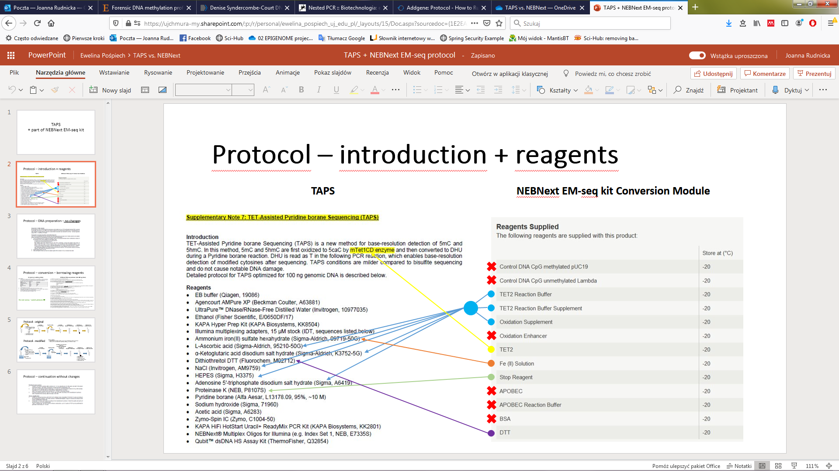

**Preparation of DNA samples**

Prepare 100ng DNA input in 28 µl (DNA methylation standard: 0%, 25%, 50%, 75%, **100%**).

I trial: 100ng DNA, DNA methylation: 100%

Human WGA Methylated DNA (5ug/20ul)

5000ng – 20ul  
 250ng – 1ul -> 100ng/ul  
 x2.5 -> 1.5ul standard + 1ul H2O -> 1ul diluted DNA + 27ul H2O

**NEBNext kit part**

* 1. **Oxidation of 5-Methylcytosines and 5-Hydroxymethylcytosines​**

**Note: The TET2 Reaction Buffer Supplement is a powder. Centrifuge before use to ensure it is at the bottom of the tube**.​

1.5.1A. Add 100 µl of TET2 Reaction Buffer to one tube of TET2 Reaction Buffer Supplement and mix well. Write date on tube.​

**NOTE: The reconstituted buffer should be stored at -20°C and discarded after 4 months.** ​

1.5.2. On ice, add the following components directly to the **28 µl adaptor ligated DNA**​

10 ul TET2 Reaction Buffer (TET2 Reaction Buffer plus reconstituted TET2 Reaction Buffer Supplement)​

1 ul Oxidation Supplement​

1 ul DTT​

4 ul TET2​

Mix thoroughly by vortexing, centrifuge briefly. For multiple reactions, a master mix of the reaction components can be prepared before addition to the sample DNA. 5mC/5hmC oxidation is initiated by the addition of the **Fe(II) solution** to the reaction after the addition of master mix.​

1.5.3. Dilute the 500 mM Fe(II) Solution (yellow) by adding 1 μl to 1249 μl of water.​  
Combine Diluted Fe(II) Solution and EM-seq DNA with Oxidation Enzymes (from Step 1.5.2)​

44 ul DNA​

5 ul Diluted Fe(II) Solution (from Step 1.5.3)​

Mix thoroughly by vortexing or by pipetting up and down at least 10 times, centrifuge briefly.​

1.5.4. Incubate at 37°C for 1 hour in a thermocycler with the heated lid set to ≥  45°C or on.​

1.5.5.Transfer the samples to ice and add **1 µl of Stop Reagent** (yellow).​

1 ul Stop Reagent​

Mix thoroughly by vortexing or by pipetting up and down at least 10 times and centrifuge briefly.​

1.5.6. Incubate at 37°C for 30 minutes then at 4°C in a thermocycler with the heated lid set to ≥  45°C or on.​

​

**+ Clean-Up of TET2 Converted DNA with Bio-Spin P-30 Gel Column (**Store at 4°C. Do not freeze.)

**Volume: 50 ul**

**Instructions for Use**

1. Invert the column sharply several times to resuspend the settled gel and remove any bubbles. Snap off the tip and place column in a 2.0 ml microcentrifuge tube (included). Remove cap.
2. Centrifuge for 2 min in a swinging bucket centrifuge at 1,000 x g (see Centrifugation Notes section) to remove the packing buffer. Discard the buffer.
3. Place the column in a clean 2.0 ml microcentrifuge tube or 12 x 75 mm test tube. Carefully apply the sample (20–100 μl) directly to the center of the column. Application of more or less than the recommended sample volume may decrease column performance.
4. After loading sample, centrifuge the column for 4 min at 1,000 x g.
5. Following centrifugation, the purified sample is now in Tris buffer. Molecules smaller than the column’s exclusion limit will be retained.
6. Properly dispose of the used column.

**1.6 Clean-Up of TET2 Converted DNA**​

1.6.1. Vortex Sample Purification Beads to resuspend. ​Before use, warm up beads in RT for at least 30 minutes.

1.6.2. Add 90 µl of resuspended NEBNext Sample Purification Beads to each sample. Mix well by pipetting up and down at least 10 times. **Be careful to expel all of the liquid out of the tip during the last mix.**​

1.6.3. Incubate samples on bench top for at least 5 minutes at room temperature. ​

1.6.4. Place the tubes against an appropriate magnetic stand to separate the beads from the supernatant. ​

1.6.5. After 5 minutes (or when the solution is clear), carefully remove and discard the supernatant. Be careful not to disturb the beads that contain DNA targets

1.6.6. Add 200 µl of 80% freshly prepared ethanol to the tubes while in the magnetic stand. Incubate at room temperature for 30 seconds, and then carefully remove and discard the supernatant. Be careful not to disturb the beads that contain DNA targets.​

1.6.7. Repeat the wash once for a total of two washes. Be sure to remove all visible liquid after the second wash using a p10 pipette tip.​

1.6.8. Air dry the beads for up to 2 minutes while the tubes are on the magnetic stand with the lid open.​

**Caution: Do not over-dry the beads. This may result in lower recovery of DNA target. Elute the samples when the beads are still dark brown and glossy looking, but when all visible liquid has evaporated. When the beads turn lighter brown and start to crack they are too dry.**​

1.6.9. Remove the tubes from the magnetic stand. Elute the DNA target from the beads by adding 26 µl nuclease-free water.  ​

1.6.10. Mix well by pipetting up and down 10 times. Incubate for at least 1 minute at room temperature. If necessary, quickly spin the sample to collect the liquid from the sides of the tube before placing back on the magnetic stand. ​

1.6.11. Place the tube on the magnetic stand. After 3 minutes (or whenever the solution is clear), transfer 25 µl of the supernatant to a new PCR tube.​

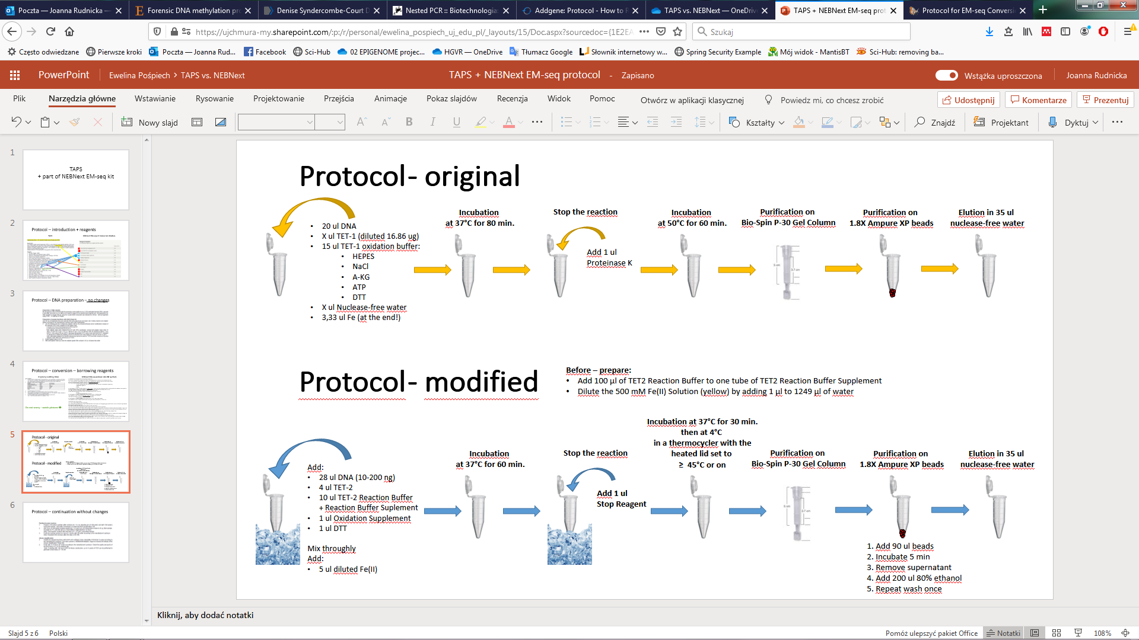

**Pyridine borane reaction**

1. Prepare 1.5 M sodium acetate buffer solution pH = 4.3 by adjusting pH of 4 M acetic acid with 5 M sodium hydroxide solution. Add water if necessary to obtain the final concentration 3 M.
2. Add 20 µL of 1.5 M sodium acetate solution pH = 4.3 and 5 µL of 10 M pyridine borane to 25 µL DNA sample. Incubate at 37°C and 850 rpm in a ThermoMixer (Eppendorf) for 16 hours.

*Note: Final reaction contains 600 mM NaAc pH = 4.3 and 1 M pyridine borane.*

1. Purify the reaction product on Zymo-IC column with PB buffer according to the manufacturer’s protocol.

*Note: Expected DNA recovery after this step is 50-70%.*

**DNA Clean & Concentrator-5 – original protocol with IC columns**

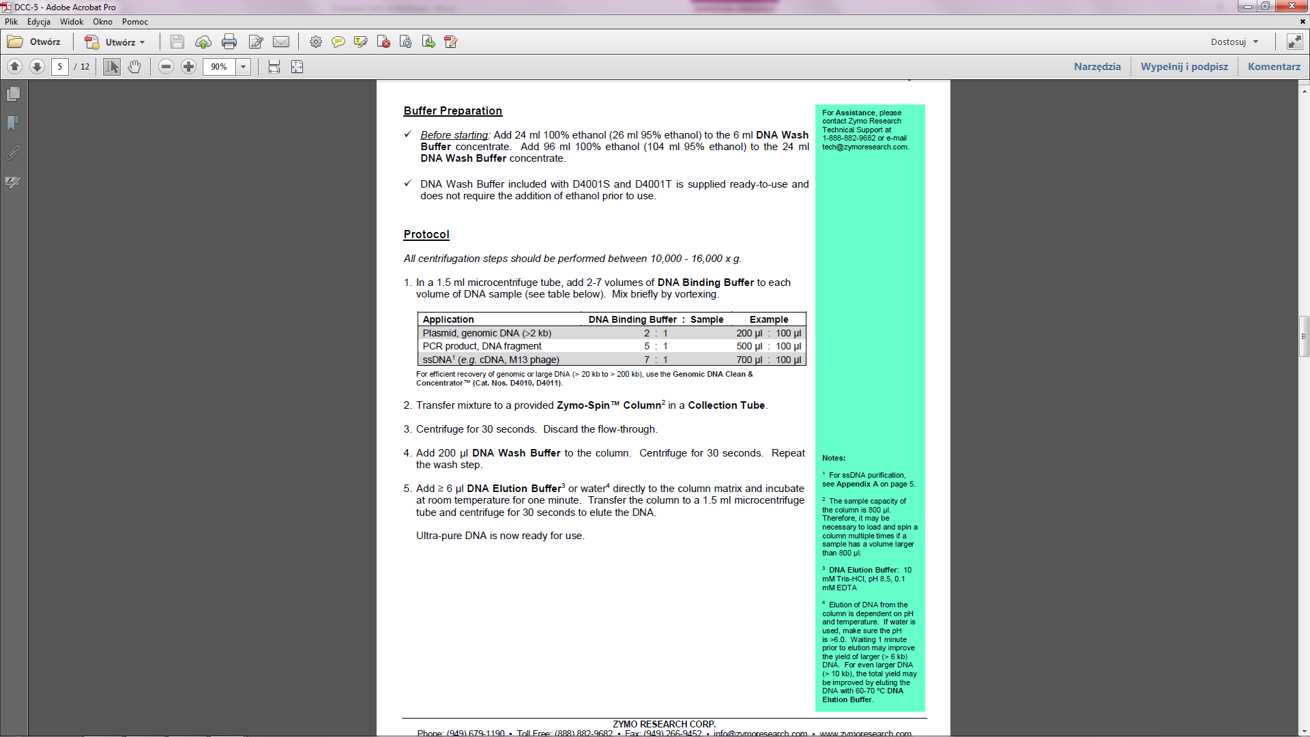

**Genomic DNA Clean & Concentrator-10 – alternative kit dedicated to genomic DNA**

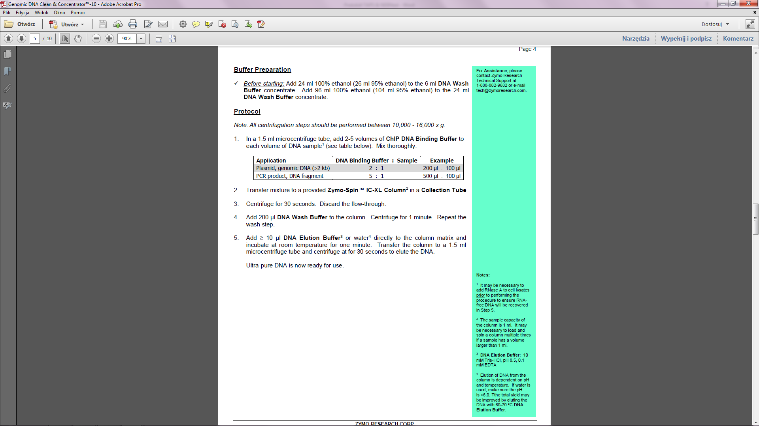

**Sanger sequencing**