ASSIGNMENT_7

# Question_1

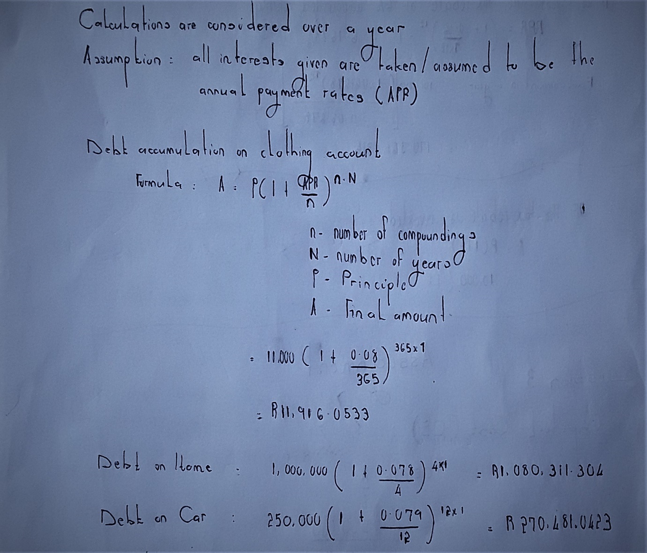

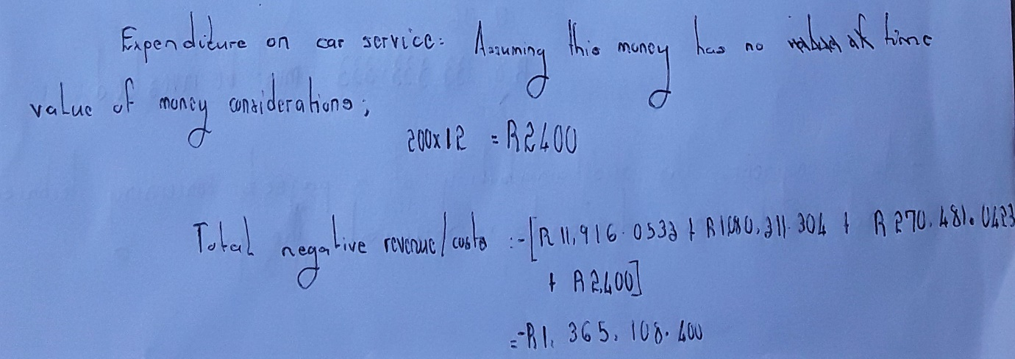

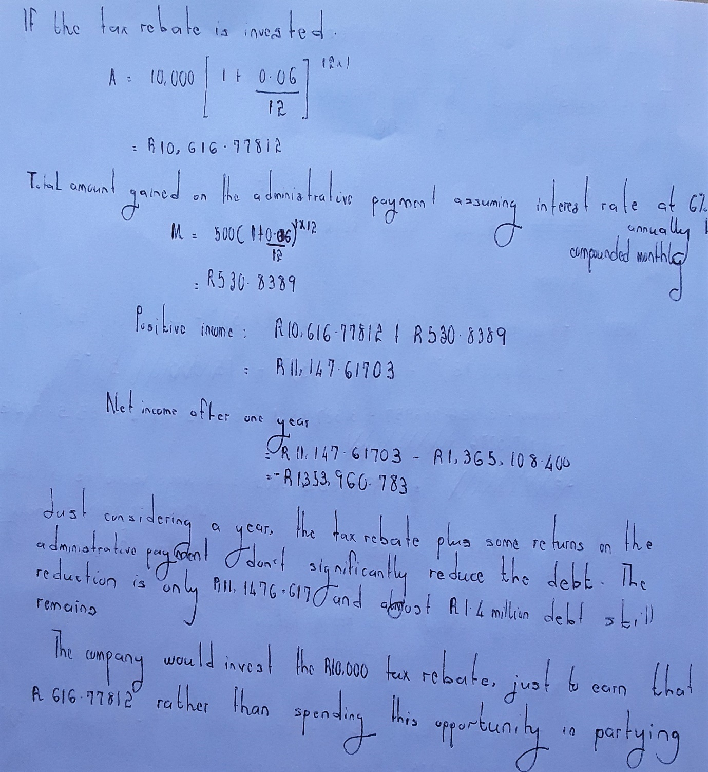

# Question_2

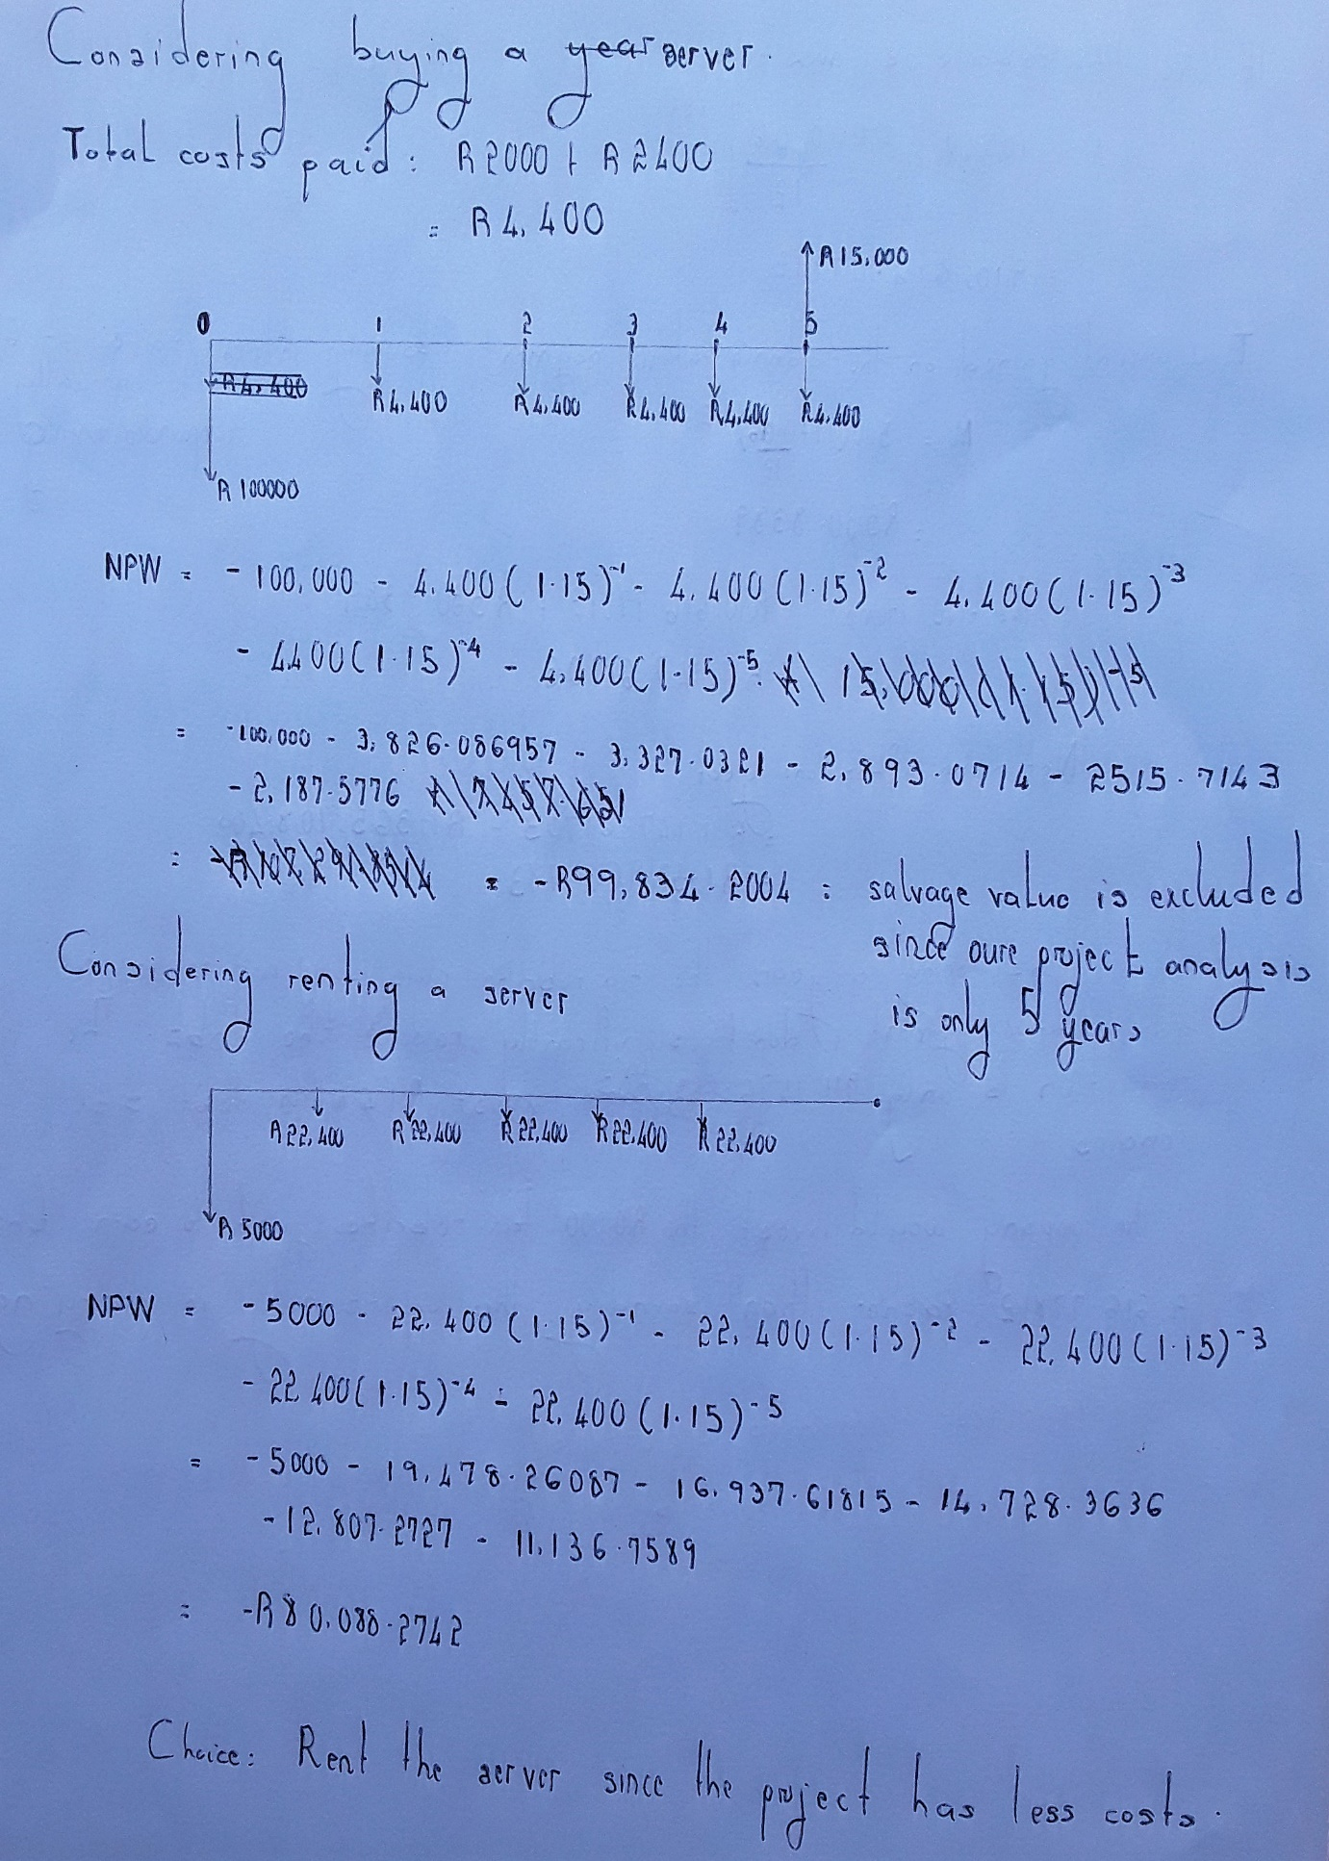

# Question_3

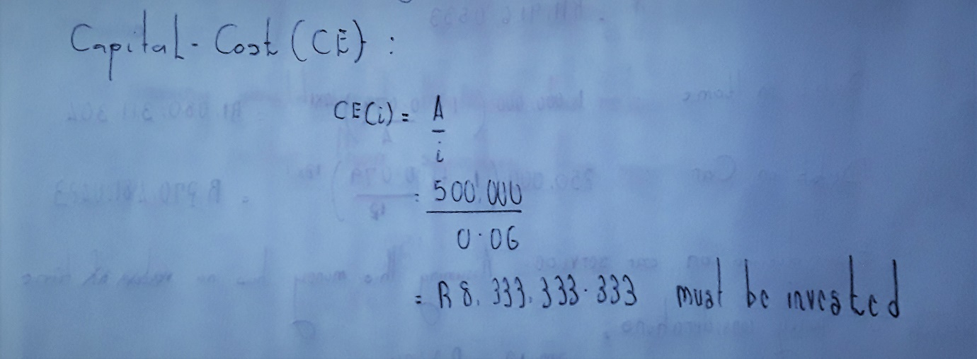

# Question_4

The sustainability of the project regarding labour, technical and maintenance demands. The project should not require highly sophisticated technologies that are not easily accessible and operated by company’s technicians. The technical ability should be readily available to implement the project.

The environmental impact of the project must be considered so that pollution such as fumes, noise and de-vegetation should be to the minimal if not avoidable. The project should impact its natural surrounding living and non-living in a positive manner.

As an engineer, safety is a priority in every project thus even though the project is so profitable but imposes very high safety risks to the work force or even to the community in which it is based, such a project should not be considered. If considered in by any chance, then maximum measures to eliminate much of its possible dangers must be first put in place.