# AWS Certified Cloud Practitioner 2020

* this is the easiest exam
* Get at least certified associate architect

### **Exam Details**



Format  
65 questions; either multiple choice or multiple response



Type  
Foundational



Delivery Method  
Testing center or online proctored exam



Time  
90 minutes to complete the exam



Cost  
100 USD (Practice Exam: 20 USD)

**6 Advantages of Cloud Computing**

1. Trade Capital Expenses for Variable Expenses – pay only when you consume computing resources and pay only for how much you consume
2. Benefit from massive economies of scale
3. Stop guessing about capacity – scale business needs with no long term contracts
4. Increase speed and agility – ex: serverless architecture – scales infinitely with demand
5. Stop spending money running and maintaining data centers
6. Go global in minutes – easily deploy applications in multiple regions around the world

**3 Types of Cloud Computing:**

1. Infrastructure as a Service (IAAS) - ex: EC2
2. Platform as a Service (PAAS) – ex: Elastic Bean Stalk
3. Software as a Service (SAAS) – ex: Gmail

**3 Types of Cloud Computing Deployments:**

1. Public Cloud – AWS, Azure, GCP
2. Hybrid – mixture of public and private
3. Private Cloud (on premise) – manage in datacenter – Openstack or Vmware

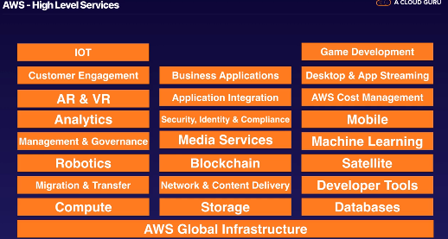  
**AWS High Level Services**

**AWS Cloud Practitioner Exam** 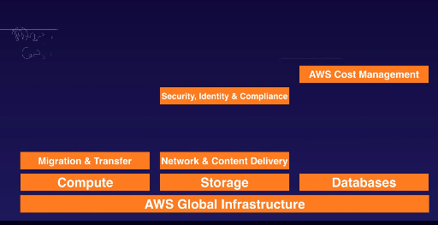

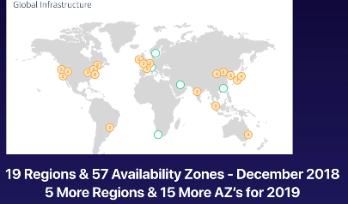

* Availability Zone ~ Data Center; spread out so if a natural disaster occurs, multiple AZ’s won’t be affected at the same time
* Region = geographical area made up of 2+ Availability Zones
* Edge Locations – endpoints used for caching content
  + More edge locations than regions
* Choosing the right AWS Region:
  + Data sovereignty laws
  + Latency to end users
  + AWS Services
    - US East 1 gets all services first

**Identity Access Management (IAM)**

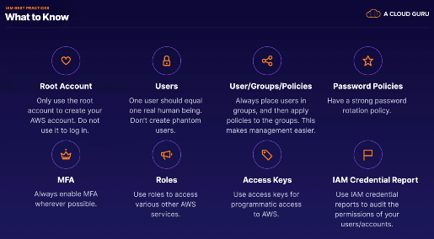

* Enable multifactor authentication (mfa) wherever possible for passwords

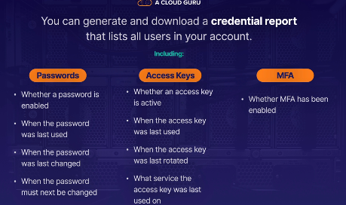

* Credential Report downloaded as CSV
  + Shows passwords, access keys, mfa

**Simple Storage Service: S3**

* One of the longest running been around since at least 2007
* S3 is a place to store flat files (ie: not changing files like videos, pictures, etc.)

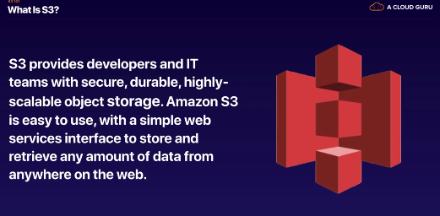

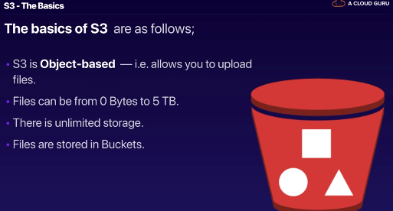

* Bucket = folder in cloud
* S3 is a universal namespace – bucket names must be unique globally
* Must be unique b/c creates a DNS address



* S3 is object based – objects = files
* S3 is key-value store
* Objects consist of:
  + Key – name of object
  + Value – sequence of bytes
  + Version ID
  + Metadata
  + Subresources: access control lists, torrent

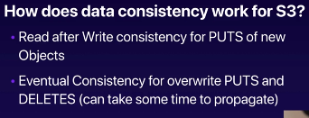 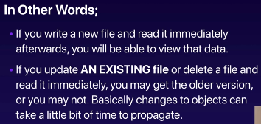

1. Read after Write consistency: you can immediately read file you place in S3
2. Eventual consistency: it takes a bit longer to access if you deleted a file

**Guarantees**

* 11 9’s durability: you won’t lose file uploaded into S3

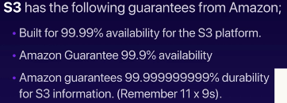

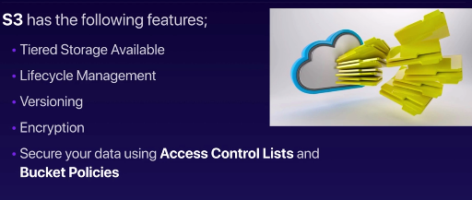

S3 Storage Classes:

1. S3 Standard
2. S3-IA: lower fee
3. S3 One Zone-IA:
4. S3 Intelligent Tiering – uses machine learning to move data across tiers
5. S3 Glacier
6. S3 Glacier Deep Archive – lowest storage
7. S3 Outposts

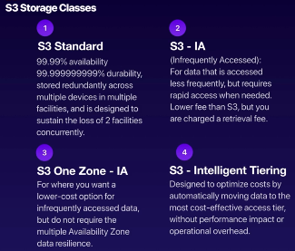

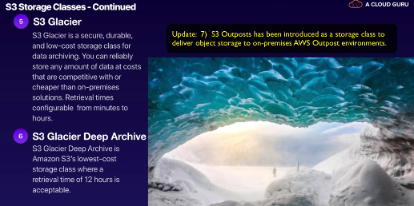

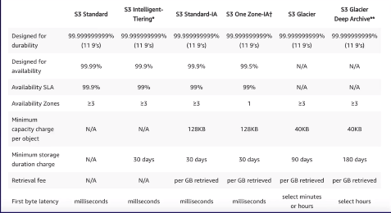

* First byte latency: how quickly you can access the first byte

