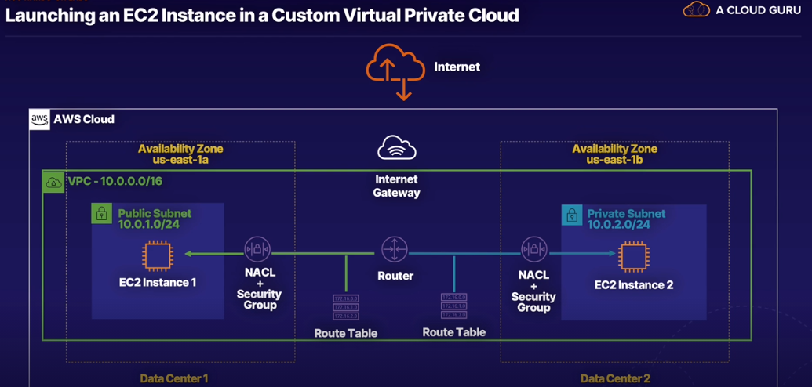

Goal: launch simple static website using EC2; build secure and scalable architecture to host your website

1. Create Virtual Public Cloud (VPC)
2. Launch 2 subnets

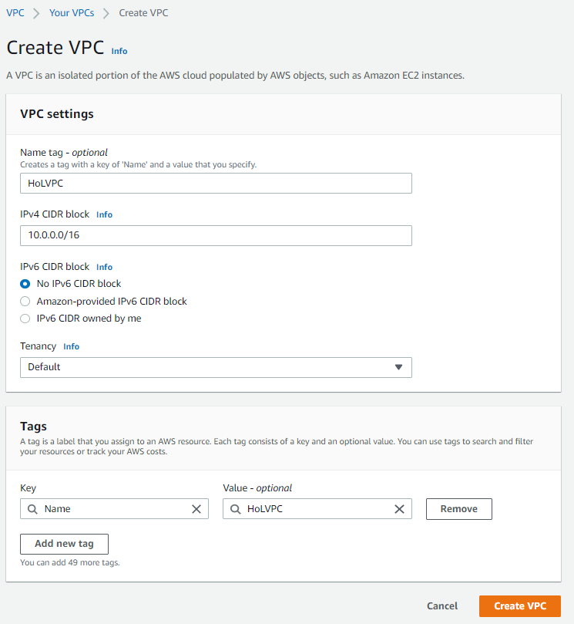

Tenancy: Default => using shared hardware

Dedicated => using dedicated hardware

Create VPC => 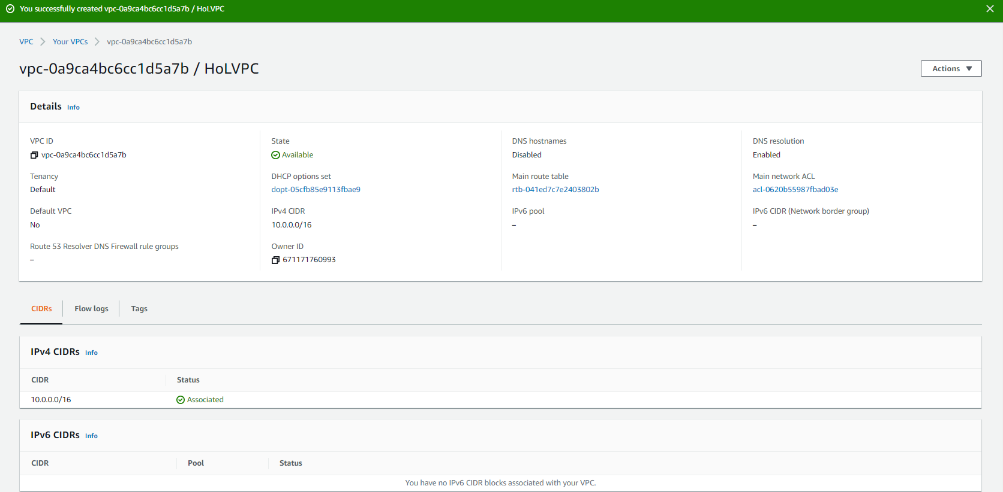

* Resources usually launched in subnets
* subnet must be entirely in one availability zone
* Create public route table and allow traffic to public internet address: 0.0.0.0/0
* Private subnet – doesn’t have route to public internet
* Security group = virtual firewall around EC2 instance

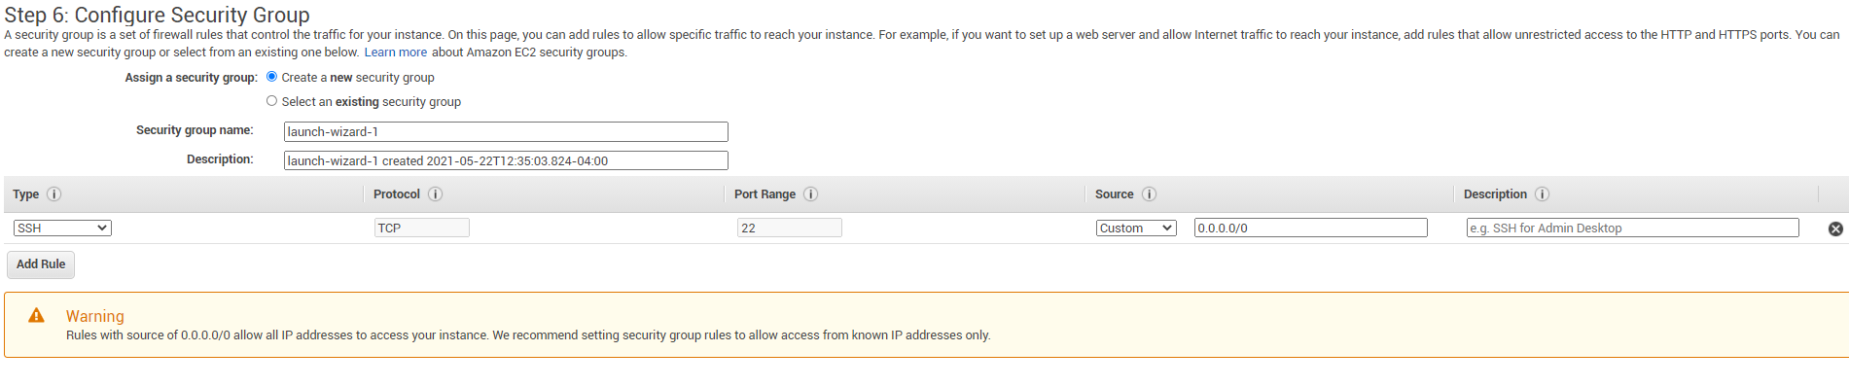

*** recommended to launch security group from known IP address only (not public)

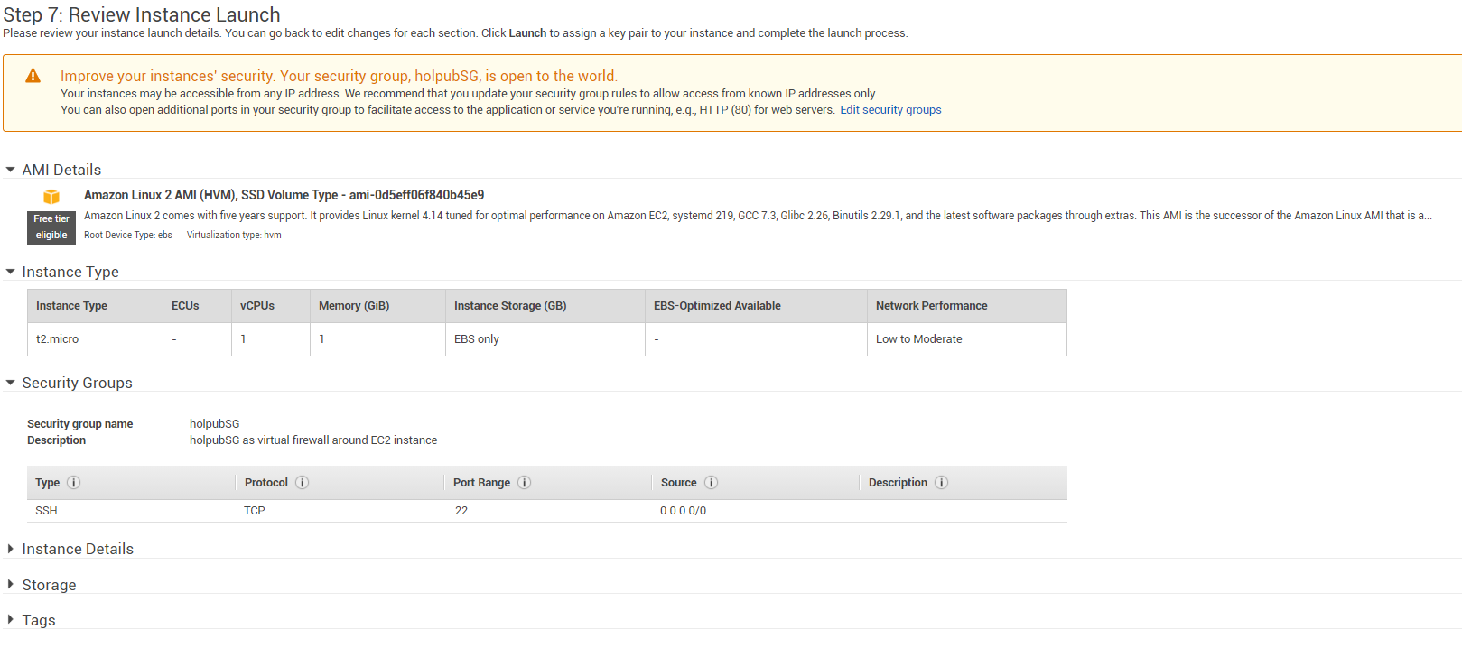

Command line:

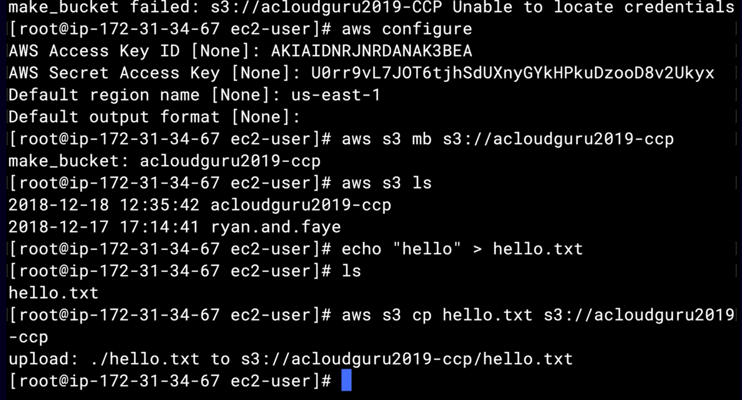

* Don’t want to use access key and secrete access key wherever possible

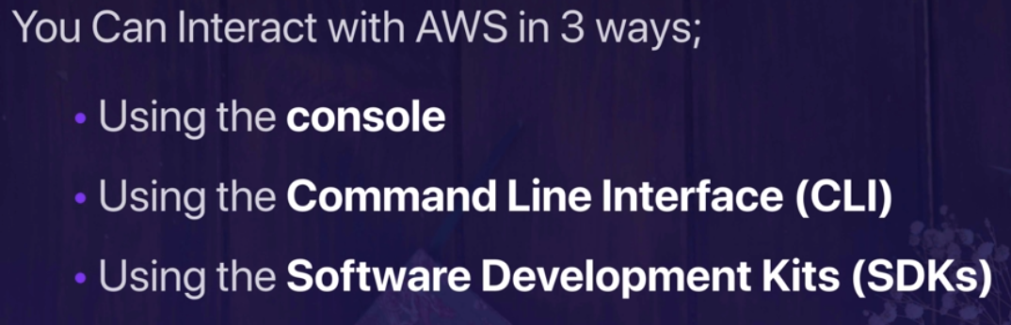

10.0.0.0/24

Update to root: sudu su

yum update –y

yum install httpd –y

service httpd start

cd /var/www/html

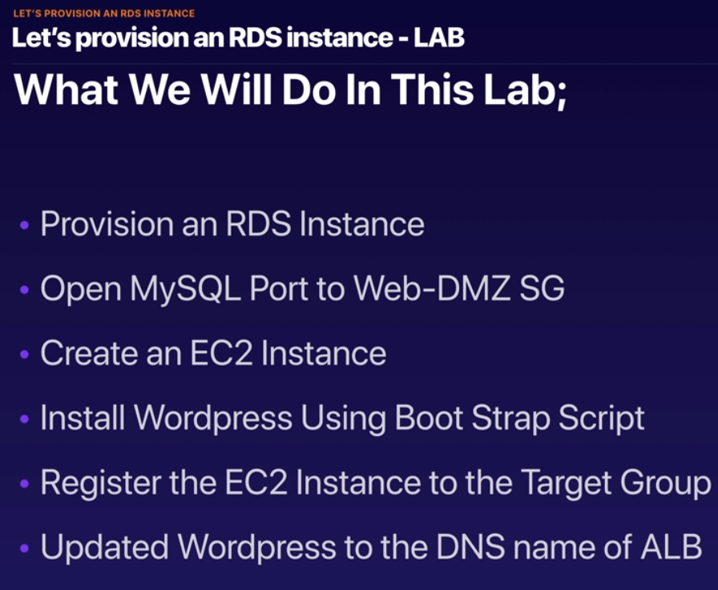

* IP address changes when you delete/add EC2 instance
* Don’t use IP address, go off website name
* Take Snapshot of EC2 instance and use to create auto scaling group – to finish off fault tolerance Wordpress site

**Let’s setup Auto scaling**

* Auto scaling creates fault tolerance
* AMI – Amazon Machine Image: takes image of EC2 instance

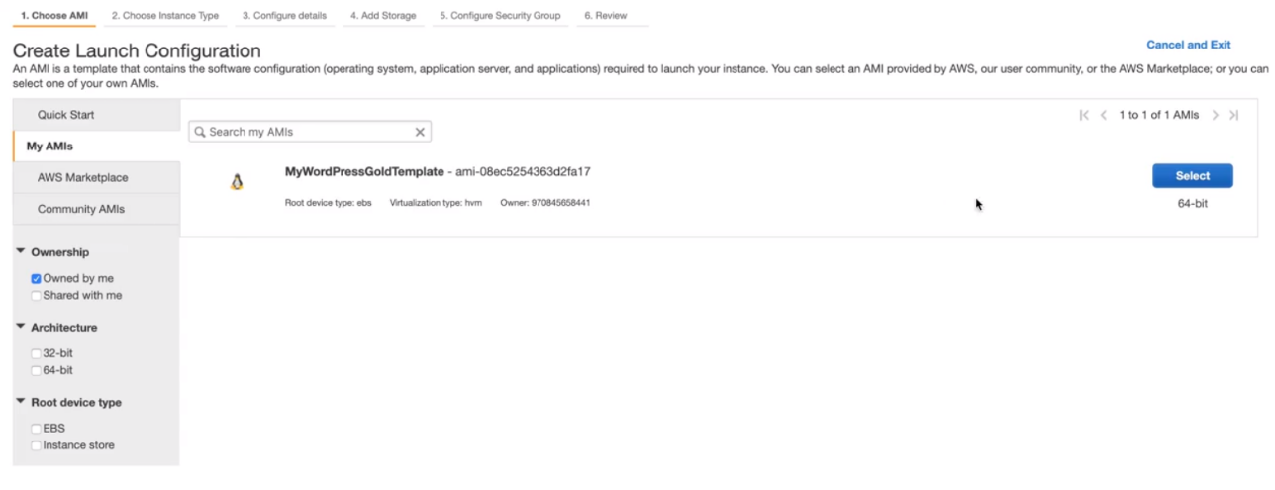

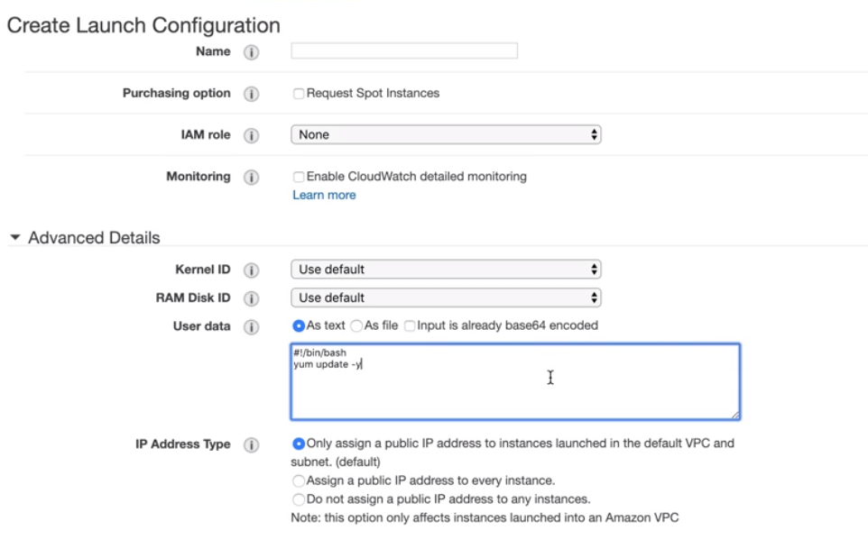

Create bootstrap => all configurations will update themselves

* Remember to also delete application load balancer and target group

**Registering a Domain Name**

* DNS (Domain Name System) – works like a phone book; process computers use to resolve domain names to IP Addresses
* DNS works on port 53

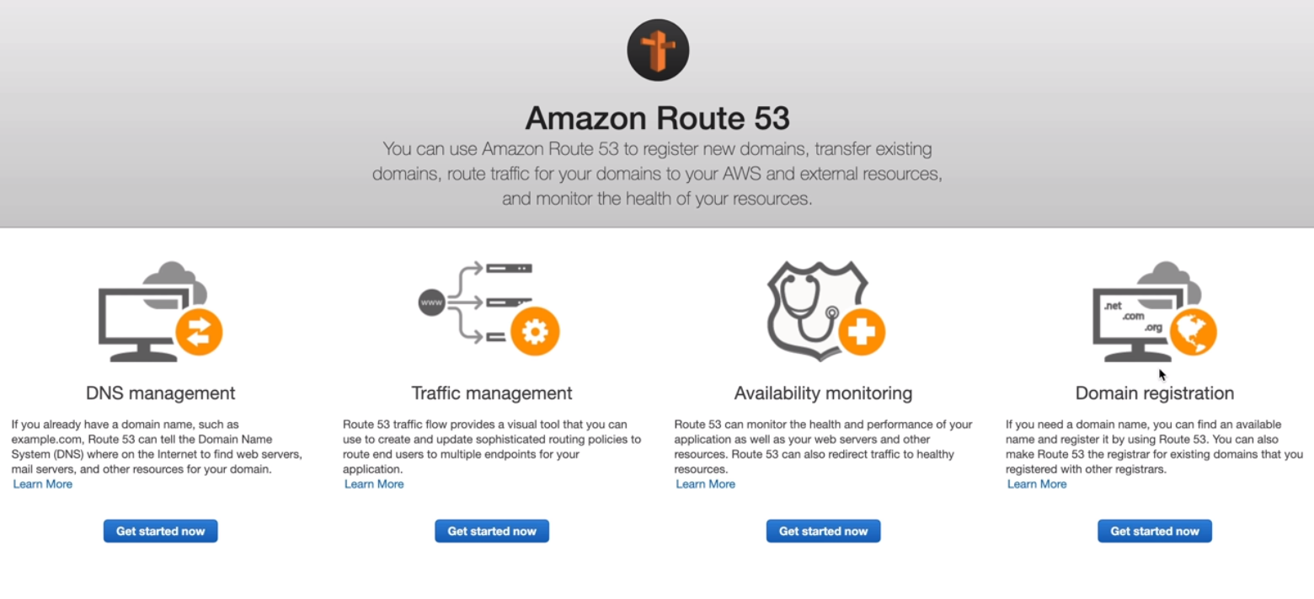

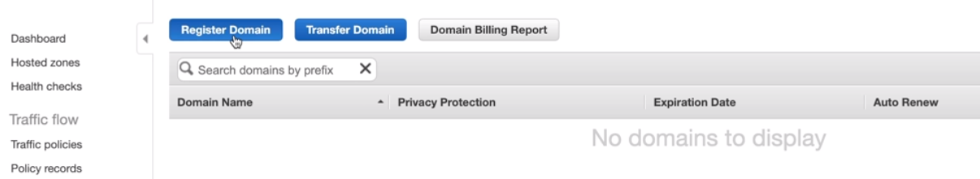

* If you are registering a domain name, make sure to have the S3 bucket for it created

Creating DNS

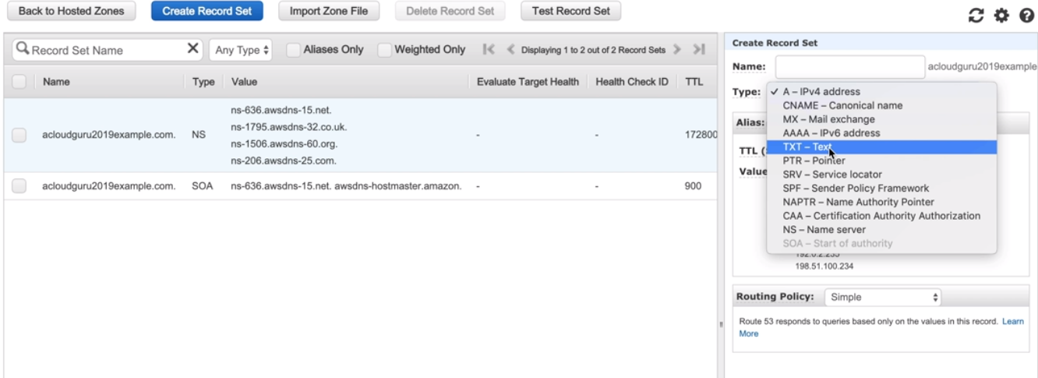

* Want to be Alias: A – Ipv4 address

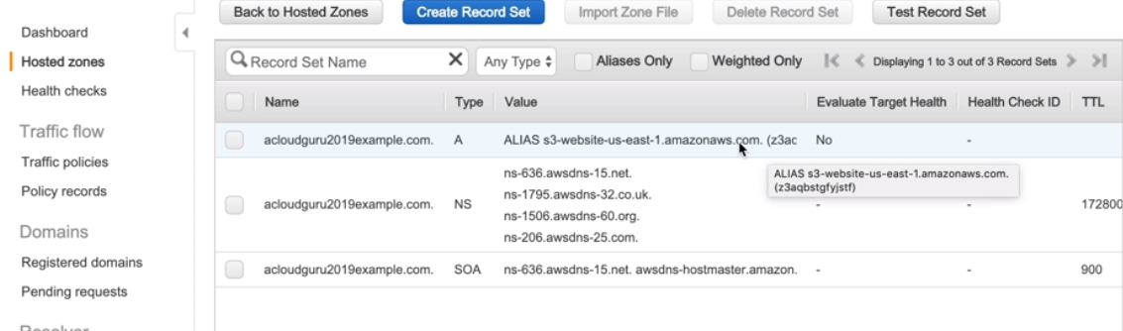

* Serverless website because it’s coming off S3, not EC2

