1. **AWS Storage Services Overview**

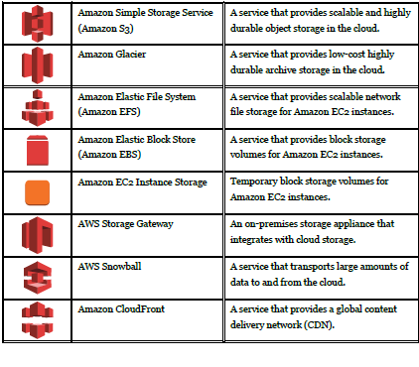

S3 range of storage classes use cases:

* Amazon S3 Standard: general-purpose storage of frequently accessed data
* Amazon S3 Standard-Infrequent Access (Standard-IA): long-lived by less frequently accessed data
* Amazon Glacier: low-cost archival data

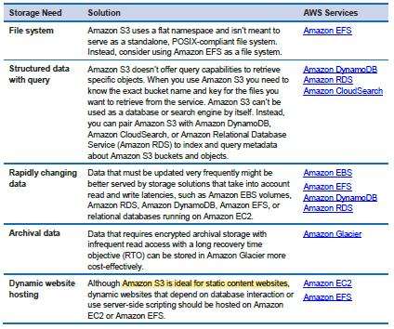

* Fastest access when S3 and EC2 are being used in the same region