Camera2Video Guide

1. Connect your device with USB
2. Install APK

* Go to directory Software/apk
* Execute installApk.bat

1. Replace your so

* Replace libmms_api.so with your own so
* Execute replaceSo.bat

1. Launch App Camera2Video
2. Settings

* Open 0,1,2 Cameras, User legacy for camera2
* Select your resolution.
* Click continue

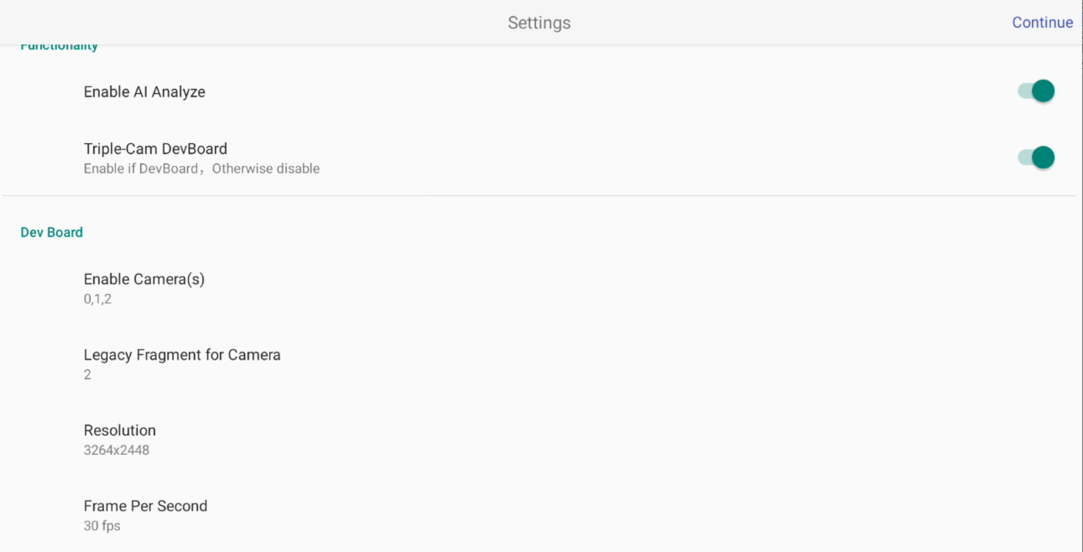

1. Click Translate to start capture 3 images from 3 cameras

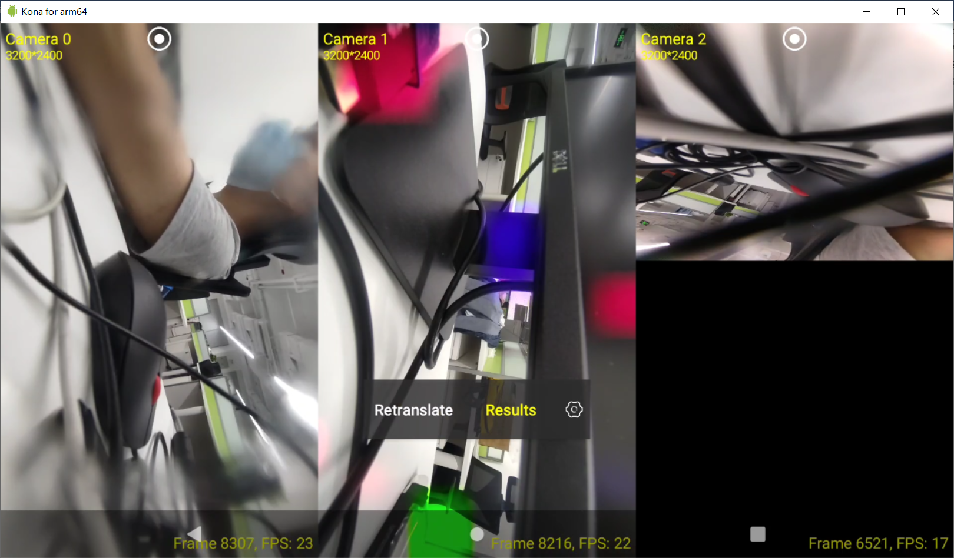

1. Click Result to show the result images(demo returns the same images of camera0/1)



1. Skip Settings from start

Check Skip Settings Next Time

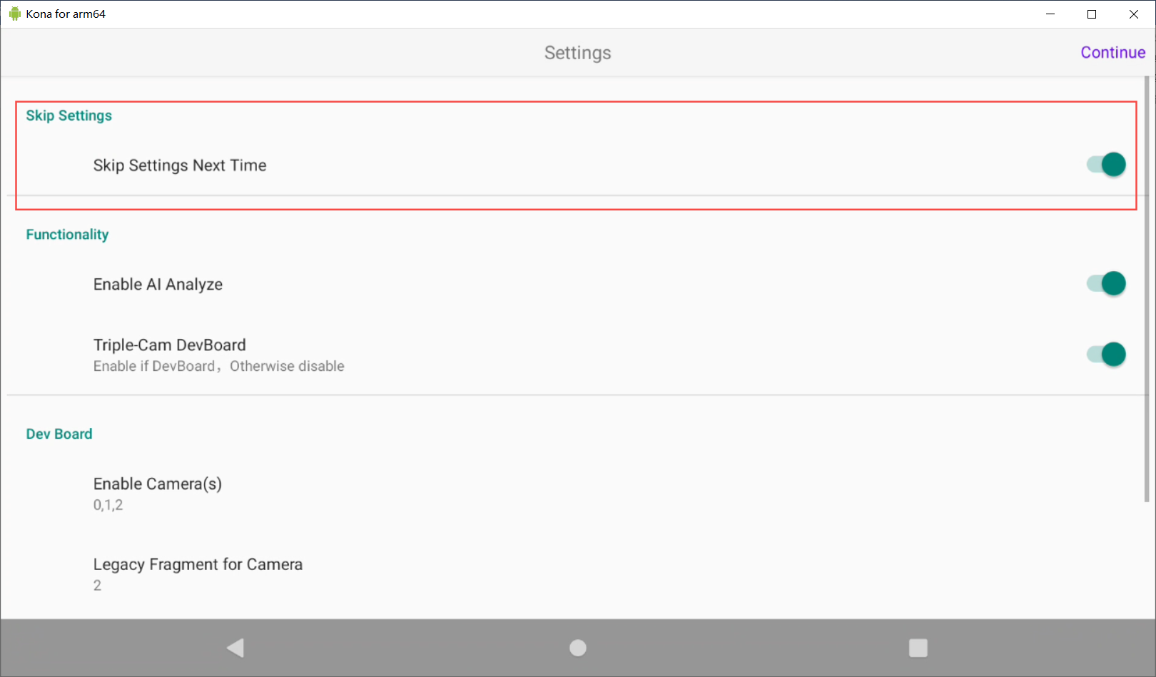

Revert the skipping:

Click Disable button, it will turns into a setting icon. It will not skip settings next time.

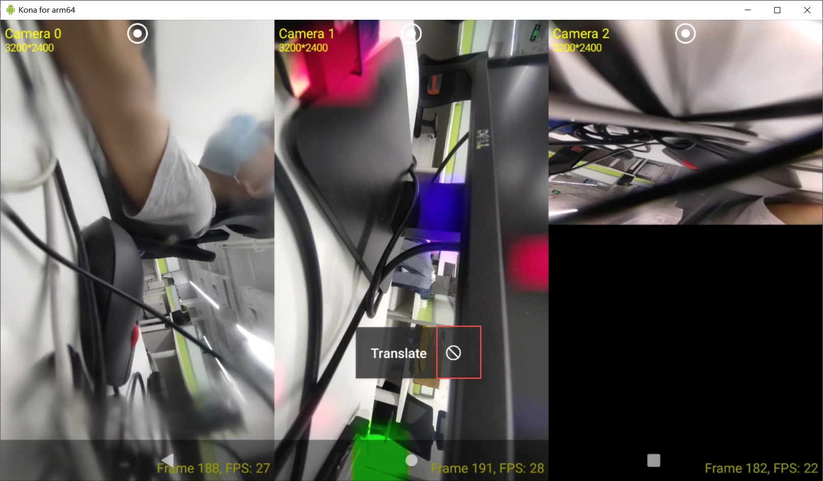

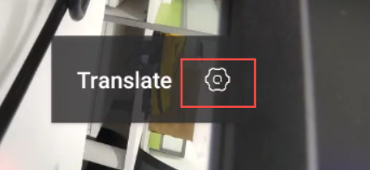

1. Debug from source code

* Open source code with Android Studio
* Trace follow key functions:

Globle.kt:

**translateImage** in Globle.kt collects images from 3 cameras.

AllCameraFragment:

**translateCallback** receives result from the translate.

The results image show on ResultActivity.

MmsBridgeApi:

MmsBridgeApi**.translateImages**(…)

**-> Java_com_example_mmsbridge_MmsBridgeApi_translateImages** in

***native-lib.cpp*** is calling the so function.