Maintenance of infrastructure systems

Literature Review

Luisa M. Mimmi1, Authorr II2

1Independent Consultant, 2 Other University

Last updated: 30 December, 2020

Table of Contents

# Introduction

Here is an introduction. This paper explores the relationship between height and weight of Starwars characters.

When Starwars was released as a book (**???**), the films were already in production. Here are some more citations from our bibliography (**???**; **???**). (**???**) demonstrated the use of an inline citation here.

# Methods

Here is the methods section. Refer to this section in the manuscript.Rmd file to see how we:

1. Input a table that does not use R code
2. Insert a figure that does not use R code
3. Insert an equation
4. Insert a footnote

## Insert Markdown tables

The following table similarly demonstrates absolutely nothing useful except how to generate a simple table in RMarkdown.

Here are some ways of inserting Markdown tables:

1. By hand using standard Markdown syntax
2. Using a [Tables Generator website](https://www.tablesgenerator.com/markdown_tables)
3. Using the [remedy RStudio addin](https://github.com/ThinkR-open/remedy)

|  |  |  |
| --- | --- | --- |
| Year | Movie | Rotten Tomatoes Score |
| 2019 | The Rise of Skywalker | 53 |
| 2016 | Rogue One | 83 |
| 2002 | Episode II: Attack of the Clones | 65 |

## Insert a figure

Figure 1: Starwars logo

Figure 1: Starwars logo

## Insert equations

Here is a nifty equation that shows absolutely nothing except how to include an equation:

George Lucas’ income = $\frac{N times people havesaid May the Force Be With You}{Carrie Fisher}*\$1 bazillion$.

## Insert footnotes.

Because we specified footnotes in the markdown extensions in our YAML[1], we can now include them in the text.

# Results

This is where most of our R code will be, relying heavily on the contents of helper.R. You can embed figures and tables directly in this section, or you can save them to another location. Every journal has slightly different requirements, so you may have to tweak your workflow depending on where you’re submitting.

## Inserting a figure in R

We can embed figures just like we did in the summary document by using R code chunks. We can also include extra information to include captions and to be able to cross reference them.

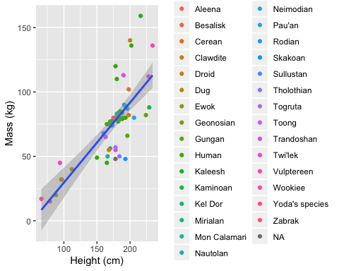

Figure 2: Mass by Height for all species

We can also just redo the plot 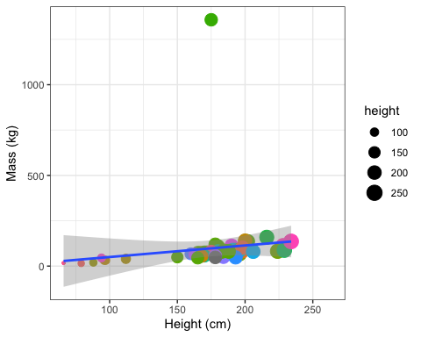

## Cross referencing figures and tables

You can cross-reference figures and tables. This is a bit more complicated, but the benefit is that you don’t have to remember which figure/table was in which position (especially helpful if you are adding/removing figs/tables during editing phase). You simply refer to the figure by its chunk label.

See Figures 2 and ?? above. Figure 3 is shown below.

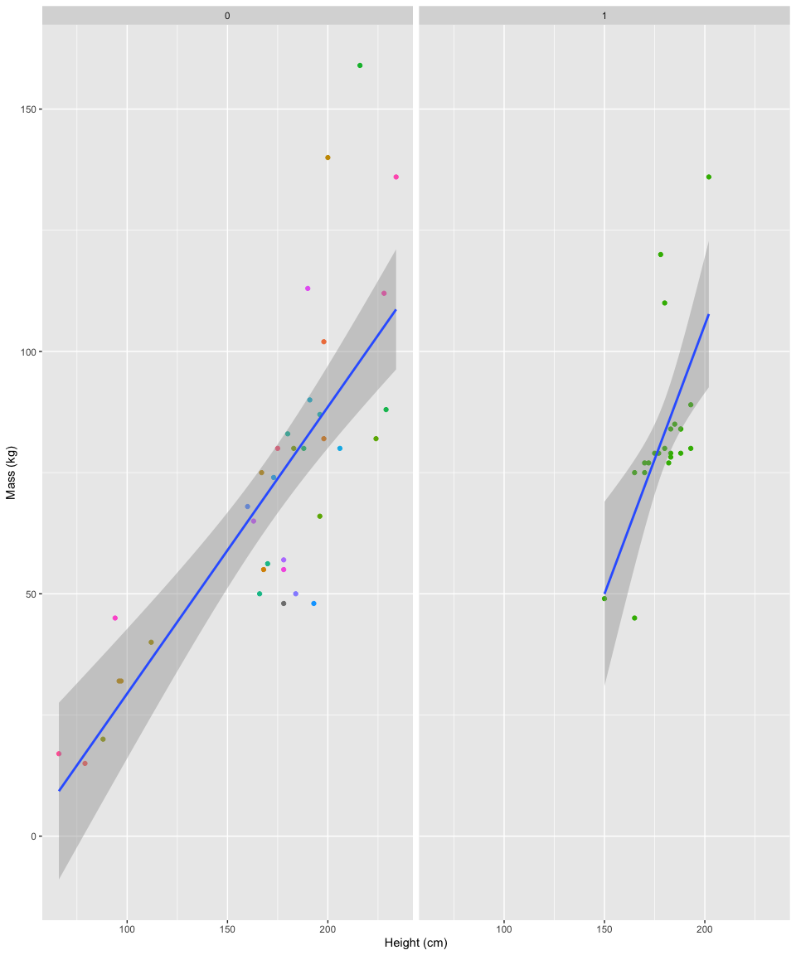

Figure 3: Mass by Height for humans vs. non-humans

See Table 1.

Table 1: Average height and mass for humans vs. non-humans

|  |  |  |  |
| --- | --- | --- | --- |
| human | height | mass | n |
| 0 | 172.9400 | 105.95135 | 52 |
| 1 | 176.6452 | 82.78182 | 35 |

**Caution**: Notice cross-referencing tables worked for the knitr::kable() option, but out markdown table above did not get automatically numbered. If you want to include both R and non-R tables, I’d suggest either 1) converting markdown tables to R code or 2) using the flextable package to generate captions and cross-references.

### Using inline R code to refer to values in tables

Here I will include a little extra embedded R code to clean up our model results, but I won’t include this code to be shown. In the next paragraph, I’ll refer directly to the contents of my model output using in-line R code. For this, we don’t use embedded chunks, but rather the syntax ` r someCodeHere `. See the next paragraph in the results.Rmd file for an example.

With Jabba the Hut removed, there was a significant main effect of height on mass ( $\hat{β}$ = 0.621, $t$ = 8.785, $p$ = <0.001).

### Printing a table

Here I will reference 2

Table 2: This is the caption for my model coefficients table.

|  |  |  |  |  |
| --- | --- | --- | --- | --- |
| Var | Estimate | Std. Error | t value | Pr(>|t|) |
| (Intercept) | -32.5407582 | 12.5605252 | -2.590716 | 0.0121882 |
| height | 0.6213599 | 0.0707276 | 8.785255 | 0.0000000 |

# Discussion

Discuss.

# Limitations

Beat reviewer #2 to the punch!

# References

1. This is the footnote.