Lit Rev DIA Chap ? Future

2019-03-19

Table of Contents

* **Zagatti et al. (2018)** have an empirical study

# OVERARCHING IDEA

The Economist says *“The fundamental problems, however, are neither the resource itself, since water is likely to remain abundant enough even for a more populous Earth, nor technical.* ***They are managerial****, or, more precisely, how to withstand economic, cultural and political pres- sures to mismanage water.”* (See Economist 2019, 1)

In general only what gets measured can be managed, so we can see recent technological advances and the emerging new approaches as a way to “SEE MORE” and therefore (possibly) “DO BETTER”. This can be argued at many different levels:

+ See "more" of where 'fresh/raw' water comes from   
 + See "more" of where water gets wasted at the community levels / along the distribution network  
 + See "more" of our own individual footprint

## Hard to “see” where water comes from (WRM perspective)

1. *Agriculture*, which uses 80% of all the water humans consume—could grow far more food with far less water with improved technologies and irrigation practices.

–> RS for Groundwater / Water footprint

1. Reuse (everyone drinks reused …. ) –> Singapore (NEwwater) but also Namibia Widhoek (1/4 of water is reused ??? )  
   <https://qz.com/is/what-happens-next-2/1438726/future-of-water/>

## Hard to “see” where water gets lost (along the distribution network)

In our **cities**, as much as a third of all water is lost to leaks or inefficient uses.

### Adjacent issue: inadequate price (regulation + suppliers’) discourage saving

## Hard to know what consumes more water (consumer perspective)

there is a *water “footprint” embedded in everything we do*: for irrigation, to grow cotton or produce steel, to make cell phones or cars, to water our gardens, and flush our toilets.

*“The average American water footprint is 7,800 liters per day. Compare that with Germans who have a water footprint of 3,900 liters or the Chinese with 2,900 liters.”* (See Thakar 2018)

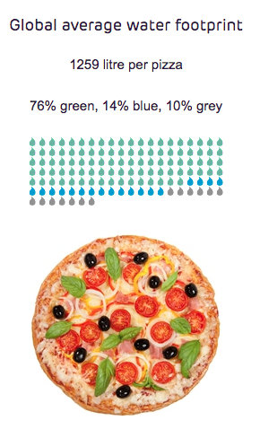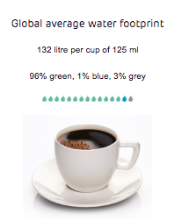 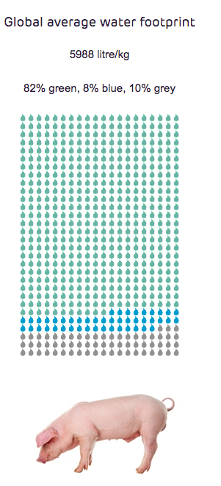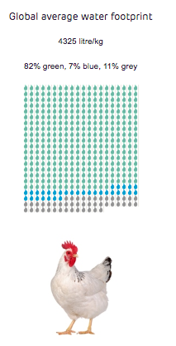

(see Hoekstra and van Heek 2017)

# (Innovative) SOLUTIONs

## Hard to “see” (WRM perspective)

#### Take it from new places

## Hard to price adequately (regulation + suppliers’) –> Local answer? (China sponge cities? )

1. Decisions at personal level (food, appliances, garden) “ew home appliances like washing machines, dishwashers, toilets, and showerheads use far less water now than they did a few years ago. The average toilet in the United States used to require over 20 liters per flush. Today, the national standard is six liters, and newer models use even less (and work even better).” (**Gleick (2018)**)
2. Decisions at communty level (use of stormwater, local streams, … local weels )
3. city
4. countries

## Inform the consumers (consumer perspective) –> Sarni etc.

# BIBLIOGRAPHY

Economist. 2019. “Thirsty Planet - Special Report on Water.”

Gleick, Peter. 2018. “We Have Enough WaterWe Just Waste Too Much of It,” November.

Hoekstra, Arjen, and Michiel van Heek. 2017. “Water Footprint Network: Product Gallery.” /en/resources/interactive-tools/product-gallery/.

Thakar, Ruth Mathews, Kanika. 2018. “Your Water Footprint Is Just as Important as Your Carbon Footprint.” *Quartz*, November.

Zagatti, Guilherme Augusto, Miguel Gonzalez, Paolo Avner, Nancy Lozano-Gracia, Christopher J. Brooks, Maximilian Albert, Jonathan Gray, et al. 2018. “A Trip to Work: Estimation of Origin and Destination of Commuting Patterns in the Main Metropolitan Regions of Haiti Using CDR.” *Development Engineering* 3:133–65. <https://doi.org/10.1016/j.deveng.2018.03.002>.