Give your
voice



User guide

Table of content
1-Introduction 3
2-Main screen 4
2.1 Project tree structure 5
2.2 Add a section 5
2.3 Insert a section 6
2.4 Rename a section 6
2.5 Import audio files in a section 6
2.6 Delete a section 6
2.7 Add a record to a section 6
2.8 Import audio files in a section 7
2.9 Mix a section to produce an MP3 file 7
2.10 Listen/Stop a record 7
2.11 Modify an existing record 7
2.12 Compress MP3 to ZIP 7
2.13 Empty the MP3 folder 9
2.14 Rename an MP3 file 9
2.15 Delete an MP3 file 9
2.16 delete the ZIP folder and its content 9
3-Project manager 10
3.1 New project 11
5-Naming the sections 12
7-Audio recording 13
7.1 Step 1 – Start-up options 13
7.2 Step 2 – SHHH! One listen to the noise! 14
7.3 Step 3 – Your turn ! 14
7.4 Step 4 – File name 15
7.5 Tips for your recordings 15
7.6 What should I do if I mispronounce something when reading ? 16
8-Audio edition 17
8.1 Actions with mouse 17
8.2 Buttons description 17
9-Mixing audio and export to MP3 19
9.1 Actions with mouse 19
9.2 Buttons description 20
9.3 Voice effects 20
9.4 Outpout file 20
9.5 Add music or sound effects 20
9.6 Delete a music or a sound effect 21
9.7 Global level setting for music and sound effects 21
9.8 Volume envelope 21
9.9 Mute music or sound effects 22
9.10 Start mixing 22
9.11 Metadata to include in MP3 22
9.12 MP3 Validation 22
10-Enhance listening 24
11-Web links 25
12-Options 26
13-Report a bug 27

Introduction
GIVE YOUR VOICE is a software for recording audio books.
It can produce files to the standards imposed by download platforms such as LittératureAudio.com et LibriVox.org, platform offering literary works in the public domain, recorded in MP3 audio format by volunteers : voice givers.

What motivated its development was the list of tasks that a voice giver must perform in order to produce a recording that meets the required standards :
- know how to use Audacity, the free, high-performance audio editing software
- organize a reading project on the computer hard disk
- respect the file name format imposed by the platform
- produce MP3 in mono, constant bitrate at 128kbps, incorporating metadata
- normalize MP3 to 89dB with MP3Gain, another free program
- produce ZIP-compressed files containing several MP3s, using other file compression software (Izarc, 7Zip, etc.)
- as well as all the additional tasks involved in uploading a test recording to the platform and then publishing its recordings there

GIVE YOUR VOICE offers you the advantage of centralizing virtually all the tasks involved in producing compliant MP3 with a single software package.
Features
- One directory per section → your project is well organized.
- Accepts multiple records in the same section → the software keeps the page number where you left off.
- Automatic background noise suppression on recordings.
- On each mispronunciation, simply press "Ctrl" key to insert a mark on the recording, so that you can easily find them again when correcting.
- Audio tools (cut, insert silence, silencing a selection, replace or add audio, Undo/Redo).
- Import audio files.
- Mix your voices with ease: audio effects such as compressor, amplification and bass boost to enhance vocals, add music, sound effects, graphic envelope for easy volume control, editable metadata, built-in and transparent audio limiter to minimize audio clipping.
- Produce MP3 files compatible with LittératureAudio.com ou LibriVox.org : compliance with file naming rules, MP3 generate at 44100Hz, mono, constant bitrate 128kbps, and normalized à 89dB.
- Compress multiple MP3 into ZIP.
- Compress your finished projects to save disk space.
- This software has been made with love, it's free and it's going to stay free !

Main screen
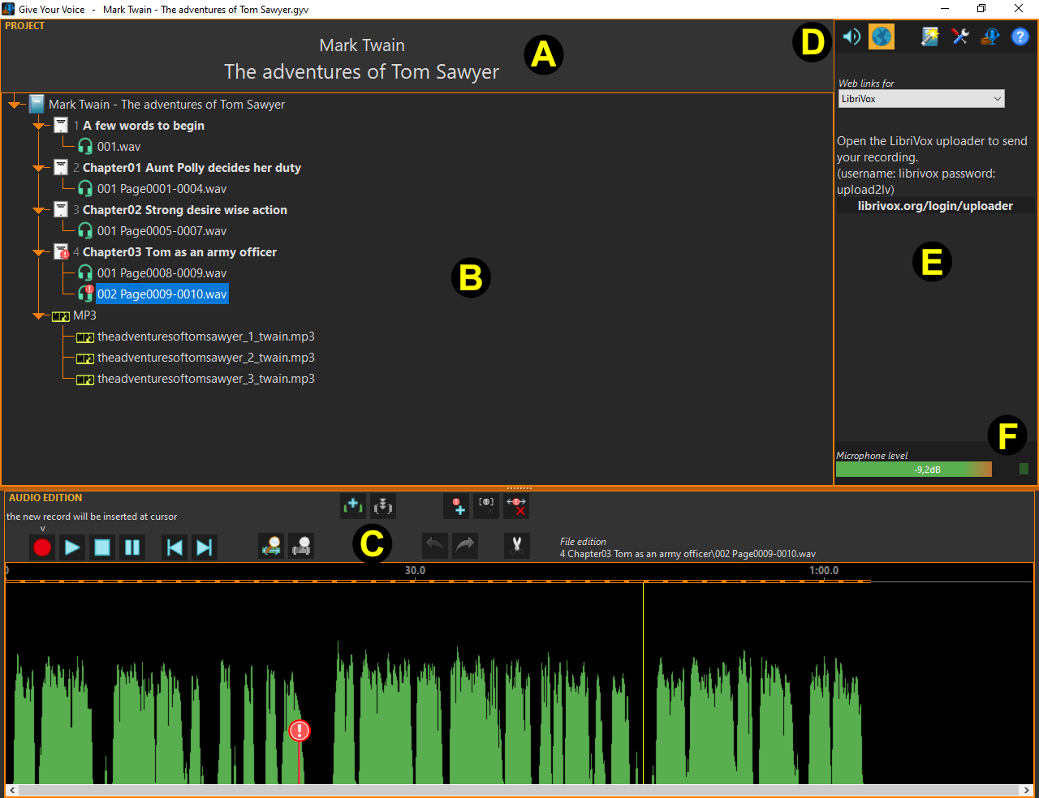
- A information on the current project
- B project tree
- C audio edition
- D general toolbar
  -  displays the listening enhancement options page
  -  displays the web links page
  -  open the project manager
  -  open the options window
  -  open the 'about' window
  -  show this user guide
- E additional functions
- F signal level from the microphone
Wherever you are in the program, pressing the F1 key displays the program help (in PDF format).

Project tree structure
A Give Your Voice project is a simple directory on the disk with the name of the project. Inside, the software creates a sub-directory for each section (chapter, text, poem...) and places the audio recording(s) there.
Project example
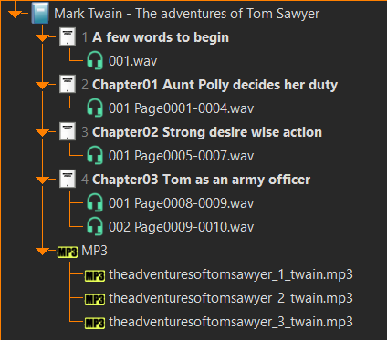
In the screenshot above, you can see the organization of the project into different chapters and the recordings in wav format.
The title of a section or record is preceded by a number to keep them in order. You don't have to worry about this, the software takes care of it.
Once all the recordings for a section (in this case, a chapter) have been made, you can mix them to produce an MP3 file. This will automatically be placed in the project's MP3 folder.
There's nothing to stop you creating a section grouping together several chapters. In this case, name it explicitly, e.g. 'Chap01 to Chap03', and omit their titles.

Add a section
Click on the root of the tree (where the blue book icon is) to bring up the toolbox.
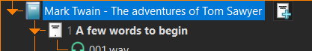
Then click on . The window for section naming appears.
If you have many sections in the tree, it may not be practical to go back to the root each time to access the button. In this case, right-click on an empty part of the project tree to bring up its context menu, then click on « Add a new section to the project ».

Insert a section
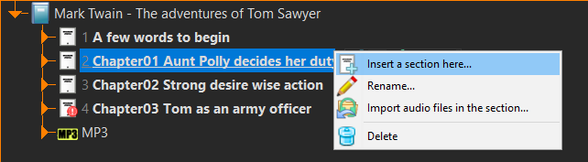
You can insert a section before another if you've forgotten one. To do this, right-click on the section to be moved and click on « Insert a section here... ». The window for section naming appears.

Rename a section
Right-click on the section to be renamed, then « Rename ».

Import audio files in a section
This is useful if, for example, you record your readings with an external device, or have received recordings from another voice giver.
Right-click on the section then « Import audio files in the section... ». A window opens; navigate to the directory where the files are located and select them. To select more than one file, hold down the Ctrl key.
When imported, the files are converted to wav mono PCM16 format and placed after existing recordings.

Delete a section
Right-click on the section to delete, then « Delete ». Warning ! All recordings in this section will be deleted from the disk !

Add a record to a section
Select the section in which you are going to add a record: to its right appears a small toolbox.
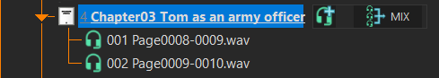
Then click on , the recording window appears.

Import audio files in a section
This is useful if, for example, you record your readings with an external device, or have received recordings from another voice giver.
Right-click on the section, then « Import audio file in the section... ». A window opens; navigate to the directory where the files are located and select them. To select more than one file, hold down the Ctrl key.
During import, files are converted to wav format, mono PCM16.

Mix a section to produce an MP3 file
Select the section and click on « MIX ». The mixing window appears.

Listen/Stop a record
Select a record: to its right appears a toolbox.
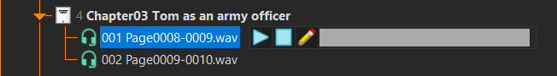
Then click on the  to start playback and  to stop it. The progress bar on the right shows the current playback position. Click on it to jump to another position.
You can also use the 'SPACE' key to play/stop audio.
You can also listen to files in the MP3 folder in the same way.

Modify an existing record
Select the record to be modified and click on . At the bottom of the main window, the panel audio edition now displays the audio and you can use its tools to rework it.
You can also double-click on a record to edit it.

Compress MP3 to ZIP
The platfom LitteratureAudio.com requires you to supply individual MP3 files, as well as one or more ZIP-compressed files containing several or all MP3s. Give Your Voice lets you generate these ZIP files. To do so, right-click on the MP3 folder, and a contextual menu will appear :
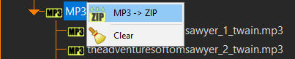
Click on « MP3->ZIP ». The MP3 compression window appears.
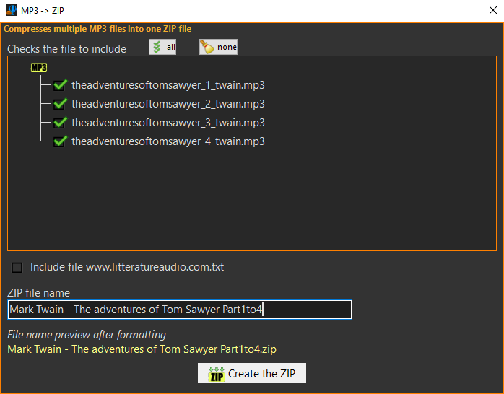
At the top, tick the MP3 files you want to include.

« Include file www.litteratureaudio.com.txt » : check this option if the ZIP file you are about to generate is destined for the LiteratureAudio.com platform. The platform asks to include a small text file in the zip.

« ZIP file name » : change the title of the ZIP file explicitly. In the example, we'll be compressing part 1 to 4, so we've modified the name accordingly.

« File name preview after formatting » : the program gives you a preview of the ZIP file name after formatting. Formatting only takes place if you have checked the option « Include file www.litteratureaudio.com.txt ».

« Create the ZIP » : click this button to start compression. A ZIP folder then appears in the project tree, and the file is placed there.

Empty the MP3 folder
Once you've uploaded your MP3 files to the distribution platform, delete them to save disk space. You can always restart a mix to generate them.
To do this, right-click on the MP3 folder in the tree and click on « Clear »

Rename an MP3 file
Right-click on an MP3 file in the MP3 folder.
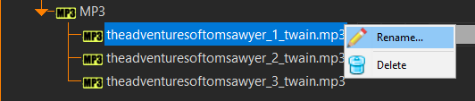
Then click on « Rename ».

Delete an MP3 file
Right-click on the MP3 file to be deleted, then « Delete ».

delete the ZIP folder and its content
Right-click on the ZIP folder in the tree, then click on « Delete ».

Project manager
To access this window, click on in the top right-hand corner of the main window.
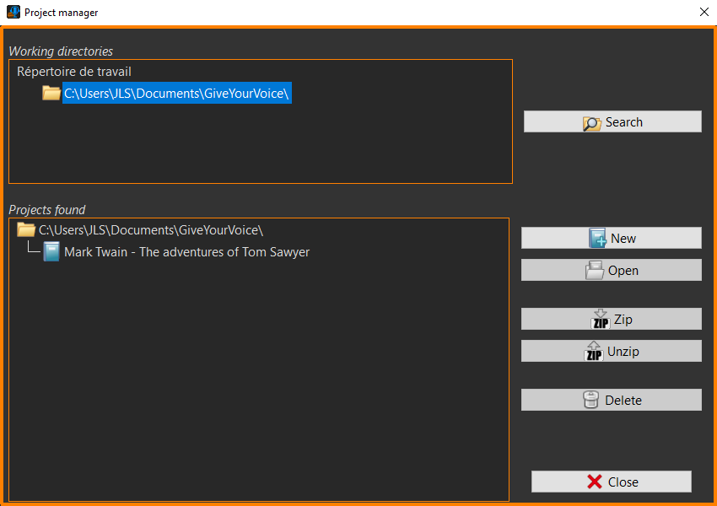
This is where you manage your reading projects.

At the top, you'll find a list of working directory. Click on an item in the list to select one.
In the lower section, you'll find a list of projects that have been found in this working directory.

- « Search » : allows you to search for and add to the list a working directory that is not yet there.
- « New » : Start a new project which will be saved in the current working directory. The new project window will open.
- « Open » : click here to open the selected project (or double-click on its name)
- « Zip » : Zip a project to save disk space.
- « Unzip » : unzips the zipped project for editing.
- « Delete » : deletes the selected project, all its contents will be erased from the disk.

New project
To access this window, click on in the main window then on « New ».

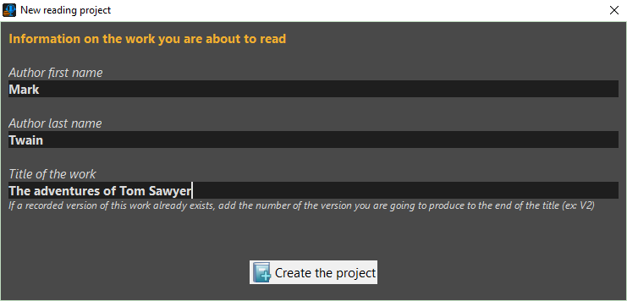
Enter the author's first and last name and the title of the work you are about to read.

At least one of the three fields must be filled in for the create button to be active.

If you are going to publish your project on a distribution platform such as LitteratureAudio or LibriVox, and if a recording of this work already exists, specify in the title the number of the version you are going to produce (e.g.: The Adventures of Tom Sawyer V2) to differentiate it from the others.

Naming the sections
The following window appears when you add or insert a section to the project tree.

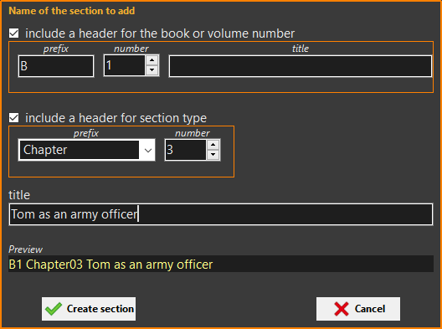
This allows you to name the new section to be created.

« Include a header for the book or volume number » : check this option if the work you are reading comprises several volumes or books. In this case, in the prefix box, enter, for example, the letter B for book or T for tome, specify its number and, if applicable, its title. This information will be added to the section name visible in the preview below.

« include a header for section type » : check this option and choose the section type from the prefix drop-down menu, then enter the section number as in the book.

« title » : and finally, enter the section title as it appears in the book.

In the example above, we create a new project section for book 1 (untitled), chapter 3, entitled Tom as an army officer.

If the proposed options don't suit your needs, uncheck them all, and in the title, enter the section name as you wish.

As their name suggests, the bottom buttons are used to create the section or cancel the operation.

Audio recording
The audio recording window appears when you click in the project tree or  in audio editing.
You can cancel a recording at any time by closing the window or pressing the Escape key.
Audio recording is a multi-stage process.

Step 1 – Start-up options
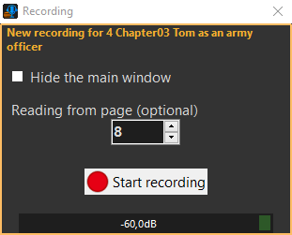
« Hide the main window » : check this option if the text you're reading is displayed on the same screen as Give Your Voice. The main window is then hidden, and you can place this little recording window wherever you like so that it doesn't interfere with your reading.

« Reading from page » : Enter the page number at the start of reading, so that you can remember it when you've finished. You can then include the page numbers read in the file name. This is optional, but highly recommended for project clarity.

« Start recording » : don't make any more noise, the software will analyze the background noise as soon as you press this button (if enabled in the program options, otherwise go directly to step 3).

Step 2 – SHHH! One listen to the noise!
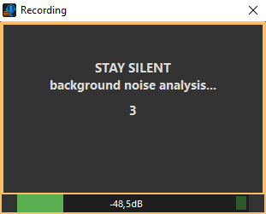
The software analyzes the background noise for three seconds. It will then be able to clean the recording of constant ambient noises such as the computer fan. Occasional noises such as a dog barking, a passing car or a fly flying over the microphone (yes, it happens!) will not be removed.
If you speak during the analysis, the software will consider your voice as noise and try to remove it at the end of the recording! Your recording will certainly have to be redone...

Step 3 – Your turn !
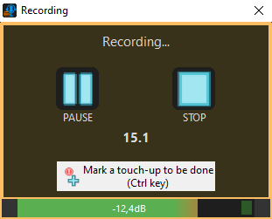
You can now read your text. A timer shows you how long you have been recording.
 Pause/Resume the recording.
Stop the recording.
 Inserts a marker. If you mispronounce something, click on this button to mark the spot. A red exclamation mark will then be visible on the audio curve, making it easier for you to retrieve the parts to be cut. Resume your reading on the beginning of the mispronounced sentence.
Use the Ctrl key to insert a marker more easily than with the mouse.

Step 4 – File name
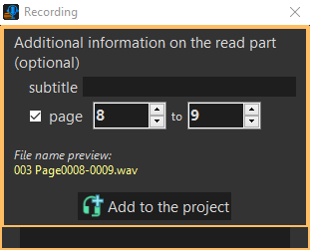
The software now asks how to name the audio file you've just recorded.

« subtitle » : if you wish, add a title here.

« page » : check this option to include the range of pages read. In this case, don't forget to update the end page.

« file name preview » : this is the file name that will be given to your recording. The first three digits are a prefix that the software automatically inserts so that the recordings appear in the right order in the project tree.

Click « Add to the project » to add the recording to the section's project.

If you don't specify a subtitle or page range, the file name will simply be the three digits record number.

Tips for your recordings
avoid saturation

> If the red LED on the right lights up too often, move away from the microphone or, if you're using a mixer, turn down its output level.

> Place the microphone slightly at an angle rather than facing it, to avoid saturation when pronouncing plosives (B, P, etc.) and sibilants (mainly S and F).

The ideal level

> Try to get closer to this level when reading passages where your voice is strongest.

What should I do if I mispronounce something when reading ?
When this happens to you, press the Ctrl (control) key on your keyboard and simply repeat from the beginning of the sentence. The Ctrl key inserts a marker on the audio curve, making it easier to retrieve the parts to cut.

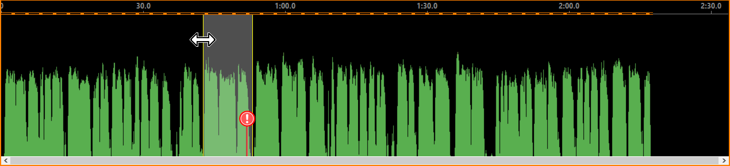
In the audio edition, make a selection around the marker. Adjust it by moving its ends with the mouse, when the cursor changes to Use the SPACE key to play/stop the selected audio. When the bad part is well selectioned, cut it by clicking on .

Audio edition
Audio editing is located at the bottom of the main window. This is where the software visualizes audio data when :
- you end a recording
- you click on after selecting a record in the project tree
- double-click on a record in the project tree

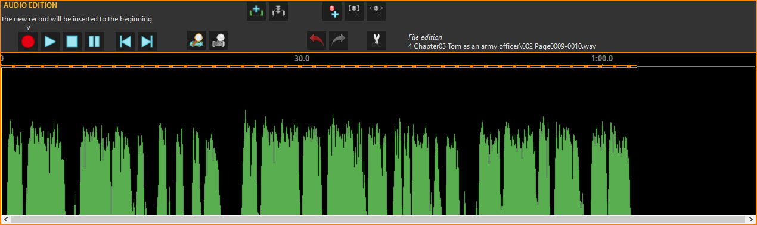
The green curve symbolizes audio. The closer it is to the top, the stronger the signal.
Any changes you make to the audio are immediately saved.
Use  to undo the last action.
Once you click on an item in the project tree, you will no longer be able to undo the most recent changes.

Actions with mouse
- Moves the cursor : left-click on the desired location.
- Selecting a part of the audio : hold down the left mouse button and move the mouse left or right. Ctrl+A to select all.
- Resize a selection : position the mouse over one of the ends of the selection, click and hold the left button and move to the right or left.
- Unselecting : left-click anywhere in the audio.
- Zoom with the mouse wheel (aim at the point where you want to zoom).
- Shift the view : RIGHT-click on the audio, hold it down and move the mouse right or left. You can also use the horizontal scroll bar at the very bottom.

Buttons description
Starts a recording that will be inserted at the cursor position. If a part of the audio is selected, the recording will replace it.
Play audio from cursor or SPACE.
Stop audio playing or SPACE.
Pause.
 Moves the cursor to the beginning.
 Moves the cursor at the end.
 Optimal zoom to see everything or Alt+A.
 Zoom on the selection.
Undo the last action or Ctrl+Z.
 Redo the last action or Ctrl+Y.
Cuts the selected part.
 Inserts silence to the cursor. Right-click on this button to change the duration of the silence to be inserted.
 Makes selection silent.
Adds a marker at the cursor position to remind you that you have a change to make.
 Deletes markers contained in the selection.
 Deletes all markers.

Mixing audio and export to MP3
This window appears when you click on « MIX » to the right of a section name in the tree structure.
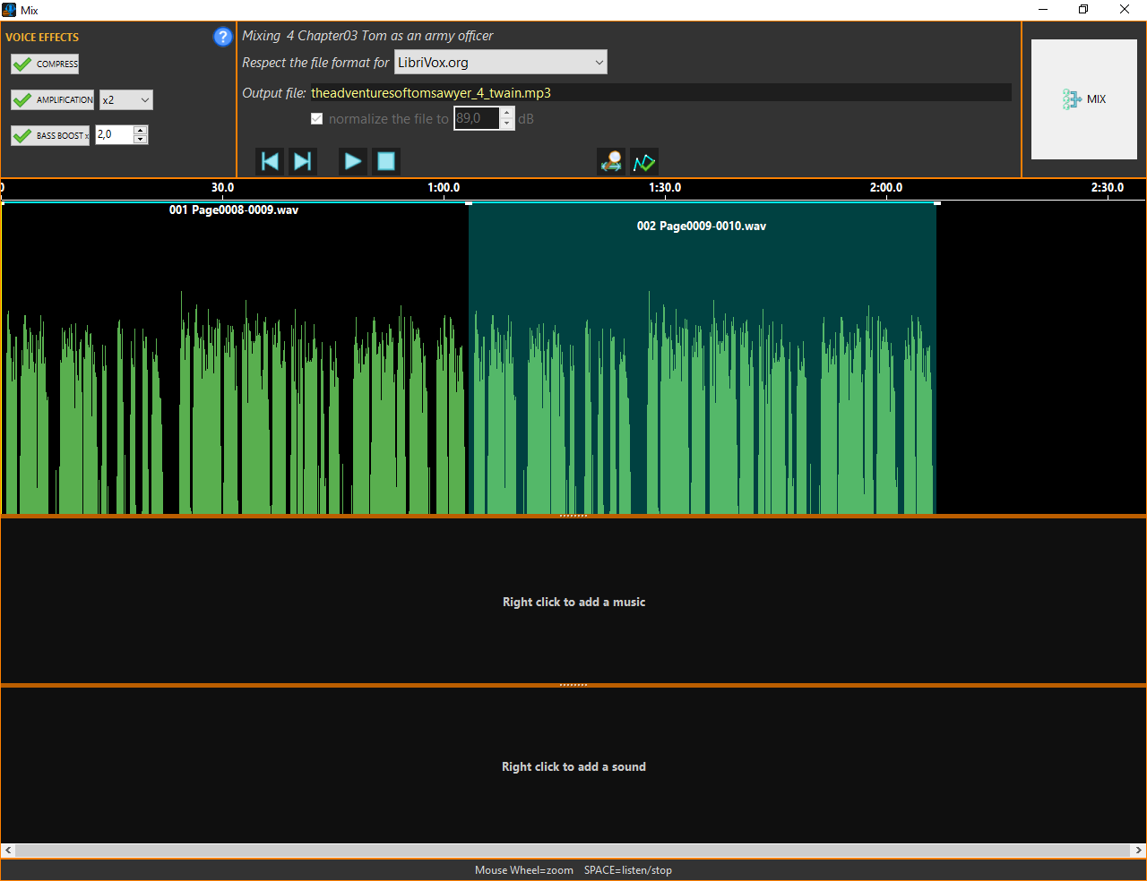
As shown in the example above, at the very top are the tools, a notch below that the timeline, and just below that the blocks corresponding to the voice recordings are displayed, which the software has placed one after the other, respecting the order of the project tree. Still further down, the music track, then the sound effects track.

Actions with mouse
- Moving the cursor : left-click on the desired location.
- Selecting an audio block : left-click on the block.
- Moving a block on the timeline : hold down the Ctrl (control) key, click and hold the left button, then move to the right or left. You'll notice that the software prevents audio blocks from overlapping.
- Zoom with the mouse wheel (aim at the point where you want to zoom).
- Trim an audio block : left-click on the block to be trimmed to select it, then position the mouse on the right or left end of the block. When the cursor changes to  hold down the left button and drag to the right or left. Use the Trim tool to shorten silence at the beginning of a voice recording, for example, or to keep only part of a music.
- Shift the view : use the horizontal scroll bar at the very bottom.

Buttons description
Moves the cursor to the beginning.
Moves the cursor to the end.
Play audio from cursor.
Stop audio.
Optimal zoom to see everything or Alt+A.
 Show or hide volume envelope.
Start mixing.

Voice effects
Here you can choose which effects will be applied to the vocals during mixing to make them more audible. To do this, start audio playback by pressing SPACE and play with the settings until you find the level that suits you best.
It is advisable to activate the compressor, unless your microphone is connected to a mixer that already has one. The compressor lowers the volume on loud passages and raises it on soft passages, such as the end of phrases.
Amplification, as the name suggests, amplifies vocals.
Bass Boost amplifies the low frequencies, rounding out the voice and making it warmer. This effect is not effective on female voices.

Please note the following points:
- Don't use too much amplification or bass boost, or your vocals will saturate.
- Keep the settings more or less the same from one section to the next, to preserve consistency in your MP3 files.
The effects only affect voice recordings, not music or sound effects.

Outpout file
« Respect the file format for » : choose the distribution platform for which you are going to produce the MP3. The software will adjust certain parameters to suit. If you want the freedom to set all parameters as you wish, select "none".
« Output file » : The name of the MP3 file to be produced is displayed here. Click on it to change it.
« Normalize the file to » : check this option to normalize the MP3 file (adjust its overall volume). Enter the level in dB (decibel) between 75dB and 105dB, the standard being 89dB. This function is similar to MP3Gain except that no normalization metadata is written to the MP3, but its volume is amplified or decreased to the desired level.

Add music or sound effects
Right-click on the music or sound effects track, then in the context menu, click on « add a music/sound effect ».

Delete a music or a sound effect
Right-click on the music or sound effect, then in the context menu, click on « delete ».

Global level setting for music and sound effects
Clic droit sur la musique ou bruitage, puis dans le menu contextuel, cliquez sur « ajuster le volume ». Grâce au curseur, ajustez le volume à votre convenance. Cochez le bouton « Muet » pour rendre le bloc muet.

Volume envelope
With it, you have total control over volume throughout an audio block. Fade in, fade out or even lower the music during vocals and raise it between each phrase - all you have to do is place dots in the right places to draw the volume envelope.
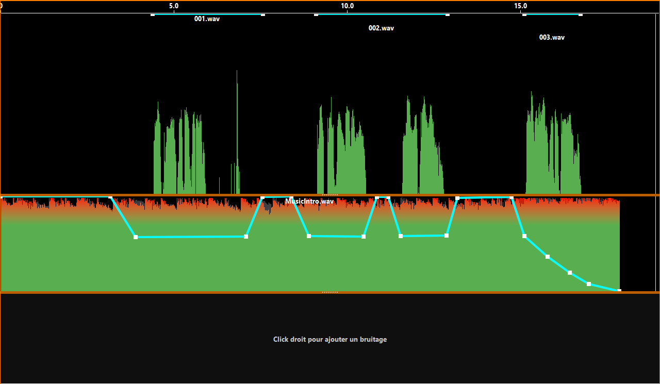
In the example above, the music is played from the beginning, then on each spoken passage, its volume decreases so as not to cover the voice, and rises between phrases, to finish by fading out.
A point at the top corresponds to 100% of the block's global volume, a point at the bottom corresponds to silence.
Adding a point : the block must be selected. Position the mouse over the turquoise envelope, where you want it. When the cursor changes to  do a left-click. A new point is inserted and you can move it.
Moving a point : the block must be selected. Position the mouse over the point, and when the cursor changes to , hold down the left mouse button and drag to the desired position.
Deleting a point : move the point far up or down, it will disappear.

Mute music or sound effects
Right-click on the music or sound effect, then click on "Invert mute" in the context menu, or check the "Mute" button in the global level setting.

Start mixing
When everything is good, click on « MIX » at top right. The metadata window will appear.

Metadata to include in MP3
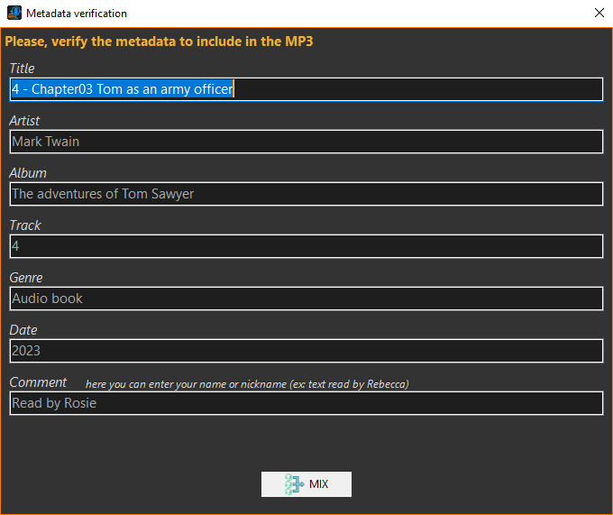
Metadata is additional information inserted into the audio file to describe it. Distribution platforms (LibriVox, LittératureAudio) require them. Complete and check the metadata to be included in the MP3 file.
When everything is good, click on « MIX ».
You won't be able to modify certain metadata fields depending on the distribution platform you've chosen.

MP3 Validation
When mixing is complete, the following panel appears:
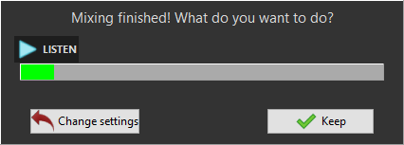
If you wish, you can click on « LISTEN » to play the MP3 file and navigate through the audio by clicking on the progress bar.

If the result is good for you, click on « Keep » : the resulting file is placed in the MP3 folder in the project tree and this closes the mixing window.

Click on « Change settings » if you need to make changes.
When you exit the mixing window, the software automatically saves the session parameters.

Enhance listening
When mixing, the audio effects you apply to the voices will amplify them and make them more audible. But when you listen to a recording from the project tree or audio editing window, the level may be too low to work properly. That's why the software offers you options to improve the listening experience.
To display these options, click on in the top right-hand corner of the main window.
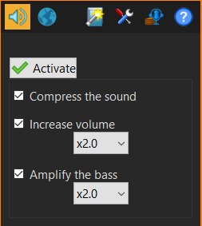
Activate the enhancement by ticking the "Activate" button and play with the settings until the audio level suits you.
This option is only applied to listening and does not modify audio files in any way.
This option is not applied to mixed files in the MP3 folder.

Web links
Give Your Voice provides you with useful Internet links when you publish your MP3s on one of the supported platforms. : Littérature Audio.com ou LibriVox.org.
A few links to royalty-free music sites are also included.
To display the Internet links page, click on in the top right-hand corner of the main window.
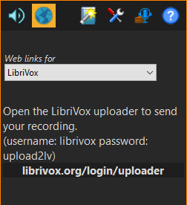
Then choose the type of links to display from the "Web links for" drop-down menu.

Options
To access this window, click on the in the top right-hand corner of the main window.
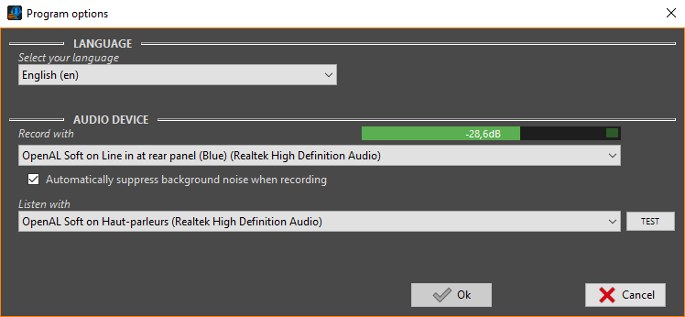
Here you'll find some of the program's setting options.
"Select your language": this drop-down menu lets you choose the language used by the program.

« Record with » : select the device to be used for audio recording. Speak into the microphone, you should see fluctuations in the sound level bar.
Check the option below if you want Give Your Voice to eliminate background noise during voice recordings. The program will then ask you for three seconds of silence before each recording so that it can be analyzed.

« Listen with » : select the device to be used for audio playback. To test it, click on the "TEST" button. You should hear some noise (shhhhh...).

Click Ok to save your changes.

Report a bug
If you notice a bug in the software, please report it. To do so, in the main window click on the button and in the window that opens, click on "Report a bug".

