**Reasons for Choosing our Database Program:**

We saw this idea unique and valuable, and it can be very useful for such companies, so we studied the way the hall company works and we started building it based on its requirements and needs.

We aim to improve the hall company and make it more organized for example: using the system to set an event with its time and date, to store employees and customers information, to calculate incomes and outcomes, and many other things the data base system can be helpful in.

We understand that every hall company operates differently, with unique processes and workflows. Our database program allows for easy customization, enabling you to tailor the system to match your specific requirements. From defining data fields to setting up automated workflows, our program empowers you to create a database that aligns perfectly with your business needs.

**We are making a DB for a multi-purpose hall i.e. weddings.  
Requirements:**

**\*The company has a single branch, and its building is owned by the business.**

**The Database will include the following:**

**1- Employees:** This entity employees name, SSN, birthdate, address, salary, contact information, date of hiring, the standard working hours are from 4pm-12pm, there are no bonuses or compensations, so the salary is only the base salary post-tax.

* The name includes first, middle and last name.
* Contact information contains email and phone number.
* Address contains city, area, street no, building no.
* The SSN is unique for each employee, but it can’t be empty.

**2- Venue**: This entity will store the venue information: location, rental fees, availability, hall and parking capacities, hall number.

* Building and hall locations, building Location contains city, area, street no, building no.
* Rental fees include the period which indicates how long the event will last in hours.

It also includes: hall capacity of choice, another attribute is (options) and it is divided to two sub-categories: décor and catering options (with décor/without décor & with catering/without catering).

* The hall number is unique for each hall; it cannot be empty.

**3- Departments:** This entity includes: name, location (which level i.e. second floor), date of establishment.

* The name is unique for each department; it cannot be empty.

**4- event:** This entity includes: date, event id.

* The event id is unique for each event but cannot be empty.

**5-customers:** Contact information, name, payment options and customer_id.

* Contact information: phone number and email.
* Name: first, middle, and last.
* The customer_id is unique for each customer; it cannot be empty.

**Relationships:**

* An employee manages a department.

1. One employee manages one department. (the min number of department managed by employee is zero, the max number is one)
2. Each department has only one manager. (the min number of managers to a department is one, so is the max)
3. All the departments have a manager.
4. Not all employees are managers.

* Each employee is supervised by another employee.

1. One supervisor supervises a lot of employees (the min number of supervisee supervised by an employee is zero but the max is n employees).
2. An employee(supervisee) is supervised by one employee (the min number of supervisors to each supervisee is zero, the max is 1 supervisor).
3. Not all employees are supervised by another employee.
4. Not all employees are supervisors.

* Each employee works in a department, also the relation has an attribute with the number of emp working in the department but it is a derived attribute.

1. An employee works in many departments (the min number of departments an employee works in is one and the max is n).
2. A department has many of employees (the min number of employees in a department is one, the max is n).
3. Each employee works in a department.
4. All departments have employees.

* An employee works on an event, also the relation has an attribute with the number of emp working on the event but it is a derived attribute.

1. An employee works on multiple events (the min number of events an employee works on is one and the max is n).
2. Multiple employees work on an event (the min number of employees working on an event is one and the max is n).
3. Each employee works on an event.
4. Each event has employees working on it.

* An event is held at a venue.

1. An event is held at one venue (the min number of events held by one venue is zero and the max is one).
2. A venue holds one event (the min number of venues that hold an event is one and the max is one).
3. Not all venues hold events.
4. Each event must be held at a venue.

* Costumers book an event.

1. A costumer can book an event (the min number of events booked by a customer is one and the max number is one).
2. An event can be booked by one customer (the min number of customers to book the event is one and the max is one).
3. All customers book events.
4. Every event is booked by a customer.

**ERD:**

**\*We choose to use ERD and not EERD because our DB does not have inheritance/super-classes/sub-classes.**

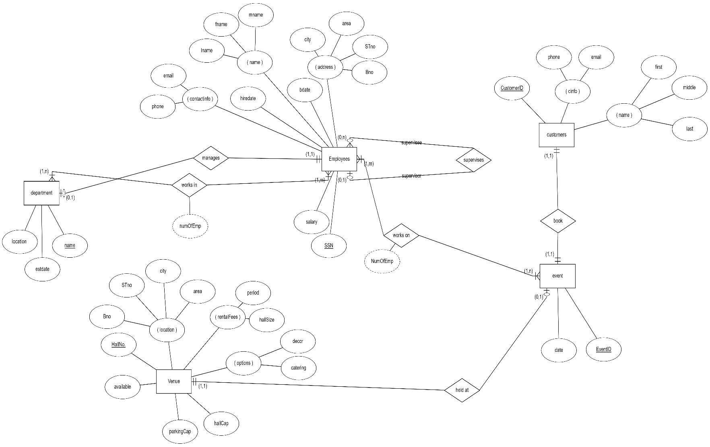

**SCHEMA:**