# Tables:

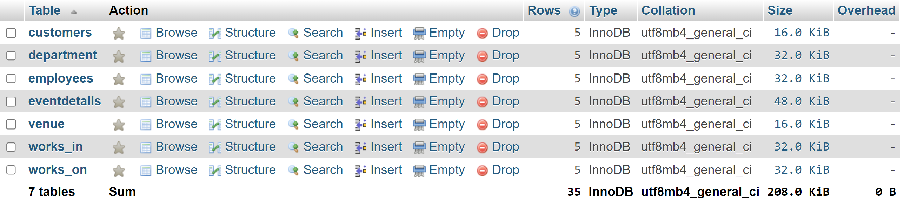

# Tables(each table after inserting records):

### Table customers:

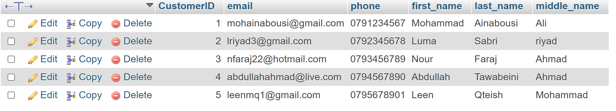

### Table department:

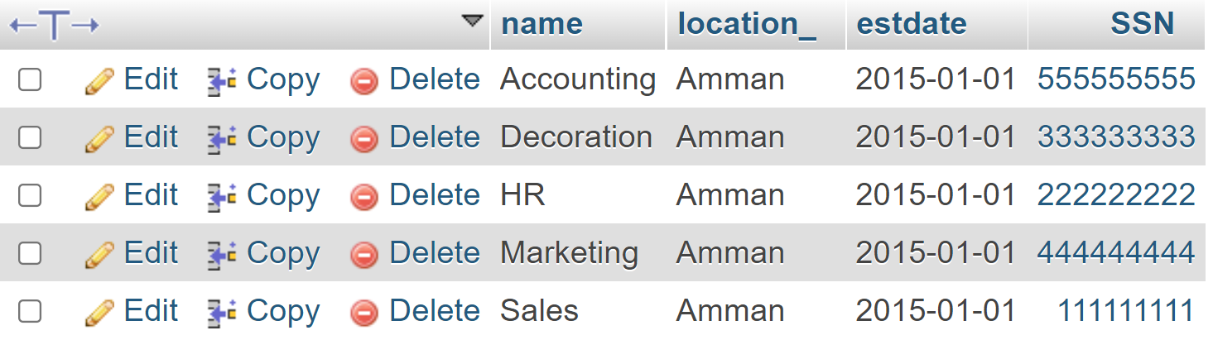

### Table employees:

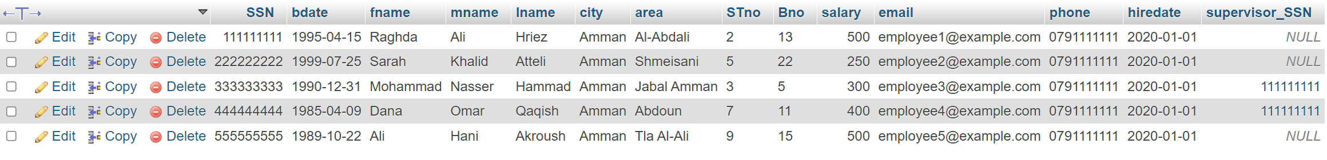

### Table eventdetails:

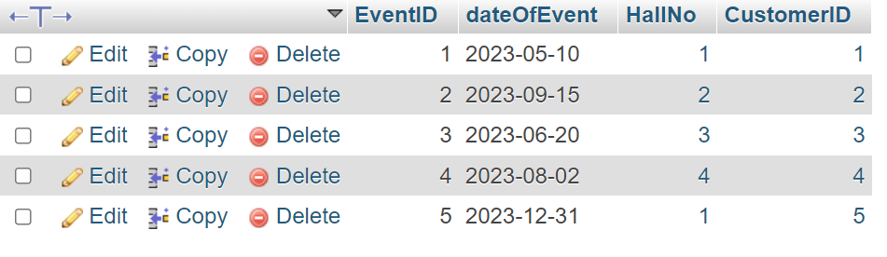

### Table venue:

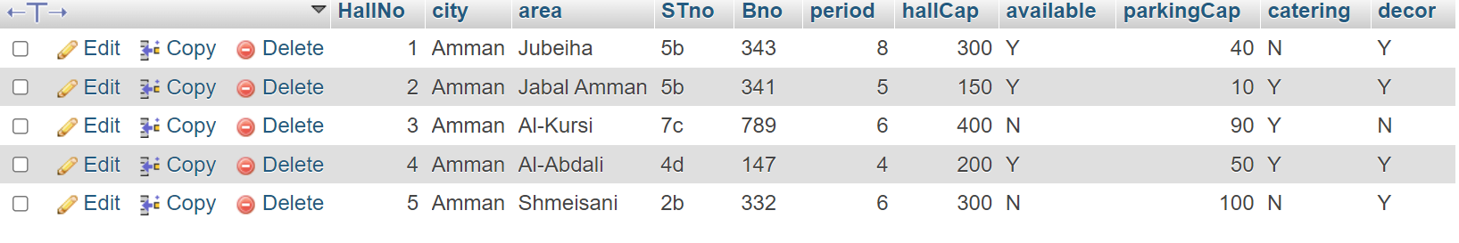

### Table works_in:

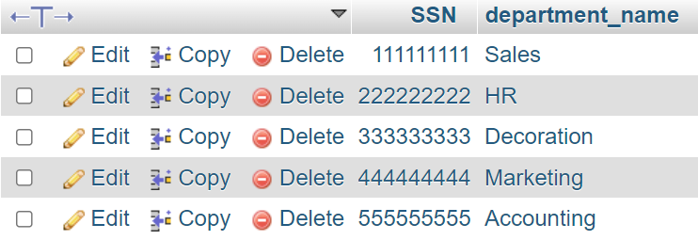

### Table works_on:

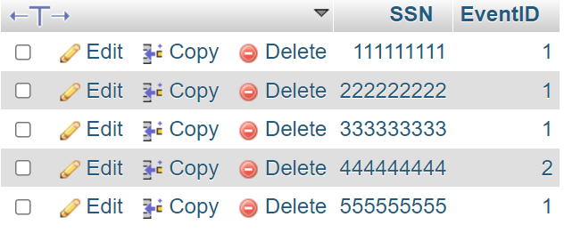

# Tools:

### Xampp + phpMyAdmin (as shown above).

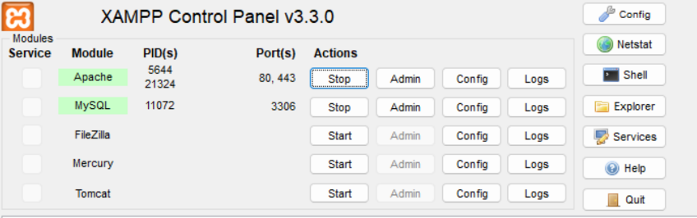

### VS code (to write HTML code and PHP code).

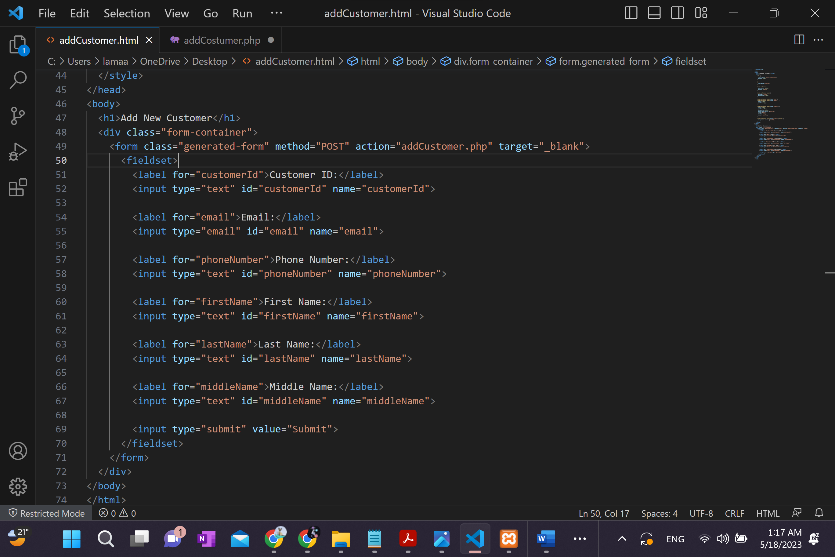

# Library:

Mysqli (connector).

# SQL server:

mySQL / used the tool Xampp to accsess it in phpMyAdmin.

# UI 1 (insert):

### Table customers before insert:



### UI(before pressing submit / after pressing submit):

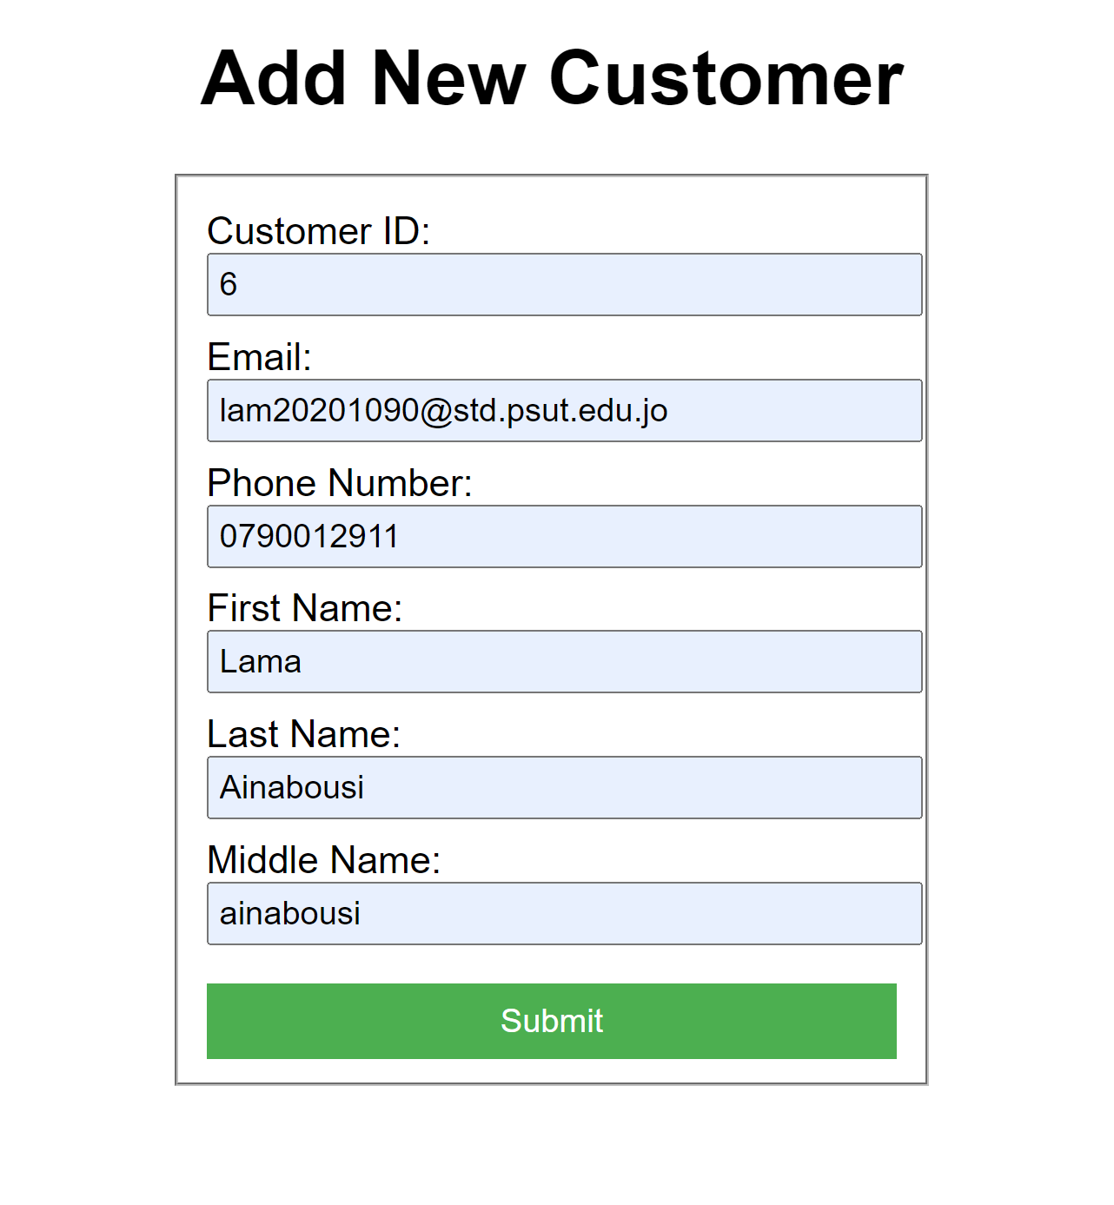 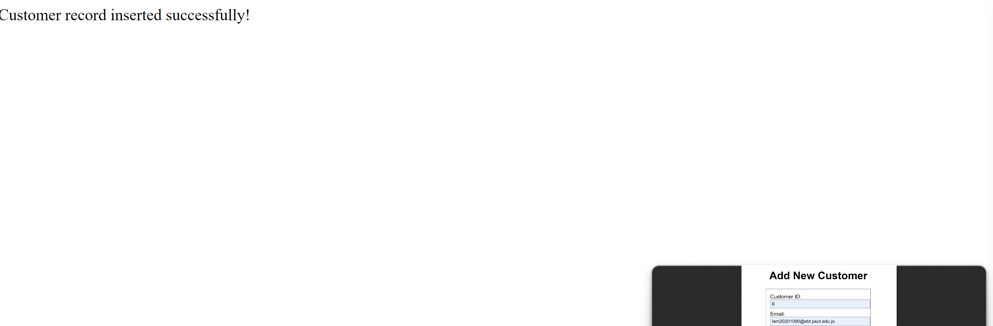

### Table customers after insert:

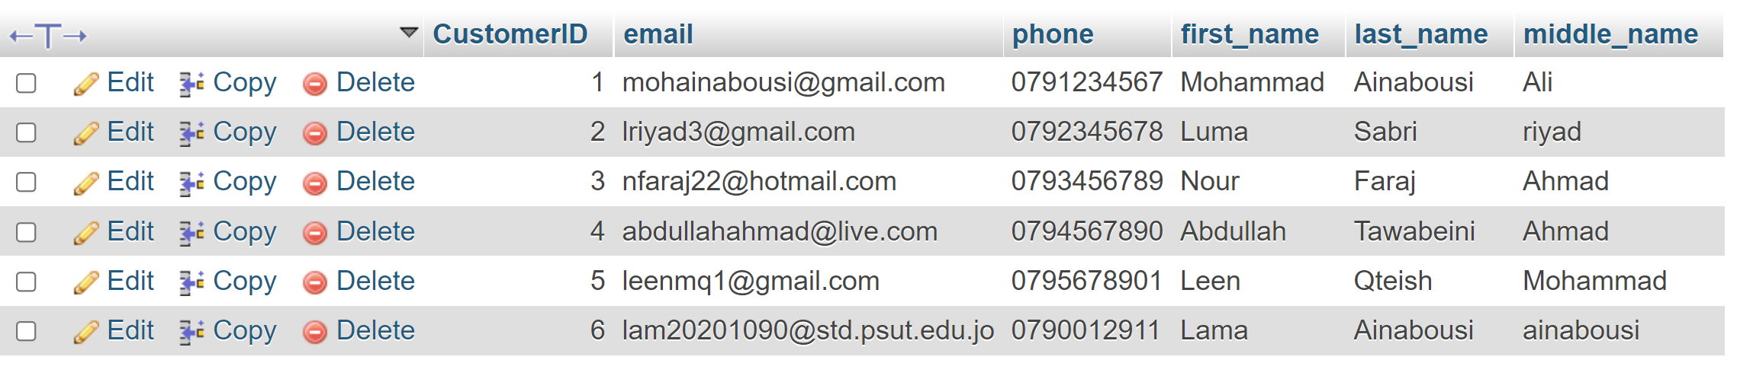

# UI 2 (search):

### Table eventdetails to search from:

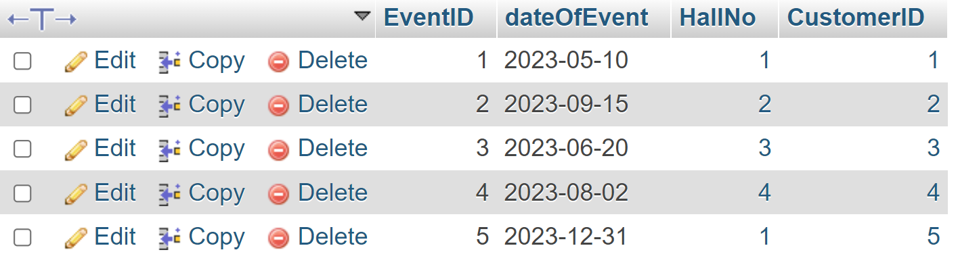

### U2(before pressing submit / after pressing submit) when the input is found:

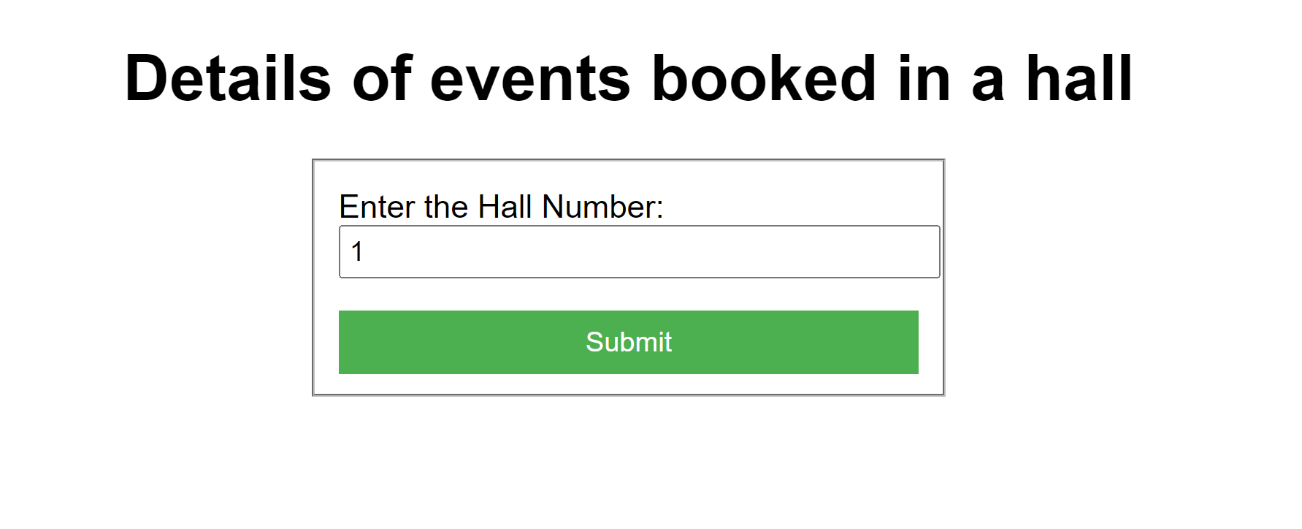

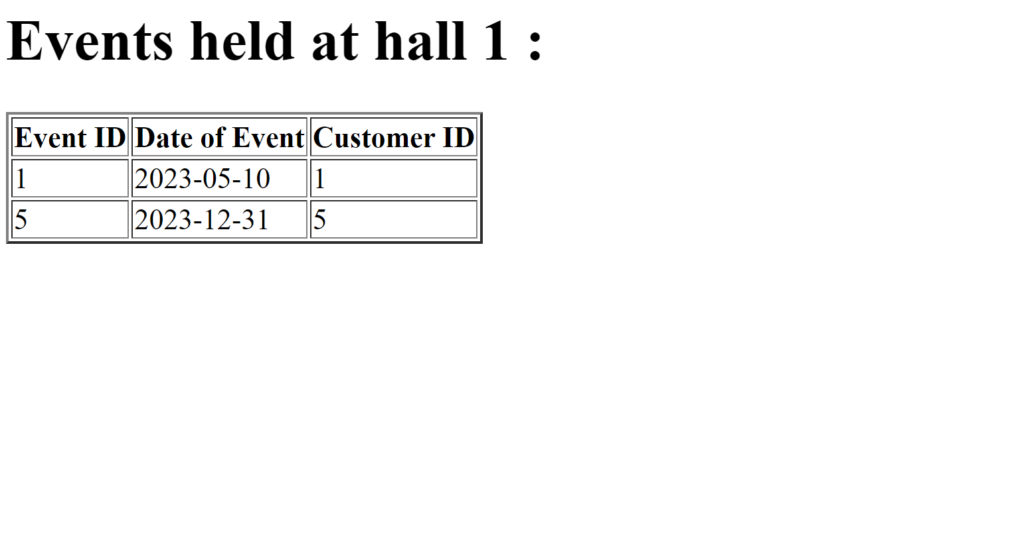

### U2(before pressing submit / after pressing submit) when the input is not found:

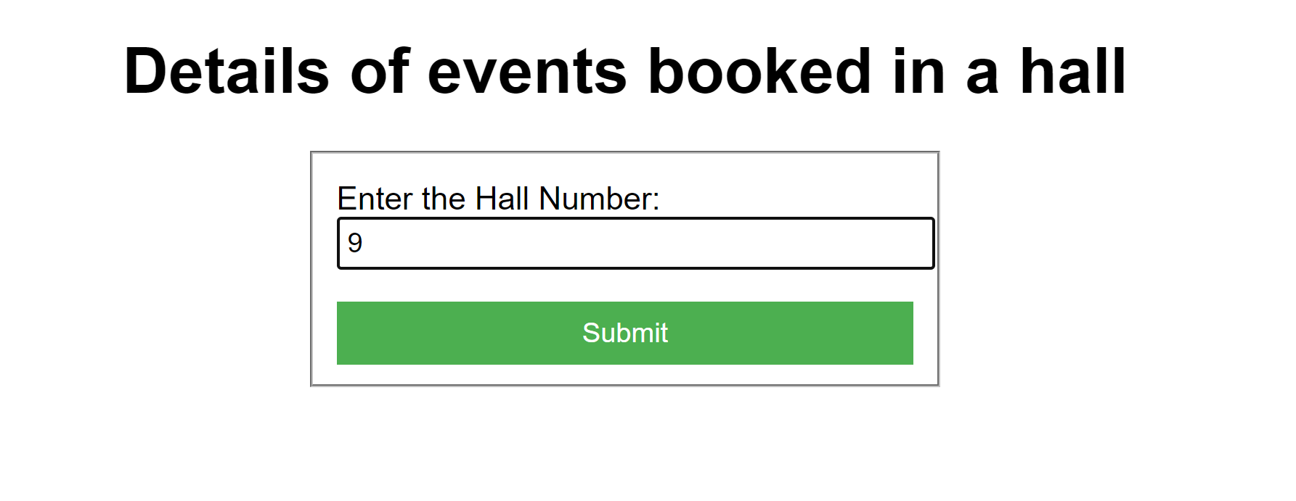



# UI 3 (search+join) //BONUS:

### Table employees:

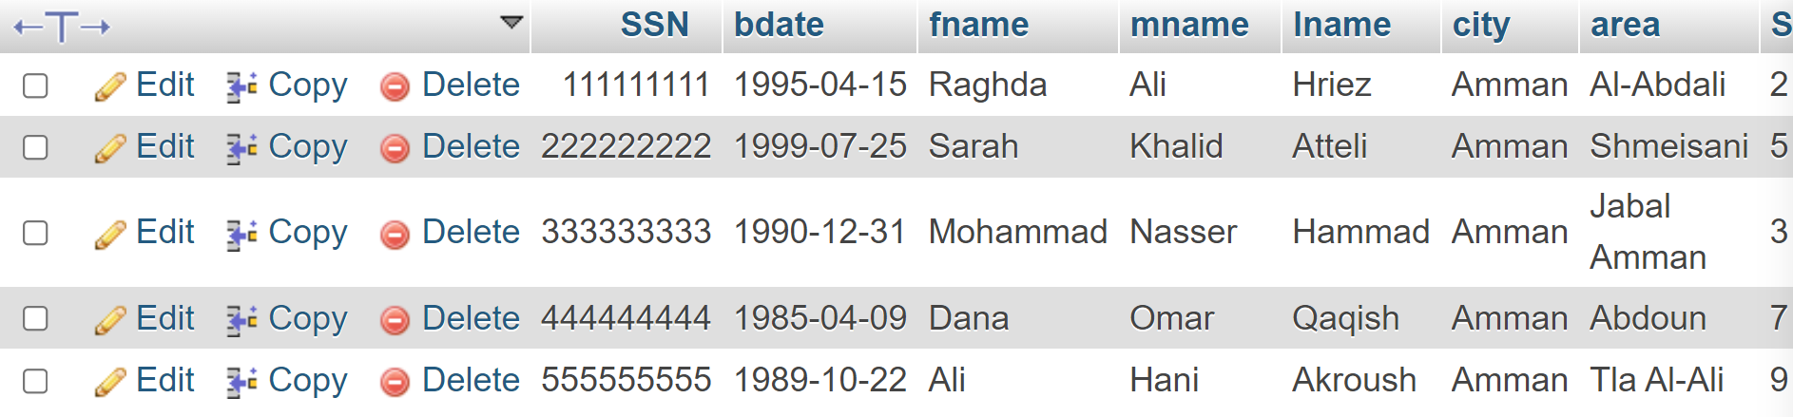

### Table works_in:

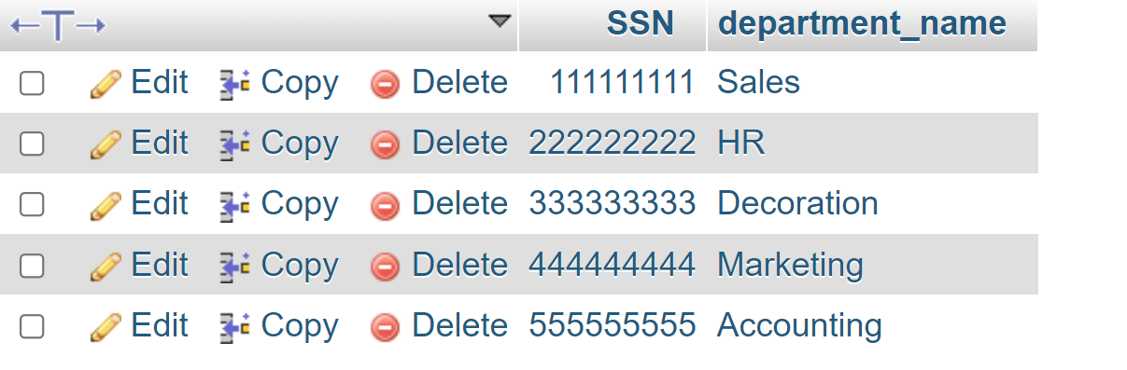

### Table departments:

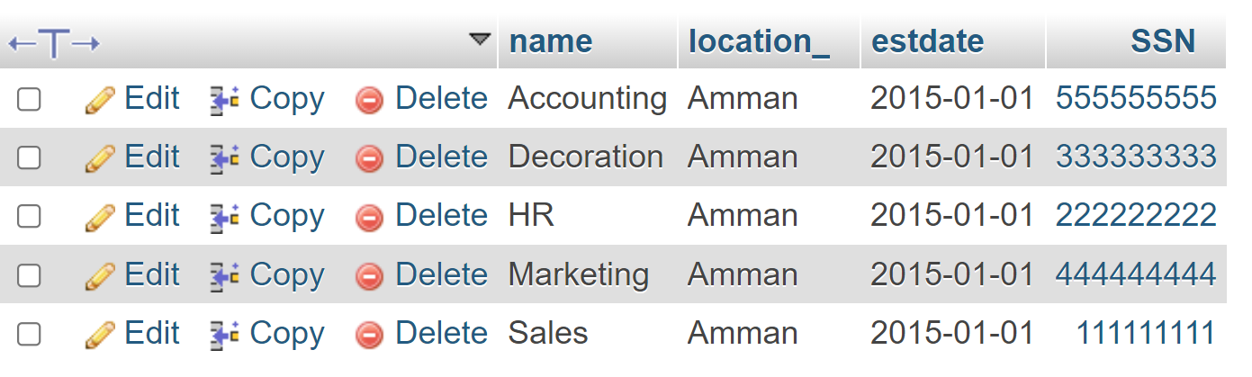

### U3(before pressing submit / after pressing submit) when the input is found:

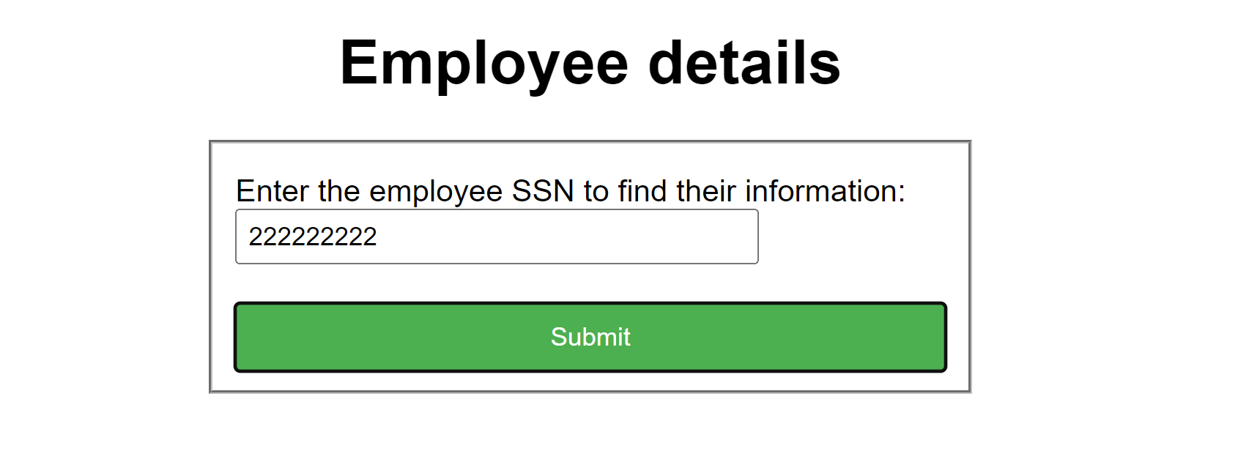

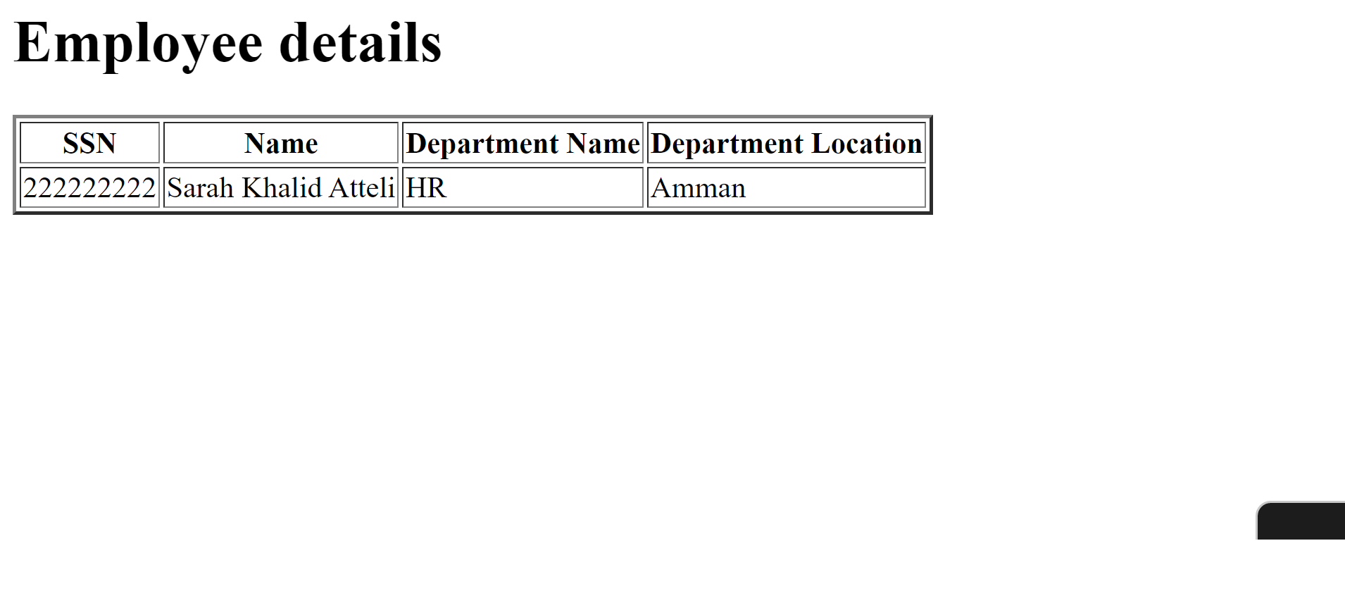

### U3(before pressing submit / after pressing submit) when the input is not found:

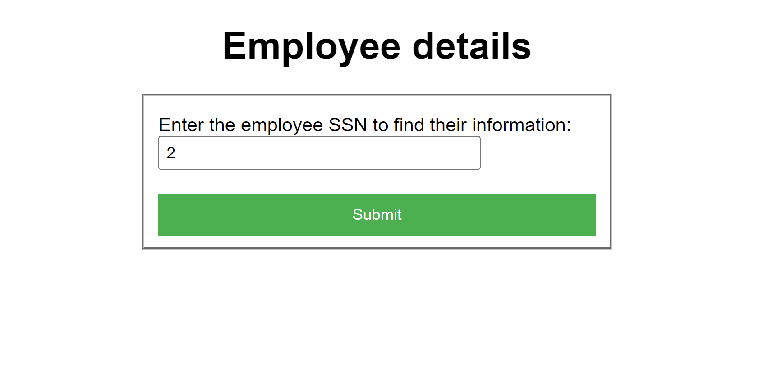

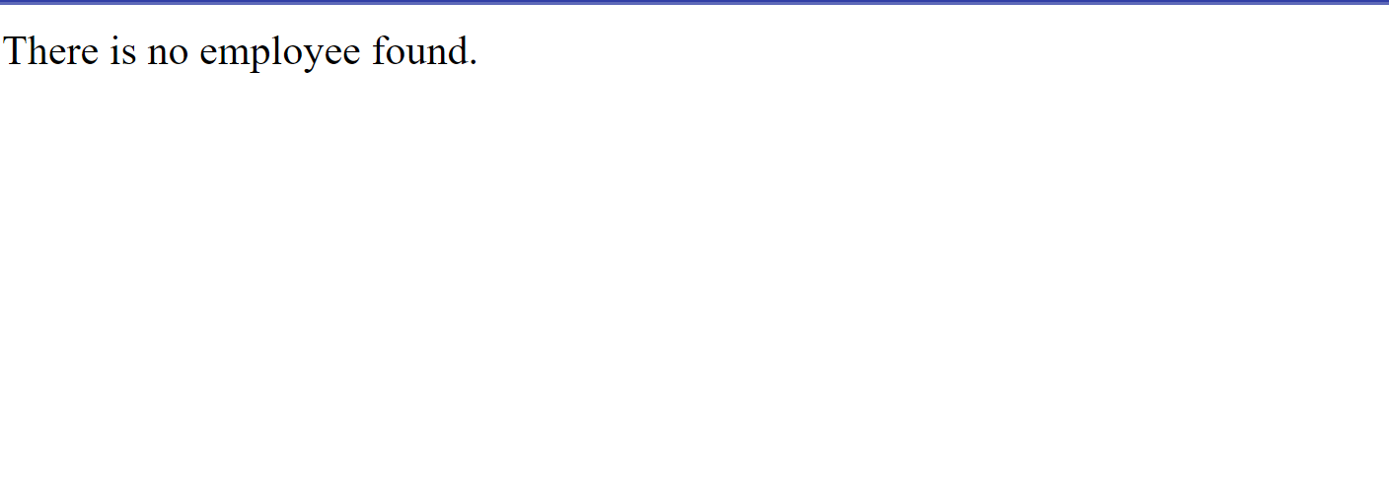

# UI 4 (insert) //BONUS:

### Table departments(before insert):

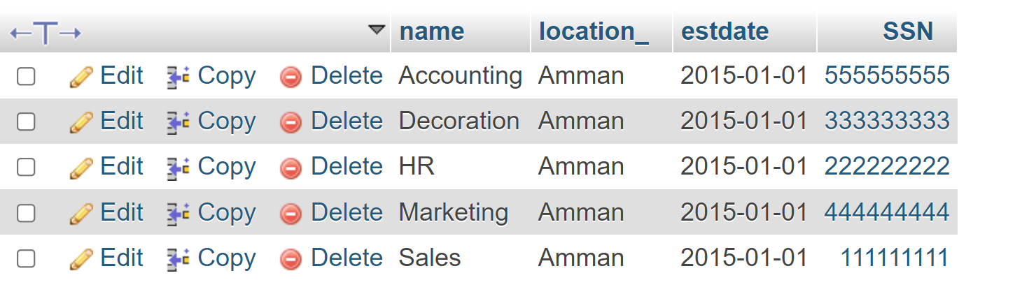

### U4(before pressing submit / after pressing submit) if the manager SSN is found:

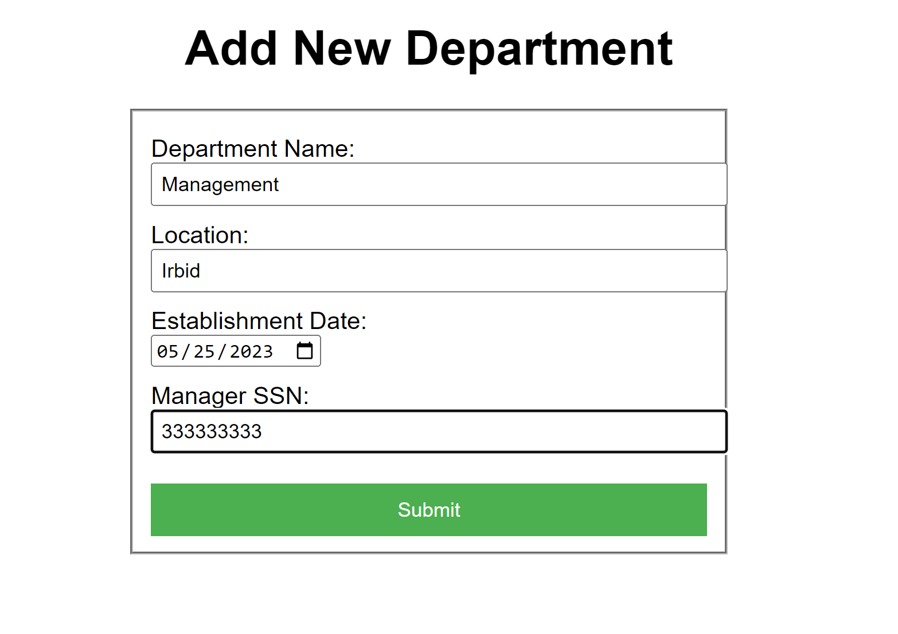



### U4(before pressing submit / after pressing submit) if the manager SSN is not found:

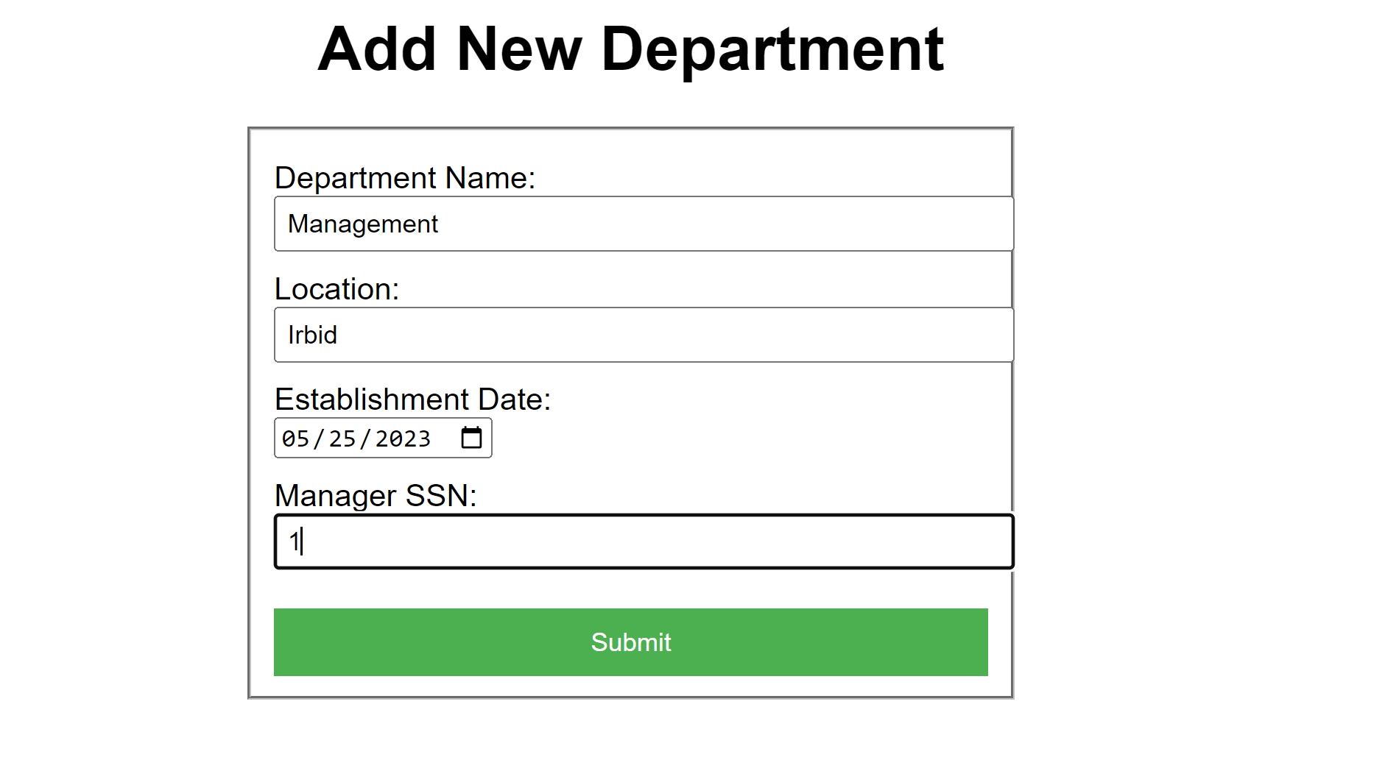

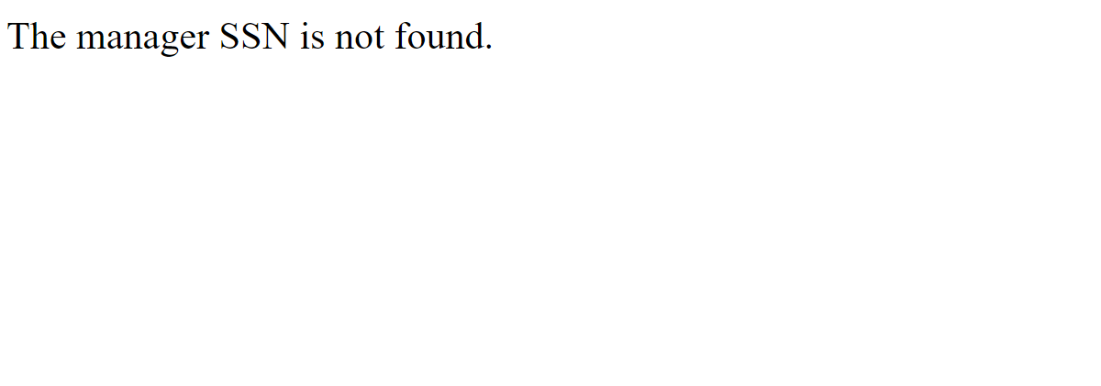

### U4(before pressing submit / after pressing submit) if the department already exists:

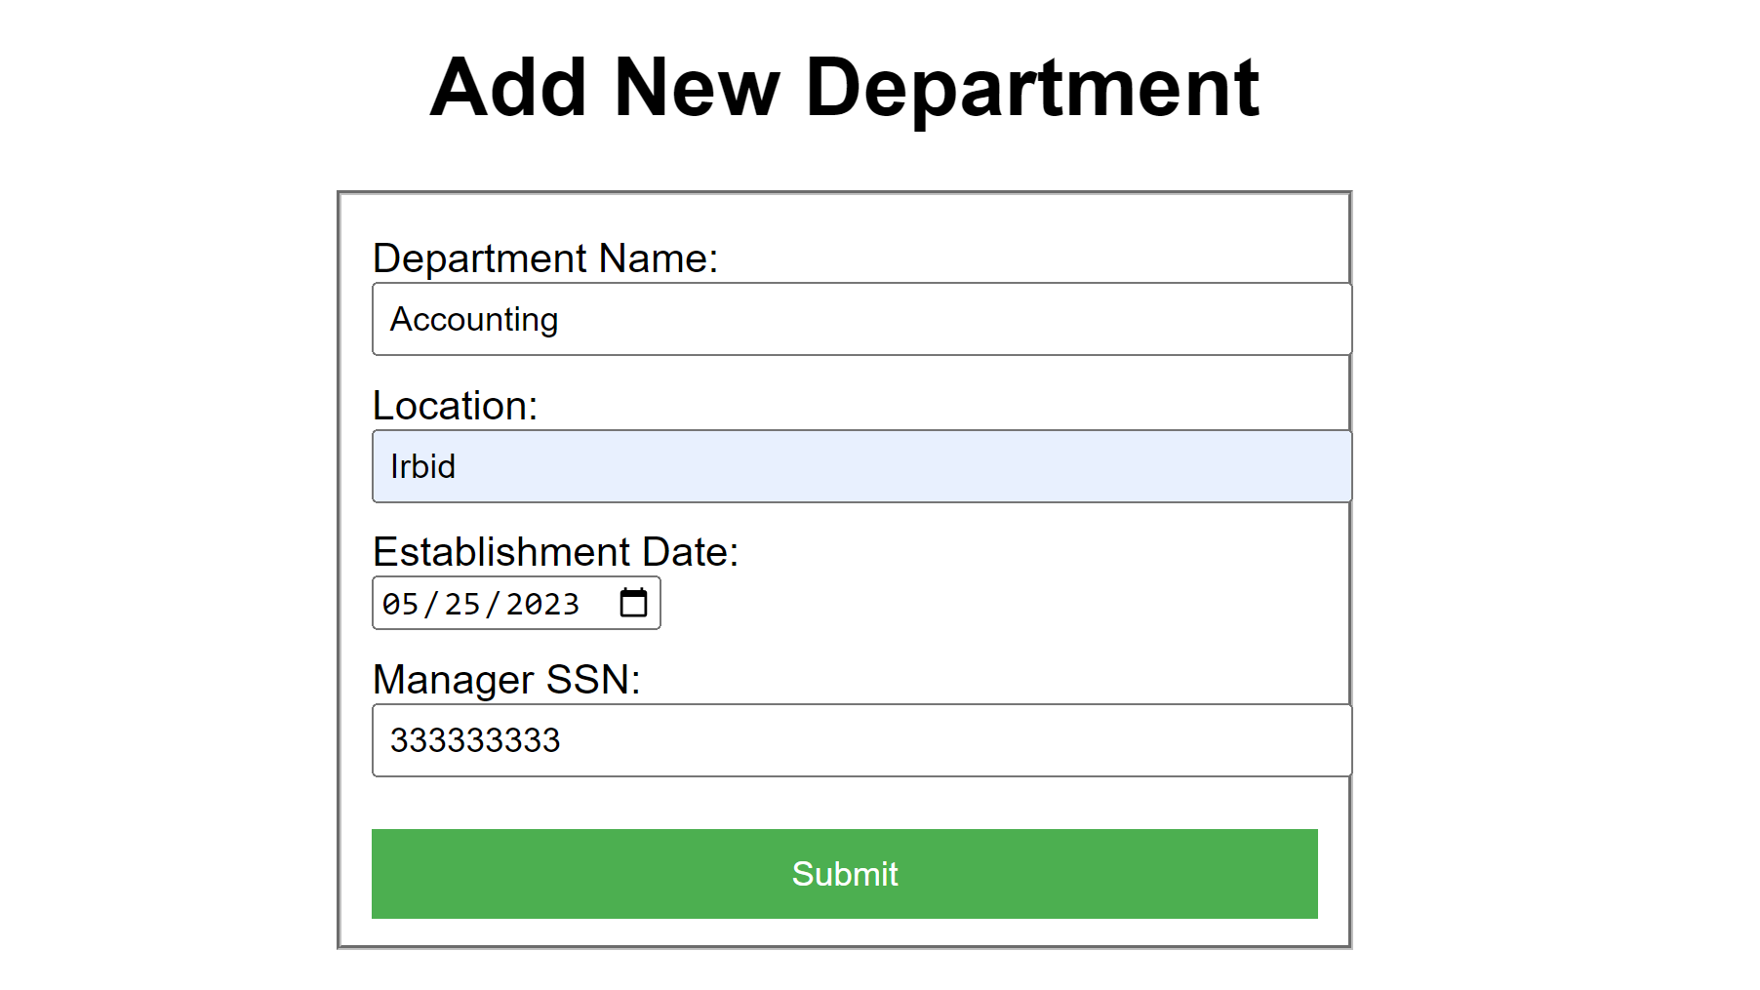

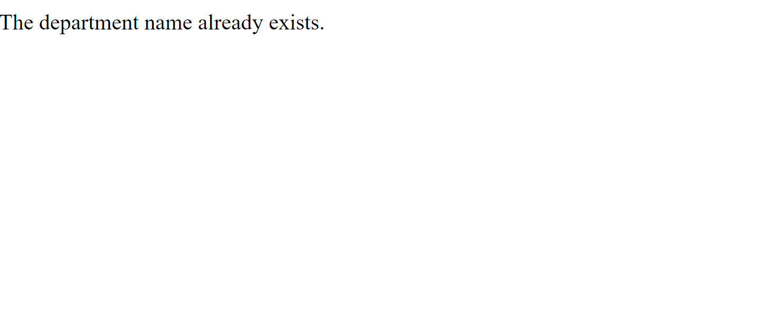

### Table departments(after insert):

