Junior Front-end developer, JS, ReactJS

Arthur Shevtsov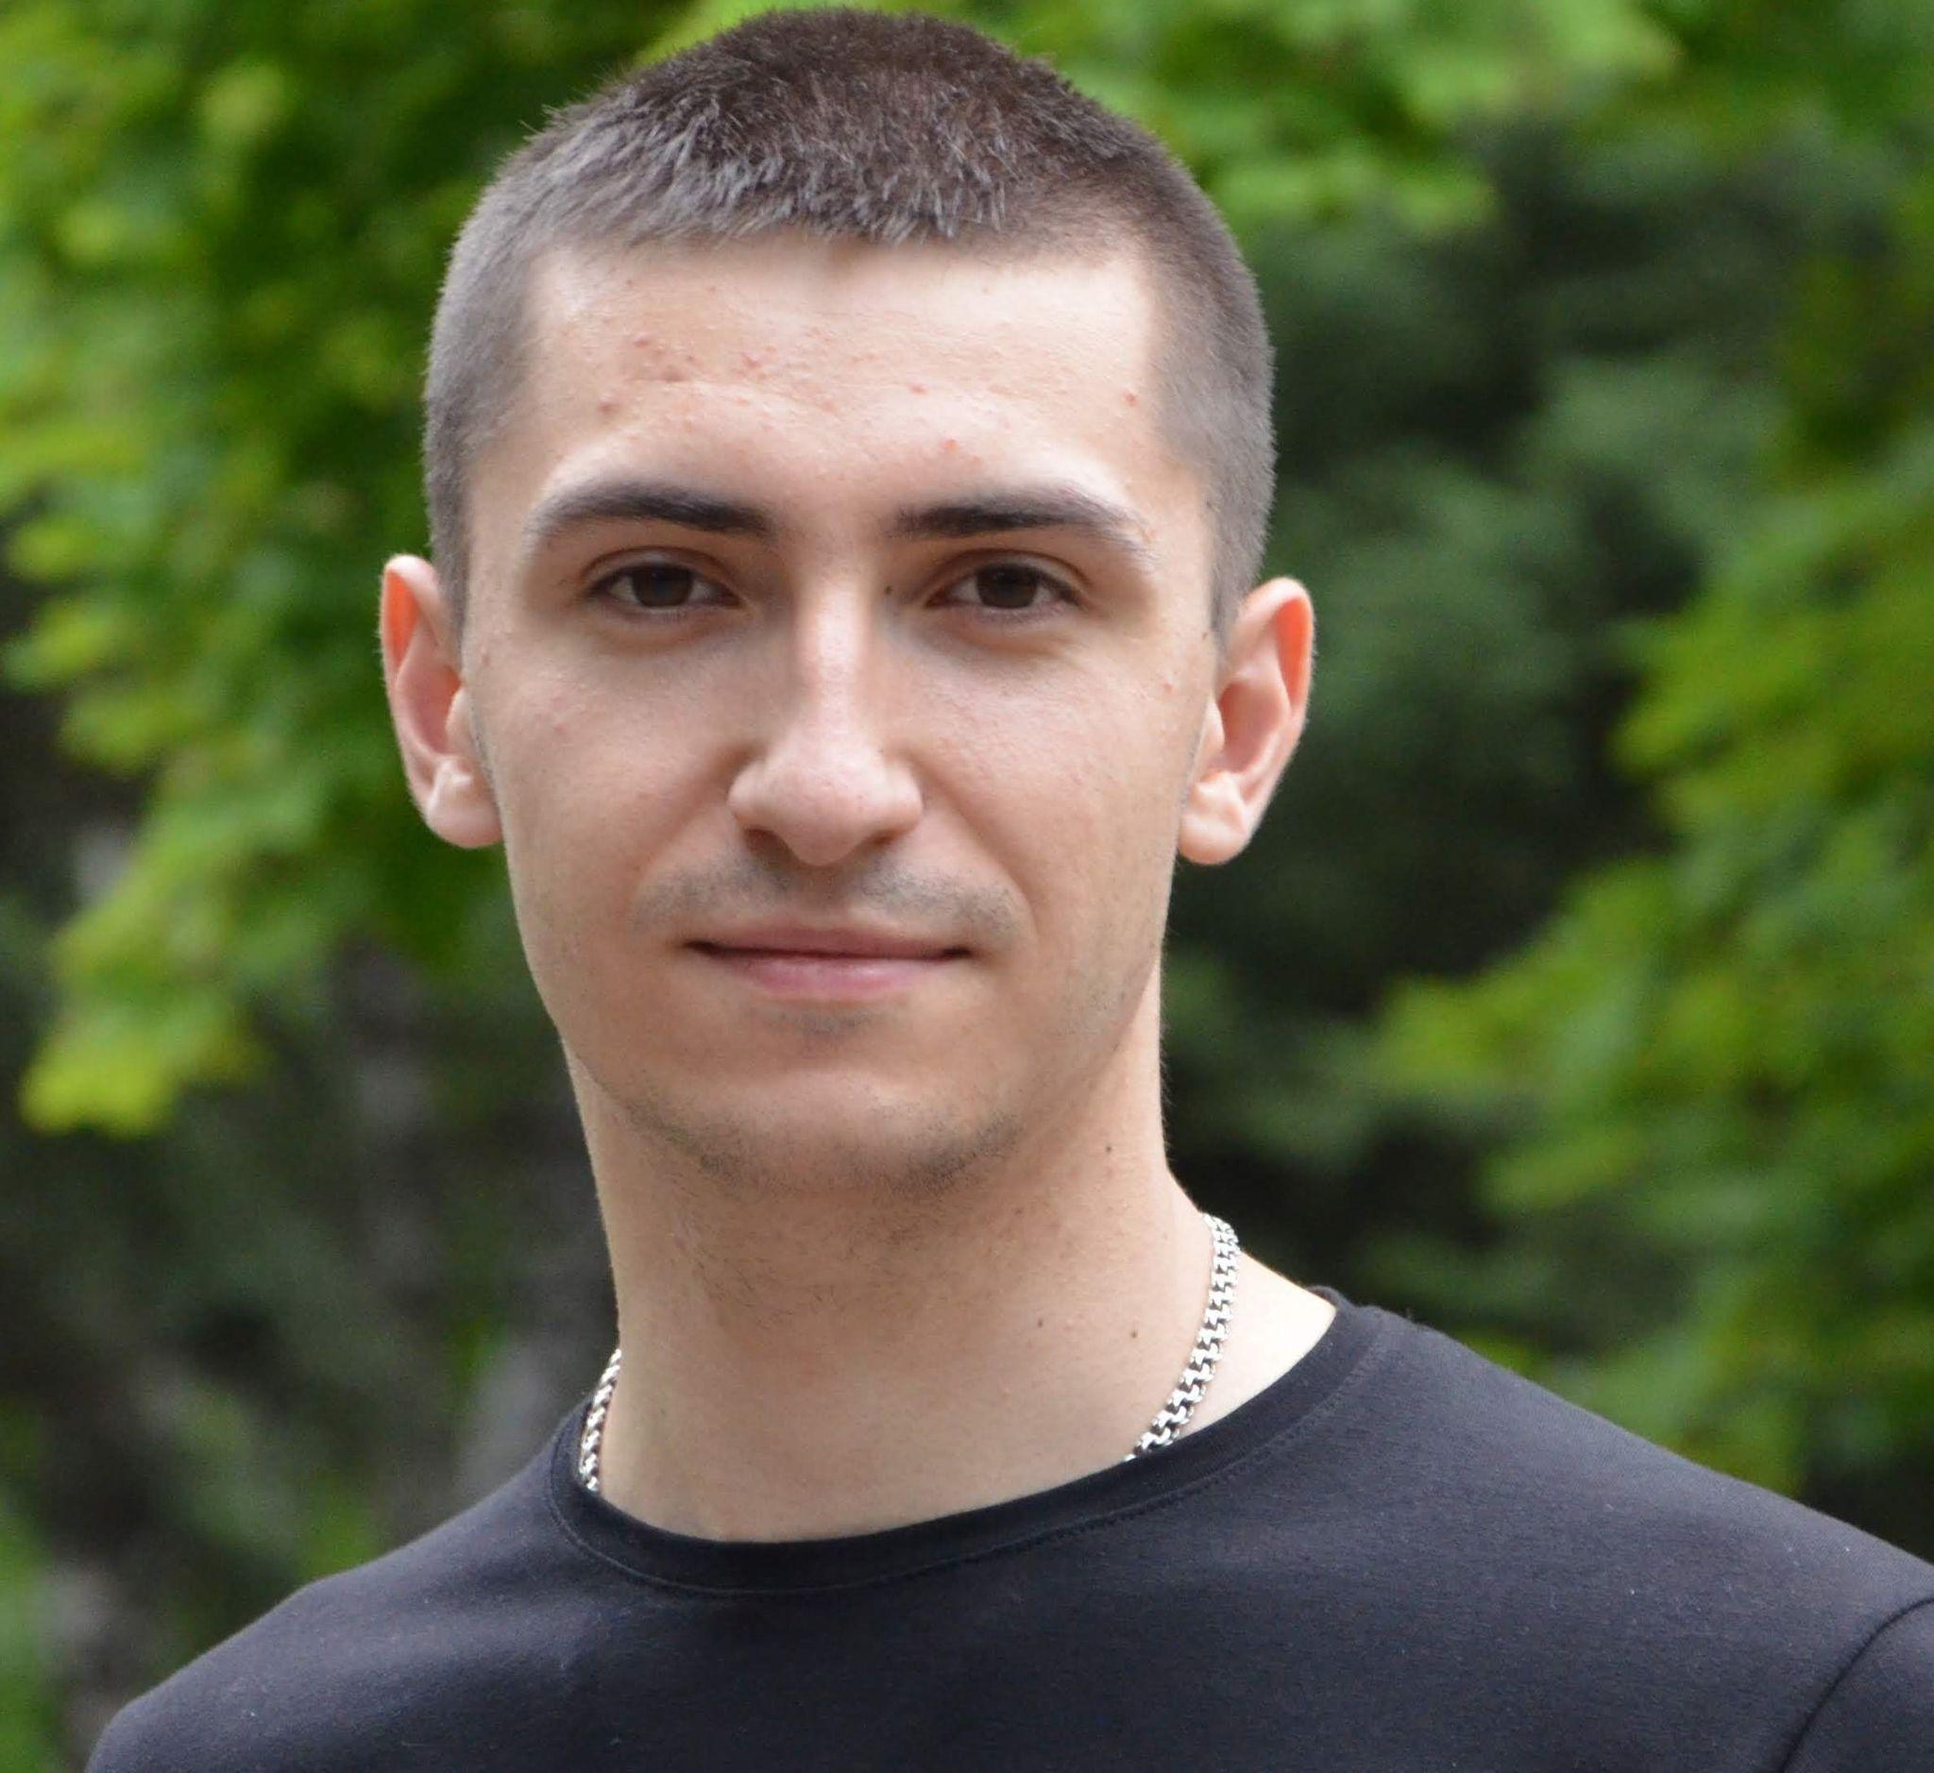

Date of Birth: 22 july 1996

Region: Kharkiv, Kramatorsk

Phone (s): +380661969163 (main)

+380675839755

Skype: Arthur Shevtsov (live:.cid.937f855f62461dda)

E-mail: [Lumenatom@gmail.com](mailto:Lumenatom@gmail.com)

Portfolio: <https://lumenatom.github.io/Portfolio_resume/>

GitHub: <https://github.com/Lumenatom>

Work experience:

Sales Expert

Aug 2020 - present time (1 year 4 months)

The Territory of Your Technique

Shop manager

Dec 2017 - May 2020 (2 years 6 months)

TECHNOSTOK, National network of hardware stores

Trade representative of TM "Zlagoda"

Jan 2017 - Dec 2017 (1 years)

TM "Zlagoda"

Education:

DITM MNTU (Kramatorsk)

Year of completion 2019

Software engineering

DITM MNTU (Kramatorsk)

Year of completion 2017

Finance, insurance

VSP NAU SK NAU (Slavyansk)

Year of completion 2015

Repair and maintenance of computer systems and networks

Language proficiency:

English - elementary

Russian - fluent

I can interview in this language

Ukrainian - native

I can interview in this language

Courses, trainings, certificates:

HTML, CSS, JS, ReactJS

Year ended 2021

Passed various small courses and online trainings. Front-end direction

Additional Information:

Personal qualities

Sociable, sociable, stress-resistant, a great desire for professional growth, responsible, creative, polite.