SubSync: An Automated Web-Based Platform for Enhancing Community Engagement in Residential Subdivisions

A Capstone Project Presented to the
Faculty of the College of Computer Studies
Carlos Hilado Memorial State University
Alijis Campus, Bacolod City

In Partial Fulfillment
of the Requirements for the Degree
Bachelor of Science in Information Technology

By
Christian J. Barbas Jr.
Jurriel A. Guanzon
Shirley Ann M. Salazar
Paul Felippe G. Tibo-oc

January 2027
TABLE OF CONTENTS
Chapter 1 1
INTRODUCTION 1
Background of the Study 2
Objectives of the Study 3
Significance of the Study 4
Scope and Limitation of the Study 6
Definition of Terms 7
Chapter 2 11
REVIEW OF RELATED LITERATURE AND STUDIES 11
Community Management Systems for Residential Communities 11
Financial Monitoring and Payment Tracking Systems 12
Issue Reporting and Complaint Management Systems 13
Communication and Announcement Systems 14
Web-Based Administrative Dashboard Systems 15
Matrix of Related Literature and Studies 16
Synthesis 17
Chapter 3 19
DESIGN AND METHODOLOGY 19
Research Design 19
System Development Life Cycle 21
Requirements Analysis 22
Sprint Planning 22
Design and Implementation 23
Testing and Review 23
Deployment and Evaluation 23
Research Respondents 24
Sampling Technique 26
Data Gathering Instrument 27
Data Gathering Procedure 28
Validity of Research Instrument 29
Reliability of Research Instrument 29
Analysis / Treatment of Data 30
Ethical Consideration 30
Operational Framework 31
Context Diagram 33
Data Flow Diagram 36
Entity Relationship Diagram 37
Use Case Diagram 39
Data Dictionary 42
Recommended Hardware Requirements 61
Software Requirements 62
Gantt Chart 64
REFERENCES 66
APPENDICES 75
APPENDIX A 75
APPENDIX B 76
Transmittal Letters 76
Letter for Beneficiary 76
Beneficiary Acknowledgement 77

Chapter 1
INTRODUCTION
Background of the Study
The rapid advancement of information technology has significantly transformed how communities manage information, communication, and service delivery throughout generations. Digital platforms are increasingly used to improve transparency, efficiency, and collaboration within organizations and communities. In residential subdivisions, these technologies can help manage financial transactions, announcements, and community concerns more effectively. However, many subdivisions still rely on traditional methods such as paper-based records, bulletin board announcements, and manual communication. These methods often result in delays, miscommunication, and limited transparency for residents.
The transition towards technology-based community monitoring systems has been extremely effective in supporting local planning and decision-making processes. A good example is the Community-Based Monitoring System (CBMS), which highlights how local data can be useful in helping local governments identify specific needs in the communities they serve (Reyes & Mandap, 2022). Similarly, intelligent community management models emphasize the use of information technology and communication networks to improve governance and operational efficiency. These systems integrate communication, monitoring, and data management to support better community services (Tang, 2022). As communities grow, the use of digital systems becomes increasingly important for efficient administration.
Digital reporting platforms also play an important role in encouraging community participation. These systems allow residents to submit complaints, concerns, and suggestions directly to administrators. Such platforms enable faster monitoring and response to issues within the community (Anggara et al., 2023). In addition, interactive mapping technologies improve usability by visually presenting geographic information. This allows users to easily locate facilities and identify reported issues within a subdivision (Bartling et al., 2021).
Web-based information systems have also been widely used to manage resident data and improve service delivery. These systems simplify the storage, access, and management of community information compared to traditional methods. They also enhance reliability, usability, and efficiency in handling administrative tasks (Melendres & Aranda, 2022). Despite these technological developments, many residential subdivisions still lack integrated digital management platforms. As a result, residents may experience limited access to information and reduced engagement with community management.
To address these challenges, this study proposes the development of SubSync: An Automated Web-Based Platform for Enhancing Community Engagement in Residential Subdivisions. The system aims to improve transparency, communication, and participation within residential communities. It integrates a post manual processing payment tracking system, communication tools, issue reporting, recommendations, and interactive mapping features. These features are designed to provide a centralized platform for residents and administrators. Through this system, the study seeks to enhance community engagement and improve subdivision management.

Objectives of the Study
The study aims to design and develop a web-based community management platform for residential subdivisions that enhances resident engagement through payment tracking, communication, issue reporting, recommendations, and interactive mapping
Specifically, the study aims to:
1. Design and develop a community management system featuring:
  - A computerized payment system using an Excel framework to digitize manual records and centralize the monitoring of resident balances and community financial updates.
  - An integrated communication module that enables direct messaging between resident and administrator. It allows administrators to post announcements, updates, and subdivision events.
  - An issue reporting system that allows residents to submit complaints and concerns while enabling administrators to efficiently monitor and respond to subdivision-related issues.
  - A recommendation feature that allows residents to suggest improvements and initiatives for the overall development of the subdivision.
  - A dynamic mapping feature that provides a visual representation of the subdivision layout, enabling residents and administrators to locate facilities, emergency tracking, monitor reported issues geographically, and support planning and decision-making through interactive map-based data visualization.
- Test the functionality of the features mentioned above
- Evaluate the system using ISO 25010 standardize evaluation tool in terms of
  - Functional Suitability
  - Performance Efficiency
  - Usability
  - Compatibility
  - Reliability
  - Security
  - Maintainability
  - Portability

Significance of the Study
The study SubSync: An Automated Web-Based Platform for Enhancing Community Engagement in Residential Subdivisions seeks to improve the management of subdivision operations, communication, financial monitoring, and community participation through a centralized digital platform. The system is designed to streamline processes such as payment tracking, issue reporting, announcements, and community recommendations while providing an interactive mapping feature for better visualization of subdivision facilities and concerns. By integrating these functions into a single web-based platform, the system aims to enhance transparency, efficiency, and accessibility for both residents and administrators. Furthermore, it supports improved decision-making and community collaboration within residential subdivisions. This system is intended to deliver significant benefits to the following stakeholders.
Subdivision Residents. Residents will benefit from improved access to financial information, announcements, and community updates. The platform will also allow them to actively participate in community improvement through issue reporting and recommendations.
Subdivision Administrators. Administrators will gain a centralized system that simplifies financial monitoring, communication, and issue management, enabling them to respond more efficiently to residents’ concerns.
Homeowners Associations. The system will improve transparency and strengthen relationships with residents by providing clear and accessible financial and administrative information.
Researchers. The researchers will enhance their skills in developing web-based systems, including database management, system integration, and user interface design. Through the development of SubSync, they will gain hands-on experience in implementing features such as payment tracking, communication modules, issue reporting, and interactive mapping. This study also allows them to apply their academic knowledge to a real-world community management system.
Future Researchers. This study may serve as a reference for future research related to community management systems, digital governance platforms, and smart community technologies.

Scope and Limitation of the Study
This study focuses on the design, development, and evaluation of SubSync: An Automated Web-Based Platform for Enhancing Community Engagement in Residential Subdivisions. The system is intended to be implemented within selected residential subdivisions to improve community management, communication, and participation. It includes key features such as real-time payment tracking, integrated communication tool, issue reporting, recommendation submission, and dynamic mapping. The platform is web-based and accessible through desktop and mobile browsers, allowing both residents and administrators to interact efficiently. The study also involves testing and evaluating the system using the ISO 25010 software quality standards, including functionality suitability, performance efficiency, usability, compatibility, reliability, security, maintainability, and portability.
Despite its contributions, the study has several limitations that must be considered. The system will be tested only within a selected subdivision or group of users, which may limit its applicability to other communities. The platform relies on stable internet connectivity, making it less effective in areas with poor or unstable network access. The financial tracking feature is limited to recording and monitoring payments and does not include integration with banking systems or automated payment gateways. Additionally, the mapping feature only supports basic visualization and does not include advanced geospatial analysis, while other services such as security monitoring and emergency response systems are covered.

Definition of Terms
For better comprehension of the study, the following terms are hereby operationally defined in both conceptual and operational contexts.
Administrator. Conceptually, an administrator is a user responsible for managing system operations and overseeing activities (Melendres & Aranda, 2022).
As applied in this study, administrators manage payments, respond to issues, post announcements, and monitor overall system usage within the SubSync platform.
Centralized System. Conceptually, a centralized system is a structure where all data and processes are managed in a single location or platform (Tang, 2022).
As applied in this study, SubSync serves as a unified system where all subdivision data, communication, and transactions are stored and managed.
Communication Module. Conceptually, a communication module is a system component that facilitates the exchange of information between users (Tang, 2022).
As applied in this study, it enables direct messaging between residents and administrators and allows posting of announcements and updates.
Community Engagement. Conceptually, community engagement refers to the active participation and involvement of individuals in activities that promote collaboration and shared decision-making within a community (Anggara et al., 2023).
As applied in this study, it refers to the participation of subdivision residents in submitting concerns, recommendations, and interacting with administrators through the SubSync platform.
Dynamic Mapping. Conceptually, dynamic mapping refers to interactive digital maps that display spatial information and update based on user interaction or data changes (Bartling et al., 2021).
As applied in this study, it visually represents subdivision layouts, facilities, and reported issues to support navigation and decision-making.
Financial Monitoring. Conceptually, financial monitoring involves tracking, analyzing, and reporting financial activities to ensure transparency and accuracy (Melendres & Aranda, 2022).
As applied in this study, it allows administrators to oversee payments, dues, and financial records within the subdivision.
Issue Reporting System. Conceptually, an issue reporting system allows users to submit and track complaints or concerns within an organization or community (Melendres & Aranda, 2022).
As applied in this study, residents can report subdivision-related problems, and administrators can monitor and respond through SubSync.
Recommendation System. Conceptually, a recommendation system allows users to provide suggestions for improvements or actions within a system or organization (Anggara et al., 2023).
As applied in this study, residents can submit ideas and proposals to improve subdivision services and facilities.
Resident. Conceptually, a resident is an individual living within a specific community or area (Reyes & Mandap, 2022).
As applied in this study, residents are users who access SubSync to check payments, receive updates, and participate in community activities.
Subdivision Management System. Conceptually, a subdivision management system is a digital solution designed to manage operations, communication, and services within a residential community (Tang, 2022).
As applied in this study, SubSync functions as a subdivision management system integrating payments, communication, issue reporting, and mapping features.
Web-Based Platform. Conceptually, a web-based platform is a system that operates through a web browser, allowing users to access services over the internet without installing software (Melendres & Aranda, 2022).
As applied in this study, it refers to SubSync, which enables residents and administrators to access features such as payment tracking, communication, and issue reporting via browsers.

Chapter 2
REVIEW OF RELATED LITERATURE AND STUDIES
This chapter presents related literature and studies from foreign and local sources that are relevant to the present study. It covers existing systems, technologies, and research related to community management systems, financial and payment tracking systems, issue reporting systems, communication platforms, geospatial mapping, and web-based dashboard systems. These studies provide a basis for understanding current technologies and identifying gaps and limitations that support the development of the proposed system.

Community Management Systems for Residential Communities
Web‑based community management systems provide centralized platforms for storing data, facilitating communication, and coordinating services within defined groups. Research on digital platforms that support community assessment and governance emphasizes that organizational factors and system-wide design standards significantly influence the effectiveness of implementation and long-term community health (Luo & Chen, 2024). These systems help users interact, share information, and collaborate within a digital environment, acting as a backbone for community operations. Features such as user profiles, member directories, and structured service modules make digital community platforms instrumental for building transparency and cohesion among residents.
In the Philippine setting, community platforms like Webyu and barangay management information systems illustrate how localized solutions improve grassroots governance. Studies have shown that web‑based barangay systems enhance administrative efficiency, reduce errors, and enable residents to access services without relying on manual procedures (Gasmido et al., 2025). Similarly, community e‑services platforms integrate multiple functions — including resident data, notifications, and service requests — demonstrating that comprehensive community management systems can strengthen transparency and responsiveness in local residential settings (Ching & Orozco, 2025). These examples affirm the relevance of centralized community management systems in enhancing operational efficiency and resident participation.

Financial Monitoring and Payment Tracking Systems
Financial monitoring and payment tracking systems are integral to ensuring transparency and accountability in community finance. Foreign research highlights that web‑based financial dashboards provide real‑time overviews of transactions, balances, and financial indicators, enabling users to monitor fiscal activity and make informed decisions (Pluto‑Kossakowska et al., 2025). These systems also support visual reporting tools that simplify complex financial data into graphs and summaries, increasing accessibility for non‑technical users and fostering trust among stakeholders through transparency.
Local research on financial systems for community governance echoes these benefits. Platforms such as e‑SITIO in Camarines Sur showcase how digital systems improve financial reporting and allow local officials to access budget data and transaction records with greater accuracy and timeliness (Briones et al., 2025). Additionally, barangay profiling and issuance systems include financial modules that help administrators track community contributions and service fees, improving operational control and resident satisfaction by reducing manual accounting errors (Ballaran et al., 2023). These findings demonstrate the importance of incorporating effective financial monitoring and tracking features in web‑based community platforms.

Issue Reporting and Complaint Management Systems
Issue reporting and complaint management systems streamline how communities document concerns and enable administrators to respond efficiently. Foreign studies on web‑based public complaint platforms illustrate that digital reporting mechanisms enhance transparency and responsiveness by offering structured channels for issue submission, categorization, and monitoring (Shofiana et al., 2025). These platforms replace manual or paper‑based systems, helping officials manage records more effectively and analyze trends in public feedback to improve services.
In the Philippines, digital reporting tools are increasingly adopted for disaster response and barangay governance. For instance, barangay disaster relief systems include modules that capture resident reports and feedback, accelerating emergency coordination and follow‑up actions (Baylon et al., 2026). Similarly, localized online reporting tools such as community complaint mechanisms have been shown to increase accessibility for residents and reduce response times for officials tasked with addressing public concerns (Ningrum et al., 2025). These studies support the idea that web‑based issue reporting systems are essential components of modern community platforms, enhancing accountability and facilitating more responsive governance.

Communication and Announcement Systems
Communication and announcement systems facilitate real‑time information exchange between administrators and residents. Research indicates that digital channels such as automated alerts, messaging modules, and bulletin boards increase participation, reduce misinformation, and help communities stay informed about relevant issues (Systematic analysis of digital tools for citizen participation, 2024). These systems enable administrators to broadcast updates to many users simultaneously, improving access to local news, meeting notices, and service changes.
Philippine studies also highlight the value of integrated communication features in local governance systems. Platforms like Webyu and LOKAL Pilipinas include announcement and alert modules that streamline how updates are disseminated to residents, fostering improved connectivity and engagement (Gasmido et al., 2025; Ching & Orozco, 2025). Research on communication skill enhancement among barangay officials further shows that effective use of digital communication tools enhances information flow and supports participatory governance (Ferranco et al., 2025). This body of research underscores the importance of adaptable communication systems in web‑based platforms to keep communities informed and engaged.

Web-Based Administrative Dashboard Systems
Web‑based administrative dashboards unify disparate community data into a cohesive visual interface that supports monitoring, evaluation, and decision‑making. Research on digital civic dashboards underlines their role in presenting complex datasets — such as service metrics, finance indicators, and resident feedback — through intuitive graphs, charts, and summaries (Pluto‑Kossakowska et al., 2025). Clear visualizations reduce information overload and improve administrators’ ability to access relevant insights quickly, fostering evidence‑based governance.
Locally, digital dashboard solutions have been developed to improve transparency, data access, and service quality in various governance contexts. For example, dynamic web‑based information systems developed in local government units provide consolidated dashboards for financial records, service requests, and community profiles, enabling officials to monitor performance and manage resources more efficiently (Albano, 2024). Recent evaluations of specialized local management systems, such as the Barangay Blotter and Clearance System in Cagayan, demonstrate that automating day-to-day transactions through computerized modules significantly enhances the efficiency of administrative operations and the overall experience for residents (Alvarez et al., 2023). These local examples affirm the value of administrative digitalization in fostering more responsive and organized community management.
Table 1
Matrix of Related Literatures and Studies
RRL | Features
System / RRL | Community Mgmt | Community Mgmt | Issue Reporting | Communication | Geospatial Mapping | Web-Based Dashboard
Community Management Information System | ✓ | ✓ | ✓ | ✓ | ✕ | ✓
Complaint Management System | ✕ | ✕ | ✓ | ✓ | ✕ | ✓
GIS-Based Community Mapping System | ✓ | ✕ | ✕ | ✕ | ✓ | ✓
Web-Based Cooperative Management System | ✓ | ✓ | ✕ | ✓ | ✕ | ✓
Smart Barangay Management System | ✓ | ✓ | ✓ | ✓ | ✓ | ✓
Online Payment and Billing System | ✕ | ✓ | ✕ | ✓ | ✕ | ✓
Maintenance Request Management System | ✕ | ✕ | ✓ | ✓ | ✕ | ✓
Community Communication Portal | ✓ | ✕ | ✕ | ✓ | ✕ | ✓
Integrated Community Service System | ✓ | ✓ | ✓ | ✓ | ✕ | ✓
Digital Resident Information System | ✓ | ✕ | ✕ | ✓ | ✕ | ✓
Financial Monitb oring System for Cooperatives | ✕ | ✓ | ✕ | ✕ | ✕ | ✓
Issue Tracking and Resolution System | ✕ | ✕ | ✕ | ✓ | ✕ | ✓
Barangay Information Management System | ✓ | ✓ | ✓ | ✓ | ✕ | ✓
GIS-Based Disaster Risk Mapping System | ✕ | ✕ | ✕ | ✕ | ✓ | ✓
Online Announcement and Notification System | ✕ | ✕ | ✕ | ✓ | ✕ | ✓
Web-Based Administrative Dashboard System | ✓ | ✓ | ✕ | ✕ | ✕ | ✓

Synthesis
The reviewed related literature and studies show that community management systems have significantly improved the way residential communities, organizations, and cooperatives manage their operations through digital platforms. These systems commonly include community or member management, financial and payment tracking, issue reporting, communication and announcement systems, and web-based dashboards. The literature emphasizes that digital systems improve operational efficiency, transparency, data accuracy, and communication between administrators and residents.
Financial monitoring systems help track payments, expenses, and financial records more accurately, while issue reporting systems improve service management and response time. Communication platforms also play an important role in disseminating announcements, reminders, and notifications, which helps improve community participation and coordination. Furthermore, several studies highlight the importance of web-based dashboards in supporting planning, decision-making, and data visualization, helping administrators monitor transactions, reports, and system activities through graphical presentations.
However, the literature also reveals that most existing systems focus only on specific features and do not integrate all functionalities into a single platform. This indicates a gap in existing systems, particularly in integrating community management, financial tracking, issue reporting, communication systems, and dashboard monitoring into one unified system. Therefore, the development of the proposed system aims to address this gap by providing an integrated community management platform that streamlines all subdivision operations into one accessible interface.

Chapter 3

DESIGN AND METHODOLOGY

Research Design
The study employs a Descriptive-Developmental Research Design to guide the design, development, and evaluation of SubSync: An Automated Web-Based Platform for Enhancing Community Engagement in Residential Subdivisions. This research design is appropriate for the study because it involves both an examination of the subdivision's existing conditions and the development of a system that addresses identified operational problems. This ensures that the system developed is aligned with the community's needs and administrative operations.
The descriptive component of the research design is used to examine and describe the current manual processes within the residential subdivision. Descriptive research is defined as a method that systematically describes a population, situation, or phenomenon without manipulating variables, focusing on existing conditions (Osio et al., 2026). In this study, it includes the management of resident records, manual tracking of dues and payments, dissemination of announcements, and the handling of community issue reports. This phase focuses on identifying and understanding operational issues such as delays in communication, data redundancy in paper-based ledgers, and the lack of a centralized data management system (Pinero, 2024). The results of this phase serve as the basis for determining the functional requirements of the proposed platform.
The developmental component of the research design is applied in the design and development of SubSync, which involves the creation of a web-based platform for administrators and residents. Development in system and software research refers to the process of designing, building, and iteratively improving software systems to solve real-world problems and meet user requirements (Perera, 2025). The system integrates key modules such as resident management, a post-manual payment tracking dashboard, an automated announcement system, and an issue reporting module. The development process follows an Agile Methodology, an iterative approach involving continuous cycles of planning, design, development, and testing to ensure that the system effectively addresses identified problems and meets the operational requirements of the subdivision (Ilustrisimo, 2026).
Through this research design, SubSync is developed based on the actual needs and operational challenges of the subdivision stakeholders, ensuring the system is grounded in real-world conditions and accurately reflects the existing workflow. By combining both descriptive analysis and developmental system design, the study bridges the gap between manual processes and digital solutions. This approach results in an integrated and centralized platform that improves data accuracy, enhances operational efficiency, and streamlines the overall management of residential activities, which is then evaluated using the software quality standards of ISO/IEC 25010:2011 (Dandan, 2026).

System Development Life Cycle
Figure 1
Agile Development Model
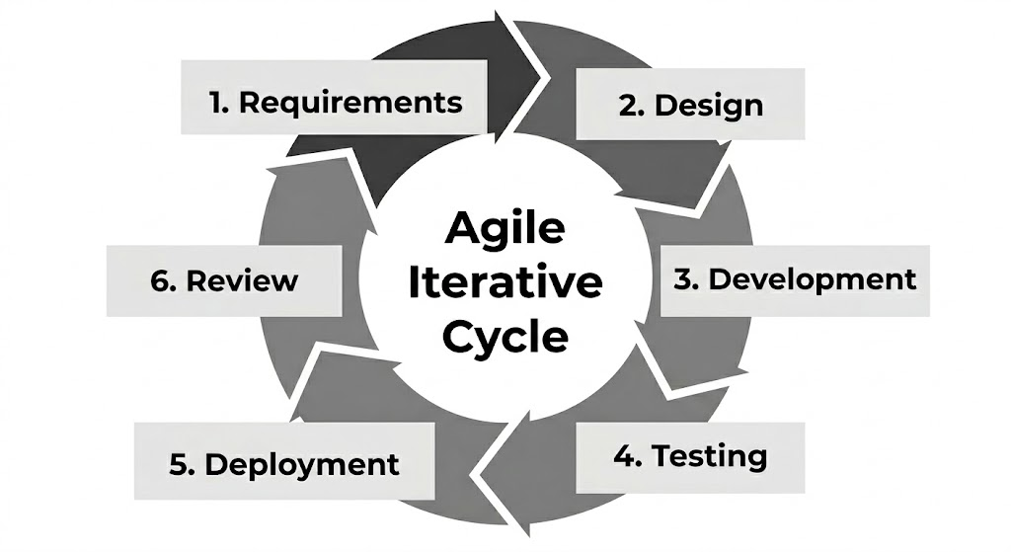
Agile development is an iterative and incremental software development approach that focuses on continuous improvement and flexibility through repeated cycles (Žužek et al., 2021). It is cyclical in nature, meaning that each iteration includes planning, design, development, and testing activities to ensure that each functional increment meets quality standards before integration (Vreuls et al., 2023). For SubSync: An Automated Web-Based Platform for Enhancing Community Engagement in Residential Subdivisions, the development process follows this agile system development life cycle (SDLC) framework. This framework allows for iterative progress through planning, design, development, testing, deployment, and evaluation to address the need for a centralized, transparent, and efficient community management tool (Dingle, 2026). This methodology enables researchers to refine key features—such as post-manual payment tracking and automated announcements—based on continuous feedback and incremental reviews of the system (Bastos, 2025).
The key phases include:
- Requirements Analysis
In this phase, the researchers identify the functional requirements for a centralized system, such as replacing paper-based records with a post-manual processing payment tracking dashboard to improve transparency for residents. This stage focuses on understanding the specific communication and management gaps within residential subdivisions to ensure the platform facilitates effective service delivery.
- Sprint Planning
The development process is divided into iterative cycles, prioritizing core modules like the integrated communication tool for resident-administrator messaging and the dynamic mapping feature for facility and emergency tracking. By breaking down the project into sprints, the researchers can focus on high-priority features first, ensuring a steady progression of functional system increments.

- Design and Implementation
During each sprint, the technical architecture is developed using a web-based tech stack, focusing on creating intuitive dashboards that simplify complex financial and spatial data for non-technical users. This involves translating the subdivision layout into a dynamic mapping system that supports better community navigation and decision-making through interactive data visualization.
- Testing and Review
Each completed module, such as the issue reporting system or the recommendation feature, undergoes rigorous functionality testing to identify and fix bugs early in the process. This stage ensures that automated notifications and geospatial visualizations respond accurately to user inputs, maintaining the reliability and responsiveness of the platform.
- Deployment and Evaluation
Following the integration of all modules including the payment history tracker and announcement systems the platform is finalized for a group of selected users. The system is then formally evaluated using the ISO 25010 quality standards, specifically assessing its functional suitability, performance efficiency, and security to ensure it meets the needs of subdivision stakeholders and IT experts.

Research Respondents
The respondents of this study are the main users and evaluators of the SubSync platform. They were chosen because they are directly involved in subdivision activities and can provide reliable feedback about how the system works in terms of functionality, usability, and effectiveness. A total of 25 respondents participated in the study, consisting of the subdivision president/administrator, homeowners' association officers, residents, and IT experts or IT professionals.
The first group is the Subdivision Administrator and HOA President, who oversee the daily operations and governance of the residential community. This group was selected because they manage the overarching records and financial summaries of the subdivision. Their feedback focuses on how the web-based system helps improve administrative oversight, especially in terms of data organization and ease of management.
The second group is the Homeowners' Association (HOA) Officers, who assist in the implementation of community rules and the dissemination of information. They were selected because they are the ones handling specific administrative tasks and coordinating community announcements. Their feedback focuses on the speed and reliability of the platform's communication modules compared to traditional methods.
The third group is the Subdivision Residents, who are the registered homeowners and tenants within the community. They are the primary users of the system for services like viewing personal payment histories and submitting community reports. Their feedback is important in knowing if the system is easy to use, helpful, and suitable for their daily needs as members of the community.
The fourth group is the IT Experts or IT Professionals, who have experience in system development and software evaluation. They help check the technical side of the system, including its performance, security, and overall quality. Their input ensures that the system is not only easy to use but also technically strong and reliable based on industry standards.
Overall, these four groups provide balanced feedback for the SubSync platform. Their responses help determine if the system is effective in terms of both user experience and technical performance. Table 2 shows the number of respondents and their distribution in terms of number and percentage.

Table 2
Research Respondents
Respondent Type | No. of Respondents | Percentage
Subdivision Administrator/President | 1 | 4%
HOA Officers | 10 | 28%
Subdivision Residents | 10 | 28%
Respondent Type | No. of Respondents | Percentage
IT Experts/IT Professionals | 5 | 40%
Total | 25 | 100%

Sampling Technique
The researchers will employ a Purposive Sampling Technique, a prominent non-probability sampling method where participants are selected based on the researcher's judgment regarding which individuals will be most informative for the study's specific objectives. Unlike probability-based methods that rely on random selection, purposive sampling focuses on criterion-based selection, ensuring that each respondent possesses unique insights or experiences essential to the phenomenon under study. This approach is particularly effective in research where the validity of the results depends on the depth of the participants' first-hand knowledge rather than general representativeness.
For the evaluation of SubSync, this technique is appropriate as it allows the researchers to target individuals with direct, practical experience in subdivision living or administrative management. Selecting respondents such as homeowners and subdivision officers ensures that the feedback regarding the platform's functional suitability and usability is grounded in real-world administrative challenges. Furthermore, for the technical evaluation phase, the researchers specifically target IT Professionals and Software Experts who meet predefined inclusion criteria, such as prior experience in system analysis or software quality assessment. These experts possess the specialized technical competency required to audit a web-based platform's architecture and security protocols. By deliberately selecting both end-users and technical specialists, the study achieves a balanced and rigorous analysis of the system's performance based on established global standards like ISO/IEC 25010.

Data Gathering Instrument
The primary research instrument used in this study is a combination of qualitative and quantitative tools designed to capture both the functional requirements and the eventual quality of the system. For the initial phase, the researchers will utilize a Semi-Structured Interview Guide to gather in-depth insights from subdivision administrators and homeowners' association officers. This guide consists of open-ended questions focused on current manual workflows, common bottlenecks in payment tracking, and existing gaps in community communication. The flexibility of a semi-structured interview allows the researchers to ask follow-up questions to clarify complex administrative tasks that the "SubSync" platform must automate.
Following the development of the platform, a Software Quality Evaluation Questionnaire adapted from the ISO/IEC 25010 standard will be employed. This instrument is designed to quantitatively measure the system's performance across eight key characteristics: Functional Suitability, Performance Efficiency, Usability, Compatibility, Reliability, Security, Maintainability, and Portability. The questionnaire utilizes a 5-point Likert Scale, ranging from "Strongly Disagree" (1) to "Strongly Agree" (5), providing a standardized metric for both IT professionals and end-users to assess the platform’s effectiveness in a subdivision environment.

Data Gathering Procedure
The data gathering procedure for this study begins with formal coordination with the selected residential subdivision and a request for permission from the homeowners' association or subdivision management to conduct the research. Once approval is granted, we will conduct semi-structured interviews with the subdivision administrators and staff to gather detailed information regarding their current manual management and communication processes. These interviews will be conducted through face-to-face sessions and online communication channels to ensure a comprehensive understanding of operational bottlenecks, such as manual payment tracking and bulletin-based announcements.
The responses from these interviews will be documented, organized, and analyzed to identify specific system requirements and guide the iterative development of the “SubSync” platform. The qualitative data gathered through these sessions will serve as the foundational basis for designing a system that accurately meets the operational needs of both residents and administrators. Furthermore, these collected insights will support the final system evaluation phase, where an ISO/IEC 25010-based instrument will be utilized to assess the platform’s quality, performance, and overall effectiveness in enhancing community engagement.

Validity of Research Instrument
A semi-structured interview guide was developed to obtain detailed information regarding the current administrative and communication processes of the selected residential subdivision in relation to the development of SubSync: An Automated Web-Based Platform for Enhancing Community Engagement in Residential Subdivisions. The guide covers essential operational domains such as resident record management, post-manual payment tracking, announcement dissemination, issue reporting, and facility mapping. The development of the interview questions was guided by the specific objectives of the study to ensure that the gathered data accurately reflects actual operational requirements and community needs. The instrument was reviewed by the researchers and refined under the guidance of the academic adviser to ensure clarity, relevance, and alignment with the study framework. This ensures that the interview guide is appropriate for eliciting comprehensive responses from the subdivision administrators and homeowners' association officers regarding existing workflows and community engagement challenges.

Reliability of the Research Instrument
To ensure consistency in data collection was ensured through the use of a standardized semi-structured interview guide administered to the secretary, encoder, and manager. All participants were provided with the same set of structured questions to maintain uniformity and allow systematic comparison of responses. Follow-up questions were utilized only when necessary to clarify responses and ensure completeness of the information gathered. The interviews were conducted following a consistent procedure, and all responses were properly documented through recording and note-taking to preserve accuracy. This process ensures that the data collected across all respondents remains consistent, dependable, and suitable for analysis.

Analysis / Treatment of Data
The data collected from the interviews are analyzed using thematic analysis to systematically interpret the responses of the subdivision administrators and officers. All responses are transcribed, examined, and organized to identify recurring patterns, significant ideas, and operational bottlenecks within the residential community. These patterns are categorized to represent core processes, such as the manual recording of dues and the traditional methods of posting announcements. The analysis focuses on revealing issues such as communication delays, limited transparency in financial tracking, and inefficiencies in responding to resident reports. The findings serve as the basis for defining the system requirements of SubSync, while the ISO/IEC 25010 standard will be utilized during the system evaluation phase to assess software quality attributes through weighted mean and descriptive statistics.

Ethical Consideration
Ethical standards are strictly observed throughout the conduct of the study to ensure the protection of all participants involved. Informed consent is obtained from the subdivision administrators, officers, and residents prior to the data gathering process, and they are fully informed of the study’s purpose, scope, and the functionality of the SubSync platform. Participation is entirely voluntary, and respondents are allowed to withdraw at any stage without any form of penalty or consequence. Confidentiality is maintained in accordance with the Data Privacy Act, ensuring that no personally identifiable information or sensitive financial records are disclosed in the study. All collected data are used solely for academic purposes and are securely stored to protect participant privacy and subdivision data integrity.

Operational Framework
An operational framework refers to a structured representation that illustrates how different components of a system interact and work together to achieve its intended functions and objectives. In information systems development, frameworks are used to organize system components, define relationships among processes, and guide the flow of data within a system to ensure proper system functionality and alignment with organizational goals (Meneses & Varajão, 2022).
Figure 2 presents the Operational Framework of the SubSync system, which illustrates the interaction among the users, system modules, central database, and administrative processes. The framework shows that the User or Resident, Admin, and Officer first accesses the system by entering login credentials through the Authentication module to ensure secure and authorized entry. Once an access response is received, the user can interact with the Community Management Platform with Geospatial Mapping, which serves as the core interface for retrieving module data and storing essential information such as resident profiles, financial records, and announcements.
The system processes and manages community data by communicating with the Central Database for the systematic storage and retrieval of information across various specialized modules. Specifically, the Financial Management component handles record-keeping and Excel imports for balance tracking, while the Facility & Geospatial Mapping module manages the location data of subdivision assets. Furthermore, the Issue & Announcement Monitoring and Messaging & Conversation components support real-time community engagement by managing updates and participant dialogues. Lastly, the Reports and Analysis component generates organized financial and issue reports based on the collected data, which supports effective decision-making, evaluation, and overall management of the residential subdivision.

Figure 2
Operational Framework 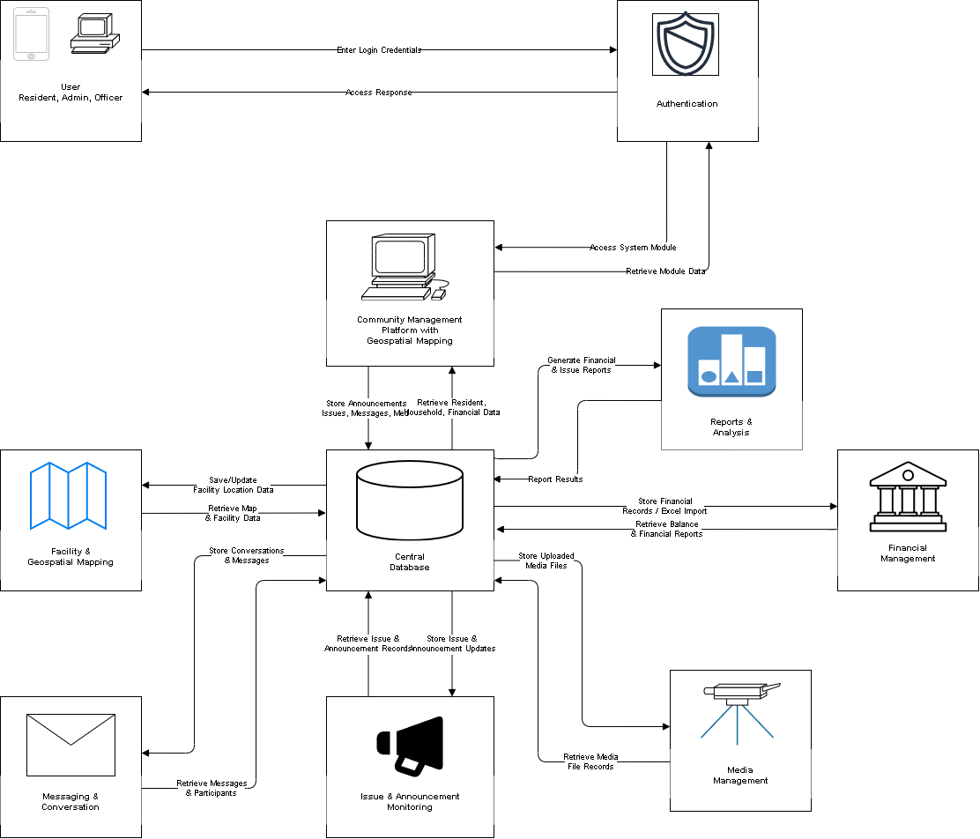

Context Diagram
A context diagram, also known as a Level 0 Data Flow Diagram (DFD), represents the entire system as a single process to demonstrate the scope of the system and its interactions with external entities. This diagram illustrates the boundaries of the system and how information is exchanged between the platform and its primary users to ensure streamlined subdivision operations. As illustrated in SubSync system, identified as the Community Management Platform with Geospatial Mapping, acts as the central hub for data exchange among three primary entities: the Resident, the Admin, and the Officer.
The Resident entity provides inputs such as issue reports, recommendations, profile and household information, and conversation replies to the system. In return, the system provides the resident with uploaded media, announcements, notifications, issue response updates, financial records, and facility map information. The Admin serves as the primary controller of the system, providing essential data such as user and household management details, financial record entries, facility map management, and posted announcements. The system provides the admin with resident suggestions, submitted issue reports, comprehensive monitoring data, and automated system alerts. Finally, the Officer interacts with the system to manage community concerns and communication. The system sends assigned issue reports, resident messages, and announcement updates to the officer, who in turn provides issue responses, posted announcements, and conversation messages back to the platform. By defining these high-level data flows, the context diagram ensures that all stakeholders have a clear understanding of the system's functional boundaries and the specific information required for effective community management.

Figure 3
Context Diagram
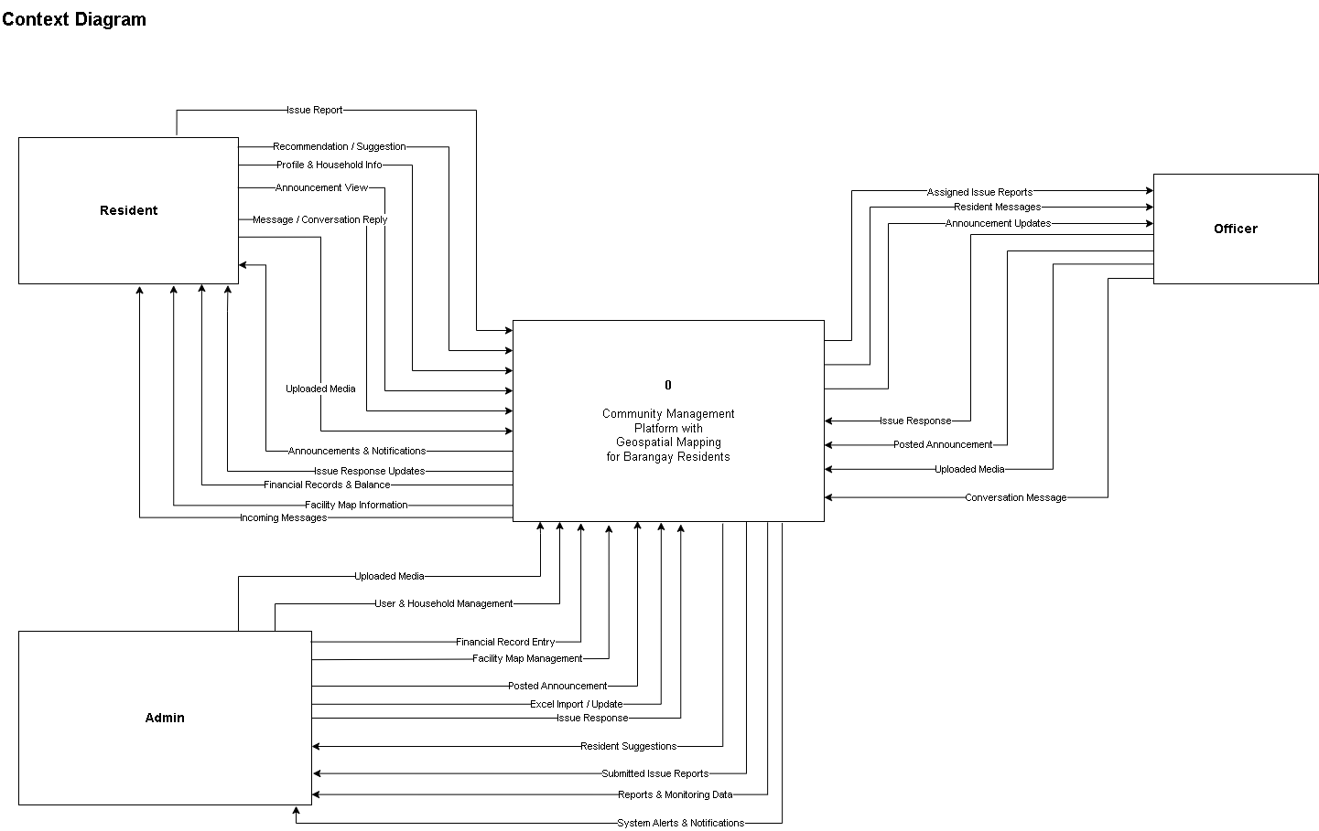

Data Flow Diagram
The Data Flow Diagram (DFD) provides a detailed visualization of the internal processes, data stores, and information pathways within the SubSync platform. As shown in the system is broken down into seven core functional processes that manage the flow of information between the Resident, Admin, and Officer entities. The User & Household Management (1.0) process handles account creation and profile updates, storing user data in the D1 User Accounts data store and issuing system alerts or confirmations back to the users. The Announcement Management (2.0) process enables admins and officers to post or draft announcements, which are stored in D2 Announcement Records and retrieved when residents request to view current community updates.
Community concerns are handled through the Issue Report Management (3.0) process, where resident reports and recommendations are stored in D3 Issue Records; these reports are then assigned to officers who provide responses and monitoring updates back to the residents and administrators. Financial transparency is maintained via the Financial Record Management (4.0) process, which allows admins to input records or perform Excel imports into D4 Financial Records, enabling residents to retrieve their current balance and financial history. For physical community assets, the Facility Map Management (5.0) process stores location data in D5 Facility Records, allowing users to request and receive facility map information.
Engagement and documentation are supported by the final two modules. The Messaging & Conversation (6.0) process manages direct communication by storing interaction data in D6 Conversation & Messages, facilitating a flow of incoming and outgoing messages among residents, officers, and administrators. Finally, the Media Management (7.0) process serves as the repository for all visual documentation, storing uploaded files in D7 Media Files and providing media confirmation to the users. Collectively, these processes ensure a streamlined, data-driven approach to subdivision management that replaces manual oversight with real-time digital tracking.

Figure 4
Data Flow Diagram
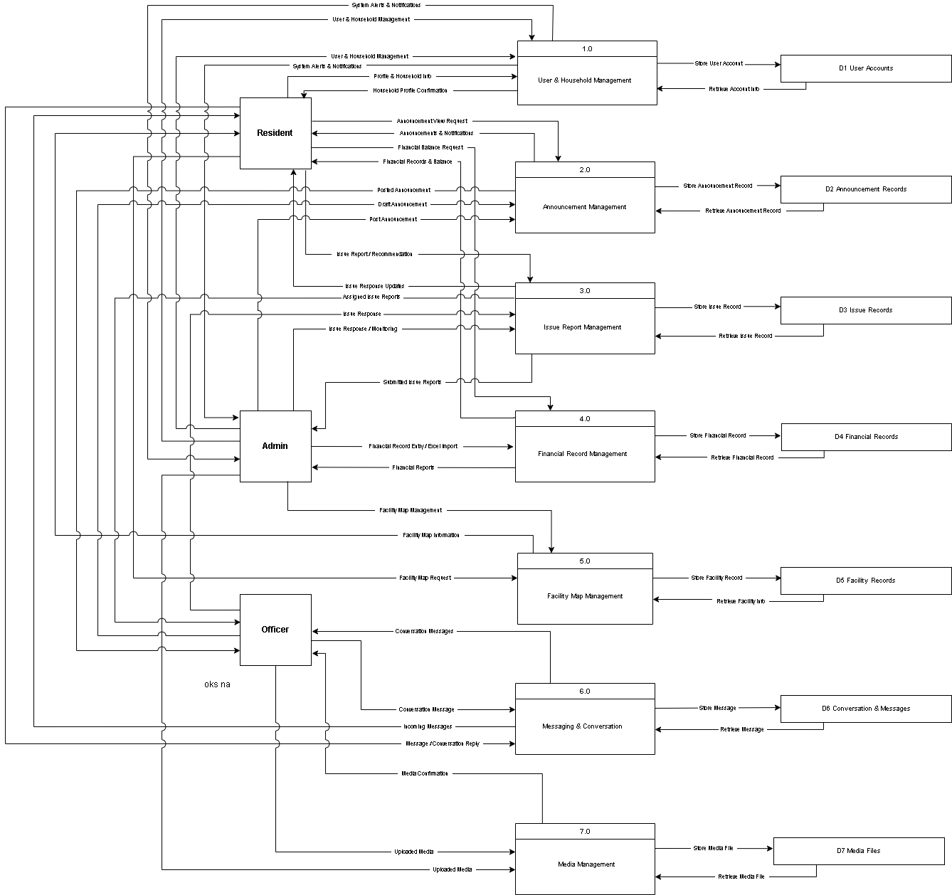

Entity Relationship Diagram

The Entity Relationship Diagram (ERD) for the SubSync system provides a detailed blueprint of the database architecture, illustrating the logical connections and data dependencies between community members and administrative modules. As shown in database is centered around three primary user entities: RESIDENT or USER, ADMIN, and OFFICER, each with specific attributes for identification, contact information, and account status. The core of the subdivision’s organizational structure is represented by the HOUSEHOLD and HOUSEHOLD_MEMBER tables, which establish a link between residents and their respective living units. To manage community engagement, the ANNOUNCEMENT table stores broadcasted information created by admins or officers, with an ANNOUNCEMENT_VIEW junction table tracking resident interaction to ensure effective communication across the subdivision.
Operational tasks are further normalized through specialized entities that handle specific community functions. The ISSUE_REPORT table captures resident concerns including descriptions and geospatial coordinates while the ISSUE_RESPONSE table links these reports to officers who provide status updates and resolutions. Financial transparency is maintained via the FINANCIAL_RECORD and TRANSACTION tables, which track community dues and balances. Communication within the platform is facilitated by the CONVERSATION and MESSAGE entities, allowing for threaded interactions among users. Furthermore, the FACILITY and MEDIA tables manage physical assets and uploaded documentation, respectively, ensuring that all subdivision data is systematically stored and easily retrievable to support informed decision-making and efficient community governance.

Figure 5
Entity Relationship Diagram
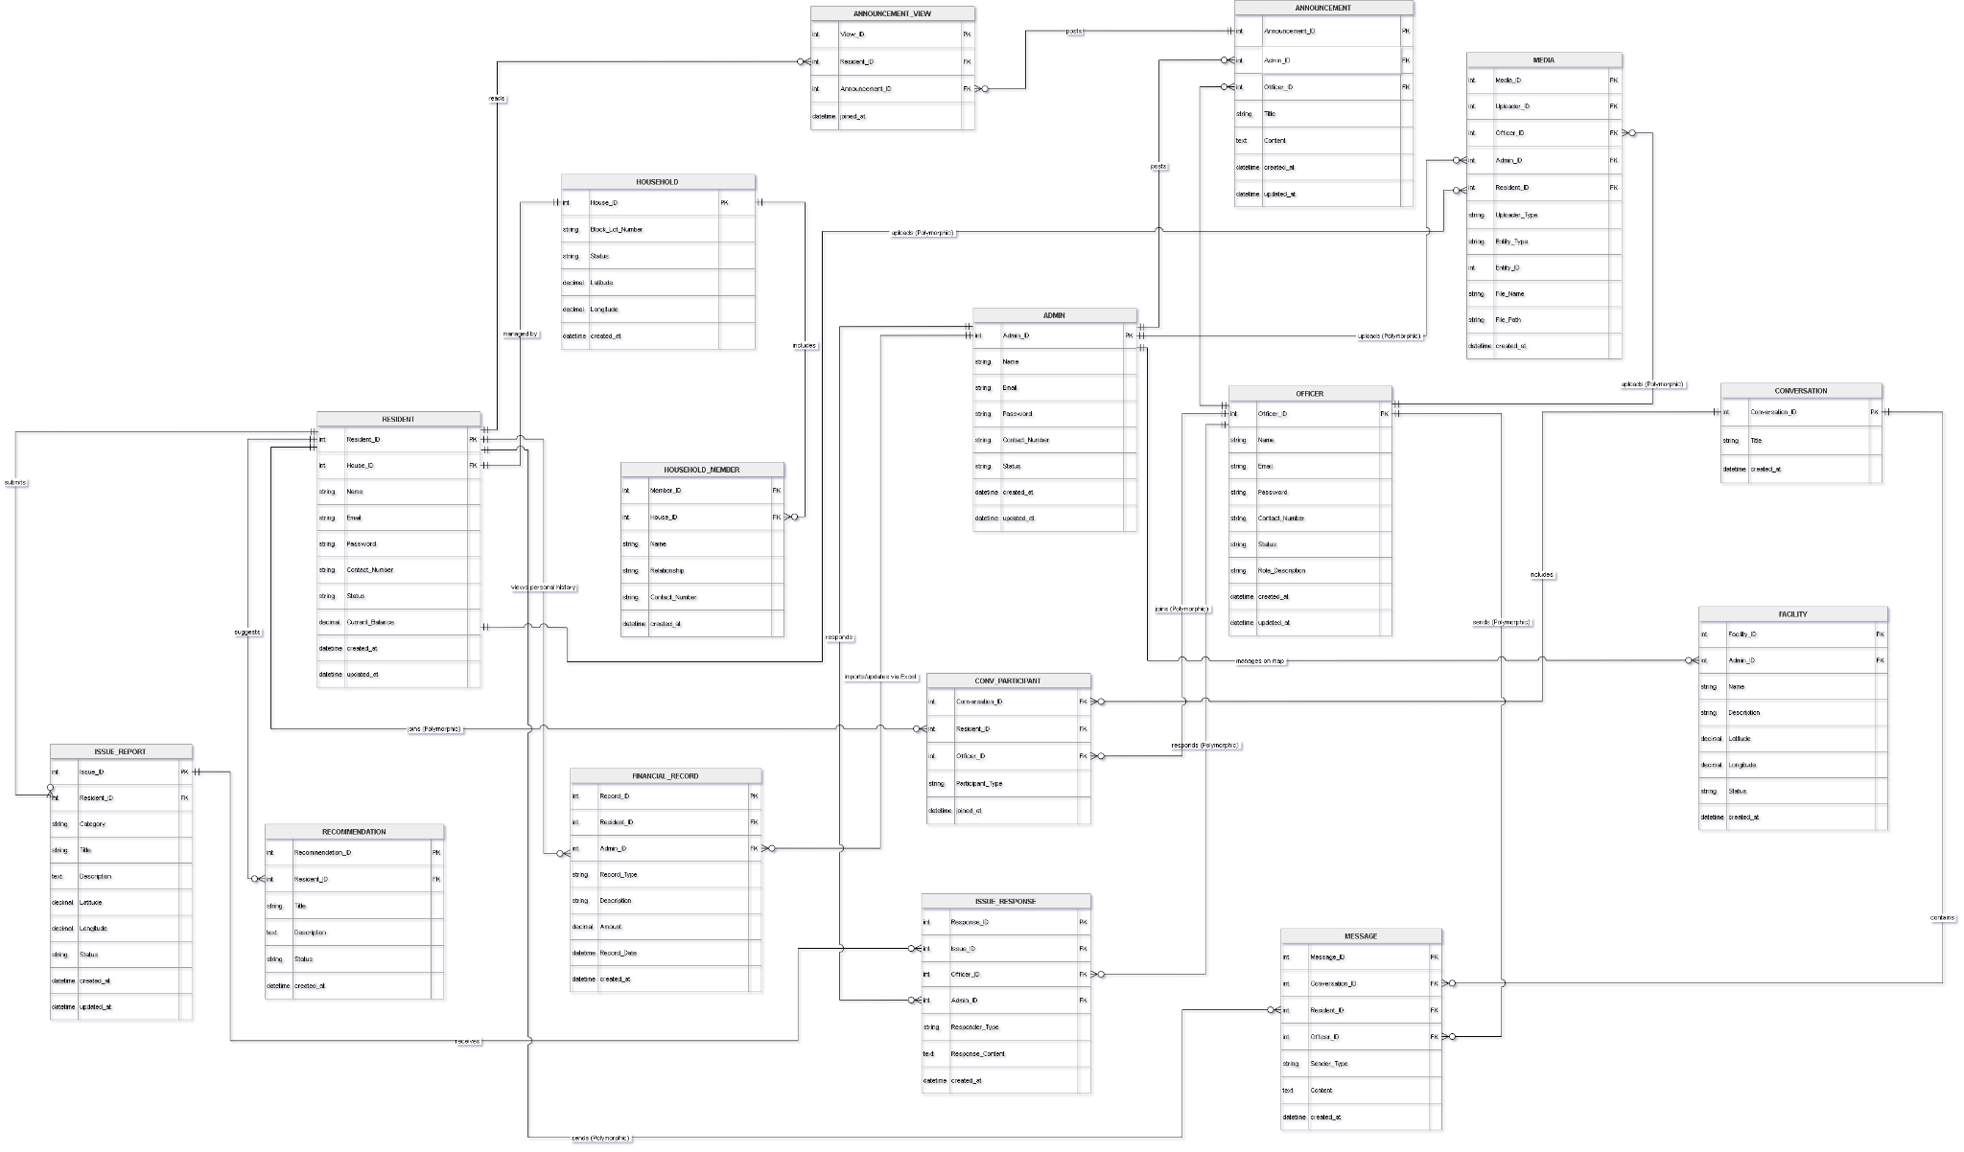

Use Case Diagram
A use case diagram is a visual guide that shows how users interact with a system and what actions they can perform. It helps explain the main features and functions of a system in a simple and organized way by identifying the users, also called actors, and the tasks they can do inside the system. This type of diagram is important because it gives developers, researchers, and stakeholders a clear understanding of how the system works and how each user will use it. It also helps make sure that the needs of the users are included during the planning and development of the system (GeeksforGeeks, 2025; EDUCBA, 2023).
Figure 5 shows the use case diagram of the IBOSSmartGeo: A Geospatial Mapping and Credit Cooperative Management Platform for Crossing IBOS Farmers. The diagram presents the interactions of the three main actors of the system namely the Member, Non-Member, and Admin. For the Non-Member, the system allows users to register an account and apply for membership so they can access the services offered by the cooperative. Members can perform important cooperative and farming-related activities such as applying for loans, approving co-maker requests, requesting savings withdrawals, scheduling machinery for farm use, viewing their digital passbook, and adding farm block information for agricultural monitoring and mapping purposes. These features help members manage their financial transactions and farming activities more conveniently and efficiently. Meanwhile, the Admin is responsible for handling and monitoring the overall operations of the system. The Admin can approve membership applications, savings withdrawals, machinery requests, and loan requests to ensure proper verification and processing of transactions. In addition, the Admin manages loans, users, agricultural supplies inventory, machinery records, and block farming information. The system also allows the Admin to record crop yields, manage machinery usage, and print reports for monitoring and documentation purposes. Overall, the use case diagram shows how the system helps improve the cooperative’s services by making transactions more organized, accessible, efficient, and supportive of the farmers’ agricultural needs and activities.

Figure 6
Use Case Diagram
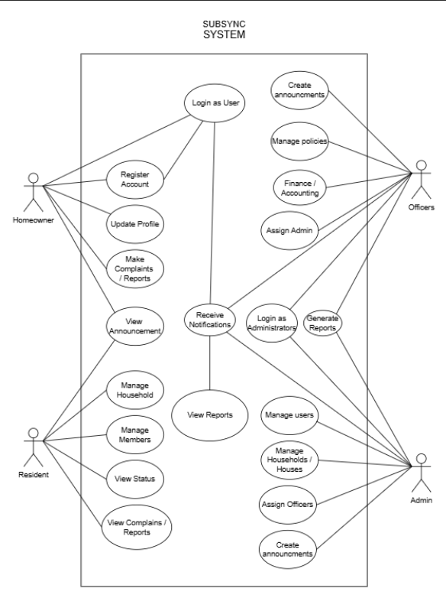

Data Dictionary

Table 3
Admin
Field Name | Data Type | Length | Description
Admin_ID | int | - | Unique identifier for each admin record.
Name | string | 100 | Full name of the administrator.
Email | string | 150 | Email address used for admin login and communication.
Password | string | 255 | Hashed password used for admin authentication.
Contact_Number | string | 20 | Contact phone number of the administrator.
Status | string | 50 | Current account status (e.g., Active, Inactive).
created_at | datetime | - | Date and time when the admin record was created.
updated_at | datetime | - | Date and time of the most recent update to the record.

Stores administrator accounts responsible for managing the barangay system, including user management, financial records, announcements, facility oversight, and overall platform administration.

Table 4
Officer
Field Name | Data Type | Length | Description
Officer_ID | int | - | Unique identifier for each officer record.
Name | string | 100 | Full name of the barangay officer.
Email | string | 150 | Email address used for officer login and communication.
Password | string | 255 | Hashed password used for officer authentication.
Contact_Number | string | 20 | Contact phone number of the officer.
Status | string | 50 | Current account status (e.g., Active, Inactive).
Role_Description | string | 255 | Description of the officer's specific role or designation.
Field Name | Data Type | Length | Description
created_at | datetime | - | Date and time when the officer record was created.
updated_at | datetime | - | Date and time of the most recent update to the record.

Stores barangay officer accounts who are responsible for handling issue responses, posting announcements, managing conversations with residents, and assisting in map management.

Table 5
Resident
Field Name | Data Type | Length | Description
Resident_ID | int | - | Unique identifier for each resident record.
House_ID | int | - | Foreign key referencing the household the resident belongs to.
Name | string | 100 | Full name of the resident.
Field Name | Data Type | Length | Description
Email | string | 150 | Email address used for resident login and communication.
Password | string | 255 | Hashed password used for resident authentication.
Contact_Number | string | 20 | Contact phone number of the resident.
status | string | 50 | Current account status (e.g., Active, Inactive).
Current_Balance | decimal | - | Resident's current financial balance within the barangay system.
created_at | datetime | - | Date and time when the resident record was created.
updated_at | datetime | - | Date and time of the most recent update to the record.

Stores resident accounts who interact with the platform to submit issue reports, recommendations, view announcements, monitor financial balances, and communicate with barangay officials.

Table 6
Household
Field Name | Data Type | Length | Description
House_ID | int | - | Unique identifier for each household record.
Block_Lot_Number | string | 50 | Block and lot number assigned to the property.
statusStatus | string | 50 | Current occupancy status of the property (e.g., Occupied, Vacant).
Latitude | decimal | - | Geographic latitude coordinate for map geolocation.
Longitude | decimal | - | Geographic longitude coordinate for map geolocation.
created_at | decimal | - | Date and time when the household record was created.

Stores information about each household or property registered within the barangay, including geospatial coordinates used for map display and location tracking.

Table 7
Household_member
Field Name | Data Type | Length | Description
Member_ID | int | - | Unique identifier for each household member record.
House_ID | int | - | Foreign key referencing the household the member belongs to.
Name | string | 100 | Full name of the household member.
Relationship | string | 50 | Relationship of the member to the resident (e.g., Spouse, Child, Sibling).
Contact_Number | string | 20 | Contact phone number of the household member.
created_at | datetime | - | Date and time when the household member record was created.

Stores information about individuals residing within a household who are associated with a registered household but do not have their own system account.

Table 8
Announcement
Field Name | Data Type | Length | Description
Announcement_ID | int | - | Unique identifier for each announcement record.
Admin_ID | int | - | Foreign key referencing the admin who posted the announcement.
Officer_ID | int | - | Foreign key referencing the officer who posted the announcement.
Title | string | 200 | Short and descriptive title of the announcement.
Content | text | - | Full body content of the announcement.
created_at | datetime | - | Date and time when the announcement was created.
updated_at | datetime | 255 | Date and time when the announcement was created.

Stores barangay announcements created and posted by administrators or officers, which are made available for residents to view through the platform.

Table 9
Announcement_view
Field Name | Data Type | Length | Description
View_ID | int | - | Unique identifier for each announcement view record.
Resident_ID | int | - | Foreign key referencing the resident who viewed the announcement.
Announcement_ID | int | 10,2 | Foreign key referencing the announcement that was viewed.
created_at | datetime | 255 | Date and time when the announcement was viewed by the resident.

Tracks and records which residents have viewed specific announcements, serving as a junction table between the Resident and Announcement entities.

Table 10
Media
Field Name | Data Type | Length | Description
Media_ID | int | - | Unique identifier for each media record.
Uploader_ID | int | - | Identifier of the entity who uploaded the file.
Officer_ID | int | - | Foreign key referencing the officer uploader, if applicable.
Admin_ID | int | - | Foreign key referencing the admin uploader, if applicable.
Resident_ID | int | - | Foreign key referencing the resident uploader, if applicable.
Uploader_Type | string | 50 | Type of the uploader entity (e.g., Admin, Officer, Resident).
Entity_Type | string | 50 | Type of entity the media is associated with (e.g., Announcement, Issue).
Entity_ID | int | - | Identifier of the associated entity (polymorphic reference).
Field Name | Data Type | Length | Description
File_Name | string | 255 | Original file name of the uploaded media.
File_Path | string | 500 | Storage path or URL where the file is saved.
created_at | datetime |  | Date and time when the media file was uploaded.

Stores uploaded media files and attachments associated with various entities in the system. This table uses a polymorphic association, allowing files to be linked to announcements, issue reports, residents, officers, or admins.

Table 11
Financial_record
Field Name | Data Type | Length | Description
Record_ID | int | - | Unique identifier for each financial record.
Resident_ID | int | - | Foreign key referencing the resident associated with the transaction.
Field Name | Data Type | Length | Description
Admin_ID | int | - | Foreign key referencing the admin who created or manages the record.
Record_Type | string | 100 | Type of financial transaction (e.g., Payment, Due, Penalty).
Description | string | 255 | Additional details or notes about the financial transaction.
Amount | decimal | - | Monetary amount of the financial transaction.
Record_Date | datetime | - | Date when the financial transaction occurred.
created_at | datetime | - | Date and time when the financial record was created.

Stores financial transaction records associated with residents, created and managed by administrators. This includes payments, dues, penalties, and other financial entries relevant to the barangay.

Table 12
Issue Report
Field Name | Data Type | Length | Description
Issue_ID | int | - | Unique identifier for each issue report record.
Resident_ID | int | - | Foreign key referencing the resident who submitted the report.
Category | string | 100 | Category of the issue (e.g., Infrastructure, Safety, Sanitation).
Title | string | 200 | Short descriptive title of the issue report.
Description | text | - | Detailed description of the reported issue.
Latitude | decimal | - | Geographic latitude of the location where the issue was reported.
Longitude | decimal |  | Geographic longitude of the location where the issue was reported.
Status | string | 50 | Current status of the issue (e.g., Pending, In Progress, Resolved).
Field Name | Data Type | Length | Description
created_at | datetime | - | Date and time when the issue report was submitted.
updated_at | datetime | - | Date and time of the most recent update to the issue report.

Stores barangay issue reports submitted by residents. Each report includes a category, description, and geospatial location data to support map-based tracking and monitoring of community concerns.

Table 13
Issue_response
Field Name | Data Type | Length | Description
Response_ID | int | - | Unique identifier for each issue response record.
Issue_ID | int | - | Foreign key referencing the issue report being responded to.
Officer_ID | int | - | Foreign key referencing the officer who provided the response, if applicable.
Field Name | Data Type | Length | Description
Admin_ID | int | - | Foreign key referencing the admin who provided the response, if applicable.
Responder_Type | string | 50 | Indicates whether the responder is an Officer or an Admin.
Response_Content | datetime | - | Full content of the response or action taken on the issue.
created_at | datetime | - | Date and time when the response was submitted.

Stores official responses to submitted issue reports, provided by barangay officers or administrators. Records the responder type and the content of the action or reply given.

Table 14
Reccomendation
Field Name | Data Type | Length | Description
Recommendation_ID | int | - | Unique identifier for each recommendation record.
Resident_ID | int | - | Foreign key referencing the resident who submitted the recommendationnumber assigned to the payment transaction.
Field Name | Data Type | Length | Description
Title | string | 200 | Short descriptive title of the recommendation.
Description | text | - | Detailed content of the suggestion or recommendation.
Status | string | 50 | Current status of the recommendation (e.g., Pending, Reviewed, Approved).
created_at | datetime |  | Date and time when the recommendation was submitted.

Stores suggestions and recommendations submitted by residents to the barangay administration. These are reviewed and managed by administrators or officers for potential implementation.

Table 15
Conversation
Field Name | Data Type | Length | Description
Conversation_ID | int | - | Unique identifier for each conversation thread.
Title | string | 200 | Optional subject or title of the conversation thread.
created_at | datetime | - | Date and time when the conversation thread was created.

Stores conversation threads initiated between residents and barangay officers or admins within the platform's messaging system.

Table 16
Conv_Participant
Field Name | Data Type | Length | Description
Conversation_ID | int | - | Foreign key referencing the associated conversation thread.
Resident_ID | int | - | Foreign key referencing the resident participant, if applicable.
Officer_ID | int | - | Foreign key referencing the officer participant, if applicable.
Field Name | Data Type | Length | Description
Participant_Type | string | 50 | Foreign key referencing the user who availed the loan.
created_at | datetime | - | Foreign key referencing the type of credit/loan product.

A junction table that defines which residents and officers are participants within a given conversation thread, supporting the messaging system's multi-participant structure.
Table 17
Massage
Field Name | Data Type | Length | Description
Message_ID | int | - | Unique identifier for each message record.
Conversation_ID | int | - | Foreign key referencing the conversation the message belongs to.
Resident_ID | int | - | Foreign key referencing the resident sender, if applicable.
Officer_ID | int | - | Foreign key referencing the officer sender, if applicable.
Field Name | Data Type | Length | Description
Sender_Type | string | 50 | Indicates whether the sender is a Resident or an Officer.
Content | text | - | Full text content of the message.
created_at | datetime | - | Date and time when the message was sent.

Stores individual messages sent within a conversation thread by either a resident or an officer, forming the communication history of each conversation.

Table 18
Facility
Field Name | Data Type | zLength
Facility_ID | int | -
Admin_ID | int | -
Name | string | 150
Field Name | Data Type | Length
Description | string | 500
Latitude | decimal | -
Longitude | decimal | -
Status | string | 50
created_at | datetime | -

Stores information about barangay facilities managed by administrators, including geospatial coordinates for display on the community map and operational status tracking.

Recommended Hardware Requirements
To ensure the smooth operation, scalability, and optimal performance of the SubSync system especially considering its media handling and geospatial mapping features the following upgraded hardware specifications are recommended.

Web Server
Component | Specification
Processor (CPU) | Multi-core processor (4 to 8 cores), 2.5 GHz or higher
Memory (RAM) | 16 GB – 32 GB (to efficiently handle concurrent database queries and mapping data)
Storage | 16 GB – 32 GB (to efficiently handle concurrent database queries and mapping Intel Core i3 / AMD Ryzen 3 equivalent or higherdata)

Admin/Officer Workstation (Client PC)
Component | Specification
Processor (CPU) | Intel Core i3 / AMD Ryzen 3 equivalent or higher
Memory (RAM) | 8 GB
Display | 1920 × 1080 resolution recommended (for clear visibility of the facility map and data tables)

Mobile Application (Resident Device)
Component | Specification
Memory (RAM) | 3 GB or higher
Storage | 100 MB free space for app installation and cache
Processor | 64-bit ARM-based processor
Sensors & Hardware | GPS (for location tracking on issue reports), Camera (for media uploads), and active Internet connection

Software Requirements
To ensure secure and efficient access to the SubSync platform, the following software specifications are recommended..

Web Server & Database Environment
Component | Specification
Operating System | Ubuntu 22.04 LTS, Debian 11, or Windows Server 2022
Database Engine | MySQL 8.0, PostgreSQL 14, or higher

Web Admin Dashboard (Client-side)
Component | Specification
Operating System | Windows 10 / Windows 11 / macOS 12+ / Modern Linux distributions
Web Browser | Latest stable release of Google Chrome, Mozilla Firefox, Apple Safari, or Microsoft Edge

Mobile Application
Component | Specification
Android OS | Android 8.0 (Oreo / API 26) or newer
iOS | iOS 13.0 or newer

GANTT CHART
The Gantt Chart is used by the proponents of the study as a tool to present the sequence of activities, schedule, and specific tasks necessary for the development of SubSync: An Automated Web-Based Platform for Enhancing Community Engagement in Residential Subdivisions. It outlines the major phases of the study, including planning, requirements analysis, system design, development, testing, evaluation, and documentation, together with the estimated duration and target dates for each activity.
The Gantt chart serves as a guide for monitoring the progress of the project and ensuring that each task is completed within the proposed timeframe. It also helps the researchers organize the iterative development process based on the Agile methodology applied in the study. Furthermore, the chart includes allowances for revisions, debugging, consultations, and unforeseen delays that may occur during the implementation and evaluation of the system. Through this timeline, the proponents can effectively manage project activities and maintain the systematic development of the SubSync platform.

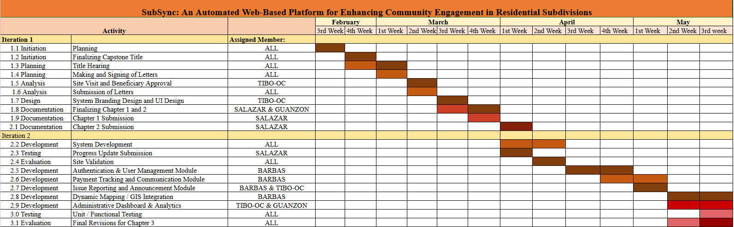

REFERENCES

Albano, H. B. (2024). Empowering local government units with open‑source tools: Building a dynamic web‑based information system. Isabela State University Linker: Journal of Engineering, Computing and Technology. https://doi.org/10.65141/ject.v1i1.n1

Anggara, M. R., Kurniawan, D., Ardiansyah, A., & Irawati, A. R. (2023). Smart village mobile-based community reporting application. ResearchGate. https://www.researchgate.net/publication/367562435_Smart_Village_Mobile-Based_Community_Reporting_Application?fbclid=IwY2xjawQlcdpleHRuA2FlbQIxMQBzcnRjBmFwcF9pZAEwAAEeUKv4ZmbrYNTjfPJP5Z9BGfe68nEwacMehfuJ5D5NS3lxJ1Av0Wz0uqhWuIY_aem_FBcR4Hnf5Sj-rEL1EJxH3Q

Alvarez, L. J. C., Belando, J., Abiog, J. S., & Miranda, A. (2023). Barangay blotter and clearance system of Sta. Maria, Gonzaga, Cagayan, Philippines. Journal of Pure and Applied Sciences, 1(1).
https://csu.org.ph/jpas/article/view/23

Ballaran, M. J. G., Donaire, M. J. M., Singzon, R. M., Naz, S. M., Tanael, D. V., & Centeno, C. J. (2023). Development and evaluation of web‑based barangay profiling and issuance system using regression analysis. World Journal of Advanced Research and Reviews. https://doi.org/10.30574/wjarr.2023.20.3.2404

Bartling, M., Resch, B., Reichenbacher, T., Havas, C. R., Robinson, A. C., Fabrikant, S. I., & Blaschke, T. (2021). Participatory geographic information systems for urban communities: Enhancing engagement and decision-making. Taylor & Francis Online. https://www.tandfonline.com/doi/full/10.1080/15230406.2021.2015720

Bastos, R. (2025). Comparative analysis of communication in project management approaches: Waterfall, agile, and hybrid. Journal of Construction Engineering and Management.
https://www.tandfonline.com/doi/full/10.1080/15623599.2025.2589827

Baylon, M. C., Cruz, J., Dionson, A., & Inocencio, A. (2026). Local government unit 4: A web‑based barangay disaster relief service (Vol. 7 No. 1). Ascendens Asia Singapore – Bestlink College of the Philippines Journal of Multidisciplinary Research. https://ojs.aaresearchindex.com/index.php/aasgbcpjmra/article/view/15636

Briones, S. V., Atole, R. R., Bello, L. C. S., Lirag, J. R. S., Seboguero, A. A., Dela Cueva, C. J., … Sabaria, J. C. B. (2025). Empowering communities through E‑SITIO: A data‑driven approach towards transformative local governance. Journal of Information Systems Engineering and Management. https://jisem-journal.com/index.php/journal/article/download/4078/1805/6685

Ching, G. E., & Orozco, M. M. (2025). Local community e‑services: An online application for streamlining community transactions and services (Thesis). ResearchGate. https://www.researchgate.net/publication/390754114_Local_Community_E-Services_An_Online_Application_for_Streamlining_Community_Transactions_and_Services

Dandan, D. (2026). Evaluating the effectiveness of Barangay Management System for local governance using software quality model of ISO 25010:2011. International Journal of Integrated Viewpoints. https://viewpoints.edukar.net/index.php/ijiv/article/download/72/93

Dingle, E. K. (2026). PACACPORTAL: Student portal of Pacac High School. Philippine E-Journals.
https://ejournals.ph/article.php?id=30195

Ferranco, J. F., Gervacio, A. G., & Ferranco, C. F. (2025). Communitech: Empowering barangay officials in rural areas through enhanced computer skills. MDPI. https://doi.org/10.3390/engproc2025107020

Gasmido, W., DeGuzman, J., Natividad, C. J., Sicuan, C. K. B., & Reyes, D. (2025). Digital barangay: Ayos Lomboy’s web‑based management and information system. Psychology and Education: A Multidisciplinary Journal, 37(5), 424‑431. https://doi.org/10.70838/pemj.370501

Ilustrisimo, D. (2026). Empowering Bantayan Island through a centralized digital tourism portal: An evaluation using ISO/IEC 25010 and UTAUT. International Journal of Education, Research, and Innovation Perspectives. https://ijerip.erio.org.ph/index.php/articles/article/view/379

Lacasandile, J., et al. (2020). Barangay profiling systems and dashboard modules for improved local governance. Philippine Journal of Public Administration. https://www.scribd.com/document/541236542/ICSET-2020-BIPS#:~:text=The%20system%20was%20tested%20in%202016%20with,public%20service%20delivery%20at%20the%20local%20level

Luo, X., & Chen, G. (2024). Socio-Ecological Factors in Building a Healthy Community: A Comparative Study of Healthy Community Assessment Standards. Buildings, 14(9), 2634.
https://www.mdpi.com/2075-5309/14/9/2634

Melendres, U. M., & Aranda, K. M. (2022). Web-based community information systems for subdivision management. Journal of Computer Studies and Practices. https://journals.stecab.com/index.php/jcsp/article/view/50?fbclid=IwY2xjawQlc1lleHRuA2FlbQIxMQBzcnRjBmFwcF9pZAEwAAEeFCpvUYE9wVvO_QM2LJUIh64qCF9kONiBCTD0GaDg2HqLYz3k_YnzfIuxVaQ_aem_qYpVhQdMgR3QVY-jGTCKTg

Mercurio, D. I., & Hernandez, A. A. (2022). An open data and geo‑based community information systems. arXiv.
https://arxiv.org/abs/2201.12544

Ningrum, D. A. C., Riadi, A. A., & Susanto, A. (2025). Design of a web‑based citizen complaint system in increasing citizen participation in the village development process. Journal La Multiapp. https://doi.org/10.37899/journallamultiapp.v6i2.2039

Osio, R. H., Ilustrisimo, D. L., & Daruca, R. H. (2026). A web-based customer satisfaction survey system for Local Government Unit: Design, implementation, and ISO/IEC 25010 quality evaluation. International Journal of Education, Research, and Innovation Perspectives. https://ijerip.erio.org.ph/index.php/articles/article/view/200

Perera, P. (2025). An innovative software development methodology for deep learning-driven visual computing in built environment applications. Journal of Information Technology in Construction. https://www.itcon.org/2025/5

Pinero, M. J. (2024). AI-integrated systems in revolutionizing citizen reporting and data analytics. The Light Explorer, 9(2). https://www.thelight-explorer.com/wp-content/uploads/2024/11/197.-MICHAEL-PINERO-June-2024.pdf

Pluto‑Kossakowska, J., Fijałkowska, A., Denis, M., & Jaroszewicz, J. (2025). Dashboard as a platform for community engagement in city development: A review of techniques, tools, and methods. Sustainability. https://www.mdpi.com/2071-1050/14/17/10809

Reyes, C. M., Vargas, A. R. P., & Arboneda, A. (2022). Evidence-based local planning and budgeting using the CBMS. Philippine Institute for Development Studies. https://www.pids.gov.ph/publication/research-paper-series/evidence-based-local-planning-and-budgeting-using-the-cbms

Shofiana, A., Riadi, A. A., & Evanita, E. (2025). Public complaints information system in government to improve website‑based public services. Journal La Multiapp, 6(4). https://doi.org/10.37899/journallamultiapp.v6i4.2419

Systematic analysis of digital tools for citizen participation. (2024). Government Information Quarterly.
https://doi.org/10.1016/j.giq.2024.101954

Tang, J. (2022). Design and research of intelligent community management system based on intelligent Internet of Things. ResearchGate. https://www.researchgate.net/publication/359439553_Design_and_Research_of_Intelligent_Community_Management_System_Based_on_Intelligent_Internet_of_Things

Vreuls, J., van der Klink, M., Koeslag-Kreunen, M., Stoyanov, S., Boshuizen, H., & Nieuwenhuis, L. (2023). Responsive curriculum development: Which factors support breaking through institutional barriers? Journal of Vocational Education & Training, 1–29
https://www.tandfonline.com/doi/full/10.1080/13636820.2023.2270470

Žužek, T., Gosar, Ž., Kušar, J., & Berlec, T. (2021). A new product development model for SMEs: Introducing agility to the plan-driven concurrent product development approach. Sustainability, 13(21), 12159.
https://www.mdpi.com/2071-1050/13/21/12159

APPENDICES

APPENDIX A

APPENDIX B
Letter for Beneficiary


Beneficiary Acknowledgement
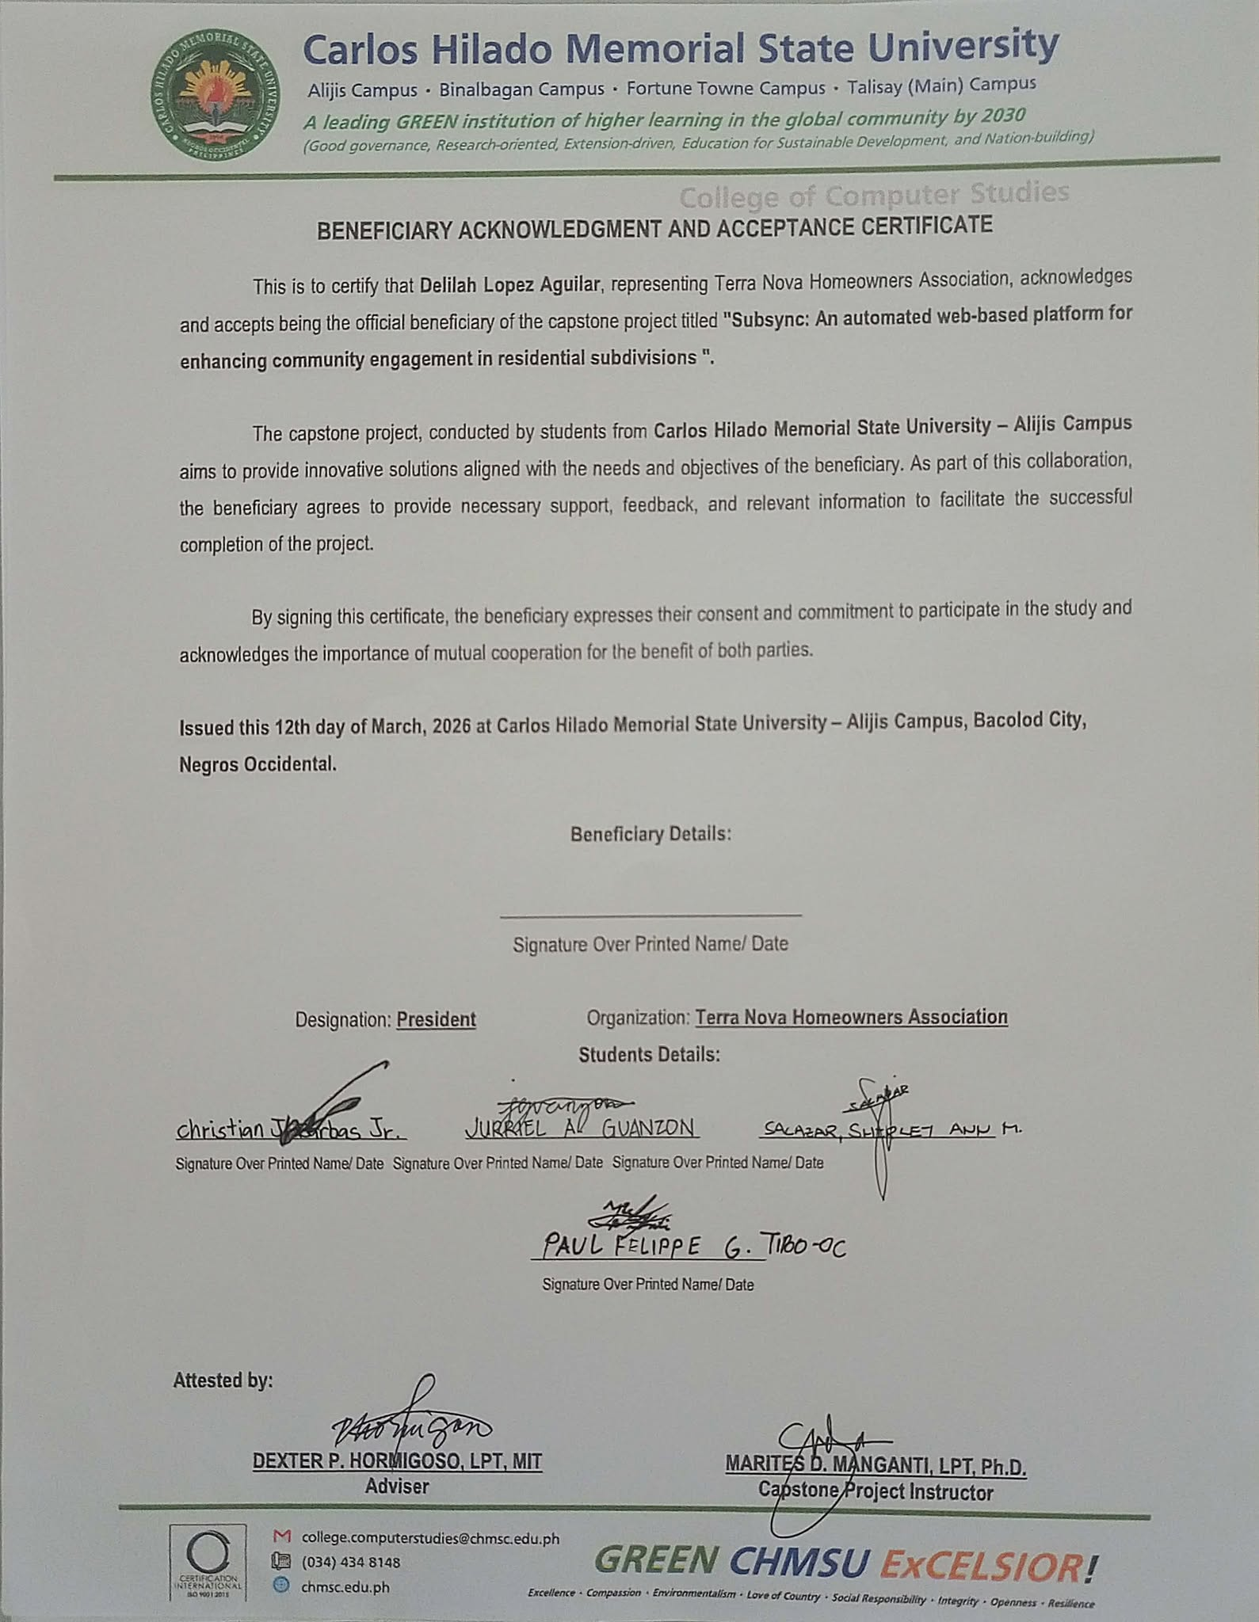

Evaluation Tools
RESEARCH INSTRUMENT
SubSync: An Automated Web-Based Platform for Enhancing Community Engagement in Residential Subdivisions
Type of Respondent :
☐ Subdivision Administrator ☐ HOA Officer ☐ Resident
☐ IT Expert / IT Professional
Direction: The following statements are designed to assess the software product quality of the SubSync System based on the ISO/IEC 25010:2011 Software Quality Standard. Kindly review each statement carefully and place a check (✔) in the box that corresponds to your answer using the rating scale below.

Rating scale:
Code | Interpretation | Description
5 | Excellent | 4.51 – 5.00. The system is complete and fully functional.
4 | Very Good | 3.51 – 4.50. The system is complete and functional.
3 | Good | 2.51 – 3.50 The system is somewhat complete and functional.
2 | Poor | 1.51 – 2.50. The system is incomplete and somewhat functional.
1 | Very Poor | 1.50 - below. The system is incomplete and non-functional.

A. Functional Suitability | 5 | 4 | 3 | 2 | 1
- Functional completeness. Degree to which the set of functions covers all the specified tasks and user objectives.
- Functional correctness. Degree to which a product or system provides the correct results with the needed degree of precision.
- Functional appropriateness. Degree to which the functions facilitate the accomplishment of specified tasks and objectives.
Total Score / Mean Score

B. Performance Efficiency | 5 | 4 | 3 | 2 | 1
- Time Behavior. The response and processing times and throughput rates of a product or system, when performing its functions meet requirements.
- Resource Utilization. The amount and types of resources used by the system, when performing its functions, meet requirements.
- Capacity. The maximum limits of a product or system parameter meet requirements.
Total Score / Mean Score

C. Usability | 5 | 4 | 3 | 2 | 1
- Appropriateness recognizability. Degree to which users can recognize whether a product or system is appropriate for their needs.
- Learnability. degree to which a product or system can be used by specified users to achieve specified goals of learning to use the product or system with effectiveness, efficiency, freedom from risk and satisfaction in a specified context of use.
- Operability. Degree to which a product or system has attributes that make it easy to operate and control.
- User error protection. Degree to which a system protects users against making errors.
- User interface aesthetics. Degree to which a user interface enables pleasing and satisfying interaction for the user.
- Accessibility. Degree to which a product or system can be used by people with the widest range of characteristics and capabilities to achieve a specified goal in a specified context of use.
Total Score / Mean Score

D. Compatibility | 5 | 4 | 3 | 2 | 1
- Co-existence. Degree to which a product can perform its required functions efficiently while sharing a common environment and resources with other products, without detrimental impact on any other product.
- Interoperability. Degree to which two or more systems, products or components can exchange information and use the information that has been exchanged.
Total Score / Mean Score

E. Reliability | 5 | 4 | 3 | 2 | 1
- Maturity. Degree to which a system, product or component meets needs for reliability under normal operation.
- Availability. Degree to which a system, product or component is operational and accessible when required for use.
- Fault tolerance. Degree to which a system, product or component operates as intended despite the presence of hardware or software fault
- Recoverability. Degree to which, in the event of an interruption or a failure, a product or system can recover the data directly affected and re-establish the desired state of the system.
Total Score / Mean Score

F. Security | 5 | 4 | 3 | 2 | 1
- Confidentiality. Degree to which a product or system ensures that data are accessible only to those authorized to have access.
- Integrity. Degree to which a system, product or component prevents unauthorized access to, or modification of, computer programs or data.
- Non-repudiation. degree to which actions or events can be proven to have taken place, so that the events or actions cannot be repudiated later.
- Accountability. Degree to which the actions of an entity can be traced uniquely to the entity.
- Authenticity. Degree to which the identity of a subject or resource can be proved to be the one claimed.
Total Score / Mean Score

G. Maintainability | 5 | 4 | 3 | 2 | 1
- Modularity. Degree to which a system or computer program is composed of discrete components such that a change to one component has minimal impact on other components.
- Reusability. Degree to which an asset can be used in more than one system, or in building other assets.
- Analysability. Degree of effectiveness and efficiency with which it is possible to assess the impact on a product or system of an intended change to one or more of its parts, or to diagnose a product for deficiencies or causes of failures, or to identify parts to be modified.
- Modifiability. Degree to which a product or system can be effectively and efficiently modified without introducing defects or degrading existing product quality.
- Testability. Degree of effectiveness and efficiency with which test criteria can be established for a system, product or component and tests can be performed to determine whether those criteria have been met.
Total Score / Mean Score

H. Portability | 5 | 4 | 3 | 2 | 1
- Adaptability. Degree to which a product or system can effectively and efficiently be adapted for different or evolving hardware, software or other operational or usage environments.
- Installability. Degree of effectiveness and efficiency with which a product or system can be successfully installed and/or uninstalled in a specified environment.
- Replaceability. Degree to which a product can replace another specified software product for the same purpose in the same environment.
Total Score / Mean Score
Overall Score and Mean Score

___________________________________________________
Signature

___________________________________________________
Date

TEST CASE EVALUATION INSTRUMENT FOR IT PROFESSIONALS

Evaluator Name (Optional): ________________________________
Age: ____________ Sex: ____________
Occupation: _____________________________________________
Device Used: ____________________________________________
Experience Level: ________________________________________
GENERAL INSTRUCTIONS: This test case evaluation checklist is designed to verify the functional correctness of the SubSync Platform. As an IT Professional, you are requested to execute the predefined test steps and verify if the system’s actual behavior matches the expected result. Please mark the status as “Pass” if the system functions correctly, or “Fail” if an error or unexpected behavior occurs. You may use the remarks column to note technical observations, bugs, or mapping/algorithmic inaccuracies.

I. Test Case Rating Scale and Interpretation
Percentage of Passed Test Case | Descriptive Rating | Interpretation
96% – 100% | Excellent | The system passed almost all test cases and functions correctly with minimal or no errors
90% – 95% | Very Good | The system passed most test cases with only minor issues detected.
85% – 89% | Good | The system functions properly but requires some improvements in certain features.
80% – 84% | Fair | The system meets basic functional requirements but several issues need correction.
Below 80% | Poor | The system failed significant test cases and requires major revisions and debugging.

II. Test Case Execution Checklist

Test Case ID | Test Scenario / Objective | Test Description | Preconditions | Test Steps | Expected Result | Status (Pass/Fail) | Remarks
TC-01 | User Authentication | Verify login using valid credentials | User account is registered | 1. Enter valid username and password 2. Click Login | User is successfully authenticated and redirected to dashboard
TC-02 | Payment Tracking | Verify resident can view financial records | Resident account is logged in | 1. Navigate to Payment Dashboard 2. View balances and payment history | System denies access and displays error message
TC-03 | Payment Tracking | Verify behavior when payment data is missing | Resident account is logged in | 1. Open payment history without records | System displays updated payment records correctly
TC-04 | Announcement Module | Verify admin can post announcements | Admin account is logged in | 1. Navigate to Announcement Module 2. Create announcement 3. Click Post | System displays “No Records Found” message properly
TC-05 | Issue Reporting | Verify residents can submit issue reports | Resident account is logged in | 1. Navigate to Issue Reporting 2. Enter issue details 3. Submit report | Announcement is successfully published and visible to residents
TC-06 | Issue Monitoring | Verify officers/admin can respond to reports | Officer/Admin account is logged in | 1. Open submitted issue 2. Add response/update | System saves report and notifies admin/officer
TC-07 | Recommendation Module | Verify residents can submit recommendations | Resident account is logged in | 1. Navigate to Recommendation Page 2. Enter suggestion 3. Submit | System updates issue status successfully
TC-08 | Mapping Feature | Verify facility map loads correctly | User is logged in with internet access | 1. Open Community Map 2. View facilities and issue markers | Recommendation is stored successfully in database
TC-09 | Mapping Feature | Verify invalid location handling | User is logged in | 1. Submit invalid map coordinates | Map displays valid subdivision locations and markers
TC-10 | Messaging Module | Verify direct messaging between resident and officer | Both accounts are active | 1. Submit invalid map coordinates | System displays location error message correctly
TC-11 | Media Upload | Verify image/file upload functionality | User account is logged in | 1. Open messaging page 2. Send message | Recipient receives message successfully
TC-12 | Media Upload | Verify image/file upload functionality | User account is logged in | 1. Upload image attachment 2. Submit | Media file uploads successfully and is stored properly
TC-13 | Dashboard Analytics | Verify admin dashboard generates report | Admin account is logged in | 1. Open dashboard analytics 2. Generate report | System displays accurate financial and issue reports
TC-14 | Cross-Platform Compatibility | Verify system accessibility on mobile and desktop | Device/browser available | 1. Open system on different devices and browsers | System functions correctly across platforms
TC-15 | System Performance | Verify response speed during multiple operations | Multiple users logged in | 1. Perform simultaneous actions within system | System remains stable and responsive

Signature over Printed Name of IT Professional Evaluator: ____________________
Date: _____________________



