TaskBridge
Integrated Project Blueprint, Legal Terms Pack, Commercial Model, Deployment Roadmap, and Future Growth Plan
Prepared for founder, agency, partner, pilot, and solicitor review | June 2026
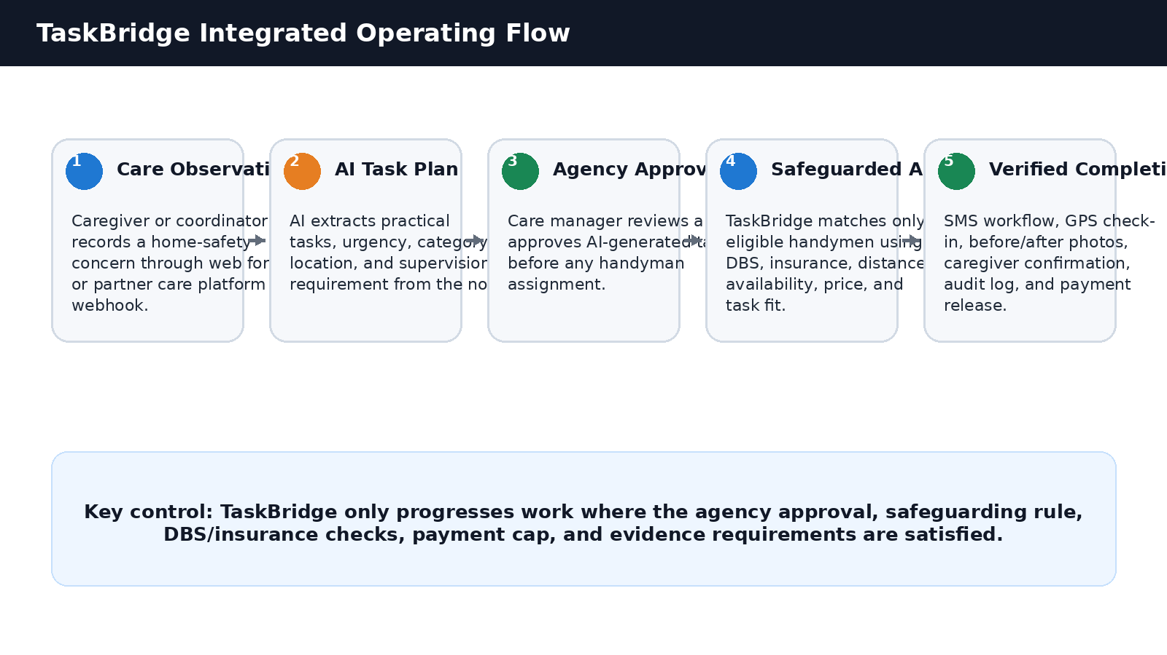

1. Executive Summary
TaskBridge is a safeguarding-first B2B middleware and operations platform for homecare agencies. It converts caregiver observations into controlled practical home-safety tasks that are outside normal personal-care duties, such as lawn mowing, window cleaning, light-bulb replacement, minor trip-hazard removal, lock repair, garden path clearance, and low-risk safety work.
The platform protects vulnerable service users by combining care-manager approval, AI-assisted task planning, DBS-aware assignment, identity and insurance checks, geolocation evidence, photo evidence, completion confirmation, audit logs, and phased payment controls.
The updated strategy deliberately starts with existing care-agency invoicing and partner/local handyman sources, then matures into inbuilt payments and an independent TaskBridge handyman network after customer base, data quality, contractor standards, and compliance evidence have been proven.

2. Business Problem and Market Need
Homecare agencies are focused on personal care and support. Their caregivers are generally not contracted, trained, insured, or permitted to complete property maintenance. This leaves a recurring operational gap: home-safety risks are seen by care staff but often remain unresolved because the agency lacks a secure way to organise practical works.
- Caregivers may notice overgrown paths, dirty windows, poor lighting, loose rails, slippery access routes, clutter, broken locks, or minor household safety issues.
- These hazards can increase falls, isolation, distress, poor visibility, unsafe access, and family concern.
- Care managers cannot simply search public marketplaces and send unverified strangers into the homes of vulnerable adults.
- Families and guardians often live far away and need a governed way to approve, pay for, and evidence the completion of practical works.
- Care agencies need a workflow that keeps caregivers within their job role while still helping service users maintain safer homes.

3. Product Positioning
TaskBridge should be positioned as a safeguarding infrastructure layer for care agencies, not as a general handyman marketplace. The language used on the landing page, demo page, contracts, and sales material should avoid overclaiming and should focus on controlled task management, DBS-aware assignment, evidence, and auditability.
Do Say | Avoid Saying
“DBS-aware practical task assignment for vulnerable-adult home safety.” | “We guarantee safe handymen.”
“Care manager approval is required before AI-generated tasks are assigned.” | “AI automatically books jobs from care notes.”
“Enhanced DBS is required for unsupervised vulnerable-adult visits unless a documented exception applies.” | “Anyone with DBS can visit vulnerable adults.”
“Caregiver confirmation is a visible completion and safety check, not technical certification.” | “Caregivers approve workmanship.”

4. User Groups and Access Model
User Group | Role | Access / Restriction
Care Manager / Coordinator | Create or approve tasks, view agency jobs, monitor visit status, confirm completion, see assigned handyman and planned time. | Cannot see internal scoring, rejected handymen, admin-only risk controls, or other agencies.
Caregiver | Raises note or confirms visible completion when present or at next scheduled visit. | No handyman selection power unless explicitly permitted by agency policy.
TaskBridge Admin | Manages tasks, agencies, handymen, exceptions, payments, caps, complaints, and audit trails. | Admin privileges based on role.
Super Admin | Full oversight, compliance configuration, user privileges, policy settings, financial caps, and incident review. | Highest privilege; actions audited.
Handyman / Trader | Receives task by SMS link, checks in, uploads photos, completes job report. | No unrestricted dashboard access to resident data.
Service User / Guardian / Family | Pays through agency invoice at Phase 1; may receive transparent task/payment information where agency permits. | No direct platform account required initially.

5. End-to-End Operating Workflow

- Caregiver or coordinator identifies a home-safety issue during care delivery.
- Issue is submitted through TaskBridge web form or received from a care management system webhook/API integration.
- AI generates one or more proposed practical tasks, category, urgency, supervision need, and notes for review.
- Care manager/coordinator reviews and approves the AI-generated task before assignment.
- TaskBridge checks agency payment cap and compliance status before releasing the job for assignment.
- Assignment engine selects eligible handyman using task type, availability, proximity, DBS status, insurance status, price, quality score, and supervision rule.
- Handyman receives secure SMS task link with limited resident information and visit instructions.
- At the property, handyman completes GPS check-in and uploads before photo.
- Handyman completes work, uploads after photo, and checks out.
- Completion is confirmed by caregiver on site, care coordinator, or next-visit caregiver confirmation.
- TaskBridge updates the agency portal, audit log, and invoice/payment records.
- Payment is processed according to the Phase 1 agency-invoice model, later evolving to inbuilt payment.

6. AI Task Generation and Approval Rules
AI is used to reduce coordinator workload, not to replace human responsibility. Any AI-generated task must remain in pending approval until a care manager or coordinator confirms that it is appropriate, non-emergency, within scope, and safe to assign.
AI Output | Required Control
Task summary | Must be editable by care manager before approval.
Task category | Must map to approved service category and exclusions list.
Urgency | Must be reviewed where urgent, safety-critical, or escalation-related.
Supervision status | Must record whether caregiver will be present throughout visit.
Resident vulnerability flag | Must trigger DBS/safeguarding assignment rules.
Qualified-trade warning | Must block or escalate tasks outside handyman scope.

7. Safeguarding and DBS Decision Model
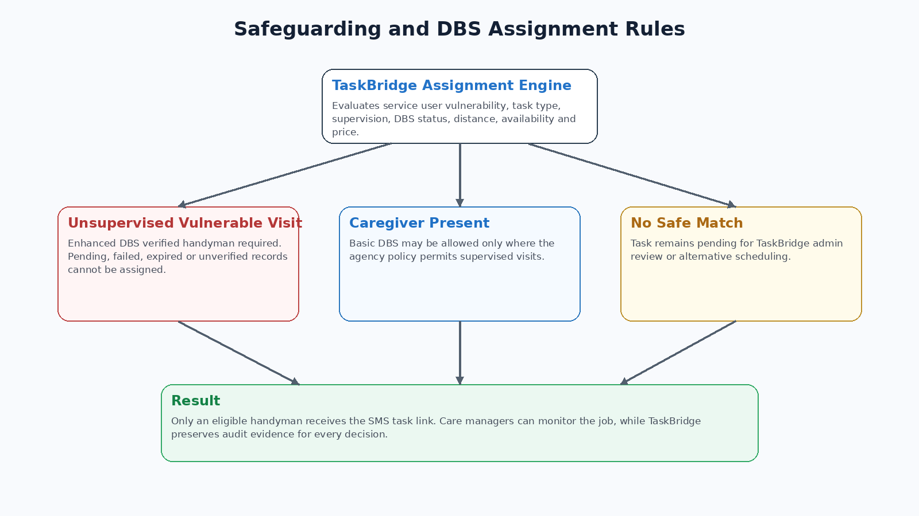
Scenario | Minimum Assignment Rule | Action
Vulnerable adult; unsupervised visit | Enhanced DBS approved, identity verified, insurance valid, and task category approved. | Auto-assign only if all controls pass.
Vulnerable adult; caregiver present throughout visit | Basic DBS may be allowed only if agency safeguarding policy permits and supervision is documented. | Assign with supervised-visit flag and caregiver confirmation requirement.
DBS pending, failed, expired, or unclear | Do not assign to vulnerable-adult task. | Hold for admin review.
High-risk or qualified task | Relevant trade qualification/insurance required or task excluded. | Escalate or reject.
Safeguarding concern beyond maintenance | Do not treat as normal job. | Escalate to agency safeguarding route.

DBS is a safeguard but not a guarantee of safety. The platform must describe handymen as “verified and approved under TaskBridge policy,” not as guaranteed safe. DBS status should be combined with identity checks, insurance, task suitability, quality history, and ongoing incident monitoring.

8. Handyman Supply Strategy and Independence Roadmap
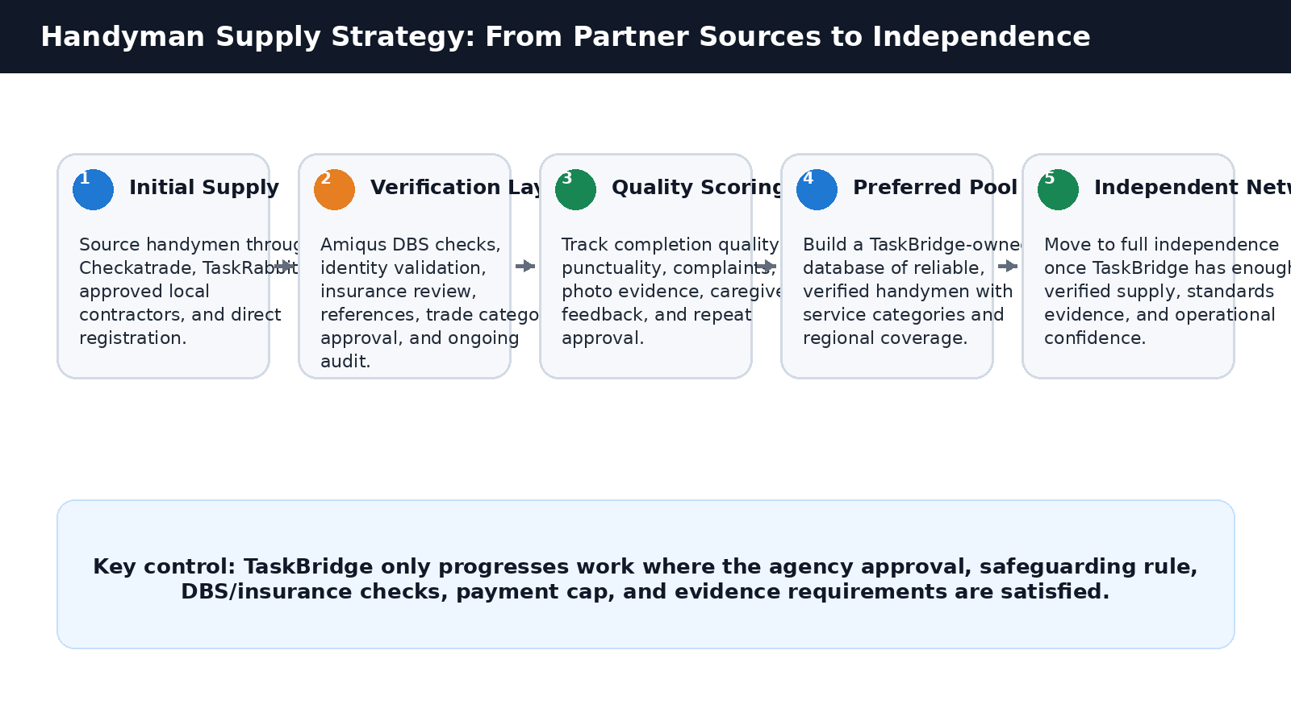
At launch, TaskBridge may source handymen from Checkatrade, TaskRabbit, approved local contractors, and direct local registrations. However, the long-term strategy is to build an independent TaskBridge-owned database of verified handymen after the business has enough evidence on quality, reliability, safeguarding behaviour, complaint rate, pricing, and regional demand.
Stage | Supply Approach | Control Requirement | Exit Criteria
Stage 1 - Partner and local sourcing | Use Checkatrade, TaskRabbit, local contractors, and direct registration. | Manual admin review, DBS/insurance checks, task limits, clear terms. | First pilot jobs completed with low dispute rate.
Stage 2 - Verified TaskBridge pool | Store profiles, DBS status, services, location, rates, insurance, and evidence history. | Quality scoring, complaints register, expiry monitoring. | Reliable pool by region/category.
Stage 3 - Preferred network | Prioritise consistently reliable handymen. | Performance thresholds, refresher checks, annual review. | Enough supply to reduce dependence on marketplaces.
Stage 4 - Independent network | TaskBridge operates its own vetted handyman pool. | Full onboarding terms, insurance, payout rules, standards manual. | Marketplace APIs become optional supply extension only.

9. Payment and Commercial Model
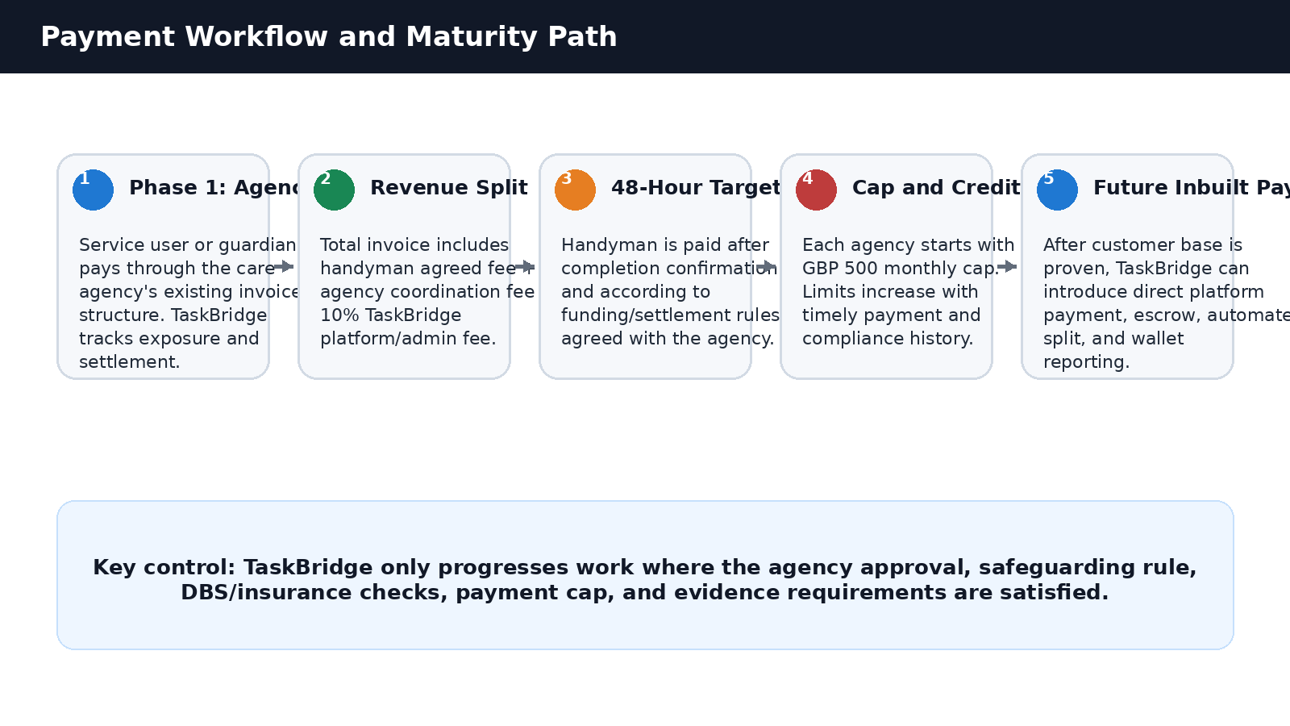

9.1 Phase 1 Payment Model: Existing Agency Invoice Structure
At launch, payment should use the care agency’s existing invoicing structure. The service user, guardian, family member, or funding representative pays the care agency in the same way they already pay for care or related services. This reduces adoption friction and avoids forcing families onto a new payment system before TaskBridge has customer base and trust.
TaskBridge should still record invoiceable task value, agency cap usage, payment due dates, settlement status, and payout eligibility. The system should make clear that it is tracking exposure and settlement even where money initially flows through the care agency.

9.2 Recommended Transparent Pricing Formula
Component | Example on GBP 100 Handyman Fee | Recipient
Agreed handyman task fee | GBP 100.00 | Handyman
Agency coordination fee at 5% | GBP 5.00 | Care agency
TaskBridge platform/admin fee at 10% | GBP 10.00 | TaskBridge
Total invoiced through care agency | GBP 115.00 | Paid by service user/guardian/family via agency invoice

The handyman should receive the agreed fee and should not have the agency fee or TaskBridge fee deducted from that agreed amount. The service user/guardian invoice should transparently show, subject to agency policy and legal review, the task fee, agency coordination fee, and TaskBridge platform/admin fee.

9.3 Handyman Payout Rule
The target is to pay the handyman approximately 48 hours after completion has been confirmed by all required parties. For Phase 1, the contract must clarify whether payout depends on agency-funded settlement, an agency deposit, or TaskBridge-funded advance. To reduce credit risk, the recommended pilot model is either:
- Agency-funded settlement: handyman payout is released when the care agency has paid TaskBridge or funded the task account; or
- Controlled float/deposit model: agency maintains a rolling deposit or prepaid balance from which confirmed task payouts are released; or
- TaskBridge-funded advance only for trusted agencies within agreed cap, after credit history is established.

9.4 Agency Monthly Cap and Credit Score
Each agency starts with a GBP 500 monthly cap. The cap controls the total monthly gross task value or invoiceable exposure that can be released through TaskBridge. The cap can increase over time where the agency demonstrates timely payment, low dispute rate, compliance with approval workflow, and good audit behaviour.
Cap Tier | Indicative Limit | Criteria
Starter | GBP 500/month | New agency, pilot period, manual review required.
Reliable | GBP 1,000/month | On-time payment history and no unresolved disputes.
Established | GBP 2,500/month | Consistent monthly use, good compliance, low incident rate.
Approved Partner | GBP 5,000+/month | Formal contract, payment automation or deposit, strong credit and governance record.

9.5 Future Inbuilt Payment Model
After TaskBridge has built a customer base and has enough transaction volume to justify payment infrastructure, the platform should move toward inbuilt payments. This may include card payments, bank transfer reconciliation, wallet balance, escrow-like holding accounts, automated split payment, invoice export, and payout dashboards. The migration should be staged and should not be built before the pilot validates demand, pricing, and payment behaviour.
Payment Phase | Description | Trigger to Move Forward
Phase 1 - Agency invoice | Use existing care agency billing and TaskBridge settlement tracking. | Pilot launches with minimal friction.
Phase 2 - Assisted settlement | Agency funds TaskBridge by invoice, prepaid balance, or direct debit; TaskBridge manages payout. | Repeat transactions and need for faster reconciliation.
Phase 3 - Inbuilt payment | TaskBridge supports direct payment collection, split fees, wallet, payout automation, and reporting. | Customer base, compliance review, payment provider approval, and finance controls are in place.

10. Recommended Deployment Phases
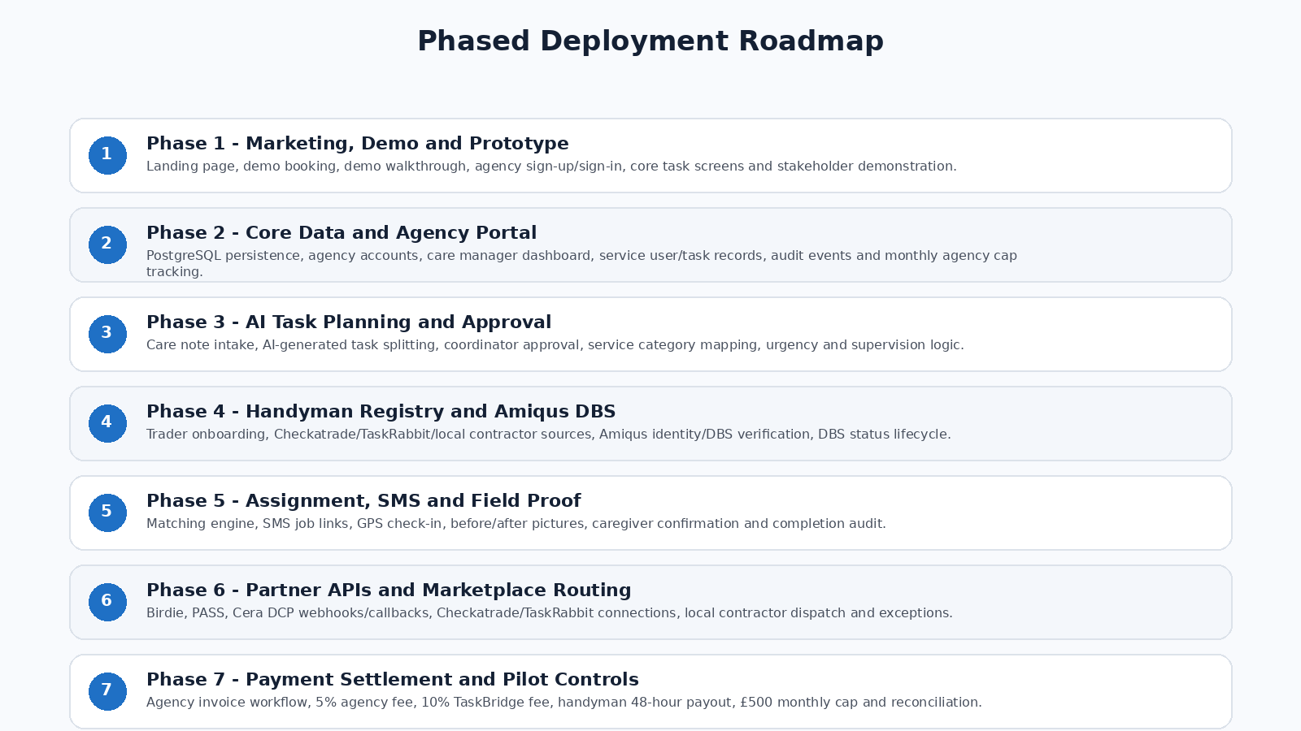
Phase | Focus | Deliverables | Reason
1 | Landing page, demo page, book demo | Marketing site, video demo, step-by-step pictorial demo, agency interest capture. | Validate messaging and generate pilot conversations.
2 | Manual concierge pilot | Manual task review, manual handyman assignment, manual completion checks, basic payment tracking. | Proves need before overbuilding automation.
3 | Agency portal | Agency login, task creation, AI suggestions, approval, status tracking, confirmation, invoice export. | Core B2B workflow.
4 | Admin and super-admin backend | Agency caps, handyman profiles, DBS/insurance status, tasks, exceptions, audit logs, payments. | Operational control and compliance.
5 | Amiqus DBS automation | Verification session, webhook, status update, expiry tracking, audit trail. | Reduces manual compliance work.
6 | SMS visit workflow | Tokenized SMS, GPS check-in, before/after photos, checkout, evidence pack. | Supports field control and proof.
7 | Care-platform integrations | Birdie, Cera DCP, PASS and other webhook/API routes. | Only after portal workflow is proven.
8 | Payment maturity | Assisted settlement, deposits, automated splits, future inbuilt payment. | Reduces credit risk and improves scale.
9 | Independent handyman network | Preferred pool, regional coverage, quality scoring, direct onboarding. | Reduces marketplace dependency.
10 | Scale and reporting | Multi-agency, multi-region, SLA reports, family visibility, dashboards, API marketplace. | Growth and enterprise readiness.

11. Platform Modules Required
Module | Required Features
Public website | Landing page, book demo, demo video, use-case explanation, safeguarding message, sign-in links.
Demo page | Step-by-step walkthrough: note, AI task, approval, assignment, SMS, GPS, photos, completion, payment.
Agency portal | Task creation, AI task approval, service user references, assigned handyman, visit time, status, evidence, invoice/export.
Admin portal | Agency onboarding, caps, task control, handyman vetting, DBS/insurance, payments, complaints, audit logs.
Super-admin portal | User privileges, policy configuration, cap overrides, incident review, compliance reports.
AI task planner | Task extraction, category, urgency, risk flag, qualified-trade warning, approval queue.
Assignment engine | Task type, availability, proximity, DBS, supervision, insurance, quality score, price, cap status.
Handyman workflow | SMS link, mobile web page, GPS check-in, before/after photos, notes, checkout.
Payment ledger | Invoiceable amount, agency fee, TaskBridge fee, handyman fee, cap, settlement, payout, disputes.
Audit and compliance | Immutable event history, access logs, DBS history, photo evidence, incident record, DPA support.

12. Recommended Legal and Policy Pack
The following templates are included as business-drafting terms. They should be reviewed and adapted by a UK solicitor before launch. They are designed to reduce common legal concerns around vulnerable adults, contractor access, DBS reliance, payment flow, liability, dispute handling, and data processing.
Document / Policy | Purpose
Agency Master Services Agreement | Contract between TaskBridge and the care agency.
Agency Acceptable Use and Approval Policy | Defines how agency staff create, approve, confirm, and dispute tasks.
Handyman / Contractor Terms | Defines independent contractor obligations, DBS/insurance, visit rules, payout, evidence, conduct.
Service User / Guardian Payment Notice | Explains payment through agency invoice and fee structure.
Safeguarding and DBS Assignment Policy | Controls unsupervised/supervised visits and DBS requirements.
Task Scope and Exclusions Policy | Defines allowed, restricted, and prohibited task categories.
Payment, Cap, Credit and Payout Policy | Defines GBP 500 cap, fee split, payout timing, credit score, disputes.
Privacy Notice and Data Processing Addendum | Defines personal data roles, minimum data, security, retention, and data-subject rights.
Incident, Complaint, Refund and Dispute Policy | Defines operational response when something goes wrong.
Insurance and Qualification Policy | Requires handyman insurance and trade-specific qualifications where needed.

PART B - Draft Legal and Commercial Terms Pack
These clauses are draft business terms for solicitor review. They should not be used as final legal documents without professional legal advice, insurance advice, and regulatory review.

13. Agency Master Services Agreement - Draft Heads of Terms

13.1 Parties and Purpose
TaskBridge provides a technology-enabled task coordination, safeguarding, compliance, and evidence workflow that helps the Agency arrange practical home-safety works for service users. The Agency remains responsible for its own care services, service-user relationship, care records, consent processes, and agency invoicing where Phase 1 payment applies.

13.2 Agency Responsibilities
- Ensure that only authorised staff create, approve, or confirm TaskBridge tasks.
- Obtain any service-user, guardian, family, funding-body, landlord, or property-owner consent needed for the work.
- Confirm whether a caregiver will be present throughout the visit where supervision is used as part of the safeguarding decision.
- Review and approve any AI-generated task before assignment.
- Ensure the task is appropriate, non-emergency, within permitted scope, and not a personal-care task.
- Pay TaskBridge amounts due under the agreed invoice, cap, deposit, or settlement model.
- Notify TaskBridge immediately of complaints, safeguarding concerns, property damage, service-user risk, or payment disputes.

13.3 TaskBridge Responsibilities
- Maintain the TaskBridge platform, agency portal, admin portal, task workflow, and audit records.
- Apply the safeguarding, DBS, insurance, assignment, and payment cap rules configured for the agency.
- Maintain records of handyman identity, DBS status, insurance status, task categories, evidence, and approval status where available.
- Provide reasonable support for task exceptions, failed visits, disputes, and audit requests.
- Use reasonable skill and care in operating the platform, while not guaranteeing that all tasks will be accepted, completed, or free of defect.

13.4 No Emergency Service
TaskBridge is not an emergency response service, clinical care service, regulated care provider, locksmith emergency service, gas emergency service, or emergency repairs provider. Urgent welfare, medical, safeguarding, gas, electrical, police, fire, or property emergency issues must be escalated through the agency’s existing emergency and safeguarding procedures.

13.5 Liability Allocation
The agreement should specify caps and exclusions of liability subject to applicable law. TaskBridge should not accept unlimited liability for handyman workmanship, agency approval decisions, family payment defaults, or events outside its reasonable control. Liability should not be excluded for fraud, deliberate wrongdoing, or any liability that cannot lawfully be excluded.

13.6 Insurance
The Agency should maintain care-provider insurance appropriate to its role. TaskBridge should maintain technology/professional liability and public liability cover appropriate to its operations. Handymen should maintain public liability and, where needed, trade-specific insurance. Insurance certificates and expiry dates should be recorded in the platform where practical.

14. Agency Acceptable Use and Approval Policy
- Agency users must not use TaskBridge to request personal care, clinical care, medication support, financial errands, or tasks that should be handled by a regulated professional unless the platform specifically supports that trade category.
- Agency users must not enter unnecessary sensitive personal data into task notes. Only minimum necessary information should be shared.
- AI-generated tasks must be reviewed and approved before assignment.
- Agency users must mark whether the visit is supervised or unsupervised and must not misstate caregiver presence to bypass DBS rules.
- Agency users must report dissatisfaction, safety concerns, or failed completion within the agreed dispute window.
- Repeated misuse, late payment, misleading approvals, or breach of safeguarding policy may lead to suspension or lower monthly cap.

15. Handyman / Contractor Terms - Draft Core Clauses

15.1 Independent Contractor Status
The handyman acts as an independent contractor and is not an employee, worker, agent, or representative of TaskBridge or the care agency unless a separate written contract says otherwise. The handyman is responsible for taxes, tools, transport, workmanship, conduct, and legal compliance relating to their business.

15.2 Verification and Eligibility
- The handyman must provide accurate identity, contact, service-category, location, rate, insurance, and qualification information.
- The handyman must complete DBS and identity verification where required and must consent to TaskBridge recording verification status.
- Enhanced DBS approval is required for unsupervised vulnerable-adult visits unless TaskBridge policy and agency policy define a documented exception.
- Basic DBS may only be considered for supervised visits where caregiver presence is recorded and the agency policy permits it.
- The handyman must notify TaskBridge of any change affecting suitability, DBS status, insurance, criminal record, safeguarding risk, or ability to complete tasks.

15.3 Visit Conduct
- Attend only at the agreed time and location.
- Use the secure SMS link and complete GPS check-in before starting work.
- Do not ask the service user for direct cash, extra payment, personal details, gifts, or unrelated work.
- Do not enter areas unrelated to the task unless needed for safe completion and permitted by the caregiver or agency instruction.
- Do not provide personal care, medical support, financial advice, medication support, transport, or other prohibited services.
- Upload before-and-after photos and completion notes as required.
- Report any safeguarding, welfare, damage, or access issue immediately through TaskBridge.

15.4 Payment to Handyman
The handyman is entitled to the agreed task fee for properly completed and confirmed work. The target payout is approximately 48 hours after completion confirmation, subject to the applicable settlement model, dispute holds, agency funding, fraud checks, and platform terms. TaskBridge may withhold or delay payment where work is disputed, evidence is missing, task scope was breached, safeguarding rules were violated, or fraud is suspected.

15.5 Quality and Rework
The handyman must complete work with reasonable skill and care and within the agreed scope. If work is incomplete, unsafe, materially defective, or not evidenced, TaskBridge may require rework, partial payment, refund, dispute review, or removal from the approved pool depending on the circumstances.

16. Service User / Guardian Payment Notice
TaskBridge-supported practical tasks are arranged through the care agency to help resolve home-safety or household-maintenance concerns that sit outside normal personal-care duties. During the initial phase, payment is made through the care agency’s existing invoice structure. The total task charge may include the handyman’s agreed task fee, the agency’s coordination fee, and the TaskBridge platform/admin fee.
- The handyman does not receive direct payment from the service user at the property.
- The service user or guardian should not pay cash or make direct side payments to the handyman.
- Before work is released, the agency should confirm any required consent and approval.
- Completion is evidenced through visit records, GPS check-in, before/after photos, and caregiver or agency confirmation.
- Any complaint, concern, or dispute should be raised with the care agency or TaskBridge through the agreed process.

17. Safeguarding and DBS Assignment Policy
The purpose of this policy is to reduce the risk of unsuitable persons attending the homes of vulnerable service users. It does not eliminate risk and should be combined with agency safeguarding procedures, DBS verification, insurance, audit logs, training, and incident reporting.
Rule | Policy Position
Unsupervised vulnerable-adult visit | Enhanced DBS approved handyman required.
Supervised visit with caregiver present throughout | Basic DBS may be considered only where agency policy permits and supervision is recorded.
DBS pending, expired, failed, unclear, or not received | Do not assign to vulnerable-adult task.
Barred list match or serious safeguarding concern | Block handyman and escalate.
Caregiver presence used as safety control | Must be true, documented, and confirmed by agency.
DBS review frequency | Expiry date, Update Service check, or periodic re-verification should be recorded.
Handyman conduct concern | Suspend pending review.

18. Task Scope and Exclusions Policy
Allowed Low-Risk Examples | Restricted / Qualified | Prohibited Unless Separately Approved
Lawn mowing, path clearing, low-level window cleaning, bulb replacement, decluttering for access, minor trip-hazard reduction, key-safe fitting where policy allows. | Electrical repair, gas work, plumbing, locksmith work, ladder work, structural repair, appliance repair, hoarding clearance, pest control, specialist cleaning. | Personal care, medication, moving/handling service user, financial errands, safeguarding investigation, emergency response, clinical tasks, transport, handling valuables, cash collection.

Each task category should have a checklist: scope, excluded activities, photo evidence required, maximum price band, whether a qualified trade is required, whether supervision is required, and whether family/property-owner consent is needed.

19. Payment, Cap, Credit and Payout Policy
- Phase 1 uses the agency’s existing invoice structure; service user/guardian/family pays the care agency.
- The platform records agreed handyman fee, 5% agency coordination fee, 10% TaskBridge platform/admin fee, invoice total, settlement status, and payout eligibility.
- Initial monthly agency cap is GBP 500 unless otherwise agreed in writing.
- Agency cap may increase based on payment history, compliance, dispute rate, task volume, and admin approval.
- TaskBridge may pause new assignments where cap is exceeded, payment is overdue, dispute rate is high, or compliance concerns exist.
- Handyman payout target is approximately 48 hours after completion confirmation, subject to funding/settlement rules and dispute holds.
- Future inbuilt payments may include direct payment collection, automated fee split, prepaid balances, direct debit, escrow-like processes, and payout automation after customer base has been proven.

20. Privacy Notice and Data Processing Addendum - Draft Heads
TaskBridge will process limited personal data relating to agencies, care users, service users, handymen, task locations, visit evidence, photos, GPS check-in, audit logs, and payment records. Data should be minimised and encrypted where appropriate. The parties should confirm whether TaskBridge acts as processor, controller, or independent controller for each processing activity.
Data Category | Control
Service user identity and address | Minimum necessary sharing; encryption at rest; restricted access.
Care notes / task notes | Avoid unnecessary clinical/sensitive data; AI processing controls.
Handyman DBS/identity/insurance | Restricted admin access; expiry tracking; do not expose full documents unnecessarily.
GPS and photos | Used for proof of visit/completion; retention policy required.
Audit logs | Admin-only access; tamper-resistant storage where possible.
Webhook/API events | Signature verification, idempotency, logging, and least-privilege credentials.

- Prepare a Data Processing Agreement with care agencies.
- Conduct a Data Protection Impact Assessment before processing vulnerable-adult task data at scale.
- Publish a privacy notice for agencies, handymen, and where needed service users/guardians.
- Use role-based access controls, encryption, audit logging, deletion/retention schedules, and data-subject request procedures.

21. Incident, Complaint, Refund and Dispute Policy - Draft
Event | Immediate Action | Possible Outcome
No access / failed visit | Record reason, notify agency, reschedule or cancel. | No charge, partial charge, or admin review.
Poor workmanship | Hold payout, request photos, ask caregiver/agency for evidence. | Rework, partial payment, refund, removal from pool.
Property damage | Escalate to admin, record evidence, notify insurer if needed. | Insurance claim, compensation, contractor suspension.
Safeguarding concern | Immediate escalation to agency safeguarding lead and TaskBridge senior admin. | Suspend handyman, incident report, external reporting where required.
Payment dispute | Freeze disputed amount, collect evidence, apply dispute window. | Release, refund, credit note, or legal recovery.
Data breach | Follow breach response plan, assess reporting duty. | Notify ICO/data subjects where legally required.

22. Insurance, Verification and Responsibility Policy - Draft
TaskBridge should use a layered responsibility model: each handyman is responsible and insured for their work; each care agency is insured for its care relationship, staff activity, coordination and invoicing role; TaskBridge maintains cover for platform, data, matching, administrative and professional-service risks. This prevents TaskBridge from relying solely on third-party marketplace checks while still recognising that platform-level risk remains.

22.1 Handyman / Taskman Insurance and Verification
- No handyman/taskman may receive a TaskBridge assignment unless their public liability insurance has been uploaded, reviewed and approved.
- Insurance expiry dates must be stored and monitored. Expired insurance automatically suspends the handyman from new assignments.
- DBS status, identity verification, relevant trade qualifications, service categories, location, availability and pricing must be stored on the profile.
- Enhanced DBS is required for unsupervised vulnerable-adult visits. Basic DBS may only be considered for supervised visits where the care agency confirms caregiver presence and policy allows it.
- The handyman remains responsible for safe conduct, workmanship, tools, travel, taxes, trade standards, and reporting any incident or safeguarding concern.

22.2 Care Agency Insurance Requirement
- Every care agency must confirm that it holds appropriate insurance before going live on TaskBridge.
- Required agency cover may include public liability, professional indemnity, employer's liability, care-sector business insurance, and any cover required by commissioners, regulators or contracts.
- TaskBridge may request certificates, policy numbers, renewal dates and minimum cover evidence during onboarding and periodic review.
- If an agency insurance record expires or becomes unsuitable, TaskBridge may suspend new task approvals until updated evidence is provided.

22.3 TaskBridge Platform-Level Cover
- TaskBridge should maintain platform-level cover for its own role, including professional indemnity or technology errors cover, cyber/data protection cover, directors' and officers' cover, and public liability where appropriate.
- This cover is not intended to replace handyman insurance or agency insurance. It is designed for risks connected with TaskBridge's platform, matching workflow, verification records, admin decisions, data handling and audit process.
- The business should seek broker and solicitor advice before launch to confirm the correct insurance mix and policy wording.

22.4 No Verified Cover, No Assignment
TaskBridge applies a strict No Verified Cover, No Assignment rule. A handyman cannot receive work without valid insurance and required verification. A care agency cannot continue approving new work if its required insurance or commercial compliance records are not maintained. This protects the vulnerable service user, the agency, the handyman and TaskBridge.

22.5 Qualification and Exclusion Controls
- Specific task categories may require trade qualifications or specialist insurance before assignment.
- TaskBridge should avoid assigning gas work, regulated electrical work, high-risk structural work, high ladder work or emergency repairs unless an approved specialist contractor category exists.
- The platform should maintain allowed, restricted and prohibited task lists and apply them before assignment.

23. Future Growth Plan
TaskBridge should grow in stages to control legal and operational risk while increasing value to agencies.
Growth Area | Future Development
Regional pilots | Start in selected regions to control handyman quality and response times.
Family visibility | Offer optional family/guardian notifications, approvals, and evidence views.
Inbuilt payment | Move from agency invoice to payment collection, split payments, wallets, and payout automation.
Independent handyman pool | Reduce reliance on third-party marketplaces as TaskBridge verifies its own network.
Reporting and outcomes | Show fall-risk reduction, task resolution time, completion rate, agency savings, and audit evidence.
Care-platform marketplace | Offer standard integrations and partner API documentation for care platforms.
Council and housing links | Support local authority, housing association, and integrated care partnerships.
Advanced AI | Risk triage, recurring hazard detection, suggested task bundles, price estimates, and exception prediction.

24. Critical Launch Checklist
Area | Minimum Before Pilot
Legal | Solicitor-reviewed agency agreement, handyman terms, payment terms, privacy notice, DPA, dispute policy.
Safeguarding | DBS policy, supervision rule, incident escalation, barred tasks, admin review process.
Insurance | TaskBridge insurance, handyman insurance capture, agency insurance confirmation.
Product | Landing page, demo page, task web form, agency approval, admin dashboard, evidence upload.
Operations | Pilot playbook, contractor onboarding, quality standards, complaints process.
Payments | Agency cap, invoice tracking, fee split, payout rule, overdue process.
Data | DPIA, security controls, retention policy, audit logs, access roles.
Sales | Pilot agency criteria, demo script, pricing example, customer onboarding pack.

25. Final Recommended Position
TaskBridge should launch as a managed safeguarding operations platform supported by software, not as a fully automated marketplace. The first objective is to prove that agencies will approve tasks, families will pay through existing agency invoices, handymen can complete safely with evidence, and the monthly cap protects financial exposure. After pilot evidence is strong, the company can expand toward inbuilt payment and an independent verified handyman network.
The strongest commercial moat is not simply AI or booking automation. It is the combined operating model: care-note intake, care-manager approval, DBS-aware assignment, insurance and quality checks, GPS/photo proof, caregiver confirmation, agency invoicing, audit evidence, and progressive credit/payment controls.

