How much sun does Golden actually get?
Sunrise tables assume you are standing on flat ground. We are standing in a valley. Here is what that costs us, and what it means for the clock.
Prepared 4 September 2026. Method and code published, see the end.
Golden is changing to permanent Mountain Standard Time on 1 November. The Regional District of East Kootenay is going the other way, to permanent Mountain Daylight Time. Most of the argument on both sides has used sunrise and sunset times from an almanac. Those times are wrong for Golden, and they are wrong by a lot.
An almanac calculates when the sun crosses a flat horizon, the kind you get at sea or on the prairie. Golden sits at 788 metres on the floor of the Columbia Valley with the Purcells on one side and the Rockies on the other. The sun rises well before it reaches us, and it leaves us well before it sets. Nobody had measured that gap, so we measured it.
Two things came out of it. In winter the difference between the clocks lands on the morning, and it favours the clock Golden has chosen. In summer it lands on the evening, and it favours the other one. Both are in here, at the same size, because leaving either out would be misleading.

What a real Golden winter day looks like
This is 21 December 2026, the shortest day, shown twice: once on the clock we are moving to, and once on the clock the regional district is moving to.
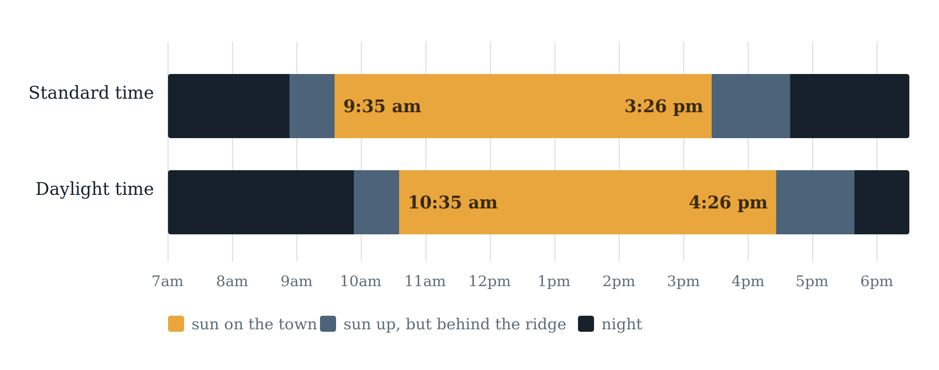
Direct sunlight reaching the townsite on the winter solstice. The mid-tone band is the period the almanac calls daylight. The bright band is when the sun is actually above the ridge and shining on the town.
Read the top bar. Under standard time the sun clears the ridge at 9:35 in the morning and drops behind the other side at 3:26 in the afternoon. The almanac said 8:53 and 4:39. So the valley takes 42 minutes off our morning and 73 minutes off our afternoon, close to two hours of the shortest day in the year.
On the shortest day, Golden gets 5 hours and 52 minutes of direct sun. The almanac promises 7 hours and 47 minutes. The difference is the mountains, and it applies whichever clock we choose.

The choice is not how much light. It is which end of the day.
This is the part that gets lost. Changing the clock does not create or destroy a single minute of sunlight. Both bars in the chart above are exactly the same length, 5 hours and 52 minutes, because they are the same day on the same mountain. The clock only decides where that window sits.
Under standard time the sun is on the town from 9:35 to 3:26. Under daylight time it is on the town from 10:35 to 4:26. That is the entire decision, stated honestly. One puts the light earlier, one puts it later, and neither gives us more of it.

What that means for a school day
Under standard time the sun arrives about an hour into the school morning and is still up when classes let out. Under daylight time it arrives about two hours into the morning, so the walk to school happens in the dark for a large part of the winter, but the sun is still up for an hour or so after the bell. Slot in the actual bell times for your own household and the trade becomes clear enough.

What that means for a working day
Someone working eight to four-thirty starts in the dark under either clock in midwinter. Under standard time they lose the last hour of the afternoon to the ridge. Under daylight time they get that hour, and lose more of the morning instead. People who work outdoors, drive the highway, or start early feel the morning end. People who want light after work feel the afternoon end. Both groups are real and both are here.

How high the mountains actually stand
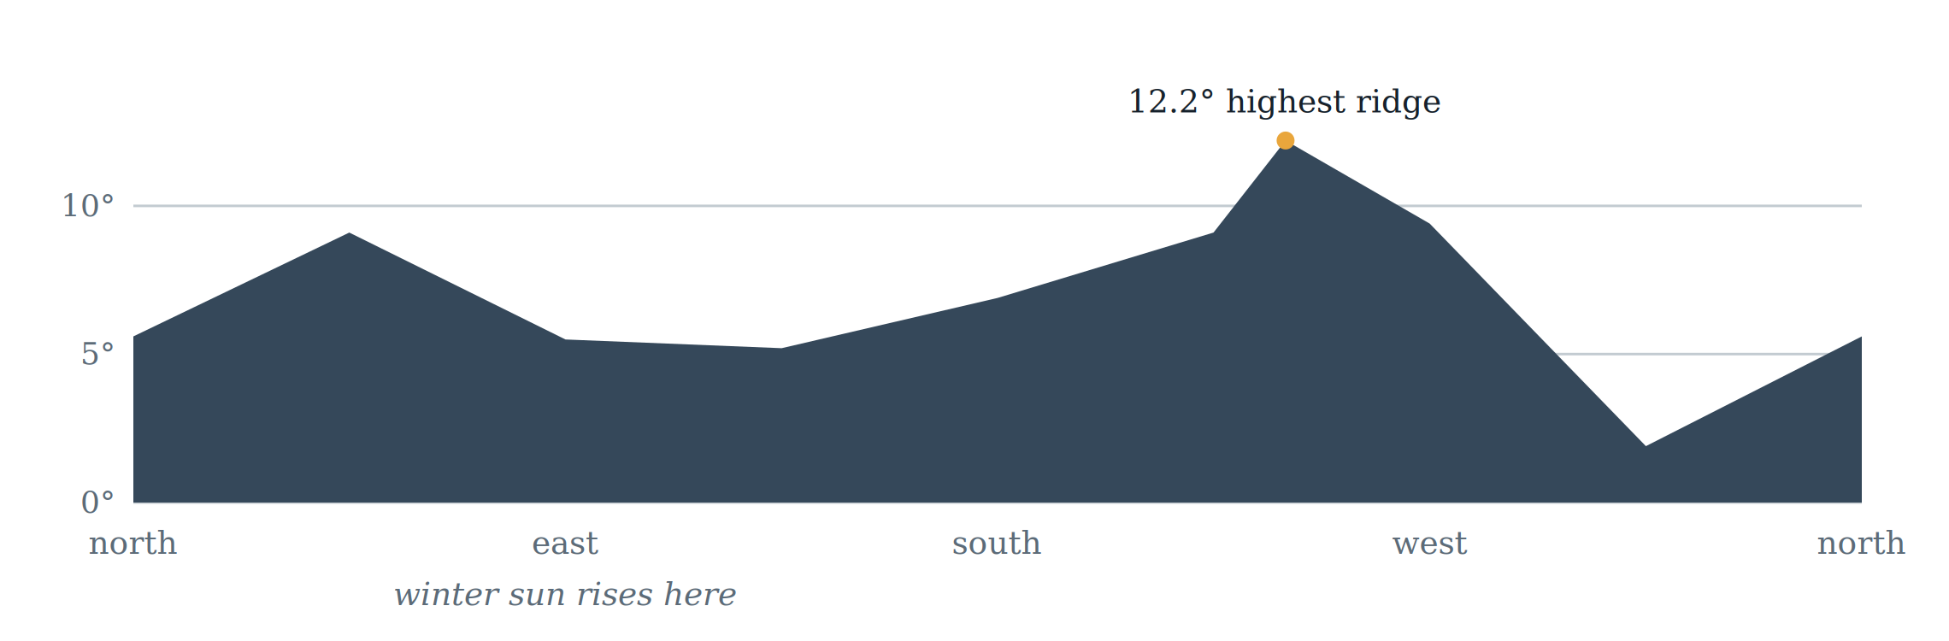
How far above level you have to look to clear the skyline, from the townsite, in each direction. Measured on 720 compass bearings from 30-metre elevation data; eight of them are plotted here along with the highest.
The highest ridge sits 12.2 degrees above level to the south-west. Looking east, where the winter sun comes up, the skyline still stands about five and a half degrees above level. That is why sunrise here is not sunrise.

Through the year
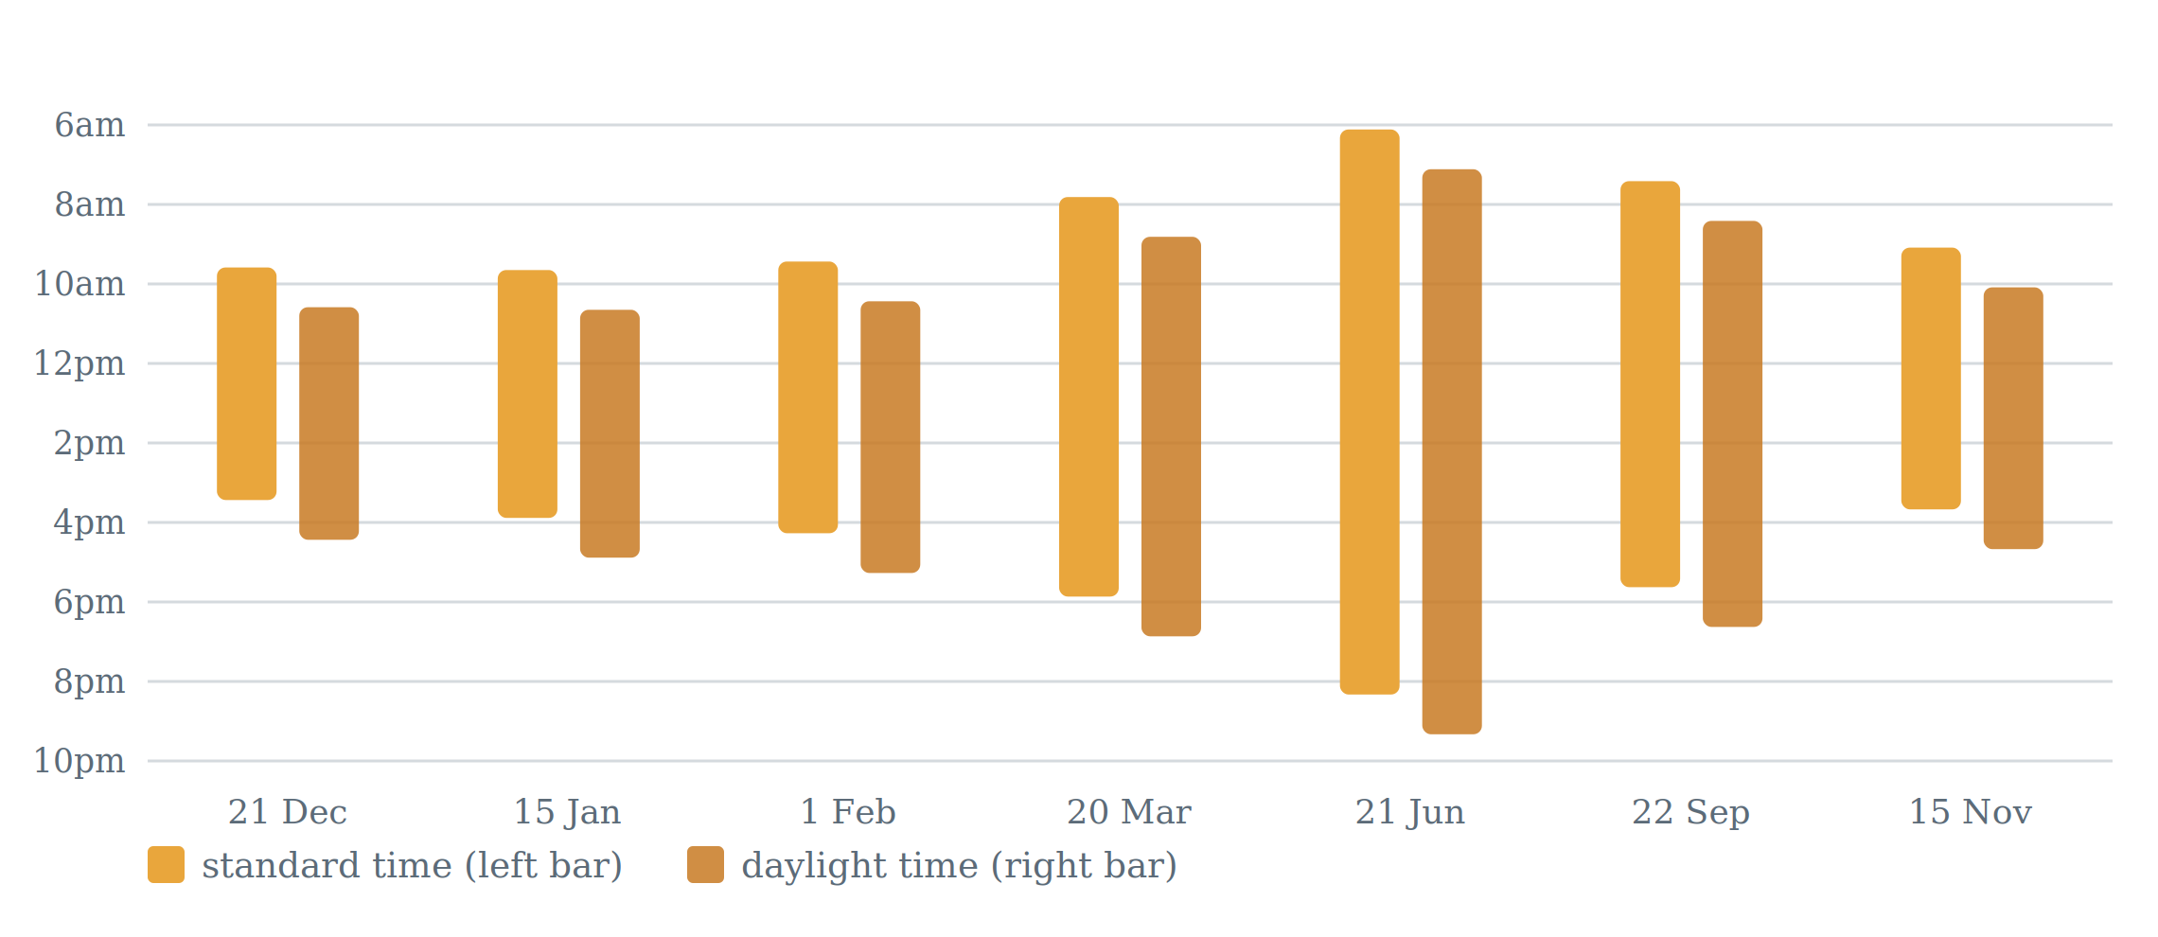
When the sun reaches the townsite and when it leaves, on seven dates through the year, under each clock. The pairs are identical in length and differ only in position.
Date | Sun on  standard | Sun off  standard | Sun on  daylight | Sun off  daylight | Sun on town
21 Dec | 9:35 am | 3:26 pm | 10:35 am | 4:26 pm | 5 h 52 m
15 Jan | 9:39 am | 3:53 pm | 10:39 am | 4:53 pm | 6 h 15 m
1 Feb | 9:26 am | 4:16 pm | 10:26 am | 5:16 pm | 6 h 51 m
20 Mar | 7:49 am | 5:52 pm | 8:49 am | 6:52 pm | 10 h 04 m
21 Jun | 6:07 am | 8:20 pm | 7:07 am | 9:20 pm | 14 h 14 m
22 Sep | 7:25 am | 5:38 pm | 8:25 am | 6:38 pm | 10 h 14 m
15 Nov | 9:05 am | 3:40 pm | 10:05 am | 4:40 pm | 6 h 36 m

Winter: the morning number
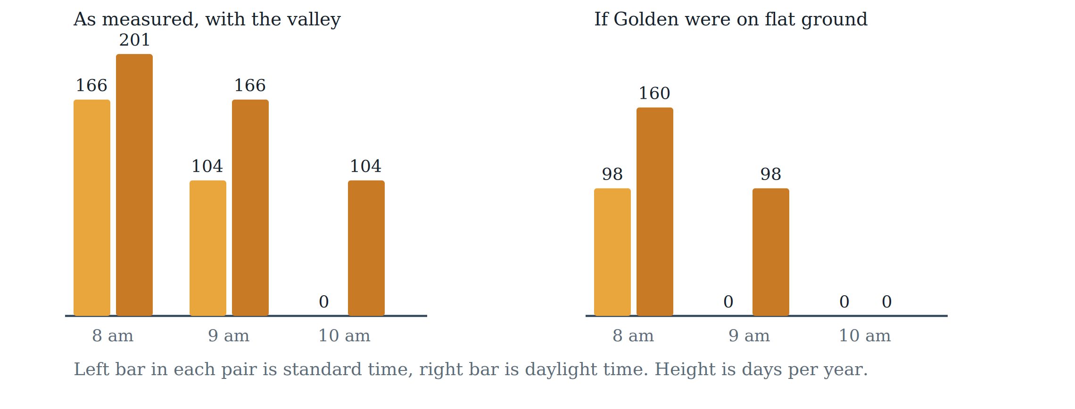
Days per year the sun has still not cleared the ridge at 8, 9 and 10 in the morning. The right-hand panel shows what the same calculation gives if you ignore the mountains, which is what published sunrise tables do.
On flat ground the sun would reach us before 10 in the morning every single day of the year, under either clock. In the real valley, under daylight time, there are 104 days a year when it does not. Under standard time there are none.
That is a genuine difference and it is the strongest single argument for the clock Golden has chosen. It is also only one half of the picture, and the other half runs the other way: standard time pulls the ridge shadow across the town earlier in the afternoon, at 3:26 on the solstice. If afternoon light matters more to you than morning light, the same measurements support the opposite conclusion.

Summer: the evening number
Winter is not the whole year, and the summer measurements run the other way. The valley actually costs Golden more direct sun in July than in December, because the midsummer sun rises at a bearing that puts it straight into the high north-eastern ridge.
Month | Almanac | Actual | Lost to terrain
July | 15.99 h | 13.69 h | 2.30 h
August | 14.46 h | 12.47 h | 1.99 h
December | 7.89 h | 5.87 h | 2.02 h

The evening is what people notice. This is the time the sun comes off the townsite, every fifth day from the first of July to the end of August, under each clock.
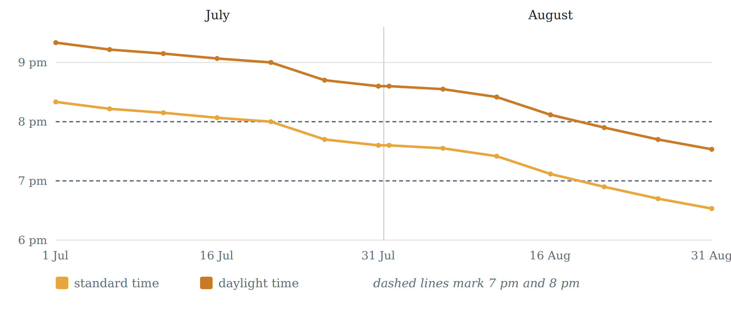
When direct sun leaves the townsite through July and August. The line does not fall smoothly because the sunset bearing walks across an uneven western skyline, crossing a ridge shoulder in late July and a gap in early August.
Under standard time the sun is off the town before 8 pm on most of August and before 7 pm on about half of it. Under daylight time the whole of July keeps sun past 8 pm, and all of August keeps it past 7 pm.
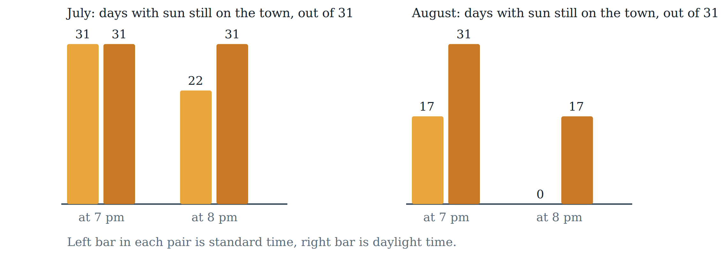
Days per month with direct sun still on the townsite at 7 pm and at 8 pm, under each clock.
These are the summer counterpart of the winter morning figures, and they are about the same size. In August, standard time gives no days at all with sun on the town at 8 pm, against 17 under daylight time. For anything that happens after work outdoors, in the busiest month of the visitor season, that is the cost side of the decision.

The two findings point in opposite directions
Set them side by side. Standard time removes 104 days a year when the sun would otherwise not reach the town until after 10 in the morning. Daylight time returns 17 August evenings with sun still on the ground at 8 pm, and 14 more with sun at 7 pm.
Neither cancels the other and no measurement can rank them, because that ranking is a judgment about whose day matters and in which season. Dark school mornings through November to February are borne by children, shift workers and anyone whose start time is fixed. Dark August evenings are borne by outdoor businesses, visitors and anyone whose free time comes after work. Both groups live here.
What the measurements do settle is that the trade is real and roughly symmetrical. Anyone who says one clock simply gives Golden more daylight is wrong, in both directions.

What this measurement does not decide
Sunlight is one input. It says nothing about the things that moved people on both sides of this debate: ties to Calgary and the Alberta visitor economy, staying on the same clock as the rest of the East Kootenay, alignment with provincial services and health authorities, or the value of a long summer evening. Those are real considerations and no amount of sunlight arithmetic settles them. Note too that these figures are direct sun on the ground: at this latitude usable light lasts roughly another 40 to 50 minutes past the times shown in midsummer, so a summer evening does not end as abruptly as the numbers alone suggest.
This report exists so that whichever way you weigh those things, you are weighing them against the correct daylight numbers instead of numbers calculated for a place that looks nothing like Golden.

How this was worked out, and how to check it
Elevation data covering 60 kilometres in every direction was used to trace the skyline from the townsite on 720 separate compass bearings, correcting for the curve of the Earth and for the way the atmosphere bends light. The sun’s position was calculated minute by minute using the standard astronomical method, and the sun counts as being on the town when it is above the ridge in the direction it happens to be sitting.
Before it was used on the valley, the same program was run twice as a check. Its sun positions were compared against published figures for Golden and matched within a quarter of a degree. Then it was run with the mountains deliberately switched off, and it reproduced ordinary almanac sunrise and sunset times. Only after both checks passed was it pointed at the real terrain.
Four things it does not account for, stated plainly. It measures one point, the townsite; other parts of town and the benches will differ. The elevation data is a surface model, so it includes trees and buildings: on distant ridgelines that makes them slightly too tall and overstates the effect, while at the observation point itself it raises the assumed viewpoint and understates it, and anything closer than about thirty metres does not appear at all. Those biases pull in opposite directions and which one wins here has not been established. It assumes clear skies, and valley cloud in December is not modelled. Winter temperature inversions bend light more than the standard correction allows, which would move true sunrise a little earlier than shown.
Testing showed the two figures are not equally firm. The morning time is robust, because the ridge falls away steeply just as the sun climbs, so even a sizeable error in the skyline barely moves it. The afternoon time is more sensitive, because the sun descends into a skyline that is rising again, and a quarter of a degree of error there is worth about ten minutes. Treat 9:35 as firm and 3:26 as give or take a few minutes.
Measurements taken 4 September 2026 for the townsite at 51.2969° N, 116.9647° W. Elevation data: 1 arc-second terrain tiles from the public AWS Terrain Tiles collection, which is SRTM-derived and void-filled. Solstice figures are for 21 December 2026; the remaining dates and all annual counts are for 2027. The program and the method are available on request so that anyone can reproduce or challenge these figures.

