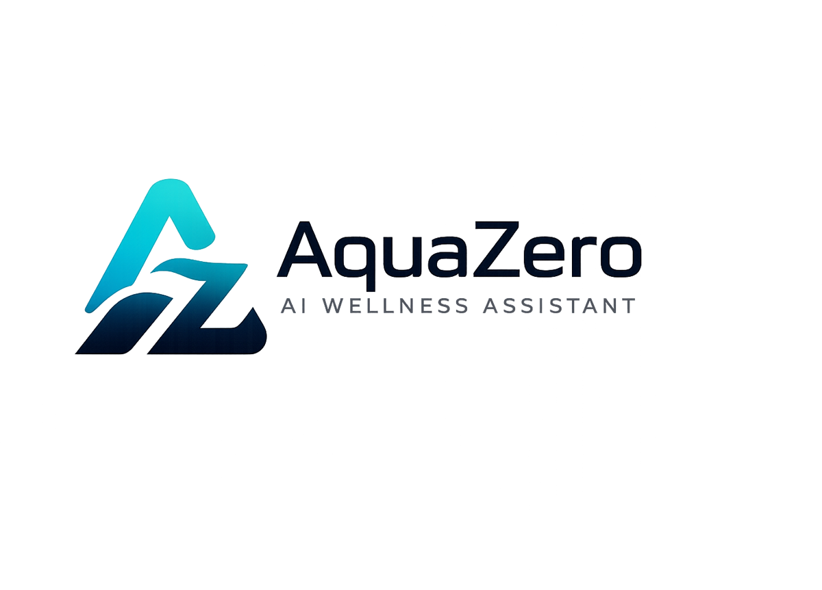
AQF-01
Project Charter and Team Roles
Scope, governance, role allocation and ways of working
AquaZeroFit, an AquaZero product
NIT3003 IT Capstone Project, Project 5
Group 15, Victoria University, Melbourne, Australia
Version 2.0, July 2026

Document Control
Field | Detail
Document | AQF-01 Project Charter and Team Roles
Version | 2.0 (AquaZeroFit rebrand, diagrams added)
Purpose | Establish what the team is building, who owns what, and how work is governed. Every other document depends on the scope and roles fixed here.
Document owner | Babatundji Williams-Fulwood, Technical Lead and Software Architect
Contributors | Eric La (Frontend), Victor Hong (Data and Quality)
Supervisor | [To be completed by the team]
Status | Draft for supervisor review
Change history | v1.0 initial draft as VitalAI. v2.0 rebranded to AquaZeroFit, diagrams added, roles assigned, sequencing applied

1. Project Identity
Item | Detail
Product name | AquaZeroFit
Brand | AquaZero
Unit | NIT3003 IT Capstone Project, Project 5
Institution | Victoria University, Melbourne, Australia
Group | Group 15
Product statement | An AI-powered wellness platform for nutrition monitoring, weight-loss goal management and personalised home training, delivered to the web and to Telegram from a single codebase
Explicit boundary | General wellness and fitness support only. Not medical diagnosis, not treatment, not professional healthcare advice

2. Team and Roles
All three members are junior software developers. Role weighting reflects declared specialisation and the volume of architectural and documentation ownership each member carries.
Team member | Student ID | Primary role
Babatundji Williams-Fulwood | [Student ID] | Technical Lead, Software Architect, Backend and AI Engineer
Eric La | [Student ID] | Frontend Developer, UI Implementation and Accessibility
Victor Hong | [Student ID] | Data and Quality Engineer, Full-Stack Support
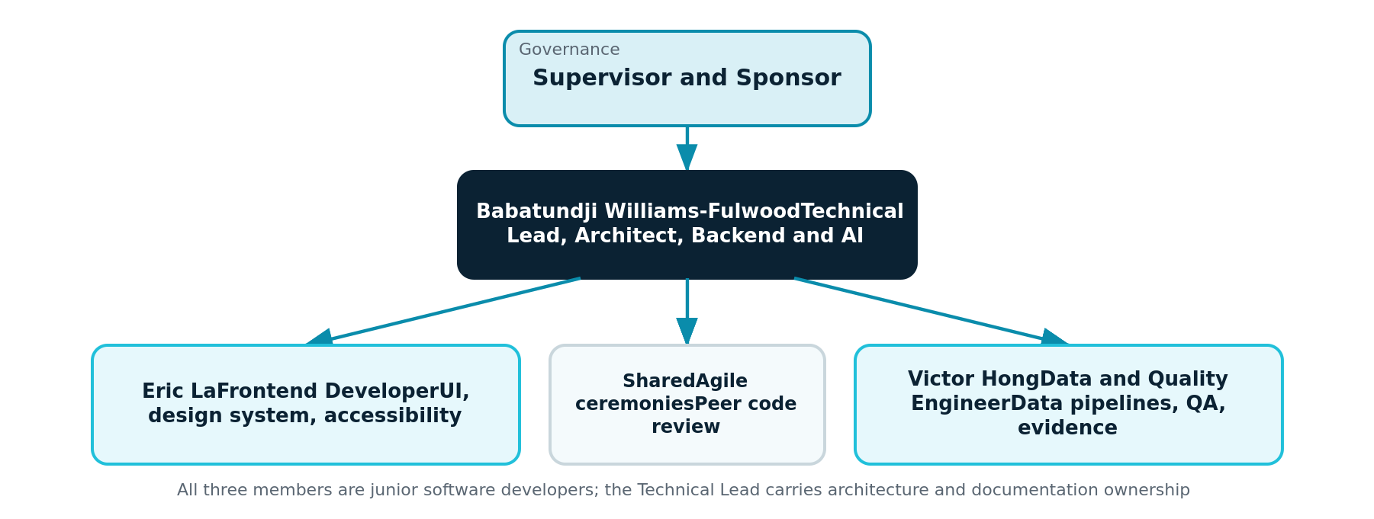
Figure 1.1: Team structure and governance reporting line

2.1 Detailed responsibility allocation
Member | Owns | Contributes to | Documentation ownership
Babatundji Williams-Fulwood | System architecture, Azure subscription and governance, backend services (auth, profile, nutrition, recommendation, training, progress), AI Gateway and prompt engineering, security and guardrails, CI/CD and infrastructure as code | Frontend integration contracts, data model review, release management, sprint facilitation | Charter, PRD, SRS, HLD, ADR Log, Data Model, API Contract, UML, LLD, AI and LLMOps, Safety, Licensing Register, Implementation Document, Runbook, Final Report
Eric La | Frontend application for both delivery targets, design system implementation from the AquaZero tokens, screen implementation, accessibility conformance, client-side state and API client | Component-level testing, UI defect triage, user manual screenshots | User Manual (primary author), UI sections of the SRS and Implementation Document, frontend entries in the Diary
Victor Hong | Data ingestion pipelines (exercise corpus and food composition data), database seeding and migrations, test plan execution, verification evidence capture, defect logging | Backend service support, API contract review, deployment smoke tests | Test Plan and QA Strategy (primary author), Progress Report evidence appendix, data sections of the Data Model, data entries in the Diary

2.2 Rationale for weighting
- Babatundji Williams-Fulwood specialises in backend and AI engineering and also covers general software engineering, so the architecture, the AI layer, the cloud platform and the majority of technical documentation sit with the Technical Lead.
- Eric La and Victor Hong hold clearly bounded, independently demonstrable ownership. This matters for assessment: each member must be able to demonstrate and explain their own work at review.
- Every member reviews at least one pull request per sprint outside their own lane, so no area has a single point of knowledge.

3. Scope
In scope | Out of scope
Secure registration, authentication and wellness profile | Medical diagnosis, treatment or medication advice
Food logging, manual and by photo, with calorie estimation | Eating disorder treatment or mental health therapy
Nutrition dashboard: calories, protein, carbohydrate, fat, water, weight | Integration with medical records or clinical systems
AI recommendation engine for meals and recipes | Wearable device synchronisation (documented as future work)
Home training and weight-loss planning, daily workout module | Native iOS and Android applications
Progress tracking with achievements | Multi-language interface
Conversational AI assistant with guardrails | Live payment processing during the capstone
Safety, privacy and ethical design layer | Clinical validation of nutrition estimates
Responsive web application and Telegram Mini App

4. Governance and Ways of Working
Practice | Detail
Method | Agile Scrum, two-week sprints across the semester
Ceremonies | Sprint planning, twice-weekly stand-up, sprint review with demonstration, retrospective
Backlog | GitHub Projects board; every item has an owner, acceptance criteria and verification evidence
Definition of Done | Code merged, tests passing, documentation updated, peer reviewed, accessibility checked for UI work, safety evaluation passed for AI work
Source control | Single GitHub monorepo, protected main branch, pull requests with at least one review
Cloud governance | One designated Azure for Students project subscription, resource-group scoped role assignments, budget alerts at 50, 75 and 90 percent
Escalation | Blockers raised at stand-up; unresolved after 48 hours they go to the supervisor

5. Success Criteria
- All eleven project requirements from the unit brief are implemented and demonstrable.
- The web application can be opened and used by a marker with a seeded account, without requiring Telegram.
- The Telegram Mini App runs the same build and is demonstrable on a physical device.
- The AI safety evaluation suite passes with zero critical failures.
- Every claim of completion in the Progress Report can be demonstrated live or evidenced in the repository.
- Each member can independently explain and demonstrate the work attributed to them.

6. Document Set and Production Order
Documents are produced and read in dependency order. Each phase depends on the phase above it being stable.
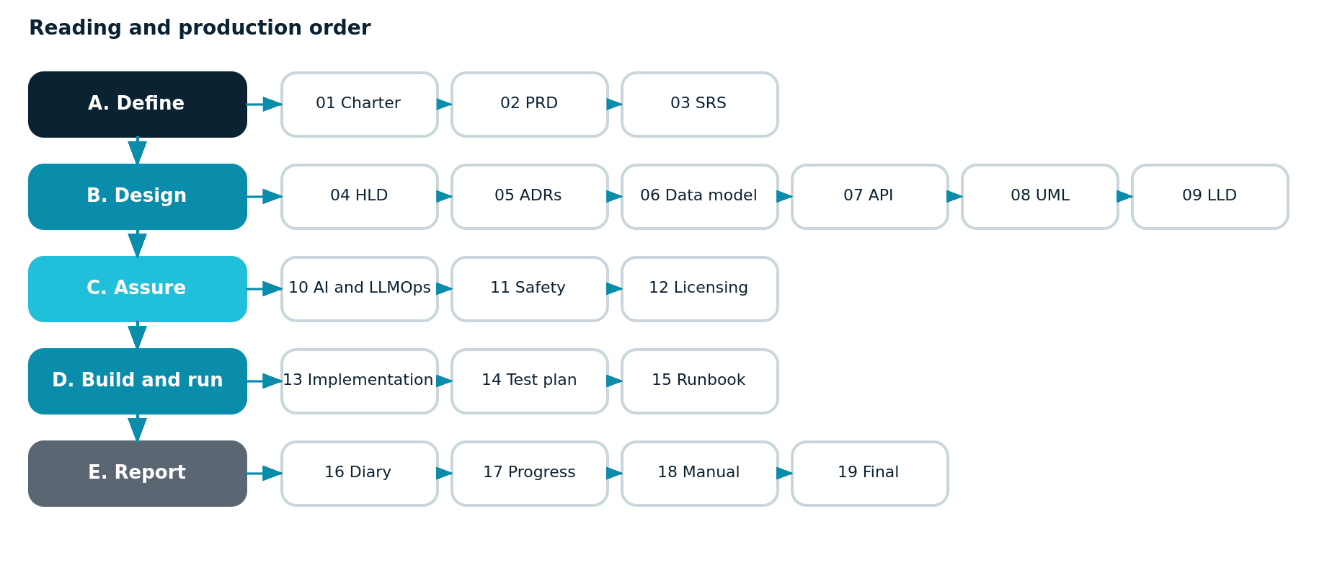
Figure 1.2: Document production and reading order across five phases
Phase | Documents | Gate before moving on
A. Define | 01 Charter, 02 PRD, 03 SRS | Scope agreed with supervisor; requirements numbered and testable
B. Design | 04 HLD, 05 ADRs, 06 Data Model, 07 API Contract, 08 UML, 09 LLD | API contract frozen so frontend and backend can build in parallel
C. Assure | 10 AI and LLMOps, 11 Safety Privacy Ethics, 12 Licensing Register | Guardrails specified and every external source licence-cleared
D. Build and run | 13 Implementation Document, 14 Test Plan, 15 Runbook | Environments live, pipeline green, evidence capture underway
E. Report | 16 Diary, 17 Progress Report, 18 User Manual, 19 Final Report | Submission

