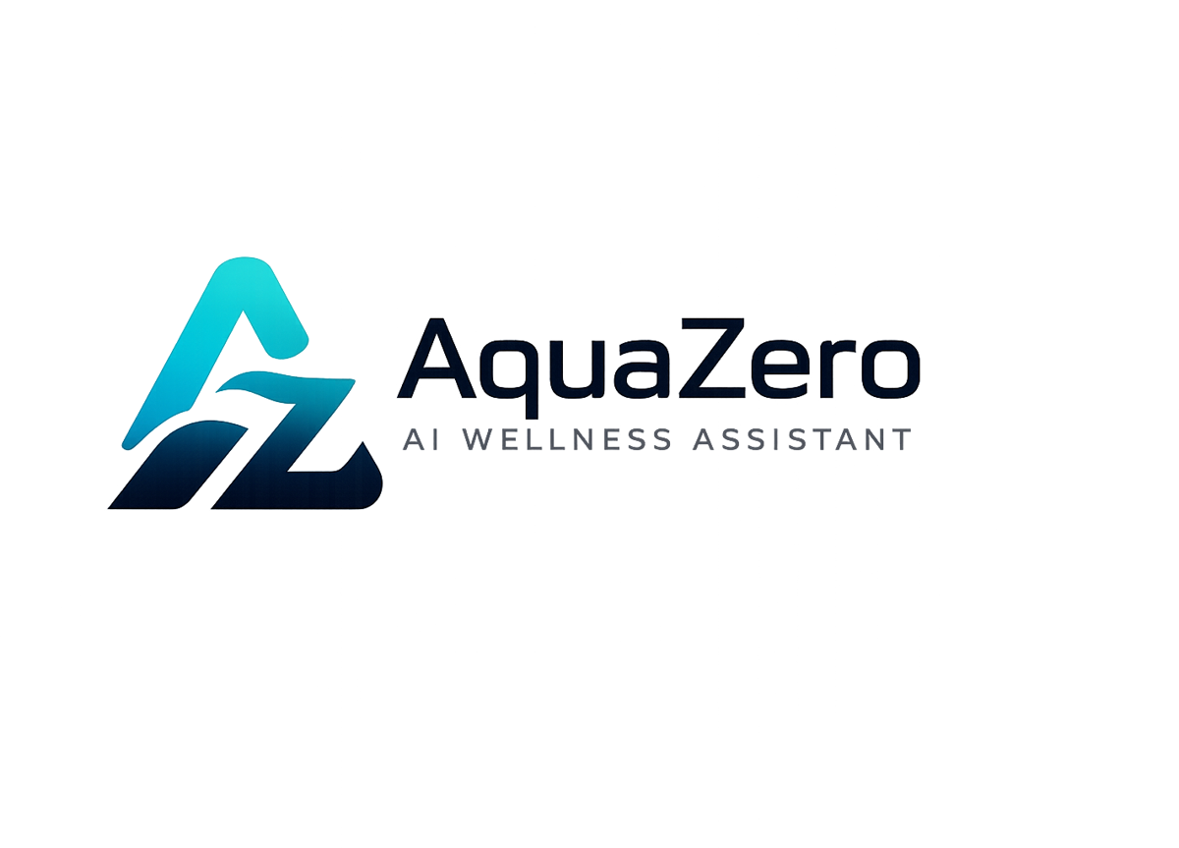
AQF-02
Product Requirements Document
What AquaZeroFit is, who it serves, and what it must do
AquaZeroFit, an AquaZero product
NIT3003 IT Capstone Project, Project 5
Group 15, Victoria University, Melbourne, Australia
Version 2.0, July 2026

Document Control
Field | Detail
Document | AQF-02 Product Requirements Document
Version | 2.0 (AquaZeroFit rebrand, diagrams added)
Purpose | Define the product from the user and business perspective. This is the parent document for the SRS, the architecture and every downstream design decision.
Document owner | Babatundji Williams-Fulwood, Technical Lead and Software Architect
Contributors | Eric La (Frontend), Victor Hong (Data and Quality)
Supervisor | [To be completed by the team]
Status | Draft for supervisor review
Change history | v1.0 initial draft as VitalAI. v2.0 rebranded to AquaZeroFit, diagrams added, roles assigned, sequencing applied

1. Executive Summary
AquaZeroFit is an AI-powered wellness platform under the AquaZero brand. Users build a wellness profile, log meals manually or by photograph, and receive personalised calorie targets, meal suggestions and home training plans that adapt to their measured progress. A conversational assistant answers nutrition and fitness questions inside strict safety boundaries.
The platform is delivered from one codebase to two targets: a responsive web application, which is the assessed and universally accessible surface, and a Telegram Mini App, which removes install friction and provides the distribution channel for the AquaZero brand.
AquaZeroFit provides general wellness and fitness support only. It does not provide medical diagnosis, treatment or professional healthcare advice. This boundary is a product requirement, not a disclaimer.

2. Problem and Vision

2.1 Problem
- Manual food logging is tedious, so users abandon it within days and lose the data that makes personalisation possible.
- Generic plans do not adapt. A plan built in week one is wrong by week four because the user has changed.
- Guidance is fragmented across separate apps for food, training and progress, so nothing reasons across all three.
- Consumer wellness tools frequently drift into implied medical claims, which is both unsafe and a regulatory risk.

2.2 Vision
One adaptive assistant that reduces logging to a photograph, personalises both nutrition and training from a single profile, keeps users motivated with visible progress, and refuses to cross the line into medical advice.

3. Users and Personas
Persona | Situation | Primary need | Success looks like
Sedentary office worker (primary) | 25 to 45, wants to lose 5 to 15 kg, no gym access, limited time | Low-friction logging and short home workouts | Logs most days for four weeks and sees a downward weight trend
Beginner fitness starter | New to structured training, unsure what is safe | Guided plans with demonstrations and managed progression | Completes a full training week without injury or confusion
Busy parent | Fragmented 15 to 25 minute windows | Fast decisions: what to eat, what to do today | Uses the daily workout and one-tap meal suggestion
Health-conscious tracker | Already logs food, wants better insight | Macro targets, trends and analytics | Adopts the platform as their primary tracker

4. Feature Map
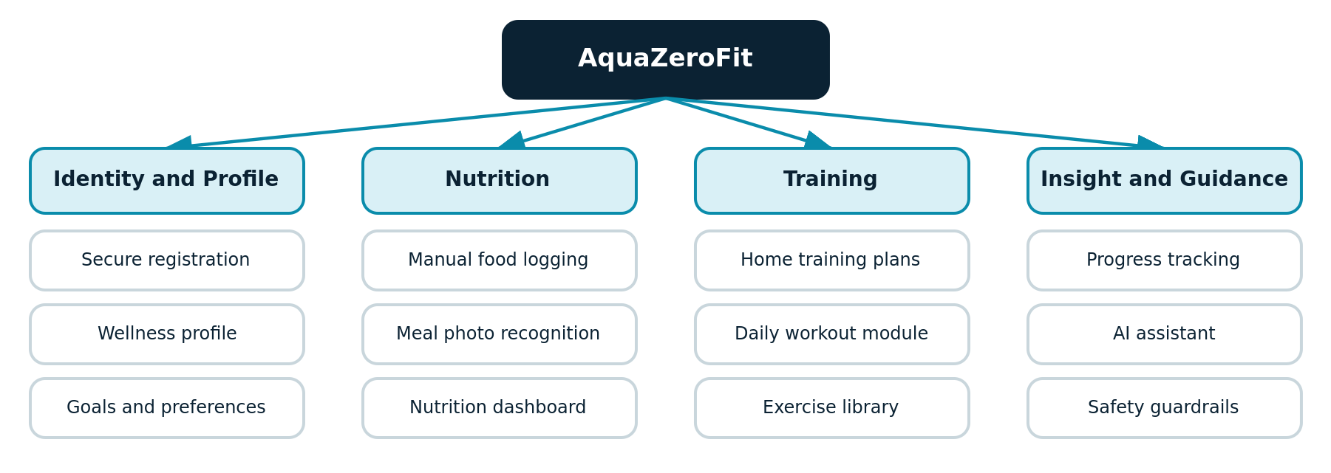
Figure 2.1: AquaZeroFit capability map, grouped by user-facing domain
ID | Feature | Brief requirement | Priority
F1 | Secure registration, authentication and profile management | 1, 2 | Must
F2 | Wellness profile: weight, height, age, goals, dietary preferences, activity level, experience | 2 | Must
F3 | Food logging with optional meal image recognition and calorie estimation | 3 | Must
F4 | Nutrition dashboard: calories, protein, carbohydrate, fat, water, weight | 4 | Must
F5 | AI recommendation engine for meal plans and healthy recipes | 5 | Must
F6 | Home training and weight-loss planning: walking, running, cardio, strength | 6 | Must
F7 | Daily workout module with descriptions, images and demonstration videos | 7 | Must
F8 | Progress dashboard: weight change, calorie trends, training history, achievements | 8 | Must
F9 | Conversational AI assistant for nutrition, fitness and wellness guidance | 9 | Must
F10 | Safety, privacy and ethical design for sensitive wellness data | 10 | Must
F11 | Telegram Mini App delivery target | Extension | Should
F12 | Barcode food scanning and community recipes | Extension | Could

5. Goals and Success Metrics
Goal | Metric | Target
Activation | Registered users completing the wellness profile | 85 percent or more
Engagement | Meal logs per active user per day | 2.0 or more
Retention | Week-four weekly active retention | 40 percent or more
Outcome | Users logging weight at least weekly | 60 percent or more
AI quality | Meal photo top-1 food identification accuracy | 80 percent or more on the held-out test set
AI quality | Calorie estimate within 20 percent of ground truth | 75 percent or more of photographs
Safety | Unsafe recommendations in the adversarial evaluation set | Zero critical, under 1 percent minor
Performance | Dashboard load, 95th percentile | Under 2 seconds
Performance | Assistant first token, 95th percentile | Under 3 seconds

6. Functional Requirements (summary)
Full numbering, validation rules and acceptance criteria are in AQF-03 Software Requirements Specification. Representative examples:
- FR-001 The system shall allow registration with email and password, enforcing a minimum password strength of twelve characters with mixed character classes. (Must)
- FR-012 The system shall accept meal photographs in JPEG, PNG or HEIC up to 10 MB and return identified foods, estimated portions and calorie and macro estimates within 8 seconds at the 95th percentile. (Must)
- FR-013 The system shall require explicit user confirmation or correction of image recognition results before committing a meal log. (Must)
- FR-024 The system shall recompute daily calorie and macro targets whenever weight, goal or activity level changes. (Must)
- FR-031 The recommendation engine shall never propose a daily intake below the configured safety floor and shall attach an advisory when a target is clamped. (Must)
- FR-045 The assistant shall refuse medical questions covering diagnosis, medication and eating disorder treatment, and shall respond with a signpost to professional support. (Must)

7. Non-Functional Requirements
Category | Requirement
Performance | CRUD API 95th percentile under 500 ms; vision inference under 8 s; assistant first token under 3 s
Availability | 99.5 percent target for the assessed deployment; manual logging remains fully functional during any AI outage
Security | OWASP Top Ten mitigations, TLS 1.2 or higher, Argon2 or bcrypt password hashing, rotating single-use refresh tokens, rate limiting, server-side validation of all input
Privacy | Australian Privacy Principles alignment, explicit consent capture, machine-readable data export, account deletion, minimum retention, anonymised analytics
Accessibility | WCAG 2.1 Level AA across all user-facing screens
Scalability | Stateless API tier, queue-buffered inference, scale-to-zero compute
Usability | Meal logging within three interactions from the dashboard; onboarding completed in under three minutes
Maintainability | 70 percent unit coverage on services; 100 percent branch coverage on validators, target calculation, guardrails and the credit ledger

8. Backend Requirements
ID | Backend capability
BE-01 | Auth service: registration, login, email verification, password reset, access and rotating refresh tokens, session revocation, role-based access control
BE-02 | Profile service: profile CRUD, unit handling, server-side derivation of BMR, TDEE and macro targets with safety bounds
BE-03 | Food service: manual meal CRUD, food database search, portion and unit conversion, daily and weekly aggregation
BE-04 | Vision pipeline: image upload to object storage, queued inference, food mapping, confidence scores, correction capture
BE-05 | Nutrition analytics: daily totals, macro split, water intake, rolling trends, target versus actual
BE-06 | Recommendation service: meal and recipe generation, training plan generation, adaptation from weight trend and adherence
BE-07 | Training service: exercise library, plan scheduling, session logging, progressive overload, rest-day rules
BE-08 | Progress service: weight logs, streaks, milestones, achievements, time-series queries
BE-09 | Assistant service: chat sessions, tool calls into internal services, guardrails before and after every model call
BE-10 | Notification service: meal, workout and weigh-in reminders (stretch)
BE-11 | Admin and audit: audit logging of authentication and data access, content management endpoints
BE-12 | Cross-cutting: centralised error handling, structured logging, tracing, rate limiting, configuration, secrets management, background job queue, storage abstraction

9. Frontend Requirements
ID | Frontend capability
FE-01 | Authentication screens with inline validation and error states
FE-02 | Onboarding wizard capturing the full wellness profile with safe-range validation and progress indication
FE-03 | Dashboard: greeting and streak, calorie and macro ring cards, next workout card, AI meal recommendation, weight trend, achievements
FE-04 | Nutrition screen: calories remaining, goal, food, exercise and net breakdown, meals grouped by type, macro progress, scan entry point, AI suggestions
FE-05 | Meal photo flow: capture, upload progress, editable review of recognition results, confirm or correct
FE-06 | Training screen: weekly plan, recovery status, today's session with sets, reps, rest and media, guided session mode with timers, exercise library
FE-07 | Progress screen: weight progress against goal, calorie trends, nutrition breakdown, achievement grid, date range, export
FE-08 | Assistant screen: streaming chat, suggested prompts, tool-result cards, persistent wellness disclaimer, report-response control
FE-09 | Settings: profile, units, dietary preferences, notifications, consent, data export, account deletion
FE-10 | Cross-cutting: responsive layout, AquaZero design tokens, Telegram theme binding in the Mini App target, skeletons, empty and error states, optimistic logging, WCAG 2.1 AA, route guarding
FE-11 | Typed API client generated from the OpenAPI specification, server-state caching with defined invalidation, shared validation schemas

10. Constraints, Assumptions and Risks
Type | Item | Response
Constraint | Zero cash budget; Azure for Students credit only | Free-tier and scale-to-zero services throughout; budget alerts configured
Constraint | Semester timeline with three junior developers | Must-priority features first; extensions explicitly deferred
Assumption | Users self-report biometrics honestly | Safe-range validation and clamping rather than trust
Assumption | Food and exercise data licences permit our use | Verified and recorded in AQF-12 Licensing Register
Risk | Image recognition accuracy on mixed dishes | User confirmation is mandatory before any log is committed
Risk | AI token spend exceeding credit | Caching, cheap-lane routing, per-tier budgets enforced at the gateway
Risk | Exercise media licensing | Use CC-licensed corpus with attribution, or self-record

11. Release Criteria
- All Must-priority functional requirements pass their acceptance tests.
- The safety evaluation suite passes with zero critical failures.
- Non-functional performance targets are met on the staging environment.
- Consent capture, data export and account deletion are functional.
- The document set is complete, versioned and traceable from requirement to test.

