
AQF-03
Software Requirements Specification
Numbered, testable functional and non-functional requirements
AquaZeroFit, an AquaZero product
NIT3003 IT Capstone Project, Project 5
Group 15, Victoria University, Melbourne, Australia
Version 2.0, July 2026

Document Control
Field | Detail
Document | AQF-03 Software Requirements Specification
Version | 2.0 (AquaZeroFit rebrand, diagrams added)
Purpose | Convert every PRD feature into requirements that can be built and verified. This document is the source of the traceability matrix.
Document owner | Babatundji Williams-Fulwood, Technical Lead and Software Architect
Contributors | Eric La (Frontend), Victor Hong (Data and Quality)
Supervisor | [To be completed by the team]
Status | Draft for supervisor review
Change history | v1.0 initial draft as VitalAI. v2.0 rebranded to AquaZeroFit, diagrams added, roles assigned, sequencing applied

1. Introduction

1.1 Purpose and readership
This specification states what AquaZeroFit must do in terms precise enough to implement and to test. Each requirement carries an identifier, a priority under MoSCoW, and acceptance criteria. Design detail belongs in AQF-04 and AQF-09, not here.

1.2 System decomposition
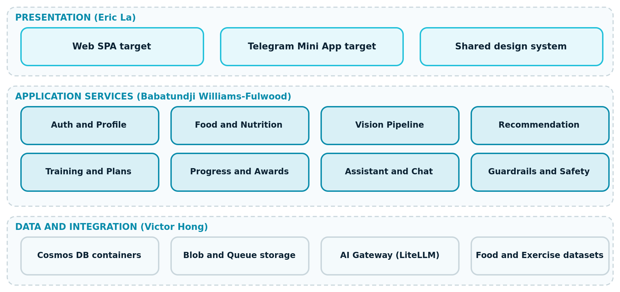
Figure 3.1: Module decomposition across presentation, application and data layers, with owning member

1.3 Requirement identifier scheme
- FR-xxx functional requirement, NFR-xxx non-functional requirement, CON-xxx constraint.
- Priority: Must, Should, Could, Won't (this release).
- Every FR traces upward to a PRD feature (F1 to F12) and downward to at least one test case identifier in AQF-14.

2. Module: Authentication and Profile (F1, F2)
ID | Requirement | Priority | Acceptance criteria
FR-001 | The system shall register a user with email and password | Must | Account created, verification email dispatched, password rejected below twelve characters or without mixed classes
FR-002 | The system shall authenticate a Telegram Mini App user from signed launch data | Must | Signature verified server-side; tampered or stale data rejected with a distinct error code
FR-003 | The system shall issue an access token and a single-use rotating refresh token | Must | Reuse of a consumed refresh token is rejected and the family is revoked
FR-004 | The system shall allow a web user to link a Telegram identity to an existing account | Should | Both identities resolve to one user record and one progress history
FR-005 | The system shall capture and store a wellness profile | Must | Weight, height, age, goal, dietary preferences, activity level and exercise experience persisted
FR-006 | The system shall validate profile values against safe ranges | Must | Weight 30 to 300 kg, height 100 to 250 cm, age 16 to 100; out-of-range values rejected with field-level messages
FR-007 | The system shall recompute derived targets when profile inputs change | Must | Targets endpoint reflects the new values on the next read
FR-008 | The system shall allow the user to export and to delete all personal data | Must | Export is machine readable; deletion removes or irreversibly anonymises all personal records

3. Module: Food Logging and Nutrition (F3, F4)
ID | Requirement | Priority | Acceptance criteria
FR-010 | The system shall allow manual meal entry with food, portion, meal type and timestamp | Must | Entry appears in the day view and updates daily totals immediately
FR-011 | The system shall provide food search over the nutrition database | Must | Results returned in under 500 ms for a cached query; source of each record is identifiable
FR-012 | The system shall accept a meal photograph and return identified foods, portions and estimated nutrition | Must | JPEG, PNG or HEIC up to 10 MB; result available within 8 seconds at the 95th percentile
FR-013 | The system shall require confirmation or correction before committing a photo-derived log | Must | No log is written until the user confirms; corrections are stored for evaluation
FR-014 | The system shall compute calories and macronutrients arithmetically from mapped food records | Must | No language model performs the arithmetic; results are reproducible for the same inputs
FR-015 | The system shall track water intake in user-selected increments | Should | Daily total shown against target
FR-016 | The system shall present a nutrition dashboard of calories, protein, carbohydrate, fat, water and weight | Must | Values match the sum of the day's logs; net calories account for logged exercise
FR-017 | The system shall resolve the current day using the client timezone | Must | A log made at 23:50 local time appears on the correct local day

4. Module: Recommendation and Training (F5, F6, F7)
ID | Requirement | Priority | Acceptance criteria
FR-020 | The system shall generate meal suggestions from remaining targets, preferences and allergies | Must | No suggestion contains a declared allergen; output validates against the meal schema
FR-021 | The system shall never propose a daily calorie target below the configured safety floor | Must | Clamping occurs server-side and attaches an advisory flag visible in the interface
FR-022 | The system shall generate a weekly home training plan from level, equipment, goal and time budget | Must | Plan contains only exercises the user can perform with declared equipment
FR-023 | The system shall express progression as iteration-indexed configuration rather than hard-coded logic | Should | Progression rules are data rows and can be inspected and tested without code change
FR-024 | The system shall present a daily workout with descriptions, images or demonstration media | Must | Every exercise in the session has at least a description and one media asset
FR-025 | The system shall allow constrained substitution of an exercise | Should | The replacement targets the same primary muscle group and respects equipment constraints
FR-026 | The system shall enforce rest-day and intensity rules for beginner users | Must | No two consecutive high-intensity sessions are scheduled for a beginner profile
FR-027 | The system shall adapt targets and plans from measured progress on a weekly cycle | Should | Adaptation is bounded by the same safety limits as initial generation

5. Module: Progress and Assistant (F8, F9)
ID | Requirement | Priority | Acceptance criteria
FR-030 | The system shall record weight entries with one canonical entry per day | Must | A second entry for the same day updates rather than duplicates
FR-031 | The system shall present weight change, calorie trends and training history over a selectable range | Must | Charts match the underlying records for the selected range
FR-032 | The system shall award achievements against published criteria | Should | Criteria are data-defined; unlocking is reproducible from the user's records
FR-033 | The assistant shall answer nutrition, fitness and wellness questions using the user's own context | Must | Responses reference the user's targets and recent logs where relevant
FR-034 | The assistant shall refuse medical, diagnostic, medication and eating disorder treatment questions | Must | Refusal returns a supportive signpost; the adversarial evaluation set passes with zero critical failures
FR-035 | The assistant shall display a persistent wellness-only disclaimer | Must | Disclaimer is visible without scrolling on every assistant screen
FR-036 | The assistant shall allow a user to report a response | Must | Report is stored with the conversation reference and surfaces in the triage queue

6. Non-Functional Requirements
ID | Category | Requirement | Verification method
NFR-01 | Performance | CRUD endpoints respond within 500 ms at the 95th percentile under expected load | Load test with recorded percentiles
NFR-02 | Performance | Assistant first token within 3 seconds at the 95th percentile | Instrumented timing in telemetry
NFR-03 | Reliability | Manual logging, dashboards and existing plans remain functional during a total AI outage | Fault injection: disable the gateway and run the smoke suite
NFR-04 | Security | No secret appears in source, logs or client bundles | Automated secret scan in continuous integration
NFR-05 | Security | A user cannot read or modify another user's records | Authorisation matrix tests across roles
NFR-06 | Privacy | Export and deletion complete within the published service window | Functional test with evidence capture
NFR-07 | Accessibility | All primary flows conform to WCAG 2.1 Level AA | Automated scan plus manual keyboard and screen-reader pass
NFR-08 | Maintainability | Coverage thresholds met on services and safety-critical modules | Coverage report enforced as a pipeline gate
NFR-09 | Portability | The same build runs as a browser application and inside Telegram | Both targets exercised in the release smoke test

7. Traceability
The traceability matrix is maintained in the repository at /docs/traceability.csv and reproduced in AQF-19 Final Report. Each row links: brief requirement, PRD feature, FR identifier, design section, implementing module, and test case identifier. No requirement may be marked complete without a test case reference and demonstrable evidence.

