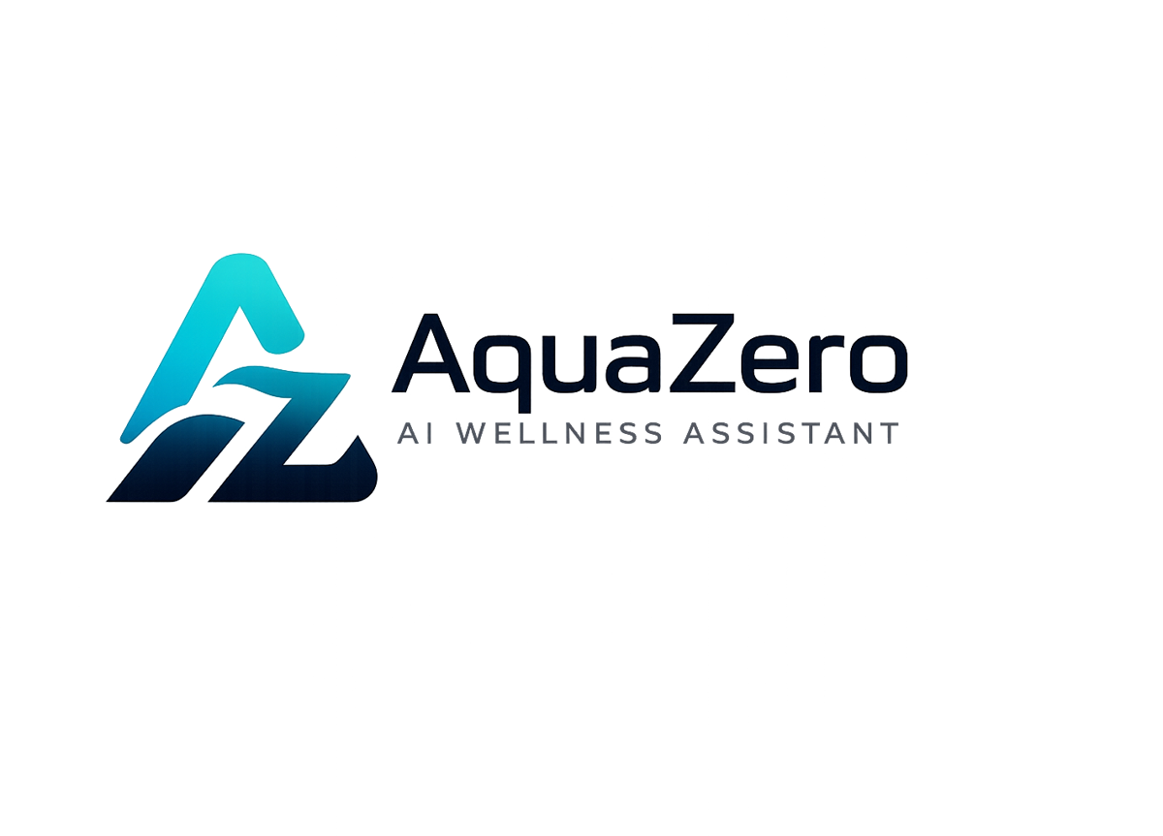
AQF-04
System Architecture (High-Level Design)
C4 views, Azure platform, AI gateway and security architecture
AquaZeroFit, an AquaZero product
NIT3003 IT Capstone Project, Project 5
Group 15, Victoria University, Melbourne, Australia
Version 2.0, July 2026

Document Control
Field | Detail
Document | AQF-04 System Architecture (High-Level Design)
Version | 2.0 (AquaZeroFit rebrand, diagrams added)
Purpose | Translate the requirements into a system structure: what the containers are, how they communicate, which platform services are used, and why.
Document owner | Babatundji Williams-Fulwood, Technical Lead and Software Architect
Contributors | Eric La (Frontend), Victor Hong (Data and Quality)
Supervisor | [To be completed by the team]
Status | Draft for supervisor review
Change history | v1.0 initial draft as VitalAI. v2.0 rebranded to AquaZeroFit, diagrams added, roles assigned, sequencing applied

1. Purpose and Scope
This document defines the architecture of AquaZeroFit at C4 Context and Container level. It covers the dual delivery model, the Azure serverless backend, the multi-provider AI gateway, data storage, security and deployment. Implementation-level detail is in AQF-09; individual decisions with their trade-offs are in AQF-05.

2. Context View
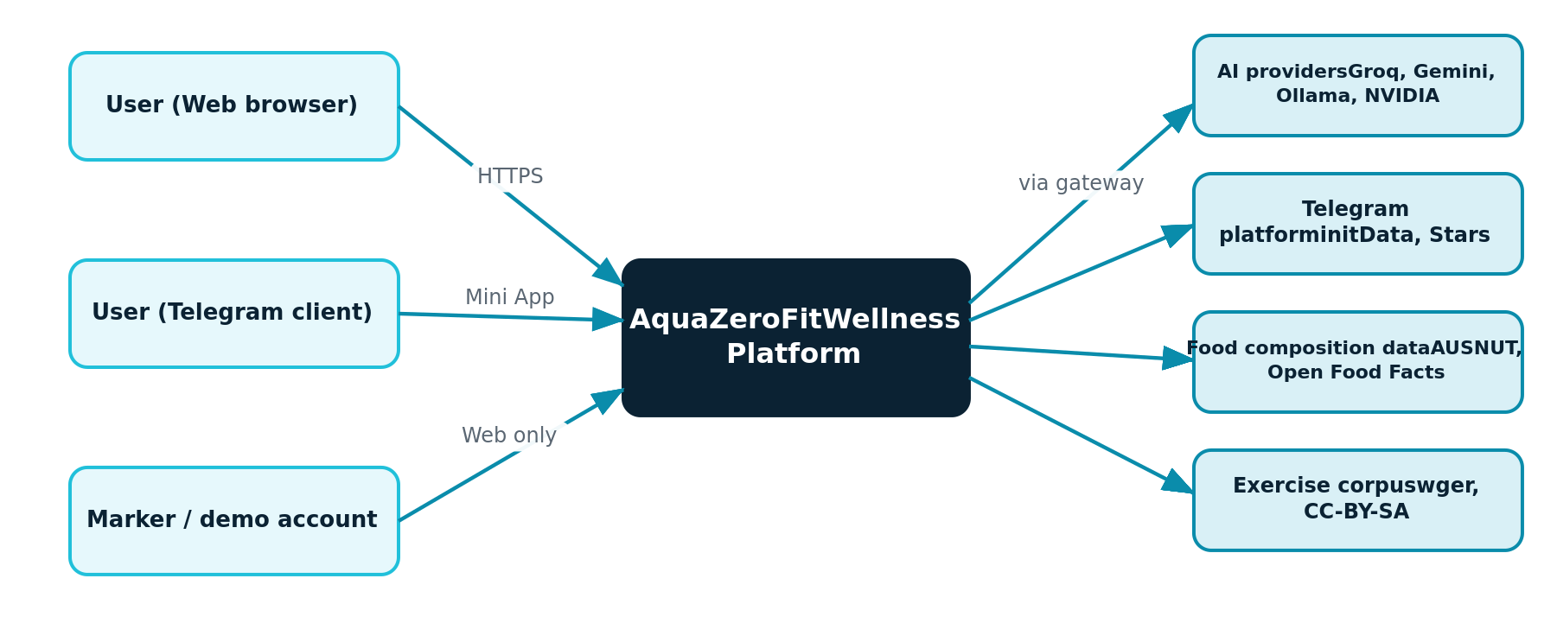
Figure 4.1: C4 Level 1, system context and external dependencies
- Web users authenticate with email and password. This is the assessed surface and never depends on Telegram availability.
- Telegram users arrive with signed launch data validated server-side before any trust is extended.
- AI providers are reached only through the gateway, never directly from feature code or from the browser.
- Food composition and exercise corpus data are ingested once and are not runtime dependencies.

3. Container View
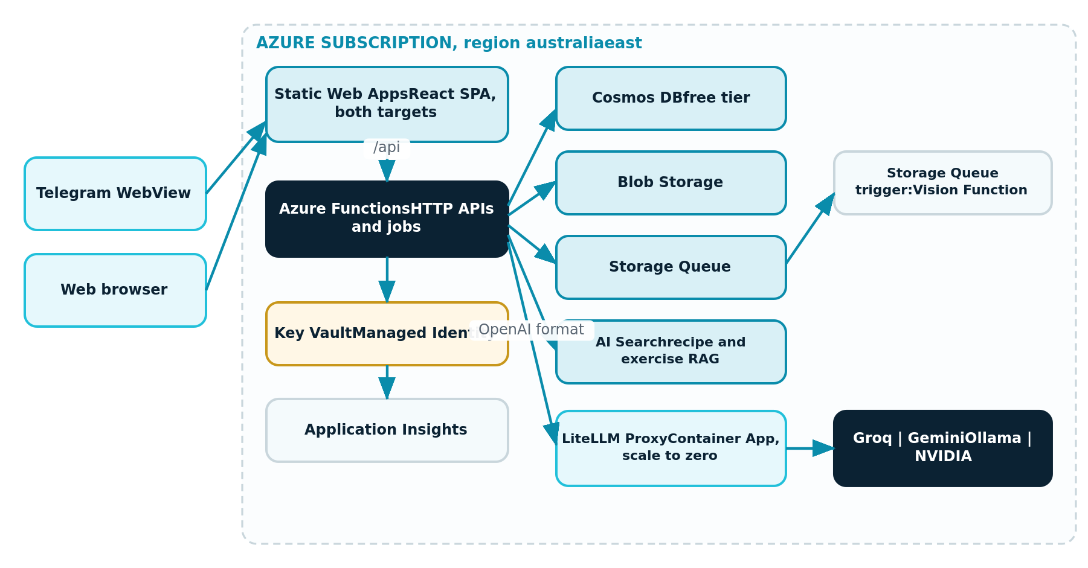
Figure 4.2: C4 Level 2, containers within the Azure subscription
Container | Technology | Responsibility
Frontend | React 18, TypeScript, Vite, hosted on Azure Static Web Apps (free tier) | Both delivery targets from one build; free TLS and custom domain, which the Mini App requires
API and jobs | Azure Functions, Consumption plan, Node.js and TypeScript | HTTP endpoints, queue-triggered inference, timer-triggered adaptation
Primary data | Azure Cosmos DB, lifetime free tier | Profiles, logs, plans, chat, credit ledger, shared content
Object storage and queue | Azure Blob Storage and Storage Queue | Meal photographs and asynchronous job buffering
AI gateway | LiteLLM Proxy on Azure Container Apps, scale to zero | One OpenAI-format endpoint fronting Groq, Gemini, Ollama Cloud and NVIDIA
Retrieval | Azure AI Search, free tier | Semantic retrieval over recipes and the exercise corpus
Secrets | Azure Key Vault with Managed Identity | All provider keys, the bot token and signing keys
Observability | Application Insights and Azure Monitor | Latency, failures, queue depth, token spend, guardrail triggers, budgets

4. Dual Delivery Model
One React codebase produces two targets. At bootstrap the application detects whether it is running inside Telegram. In the browser it renders the AquaZero design system directly; inside Telegram it additionally binds the client theme variables and uses native controls.
isTMA() -> false : responsive web target (assessed surface, seeded marker account)
-> true : Telegram Mini App (native controls, theme binding, haptics)
shared: routing, state, API client, design tokens, business logic, accessibility
Rationale: a Telegram-only build would make assessment dependent on the marker having Telegram installed and on the bot registration behaving on demonstration day. The web target removes that risk while the Mini App target delivers the distribution advantage.

5. AI Gateway
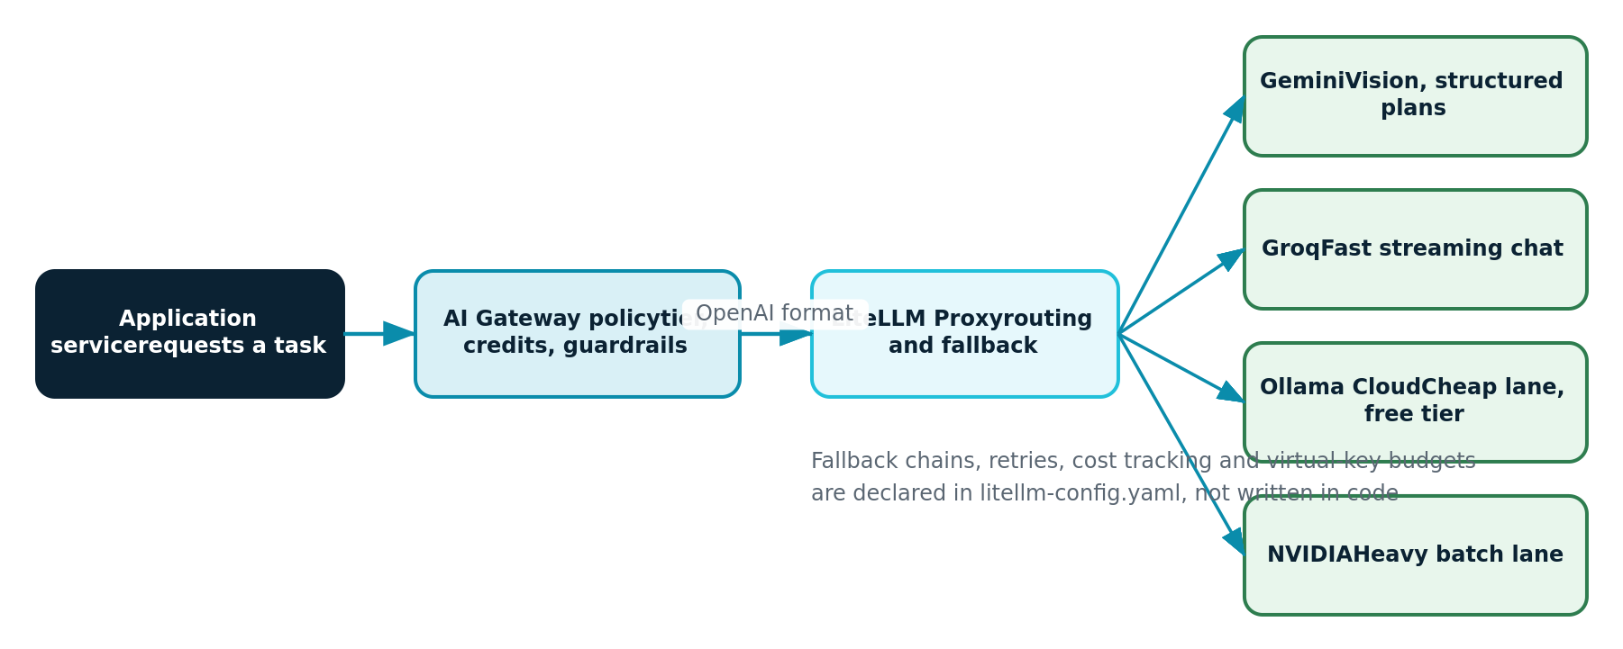
Figure 4.3: AI gateway, policy in our code and routing in configuration

5.1 Provider routing policy
Task | Primary lane | Fallback | Reason
Meal photograph analysis | Gemini | NVIDIA | Multimodal input with reliable structured output
Assistant chat | Groq | Ollama Cloud, then Gemini | Lowest latency for streaming turns
Plan and recipe generation | Gemini | Groq, then Ollama Cloud | Best adherence to long structured schemas
Intent and safety pre-screen | Ollama Cloud | Groq | High volume, near-zero cost
Heavy batch insight | NVIDIA | Gemini | Isolated lane so heavy jobs never contend with chat

5.2 Division of responsibility
Stays in AquaZeroFit code | Declared in gateway configuration
Authentication, authorisation and rate limiting | Fallback chains per model group
Tier policy and credit reservation | Retries, timeouts and load balancing
Wellness guardrails and refusal categories | Per-request cost tracking
Deterministic nutrition arithmetic | Virtual keys with hard budgets per tier
Prompt version pinning and evaluation gates | Logging callbacks into telemetry
Virtual keys with hard budgets mean a free-tier user is technically incapable of reaching a premium lane even if an application-level policy check were bypassed. The credit ledger remains the business record; the virtual key is the enforcement ceiling. This is deliberate defence in depth.

6. Data Flows

6.1 Meal photograph to confirmed log
client -> POST /meal-photos -> blob write -> queue message -> vision function
vision -> gateway (vision lane) -> foods, portions, confidence -> map to food records
code computes kcal and macros -> client reviews and corrects -> POST confirm -> log committed

6.2 Assistant turn
authenticate -> rate limit -> tier and credit check -> input guardrail
-> gateway (chat lane) with tool calls into nutrition, plan and progress services
-> output guardrail and numeric rules -> stream response -> telemetry

6.3 Weekly adaptation
timer trigger -> analyse weight trend and adherence -> recompute targets within safety bounds
-> regenerate or adjust plan -> notify user in application

7. Security Architecture
Concern | Control
Mini App trust boundary | Launch data is untrusted until the server verifies the signature with the bot token and checks freshness. Only then is an identity established
Session management | Both authentication paths issue the platform's own short-lived access token plus a single-use rotating refresh token with family revocation on reuse
Secrets | Key Vault in role-based mode; Functions and the gateway container read via Managed Identity; developers hold access on the development environment only
Team access | Members are guests in security groups with Contributor scoped to the development resource group only; production changes flow exclusively through the pipeline
Abuse | Per-user and per-IP rate limits in middleware; per-tier budgets at the gateway; Azure API Management documented as the enterprise upgrade
Data protection | Encryption in transit and at rest, logical separation of sensitive wellness data, audit logging, export and deletion endpoints

8. Deployment View
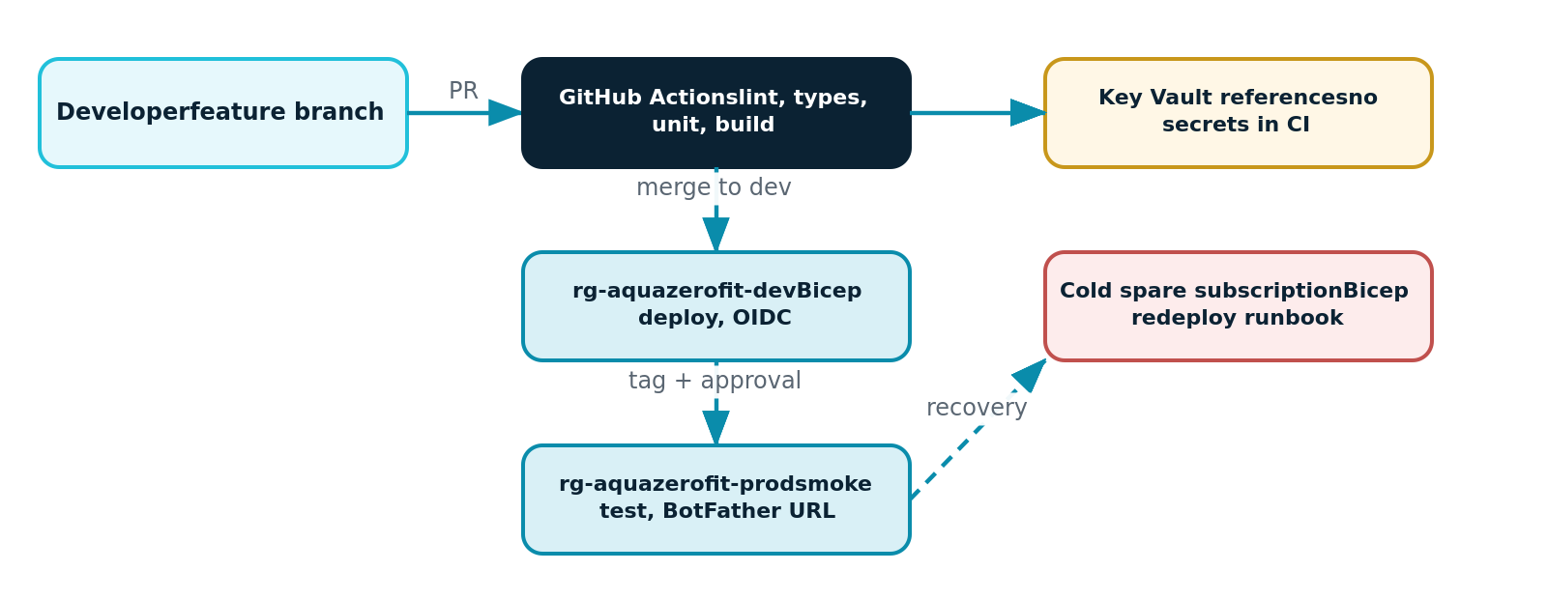
Figure 4.4: Environments, pipeline and recovery path
Environment | Resource group | Trigger | Purpose
Development | rg-aquazerofit-dev | Push to the dev branch | Integration and team testing, free tiers only
Production (assessed) | rg-aquazerofit-prod | Tagged release with approval | Marker demonstration; the registered Mini App URL points here
Cold spare | Backup member subscription | Manual runbook | Disaster recovery within approximately one hour

9. Quality Attributes
Attribute | Target | Mechanism
Performance | CRUD under 500 ms, chat first token under 3 s | Warmed consumption plan, low-latency chat lane, cached targets and food search
Reliability | Core features survive total AI failure | Gateway fallbacks and circuit breaking, queue buffering, defined degradation matrix
Cost | Within the student credit for the semester | Scale to zero, free tiers, cheap-lane routing, budget alerts
Security | No secrets in the repository, OWASP mitigations | Key Vault with Managed Identity, OIDC pipeline, signature validation, scoped roles
Evolvability | A new AI provider added in under one day | Single gateway boundary; routing is configuration, not code

