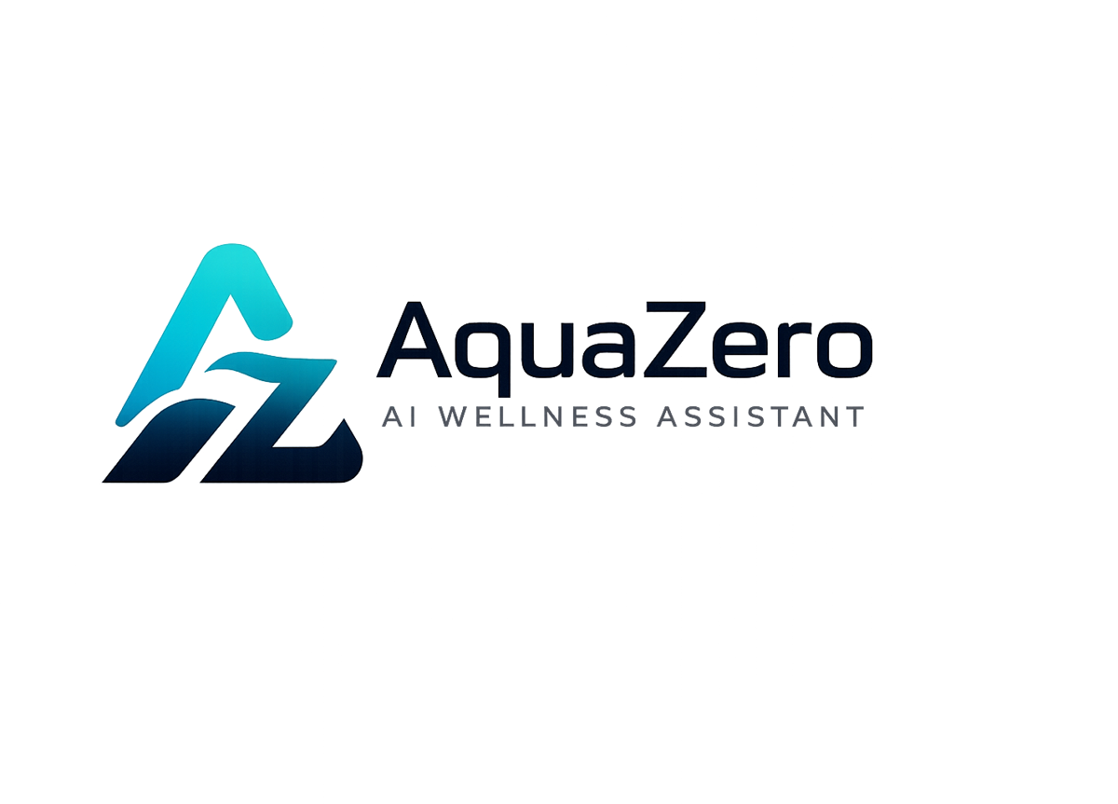
AQF-05
Architecture Decision Records
Eighteen recorded decisions with context, choice and consequences
AquaZeroFit, an AquaZero product
NIT3003 IT Capstone Project, Project 5
Group 15, Victoria University, Melbourne, Australia
Version 2.0, July 2026

Document Control
Field | Detail
Document | AQF-05 Architecture Decision Records
Version | 2.0 (AquaZeroFit rebrand, diagrams added)
Purpose | Preserve the reasoning behind every significant technical choice so it can be reviewed, challenged and revisited with full context.
Document owner | Babatundji Williams-Fulwood, Technical Lead and Software Architect
Contributors | Eric La (Frontend), Victor Hong (Data and Quality)
Supervisor | [To be completed by the team]
Status | Draft for supervisor review
Change history | v1.0 initial draft as VitalAI. v2.0 rebranded to AquaZeroFit, diagrams added, roles assigned, sequencing applied

Index
ID | Decision
ADR-001 | One React codebase with two delivery targets
ADR-002 | Serverless Azure Functions over virtual machines or Kubernetes
ADR-003 | Azure Cosmos DB free tier as the primary database
ADR-004 | A single AI gateway boundary instead of provider SDK calls in feature code
ADR-005 | Per-task provider routing across Groq, Gemini, Ollama Cloud and NVIDIA
ADR-006 | Azure Key Vault with Managed Identity for all secrets
ADR-007 | Dual authentication converging on one identity record
ADR-008 | Queue-based asynchronous meal photograph pipeline
ADR-009 | Azure Static Web Apps for frontend hosting
ADR-010 | Infrastructure as code deployed by pipeline with federated credentials
ADR-011 | Rate limiting in middleware now, API Management at enterprise stage
ADR-012 | Deploy the gateway as a container rather than embedding a Python SDK
ADR-013 | Use the open exercise corpus for data and model only, never its code
ADR-014 | Dual food data source: authoritative Australian composition data plus the open long tail
ADR-015 | Models identify, code calculates
ADR-016 | Licence register and automated licence guard as a standing control
ADR-017 | Use the maintained launch-data validation library rather than hand-rolled cryptography
ADR-018 | Reject retired platform proxy features; API Management is the only sanctioned gateway

Records

ADR-001: One codebase, two delivery targets
Status: Accepted

Context
The unit is assessed on an accessible product while the business plan needs Telegram distribution. A Telegram-only build risks marker friction and demonstration-day registration failure; two separate applications double the work for a three-person team.

Decision
Scaffold from the official React template for Telegram Mini Apps and branch behaviour at bootstrap. The responsive web build is the assessed artefact; the identical build registered with the bot is the distribution channel.

Consequences
- Assessment never depends on Telegram being installed or the bot behaving.
- Theme binding and native controls apply only in the Mini App branch.
- Server-side launch data validation becomes mandatory (ADR-007).
- The dual-channel delivery is a genuine differentiator in the report and demonstration.

ADR-002: Serverless compute
Status: Accepted

Context
The budget is a student credit. Traffic is bursty: development activity, then marker visits. The team also needs certification-relevant cloud experience.

Decision
Azure Functions on the Consumption plan for all HTTP endpoints and background jobs. No virtual machines and no Kubernetes for the capstone.

Consequences
- Compute cost is effectively zero at project scale.
- Cold starts are mitigated by a scheduled warm ping before demonstrations.
- Container Apps remains the documented migration path if a component outgrows Functions.

ADR-003: Cosmos DB free tier
Status: Accepted

Context
It is the only Azure database that remains free permanently rather than for twelve months. The data is naturally document shaped: profiles, daily logs, plans, transcripts, ledger entries.

Decision
Use Cosmos DB with deliberate partition-key design. Model aggregates as documents and avoid cross-partition queries on hot paths.

Consequences
- No database cost, including after student credits lapse.
- The team accepts a NoSQL learning curve; the container and partition map in AQF-06 prevents poor early modelling.
- Relational vector search is unavailable, so retrieval uses Azure AI Search.

ADR-004: One AI gateway boundary
Status: Accepted

Context
Four provider integrations scattered through feature code would create four integration styles, four failure modes and vendor lock-in per feature.

Decision
All inference passes through one internal gateway module exposing a single interface. Routing, fallbacks, tiering, metering, guardrails and telemetry live only at that boundary. A lint rule forbids provider imports elsewhere.

Consequences
- Swapping or adding a provider is a configuration change.
- One place enforces safety filtering and records token spend.
- The gateway is the most reusable asset produced by the project.

ADR-005: Per-task provider routing
Status: Accepted

Context
The providers have materially different strengths in latency, multimodality, context length and cost.

Decision
Adopt the routing table in AQF-04 section 5.1 with fallback chains defined per task rather than globally.

Consequences
- Latency-sensitive chat never queues behind heavy generation.
- Free-tier users are structurally confined to the cheap lane.
- Routing must be re-evaluated as provider models change; the evaluation suite gates any change.

ADR-006: Key Vault with Managed Identity
Status: Accepted

Context
Four provider keys plus the bot token are catastrophic to leak, and keys have previously been exposed in screenshots within the wider team's work, so the process risk is demonstrated rather than theoretical.

Decision
All secrets live in Key Vault in role-based mode. Runtime components read them through Managed Identity. Nothing secret is committed, screenshotted or logged. Any key exposed anywhere is rotated the same day.

Consequences
- No secrets in the repository or pipeline variables.
- Rotation is a single operation with no redeployment.
- Direct hands-on coverage of cloud security certification domains.

ADR-007: Dual authentication, one identity
Status: Accepted

Context
Web markers need email and password. Telegram users expect zero-friction entry. Two parallel user systems would fragment progress history.

Decision
Both paths converge on one user record and one session model. Telegram launch data is validated server-side before an identity is established or created.

Consequences
- One authorisation middleware and one progress history regardless of channel.
- Account linking is a designed flow rather than an afterthought.
- The validation boundary is unit tested with good, tampered and stale vectors.

ADR-008: Asynchronous photograph pipeline
Status: Accepted

Context
Vision inference takes seconds and can fail. A synchronous request would time out, block the interface and lose work.

Decision
Uploads write to blob storage and enqueue a job. A queue-triggered function performs inference and stores predictions. The client polls, then confirms or corrects before anything is committed.

Consequences
- The interface stays responsive and retries are safe.
- Human confirmation is a designed safety control, not a workaround.
- Queue depth becomes a monitored health signal.

ADR-009: Static Web Apps for hosting
Status: Accepted

Context
Alternative static hosts were considered and are capable. The semester goal includes maximising Azure hands-on experience and keeping one identity, tooling and pipeline story.

Decision
Host the frontend on Azure Static Web Apps, which provides free TLS, custom domains and preview environments with native pipeline integration.

Consequences
- Single-cloud operations and one pipeline.
- The registered Mini App URL stays synchronised with the deployment URL.
- The decision binds the capstone only and is revisited with real traffic data later.

ADR-010: Infrastructure as code with federated credentials
Status: Accepted

Context
Manual portal configuration is unreproducible and unmarkable, and stored deployment credentials in a pipeline are a leak risk.

Decision
Declare the entire stack in Bicep under /infra. The pipeline authenticates with OIDC federated credentials and deploys on merge to development and on tagged release to production behind an approval gate.

Consequences
- The cold-spare recovery becomes a one-hour runbook rather than a rebuild.
- Infrastructure changes are reviewed like application code.
- Direct relevance to administrator and DevOps certification domains.

ADR-011: Middleware rate limiting now
Status: Accepted

Context
Unthrottled AI endpoints invite abuse that could exhaust the credit overnight. A full API management tier adds cost and configuration weight beyond capstone needs.

Decision
Enforce per-user and per-IP limits in Functions middleware backed by fast counters. Document API Management as the enterprise-stage upgrade with policy throttling, per-tenant subscriptions and a developer portal.

Consequences
- Real protection at no added platform cost.
- The middleware is unit testable and its triggers appear in telemetry.
- The upgrade path is additive rather than a rewrite.

ADR-012: Gateway as a container
Status: Accepted

Context
The backend is TypeScript while the chosen gateway library is Python. Embedding it would split the codebase; hand-rolling an equivalent would reimplement fallbacks, budgets and cost tracking poorly.

Decision
Deploy the gateway as a container on Azure Container Apps with consumption scaling to zero, exposing one OpenAI-format endpoint that the Functions call over HTTP.

Consequences
- The TypeScript gateway module shrinks to policy plus one HTTP call.
- Fallbacks, retries, budgets and cost tracking arrive as configuration.
- One additional container to operate, mitigated by scale-to-zero and a health check.
- Pin a released version tag; never track the library's default branch, which is a staging branch.

ADR-013: Open corpus for data and model only
Status: Accepted

Context
The most mature open fitness platform is strong copyleft licensed. Deploying a derivative as a service would oblige us to release corresponding source, which is incompatible with a commercial product. Its exercise data carries a separate, permissive content licence.

Decision
Take the exercise corpus through the public interface under its content licence with full attribution, and take its routine and session concepts as design influence. Take no source code and deploy no modified instance.

Consequences
- The commercial path stays unencumbered.
- Attribution and share-alike obligations on the data are real and are met in-product and in the repository.
- The application ships with a substantial seeded exercise library rather than an empty screen.

ADR-014: Dual food data source
Status: Accepted

Context
Crowd-sourced food data is broad and barcode friendly but of variable regional quality; credible nutrition needs a curated authority.

Decision
Combine authoritative Australian food composition data for whole foods and macronutrients with the open crowd-sourced database for packaged and barcode items. Confirm current licence terms at ingestion and record them in the register.

Consequences
- Materially better accuracy for the Australian market.
- Low-confidence entries are flagged in the interface and never presented as clinical data.
- Barcode scanning becomes possible at zero AI cost.

ADR-015: Models identify, code calculates
Status: Accepted

Context
An evaluated reference design allows the vision model to estimate calories directly. Language models are unreliable at arithmetic and their estimates cannot be audited, which is unacceptable in a wellness product with safety obligations.

Decision
Split the pipeline into five steps where identification and framing are model calls and mapping, filtering and arithmetic are deterministic code.

Consequences
- Cheaper, reproducible and defensible.
- Each step has its own evaluation metric, which strengthens the AI evaluation deliverable.
- Deterministic allergen filtering makes zero tolerance for false negatives achievable and testable.

ADR-016: Licence register and automated guard
Status: Accepted

Context
Of the external sources evaluated, one is strong copyleft, one is non-commercial, one is unlicensed and one is archived around a retired platform feature. Without a control, incompatible code enters a repository by convenience and is found too late.

Decision
Maintain a licence register with a verdict and review date per source, third-party notices, and content attribution. Add pipeline guards for banned files, boundary violations and dependency licences outside the allowlist.

Consequences
- Incompatible code cannot enter unnoticed.
- The register is direct evidence of professional technology evaluation.
- A small ongoing discipline cost per new dependency.

ADR-017: Use the maintained validation library
Status: Accepted

Context
Hand-rolling the launch data signature check risks subtle encoding and comparison defects that are invisible until exploited. A maintained, permissively licensed library performs exactly this function.

Decision
Use the maintained library for server-side validation, wrapped in our own validator so our error taxonomy is preserved. Keep the algorithm in AQF-09 as the specification and the basis of our own test vectors.

Consequences
- Correctness is inherited rather than reinvented.
- We still write and own the tests that prove the boundary works.
- Documents now name packages that actually exist, so the build matches the design.

ADR-018: Reject retired proxy features
Status: Accepted

Context
The platform's legacy function proxy capability was retired in September 2025, works in the current runtime only behind a feature flag, cannot be managed in the portal, and has no supported migration tooling.

Decision
No proxy configuration file exists in this repository, enforced by a pipeline guard. Routing needs are met by function routing today and by API Management at enterprise stage, consistent with ADR-011.

Consequences
- The project does not build on a feature that could be removed at any time.
- The evaluation and the supported alternative form a currency check worth reporting.
- The enterprise upgrade remains additive.

