
AQF-06
Data Model and Database Schema
Containers, partition keys, entities, constraints and lifecycle
AquaZeroFit, an AquaZero product
NIT3003 IT Capstone Project, Project 5
Group 15, Victoria University, Melbourne, Australia
Version 2.0, July 2026

Document Control
Field | Detail
Document | AQF-06 Data Model and Database Schema
Version | 2.0 (AquaZeroFit rebrand, diagrams added)
Purpose | Define the authoritative data structure so services, the API contract and the ingestion pipelines agree on one model.
Document owner | Babatundji Williams-Fulwood, Technical Lead and Software Architect
Contributors | Eric La (Frontend), Victor Hong (Data and Quality)
Supervisor | [To be completed by the team]
Status | Draft for supervisor review
Change history | v1.0 initial draft as VitalAI. v2.0 rebranded to AquaZeroFit, diagrams added, roles assigned, sequencing applied

1. Storage Strategy
AquaZeroFit stores operational data in Azure Cosmos DB on the lifetime free tier, meal photographs in Blob Storage, and job messages in Storage Queues. Partition keys are chosen so that the hot path, rendering one user's day, is always a single-partition read.
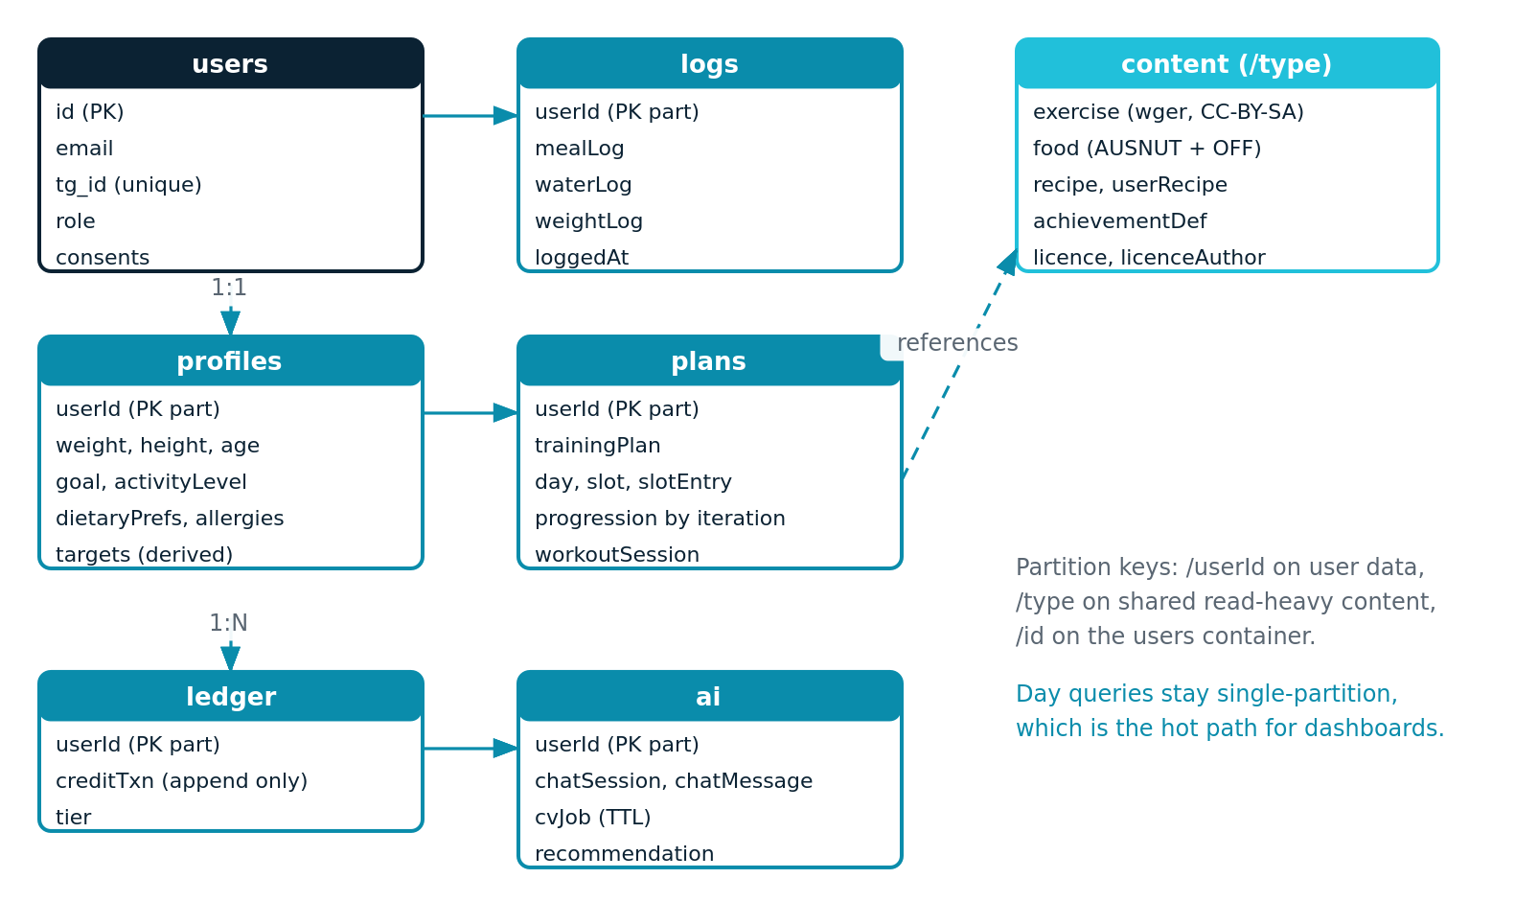
Figure 6.1: Container map, key entities and partition strategy

2. Containers
Container | Partition key | Document types | Access pattern
users | /id | user, credentials, consent record, telegram link | Point read by id; unique key policy on tg_id for launch lookups
profiles | /userId | wellnessProfile, derivedTargets | One read per session; targets denormalised so the dashboard needs no join
logs | /userId | mealLog, mealLogItem, waterLog, weightLog | Range query by userId and date; the highest volume container
plans | /userId | trainingPlan, planDay, slot, slotEntry, progressionRule, workoutSession, sessionExercise | Read current plan and today's session; append session history
content | /type | exercise, exerciseMedia, food, recipe, userRecipe, achievementDefinition | Read heavy, shared across users, aggressively cached
ai | /userId | chatSession, chatMessage, cvJob, recommendation | Append and read recent; time-to-live on completed vision jobs
ledger | /userId | creditTransaction (append only) | Balance derived by folding transactions; never updated in place
audit | /userId | authEvent, dataAccessEvent, guardrailTrigger | Write mostly; queried during incident review

3. Key Entity Definitions

3.1 wellnessProfile
Field | Type | Constraint
weightKg | number | 30 to 300, stored canonically in kilograms
heightCm | number | 100 to 250, stored canonically in centimetres
age | integer | 16 to 100
sex | enum | Used only for the metabolic formula; optional with a documented default
goal | enum | lose, maintain, gain
activityLevel | enum | sedentary, light, moderate, active, veryActive
exerciseExperience | enum | beginner, intermediate, advanced
dietaryPreferences | string array | Controlled vocabulary
allergies | string array | Drives deterministic exclusion, treated as safety critical
equipment | string array | Constrains exercise selection
unitPreference | enum | metric or imperial; conversion happens at the edge only

3.2 derivedTargets
bmr, tdee, kcalTarget, proteinG, carbsG, fatG, waterMl,
clamped: boolean, clampReason: string|null, computedAt, formulaVersion
Targets are always computed server-side and stored with the formula version so a change in method is traceable in historical records.

3.3 exercise (from the licensed corpus)
id, name, description, category, primaryMuscles[], secondaryMuscles[],
equipment[], difficulty, media[], licence, licenceAuthor, sourceId
The licence and licenceAuthor fields are never stripped. They are required to satisfy the attribution obligation recorded in AQF-12.

3.4 trainingPlan and progression
trainingPlan { id, userId, startDate, endDate, currentIteration, days[] }
planDay { order, focus, slots[] }
slot { order, entries[] }
slotEntry { exerciseId, notes }
progressionRule { slotEntryId, kind: weight|reps|sets|rest|rir, iteration, value }
An iteration is one complete pass through all days of a plan. Progression rules are keyed by iteration number, so progression is inspectable data rather than branching code. This makes generated plans testable and auditable, which matters because they are partly AI generated.

4. Constraints and Validation
Rule | Enforcement point
Numeric ranges on all biometric fields | Schema validation at the API edge and again in the service layer
kcalTarget never below the configured floor | Target calculator clamp, unit tested to 100 percent branch coverage
One canonical weight entry per user per day | Upsert keyed on userId and local date
No meal log committed from unconfirmed recognition | Vision job state must be confirmed before write
Allergen exclusion | Deterministic filter with zero tolerance for false negatives
Credit ledger is append only | No update or delete operation exists on the container

5. Indexing and Performance
- Composite index on userId and loggedAt for the logs container, supporting day and range queries.
- Unique key policy on tg_id within the users container for constant-time Telegram lookup.
- Selective indexing on the content container: index searchable fields, exclude large media and description bodies from the index to control request units.
- Time-to-live on completed vision jobs so raw prediction payloads do not accumulate.
- Cached read-through for food search and the exercise library, invalidated on content publication only.

6. Data Lifecycle
Data | Retention | On account deletion
Profile and biometrics | Life of the account | Erased
Meal, water and weight logs | Life of the account | Erased
Meal photographs | Deleted after confirmation plus a short grace window | Erased, blob soft delete then purge
Chat transcripts | Rolling window, user clearable | Erased
Credit ledger | Retained in anonymised form for financial integrity | Anonymised, user reference removed
Audit events | Retained for the published security window | Anonymised, not erased, and the reason is documented in AQF-11
Aggregate analytics | Indefinite | Already anonymous, no user reference exists

7. Migrations and Seeding
- Documents carry a schema version field. A migration function upgrades lazily on read, with a batch sweep for consistency.
- Every migration pull request includes a rollback note and is reviewed by the technical lead.
- Seeding is scripted and repeatable: the exercise corpus and the food composition data are ingested by named scripts owned by Victor Hong, with record counts logged as evidence.
- A seeded demonstration account exists in every environment so a marker can open the product and see a populated experience immediately.

