
AQF-07
API Contract
Conventions, authentication flows and the version one endpoint surface
AquaZeroFit, an AquaZero product
NIT3003 IT Capstone Project, Project 5
Group 15, Victoria University, Melbourne, Australia
Version 2.0, July 2026

Document Control
Field | Detail
Document | AQF-07 API Contract
Version | 2.0 (AquaZeroFit rebrand, diagrams added)
Purpose | Freeze the interface between frontend and backend so both can be built in parallel. The machine-readable source of truth is the OpenAPI specification in the repository.
Document owner | Babatundji Williams-Fulwood, Technical Lead and Software Architect
Contributors | Eric La (Frontend), Victor Hong (Data and Quality)
Supervisor | [To be completed by the team]
Status | Draft for supervisor review
Change history | v1.0 initial draft as VitalAI. v2.0 rebranded to AquaZeroFit, diagrams added, roles assigned, sequencing applied

1. Conventions
- Base path /api/v1. Breaking changes require a new version segment; additive changes do not.
- Authorisation header carries a bearer access token. Access tokens are short lived; refresh tokens are single use and rotate.
- Every non-success response uses one envelope: code, message and optional details, with a stable machine-readable code.
- Pagination is cursor based using cursor and limit, with a maximum limit of one hundred; responses return nextCursor.
- Creation endpoints accept an idempotency key so a retry returns the original result rather than duplicating a log.
- Timestamps are ISO 8601 in UTC. The client supplies its timezone so day boundaries resolve correctly.
- Any AI-derived payload carries a metadata block naming the provider, model, prompt version and confidence where applicable.

2. Authentication

2.1 Web
POST /auth/register { email, password } -> 201, verification dispatched
POST /auth/login { email, password } -> { accessToken, refreshToken, user }
POST /auth/refresh { refreshToken } -> rotated pair, old token invalidated
POST /auth/logout -> refresh family revoked

2.2 Telegram Mini App
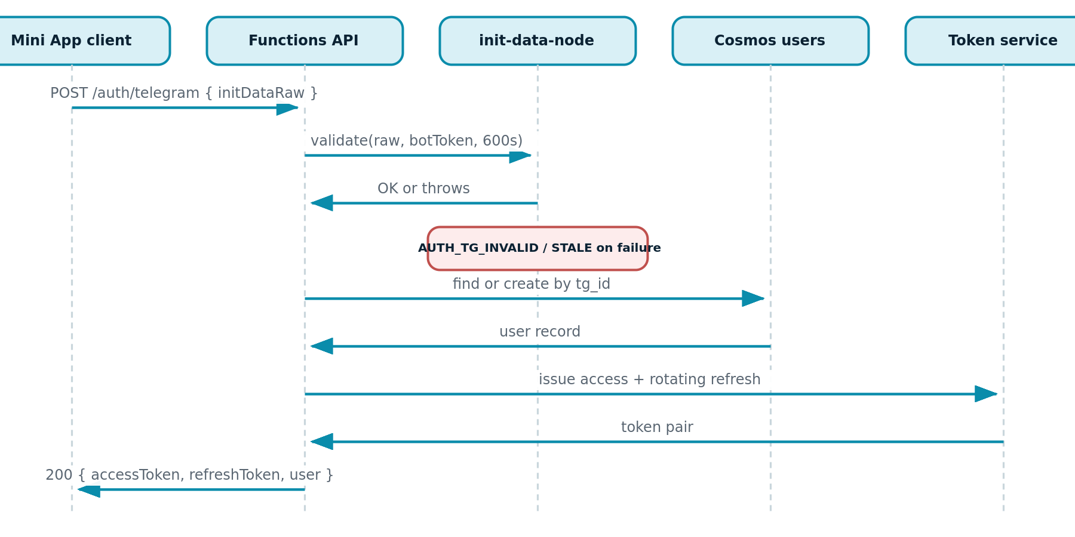
Figure 7.1: Mini App authentication sequence with server-side validation
The raw launch data string is accepted only by this endpoint, only over TLS, and is never persisted. Validation checks the signature against the bot token and rejects data older than the configured freshness window before any identity is established.

3. Endpoint Surface

3.1 Account and profile
Method | Path | Auth | Purpose
POST | /auth/register | none | Create account
POST | /auth/login | none | Issue token pair
POST | /auth/telegram | none | Validate launch data and issue token pair
POST | /auth/refresh | refresh | Rotate token pair
POST | /me/link-telegram | bearer | Attach a Telegram identity to the current account
GET / PUT | /me/profile | bearer | Read or update the wellness profile
GET | /me/targets | bearer | Computed calorie and macro targets with any clamp advisory

3.2 Food, water and logging
Method | Path | Auth | Purpose
GET | /foods?search= | bearer | Nutrition database search, cached, source identified per record
POST | /meal-logs | bearer | Create a manual meal log, idempotency key supported
GET | /meal-logs?date= | bearer | Day view grouped by meal type
PUT / DELETE | /meal-logs/{id} | bearer | Edit or remove an entry
POST | /meal-photos | bearer | Multipart upload, returns 202 with a job identifier
GET | /meal-photos/{jobId} | bearer | Job status and predictions with confidence
POST | /meal-photos/{jobId}/confirm | bearer | Commit corrected predictions to the log
POST | /water-logs | bearer | Record a water increment

3.3 Analytics, recommendations, training and progress
Method | Path | Auth | Purpose
GET | /analytics/nutrition/daily?date= | bearer | Ring data: remaining calories, macro progress, net calories
GET | /analytics/nutrition/trends?range= | bearer | Trend series for charts
POST | /recommendations/meals | bearer | Context-aware meal suggestion with AI metadata
POST | /recommendations/{id}/log | bearer | One-tap add a suggestion to the log
POST | /recommendations/{id}/feedback | bearer | Signal into the evaluation loop
GET | /plans/current | bearer | Active weekly plan with iteration state
POST | /plans/generate | bearer | Generate or regenerate a plan
GET | /workouts/today | bearer | Today's session with sets, reps, rest and media
POST | /workouts/{id}/complete | bearer | Log session results
POST | /workouts/{id}/swap-exercise | bearer | Constrained substitution
POST | /weight-logs | bearer | Record a weigh-in
GET | /progress/summary | bearer | Weight series, streaks and achievements

3.4 Assistant, privacy and administration
Method | Path | Auth | Purpose
POST | /chat/sessions | bearer | Open a conversation
POST | /chat/sessions/{id}/messages | bearer | Send a message, response streams via server-sent events
GET | /me/export | bearer | Asynchronous export producing a download link
DELETE | /me | bearer | Account deletion with a grace period
GET / PUT | /me/consents | bearer | Read or update consent state
GET | /admin/users | admin | Support and monitoring overview
PUT | /admin/exercises/{id} | admin | Content library management

4. AI Admission Sequence
Every endpoint capable of triggering a model call enforces this order. Skipping a step is a defect, not an optimisation.
1 authenticate -> 2 rate limit (per user and per IP) -> 3 tier and credit check
-> 4 input guardrail -> 5 gateway routing -> 6 output guardrail and numeric rules
-> 7 respond and record telemetry

5. Error Taxonomy
Code | HTTP | Meaning and client behaviour
AUTH_TG_INVALID | 401 | Launch data signature failed. Client restarts the launch flow
AUTH_TG_STALE | 401 | Launch data older than the freshness window. Client restarts the launch flow
VALIDATION_FAILED | 400 | Schema or safe-range violation. Details list the offending fields
RATE_LIMITED | 429 | Limit reached. Retry-After header supplied
CREDITS_INSUFFICIENT | 402 | Balance below task cost. Payload carries purchase screen data
SAFETY_INPUT | 422 | Input guardrail blocked the request. Client shows the supportive signpost
SAFETY_OUTPUT | 422 | Generation failed post-filter. Client offers a retry or a manual path
AI_UNAVAILABLE | 503 | All providers in the chain failed. Client offers the manual path

