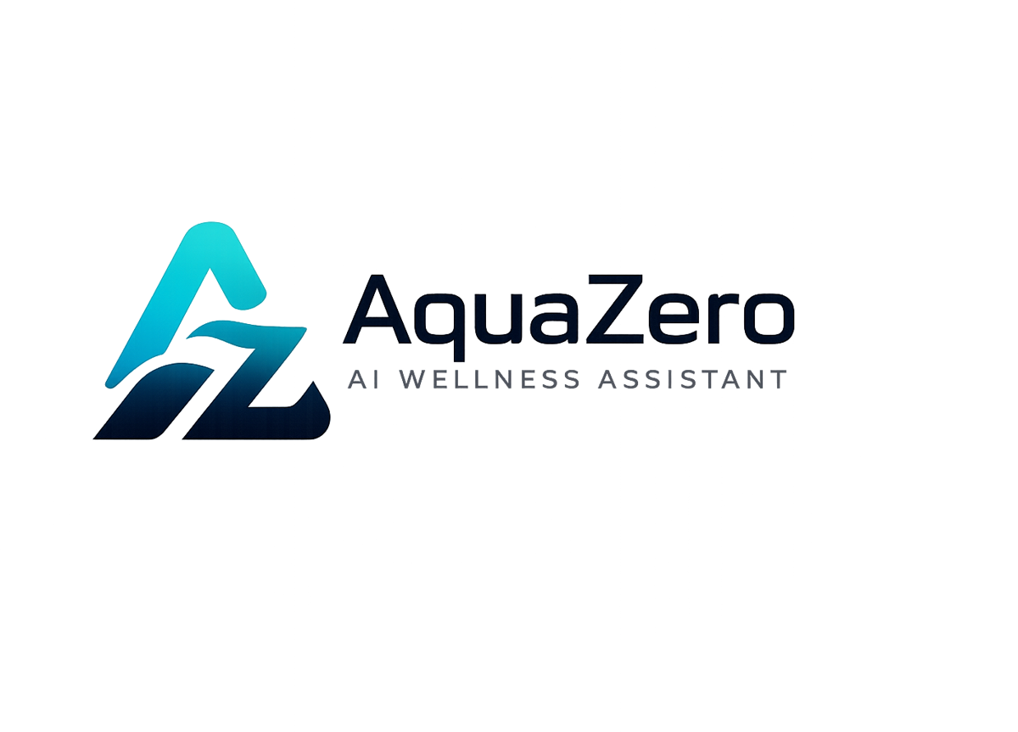
AQF-08
UML Diagram Package
Use case, class, sequence, activity, state and deployment views
AquaZeroFit, an AquaZero product
NIT3003 IT Capstone Project, Project 5
Group 15, Victoria University, Melbourne, Australia
Version 2.0, July 2026

Document Control
Field | Detail
Document | AQF-08 UML Diagram Package
Version | 2.0 (AquaZeroFit rebrand, diagrams added)
Purpose | Provide the modelling views required by the unit brief, each tied to the requirement or flow it explains.
Document owner | Babatundji Williams-Fulwood, Technical Lead and Software Architect
Contributors | Eric La (Frontend), Victor Hong (Data and Quality)
Supervisor | [To be completed by the team]
Status | Draft for supervisor review
Change history | v1.0 initial draft as VitalAI. v2.0 rebranded to AquaZeroFit, diagrams added, roles assigned, sequencing applied

1. How to Read This Package
Each diagram is generated from the design documents rather than drawn independently, so the package cannot drift from the architecture. Source files are versioned in the repository under /docs/uml alongside the exported images.
View | Answers | Figure
Use case | Who uses the system and what they can do | 8.1
Class | What the code objects are and how they relate | 8.2
Sequence: authentication | How a Mini App user is trusted | 8.3
Sequence: meal photograph | How a photograph becomes a verified log | 8.4
Activity | How a new user reaches their first plan safely | 8.5
State | How asynchronous jobs and sessions transition | 8.6
Deployment | Where the software runs and how it is released | 8.7

2. Use Case View
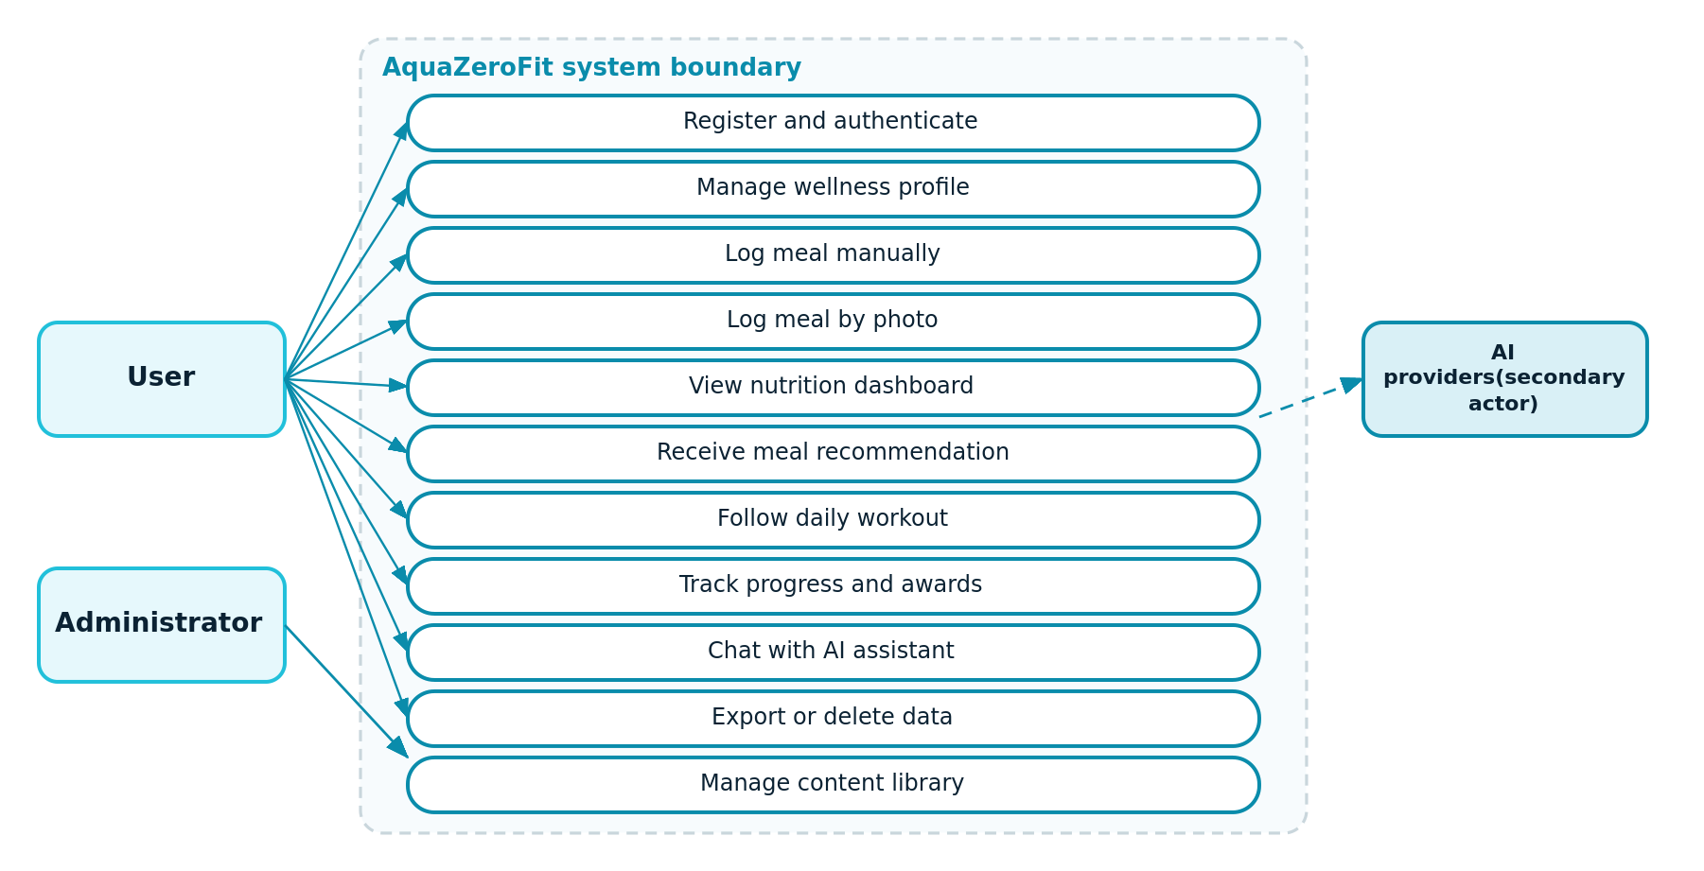
Figure 8.1: Use case diagram with system boundary and secondary actor
The AI providers appear as a secondary actor reached only through the gateway. They are never invoked directly by a use case, which is the modelling expression of the boundary rule in ADR-004.

3. Class View
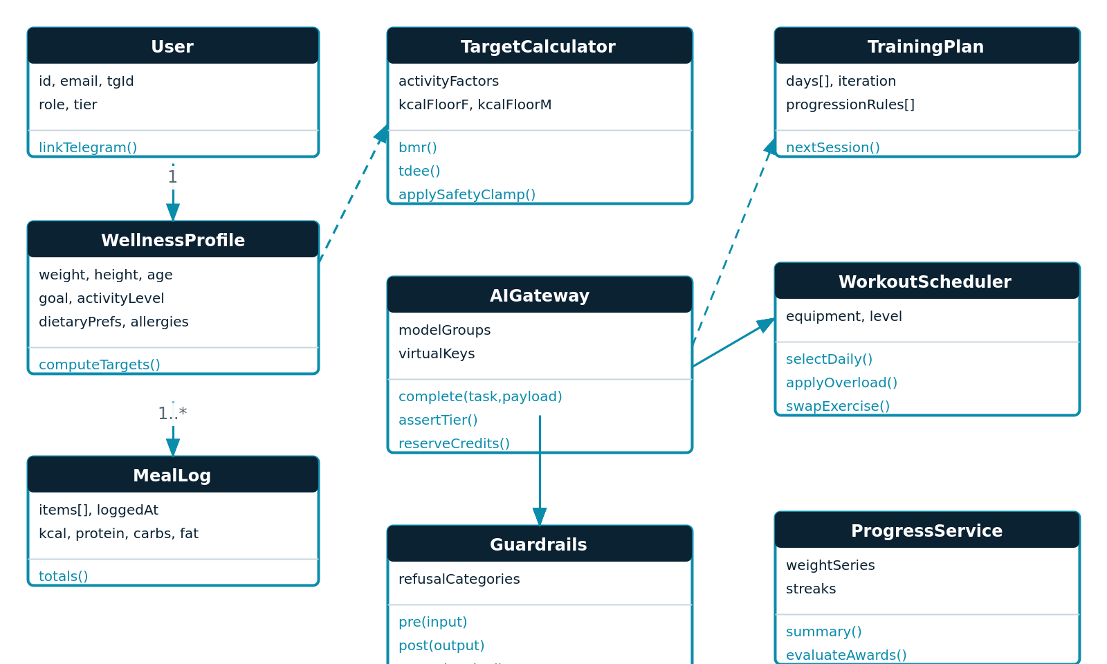
Figure 8.2: Domain and service classes with key attributes and operations
- TargetCalculator is deliberately separate from WellnessProfile so the metabolic formula and its safety clamp can be unit tested in isolation to full branch coverage.
- Guardrails is a dependency of AIGateway rather than a caller, so no code path can reach a provider without passing through it.
- WorkoutScheduler reads progression rules as data; it contains no per-exercise branching logic.

4. Sequence Views
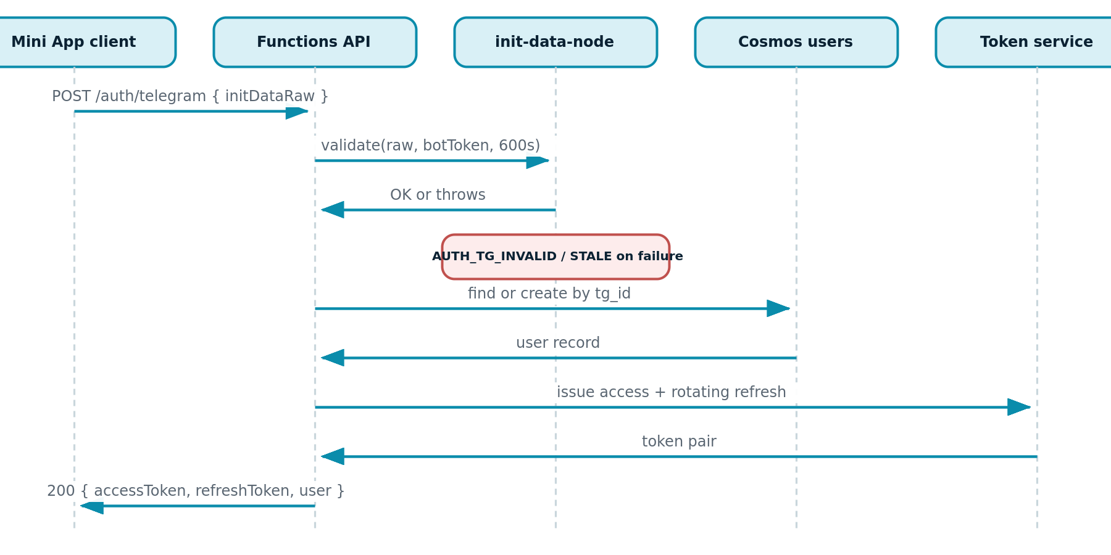
Figure 8.3: Telegram Mini App authentication and token issuance
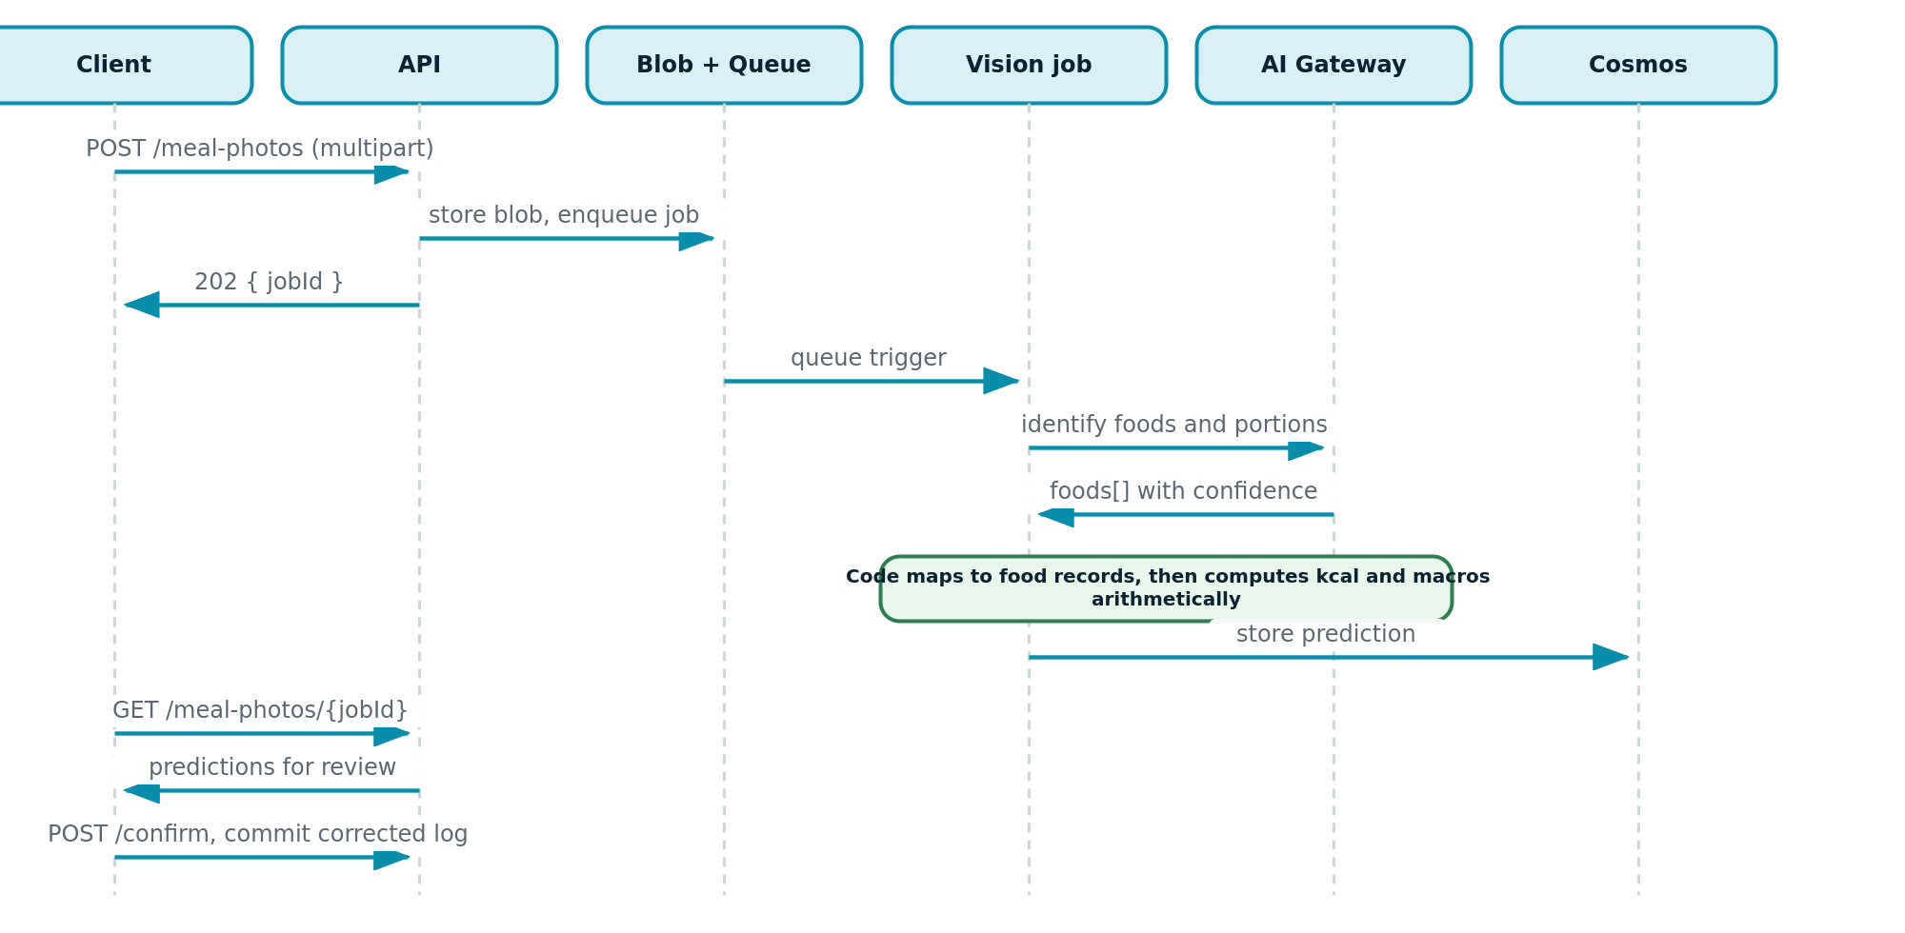
Figure 8.4: Meal photograph from upload to confirmed log, showing the deterministic calculation step
Note in Figure 8.4 that the model returns identified foods and portions only. Mapping, filtering and arithmetic occur in code between the model response and the stored prediction. This is the visual statement of ADR-015.

5. Activity View
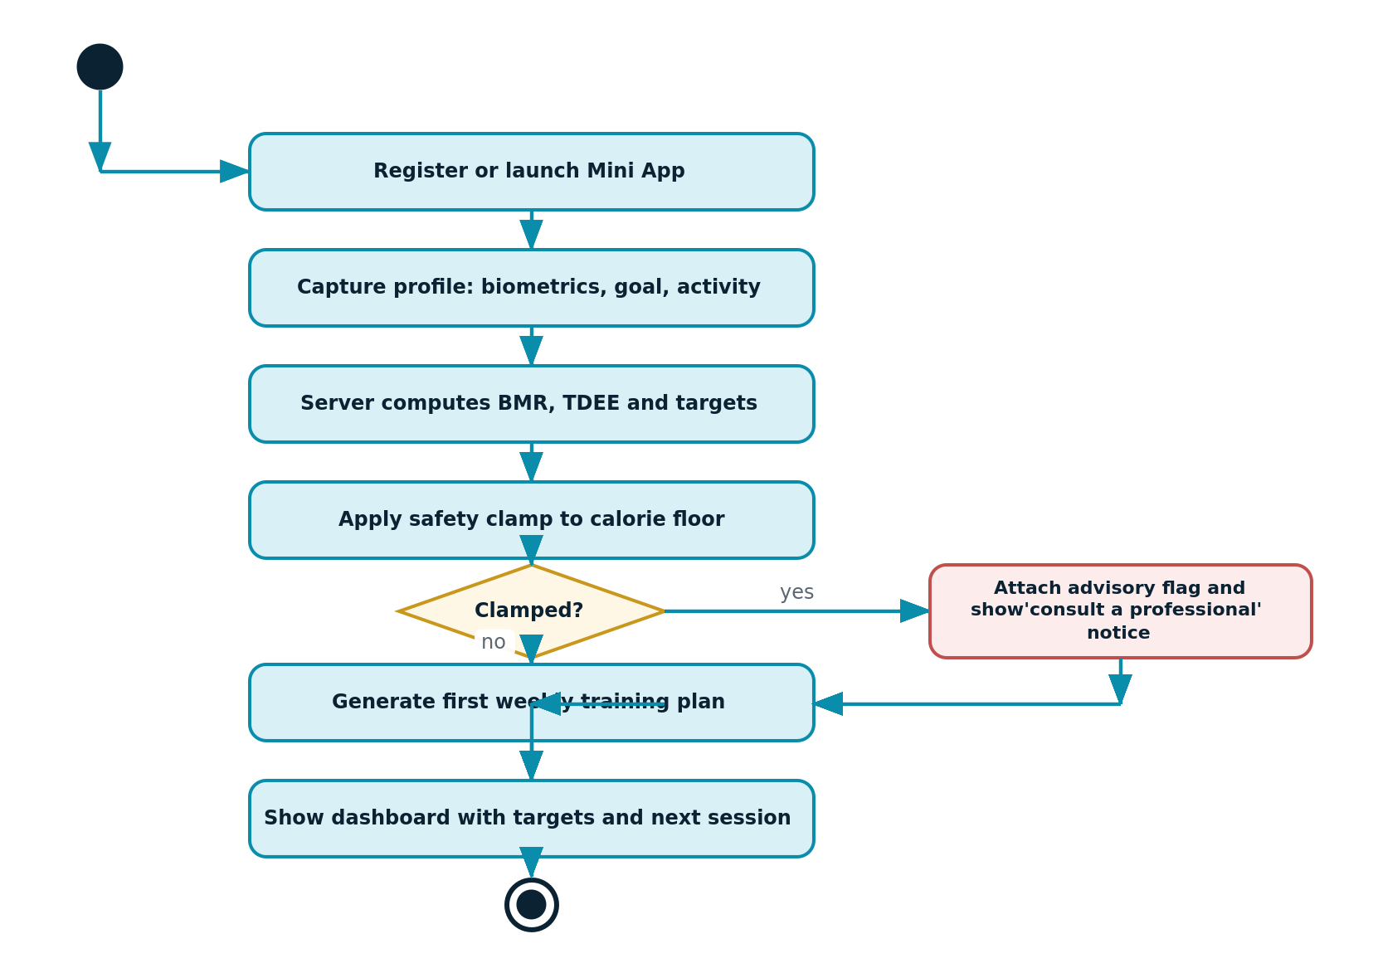
Figure 8.5: Onboarding to first plan, including the safety clamp decision
The decision node is the safety clamp. If the computed target falls below the configured floor, the system clamps it, attaches an advisory and surfaces guidance to consult a professional. There is no path in which an unsafe target reaches the user.

6. State View
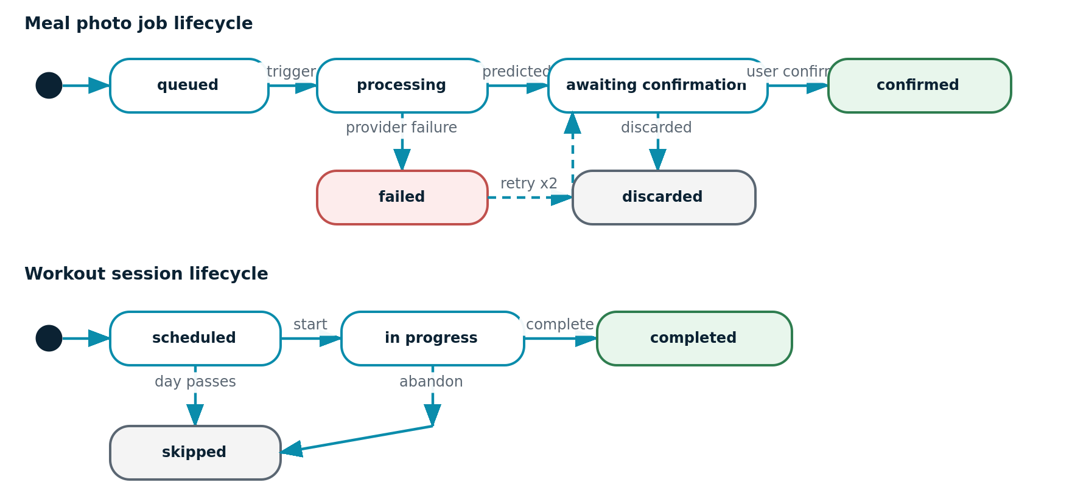
Figure 8.6: Lifecycle of a vision job and of a workout session

7. Deployment View
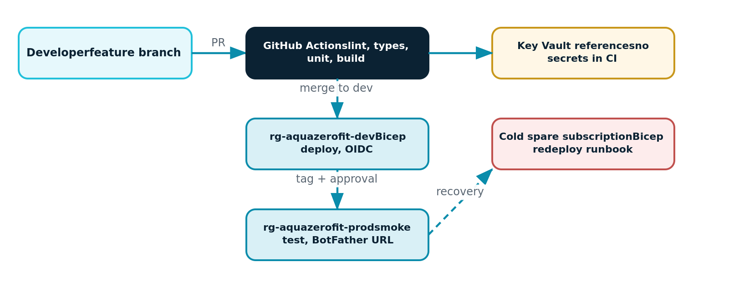
Figure 8.7: Deployment topology, release path and recovery route

8. Traceability of Diagrams to Requirements
Figure | Requirements covered
8.1 Use case | F1 to F10, brief requirements 1 to 9
8.2 Class | FR-005 to FR-007, FR-020 to FR-027
8.3 Sequence, authentication | FR-002, FR-003, NFR-04, NFR-05
8.4 Sequence, meal photograph | FR-012 to FR-014, brief requirement 3
8.5 Activity | FR-006, FR-007, FR-021
8.6 State | FR-013, FR-024, NFR-03
8.7 Deployment | NFR-01, NFR-03, NFR-04

