
AQF-09
Low-Level Design
Module map, normative algorithms, component contracts and engineering standards
AquaZeroFit, an AquaZero product
NIT3003 IT Capstone Project, Project 5
Group 15, Victoria University, Melbourne, Australia
Version 2.0, July 2026

Document Control
Field | Detail
Document | AQF-09 Low-Level Design
Version | 2.0 (AquaZeroFit rebrand, diagrams added)
Purpose | Give developers everything needed to write the code without re-deriving decisions: exact algorithms, interfaces, error handling and standards.
Document owner | Babatundji Williams-Fulwood, Technical Lead and Software Architect
Contributors | Eric La (Frontend), Victor Hong (Data and Quality)
Supervisor | [To be completed by the team]
Status | Draft for supervisor review
Change history | v1.0 initial draft as VitalAI. v2.0 rebranded to AquaZeroFit, diagrams added, roles assigned, sequencing applied

1. Backend Module Map
Module | Key units | Responsibility | Owner
auth | AuthController, TelegramAuthValidator, TokenService | Registration, login, launch data validation, token issue and rotation | Babatundji
profile | ProfileService, TargetCalculator | Profile CRUD and derived targets with safety bounds | Babatundji
food | FoodSearchService, MealLogService | Search, meal CRUD, daily aggregation | Babatundji
vision | PhotoIntakeFunction, VisionJobFunction, PredictionMapper | Upload, queued inference, mapping, confirmation | Babatundji
ai | AIGateway, TierPolicy, CreditLedger, Guardrails | All model access, routing policy, metering and safety | Babatundji
training | PlanGenerator, WorkoutScheduler, SessionLogger | Plan generation, daily selection, overload, session logs | Babatundji
progress | ProgressService, AchievementEngine | Weight series, streaks, award evaluation | Babatundji
chat | ChatService, ToolExecutor | Sessions, streaming, tool calls into internal services | Babatundji
data | Seeders, Migrations, FoodDataClient | Corpus ingestion, schema migration, external data access | Victor
platform | RateLimiter, ErrorMapper, Telemetry, SecretsClient | Cross-cutting middleware and infrastructure access | Babatundji

2. Normative Algorithms

2.1 TelegramAuthValidator
Specification of the validation performed. The implementation calls the maintained library (ADR-017) wrapped in our validator so our error codes are preserved; this pseudocode remains the basis of our own test vectors.
params = parse launch data as URL query pairs; extract and remove 'hash'
dataCheckStr = join sorted 'key=value' pairs with newline
secretKey = HMAC_SHA256(key = 'WebAppData', message = BOT_TOKEN)
calculated = hex(HMAC_SHA256(key = secretKey, message = dataCheckStr))
require timingSafeEqual(calculated, hash) else AUTH_TG_INVALID
require now - auth_date <= 600 seconds else AUTH_TG_STALE
return parsed user identity
Mandatory test vectors: a known-good payload, a payload with one tampered field, and a payload with a stale timestamp.

2.2 TargetCalculator
BMR (Mifflin-St Jeor): male 10w + 6.25h - 5a + 5 | female 10w + 6.25h - 5a - 161
TDEE = BMR * factor { sedentary 1.2, light 1.375, moderate 1.55, active 1.725, very 1.9 }
deficit: target loss <= 0.5 to 1.0 percent of bodyweight per week
kcalTarget = TDEE - deficit
clamp: kcalTarget >= floor (configured, default 1200 female / 1500 male)
if clamped -> set clamped=true, clampReason, and surface advisory
protein g = 1.6 to 2.2 per kg by goal ; fat >= 20 percent of kcal ; carbs = remainder

2.3 AIGateway.complete
TierPolicy.assert(user, task) // free lane confinement
CreditLedger.reserve(user, cost(task)) // 402 if insufficient
input = Guardrails.pre(payload) // 422 SAFETY_INPUT on block
resp = POST {GATEWAY}/v1/chat/completions {
model: MODEL_GROUP[task], // logical group, not a provider
messages: input, response_format: schemaFor(task) }
with header Authorization: Bearer virtualKeyFor(user.tier)
out = Guardrails.post(resp); NumericRules.check(out) // kcal floor, macro sanity
CreditLedger.commit(); Telemetry.log(provider, tokens, latency, promptVersion)
Application code knows only logical model group names such as visionPrimary, chatFast and planStructured. Real provider models, fallback chains, retries and budgets live in gateway configuration.

2.4 WorkoutScheduler.selectDaily
pool = exercises where equipment subset of user.equipment and difficulty <= user.level
score = muscle-group recency (>= 48h rest per group) + plan template slot + user feedback
overload: if last two sessions completed at target -> increase reps, then load, then volume
enforce: rest days; no consecutive high-intensity days for a beginner profile
output: session with sets, reps, rest, primary muscle and at least one media asset

3. Meal Photograph Pipeline
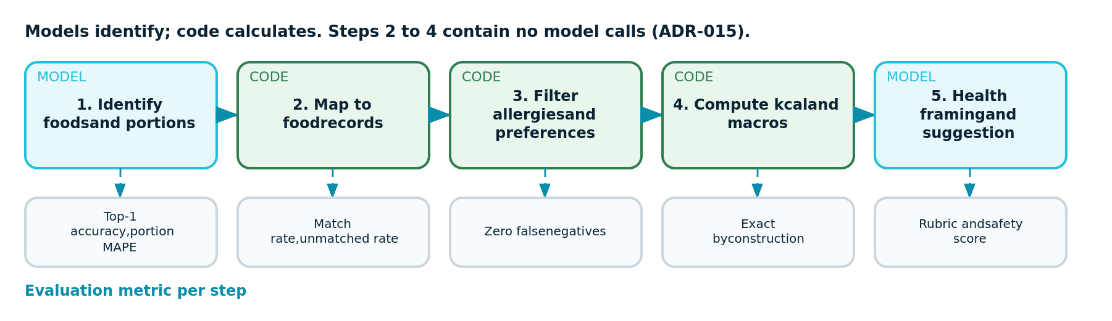
Figure 9.1: Five-step pipeline showing which steps are model calls and which are deterministic code
Steps two, three and four contain no model calls. Calories are looked up and multiplied, not estimated. Allergen filtering is deterministic because a false negative there is a safety failure, not a quality issue.

4. Frontend Component Contracts
Component | Props | States and rules
RingProgress | value, target, size, tone | Aqua for positive progress, deep navy for baseline, coral for alert; animates on mount; accessible label states value of target
MetricCard | label, value, unit, delta, tone | Skeleton, empty and error variants are mandatory, not optional
MealCard | meal, onAdd, onEdit | Shows calories and macro line; optimistic add with rollback toast on failure
ScanReview | predictions, onConfirm, onCorrect | Every field editable, confidence visible, confirm disabled while saving, never auto-commits
ExerciseCard | exercise, media, onOpen | Lazy-loads media; rest and primary muscle chips
ChatStream | messages, onSend, streaming | Appends streamed tokens, polite live region, persistent disclaimer slot, report control
- Server state is cached with explicit invalidation: committing a log invalidates the daily analytics and dashboard ring queries.
- The AquaZero design tokens are the default theme. Inside Telegram the client theme variables are bound and preferred for surfaces so the application matches the user's client.
- Assistant output is markdown and is sanitised before rendering. Model output is untrusted input to the document.

5. Error Handling and Resilience
- Per-provider timeout with retry and backoff, plus circuit breaking, handled at the gateway.
- User-facing degradation matrix: if all AI lanes fail, manual logging, dashboards and existing plans remain fully functional.
- Idempotency keys on log creation so a retry never duplicates a meal.
- Poisoned queue messages move to a dead-letter path after five dequeues and raise an alert.

6. Engineering Standards
Standard | Rule
Module boundary | No provider SDK import outside the ai module; enforced by lint rule and pipeline check
Coverage | 70 percent on services; 100 percent branch coverage on validator, target calculator, guardrails and ledger
Comments | Explain why, not what. Safety floors, signature ordering and partition choices carry a comment linking to the relevant ADR
Pull requests | Description states approach, impact, testing performed and edge cases; screenshots for interface work; at least one reviewer outside the author's lane
Banned files | No proxy configuration file anywhere in the tree (ADR-018), enforced in the pipeline
Secrets | No secret in source, log or client bundle; automated scan on every pull request

