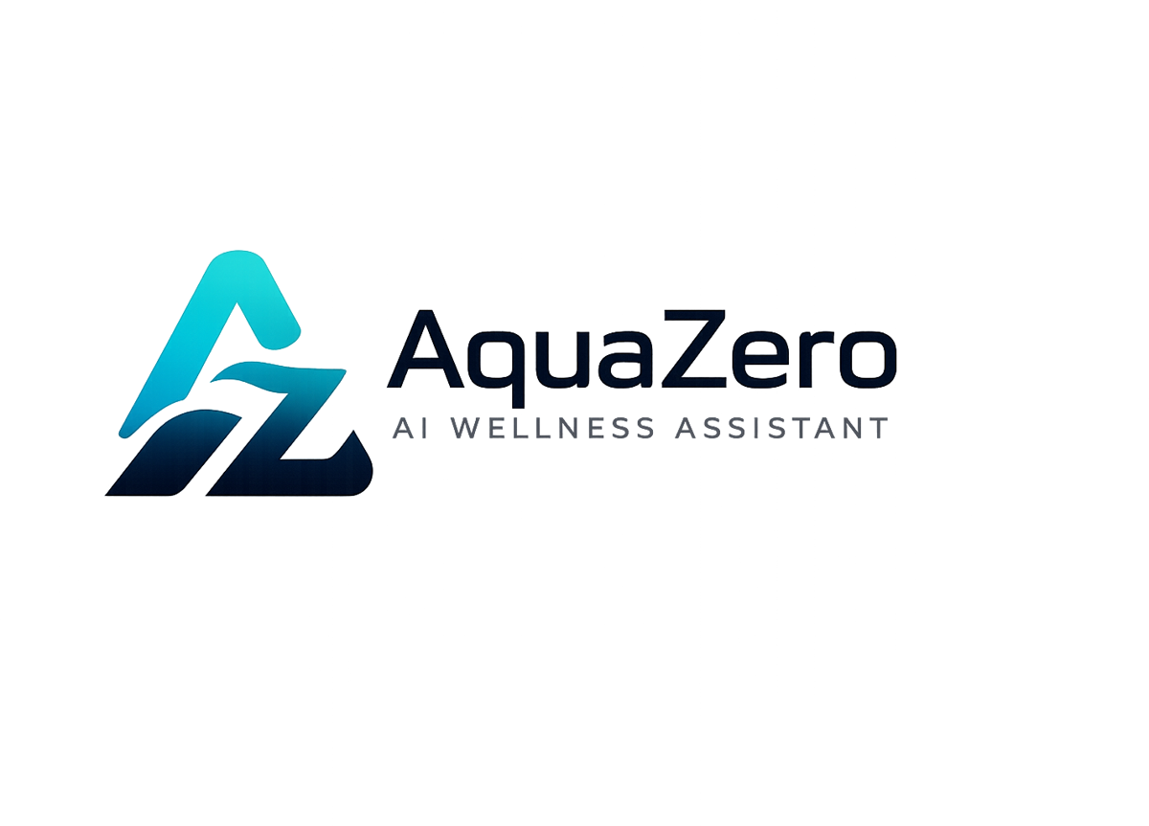
AQF-11
Safety, Privacy and Ethical Design
Boundaries, guardrails, data protection and ethical commitments
AquaZeroFit, an AquaZero product
NIT3003 IT Capstone Project, Project 5
Group 15, Victoria University, Melbourne, Australia
Version 2.0, July 2026

Document Control
Field | Detail
Document | AQF-11 Safety, Privacy and Ethical Design
Version | 2.0 (AquaZeroFit rebrand, diagrams added)
Purpose | Satisfy brief requirement ten as a first-class engineering concern. This document defines what the product will not do and how that is enforced in code.
Document owner | Babatundji Williams-Fulwood, Technical Lead and Software Architect
Contributors | Eric La (Frontend), Victor Hong (Data and Quality)
Supervisor | [To be completed by the team]
Status | Draft for supervisor review
Change history | v1.0 initial draft as VitalAI. v2.0 rebranded to AquaZeroFit, diagrams added, roles assigned, sequencing applied

1. Scope Boundary
AquaZeroFit provides general wellness and fitness support only. It does not provide medical diagnosis, treatment, medication guidance, mental health therapy or eating disorder treatment, and it does not integrate with clinical systems. This is a product boundary enforced in code, not a disclaimer added at the end.
The product will | The product will not
Estimate calories and macronutrients from logged food | Diagnose any condition or interpret medical results
Suggest meals within the user's stated preferences and targets | Advise on medication, supplements as treatment, or clinical nutrition therapy
Generate home training plans within safe progression limits | Prescribe rehabilitation for an injury
Signpost professional help when a question falls outside scope | Provide counselling or eating disorder treatment
Show trends and let the user draw conclusions | Claim a health outcome or imply clinical efficacy
Commercial note: the moment marketing copy promises diagnosis, treatment or a medical outcome, the product enters software-as-a-medical-device territory in Australia. The capstone boundary and the commercial boundary are deliberately the same line.

2. Content Safety Policy
Policy | Rule | Enforcement
Calorie floor | No generated target may fall below the configured floor, default 1200 kcal female and 1500 kcal male | Deterministic clamp in TargetCalculator, unit tested to full branch coverage
Deficit ceiling | Weight-loss rate capped at 0.5 to 1.0 percent of bodyweight per week | Bounded in target derivation and in weekly adaptation
No extreme protocols | No prolonged fasting, crash diets, purging or dehydration practices in any output | Prompt policy plus output filter plus numeric rules
Exercise safety | No high-risk movement for a beginner profile; warm-up included; pain means stop | Scheduler constraints plus content tagging in the exercise library
Allergen exclusion | Declared allergens never appear in a suggestion | Deterministic filter, zero tolerance for false negatives, tested
Age | Minimum age sixteen; users under eighteen receive conservative defaults and additional signposting | Registration validation and profile-driven policy

3. Guardrail Architecture
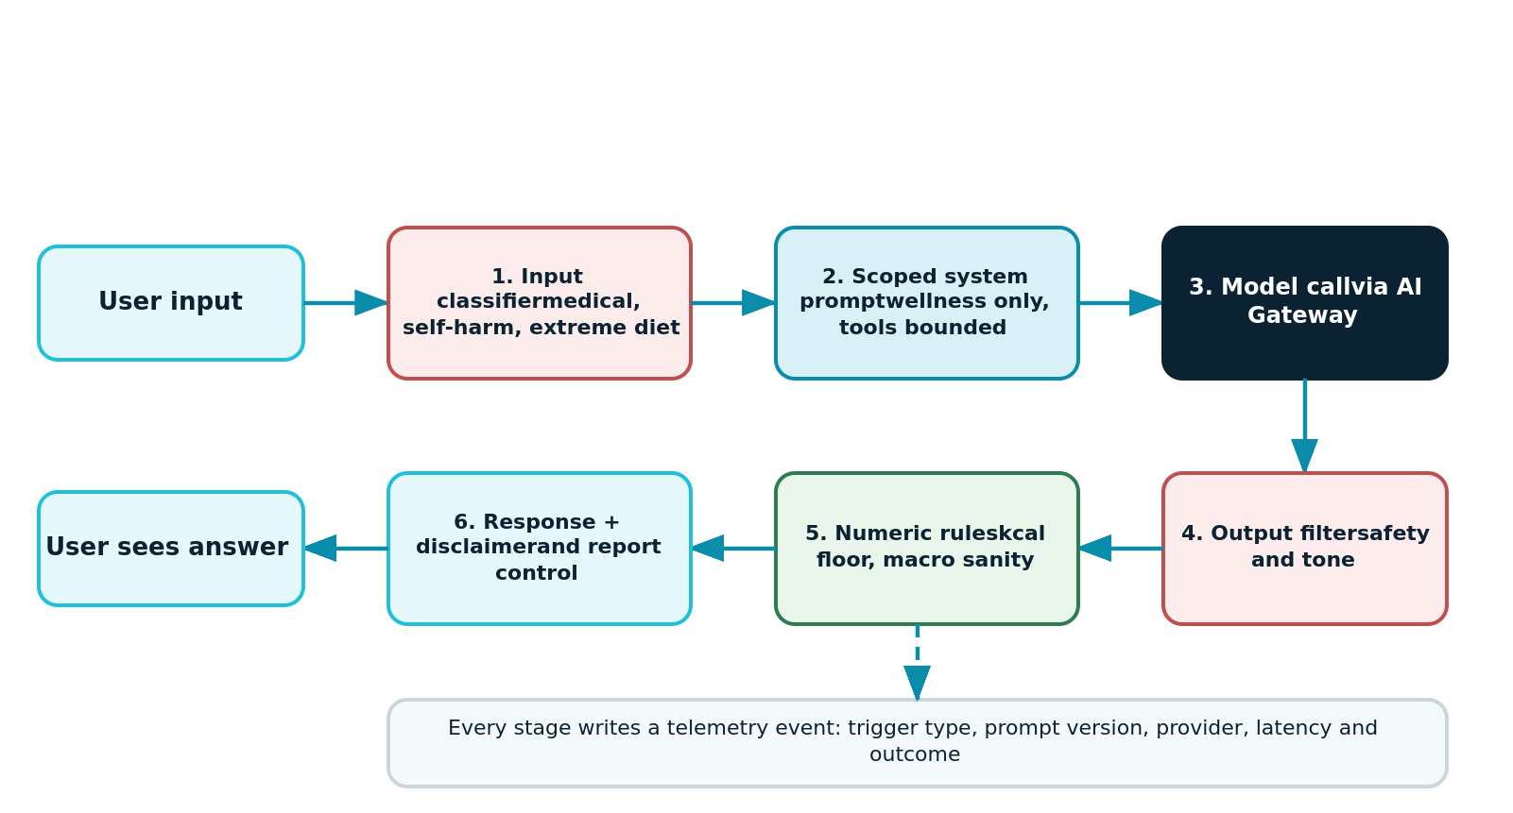
Figure 11.1: Six-stage guardrail path around every model call, with telemetry at each stage
- Stage one screens input before any premium token is spent, using the cheap lane, which makes safety inexpensive.
- Stage two constrains the model with a scoped system prompt and a bounded tool set.
- Stage four filters generated content; stage five applies numeric rules that a language model cannot be trusted to respect.
- Stage six attaches the persistent disclaimer and the report control, so the user always has a way to flag a bad answer.
- Every stage writes a telemetry event, so guardrail behaviour is measurable rather than assumed.

4. Crisis Handling
Signal category | Response
Self-harm or suicidal language | Stop the wellness flow. Respond with a brief, warm message, provide Australian support contacts including Lifeline on 13 11 14, and do not continue with diet or exercise content in that turn
Eating disorder indicators | Do not provide calorie or restriction content. Signpost the Butterfly Foundation National Helpline on 1800 33 4673 and encourage professional support
Requests for unsafe restriction | Refuse the specific request, explain the safety floor plainly, and offer a safe alternative
Medical questions | Refuse with a supportive signpost to a general practitioner or accredited practising dietitian
- Responses never name or describe methods of self-harm.
- Every crisis trigger is logged for review without storing the message content beyond the retention window.
- The team does not present these responses as clinical care. They are a safe handover to people who provide it.

5. Privacy Design

5.1 Data inventory and classification
Data | Classification | Basis and handling
Email and credentials | Personal information | Required for account; password hashed with a modern algorithm, never recoverable
Weight, height, age, body metrics | Sensitive health-adjacent information | Explicit consent at onboarding; logically separated; encrypted at rest and in transit
Meal logs and photographs | Sensitive health-adjacent information | Photographs deleted after confirmation plus a short grace window
Chat transcripts | Personal information | Rolling retention window; user can clear at any time
Telegram identifier | Personal information | Stored only to resolve identity; no other Telegram data retained
Aggregate analytics | Anonymous | No user reference exists; cannot be re-identified

5.2 Rights and controls
Right | Implementation
Be informed | Plain-language privacy notice presented at onboarding, not buried in terms
Consent and withdraw | Granular consent record; withdrawal disables the dependent feature rather than the account
Access and portability | Machine-readable export endpoint producing a downloadable archive
Erasure | Account deletion erases or irreversibly anonymises all personal records within the published window
Correct | All profile and log data is user editable

5.3 Security controls supporting privacy
- Encryption in transit and at rest across all stores.
- Role-based access with least privilege; no team member holds standing production data access.
- Audit logging of authentication and data access events, retained for the published security window and anonymised rather than erased on deletion, so that a security record survives while personal identity does not.
- Secrets in a managed vault, retrieved at runtime by identity; any exposed key rotated the same day.
- Breach response: freeze sessions, rotate secrets, assess scope from audit logs, notify affected users and the supervisor, document the timeline.

6. Ethical Commitments
Commitment | How it shows up in the product
Weight-neutral, non-shaming language | Copy review checklist; no language framing a body or a food as bad; progress framed as behaviour, not worth
No dark patterns | Streaks celebrate but never guilt; cancelling and deleting are as easy as signing up
Transparency about AI | AI-generated content is labelled; recognition confidence is shown; the user always confirms before data is committed
Cultural inclusivity in food | Evaluation set spans multiple cuisines; a recommendation that only ever suggests one food culture is treated as a defect
Honest uncertainty | Low-confidence recognitions and crowd-sourced food records are visibly flagged rather than presented as fact
Human in the loop | No automatic commitment of AI-derived data; the user is the final authority on their own record

7. Risk Assessment
Risk | Likelihood | Impact | Mitigation
User acts on an unsafe generated target | Low | Severe | Deterministic clamp, advisory flag, professional signposting, tested to full coverage
Assistant answers a medical question | Medium | Severe | Input classifier, scoped prompt, output filter, adversarial evaluation as a merge gate
Allergen appears in a suggestion | Low | Severe | Deterministic filtering in code, never delegated to the model
Sensitive data exposure | Low | Severe | Vault-managed secrets, least privilege, audit logging, breach runbook
Recognition error produces wrong nutrition data | High | Low | Mandatory user confirmation; confidence displayed; corrections feed evaluation
User in crisis receives a wellness answer | Low | Severe | Crisis classifier ahead of the wellness flow; support contacts; no method content

