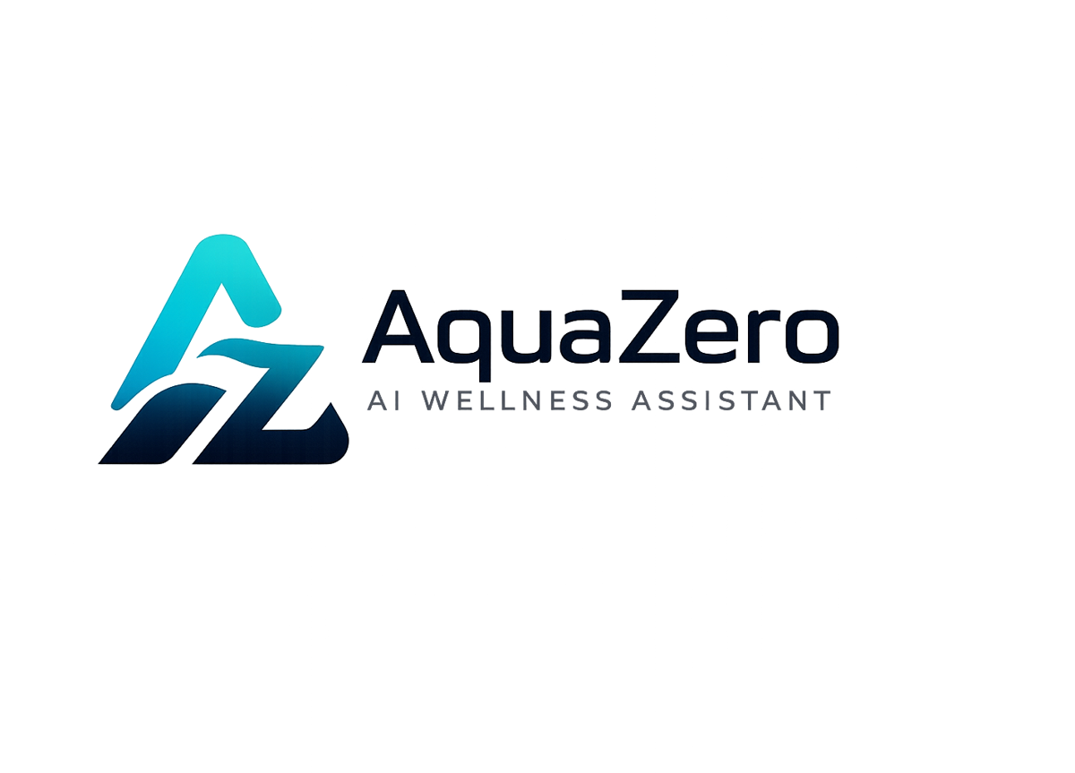
AQF-13
Technical Implementation Document
Repository, environment setup, build sequence and implementation evidence
AquaZeroFit, an AquaZero product
NIT3003 IT Capstone Project, Project 5
Group 15, Victoria University, Melbourne, Australia
Version 2.0, July 2026

Document Control
Field | Detail
Document | AQF-13 Technical Implementation Document
Version | 2.0 (AquaZeroFit rebrand, diagrams added)
Purpose | Record how the design was actually built: the repository layout, the tooling, the build order, and where the evidence of each implemented requirement lives.
Document owner | Babatundji Williams-Fulwood, Technical Lead and Software Architect
Contributors | Eric La (Frontend), Victor Hong (Data and Quality)
Supervisor | [To be completed by the team]
Status | Draft for supervisor review
Change history | v1.0 initial draft as VitalAI. v2.0 rebranded to AquaZeroFit, diagrams added, roles assigned, sequencing applied

1. Technology Stack as Implemented
Layer | Technology | Rationale reference
Frontend | React 18, TypeScript, Vite, official Telegram Mini App template | ADR-001, ADR-017
Styling | Utility CSS mapped to AquaZero design tokens; Telegram theme variables bound in the Mini App branch | AQF-09 section 4
Backend | Azure Functions, Node.js, TypeScript | ADR-002
Database | Azure Cosmos DB, free tier | ADR-003
Storage and queue | Azure Blob Storage, Azure Storage Queue | ADR-008
AI gateway | Gateway proxy container on Azure Container Apps | ADR-004, ADR-012
Providers | Groq, Gemini, Ollama Cloud, NVIDIA | ADR-005
Retrieval | Azure AI Search, free tier | AQF-04 section 3
Secrets | Azure Key Vault with Managed Identity | ADR-006
Infrastructure | Bicep templates, pipeline deployed with federated credentials | ADR-010
Observability | Application Insights and Azure Monitor | AQF-10 section 4

2. Repository Layout
/apps/web React application, both delivery targets
/apps/api Azure Functions, service modules and jobs
/packages/shared Types, validation schemas, generated API client
/infra Bicep templates and parameter files
/prompts Versioned prompt files, one per prompt identifier
/evals Evaluation sets and the runner used as a pipeline gate
/scripts Seeding and migration scripts
/docs This document set, UML sources, traceability matrix
/content ATTRIBUTION.md and licensed content notes
THIRD_PARTY_NOTICES.md, README.md, CHANGELOG.md

3. Environment Setup

3.1 Prerequisites
- Node.js LTS and a package manager, Azure CLI, Bicep, Docker for the gateway container, Git.
- An Azure for Students subscription for the project, with a second member's subscription held as a cold spare.
- Access to the four AI provider accounts and a Telegram bot token obtained from the platform bot manager.

3.2 First-time provisioning
- Authenticate with the Azure CLI and select the project subscription.
- Deploy the infrastructure template, which creates both resource groups and every service including budgets and policy assignments.
- Populate the vault with the provider keys, the bot token and the signing key. Names are canonical and are listed in AQF-15.
- Grant the Functions and gateway identities read access to the vault and verify with the health endpoint, which lists secret names only.
- Run the seeding scripts for the exercise corpus and the food composition data, recording the ingested record counts.
- Register the deployed frontend URL with the platform bot manager so the Mini App launches against the correct environment.

3.3 Local development
npm install # workspace install at the repository root
npm run dev # web target in a browser, Telegram environment mocked
npm run dev:https # local TLS, required for a real Telegram launch
npm run api # Functions host locally against development resources
npm run seed:exercises # populate the content container
npm run seed:foods # populate the food composition data
npm run test # unit and integration suites
npm run eval # AI evaluation sets, the same runner the pipeline uses

4. Build Sequence
Work is implemented in dependency order so that no module is blocked waiting on an unbuilt dependency. This ordering is the basis of the sprint plan.
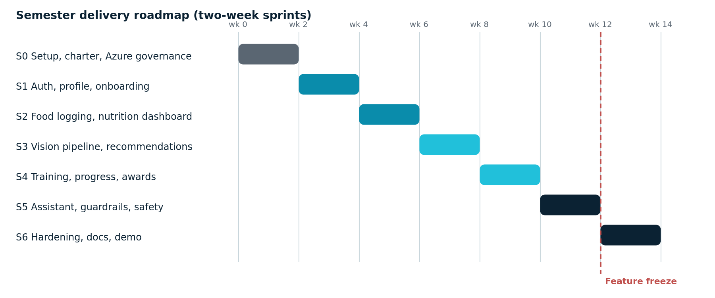
Figure 13.1: Implementation sequence across the semester
Order | Work | Depends on | Owner
1 | Repository, pipeline, infrastructure template, governance and access | Charter approved | Babatundji
2 | Authentication for both paths, token service, session model | Infrastructure live | Babatundji
3 | Profile capture and target derivation with safety clamp | Authentication | Babatundji
4 | Design system implementation and application shell for both targets | API contract frozen | Eric
5 | Content ingestion: exercise corpus and food composition data | Database provisioned | Victor
6 | Manual food logging and nutrition dashboard | Profile and content | Babatundji and Eric
7 | Gateway container, provider configuration and guardrails | Vault populated | Babatundji
8 | Vision pipeline: upload, queue, inference, mapping, confirmation | Gateway and content | Babatundji and Eric
9 | Recommendation and training plan generation | Gateway and targets | Babatundji
10 | Training screens and guided session mode | Plan generation | Eric
11 | Progress, achievements and analytics | Logging and training | Babatundji and Eric
12 | Assistant with tool calls and full guardrail chain | All services | Babatundji
13 | Privacy controls: consent, export, deletion | All data stores | Babatundji and Victor
14 | Test execution, evidence capture, defect closure | Features complete | Victor
15 | Mini App polish, bot registration, demonstration rehearsal | Everything above | Team

5. Implementation Notes and Deviations
Area | Note
Validation library | Launch data validation uses the maintained library rather than hand-rolled cryptography. The specification in AQF-09 remains the basis of our own test vectors, which we still author and own
Gateway deployment | The gateway runs as a container rather than as an in-process library because the backend is TypeScript and the library is Python. This kept the codebase in one language
Arithmetic | Calorie and macronutrient computation was moved out of the model and into code after evaluating an alternative design that let the model estimate. The result is reproducible and cheaper
Banned artefact | No proxy configuration file exists in the repository; a pipeline guard enforces this after the evaluated sample was found to rely on a retired platform feature
Deferred | Wearable synchronisation, native applications, live payments and multi-language support are documented as future work rather than partially built

6. Evidence Index
Requirement area | Evidence location
Authentication and profile | Unit tests for the validator and target calculator; demonstration of registration through to first plan
Food logging and recognition | Integration tests; recorded photograph-to-log walkthrough; correction rate in telemetry
Recommendations and training | Evaluation run output with rubric scores; generated plan samples in the repository
Progress and achievements | Integration tests against seeded histories; dashboard screenshots
Assistant and safety | Adversarial evaluation report with pass rates; guardrail trigger telemetry
Privacy controls | Export archive sample and deletion verification record
Infrastructure and pipeline | Bicep templates, pipeline run history, cost report from the portal

