
AQF-15
Runbook and Deployment Guide
Provisioning, configuration, monitoring, incidents and recovery
AquaZeroFit, an AquaZero product
NIT3003 IT Capstone Project, Project 5
Group 15, Victoria University, Melbourne, Australia
Version 2.0, July 2026

Document Control
Field | Detail
Document | AQF-15 Runbook and Deployment Guide
Version | 2.0 (AquaZeroFit rebrand, diagrams added)
Purpose | Operate the system safely: how code reaches each environment, every configuration value, and exactly what to do when something fails.
Document owner | Babatundji Williams-Fulwood, Technical Lead and Software Architect
Contributors | Eric La (Frontend), Victor Hong (Data and Quality)
Supervisor | [To be completed by the team]
Status | Draft for supervisor review
Change history | v1.0 initial draft as VitalAI. v2.0 rebranded to AquaZeroFit, diagrams added, roles assigned, sequencing applied

1. Deployment
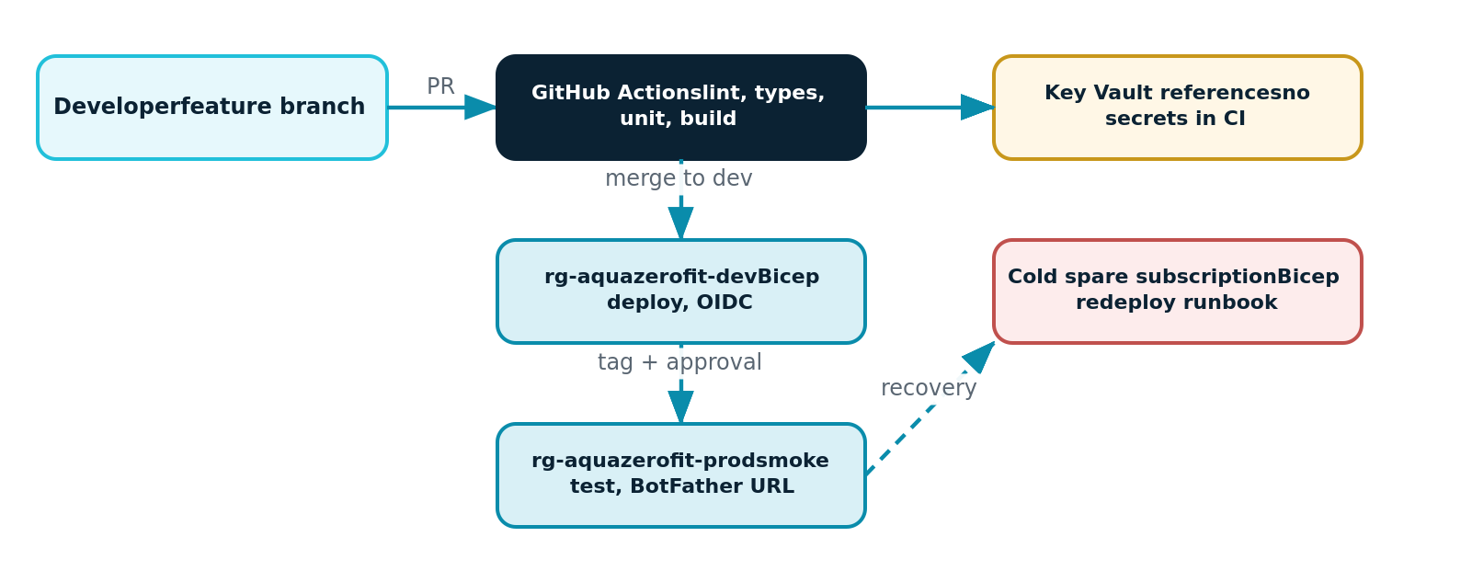
Figure 15.1: Release path from pull request to production, with the recovery route
feature branch -> pull request checks: lint, type check, unit, build, licence guard
merge to dev -> pipeline authenticates with federated credentials -> infrastructure
what-if -> deploy development -> end-to-end smoke suite
tag a release -> approval gate -> deploy production -> smoke -> verify Mini App URL

2. Configuration Reference
Setting | Location | Note
GROQ-API-KEY | Key Vault | Fast chat lane
GEMINI-API-KEY | Key Vault | Vision and structured generation lane
OLLAMA-CLOUD-API-KEY | Key Vault | Cheap lane and free-tier routing
NVIDIA-API-KEY | Key Vault | Heavy and specialised lane
TELEGRAM-BOT-TOKEN | Key Vault | Launch data signature verification and bot calls
JWT-SIGNING-KEY | Key Vault | Rotate quarterly with a dual-key overlap window
GATEWAY-MASTER-KEY | Key Vault | Gateway administration; virtual keys are derived per tier
AI_FREE_TIER_HOURLY_LIMIT | Application configuration | Default three requests per hour
KCAL_FLOOR_F / KCAL_FLOOR_M | Application configuration | 1200 and 1500. Any change requires sign-off against AQF-11
COSMOS_ENDPOINT, SEARCH_ENDPOINT, STORAGE_ACCOUNT | Application configuration | Non-secret, taken from infrastructure outputs
Standing rule: any key that appears in a screenshot, a paste, a log or a screen share is rotated the same day, without debate and without waiting for evidence of misuse.

3. Monitoring
Dashboard or alert | Threshold | First response
API failure rate | Above 2 percent over ten minutes | Check recent deployment; roll back if correlated
API latency, 95th percentile | Above 500 ms sustained | Check database request units and cold starts
Queue depth | Above 25 for ten minutes | Check the vision function for failures or a provider outage
Provider error rate | Above 20 percent over fifteen minutes | Confirm fallback is active; consider degrading the feature
Guardrail trigger spike | Sustained deviation from baseline | Review samples for abuse or a prompt regression
Budget consumption | 50, 75 and 90 percent | Review spend by feature; tighten routing if needed

4. Incident Runbooks

4.1 AI provider degraded or unavailable
- Confirm which lane is failing on the provider dashboard. Fallbacks should already be active.
- If a whole chain fails, set the affected feature flag to degraded: recommendations serve cached plans, the assistant returns the manual guidance notice, photograph jobs remain queued and resume automatically.
- Verify with the smoke script that manual logging, dashboards and existing plans still work. This is the contract in NFR-03.
- Record the start time, affected features and user impact for the incident note.

4.2 Key rotation, scheduled or after exposure
- Generate the replacement key at the provider.
- Add it to the vault as a new version. Runtime components pick it up on the next cold start; restart to force.
- Confirm on the health endpoint that the new version is live.
- Only then revoke the previous key at the provider.
- Record the rotation, the reason and the date in the security register.

4.3 Subscription credit exhausted
- The student subscription disables rather than bills, so there is no financial exposure.
- Execute the cold-spare procedure: deploy the infrastructure template to the backup subscription.
- Restore the most recent database export and repopulate the vault.
- Update the registered Mini App URL and the frontend API base.
- Run the smoke suite. Target time to service: approximately one hour.

4.4 Queue backlog
- Inspect vision function failures in telemetry. A poisoned message moves to the dead-letter path after five dequeues.
- If a provider outage caused the backlog, jobs drain automatically on recovery; the interface shows jobs as queued rather than failed.

4.5 Suspected data breach
- Freeze: revoke refresh token families by rotating the signing key, and rotate all vault secrets.
- Preserve: capture audit logs and telemetry before anything is redeployed.
- Assess scope from the audit trail: which identities, which records, what window.
- Notify the supervisor immediately and affected users in accordance with AQF-11.
- Document the timeline, the cause and the corrective action.

5. Backup and Recovery
- Database: continuous backup where the tier permits, plus a nightly export of every container to cool storage with thirty-day retention.
- Photographs: soft delete for fourteen days; lifecycle transition to cool storage after thirty days.
- A restore drill is performed once mid-semester to prove the one-hour recovery claim, and the result is recorded as operational evidence in the progress report.

6. Demonstration Day Checklist
When | Action
Twenty-four hours before | Freeze deployments; run the full end-to-end suite; verify the marker account; warm the Functions application; confirm the Mini App URL resolves
One hour before | Health endpoint green; provider dashboard green; backup recording present on local storage; phone charged and signed in
During | Demonstrate the web application first because it is the assessed path; show the Mini App on a device as the closing item
If anything fails | Switch to the recorded walkthrough immediately and continue the narrative. Do not debug in front of the panel

