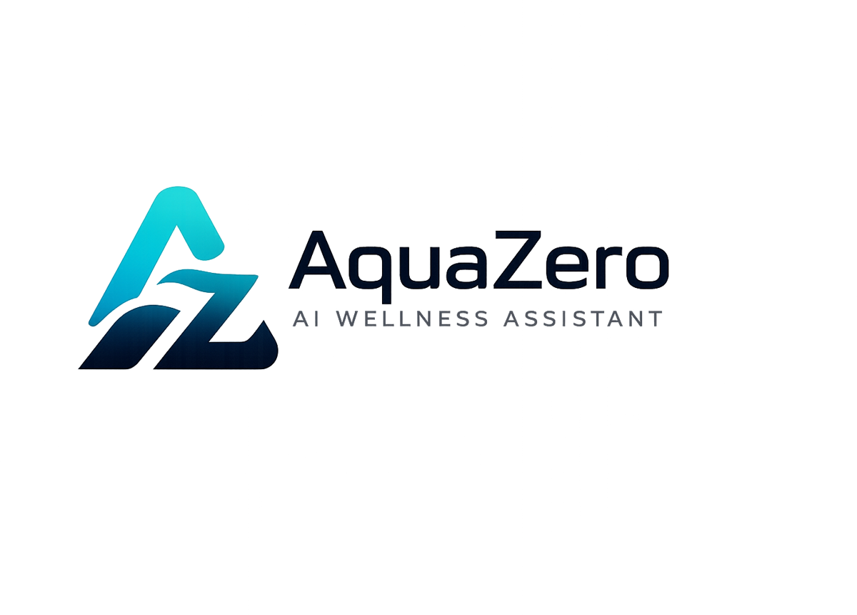
AQF-17
Progress Report
Status, deliverables, contributions, verification and next stage
AquaZeroFit, an AquaZero product
NIT3003 IT Capstone Project, Project 5
Group 15, Victoria University, Melbourne, Australia
Version 2.0, July 2026

Document Control
Field | Detail
Document | AQF-17 Progress Report
Version | 2.0 (AquaZeroFit rebrand, diagrams added)
Purpose | Report project status accurately, distinguish completed from in-progress work, evidence each member's contribution, and set out a realistic plan for the remaining work.
Document owner | Babatundji Williams-Fulwood, Technical Lead and Software Architect
Contributors | Eric La (Frontend), Victor Hong (Data and Quality)
Supervisor | [To be completed by the team]
Status | Draft for supervisor review
Change history | v1.0 initial draft as VitalAI. v2.0 rebranded to AquaZeroFit, diagrams added, roles assigned, sequencing applied

1. Report Information
Field | Detail
Project | AquaZeroFit, an AquaZero product
Unit | NIT3003 IT Capstone Project, Project 5
Group | Group 15, Victoria University
Reporting period | [Start] to [End]
Submission date | [Date]
Supervisor | [Name]
Team member | Student ID | Primary role
Babatundji Williams-Fulwood | [Student ID] | Technical Lead, Software Architect, Backend and AI Engineer
Eric La | [Student ID] | Frontend Developer, UI Implementation and Accessibility
Victor Hong | [Student ID] | Data and Quality Engineer, Full-Stack Support

2. Project Overview
AquaZeroFit is an AI-powered wellness platform that helps users monitor nutrition, manage weight-loss goals and follow personalised home training plans. Users build a wellness profile, log meals manually or by photograph, and receive calorie targets, meal suggestions and daily workouts that adapt to their measured progress. A conversational assistant answers nutrition and fitness questions within enforced safety boundaries.
The platform is delivered from one codebase to a responsive web application and a Telegram Mini App. The backend runs on Azure using serverless compute, a free-tier document database and a gateway that fronts four AI providers. The product provides general wellness support only and does not provide medical advice.

3. Overall Progress Summary
Status: in progress. The team reports progress by deliverable rather than by file, and marks a deliverable complete only when it can be demonstrated, explained and verified.
Area | Status | Position
Platform, infrastructure and pipeline | Completed | Both environments deploy from templates; pipeline green; access control and budgets in place
Authentication and profile | Completed | Both authentication paths working; targets computed with the safety clamp; full branch coverage on the safety-critical modules
Content and data ingestion | Completed | Exercise corpus and food composition data ingested with attribution retained
Nutrition logging and dashboard | Completed | Manual logging, aggregation and the dashboard verified against source records
AI gateway and vision pipeline | In progress | Gateway deployed and routing verified; recognition accuracy baseline captured; correction workflow being refined
Recommendations and training | In progress | Generation working against schema; progression rules implemented; adaptation cycle under test
Progress and achievements | In progress | Data and charts implemented; achievement criteria being finalised
Assistant and guardrails | In progress | Chain implemented; adversarial evaluation running; refusal coverage being extended
Privacy controls | In progress | Consent and export complete; deletion path under verification
Telegram Mini App target | In progress | Runs from the shared build; bot registration and device testing outstanding
Documentation | Completed | Nineteen-document set produced, versioned and traceable

4. Deliverables and Milestone Progress
Deliverable | Brief req. | Status | Verification evidence | Owner
Registration, authentication, profile | 1, 2 | Completed | Live demonstration; unit tests on validator and calculator; authorisation matrix tests | Babatundji
Food logging, manual | 3 | Completed | Demonstration; integration tests; totals reconcile to source records | Babatundji
Meal image recognition and estimation | 3 | In progress | Photograph to confirmed log demonstration; accuracy baseline from the evaluation set | Babatundji
Nutrition monitoring dashboard | 4 | Completed | Demonstration; values verified against logs | Eric
Meal and recipe recommendation | 5 | In progress | Generated samples; rubric scores; zero allergen violations in the evaluation set | Babatundji
Home training and planning | 6 | In progress | Generated plans; progression rules inspected as data | Babatundji
Daily workout module with media | 7 | In progress | Session demonstration; media present on every exercise | Eric
Progress tracking dashboard | 8 | In progress | Charts verified against seeded histories | Eric
Conversational assistant | 9 | In progress | Conversation demonstration; adversarial evaluation report | Babatundji
Safety, privacy and ethical design | 10 | In progress | Guardrail telemetry; clamp tests; export and deletion verification | Babatundji
Prompt bank, LLMOps, workflow, UML, design | 11 | Completed | AQF-05, AQF-08, AQF-10, AQF-12 and the design system | Babatundji
Formal test evidence pack | All | In progress | Test case table with recorded outcomes | Victor

4.1 Definition of completed work
A deliverable is marked Completed only when the function can be demonstrated live, the implementation method can be explained by its owner, and the result can be independently verified. Written code alone does not constitute completion. This definition is applied strictly, which is why several items that are largely built remain marked In progress.

4.2 Schedule position
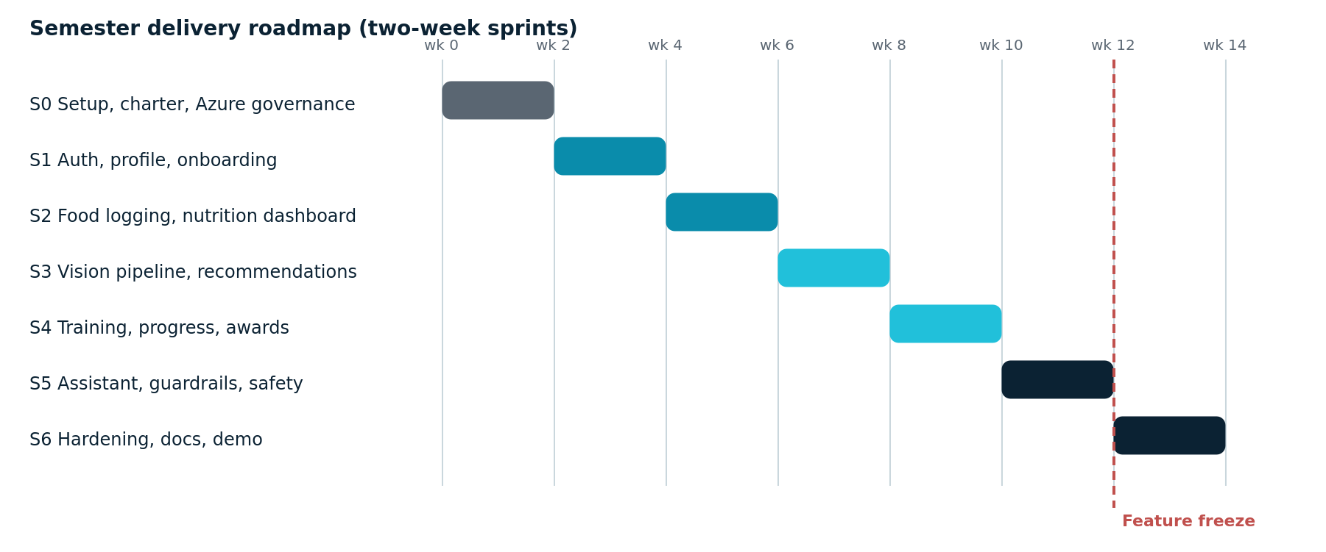
Figure 17.1: Planned sprint sequence with the feature freeze point
The core build is substantially complete and the highest-risk technical work, the gateway and the vision pipeline, was deliberately scheduled before the midpoint rather than left to the end. The principal remaining risk is that integration testing and evidence capture compress into the final sprint, which is why the feature freeze is fixed at week twelve.

5. Individual Contributions
The report is submitted by the team, but each contribution below is specific and independently verifiable. At review, each member demonstrates and explains their own work.
Member | Responsibility | Completed contribution | Verification | Next task
Babatundji Williams-Fulwood | Architecture, cloud platform, backend services, AI layer, security, most documentation | Repository and pipeline; infrastructure templates and access governance; both authentication paths and the token model; target calculation with the safety clamp; gateway deployment with routing, fallbacks and per-tier budgets; vision pipeline; recommendation and plan generation; guardrail chain; fifteen of the nineteen documents | Commit history; unit tests at full branch coverage on safety-critical modules; live demonstration of each service; evaluation reports | Complete assistant refusal coverage and the weekly adaptation cycle; lead the integrated demonstration
Eric La | Frontend for both targets, design system, accessibility | Application shell and routing for web and Mini App targets; AquaZero design tokens implemented; authentication and onboarding screens; nutrition screen; recognition review screen; training and guided session screens; progress screen; loading, empty and error states throughout | Commit history; component tests; accessibility scan results; screen demonstrations | Complete the Mini App device testing, finish the progress screen polish and author the User Manual
Victor Hong | Data ingestion, database seeding, testing and evidence | Exercise corpus and dual food data ingestion with attribution retained; indexing and caching; authorisation matrix and integration test suites; photograph evaluation set assembly; cold-spare deployment verification | Commit history; ingestion record counts; test suite output; recorded recovery timing | Execute the full test plan, capture the evidence pack and close defects with owners

6. Technical Approach and Verification
Component | Technology | Purpose
Frontend | React, TypeScript, Vite, official Mini App template | One codebase serving a browser application and a Telegram Mini App
Backend | Azure Functions, Node.js, TypeScript | HTTP endpoints, queued inference, scheduled adaptation
Data | Azure Cosmos DB, Blob Storage, Storage Queue | Profiles, logs, plans, content, photographs and job buffering
AI | Gateway container fronting Groq, Gemini, Ollama Cloud and NVIDIA | Routing, fallbacks, cost tracking and per-tier budgets behind one interface
Security | Key Vault with Managed Identity, federated pipeline credentials | No secrets in source or pipeline
Source control | GitHub with protected branches and required review | Version history and evidence of individual contribution

7. Challenges and Risks
Risk | Priority | Impact | Response | Owner | Status
Recognition accuracy on mixed dishes | High | Incorrect nutrition data reaching a log | Mandatory user confirmation before commit; confidence displayed; corrections feed evaluation | Babatundji | Controlled
Integration testing compressed into the final sprint | High | Subsystems may fail when connected late | Feature freeze at week twelve; one complete end-to-end scenario prioritised over new features | Victor | In progress
AI token spend against a fixed student credit | Medium | Loss of environment near submission | Cheap-lane routing, caching, per-tier budgets, alerts at 50, 75 and 90 percent | Babatundji | Controlled
Cloud credit exhaustion or subscription disable | Medium | Demonstration environment unavailable | Cold-spare subscription with a verified one-hour redeployment runbook | Babatundji | Controlled
Uneven workload across three members | Medium | Assessment of individual contribution becomes unclear | Bounded, independently demonstrable ownership per member; cross-lane review each sprint | Team | Open
Safety regression from a prompt change | High | Unsafe advice reaching a user | Adversarial evaluation as a merge gate; prompt versions pinned; rollback runbook | Babatundji | Controlled

8. Team Communication and Management
Area | Position
Method | Agile Scrum, two-week sprints, twice-weekly stand-up
Task tracking | GitHub Projects board; every item carries an owner, acceptance criteria and required verification evidence
Progress tracking | This report, the development diary and the sprint board, reconciled at each review
Code review | At least one reviewer per pull request, and each member reviews outside their own lane each sprint
Improvement action | Weekly five-minute cost review added to stand-up after the first budget alert threshold discussion

9. Next-Stage Plan
Planned task | Owner | Target | Expected outcome
Complete assistant refusal coverage and rerun the adversarial set | Babatundji | Week 1 | Zero critical failures recorded in the evaluation report
Finish the weekly adaptation cycle within safety bounds | Babatundji | Week 1 | Targets and plans adjust from measured progress, bounded and tested
Mini App device testing and bot registration | Eric | Week 1 | Verified launch on a physical device against the production deployment
Execute the full test plan and capture the evidence pack | Victor | Week 1 to 2 | Test table with recorded pass and fail outcomes
Close all severity one and two defects | Assigned owner | Week 2 | Stable demonstration build
Rehearse the end-to-end demonstration twice and record a backup | Team | Week 2 | Demonstration runs without live debugging
Finalise the traceability matrix and the Final Report | Babatundji | Week 2 | Every requirement traced from brief to test evidence

Appendix A. Supporting Evidence Index
Ref | Evidence | Location | Purpose
A1 | Application repository | [Team GitHub URL] | Commit history and individual contribution evidence
A2 | Development diary | AQF-16 | Dated subsystem records and meeting minutes
A3 | Test evidence pack | AQF-14 and the test results appendix | Test cases with recorded outcomes
A4 | AI evaluation reports | /evals output, summarised in AQF-10 | Accuracy, rubric and safety pass rates
A5 | Infrastructure and pipeline history | /infra and pipeline run history | Reproducible environments and deployment evidence
A6 | Cost report | Cloud portal export | Spend within the student credit
A7 | Licence register | AQF-12 | Verified verdicts and discharged obligations

