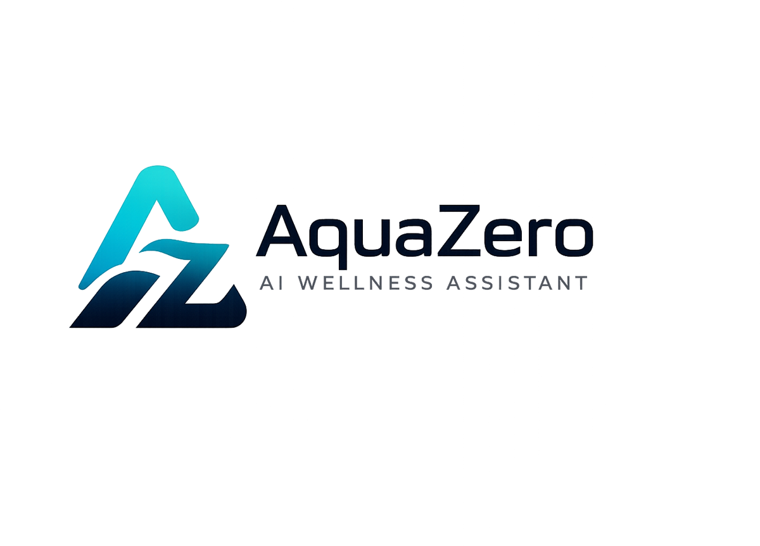
AQF-18
User Manual
Installation, first use, feature guide and troubleshooting
AquaZeroFit, an AquaZero product
NIT3003 IT Capstone Project, Project 5
Group 15, Victoria University, Melbourne, Australia
Version 2.0, July 2026

Document Control
Field | Detail
Document | AQF-18 User Manual
Version | 2.0 (AquaZeroFit rebrand, diagrams added)
Purpose | Enable a new user, a marker or a supervisor to install, access and operate AquaZeroFit without assistance. Primary author: Eric La.
Document owner | Babatundji Williams-Fulwood, Technical Lead and Software Architect
Contributors | Eric La (Frontend), Victor Hong (Data and Quality)
Supervisor | [To be completed by the team]
Status | Draft for supervisor review
Change history | v1.0 initial draft as VitalAI. v2.0 rebranded to AquaZeroFit, diagrams added, roles assigned, sequencing applied

1. System Overview
AquaZeroFit is a wellness application that helps you track what you eat, follow a home training plan and see your progress over time. You can use it in two ways: as a website in any modern browser, or as a Mini App inside Telegram. Both give the same features and share the same account.
AquaZeroFit provides general wellness and fitness support only. It does not diagnose conditions, does not replace medical advice, and will decline medical questions. If you have a health condition, are pregnant, or are recovering from injury, speak to a qualified professional before changing your diet or exercise routine.

2. Getting Started

2.1 Using the web application
- Open your browser and go to the AquaZeroFit address supplied by the team.
- Select Create account and enter your email address and a password of at least twelve characters using a mix of letters, numbers and symbols.
- Check your email and confirm your address.
- Sign in. The onboarding wizard begins automatically.

2.2 Using the Telegram Mini App
- Install Telegram on your phone or open Telegram on the desktop.
- Search for the AquaZeroFit bot using the handle supplied by the team, and open the chat.
- Tap Start, then tap the Open button. The Mini App launches inside Telegram.
- You are signed in automatically using your Telegram account. There is no password to enter.

2.3 Linking both
If you already have a web account and want to use Telegram as well, sign in on the web, open Settings, and choose Link Telegram. Both then share one account and one history.

2.4 Completing your wellness profile
- Enter your weight, height and age. Values outside a safe range are rejected with a message explaining the accepted range.
- Choose your goal: lose weight, maintain or gain.
- Choose your activity level, from sedentary to very active.
- Choose your exercise experience: beginner, intermediate or advanced.
- Add any dietary preferences and, importantly, any allergies. Allergies are excluded from every suggestion.
- Select the equipment you have at home. If you have none, choose bodyweight only and your plan will use no equipment.
- Review your calculated daily calorie and macronutrient targets and finish. Your first weekly plan is generated.
If your goal would produce a daily calorie target below the safe minimum, AquaZeroFit raises it to the safe level, tells you it has done so, and suggests speaking to a professional. This behaviour cannot be turned off.

3. Using AquaZeroFit

3.1 Dashboard
- Rings at the top show calories, protein, carbohydrate and fat for today against your targets.
- The next workout card shows today's session and starts it in one tap.
- The recommendation card suggests a meal that fits your remaining targets. Add to log records it without retyping.
- The weight trend chart shows your recent direction of travel.
- Achievements show what you have unlocked and what is close.

3.2 Logging a meal by hand
- Open Nutrition and choose the meal: breakfast, lunch, dinner or snack.
- Select Add and search for the food.
- Choose the portion size and confirm. Your dashboard updates immediately.

3.3 Logging a meal by photograph
- Open Nutrition and select Scan Meal Photo.
- Take a photograph or choose one from your device. Accepted formats are JPEG, PNG and HEIC, up to 10 MB.
- Wait a few seconds while the photograph is analysed. You can leave the screen; the result waits for you.
- Review the identified foods. Each item shows an estimated portion and a confidence indicator.
- Correct anything that is wrong. This is expected; the estimate is a starting point, not a verdict.
- Select Confirm. Nothing is added to your log until you confirm.
Tip: photograph the meal from above with the whole plate in frame and good light. Mixed dishes such as stews are harder to identify than separated components.

3.4 Training
- Training shows your weekly plan and today's session with sets, repetitions and rest periods.
- Start opens the guided session: one exercise at a time, full screen, with a rest timer between sets.
- Each exercise has a description and a demonstration image or video. Read it before your first attempt.
- If an exercise is not possible today, use Swap. The replacement targets the same muscle group with the equipment you have.
- Rest days are part of the plan, not a failure. Progress comes from recovery as much as from training.

3.5 Progress
- Record your weight at the same time of day, ideally in the morning. Day-to-day fluctuation is normal; the trend matters.
- Calorie trends show your intake against target over the selected range.
- Training history shows completed sessions and your consistency.
- Export produces a file containing your data, which is yours to keep.

3.6 AI assistant
- Ask questions in plain language, for example: what should I eat tonight with 600 calories left?
- The assistant knows your targets and recent logs, so answers are specific to you.
- It will decline medical questions and point you to a professional. This is deliberate.
- If a reply is wrong or unhelpful, use the report control. Reports are reviewed.

3.7 Settings and privacy
- Change your units between metric and imperial at any time; all history converts.
- Update dietary preferences and allergies whenever they change.
- Export your data as a machine-readable file.
- Delete your account. This removes your personal records permanently. It cannot be undone.

4. Troubleshooting
Problem | Cause | Solution
The Mini App shows a blank screen in Telegram | The application did not finish loading or your Telegram version is older than required | Close and reopen the Mini App. If it persists, update Telegram, or use the web address in a browser instead
Photograph analysis is taking a long time | The AI service is busy or temporarily unavailable | Leave the screen; your job is queued and will complete. If it does not, log the meal manually. Manual logging always works
The assistant will not answer my question | The question falls outside wellness scope, for example a medical or medication question | This is intended behaviour. Consult a general practitioner or accredited practising dietitian
My calorie target is higher than I asked for | Your requested goal would have produced a target below the safe minimum | The target was raised to the safe level. This is a safety control and cannot be disabled
A suggested meal contains something I cannot eat | The item is a dietary preference rather than a recorded allergy | Add it as an allergy in your profile. Allergies are excluded absolutely; preferences are strongly weighted
My dashboard does not match what I logged | A log was recorded near midnight and fell on the adjacent day | Open Nutrition and check the previous day. Day boundaries follow your device timezone
I cannot sign in on the web | Wrong password or unverified email address | Use Forgot password. If the account is new, confirm the verification email first
The exercise video will not play | Network restriction or a slow connection | Use the written description and the still image, which are always available offline of video

5. Getting Help
- For product questions, contact the AquaZeroFit team through the address supplied with your account.
- For urgent health concerns, contact your general practitioner or, in an emergency in Australia, call 000.
- For mental health support in Australia, Lifeline is available on 13 11 14.
- For eating disorder support in Australia, the Butterfly Foundation National Helpline is available on 1800 33 4673.

