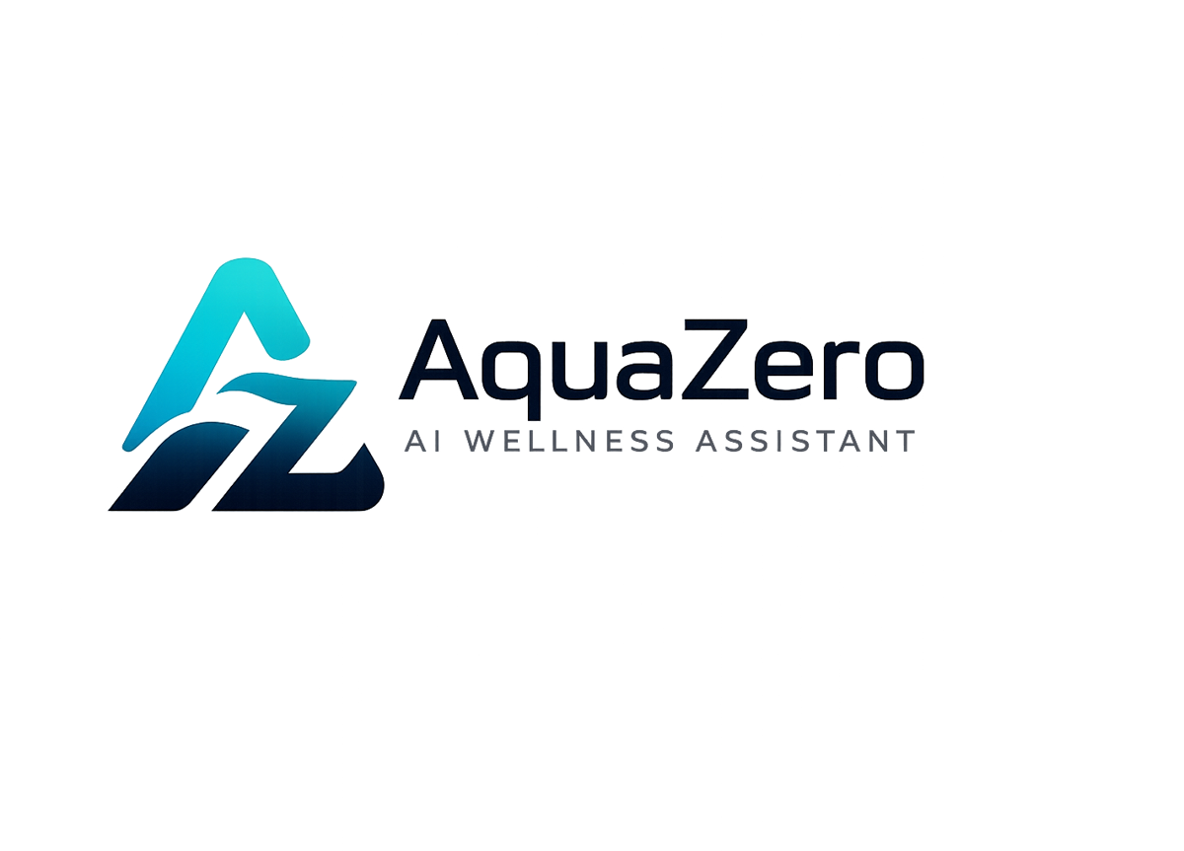
AQF-19
Final Report
Scope review, requirements outcome, architecture, challenges and contributions
AquaZeroFit, an AquaZero product
NIT3003 IT Capstone Project, Project 5
Group 15, Victoria University, Melbourne, Australia
Version 2.0, July 2026

Document Control
Field | Detail
Document | AQF-19 Final Report
Version | 2.0 (AquaZeroFit rebrand, diagrams added)
Purpose | Present the completed project: what was built, how it meets the brief, what was learned, and what each member contributed.
Document owner | Babatundji Williams-Fulwood, Technical Lead and Software Architect
Contributors | Eric La (Frontend), Victor Hong (Data and Quality)
Supervisor | [To be completed by the team]
Status | Draft for supervisor review
Change history | v1.0 initial draft as VitalAI. v2.0 rebranded to AquaZeroFit, diagrams added, roles assigned, sequencing applied

1. Introduction

1.1 Project summary
AquaZeroFit is an AI-powered wellness platform developed for Project 5 of the NIT3003 capstone. It helps users monitor nutrition, manage weight-loss goals and follow personalised home training plans. Users create a wellness profile, log meals manually or by photograph, and receive calorie targets, meal suggestions and daily workouts that adapt to measured progress. A conversational assistant provides guidance within enforced safety boundaries.
The distinguishing decisions of this project were: delivering one codebase to both a web application and a Telegram Mini App; treating the AI layer as engineered infrastructure with a gateway, versioned prompts and evaluation gates rather than as prompt calls scattered through feature code; and treating safety as a coded control rather than a disclaimer.

1.2 Scope review
The delivered scope matches the charter. All ten functional requirement areas from the brief were implemented, and the eleventh, covering prompt bank, LLMOps, workflow, UML and design, is evidenced across this document set. Items deliberately excluded and documented as future work were wearable synchronisation, native mobile applications, live payments and multi-language support. Excluding them was a scope decision made early rather than a failure discovered late.

2. Requirements Outcome
Brief requirement | Outcome | Evidence
1. Secure registration, authentication and profile | Delivered | Both authentication paths; rotating single-use refresh tokens; full branch coverage on the validator
2. Wellness profile | Delivered | Profile capture with safe-range validation; server-side target derivation
3. Food logging with image recognition | Delivered | Manual logging and the five-step photograph pipeline with mandatory confirmation
4. Nutrition monitoring dashboard | Delivered | Calories, macronutrients, water and weight, reconciled to source records
5. Meal and recipe recommendation | Delivered | Structured generation with deterministic allergen exclusion
6. Home training and weight-loss planning | Delivered | Plan generation with iteration-indexed progression and safety bounds
7. Daily workout module with media | Delivered | Guided session mode; every exercise carries a description and media
8. Progress tracking dashboard | Delivered | Weight, calorie trends, training history and achievements
9. Conversational assistant | Delivered | Tool-calling assistant with the six-stage guardrail chain
10. Safety, privacy and ethical design | Delivered | AQF-11; calorie clamp; crisis handling; consent, export and deletion
11. Prompt bank, LLMOps, workflow, UML, design | Delivered | AQF-05, AQF-08, AQF-10, AQF-12 and the AquaZero design system

3. System Architecture
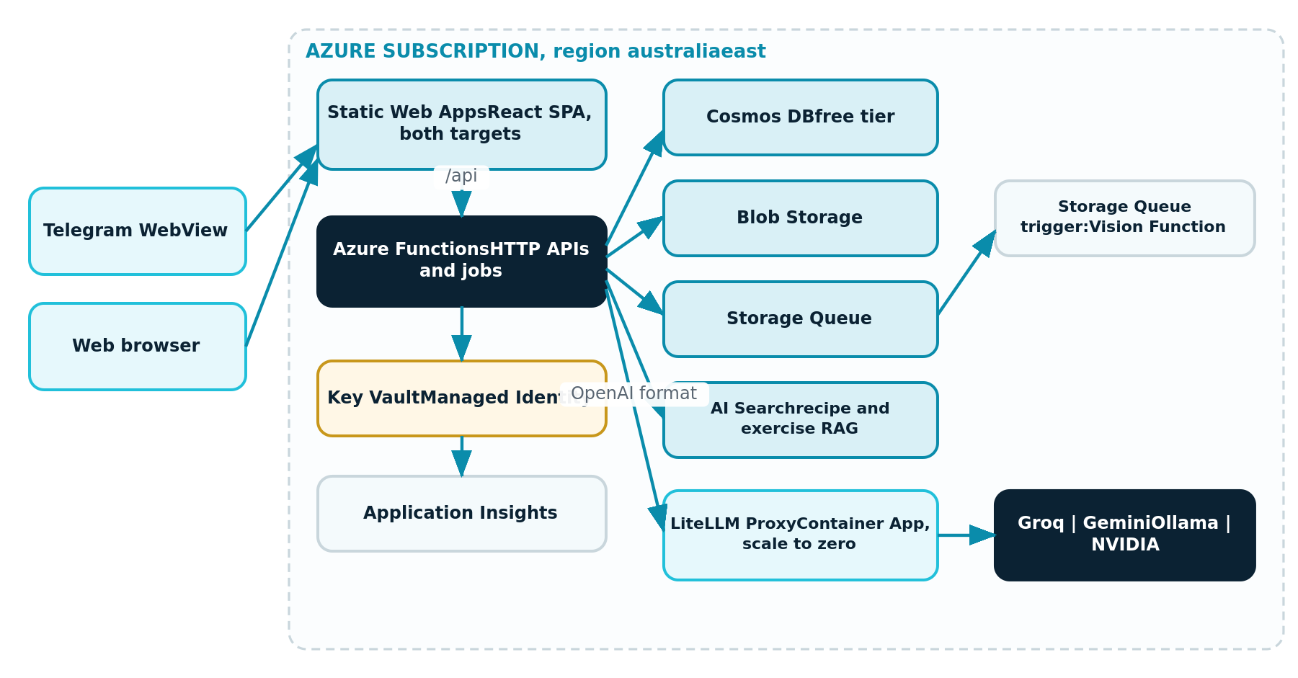
Figure 19.1: Delivered architecture within the Azure subscription
- One React codebase produces both delivery targets, with behaviour branching at bootstrap.
- Azure Functions on a consumption plan serve the API and run queue-triggered and scheduled jobs.
- Cosmos DB on the lifetime free tier stores all operational data, partitioned so that a user's day is a single-partition read.
- A gateway container fronts four AI providers, holding routing, fallbacks, cost tracking and per-tier budgets in configuration.
- Secrets live in a managed vault and are read at runtime by identity. No secret exists in source or in the pipeline.

4. Database
The team selected a document database rather than a relational one because the operational data is naturally document shaped and because it is the only option on the platform that remains free permanently, which matters for a project with no budget and for the product's life after the semester.
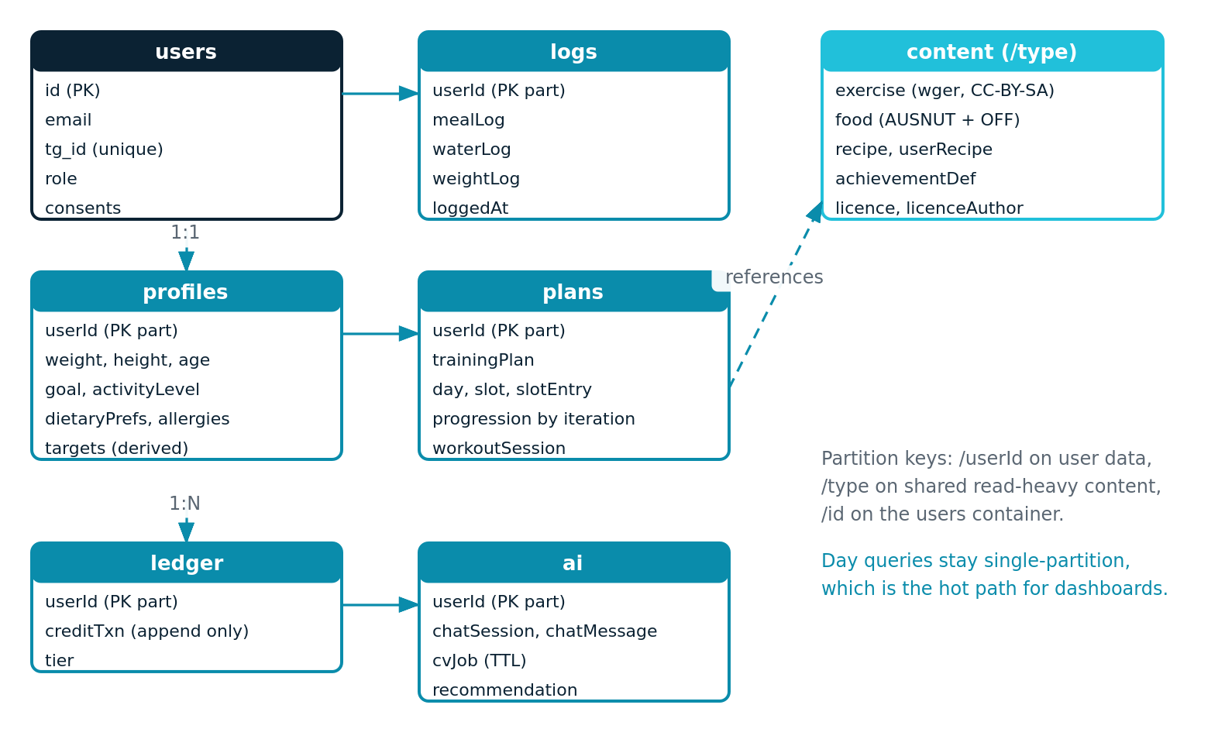
Figure 19.2: Container map and partition strategy as delivered
Partition keys were chosen against the hot path rather than against the entity list. Rendering a user's day is one single-partition read, which is why the dashboard meets its latency target on a free tier.

5. AI Engineering
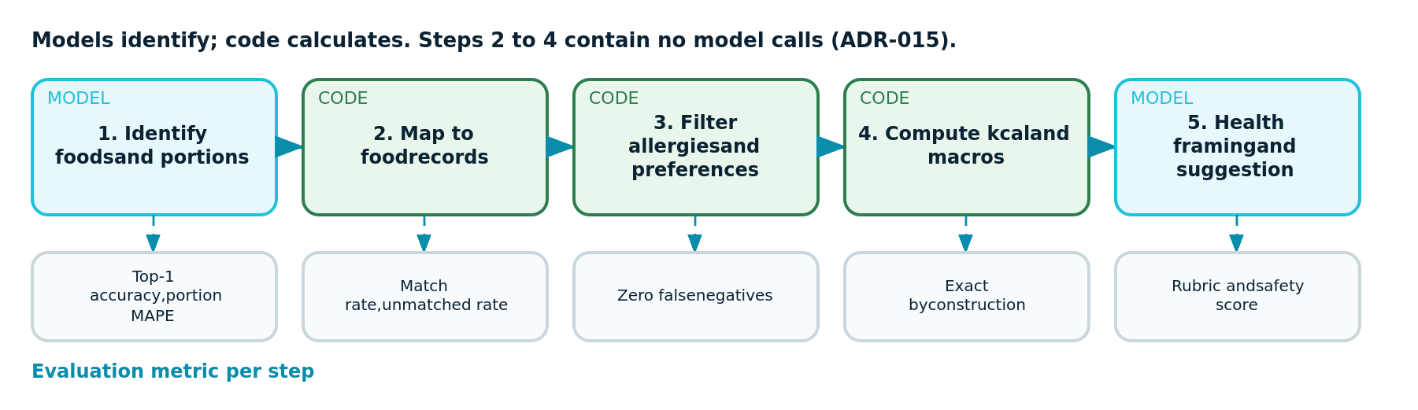
Figure 19.3: The meal photograph pipeline, showing which steps are model calls
The most consequential engineering decision in the project was to remove arithmetic from the model. An evaluated reference design allowed the vision model to estimate calories directly. Testing showed this to be unreproducible and unauditable. Splitting the pipeline so that the model identifies and code calculates made results deterministic for identical inputs, reduced cost, and produced an evaluation metric for each step rather than one impression of overall quality.
- Nine versioned prompts, each with a defined output schema, examples and known failure modes.
- Four evaluation sets, with the adversarial safety set acting as a merge gate rather than a warning.
- Provider routing by task, so latency-sensitive chat never queues behind heavy generation.
- Per-tier virtual keys with hard budgets, so a policy bug cannot produce unbounded spend.

6. Challenges and Problems
Challenge | Response | Outcome
Three of the evaluated open-source sources could not legally be used: one strong copyleft, one non-commercial, one unlicensed | Verified every licence before writing code; adopted data and patterns only where permitted; recorded verdicts in a register with pipeline enforcement | No incompatible code entered the repository, and the evaluation itself became evidence of professional practice
An evaluated platform sample relied on a feature retired in September 2025 | Checked currency rather than trusting the sample; adopted the supported alternative and banned the artefact in the pipeline | Avoided building on a removed feature
The chosen gateway library is Python while the backend is TypeScript | Deployed the gateway as a container exposing a standard interface rather than splitting the codebase | One language in the codebase and richer gateway features than a hand-rolled adapter would have provided
Image recognition is imperfect on mixed dishes | Made user confirmation mandatory, displayed confidence, and fed corrections into the evaluation set | Errors became a measurable signal rather than silent bad data
A fixed student credit with no cash budget | Free-tier and scale-to-zero services throughout, cheap-lane routing, caching and budget alerts | The project ran within credit with a verified cold-spare recovery path
Three junior developers with uneven specialisation | Bounded, independently demonstrable ownership per member, with cross-lane review each sprint | Each member can demonstrate and explain their own work at review

7. What We Would Do Differently
- Assemble the evaluation sets in the first sprint rather than alongside the feature. Every AI decision after that point would have had a measurement behind it from the start.
- Write the licence register before reading any source code, not after. Two sources were studied in detail before their licences ruled them out.
- Schedule the first end-to-end integration in week four with a deliberately thin slice, rather than integrating a rich set of features later.
- Introduce accessibility scanning at the first screen rather than after several screens existed, which would have avoided retrofitting focus states.

8. Student Contributions
Member | Contribution
Babatundji Williams-Fulwood | Technical lead and architect. Designed the system architecture and authored the architecture, requirements, decision, data, interface, low-level design, AI, safety, licensing, implementation and runbook documentation. Implemented the cloud platform, governance and pipeline; both authentication paths and the token model; profile and target derivation including the safety clamp; the AI gateway with routing, fallbacks and per-tier budgets; the vision pipeline; recommendation and training plan generation; the guardrail chain; and the privacy controls. Led sprint facilitation and the integrated demonstration
Eric La | Frontend developer. Implemented the application shell and routing serving both delivery targets from one codebase, the AquaZero design system, the authentication and onboarding screens, the nutrition screen, the recognition review screen, the training and guided session screens and the progress screen, together with loading, empty and error states throughout. Owned accessibility conformance and authored the User Manual
Victor Hong | Data and quality engineer. Implemented the exercise corpus and dual food data ingestion with attribution retained, database seeding, indexing and caching. Authored and executed the test plan including the authorisation matrix and integration suites, assembled the photograph evaluation set, verified the cold-spare recovery procedure and owned the evidence pack and defect tracking

9. Conclusion
AquaZeroFit meets the requirements of Project 5 and does so with engineering practices that would survive contact with a real user base: a documented architecture with recorded decisions, a licence-clean dependency chain, an AI layer with measurable quality and enforced safety, and an operational runbook with a tested recovery path. The safety boundary that the brief asks for is implemented as code, not as a sentence in a footer, which is the difference between a product that says it is safe and one that is.

10. References and Document Set
Reference | Document
AQF-01 | Project Charter and Team Roles
AQF-02 | Product Requirements Document
AQF-03 | Software Requirements Specification
AQF-04 | System Architecture (High-Level Design)
AQF-05 | Architecture Decision Records
AQF-06 | Data Model and Database Schema
AQF-07 | API Contract
AQF-08 | UML Diagram Package
AQF-09 | Low-Level Design
AQF-10 | AI Prompt Bank and LLMOps Plan
AQF-11 | Safety, Privacy and Ethical Design
AQF-12 | Upstream Integration and Licensing Register
AQF-13 | Technical Implementation Document
AQF-14 | Test Plan and Quality Assurance Strategy
AQF-15 | Runbook and Deployment Guide
AQF-16 | Development Diary
AQF-17 | Progress Report
AQF-18 | User Manual
AQF-19 | Final Report
External sources, their verified licences and the obligations accepted are recorded in AQF-12. Citations for any academic sources used in the report body are to be completed by the team in the referencing style required by the unit.

