Data Structure and Algorithm

Laboratory Activity No. 4

Arrays

|  |  |
| --- | --- |
| *Submitted by:* | *Instructor:* |
| Luminario, Venice Lou Gabrielle M. | Engr. Maria Rizette H. Sayo |

August 16, 2025

# Objectives

Introduction

Array, in general, refers to an orderly arrangement of data elements. Array is a type of data structure that stores data elements in adjacent locations. Array is considered as linear data structure that stores elements of same data types. Hence, it is also called as a linear homogenous data structure.

This laboratory activity aims to implement the principles and techniques in:

* Writing algorithms using Array data structure
* Solve programming problems using dynamic memory allocation, arrays and pointers

# Methods

Jenna’s Grocery

Jenna wants to buy the following fruits and vegetables for her daily consumption. However, she needs to distinguish between fruit and vegetable, as well as calculate the sum of prices that she has to pay in total.

Problem 1: Create a class for the fruit and the vegetable classes. Each class must have a constructor, deconstructor, copy constructor and copy assignment operator. They must also have all relevant attributes (such as name, price and quantity) and functions (such as calculate sum) as presented in the problem description above.

Problem 2: Create an array GroceryList in the driver code that will contain all items in Jenna’s Grocery List. You must then access each saved instance and display all details about the items.

Problem 3: Create a function TotalSum that will calculate the sum of all objects listed in Jenna’s Grocery List.

Problem 4: Delete the Lettuce from Jenna’s GroceryList list and de-allocate the memory assigned.

# Results

This Program will be an assistant for Jenna as her Smart Grocery Assistant. It will create a list of her all items digitally, storing the price of all of her products, price and quantity. It will display the receipt into a table like form with individual categories and cost. It can calculate all of the cost, and jenna will not use manual math when she use this program. Jenna can remove or add items in her inventory. This simple layout can manage her grocery store with ease, It can also be very flexible to jenna because she will have a shorter time to compute all of the buyed items into her cost.

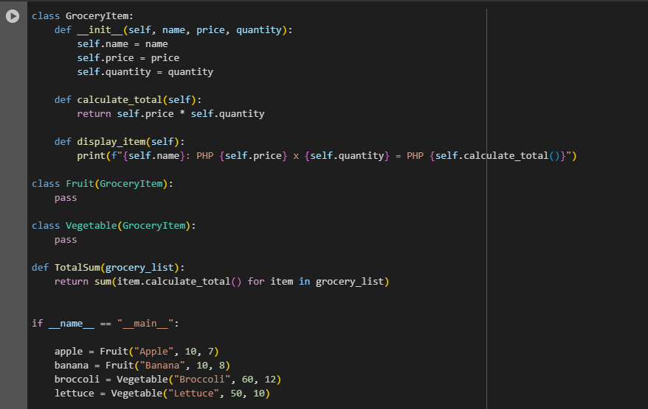

Figure 1 Screenshot of program

So this is the grocery item it will detect all of the element that will put inside the grocery list that will contains the name, price, and quantity of the item.

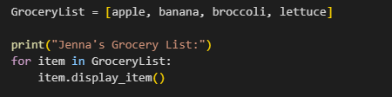

Figure 2 Screenshot of program

This will prints the heading "Jenna's Grocery List:", then it will loops through each item that is in the list, calling a method named display_item() to display all of the details on each items.

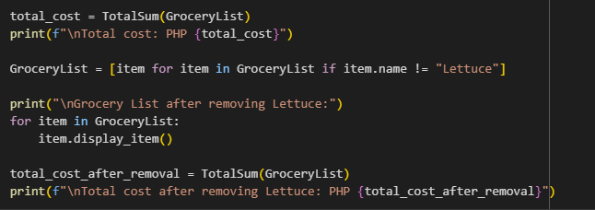

Figure 3 Screenshot of program

This will calculate the first total cost of the grocery list using a function called TotalSum, it will prints the total price or cost in the grocery list, then removes the item with the name "lettuce" from the list, and lastly it will print the updated grocery list by calling the display_item() method for the remaining item.

# Conclusion

In conclusion this activity helped me to make my own program by using these codes to help me in my mini store here at home, and it also make my learnings enhance in coding, maybe I can enhance this more to make it more applicable to other store owner like my self so they cannot do the traditional method that compute manually, this code will be more efficient and less time consuming to store owners.

**References**

GeeksforGeeks. (n.d.). *Python list comprehension*. GeeksforGeeks. <https://www.geeksforgeeks.org/python-list-comprehension/>

Zelle, J. M. (2017). *Python programming: An introduction to computer science* (3rd ed.). Franklin, Beedle & Associates.

W3Schools. (n.d.). *Python for loops*. W3Schools. https://www.w3schools.com/python/python_for_loops.asp