Software Design
Progress Report No. 4

Rationale of the System

Submitted by: | Instructor:
Calica, Ljay L.  Luminario, Venice Lou Gabrielle  Inverzo, Kyle D.  Aquino, Jester J.  Tan, Charles Dominic T.  Gabuyo, Ivan Love D.  Elpedes, Glen Jorge A. | Engr. Maria Rizette H. Sayo

12/15/25

Objectives
The objectives of this laboratory project are:
• To describe the design and development of a software system using modern software engineering models such as the Spiral and Agile models.
• To explain the features, structure, and functionality of the proposed system.
• To justify the selection of Agile and Spiral models based on project size, risk, and evolving requirements.
• To demonstrate how iterative development, risk analysis, and user feedback contribute to software quality and reliability.

Methods
The development of the system followed structured software engineering methodologies, primarily combining the Spiral Model and Agile principles. The Spiral Model was applied to identify and manage risks through repeated cycles of planning, risk analysis, engineering, and evaluation. Each iteration helped address technical, schedule, and requirement-related risks before moving forward, ensuring a more controlled and reliable development process.
Agile methodology was implemented through short iterations known as sprints, which involved planning, designing, coding, testing, and reviewing system features. Continuous collaboration among developers and stakeholders allowed timely feedback and improvements. Project deliverables included system documentation, functional and subsystem demonstrations, as well as evaluations of accuracy, performance, and reliability, resulting in a flexible, user-centered, and risk-aware system.

Results
The implementation of the software development methodologies resulted in a functional and well-structured system. The iterative approach enabled the team to deliver working features at the end of each sprint, ensuring steady progress and early validation of system components.
Data visualizations such as tables and workflow diagrams were used to present system processes, sprint progress, and feature completion. Continuous testing and evaluation improved accuracy and reduced errors. The Agile approach allowed rapid adjustments based on feedback, while the Spiral Model ensured early identification and mitigation of risks, ultimately enhancing system quality, flexibility, and user satisfaction.


Figure 1 Screenshot of program

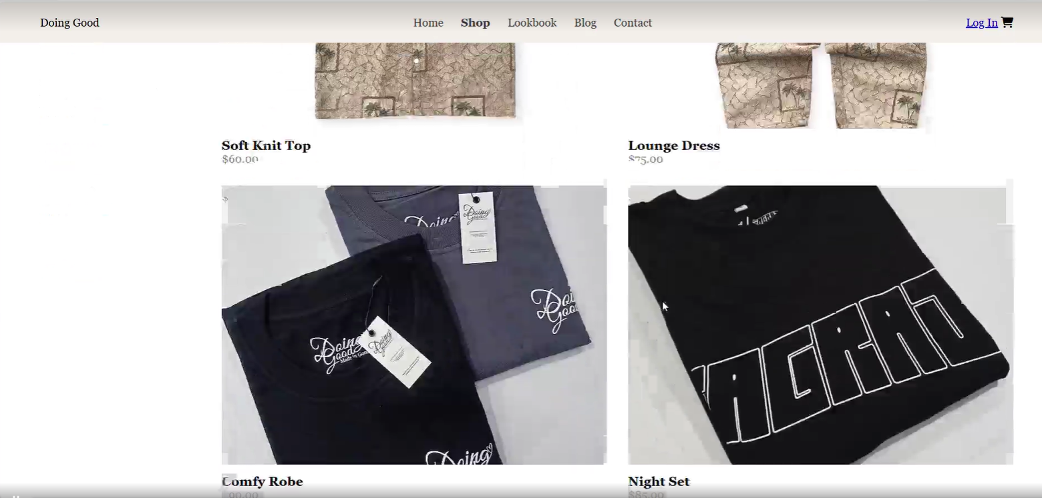
Figure 2 Screenshot of program

Conclusion

This laboratory project demonstrated the effectiveness of using the Spiral Model and Agile methodology in software design and development by integrating risk analysis, iterative development, and continuous feedback, which resulted in a flexible and reliable software system. The study highlights the importance of selecting appropriate development models based on project requirements and risk levels, as these methodologies contributed to improved software quality, adaptability, and successful project outcomes.

References
[1] B. W. Boehm, “A Spiral Model of Software Development and Enhancement,” IEEE Computer, vol. 21, no. 5, pp. 61–72, May 1988.
[2] I. Sommerville, Software Engineering, 10th ed. Boston, MA, USA: Pearson Education, 2016.
[3] K. Beck et al., “Manifesto for Agile Software Development,” 2001.
https://agilemanifesto.org

