Software Design
Progress Report No. 5

Requirement Analysis

Submitted by: | Instructor:
Luminario, Venice Lou Gabrielle M.  Calica, Ljay L.  Gabuyo, Ivan Love D.  Inverzo, Kyle Andrei D.  Aquino, Jester J.  Tan, Charles Dominic S.  Elpedes, Glen Jorge A. | Engr. Maria Rizette H. Sayo

December, 19, 2025

Objectives
In this section, the goals in this laboratory are:
- To clearly identify and understand the requirements of a clothing brand web system used for online retail operations.
- To explain the difference between requirement definition and requirement specification and how each is used in system design.
- To apply requirement analysis techniques to ensure that the system meets the needs of both customers and administrators.
- To support the development of a secure, usable, and efficient web-based retail system.

Methods
Requirement elicitation is one of the critical parts of the process. We must use various techniques to determine what the users need and what the customers really want.

Two Kinds of Requirements:

1. Requirement Definition
This is written using simple and clear language that the client and users can easily understand. It describes what the system should do, such as allowing customers to view products or letting administrators manage inventory.

2. Requirement Specification
This is written in technical terms for developers. It explains how the system will be built, including system architecture, database structure, and software tools such as React and Node.js.

Background
Throughout the semester, the team develops a system, which in this project is a Clothing Brand Web System for Online Retail Operations. This system applies software and engineering design principles to solve real-world business problems, such as manual inventory tracking and inefficient order processing.

The purpose of developing this system is to help the team gain a deeper understanding of how real systems are analyzed, designed, and improved. By working on this project, the team learns how system analysis can be useful in professional and academic settings.
This system may also serve as a foundation for future research, system enhancement, or a thesis project. It supports practical learning by connecting theory with real applications.

Laboratory Activity
The laboratory activity focuses on understanding and designing the clothing brand web system.

- The system application is described, including its purpose and main functions.

- The engineering system to be analyzed is the web-based retail platform for managing products, orders, and inventory.

- The project was chosen based on the team’s interest in web systems and e-commerce technologies.

- Requirement-gathering methods such as interviews, surveys, and simple diagrams are used to collect system needs.

**Be sure to describe the following:
1. What is the system? What does it include, and what does it exclude?

The system is a web-based platform that allows customers to browse clothing products, place orders, and manage accounts. Administrators can manage products, inventory, and orders.
The system includes front-end interfaces, back-end processing, and a database. It excludes mobile applications and advanced third-party integrations.

2. What are its principal design levers or variables? What can we manipulate to improve its performance? What kind of model do we have to analyze the effect of these variables?

The main variables include system response time, security features, user interface design, and database structure. These variables can be adjusted to improve performance, usability, and reliability.
Simple models such as performance testing and usability evaluation are used to analyze their effects.

3. What are the benefits of this system? What models do we have of how the design affects these variables?

Results
Present the visualized procedures done. Also present the results with corresponding data visualizations such as graphs, charts, tables, or image . Please provide insights, commentaries, or explanations regarding the data. If an explanation requires the support of literature such as academic journals, books, magazines, reports, or web articles please cite and reference them using the IEEE format.

Please take note of the styles on the style ribbon as these would serve as the style format of this laboratory report. The body style is Times New Roman size 12, line spacing: 1.5. Body text should be in Justified alignment, while captions should be center-aligned. Images should be readable and include captions. Please refer to the sample below:

The procedures performed during the laboratory activity are presented through diagrams, tables, screenshots, and charts. These visuals show how requirements were gathered, organized, and analyzed.

Each result is explained clearly to show how the data supports the system design. Where needed, explanations are supported by references from reliable sources such as books, reports, or web articles. All references are cited using the IEEE format.
Figures and tables are properly labeled and aligned according to the required format.

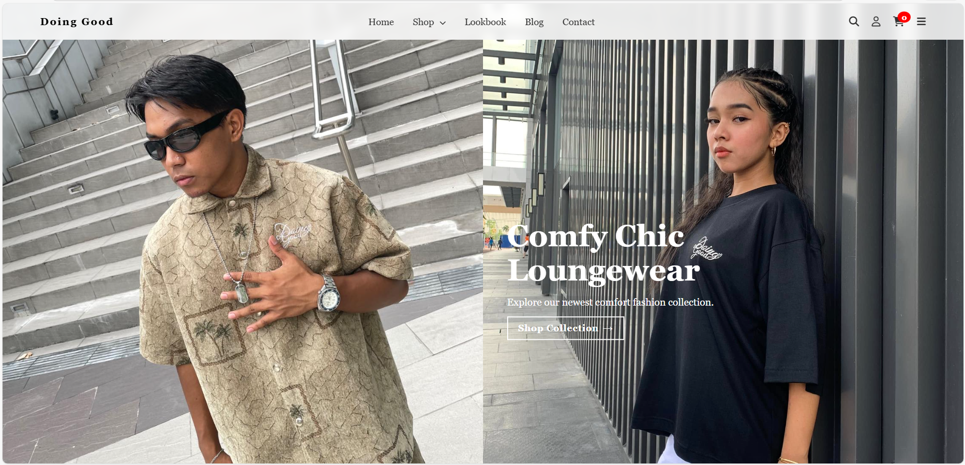
Figure 1 Screenshot of program
If an image is taken from another literature or intellectual property, please cite them accordingly in the caption. Always keep in mind the Honor Code [1] of our course to prevent failure due to academic dishonesty.

Conclusion
This laboratory activity helped the team understand the importance of requirement analysis in system design. By identifying and organizing system requirements, the team was able to design a clear and effective clothing brand web system.

The activity strengthened the team’s ability to think like system designers and apply engineering principles to real-world problems. Overall, the laboratory exercise contributed to the successful planning and development of the web-based retail system.

References
[1] https://www.w3.org/TR/WCAG21/
[2] https://www.w3.org/WAI/standards-guidelines/wcag/
[3] https://www.iso.org/obp/ui/#iso:std:iso-iec-ieee:29148:ed-1:v1:en

