Software Design
Progress Report No. 6

Storyboard

Submitted by: | Instructor:
Luminario, Venice Lou Gabrielle M.  Calica, Ljay L.  Gabuyo, Ivan Love D.  Inverzo, Kyle Andrei D.  Aquino,  Jester J.  Tan, Charles Dominic S.  Elpedes, Glen Jorge A. | Engr. Maria Rizette H. Sayo

December, 19, 2025

Objectives
In this section, the goals in this laboratory are:

- To demonstrate how system requirements are identified in a step-by-step manner during system development.

- To list and clearly explain the two types of requirements used in system design, namely requirement definition and requirement specification.

Methods
Instruction: Create a storyboard of your software or system.

Manual System:
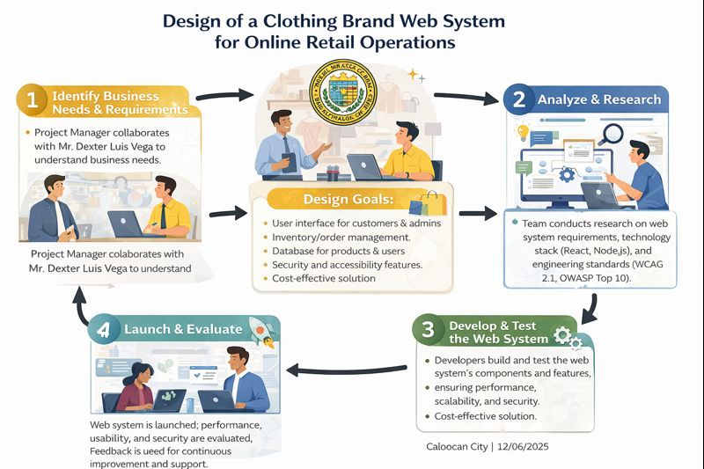
Figure 1. Storyboard of the Manual System for Online Clothes Browsing

Automated System:
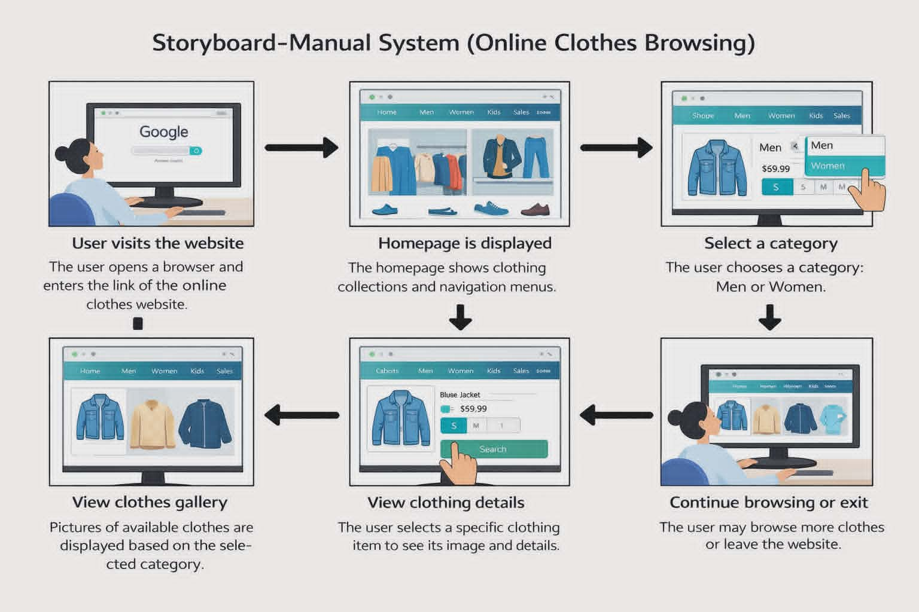
Figure 2. Automated System Design for a Clothing Brand Web System

Results
This section presents the visualized procedures and explains the outcomes based on the manual and automated systems.

A. Visualized Procedures

The storyboard diagrams clearly show the difference between manual and automated processes. The manual system focuses on user-driven browsing with limited system intelligence, while the automated system integrates structured workflows, database management, and security mechanisms.

B. Comparative Analysis

Table 1. Comparison of Manual and Automated Systems
Manual System: • Requires more user effort • Limited interaction and functionality • No integrated inventory or order management • Higher chance of human error
Automated System: • Faster and more efficient processes • Integrated inventory and order management • Enhanced security and accessibility features • Scalable and cost-effective for long-term operations

C. Insights and Discussion

The results indicate that automating the clothing brand web system significantly improves efficiency, accuracy, and user satisfaction. Automated systems reduce manual workload and support real-time data processing, which is critical for online retail operations. According to system development principles, automation enhances reliability, usability, and maintainability of web-based systems [1].

Conclusion
The conclusion expresses the summary of the whole laboratory report as perceived by the authors of the report.

This laboratory demonstrated how system requirements are identified and transformed into both manual and automated system designs. Through storyboard creation, the differences between traditional manual processes and modern automated web systems were clearly visualized. The automated system proved to be more efficient, secure, and suitable for online retail operations. Overall, the activity enhanced the authors’ understanding of system requirements, design workflows, and the importance of automation in modern web-based applications.

References
[1]https://dn790001.ca.archive.org/0/items/bme-vik-konyvek/Software%20Engineering%20-%20Ian%20Sommerville.pdf
[2]https://ptgmedia.pearsoncmg.com/images/9780735679665/samplepages/9780735679665.pdf

