Executive Summary:
Our mutual fund has been tasked to leverage the output of our company’s new AI closing price prediction model, to determine an optimal trade schedule which will maximize portfolio growth. To address this problem, I have developed a Mixed Integer Linear Program (MILP) model which not only quickly determines this optimal production schedule, despite upwards of 57k different combinations of constraints and decision variables, but is also generalized and contained within a fully interactive user interface, which can empower such decisions in the future, as Metal Co. expands its operations. Additionally, I have added the capability to make such decisions considering not only material, but also operational capacities; with further opportunities to tailor this dynamic and interactive tool to consider optimal purchasing of raw materials and staffing allocations. Using my recommended adjustments to production scheduling, aided by this new optimization tool, Metal Co. can increase its annual profits by approximately 13% or 13.5 million dollars.

This tool can be explored on my repo, at: https://lumineest.github.io/OperationsResearch/
Respectfully,
Joel Wood
Introduction:
Metal Co. has requested an evaluation of its production schedule to determine what the optimal build mix is to increase profitability. Specifically, the request was to determine the optimal build based on material processing capacity. To accomplish this, I have constructed a Mixed-Integer Linear Programming (MILP) model which is implemented using CPLEX string generation in JavaScript, passed into the HiGHs WASM solver. This solver is able to quickly determine the optimal weekly schedule based on material constraints. However, I further expanded the model to additionally consider cycle times and change-overs, to ensure that not only material, but also time constraints are evaluated while finding both an optimal and feasible solution.
This linear model has been encapsulated within an interactive website, using the D3 library to generate data visualizations to dynamically explore the solution, adjustments in parameters, and also to evaluate alternative and additional product lines. This website can be viewed at https://lumineest.github.io/OperationsResearch/. Based on the proposed improved production schedule in this report, it is possible for the company to increase their annual profits by roughly 13%, or upwards of $13.5 million dollars
- Joel Wood

Assumptions:
The following assumptions were assumed for this model, based on provided information:
- All employees are scheduled in full-hour blocks, these only start and end on integer values. This means that an employee may be scheduled from 11am to 5pm, but not from 11am to 4:30pm. All assignments can only accrue in full hour increments.
- Lunches and breaks are not accounted for in the schedule, and are assumed to be accounted for in the current demand levels; however, the specifics of when lunches should be taken or if they are even necessary (many states do not require a lunch break unless a shift exceeds 5-6 hours) is not accounted for in this model based on the requested model behavior.
- Customer demand is consistently known within the scheduled week, and scheduling is intended to meet that required minimum requirement. This means that slack based on stochastic fluctuations in demand isn’t considered in the model.
- Each employee has a max number of hours they can be scheduled. This max value may be exceeded by up to 20 additional hours a week; however, these additional hours will be paid at 1.5 times their normal hourly rate as overtime.
- Each employee has a minimum number of hours they can be scheduled, all employees scheduled must have at least their minimum hours. Furthermore, employees may only be scheduled within their weekly availability.
- It is assumed, based on the data provided, that employees can only be scheduled during hours which have customer demands, and that employees cannot have availability, which exists outside those demand hours. i.e. An employee cannot have an availability during 2 am, when there is not work demand.
- There are five skill-groups: Cashiering, Stocking, Customer Service, Back Room, and Floor Associates. Each of these has a demand which must be met within each hour slot. It is thus assumed and shown in the provided data that the number of trained employees for each of these skill slots meets the required demand.
- Employees should be scheduled in contiguous blocks, such that they will not clock out and back in within the same day. It is assumed that this is a soft-constraint compared to meeting customer demand. If the number of employees drops below too low, a schedule which meets customer demands is required, even if perfect blocking is relaxed. Employee Availability should also be in a single daily block.
- There is not a minimum or maximum shift length, so employees may be scheduled anywhere from 1 to 11 hours in a day. This is an additional constraint which would lively vary from employee-to-employee. As this is unknown, it was not modeled.
- Based on the blocking requirement, it is assumed that the company is willing to overstaff to ensure that employees’ requirements are met. The current sum of employee minimum hours is greater than the customer demand, so overstaffing is necessary for a feasible schedule to meet the employee requirements.
Methodology:
The implementation of a scheduling model which implements blocking of schedules, where all hours an employee is scheduled within a day are contiguous, requires the construction of a Mixed Integer Linear Program Model for shift linkage to be implemented. Due to how many binary variables are needed, even with linear relaxation of the skill assignments, this model easily becomes infeasible to perform within a web browser. By reinforcing blocking within the objective formula itself, the solution space is constructed in such a way that a near-optimal solution is returned within a matter of minutes.
Due to the complexity of the model, behaviors may vary between machines and can be adjusted using various control parameters. This solver was able to be fine-tuned to handle the full default configuration of 100 employees in under 5 minutes. Extending the timer beyond this gave no meaningful improvement in the solution; as such, a timer is used to terminate solving at this point—helping to maintain a consistent user-experience.
There is additionally a function included to “Optimize Staffing”, which implements a modified version of Golden Section Search, which leverages parallel processing to check multiple staffing levels simultaneously. Due to aggressive pruning of the search space, an optimal selection can be returned in approximately 15-20 minutes. Partial staffing configurations are especially sensitive to machine capabilities due to the greater complexity of their branch-and-bound trees and performing these checks in parallel consistently may require an expansion of timing parameters depending on machine capabilities. While full rosters will behave consistently, partial checks will vary by machine.
This model has been tested and implemented in the following configuration:
12th Gen Intel(R) Core™ i5-1245U 1.60GHz CPU with 10 Cores and 12 Logical Processors, supplemented with 16GB of RAM.
Sets and Parameters:
let objTerms = [];
let constraints = [];
let binaries = new Set();
let continuous = [];

$e ∈\left\{1, …, 100\right\}$ : Set of Employees to be scheduled (100 current employees)
$t ∈\left\{1, …, 77\right\}$ : Set of Operational hours over the course of a week
(10:00 - 20:00, 7 days of the week)
$d ∈\left\{1, …, 7\right\}$ : Set of days on which an employee may be scheduled.
$s ∈\left\{1, …, 5\right\}$ : Set of skills which have demand and may be scheduled to.
(Stocking, Cashiers, Customer Service, Backroom, Floor Associate)
The CPLEX Strings are initialized using a set of different arrays, in which the following sections are input, to ultimately be joined and passed into the HiGHs solver.
Global Parameters: 386 total
- ${Req}_{t,s}$: the minimum needed employees scheduled for skill s at hour t. 77*5=385
- Cap: the number of employees which must be scheduled, with a default of 100.
The ${Req}_{t,s}$and Cap parameters are declared and brought in through the state-managed params, which imports the values from the UI governed DOM (Document Object Model).
const { employees, demands, preferredEmployees } = params;
const skillNames = ["Cashiers", "Stocking", "Customer Service", "BackRoom", "Floor Associate"];

// Validate Headcount
let preferredCount = parseInt(preferredEmployees) || employees.length;
if (preferredCount > employees.length) preferredCount = employees.length;
const isFullRoster = preferredCount === employees.length;

// --- PARAMETERS PRE-PROCESSING ---
const validHours = new Set(); // Float32Array is ideal for large sparse matrices
const skillDemandAtT = Array.from({length:168},()=>new Float32Array(skillNames.length));
// Identify hours where there is demand, Variables outside these hours are pruned.
demands.forEach(d => {
const t = d.day * 24 + d.hour;
let globalD = 0;
skillNames.forEach((s, i) => {
const val = parseFloat(d[s]) || 0;
if (val > 0) {
skillDemandAtT[t][i] = val;
globalD += val;
}
});
if (globalD > 0) validHours.add(t);
});
Employee Parameters: . 3*100 + [77*100] + [5*100] = 8500 total
- ${Pay}_{e}$: the (non-overtime) hourly wage for employee e. 100
- ${MinH}_{e}$: the minimum hours an employee should be scheduled. 100
- ${MaxH}_{e}$: the maximum hours an employee should be scheduled (excluding OT). *
- ${Avail}_{e,d}$: the set of valid hours employee e can work on day d. 77*100 = 7700
- ${Qual}_{e,s}$: the skills that employee e is qualified to perform. 5*100 = 500
These parameters are handled within the state management array, passed, based on the inputs of the excel file used to denote employee scheduling requirements and availability.
// Returns sorted list of valid hours for an employee on a specific day
const getEmpDayAvail = (emp, d) => {
return (emp.availability[d] || [])
.map(Number)
.filter(h => validHours.has(d * 24 + h))
.sort((a, b) => a - b);
};
// Tracker to link Employee Variables to Demand Constraints
const demandConstraintLHS = Array.from({length:168}, () => skillNames.map(() => []));
batchEmployees.forEach((emp, eIdx) => {
const baseWage = parseFloat(emp.pay) || 20;
const maxH = parseFloat(emp.maxHrs) || 40;
const minH = parseFloat(emp.minHrs) || 0;
let empAllY = []; // Track all hours worked in week
let empDailyActive = []; // Track all active days in week
let totalAvailableHours = 0;
};

Binary Decision Variables: 7,800 Total
- $y_{e,t}$ : 1 if employee e works at hour t, 0 otherwise 100*77 = 7,700
- $u_{e}$ : 1 if employee e is scheduled at all, 0 otherwise 100
These binary variables are necessary for implementing the logic and activation states needed to enforce blocking of schedules. Of particular note, they are used in parallel with constraints to enforce binary behavior of the continuous-relaxed variables below: They are restricted to strictly 0 or 1, and act like the switches of it an employee is scheduled. Schedule blocking cannot be achieved without $y_{e,t}$. Although not necessary for blocking, $u_{e}$ is not continuously relaxed, but rather remains binary, to avoid floating point issues with its equality constraint, and for Branch-and-Bound pruning efficiency. While it does increase the theoretical Branch-and-Bound tree size, it greatly helps improve memory management and improves tree traversal—resulting in a faster and more stable model.
Continuous Relaxed Decision Variables: 39,200 Total
- $w_{e,t,s}$ : assignment of employee e to skill s at hour t. 100*77*5 = 38,500
- ${da}_{e,d}$ : assignment of employee e to be scheduled on day d. 100*7 = 700
Due to the constraints used, these variables behave as binary, in which the value is 1 if the employee is scheduled, and 0 if it is not. However, this is accomplished by tying the variables to the binary $y_{e,t}$ and allows this variable to be treated as a continuous variable, by adding explicit bounds and/or constraints of between 0 and 1. This makes it so that if any of the linked binaries is equal to one, the value of these variables are also one. This drastically reduces the computational complexity of this model by shifting the theoretical branch and bound search from a theoretical $2.569*{10}^{14,148}$ to a large but much smaller $1.08*{10}^{2,348}$. This makes it so that while the solver still takes several minutes to process, it would otherwise be infeasible to compute in a browser. Without the use of continuous relaxation, the model would fail almost immediately due to memory overflow.
Continuous Decision Variables: 1,600 Total
- ${start}_{e,d}$ : starting hour of employee e’s shift on day d. 100*7 = 700
- ${end}_{e,d}$ : ending hour of employee e’s shift on day d 100*7 = 700
- ${reg}_{e}$ : total standard hours scheduled for employee e. 100
- ${ot}_{e}$ : total overtime (greater than max hours) scheduled for employee e. 100
batchEmployees.forEach((emp, eIdx) => {
// Payroll Variables
continuous.push(`reg_${eIdx}`, `ot_${eIdx}`);
binaries.add(`uEmp_${eIdx}`);
for (let d = 0; d < 7; d++) { // Loop Days (0-6)
const avail = getEmpDayAvail(emp, d);
if (avail.length === 0) continue;
totalAvailableHours += avail.length;
const earliest = avail[0];
const latest = avail[avail.length - 1];
// Shift Variables
const da = `da_${eIdx}_${d}`;
const startVal = `start_e${eIdx}_d${d}`;
const endVal = `end_e${eIdx}_d${d}`;
continuous.push(da, startVal, endVal);
let dayY = [];
avail.forEach(h => { // Loop Hours in Day
const t = d * 24 + h;
const mySkills = (emp.skills || []).map(s => s.trim());
let canCover = false;
mySkills.forEach(s => { // Prune Availability
const sIdx = skillNames.indexOf(s);
if (sIdx!== -1 && skillDemandAtT[t][sIdx] > 0) canCover=true;
});
if (!canCover) return;
const y = `y_${eIdx}_${t}`; // CORE WORKING BINARY: y_{e,t}
binaries.add(y);
dayY.push(y);
empAllY.push(y);
});
}}
The code above does not include $w_{e,t,s}$ which is instead added while configuring shift contiguity constraints within later, deeper loops. An optimization used for this model is that variables are not added blindly where they cannot have values assigned. Variables are added only at the interception of employee demand and customer demand, pruning invalid shifts from being added—there is no need to consider if an employee can work on a day when they are not available.
Objective Function:
The objective function of the model is to minimize the labor costs of scheduling employees; however, it also implements a couple heavy penalties to enforce employee scheduling requirements. The priorities of a company in making a schedule are as follows, in order of criticality:
- Labor Law Compliance – Max Hour constraints are critical to ensure this.
- Customer Demand – A company exists primarily to meet their customer’s demand, and failing to do so consistently will lead to a loss of reputation and income. Therefore, meeting customer needs is a hard constraint as well.
- Employee Wants – A company should aim to provide competitive scheduling for their employees, or else they will lose their workforce. However, there may be times where exceptions need to be made. The company should avoid these situations; however, these should not invalidate a schedule.
  - Minimum Hours – these are critical for Employees to meet their financial obligations and should only be missed in the worst-case situations.
  - Contiguous Shifts – Gaps in shifts are inconvenient and annoying, but do not impact the ability to meet obligations. These should be allowed in situations where other constraints become extremely limiting. In situations where gaps occur, employees should be offered an action plan for how they can adjust their availability or skills to be able to meet the other constraints.
To incentivize contiguous scheduling, a Gap penalty is applied, in which the number of hours worked in a day is subtracted from the difference between the last and first scheduled hour of the day for an employee, plus an hour if the employee is activated. This results in the total number of unscheduled hours which form a gap within the employees’ schedule. This count is penalized at ten times the employee’s wage, making it so that any possible scheduling is preferred to allowing gaps. This does not prevent gaps but disincentivizes them as a soft constraint. If filling in the gaps would violate the absolute maximum hours an employee can work and/or the needed demands for the store, then a gap may form. Therefore, a degradation of blocking in the schedule is representative of a vulnerable schedule which cannot handle variance from its plan, lacking flexibility to respond to employees taking PTO. By implementing this penalty within just the Objective Function, the model eliminates the need for a massive number of binary variables to bind together in hard constraints. This decision not only improves model performance but also allows it to explore alternative staffing levels better, and ultimately ensures critical requirements can be met, if possible.
This Gap penalty is then added to the cost of scheduling an employee, accounting for both their regular pay and overtime rate. Additionally, a fractional cent adjustment is subtracted from these wages, to ensure that all employees, even those with the same wage, will have a different value within the solver. This helps prevent the solver from getting stuck due to symmetrical configurations, allowing for more efficient branch pruning.
$$Minimize Z=\sum_{e∈E}{{Pay}_{e}\left({reg}_{e}+1.5*{ot}_{e}\right)+\sum_{d∈D}{P_{gap}\left({end}_{e,d}-{start}_{e,d}+ {da}_{e,d}-\sum_{t∈d}{y_{e,t}}\right)}}$$
batchEmployees.forEach((emp, eIdx) => {
const CONTIGUITY_PENALTY = baseWage * 10.0; // Penalty for schedule gaps
const effectiveWage = baseWage – ((eIdx / employees.length) * 0.001;);
objTerms.push(`${fmt(effectiveWage)} reg_${eIdx}`);
objTerms.push(`${fmt(effectiveWage * 1.5)} ot_${eIdx}`);
for (let d = 0; d < 7; d++) { // Loop Days (0-6)
// Contiguity Penalty (Applied directly to variables)
objTerms.push(`${fmt(CONTIGUITY_PENALTY)} end_e${eIdx}_d${d}`);
objTerms.push(`-${fmt(CONTIGUITY_PENALTY)} start_e${eIdx}_d${d}`);
objTerms.push(`${fmt(CONTIGUITY_PENALTY)} da_${eIdx}_${d}`);
avail.forEach(h => { // Loop Hours in Day
const t = d * 24 + h;
objTerms.push(`-${fmt(CONTIGUITY_PENALTY)} y_${eIdx}_${t}`);
});
}
Constraints:
- Shift Logic, these constraint limit shifts to occurring within the employee availability, the customer demand, and ensure that activity of employees are connected to scheduled shift hours.
  - Min Start: shift start must be after earliest employee availability
$${start}_{e,d}- {earliest}_{e,d}{*da}_{e,d}≥0 ∀ E,D$$
  - Max End: shift start must be before latest employee availability
$${end}_{e,d}- {latest}_{e,d}{*da}_{e,d}≤0 ∀ E,D$$
  - Non-Working: if not working on day d, start/end must be 0
$${start}_{e,d}-24*{da}_{e,d}≤0 ∀ E,D$$
3 * (100 * 7) = 2,100 Shift Logic Constraints
- Hourly Logic Linking, these constraints define shift bounds based on worked hours within that shift.
  - Start Bound: if working (y=1), start time must be $≤$ the current hour
$${start}_{e,d}+{24y}_{e,t}≤t+24 ∀ E,T$$
  - End Bound: if working (y=1), end time must be $≥$ the current hour
$${end}_{e,d}-{t*y}_{e,t}≥0 ∀ E,T$$
  - Day Linking: if any hours are worked, then the activity variable is 1.
$$y_{e, t}-{da}_{e,d}≤0 ∀ E,T$$
3 * (100 * 77) = 23,100 Hourly Logic Linking Constraints
batchEmployees.forEach((emp, eIdx) => {
for (let d = 0; d < 7; d++) { // Loop Days (0-6)
// SHIFT BOUNDARIES
constraints.push(` b_min_${eIdx}_d${d}: ${startVal}-${earliest} ${da}>=0`);
constraints.push(` b_max_${eIdx}_d${d}: ${endVal}-${latest} ${da} <= 0`);
constraints.push(` z_s_${eIdx}_d${d}: ${startVal} - 24 ${da} <= 0`);
avail.forEach(h => {
// Start and End Time Constraints
constraints.push(` s_set_${eIdx}_${t}: ${startVal}+24 ${y}<=${h+24}`);
constraints.push(` e_set_${eIdx}_${t}: ${endVal} - ${h} ${y} >= 0`);
// Activation Link: If y=1, Day Active (da) MUST be 1.
constraints.push(` da_lk_${eIdx}_${t}: ${y} - ${da} <= 0`);

- Skill Assignment, this constraint handles the continuous relaxation of the ‘binary’ assignment of skills to employees and hour. Due to $y_{e,t}$ being a binary ‘activity’ variable, this constraint forces only one specific skill to be assigned at a time. If an employee is available at a time where none of their skills have demand, the constraint instead is $y_{e,t}=0$.
$$\sum_{s∈{Qual}_{e}}{w_{e,t,s}- y_{e,t}}= 0 ∀ E, T$$
Furthermore, an upper boundary is assigned such that skills cannot be assigned to hours which are not scheduled.
$$w_{e,t,s}- y_{e,t}≤0 ∀ E, T, S$$
- Day Hours Cap: caps the sum of hours worked in a day to that day.
$$\sum_{t∈d}{y_{e, t}}-{24*da}_{e,d} ≤0 ∀ E,D$$
(100 * 77) + (100 * 77 * 5) + (100 * 7) = 46,900 Skill Assignment Constraints
// --- Skill Assignment (w_{e,t,s}) ---
let validWs = [];
mySkills.forEach(s => {
const sIdx = skillNames.indexOf(s);
if (sIdx !== -1 && skillDemandAtT[t][sIdx] > 0) {
const w = `w_${eIdx}_${t}_${sIdx}`;
validWs.push(w);
// Register variable for the Demand Constraint
demandConstraintLHS[t][sIdx].push(w);
// Bound: You can't perform a skill if you aren't working)
constraints.push(` w_bnd_${eIdx}_${t}_${sIdx}: ${w}-${y}<= 0`);
}
});
if (validWs.length > 0) {
// Equality: Sum(Skills) == Working Status
constraints.push(`lnk_w_${eIdx}_${t}:${validWs.join("+")}-${y}=0`);
} else {
// Force y=0 if no valid skills exist for the demand
constraints.push(` no_dem_${eIdx}_${t}: ${y} = 0`);
}
});
// DAY ACTIVATION LINKING
if (dayY.length > 0) {
constraints.push(`set_da_${eIdx}_d${d}:${dayY.join(" + ")}-24 ${da}<=0`);
empDailyActive.push(da);
}}

- Weekly Payroll Bounds, this constraint ensures that the total hours worked equals the combination of regular and overtime hours, where overtime is allowed to be up to 20 hours over an employee’s max hours.
  - Schedule Balance: scheduled hours must equal the sum of OT and Reg.
$$\sum{y_{e, t}}-{reg}_{e}- {ot}_{e}=0 ∀ E$$
  - Max Regular: employees shall not have their regular wage hours exceed their maximum desired scheduled hours.
$${reg}_{e}-{MaxH}_{e}* u_{e}≤ 0 ∀ E$$
  - Min Hours: this forces all scheduled employees to meet their minimum required hours.
$${reg}_{e}- {MinH}_{e}* u_{e}≥0 ∀ E$$
  - Max OT: employees may only be scheduled up to 20 hours of OT
$${ot}_{e}≤20 ∀ E$$
4 * 100 = 400 Weekly Payroll Bound Constraints

const workSum = empAllY.length > 0 ? empAllY.join(" + ") : "0";
// Sum(y) = Regular + Overtime
constraints.push(` bal_${eIdx}: ${workSum} - reg_${eIdx} - ot_${eIdx} = 0`);
// Max Hours: Regular <= Contract Max (if Scheduled)
constraints.push(` max_${eIdx}: reg_${eIdx} - ${fmt(maxH)} u_${eIdx} <= 0`);
// Min Hours: Regular + OT + Slack >= Contract Min (if Scheduled)
const safeMin = Math.min(minH, totalAvailableHours);
if (safeMinShift > 0) {
constraints.push(` minh_${eIdx}: reg_${eIdx}-${fmt(safeMin)} u_${eIdx}>=0`);
}
// OT Cap: Hard limit on overtime (e.g., max 20 hours OT)
constraints.push(` ot_${eIdx}: ot_${eIdx} <= 20`);

- Demand Satisfaction, this constraint uses the total workers assigned to a skill s at hour t, to ensure that customer demand is met. It is important to note that f
$$\sum_{e∈E}{w_{e,t,s}}≥ {Req}_{t,s} ∀ T, S$$
- Employee Linking: if any hours are worked, then an employee is allocated for that day, and their ‘global’ weekly activation is forced to 1. If an employee has zero days of availability that overlap with demand (does not exist in current date), then instead $u_{e}=0$ is used.

$${da}_{e,d}-u_{e}≤ 0 ∀ E, D$$

- Workforce Cap, this constraint states that the total activated employees must exactly equal the target headcount
$$\sum_{e∈E}{u_{e}}= Target$$
(77 * 5) + (7 * 100) + 1 = 1086 Demand Satisfaction Constraints
Bounds:
- Non-Negativity, all continuous decision variables are additionally constrained as being physically bound by zero (cannot have negative assets). This is handled implicitly by the model, contributing an additional 40,900 Bounds.
- Binary Bounds, all binary decision variables are additionally constrained as being bound between 0 and 1, which adds 2 * 8500 = 17,000 Bounds
- Continuous Upper Bounds, the continuous relaxed decision variables of da, for if a day is activated for an employee must also be bound to be ≤ 1 for 700 Bounds
// Global Activity Link
if (empDailyActive.length > 0) {
const u = `u_${eIdx}`;
empDailyActive.forEach(da=>constraints.push(`lnk_u_${eIdx}_${da}:${da}-${u}<= 0`));
} else {
constraints.push(` f_inact_${eIdx}: u_${eIdx} = 0`);
}
});
// Demand Constraints
validHours.forEach(t => {
skillNames.forEach((_, sIdx) => {
const req = skillDemandAtT[t][sIdx];
if (req > 0) {
const workers = demandConstraintLHS[t][sIdx];
const lhs = workers.length > 0 ? workers.join(" + ") : "0";
constraints.push(` dem_${sIdx}_${t}: ${lhs} >= ${fmt(req)}`);
}
});
});
// Headcount Constraint
const allU = batchEmployees.map((_, i) => `u_${i}`);
constraints.push(` wf_cap: ${allU.join(" + ")} = ${fmt(targetHeadcount)}`);
// --- Formatting Explicit Relaxation Bounds ---
const relaxedBounds = continuous
.filter(c => c.startsWith('da_'))
.map(c => `${c} <= 1`)
.join("\n");

The sum of constraints is 132,186 Total Constraints/Bounds, with 48,600 Decision Variables. Forming a matrix with over 6.4 billion potential combination elements. While this matrix is sparse, the Mixed Integer Model requires a Branch and Bound traversal where this matrix is linearly solved up to a theoretical $2^{7,800}$, which is a number so large that it exceeds the atoms in universe by a massive margin. This model is still solvable for a near-optimal configuration, but will still take several minutes to solve, even with strategic pre-solving and tree-traversal algorithms. These CPLEX LP Stings are then joined with the shown joining:
// --- FINALIZING LP CPLEX STRING ---
const lpString = [
"Minimize", " obj: " + objTerms.join(" + "),
"Subject To", ...constraints,
"Binaries", Array.from(binaries).join("\n"),
"Bounds", continuous.map(c => `${c} >= 0`).join("\n"),
relaxedBounds, "End"
].join("\n");

The following additional behaviors were built into the worker function to improve stability across a wider range of general potential inputs:
- Memory-Hardened Worker: The solving of the Linear Program was placed in its own separate script, with 1 GB memory allocation assigned to it within a declared WASM module. This was to help prevent memory leakage which would cause crashes, and to allow computations to occur in parallel to the browser UI. This combined with a debounce of the DOM, allow the website to update values dynamically without causing instability or lag.
- Numerical Stability: Due to making the problem generalized within a browser, the solver can encounter stability problems which arise when certain values are too large compared to others. To help mitigate this, a fmt() function was used to trim excess precision beyond 6 decimal places.
- Double Pass: Within partial rosters, the solver spends so much time trying to find an optimal combination of employees that it fails to properly isolate a stable schedule in a reasonable amount of time. Partial rosters are used primarily as a long-term planning tool for identifying long-term staffing strategies. The minimum hours requirement infers that true scheduling should always be used in full roster, so these partial rosters do not represent true schedules. Long-term decisions of staffing should not be governed primarily by wage levels of the employees, as such a decision would lead to naively loosing experienced employees; rather, availability of both shifts and skills should be a motivating factor. Therefore, to help bring stability of the solver across many different configurations, in which some will take meaningfully longer than others, a double pass method is used for partial rosters.

  - First Pass: This first pass is given sufficient time to find a stable combination of employees which can meet the hard constraints of customer demand and min/max employee scheduling requirements. This state is generally reached within around 2 minutes of solving—although this timing may need to be adjusted based on PC configuration. If you encounter schedule returns on partial roosters which don’t schedule employees, then the DOUBLE_PASS_LIMIT variable should be increased.

  - Second Pass: Any employees which were not scheduled during the first pass are pruned from the employee list, and a new “full roster” is passed into the solver. The solver has much greater stability in evaluating a full roster, so this second pass allows the solver to quickly take what is already known to meet the hard constraints, and to then optimize it to reduce gaps in employee schedules and minimize overtime. If returned schedules show gaps in their schedules, then the DOUBLE_PASS_LIMIT can similarly be increased to give more time to find an optimal schedule. However, as this represents a long-term goal, it is likely more beneficial to simply look for cross training opportunities to fill these gaps.
This double-pass approach enables greater stability when doing parallel computations, but due to its tight timing limits, its behavior will greatly vary based on computing capability and will require fine-tuning for generalized use.
if (isFullRoster) {
const result = runSolverPass(employees, preferredCount, SINGLE_PASS_LIMIT);
if (!result.Columns) return { status: 'Error', error: "Infeasible/Timeout" };
const roster = parseResultToRoster(employees, result.Columns);
return finalizeAndReturn(roster, result.ObjectiveValue);
}
else { // Select the best employees
const result1 = runSolverPass(employees, preferredCount, DOUBLE_PASS_LIMIT);
if (!result1.Columns) return { status: 'Error', error: "Pass 1 Infeasible" };
const rosterPass1 = parseResultToRoster(employees, result1.Columns);
// Identify the Selected Employees to Schedule
const activeEmployees = employees.filter((_, i) => rosterPass1[i].isSelected);
const droppedEmployees = employees.filter((_,i) =>!rosterPass1[i].isSelected);
// Optimize these active employees
const result2 = runSolverPass(activeEmployees, activeEmployees.length, DOUBLE_PASS_LIMIT);
if (!result2.Columns) {
console.warn(">> Pass 2 Failed. Reverting to Pass 1 result.");
return finalizeAndReturn(rosterPass1, result1.ObjectiveValue);
}
const rosterPass2 = parseResultToRoster(activeEmployees, result2.Columns)
const activeMap = new Map(rosterPass2.map(r => [r.id, r])); // form roster
const fullRoster = employees.map(emp => {
if (activeMap.has(emp.id)) return activeMap.get(emp.id);
// Return empty record for unscheduled employees
return {
id: emp.id, skills: emp.skills, pay: parseFloat(emp.pay) || 15,
schedule: Array(168).fill(null),
regHrs: 0, otHrs: 0
};
});
return finalizeAndReturn(fullRoster, result2.ObjectiveValue);
}

Post-Solve Skill Smoothing Heuristic:
The MILP model only views skills as a requirement which has a minimum requirement to fill but does not manage the optimality of how to use excess staffing of skills; this leads to a chaotic and messy schedule where employees are constantly changing roles. This heuristic takes existing assignments and determines if a different skill can be assigned at that slot to reduce excess skill swaps throughout the day and to smooth overstaffing levels across skill groups. While the MILP finds a near optimal way to schedule contiguous shifts while minimizing labor costs, this heuristic helps find ways to make excess skill assignments smoother for both employees and the company. If the scheduling requirements are going to force excess staffing, and assuming that all skills are going to cost the same to staff an employee, then it makes sense to spread out the staffing. This enables breaks/lunches to be planned more easily within the schedule and also reduces the chaos of unnecessarily shifting employees around between departments.
function smoothSkillAllocation(rawRoster, demands, skillNames) {
const sched = Array.from({ length: 168 }, () => ({}));
const activeAtHour = Array.from({ length: 168 }, () => []);
rawRoster.forEach((emp, eIdx) => {
for (let t = 0; t < 168; t++) {
if (emp.schedule[t] !== null) {
activeAtHour[t].push(eIdx);
}
}
});
const INERTIA_MULTIPLIER = 100.0; // Prioritize staying in the same role
const DECAY_FACTOR = 0.5; // Exponential decay to spread surplus
let skillScores = new Array(skillNames.length).fill(1.0);
// FORWARD PASS (Chronological Inertia & Demand Fulfillment)
for (let t = 0; t < 168; t++) {
if (activeAtHour[t].length === 0) continue;
let unassigned = [...activeAtHour[t]];
let hourDemand = new Array(skillNames.length).fill(0);
const day = Math.floor(t / 24); // Map Hard Demand for Hour 't'
const hour = t % 24;
const demandRow = demands.find(d=>parseInt(d.day)===day&&parseInt(d.hour)===hour);
if (demandRow) {
skillNames.forEach((s, sIdx) => {
hourDemand[sIdx] = parseFloat(demandRow[s]) || 0;
});
}
// --- Hard Demand Fulfillment ---
for (let sIdx = 0; sIdx < skillNames.length; sIdx++) {
let needed = hourDemand[sIdx];
while (needed > 0 && unassigned.length > 0) {
// Sort unassigned pool by INERTIA (Did they do this skill last hour?)
unassigned.sort((a, b) => {
const aInertia = (t > 0 && sched[t-1][a] === sIdx) ? 1:0;
const bInertia = (t > 0 && sched[t-1][b] === sIdx) ? 1:0;
return bInertia - aInertia; // Descending priority
});

const empIdx = unassigned.find(
idx => rawRoster[idx].skills.includes(skillNames[sIdx]));
if (empIdx !== undefined) {
sched[t][empIdx] = sIdx; // Remove from pool
unassigned = unassigned.filter(id => id !== empIdx);
needed--;
} else {
break;
}
}
}
// --- Surplus Allocation (Decay + Inertia) ---
unassigned.forEach(empIdx => {
const empSkills = (rawRoster[empIdx].skills || [])
.map(s => skillNames.indexOf(s))
.filter(idx => idx !== -1);
if (empSkills.length === 0) return;
let bestSkill = empSkills[0];
let bestScore = -1;
empSkills.forEach(sIdx => {
let score = skillScores[sIdx];
// Apply Inertia Multiplier if they performed this skill last hour
if (t > 0 && sched[t-1][empIdx] === sIdx) {
score *= INERTIA_MULTIPLIER;
}
if (score > bestScore) {
bestScore = score;
bestSkill = sIdx;
}
});
// Lock assignment and decay the global score for that skill
sched[t][empIdx] = bestSkill;
skillScores[bestSkill] *= DECAY_FACTOR;
});
skillScores = skillScores.map(s => s + 0.1);
}
// BACKWARD PASS (Orphan Eradication / Smoothing Swaps)
for (let t = 166; t >= 1; t--) {
const empsAtT = Object.keys(sched[t]).map(Number);
// Compare every pair of employees working at hour 't'
for (let i = 0; i < empsAtT.length; i++) {
for (let j = i + 1; j < empsAtT.length; j++) {

const empA = empsAtT[i];
const empB = empsAtT[j];
const skillA = sched[t][empA];
const skillB = sched[t][empB];
if (skillA === skillB) continue; // no swap needed
// Ensure both employees are capable of performing the other's skill
const canADoB = rawRoster[empA].skills.includes(skillNames[skillB]);
const canBDoA = rawRoster[empB].skills.includes(skillNames[skillA]);
if (!canADoB || !canBDoA) continue;
// Helper: Count how many times employee breaks their skill continuity
const cntTran = (emp, testSkill) => {
let trans = 0;
if (sched[t-1][emp] !== undefined && sched[t-1][emp] !== testSkill) trans++;
if (sched[t+1][emp] !== undefined && sched[t+1][emp] !== testSkill) trans++;
return trans;
};
// Evaluate the total friction before and after a hypothetical swap
const currentFriction = cntTran(empA, skillA) + cntTran(empB, skillB);
const swappedFriction = cntTran(empA, skillB) + cntTran(empB, skillA);
// If a swap reduces the number of skill breaks, execute the swap
if (swappedFriction < currentFriction) {
scheduleByHour[t][empA] = skillB;
scheduleByHour[t][empB] = skillA;
}
}
}
}
// ========================================================================
// CONSTRUCT FINAL ROSTER
// ========================================================================
const finalRoster = JSON.parse(JSON.stringify(rawRoster));
finalRoster.forEach((emp, eIdx) => {
for (let t = 0; t < 168; t++) {
if (emp.schedule[t] !== null) {
const assignedSkillIdx = scheduleByHour[t][eIdx];
if (assignedSkillIdx !== undefined && assignedSkillIdx !== -1) {
emp.schedule[t] = skillNames[assignedSkillIdx];
}
}
}
});

return finalRoster;
}

The Smoothing Heuristic uses a forward and backward pass through the MILP’s returned schedule. The first pass takes all scheduled shifts and assigns skills to them based on a balance between Global Equity of staffing levels for each skill, and the internal stability of an employee’s schedule. This greedy algorithm goes through, hour by hour and assigns skills based on a Global Decay factor which decreases the desirability to fill a skill exponentially as it becomes over staffed. This incentivizes an even increase in overstaffing across skill groups. Conversely, a weight is also applied for employees towards selecting skills which they were already working on. During the backward pass, the algorithm looks to resolve end of shift skill breaks, and to reduce the overall ‘friction’ between employees—where friction is based on how many times their skill blocks are broken. The algorithm then looks to minimize the swap of skills by employees within that hour to reduce the number of breaks. This functions as a cleaning sweep to offset the limitations of a forward passing greedy algorithm.
As previously mentioned, while checking partial rosters, gaps may occur in the schedule blocking. These could be reasonably filled using the heuristic; however, this behavior was not implemented for two reasons.
- The deterioration of blocking is a good representative of schedules which have deteriorating flexibility.
- Gaps in a schedule help show where cross training opportunities exist.
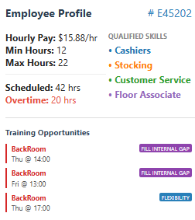
In essence, by not covering up this deterioration in a soft constraint, they can be used as a diagnostic for how to improve scheduling. Within the GUI of the website, a modified version of the smoothing heuristic is used to help identify optimal ways to fill in gaps through training and/or availability changes.
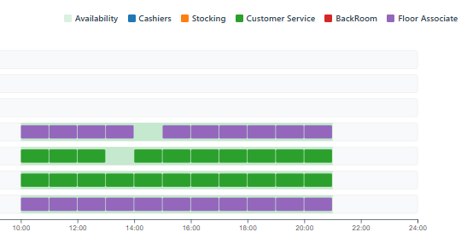
When checked on a very tight schedule, in which many employees are maxed out on overtime due to trimming over a third of the workforce (which is not recommended), this tool identifies which skills are most in demand, and how an employee could best be trained such that they could swap skills to fill these gaps. In the case shown, if the employee is trained on how to do the backroom, they can avoid having these gaps.
Optimal Work Force Golden Section Search:
Another functionality requested for this tool is for it to be able to help guide decisions about what the optimal staffing levels would be. Currently, the company has a total weekly demand of 2,283 hours. For a solver, which takes 5 minutes to return an optimal staffing level and schedule, to iteratively check each possible value from 57 (2283 / 40) to 100 would take roughly 3 hours and 40 minutes. However, the optimal value itself should be reasonably convex, in that low employee counts will have excess OT, and high employee counts will have excessive regular hours. Therefore, a modified Golden Section Search is used which leverages parallel computation to rapidly close onto a minimum within the many schedule configurations. This enables this search to be completed in 3 to 4 searches (depending on how well the computer handles partial rosters), meaning that what would normally take almost 4 hours, can be completed in as little as 15 minutes.
Before starting the search, the search space is bound within calculated feasibility bounds.
- Lower Bound: this is calculated by taking the required demand across all skills and all times (2283), then sorting employees based on their maxHrs. It then adds those hours until it reaches the demand, to establish an absolute minimum number of employees which can meet that demand without overtime. However, this addition of employees is adjusted by an availability yield of 90%, with the understanding that employees will use PTO, and no schedule should ever be at its absolute minimum number of employees. This value is calculated to be 64 employees.
- Upper Bound: this is calculated as the total demand divided by 30. The average upper bound for employees is 33.4 hours, so it is reasonable to assume that an average schedule for employees to not generate excessive hours will schedule at least 30 hours per employee on average. This gives an upper bound of 77.
From these bounds, a golden section search (GSS) is initiated, in which the golden ratio of Φ is used to select two points C and D within the bracket of [A, B]. On the first step, these two values can be computed in parallel; however, in successive iterations, one of the values is reused. This leads to an idle worker function. To effectively leverage parallel computation, the mid-point of C and D is similarly computed when a spare worker is available. This allows for a more effective use of computing resources to converge faster.
$$C=B- \frac{B-A}{Φ}; D=A+ \frac{B-A}{Φ}; M= \frac{C+D}{2}$$
After each round of computing is done by the parallel workers, the following logic is used to determine the next points to evaluate:
A (Lower Bound) < C (Golden Left) < M (Midpoint) < D (Golden Right) < B (Upper Bound)
- C is Cheapest – set new search bounds to [A, M]
- D is Cheapest – set new search bounds to [M, B]
- M is Cheapest – set new search bounds to [C, D]
This trinary logic leveraging both GSS and Mid-point search enables both active use of parallel computation across all searches, but it also converges more aggressively than either of these techniques do by themselves. However, due to how this is using Integer searches, the algorithm can become unstable as it reaches narrow brackets at the end of the solving. Therefore, once a bracket is only 3 integers wide, the above algorithm breaks and instead transitions to simply checking all untested integers still within the bracket. This combination of pre-search pruning and parallel GSS/Midpoint search enables the search space to be consistently explored in just 3 iterations. These iterations can be tracked within the Console of the Browser Developer Tools, which output as follows:
Bracket: [64, 77] | Solving: 69, 72

Total Scheduled | 69
Objective Value | '-109131.85'
Actual Cost | '$51886.45'

Total Scheduled | 72
Objective Value | '-118536.62'
Actual Cost | '$53620.67'

Bracket: [64, 72] | Solving: 67, 68

Total Scheduled | 68
Objective Value | '-82634.92'
Actual Cost | '$52623.15'

Total Scheduled | 67
Objective Value | '-66264.14'
Actual Cost | '$52500.39'

Bracket: [68, 72] | Solving: 70, 71

Total Scheduled | 70
Objective Value | '-112991.33'
Actual Cost | '$52793.72'

Total Scheduled | 71
Objective Value | '-116245.96'
Actual Cost | '$53763.11'

--- WINNER: 69 ($51886.45) ---
async findOptimalHeadcount(params, onProgress) {
await this.init();
const PHI = (1 + Math.sqrt(5)) / 2;
// Calculate heuristic bounds based on demand to narrow the search space
let totalDemand = 0;
const skills = ["Cashiers", "Stocking", "Customer Service", "BackRoom", "Floor Associate"];
params.demands.forEach(d => skills.forEach(s => totalDemand += parseFloat(d[s]|| 0)));
// Extract employee max hours and sort from highest to lowest
const sortedMaxHours = params.employees
.map(e => parseFloat(e.maxHours) || parseFloat(e.maxHrs) || 40)
.sort((valA, valB) => valB - valA);
// Calculate the theoretical minimum employees needed (Lower Bound 'a')
let accumulatedHours = 0;
let theoreticalMinEmployees = 0;
const AVAILABILITY_RATE = 0.90; // a yield rate based on PTO/Call-Out Rates
for (let i = 0; i < sortedMaxHours.length; i++) {
accumulatedHours += (sortedMaxHours[i] * AVAILABILITY_RATE);
theoreticalMinEmployees++;
// Stop once our cumulative 90% capacity exceeds the total demand
if (accumulatedHours >= totalDemand) {
break;
}
}
// If demand exceeds total theoretical supply, default to the full roster
if (accumulatedHours < totalDemand) {
theoreticalMinEmployees = sortedMaxHours.length;
}
// Conservative Bounds:
let a = theoreticalMinEmployees; // New Lower Bound
let b = Math.ceil(totalDemand / 30); // Upper Bound
while ((b - a) > 2) { // Continue shrinking until the bracket is too small
// --- CALCULATE MANDATORY PIVOTS (Global Section Search) ---
let c = Math.round(b - (b - a) / PHI);
let d = Math.round(a + (b - a) / PHI);
// Integer Safety: Ensure C and D are distinct and inside bounds
if (c === d) c = Math.max(a, c - 1);
if (d === c) d = Math.min(b, d + 1);
const tasks = []; // Determine Workload
if (!this.cache.has(c)) tasks.push(c);
if (!this.cache.has(d) && d !== c) tasks.push(d);
let m = Math.round((c + d) / 2); // The Midpoint of [c, d]
// the Golden Section of [a, d]
let specL = Math.round(a + (d - a) * (2 - PHI));
// the Golden Section of [c, b]
let specR = Math.round(c + (b - c) * (PHI - 1));
// --- SPECULATIVE "HEDGE" (Bisection & Next GSS) ---
const speculativeCandidates = [m, specL, specR];
for (const specPoint of speculativeCandidates) {
// Stop adding tasks once our worker pool is completely full
if (tasks.length >= this.poolSize) break;
// Ensure point is in bounds, not already queued, and not cached
if (specPoint > a && specPoint < b && !tasks.includes(specPoint)
&& !this.cache.has(specPoint)) { tasks.push(specPoint); }
}
// --- PARALLEL EXECUTION ---
if (tasks.length > 0) { // Ensure we don't exceed pool size
const activeTasks = tasks.slice(0, this.poolSize);
// Map tasks to workers using modular arithmetic
const promises = activeTasks.map((n, idx) =>
this.runWorker(idx % this.poolSize, params, n, onProgress)
); // Wait for all active tasks to finish, before continuing
await Promise.all(promises);
}
// --- BRACKET UPDATE ---
const rC = this.cache.get(c);
const rD = this.cache.get(d);
const rM = (m !== null) ? this.cache.get(m) : null;
// Use Infinity for failed/missing values to naturally disqualify them
const cCost = rC ? rC.cost : Infinity;
const dCost = rD ? rD.cost : Infinity;
const mCost = rM ? rM.cost : Infinity;
if (rM) {
// --- TRINARY LOGIC (We have 3 points: C, M, D) ---
if (cCost < mCost && cCost < dCost) {
console.log(" >> Left Winner. Shrink to [A, M]");
b = m;
} else if (dCost < mCost && dCost < cCost) {
console.log(" >> Right Winner. Shrink to [M, B]");
a = m;
} else {
console.log(" >> Midpoint Winner, Shrink to [C, D]");
a = c;
b = d;
}
} else {
if (cCost < dCost) {
b = d; // Pivot Left
} else {
a = c; // Pivot Right
}
}
}

// FINAL SCAN
const candidates = [];
for (let i = a; i <= b; i++) candidates.push(i);
// Solve any stragglers in the final bracket in strict batches
const unknowns = candidates.filter(n => !this.cache.has(n));
if (unknowns.length > 0) {
// Process unknowns in chunks equal to poolSize
for (let i = 0; i < unknowns.length; i += this.poolSize) {
const batch = unknowns.slice(i, i + this.poolSize);
await Promise.all(batch.map((n, idx) =>
this.runWorker(idx, params, n, onProgress)
));
}
}
let bestN = a;
let minCost = Infinity;
let bestObj = null;
// Iterate over candidates to find absolute minimum
candidates.forEach(n => {
const r = this.cache.get(n);
if (r && r.cost < minCost) {
minCost = r.cost;
bestN = n;
bestObj = r;
}
});

Web-Based Data Visualizations:
Due to the complexity of the outputs having 385 demand types (5 skills across 77 hours) and 100 employees, the viewing of schedules can be cumbersome within a simple spreadsheet. For this reason, all functionalities of the schedule optimizer are encapsulated within a web-based optimization tool, which leverages the D3 library to create dynamic visualizations which make it easier to navigate and understand the schedules of 100 people across a week. These visualizations are divided between three different panels.
Demand and Supply:
This panel shows the demand for each skill group across each operational hour. It also includes a summary of the total number of employees which have availability and that given skill during each of those hours. This helps identify which days and skills have the most friction between the supply and demand of those skills.
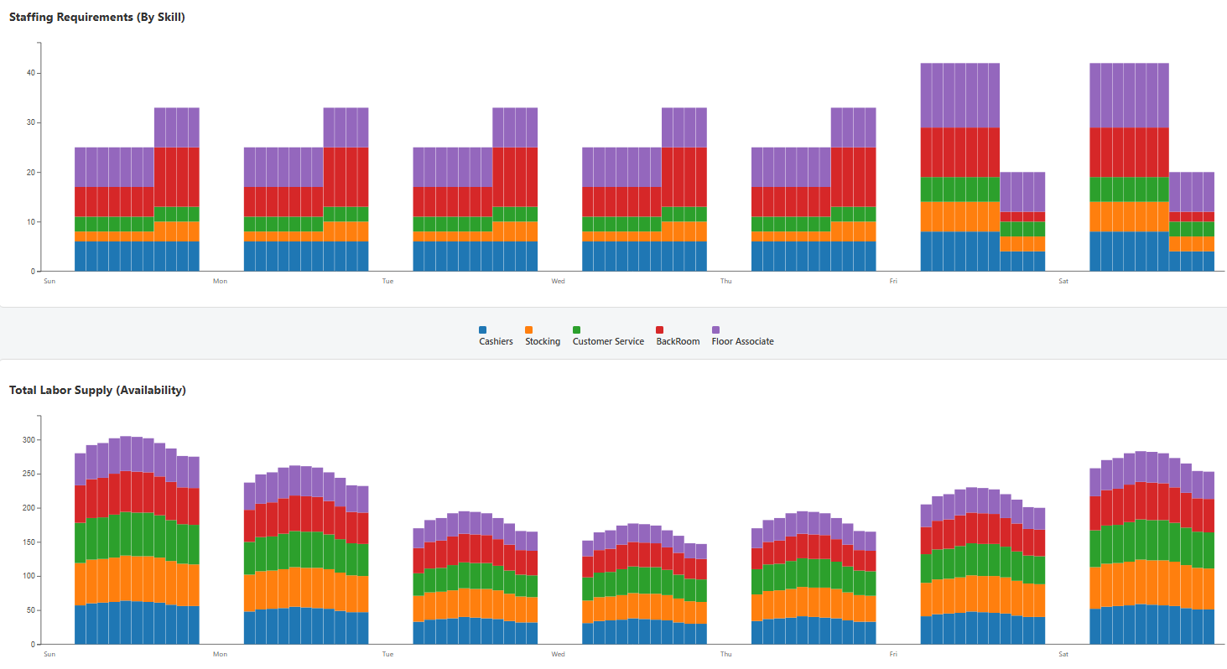
Scheduling:
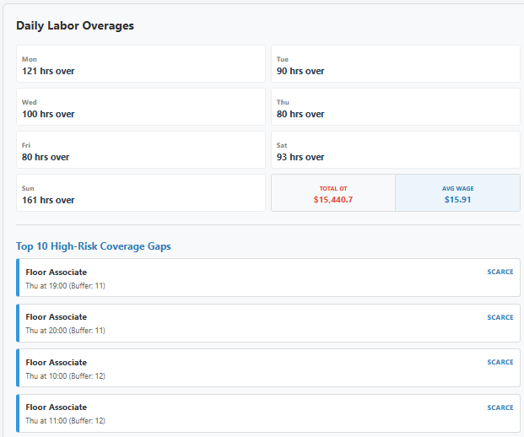
The Scheduling tab displays a daily schedule, which can be switched to any day of the week, using a drop-down selection at the top. In the schedule, each row represents a different employee, with their scheduled shifts and designated skills being filled-in with different colors (denoting the skill). This is then augmented with a table to the right which provides weekly summaries of the scheduling, such as how many hours each day is overscheduled, what the average base hourly wage of scheduled employees is and how much OT the current schedule it is using. This is further supported by a list of times and skills which lack flexibility to handle variations in supply or demand. These represent opportunities to improve overall flexibility of scheduling and the reliability of the company to meet customer demand, by focusing on how to increase availability of those skills at those time-periods.
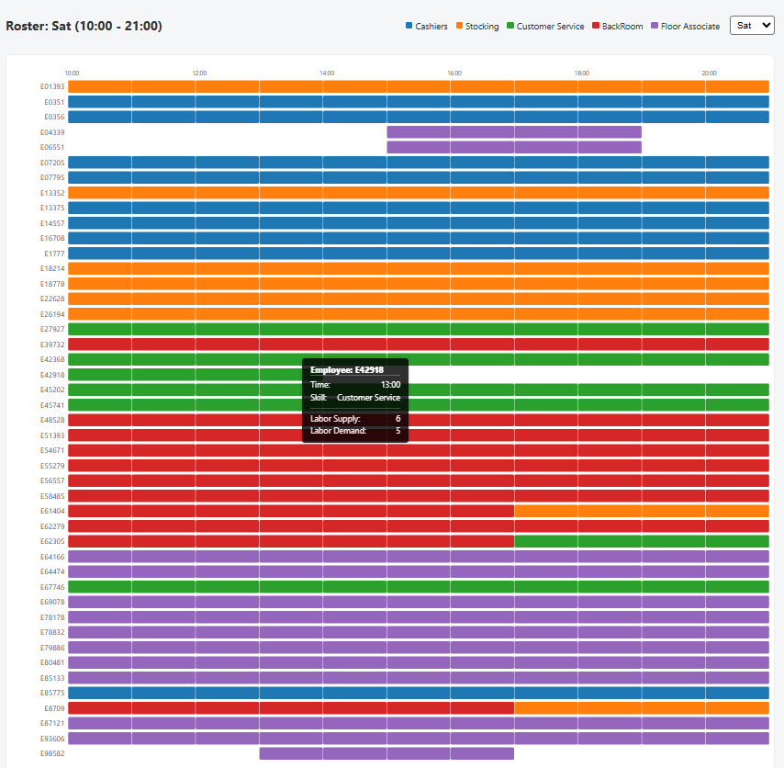
Employees:
The final tab includes a daily schedule view which can be used to view details of individual employees and their schedules, as well as training recommendations. In the left side-bar is a box which can be used to both search and navigate individual employee schedules. From this, the smoothing heuristic is leveraged to also give recommendations on training opportunities in new skills which would enable further flexibility in handling customer demand. It particularly focuses on how these additional skills would help improve schedule flexibility, provide them shift extensions, or help address gaps in their shifts. Therefore, this functions as not only a scheduling tool, but also as a tool to identify weaknesses in the schedule and how to improve them through employee cross-training.
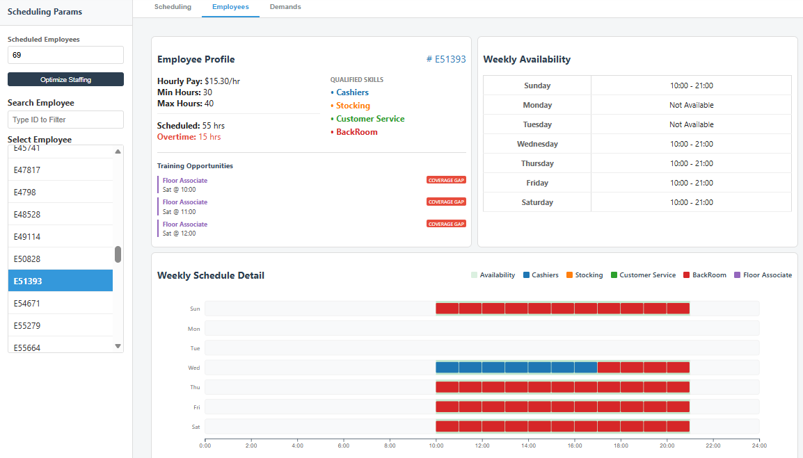
Collectively, these visualizations enable dynamic exploration of schedules and can be further refined to display additional key HR or Scheduling Data. In this way, my tool provides more than just a singular answer, but rather a generalized tool which can be leveraged to continuously improve on how wages are spent, and how employees are trained and allocated to meet customer demands while allowing teams to be able to run with minimal disruptions throughout the day due to changes in availability and demand of different skill groups.
Solution:
Using the above methodology, the default configuration of this solver is to explore a solution which applies to the full roster of 100 employees. This full roster, as previously mentioned, returns a near optimal solution in under 5 minutes. Extending this solve time to greater values had no meaningful impact on the labor costs, as even letting the solver run for 20 minutes returned the same result as 5. Therefore, on the following pages, the output schedule will be shown as seen within the visualization tool, which can be further explored at https://lumineest.github.io/OperationsResearch/ through the use of tooltips and individual employee panels. The labor costs from the proposed schedule are $66,126.27

Analysis:

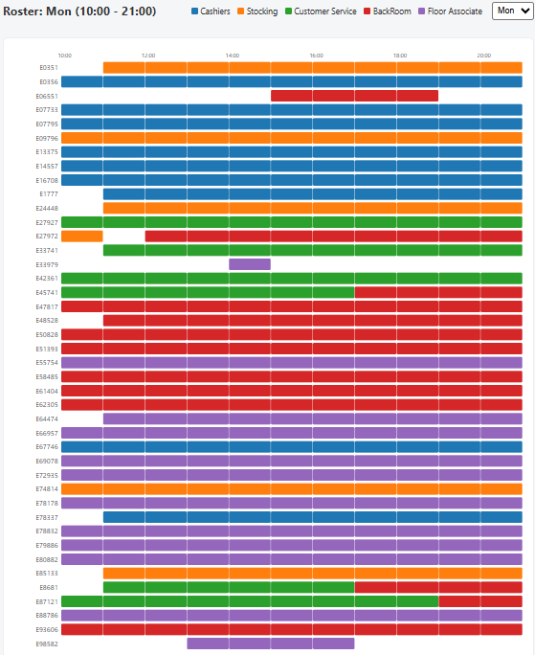
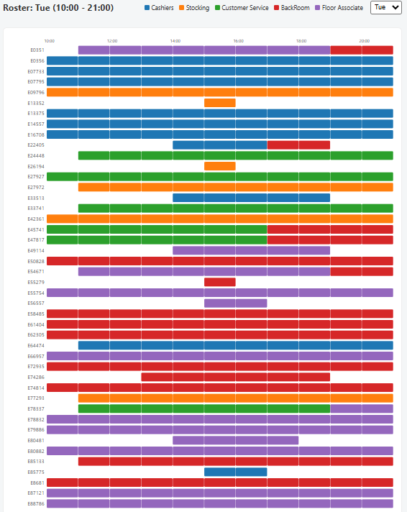
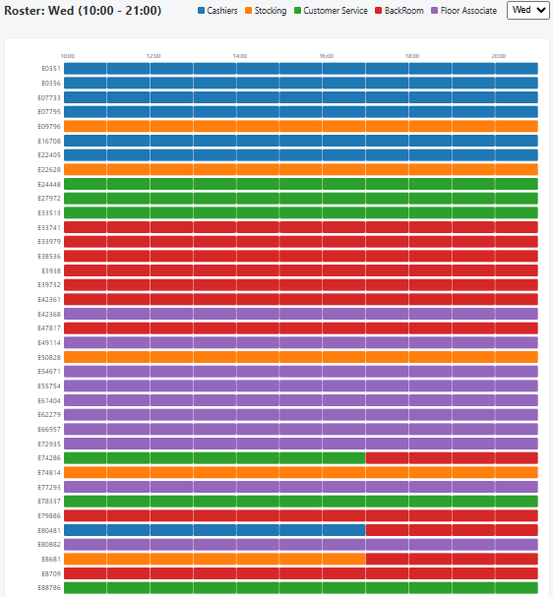
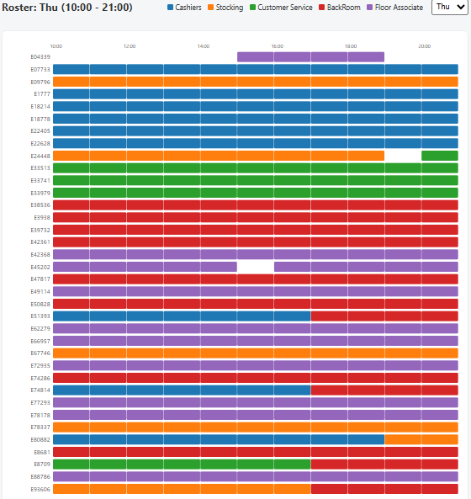
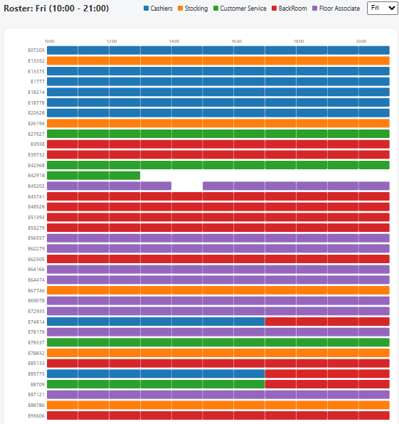
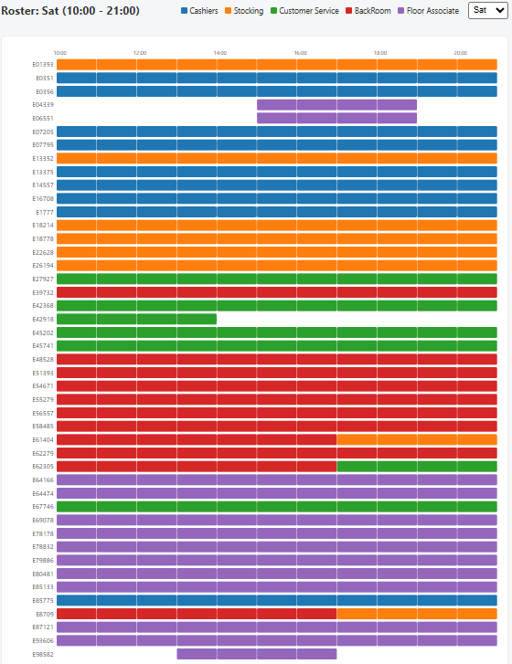
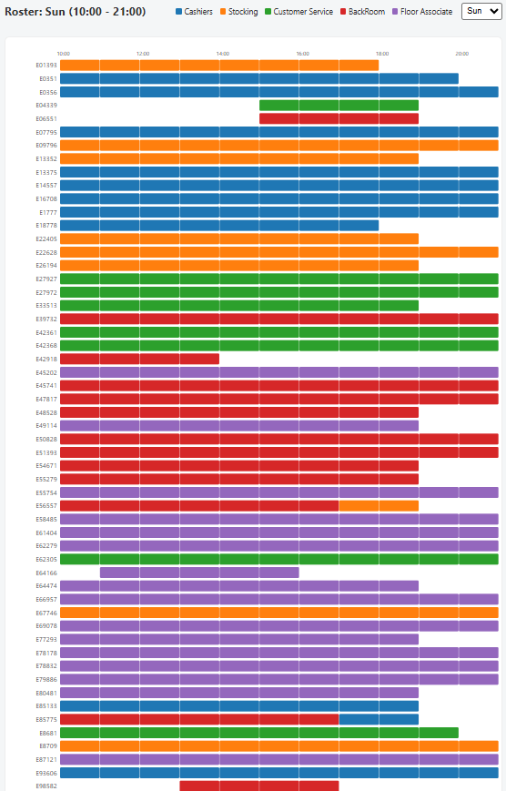

Based on the assumption that the market is able to absorb any amount of trade volume without impacting on long-term valuation of stocks, the final portfolio value is estimated to be around $641 million dollars. However, this is not how markets behave, and it would be remiss to not account for this. Ultimately, the alpha value is actually based on the ratio of traded shares to the whole, which means that not all shares will truly have the same impact. However, this effect can still be generalized so long as the types of stocks traded in have a similar market cap. This alpha value can then be extrapolated based on the mutual fund’s average trade volume in relation to those market caps. Without more information, I will assume that an appropriate alpha for a new mutual fund is 0.22, which is the average observed within Equity Markets This value could be further refined by establishing a feedback loop with the AI market prediction model.
By applying this 0.22 alpha decay, the output of the model is drastically shifted, in which trading becomes more smoothed, and the fluctuations between holdings become more diverse than within a naïve interpretation of the AI model’s predictions. The solver returns a final annual portfolio valuation of approximately $180.9 million dollars, with much of the trading done throughout the year being focused on Tesla shares. This is over a 1700% return on the initial investment of $10 million dollars, far outpacing the average success of investors on
- Re-evaluation of Assumptions:
As seen in the above model output, there is a substantial back order for Rebar, which exists on Monday, in which demand cannot be met. However, there is also an abundance of production capacity on Sundays. If we assume that the current assumption that inventory cannot carry over between weeks is not valid, then it is possible to completely avoid backorders. This would both increase profitability further, and also better reinforce trust from customers. If we shift the back orders for Rebar (200 on Monday, and 5 on Tuesday) to being supplied by excess inventory at the end of the prior week’s Sunday, then we can recalculate this profitability as follows.
$\$2,256,410-\left(200*\$240*0.02\right)- \left(5*\$240*0.04\right)+\$20\left(200+\left(5*2\right)\right)=$ $2,259,600
It is recommended therefore that an additional 205 tons of rebar should be produced on Sundays, which is a volume which can be supported with the existing availability. It is believed that the current restriction of no starting inventory on Mondays is inherently flawed for a 7-day production, and absolving this through an increased production on Sundays will further increase the profit up to around $13.5 million a year, almost a $200k improvement over the zero-inventory carryover model.
Before implementing this new suggested production schedule, it is further recommended that the current tool developed at https://lumineest.github.io/OperationsResearch/ be explored with its expanded capabilities for evaluating production times. Manufacturing is usually constrained by both material and time; and therefore, the current model requested which evaluates only the material constraints is fundamentally flawed. Even a brief exploration of the tool will show that considering the variables of Cycle Time, Change-over Costs, and Change-over Times will have a demonstratable impact on both the optimal solution, and even the viability of this proposed production schedule.
Conclusion:
By implementing this improved production schedule, annual revenue can be increased between $13.3 - $13.5 million, depending on if weekly inventory carryover is a necessary constraint. This can be explored in greater detail with the designed website, as market and work conditions change, offering more than just a single solution, but rather an implementable tool. However, there are still opportunities to further improve this model, as even with the added ability to evaluate the time constraints of production, these fail to account for differences in operational expenses and marginal changs in material lot-size purchasing. The current model assumes constant procurement and manufacturing expenses; however, these are often not constant and instead have marginal costs which increase/decreased based on their volume. I propose a long-term arrangement in which I can refine this model and expand on it as a functional tool to improve material procurement, inventory handling, and the allocation of man-power.
Appendix – Code-Base:
While much of the most relevant code has been shown in-line within the methodology of this report, this only represents a fragment of the full optimization solver tool. Rather than providing an extensive read-out of the relevant code (which is roughly 2700 lines), the following link contains the full-code base, which can be directly explored as needed:
https://github.com/LumineEst/OperationsResearch
The code is comprised primarily of JavaScript (87%), with the remainder being a balance of HTML and CSS which helps set the structure and styles respectively. The relevant repository structure is as follows:
├── data/
│ └── Stocks.xlsx # Predicted Stock Closing Prices
├── libs/
│ ├── highs.js # JS Interface for the HiGHs optimization solver
│ └── highs.wasm # Compiled WASM binary for MILP solving
├──Scripts/
│ ├── stocks.js # Tab Specific Input/Output Parsing & Visualization Script
│ └── stocksWorker.js # Optimization Solver Worker Function.
├── index.html # Application entry point, Initial DOM structure
├── script.js # Primary script to manage Core UI functionality
└── style.css # CSS Stylesheet across all tabs (handling visual styles)
- index.html - builds the overall visual structure of the website
- style.css - contains the various styling rules which control static visuals across tabs.
- script.js - contains key functionalities related to initializing the website and connecting the User Interface to the state-management of global variables.
- stocks.js – contains the scripts which process internal user inputs of the “Stock Trading Optimizer”, parses and calls the solver with these inputs, and generates the data visualizations.
- stocksWorker.js – contains the script which constructs the CPLEX string representation of the MILP model, segmented to allow parallel computation of the optimizer alongside the website’s visuals.
- highs.js – the JS interface which converts the string into WASM compatible format.
- Highs.wasm – the WebAssembly binary file which performs actual computations.

