
POKHARA UNIVERSITY
LAB REPORT ON
Internet Technology II (5)

In partial fulfillment in the degree of
Bachelor of Computer Information System(BCSIT)

Shulabh Shrestha
P.U. Reg No. 2024-2-08-0747
P.U. Roll No. 24080115

Submitted to
Department of Computer Information System
Uniglobe College
New Baneshwar, Kathmandu

Dec 2025
GITHUB LINK: https://github.com/Lumineskz/IT2-Assignments/

- Create a PHP webpage that uses file inclusion to display a common header and footer.
Requirements:
Create a file header.php containing a simple heading and navigation menu.
Create a file footer.php containing a copyright message.
Create a file home.php that includes both header and footer using the include statement.
Display your main page content in the middle of the included header and footer.

Source Code:
headerInclude.php:
<header class="main-header">
<div class="header-content">
<span class="top">This is header</span>
</div>
</header>
footerInclude.php:
<footer>
<div class="footer-content">
<span class="bottom">This is footer</span>
</div>
</footer>
headerAndFooter.php:
<!DOCTYPE html>
<html lang="en">
<head>
<meta charset="UTF-8">
<meta name="viewport" content="width=device-width, initial-scale=1.0">
<title>Document</title>
<link rel="stylesheet" href="style.css">
</head>
<body>
<?php include 'headerInclude.php'; ?>

<div class="body">
<p>This is body</p>
</div>
<?php include 'footerInclude.php'; ?>
</body>
</html>
Output:
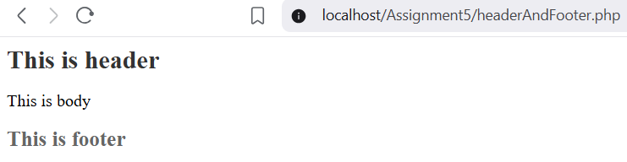

- Write a PHP script that sets a cookie named user_color with a value chosen by the user (e.g., "red", "blue", "green"). Then create another page that reads this cookie and displays:
“Your selected color is: (value)”.
Source code:
(Cookies.php):
<?php
if (isset($_POST['color'])) {
$color = $_POST['color'];
// Set cookie valid for 1 day
setcookie("user_color", $color, time() + 86400, "/");
echo "Cookie has been set! <a href='show_color.php'>Go to color page</a>";
}
?>
<!DOCTYPE html>
<html>
<body>
<form method="post">
<label>Select a color:</label>
<select name="color">
<option value="red">Red</option>
<option value="blue">Blue</option>
<option value="green">Green</option>
</select>

<input type="submit" value="Save Color">
</form>

</body>
</html>
(show_color.php):
<?php
if (isset($_COOKIE['user_color'])) {
$selectedColor = $_COOKIE['user_color'];
echo "Your selected color is: " . htmlspecialchars($selectedColor);
} else {
echo "No color has been selected yet.";
}
?>
Output:
Localhost/cookies.php:
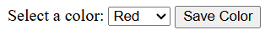
Localhost/show_color.php:

Localhost/cookies.php:
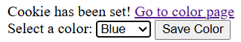
Localhost/show_color.php:
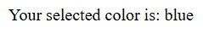

- Create a PHP application that tracks how many times a user has visited a specific page during their current browsing session.
Requirements:
Start a session using session_start().
Create or update a session variable named visit_count.
Each time the user refreshes or revisits the page, increase the count by 1.
Display a message like:
“You have visited this page X times in this session.”
Add a button or link that resets the counter by clearing the specific session variable.
Source code:
<?php
session_start();
$_SESSION['user_visits'] = isset($_SESSION['user_visits']) ? $_SESSION['user_visits'] + 1 : 1;
echo "You have visited this page " . $_SESSION['user_visits'] . " times in this session.";
// reset button
echo '<form method="post"><button type="submit" name="reset">Reset Counter</button></form>';
if (isset($_POST['reset'])) {
session_destroy();
header("Location: " . $_SERVER['PHP_SELF']);
exit();
}
?>
Output:
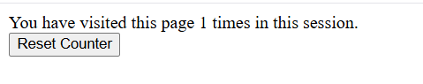

- Write php code to implement session-based authentication and authorization.
Login.php:
<?php
session_start();
if($_SERVER["REQUEST_METHOD"]== "POST"){
$username = $_POST['username'];
$password = $_POST['password'];
$users = [
"admin" => ["password" => "admin123", "role" => "admin"],
"student" => ["password" => "user123", "role" => "student"]
];
// Validate credentials
if(isset($users[$username])&& $users[$username]['password']===$password){
$_SESSION['username'] = $username;
$_SESSION['role'] = $users[$username]['role'];
// Redirect based on role
if(($_SESSION['role'])==="admin"){
header("Location:admin.php");
}else{
header("Location: student.php");
}
exit();
}else{
echo "<p>Invalid username or password</p>"; // Display error message
}
}
?>
<!DOCTYPE html>
<html lang="en">
<head>
<meta charset="UTF-8">
<meta name="viewport" content="width=device-width, initial-scale=1.0">
<title>Document</title>
</head>
<body>
<h2>Log in form</h2>
<form action="" method="post">
Username: <input type="text" name="username" required><br>
Password: <input type="password" name="password" required><br>
<input type="submit" value="Login">
</form>
</body>
</html>
Admin.php:
<?php
session_start();
if(!isset($_SESSION["username"]) || $_SESSION["role"] !== "admin"){
header("Location: access_denied.php");
exit();
}
?>

<!DOCTYPE html>
<html lang="en">
<head>
<meta charset="UTF-8">
<meta name="viewport" content="width=device-width, initial-scale=1.0">
<title>Admin Dashboard</title>
</head>
<body>
<h2>Welcome Admin, <?php echo $_SESSION['username']; ?>!</h2>
<p>This is the admin dashboard. Only admin users can access this page</p><br>
<a href="logout.php">Logout</a>
</body>
</html>
Student.php:
<?php
session_start();
if(!isset($_SESSION["username"]) || $_SESSION["role"] !== "student"){
header("Location: access_denied.php");
exit();
}
?>
<!DOCTYPE html>
<html lang="en">
<head>
<meta charset="UTF-8">
<meta name="viewport" content="width=device-width, initial-scale=1.0">
<title>Student Dashboard</title>
</head>
<body>
<h2>Hello Student, <?php echo $_SESSION['username']; ?>!</h2>
<p>This is the student dashboard. Only student users can access this page</p><br>
<a href="logout.php">Logout</a>
</body>
</html>
AccessDenied.php:
<!DOCTYPE html>
<html lang="en">
<head>
<meta charset="UTF-8">
<meta name="viewport" content="width=device-width, initial-scale=1.0">
<title>Document</title>
</head>
<body>
<h2 style="color:red">Access Denied</h2>
<p>You do not have permission to access this page.</p>
<a href="login.php">Go to Login Page</a>
</body>
</html>
Logout.php:
<?php
session_start();
// Destroy all session data
session_destroy();
// Redirect to login page
header("Location: login.php");
exit();
?>
Outputs:
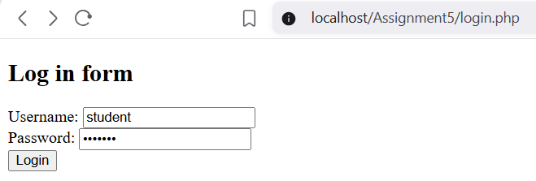
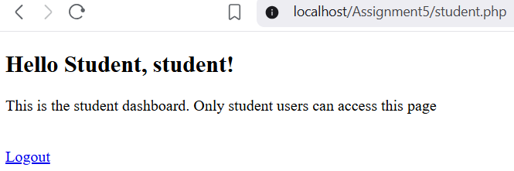

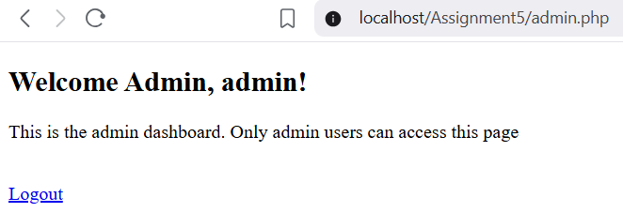

When student tries to access Admin.php:
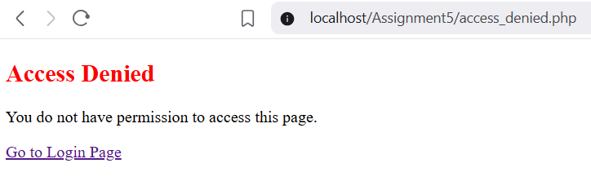
- Write a PHP program that uses a try-catch-finally block to handle file upload. Throw a custom exception with a meaningful message.
SourceCode:
FileUpload.php:

<!DOCTYPE html>
<html lang="en">
<head>
<meta charset="UTF-8">
<meta name="viewport" content="width=device-width, initial-scale=1.0">
<title>Document</title>
</head>
<body>
<form action="tryCatchException_onSubmit.php" method="POST" enctype="multipart/form-data">
<h2>Input a txt file:</h2>
<input type="file" name="fileInput"><br><br>
<input type="submit" value="Upload File">
</form>
</body>
</html>
tryCatchException_onSubmit.php:
<?php
$fileInput = $_FILES['fileInput'] ?? null;
try {
if(!$fileInput || $fileInput['error'] !== UPLOAD_ERR_OK){
throw new Exception("No file uploaded.",401);
}
$fileName = $fileInput['name'];
if(pathinfo($fileName, PATHINFO_EXTENSION) !== 'txt'){
throw new Exception("Invalid file type. Only .txt files are allowed.",402);
}
} catch (Exception $e) {
echo "Error: ".$e->getMessage()." Code: ".$e->getCode();
}finally{
echo "\nFile upload attempt completed.";
}
?>
Output:
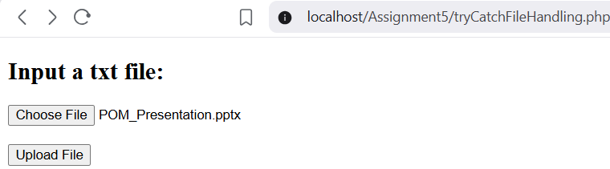

No file:

Non .txt file:

