UNIGLOBE COLLEGE
(Affiliated to Pokhara University)
New Baneswor, Kathmandu



Fourth Semester Project Report On
“Click2Eat – Canteen Pre-order system”
(PRJ181)

A Fourth Semester Project Report on the partial fulfillment of the requirement of bachelors of computer science and information technology

Under the supervision of
Anish Dhamala
Lecturer/Supervisor

Submitted By:
Shulabh Shrestha
Aaishwarya Prashant
Saistha Pradhan

“Click2Eat – Canteen Pre-order system”
(PRJ181)

A fourth semester project report submitted in partial fulfillment of the requirements for the degree of Bachelor of Computer System and Information Technology awarded by Pokhara University

Submitted By
Shulabh Shrestha
Aaishwarya Prashant
Saistha Pradhan

Submitted To
UNIGLOBE COLLEGE
Department of Computer Science and Information Technology
New Baneshwor, Kathmandu, Nepal
May 2026

Abstract

The Canteen Pre-order System is a web application built to streamline and revolutionize the food ordering procedure at a college canteen, making it easier for students to order food online without standing in line, wasting precious time. This application will allow students to create a user account, log in, choose from the menu options, browse specials of the day, check which products are sold out, and order instantly using a one-click option without having to go through the hassle of filling a shopping cart. After placing the order, users will be able to see its current status, which includes Pending, Preparing, Ready for Pick-Up, and Payment Made and Order Completed. Besides, students can track their past orders and refer back to them when needed. From the admin's perspective, the system will offer a dashboard where canteen employees can manage the menu items, add new food products, edit their descriptions, remove items that are no longer offered, update item availability, mark some products as sold out, and easily handle incoming orders. The project uses a well-organized relational database, including tables for students, admins, menu items, orders, and completed orders.
In addition to core functionalities, the system prioritizes security and future scalability to accommodate peak rush hours within the college campus. Robust data validation and protection mechanisms against common web vulnerabilities, such as SQL injection and Cross-Site Request Forgery (CSRF), are deeply integrated into the application's processing layer. Looking forward, the platform is designed with modularity in mind, allowing for smooth future enhancements such as the integration of local digital payment gateways for cashless transactions and real-time push notifications to alert students the exact moment their food is ready. This comprehensive approach not only minimizes administrative overhead for canteen staff but also provides valuable analytical insights into daily sales patterns, helping management optimize inventory and reduce food waste.

TABLE OF CONTENTS

Abstract iii
TABLE OF CONTENTS iv
LIST OF FIGURES vi
ABBREVIATIONS vii
CHAPTER 1: INTRODUCTION 1
1.1 Background 1
1.2 Problem Statement 2
1.3 Objectives of the Project 2
1.4 Scope of the Project 3
1.5 Limitations of the Project 3
1.6 Significance of the Study 3
CHAPTER 2: LITERATURE REVIEW 4
2.1 Overview 4
2.2 Review of Existing Systems 4
2.2.1 QR-Based Canteen System 4
2.2.2 Android-Based Canteen Ordering System 4
2.2.3 Smart Canteen Management System 5
2.3 Research Gap 6
CHAPTER 3: SYSTEM ANALYSIS AND DESIGN 7
3.1 Project Management Strategy and Development Tools 7
3.1.1 Project Team 7
3.1.2 Project Flow and Schedule 7
3.1.3 Responsibilities 7
3.1.4 Development Tools 8
3.2 System Analysis 9
3.2.1 Requirement Analysis 9
3.2.2 Feasibility Analysis 10
3.3 System Design 11
3.3.1. Activity Diagram 11
3.3.2 ER Diagram 12
3.3.5 Use Case Diagram 13
3.3.6 Sequence diagrams 14
3.3.7 Class Diagram 15
3.3.8 Schema Diagram 16
CHAPTER 4: System Implementation 17
4.1 Detailed Project Schedule 17
4.2 Gantt Chart 18
4.2 Implementation 18
4.2.1 Log in Module 18
4.2.2 Student/Faculty Dashboard Module 19
4.2.3 Menu Page Module 19
4.2.4 Admin Dashboard Module 20
4.2.5 User Management Module 20
4.2.6 Menu Management Modules 21
4.2.7 Timing Schedule Module 22
4.2.8 Landing Page Module 22
References 23

LIST OF FIGURES
Figure 1: Activity Diagram 11
Figure 2: ER Diagram 12
Figure 3: Use case diagram 12
Figure 4: Sequence diagram 13
Figure 5: Class Diagram 13

ABBREVIATIONS
CSS  HTML  JS  PHP  SQL  XAMPP | Cascading Style Sheet  Hyper Text Markup Language  JavaScript  Hypertext Preprocessor  Sequence Query Language  Cross-Platform (X), Apache (A), MariaDB (M), PHP (P), and Perl (P)

CHAPTER 1: INTRODUCTION

Background
The Click2Eat – Canteen Pre-order System is a web-based application developed to improve and modernize the traditional food ordering process used in college and university canteens. In many educational institutions, students and faculty members often experience long waiting lines and overcrowding during lunch breaks or free periods. Since most canteens still rely on manual ordering and payment systems, customers are required to stand in queues to place orders, wait again for food preparation, and sometimes discover that their desired food items are already unavailable. These problems waste valuable time, create inconvenience for users, and increase pressure on canteen staff during busy hours. The Click2Eat system is proposed as a digital solution to make the ordering process faster, more organized, and more efficient for both customers and administrators.
The system allows students and faculty members to access the canteen menu through an online platform where they can view available food items, prices, and stock availability in real time. Instead of physically visiting the canteen to order food, users can simply log into the system, select their preferred meals, and place pre-orders before arriving at the canteen. This reduces unnecessary crowding and minimizes waiting time significantly. Users can also track the status of their orders, such as whether the order is pending, being prepared, ready for collection, or already collected. In addition, the system maintains an order history feature that enables users to review their previous orders for convenience and record keeping. By offering these features, the system provides a more user-friendly and time-saving experience compared to traditional manual ordering methods.
The project also includes an administrative dashboard for canteen management. Through this dashboard, canteen staff or administrators can efficiently manage menu items, update food prices, control daily stock quantities, and mark certain items as sold out whenever necessary. The admin panel also helps staff monitor all incoming orders, manage pending requests, and organize food preparation in a systematic manner. This reduces confusion during peak hours and improves overall workflow inside the canteen. Since stock is updated digitally, the chances of accepting orders for unavailable food items are greatly reduced. Furthermore, the system helps maintain proper digital records of orders and transactions, making it easier to track sales and analyze customer preferences in the future.
Another important aspect of the Click2Eat system is its contribution to improving overall productivity and customer satisfaction within the college environment. Students often have limited break times between classes, and spending a large portion of that time waiting in queues can negatively affect their schedules and academic activities. By enabling quick and convenient food pre-ordering, the system allows users to manage their time more effectively. Faculty members can also benefit from the system by avoiding crowded areas and receiving faster service. At the same time, canteen staff can prepare orders in advance based on digital requests, reducing pressure and improving service quality. The project therefore creates benefits for both customers and administrators by introducing a more organized and technology-driven approach to canteen management.

Problem Statement
Many students and faculty members face long waiting lines, overcrowding, and delays while purchasing food from the college canteen, especially during break hours. Traditional manual ordering methods also make it difficult for canteen staff to manage orders, track stock availability, and handle large numbers of customers efficiently. In addition, customers often do not know whether food items are available or when their orders are ready for collection. The Click2Eat – Canteen Pre-order System aims to solve these problems by providing a digital platform where users can pre-order meals, view available menu items in real time, and track their order status, while allowing administrators to manage menu items, stock, and orders more effectively.

1.3 Objectives of the Project
The Objectives of the Project are as follows:
- To enable quick and easy pre-ordering of food for students
- To enable admins to manage menu items, food availability, and real-time order processing
- To provide clear tracking of order status

1.4 Scope of the Project
The Scope of the project are as follows:
- Digital menu with admin-controlled “Today’s special”
- One click ordering system with confirmation or undo and real time order status tracking
- Admin dashboard to manage orders, mark items as sold out and update “Paid and collected”

1.5 Limitations of the Project
The project has its limitations which are the things that it doesn’t include, they are:
- The system requires a stable internet connection to access the website, place orders, and update order information. Users may face difficulties using the system during network issues or internet outages.
- The current version of the system may only support cash-on-collection or simple payment methods and does not include advanced online payment gateway integration
- The platform is designed primarily for single canteen environment, making it less suitable for managing multiple branches or larger-scale food service operation without future expansion

1.6 Significance of the Study
This study is significant because it helps improve traditional canteen systems by reducing long queues, saving time, and enhancing food service efficiency through digital automation. Similar studies have shown that smart canteen systems improve operational management, user convenience, and institutional service quality [1, 2, 3]. This project specifically provides a simplified one-click pre-order solution for educational institutions, making food ordering faster for students while supporting better menu and order management for canteen administrators.

CHAPTER 2: LITERATURE REVIEW

2.1 Overview
With the rapid advancement of digital technologies, traditional manual systems in various domains are being replaced by automated and efficient solutions. In educational institutions, canteen services still largely depend on manual ordering processes, which often result in long queues, delays, and inefficient management. To address these issues, several digital canteen and food ordering systems have been proposed in previous studies. This section reviews some of the existing systems and identifies their limitations.

2.2 Review of Existing Systems

2.2.1 QR-Based Canteen System
One of the widely proposed approaches is the QR-Based Canteen System developed by Joshi, S., Kasaju, B., Karki, P., Aryal, S. K., & Chhetri, S. B. [1]. This system uses Quick Response (QR) codes to provide users with access to the digital menu. Students can scan the QR code using their mobile devices, view available food items, and place orders electronically. The main advantage of this system is that it reduces physical interaction and eliminates the need for printed menus or manual order-taking.
Additionally, the QR-based approach helps in minimizing crowding at the ordering counter and supports a more hygienic environment. It is especially useful in situations where contactless services are preferred. However, despite these advantages, the system introduces certain usability challenges. Users are required to scan the QR code every time they want to access the menu, which adds an extra step and may not be convenient for frequent use.

2.2.2 Android-Based Canteen Ordering System
Another commonly proposed solution is the Android-Based Canteen Ordering System by Toma, S. T. F., Karmaker, D., Iqbal, S., Pantho [2]. This system provides a dedicated mobile application through which users can browse menus, place orders, and manage their requests. The use of a mobile application offers a structured and interactive interface, making it easier for users to navigate through different options.
This system is particularly effective in reducing congestion during peak hours, as students can place orders remotely without physically visiting the counter. It also helps canteen staff manage orders more efficiently by maintaining a digital record of requests.
However, the requirement of installing a mobile application creates a significant limitation. Not all users may have sufficient storage space or compatible devices to run the application. Additionally, the system is platform-dependent, as it primarily supports Android devices, thereby excluding users from other platforms such as iOS or those without smartphones.
Another drawback is that application-based systems often require regular updates and maintenance, which can increase complexity and cost. These factors reduce the accessibility and practicality of the system, especially in environments where simplicity and ease of use are essential.

2.2.3 Smart Canteen Management System
The Smart Canteen Management System proposed by Narendran, A., Inuguri, A. H., Yashaswini, M., Sundaram, S., & Khanna, M. [3] provides a more comprehensive approach to canteen automation. This system integrates multiple features, including digital menu management, order processing, billing, and online payment systems. It aims to create a fully automated environment that enhances operational efficiency and reduces manual workload.
One of the major strengths of this system is its ability to handle multiple aspects of canteen management in a single platform. The inclusion of online payment systems also adds convenience for users and ensures proper transaction records.
Despite these advantages, the system is relatively complex and may not be suitable for small-scale environments such as college canteens. The integration of advanced features increases the system’s complexity, making it harder to implement and maintain. Additionally, the focus on online payment may not align with the preferences of all users, particularly in environments where cash transactions are more common.
Moreover, the system does not emphasize quick and minimal interaction, which is a key requirement in busy campus settings. Students typically prefer fast and straightforward solutions, and overly complex systems may reduce user adoption.

2.3 Research Gap
Based on the analysis of the existing systems, several research gaps have been identified:
- Most systems require additional steps such as QR code scanning or application installation
- Lack of simple and efficient one-click ordering mechanisms
- Limited implementation of real-time order tracking
- Systems are either too complex or not tailored for campus environments
- Accessibility issues due to platform dependency
- Lack of focus on user-friendly and minimal interaction design
These limitations indicate the need for a system that is simple, efficient, and specifically designed for the requirements of students and campus canteens.

CHAPTER 3: SYSTEM ANALYSIS AND DESIGN

3.1 Project Management Strategy and Development Tools
The project follows a structured development model using PHP, MySQL, HTML/CSS, and XAMPP.

3.1.1 Project Team
Team Resource | Role
Shulabh Shrestha | Group Leader
Raja Mandal | Member
Aishwarya Prashant | Member
Saistha Pradhan | Member
Table 2: Team Resource and Roles
The Swift project by this group is supervised by Ms. Annu Khanna Nakarmi.

3.1.2 Project Flow and Schedule
- Team Size: 4
- Total Project Duration: 11 weeks
- Effort Required per person: 6 hours per week

3.1.3 Responsibilities
This section States the responsibilities of each members of the project

3.1.3.1 Responsibilities of Supervisor
- Provide guidance throughout the planning, analysis, design, and implementation phases of the project.
- Offer constructive feedback to improve system design, security, and functionality.
- Evaluate the final system, documentation, and presentation as part of academic assessment.

3.1.3.2 Responsibilities of team member
- Conduct requirement analysis to understand the problem domain and define system features
- Design System Architecture, workflow diagrams, DFDs, ERDs, and use case for the project
- Develop full web application using PHP, HTML, CSS and JavaScript.
- Ensure timely completion of all project phases according to the schedule
- Prepare final report, demonstration materials, and contribute to the final evaluation process

3.1.4 Development Tools
Backend: PHP
Frontend: HTML/CSS/JavaScript
Database: MySQL
Server: Apache
Testing: Manual Testing

3.1.4.1 Backend Tools
PHP is used for backend language as it is one of the most widely used language for server side development and it integrates seamlessly with MySQL making data handling efficient. PHP runs smoothly on apache servers providing stable environment.

Front End Tools
HTML Provides the structure and layout of webpages. It is used to design components like forms, buttons, food item cards and images.
CSS Controls the styling, appearance, and responsiveness of the website. Makes the interface visually appealing and user-friendly. It helps maintain consistency across pages.
JavaScript Adds interactivity and dynamic behavior to the web pages. JS is used for form validation, real-time UI updates, and enhancing user experience. It helps with asynchronous interactions and improves the responsiveness of the system.

Web Server
Apache is used as a web server because it is stable, open source and widely used in php applications. It’s fully compatible with XAMPP environments and commonly used by developers.

Testing Tools
Manual testing is chosen because the project is medium scale, making manual checks practical and efficient. Allows the developer to interact directly with the system identify UI/UX.

System Analysis
The system is designed based on collected requirements for secure login, order tracking, admin controls, and user experience

3.2.1 Requirement Analysis
The collected information is structured, conflicts are resolved and requirements are prioritized.

3.2.1.1 Functional Requirements(FR):
- FR1: The system shall allow students, faculty members, and administrators to create accounts and securely log in using valid credentials.
- FR2: The system shall provide different access levels for users (students/faculty) and administrators, ensuring each role can only access permitted features.
- FR3: The system shall allow users to view the daily canteen menu with food items, prices, and availability status in real time.
- FR4: The system shall allow users to select food items and place pre-orders for available menu items.
- FR5: The system shall allow users to view current order status such as pending, preparing, ready for pickup, and completed. (User side)
- FR6: The system shall maintain order history for students to review completed orders.
- FR7: The system shall allow the administrator to add, edit, and delete food items from the menu.
- FR8: The system shall allow the administrator to update daily stock availability and mark items as sold out.
- FR9: The system shall allow admins to view and manage incoming student orders.
- FR10: The system shall allow administrators to view, accept, update, and manage all incoming orders.(Admin side)
- FR12: The system shall allow administrators to update the status of each order in real time (e.g., preparing, ready, collected).
- FR13: The system shall allow the administrator to manage user accounts, including viewing, adding, or deactivating users if required.
- FR14: The system shall provide administrators with basic reports such as total orders, popular items, and daily sales summary.

3.2.1.2 Non-Functional Requirements(NFR):
- NFR1: The system should provide a simple, user-friendly, and responsive interface for both students and admins.
- NFR2: The system should process menu loading, order placement, and status updates efficiently with minimal delay.
- NFR3: The system should ensure secure authentication and protect user login credentials.
- NFR4: The system should maintain data accuracy and consistency within the database.
- NFR5: The system should be available and accessible through standard web browsers.
- NFR6: The system should support scalability for future enhancements such as online payment or multiple-item ordering.

3.2.2 Feasibility Analysis

3.2.2.1 Technical Feasibility
Easily developed using basic web technologies with no complex requirements.

3.2.2.2 Operational Feasibility
Simple for students and staff to use, improving canteen workflow.

3.2.2.3 Economic Feasibility
Development tools like XAMPP, VS Code and MySQL are free to use and maintenance cost are low due to system’s simplicity.

3.2.2.4 Time feasibility
This project is simple enough to be completed within 1-2 months. Tasks such as UI design, backend design, database setup, and testing are manageable during this time frame.

3.3 System Design

3.3.1. Activity Diagram
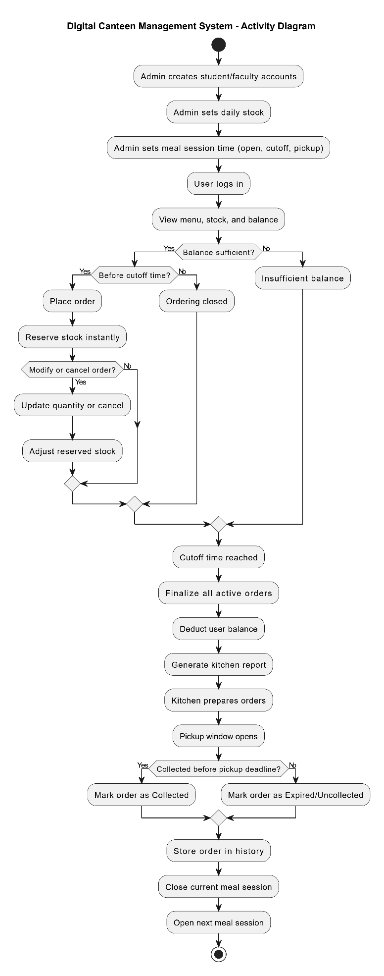
Figure 1: Activity Diagram
The activity diagram for the Click2Eat – Canteen Pre-order System illustrates the workflow of both users and administrators. The process begins when a user accesses the system and logs in or registers. After successful authentication, the user can view the daily menu, select food items, and place an order. The system then generates an order confirmation and allows the user to track the order status until it is ready for collection, after which the user collects the food and can also view order history. On the other hand, the admin logs in to manage the system by updating menu items, controlling stock availability, and monitoring incoming orders. The admin processes each order and updates its status in real time while also generating reports for better management. This diagram overall represents the interaction between user ordering activities and admin management tasks in a structured flow.

3.3.2 ER Diagram
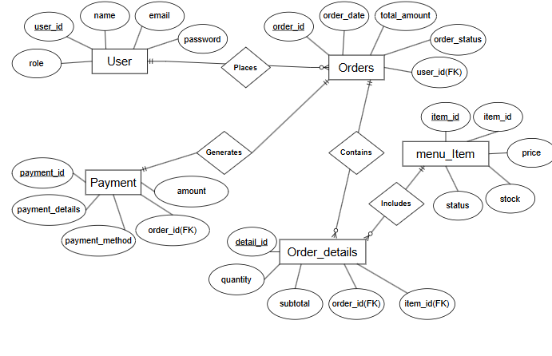
Figure 2: ER Diagram
This ER diagram shows the main entities of the Digital Canteen Pre-order System: Students, Orders, Menu Items, Admin, and Order History. Students place orders, select menu items, and view their order history. Each order stores student details, selected food, payment amount, and status. Admin manages menu items and receives student orders for processing. Completed orders are stored in Order History for future reference

3.3.5 Use Case Diagram
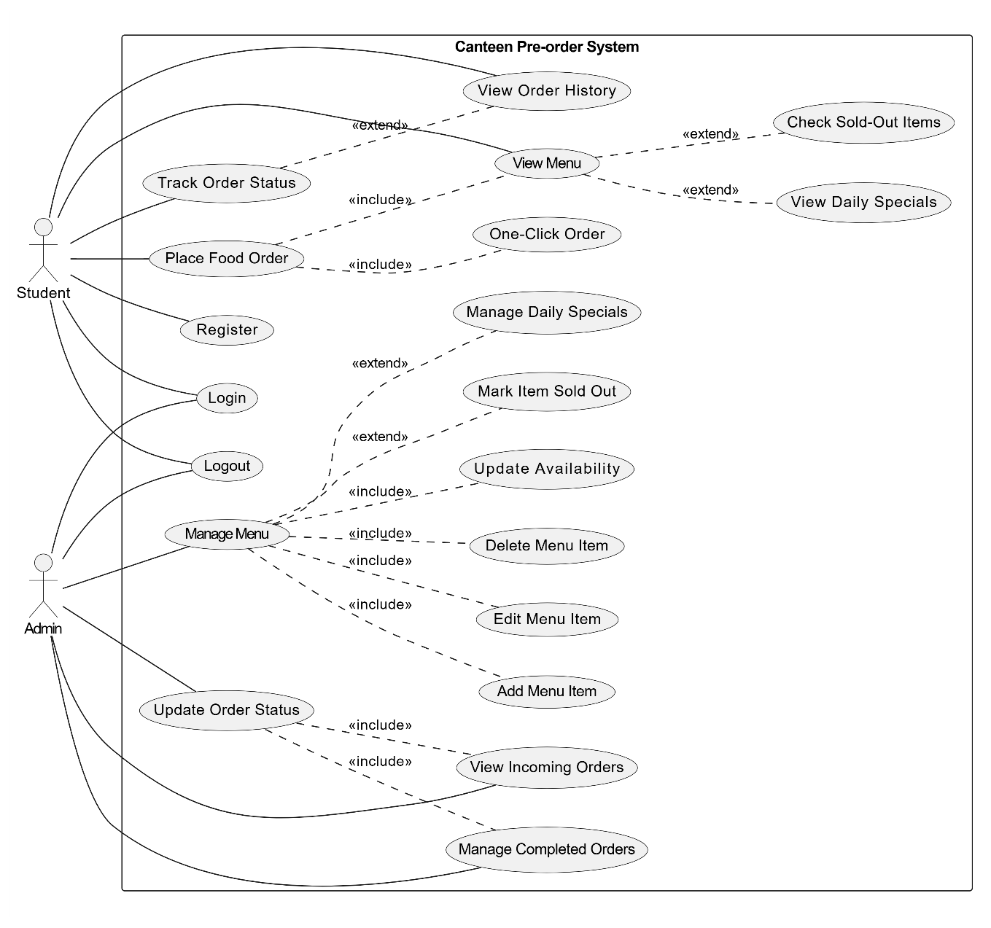
Figure 3: Use case diagram
The include relationships show mandatory sub-processes such as user validation during login, checking item availability when viewing the menu or placing orders, and payment processing as part of order placement. These are essential steps that must always occur within the main use cases. The extend relationships represent optional or conditional functionalities, where tracking order status and viewing order history extend from the main “Place Order” use case, depending on user actions after placing an order. Overall, this enhanced diagram provides a more realistic and structured representation of system behavior, improving clarity of shared and optional processes within the system.

3.3.6 Sequence diagrams
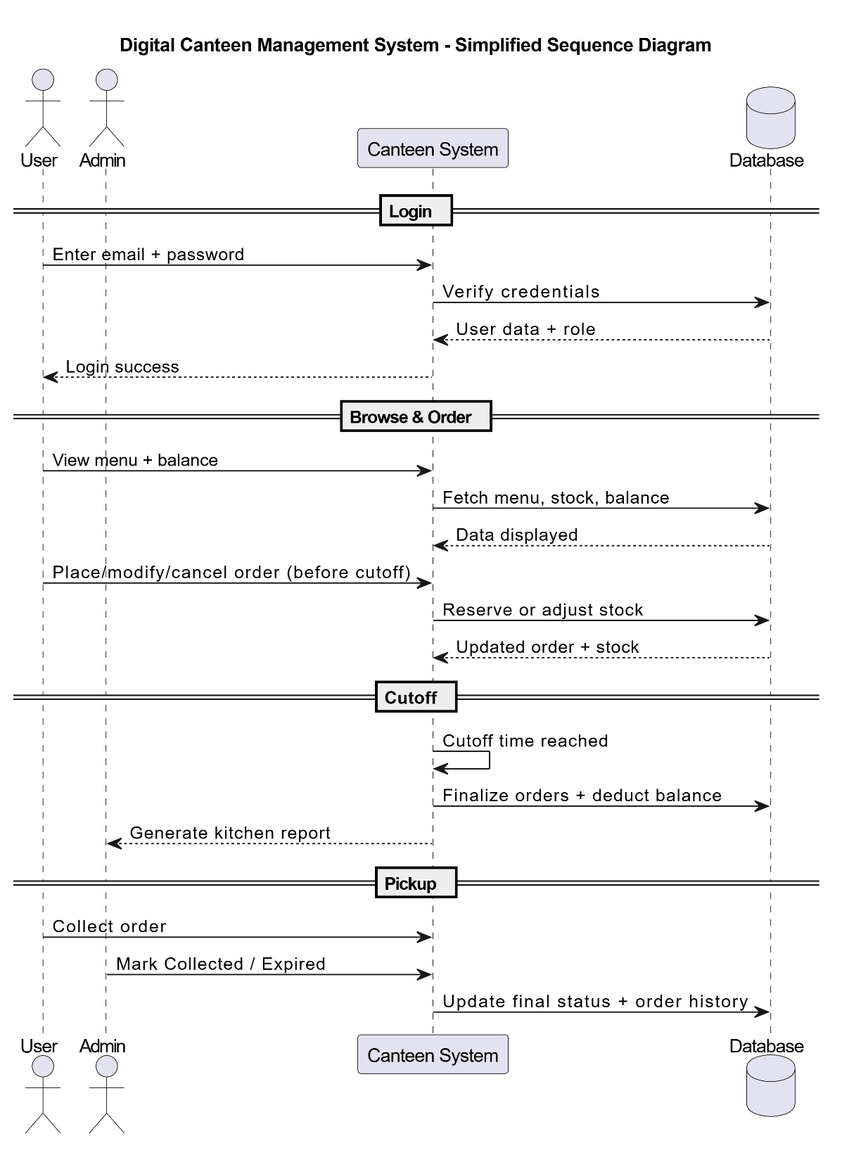
Figure 4: Sequence diagram
This sequence diagram shows the step-by-step interaction between Student, Admin, Canteen System, and Database in the Digital Canteen Pre-order System. First, the student browses the menu, and the system fetches menu data from the database. The student then places a one-click order, which is stored as pending and notified to the admin. The admin processes the order by updating its status to preparing or ready, and the student receives live status updates. Finally, during pickup, the student pays physically, the admin marks the order as paid and collected, and the system stores the completed order in order history.

3.3.7 Class Diagram
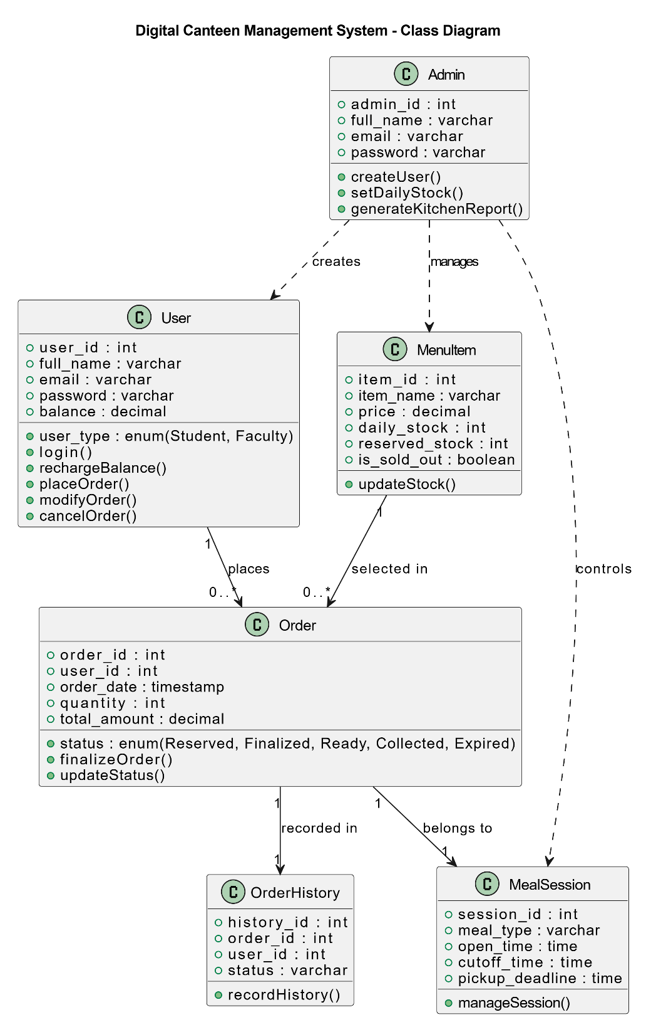
Figure 5: Class Diagram
The class diagram of the Digital Canteen Pre-order System represents the main system entities and their relationships. The Student class handles student information and ordering functions, while the Admin class manages menu items and order processing. The MenuItem class stores food item details such as price, image, and availability status. The Order class records student orders, selected menu items, total amount, and order status, whereas the OrderHistory class stores completed order records.

3.3.8 Schema Diagram
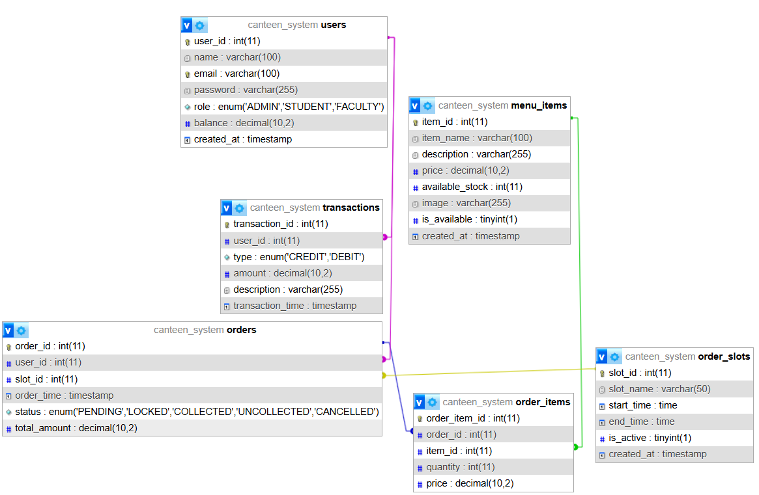
Figure 6: Schema Diagram
This database schema maps out a Canteen Pre-order System by cleanly separating user accounts, financial records, and the food ordering lifecycle through structured relational tables. It tracks student and staff balances within the users table, logging every deposit or payment as a CREDIT or DEBIT inside the transactions table. Food options and inventory are managed in menu_items, while the actual purchases are captured by orders and broken down into specific quantities via the many-to-many intermediate table, order_items. Finally, the system integrates an order_slots table linked to each order, allowing the canteen to efficiently regulate and schedule specific pick-up time windows for customers.

CHAPTER 4: System Implementation

4.1 Detailed Project Schedule
Task Id | Task Name | Start Date | End Date | Dur
1 | Title Defense
1.1 | Topic Brainstorming | 26-Apr | 26-Apr | 1
1.2 | Topic Decision | 27-Apr | 27-Apr | 1
1.3 | Presentation Preparation and Division | 28-Apr | 29-Apr | 2
2 | Proposal Defense
2.1 | Literature Review and Figma Designing | 30-Apr | 2-May | 3
2.2 | UML Diagrams | 3-May | 6-May | 4
2.3 | Backlog | 7-May | 7-May | 1
2.4 | Preparation of Documentation and Presentation | 8-May | 9-May | 2
3 | Mid-Term Defense
3.1 | Correction of Diagrams and Project Work Division | 14-May | 15-May | 2
3.2 | Gantt chart | 18-May | 18-May | 1
3.3 | Project Start
3.3.1 | Database Definition and Login/Signup Page | 20-May | 22-May | 3
3.3.2 | User Dashboard and Admin Dashboard redirection | 23-May | 24-May | 2
3.3.3 | Order Menu creation(For users) and Admin custom menu for daily "Today's special" unique menu | 26-May | 28-May | 3
3.3.4 | Order POST Logic and display order on admin side | 28-May | 29-May | 2
3.4 | Testing and Test Case Creation | 30-May | 2-Jun | 4
3.5 | Documentation Correction | 3-Jun | 4-Jun | 2
3.6 | Documentation for Mid-Term Defense Creation | 5-Jun | 8-Jun | 4
3.7 | Presentation Preparation and Division | 12-Jun | 13-Jun | 2
3.8 | Mid-terms | 14-Jun | 27-Jun | 14
4 | Pre-board Defense
4.1 | Admin page: Register user, Add Menu Item | 28-Jun | 30-Jun | 3
4.2 | Admin page: Manage Menu Item | 30-Jun | 1-Jul | 2
4.3 | Admin Page: Add Balance, Manage Users | 1-Jul | 3-Jul | 3
4.4 | Admin Page: Timing Schedule Add and Edit | 4-Jul | 8-Jul | 5
4.5 | User Page: Display Menu, Display Balance | 9-Jul | 10-Jul | 1
4.6 | User Page: User Dashboard and Order button modification | 11-Jul | 12-Jul | 4

4.2 Gantt Chart
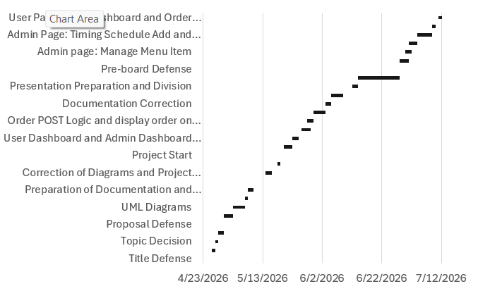

4.2 Implementation

4.2.1 Log in Module
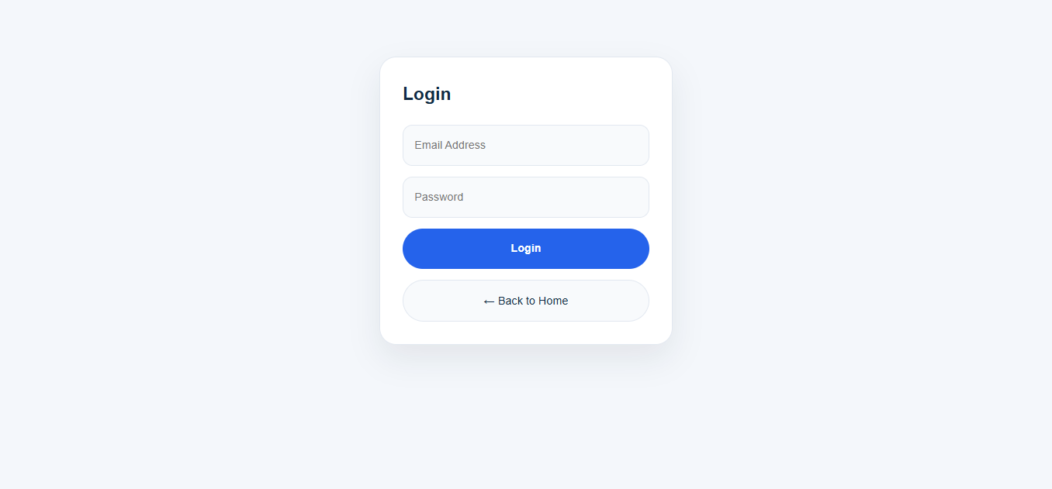
Figure 6: Log in Page
Allows users to log in, but requires admin to make user accounts for faculty and student users.

4.2.2 Student/Faculty Dashboard Module
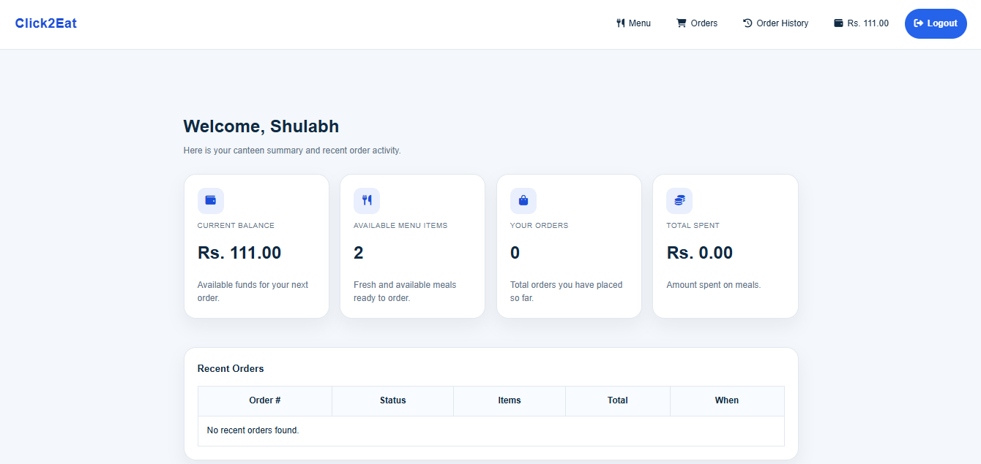
Figure 7: Student and Faculty Dashboard
Shows basic information for the user such as balance, no. of food items today, y our orders and total spent

4.2.3 Menu Page Module
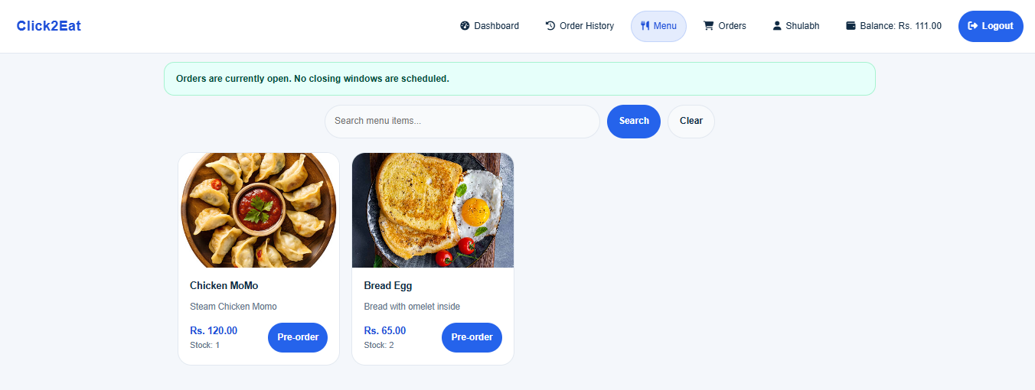
Figure 8: Menu page
Shows menu items with pagination. Allows users to search menu items and also the order closes when reaching closing time and orders are finalized

4.2.4 Admin Dashboard Module
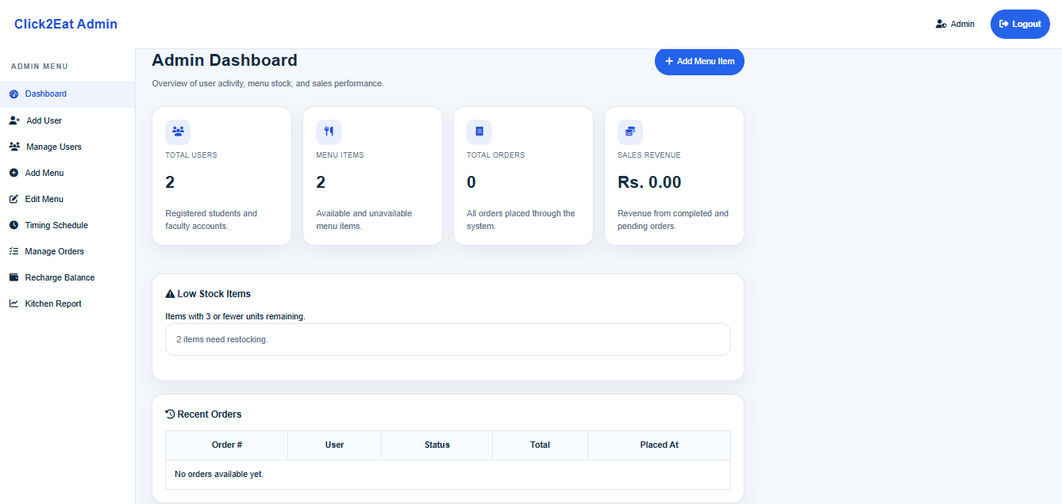
Figure 9: Admin Dashboard
Admin dashboard that shows information required for the admin such as total users, total menu items, total orders and sales revenue.

4.2.5 User Management Module
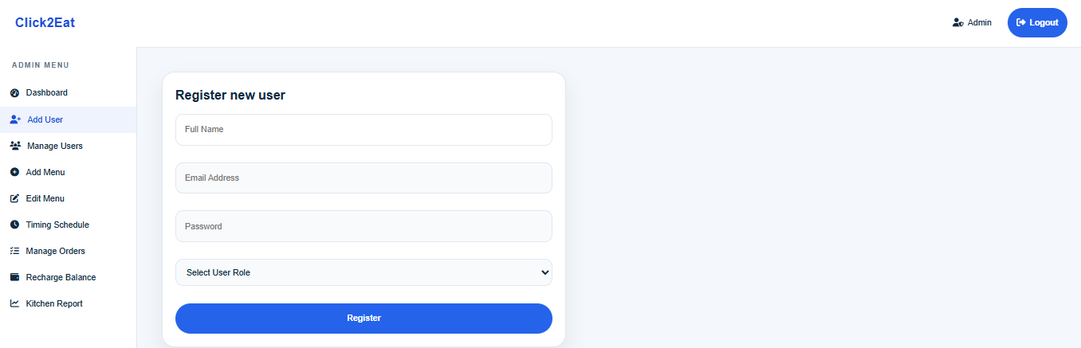
Figure 10: Add User
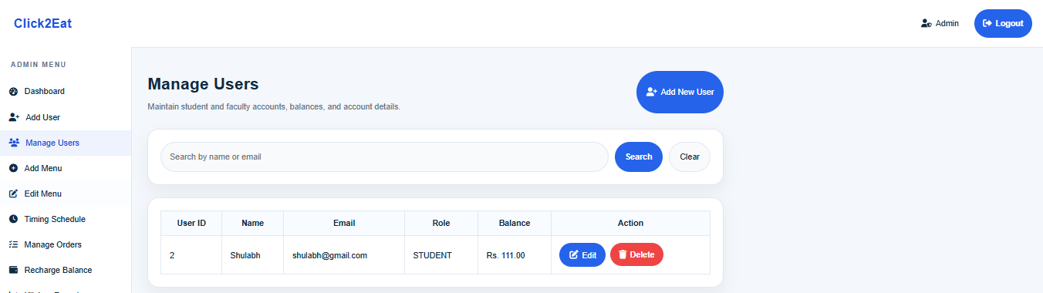
Figure 11: Manage users
Allows admin to add, edit and delete users.

4.2.6 Menu Management Modules
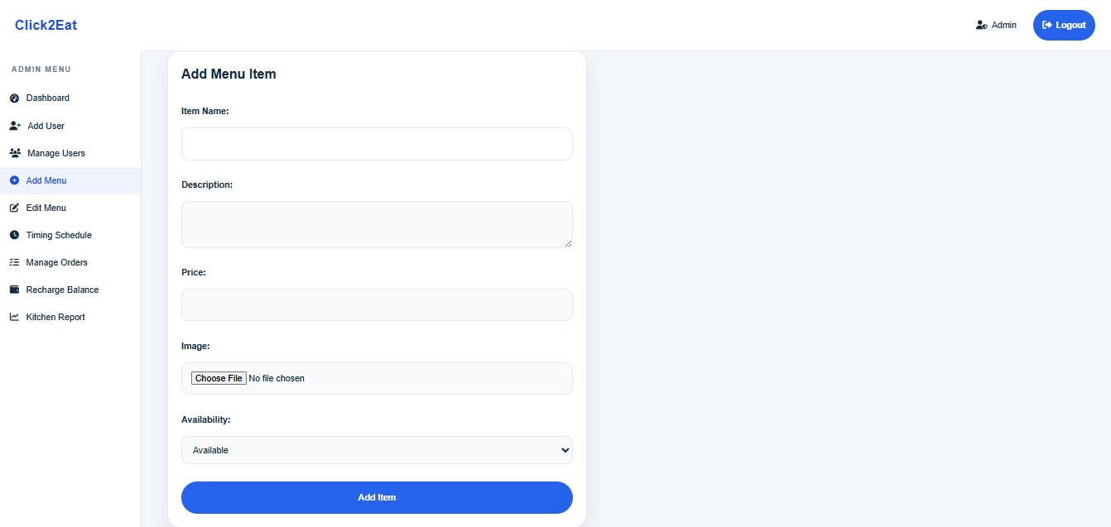
Figure 12: Add new menu Item
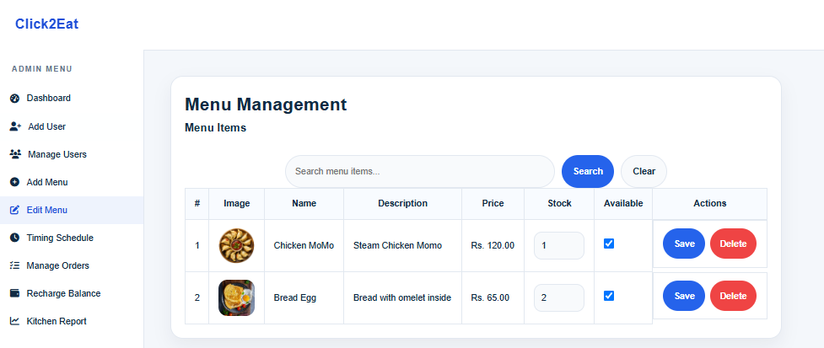
Figure 13: Edit Menu items
Allows admin to add new menu item and edit their stock and availability(For today’s special logic) and even delete menu items.

4.2.7 Timing Schedule Module
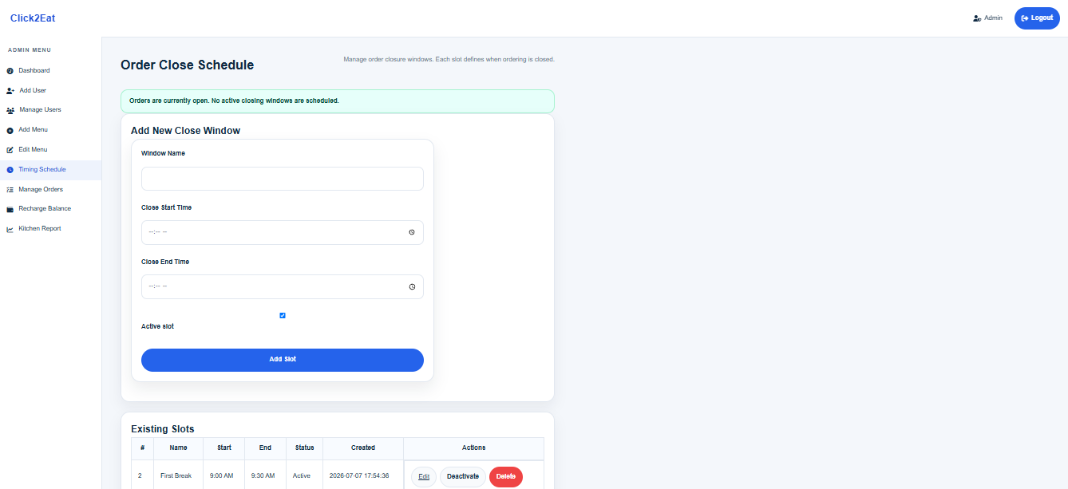
Figure 14: Timing Schedule page
Admin is able to add, edit, activate and deactivate the timing schedules to which the orders are closed and finalized

4.2.8 Landing Page Module
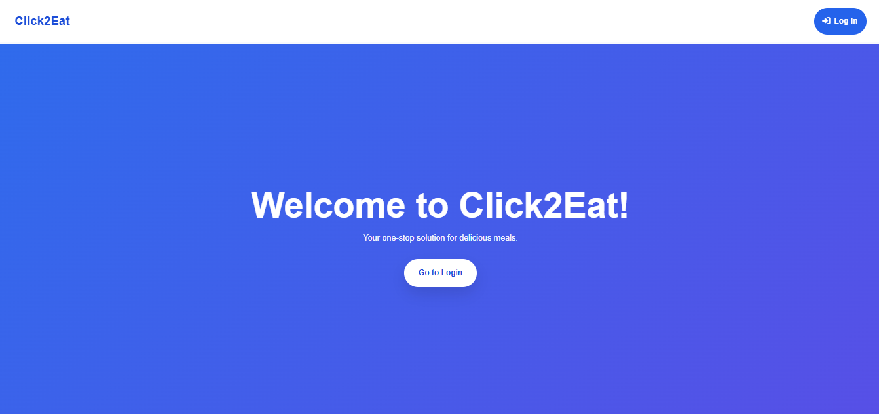
Figure 15: Landing Page
This is the first page user sees upon entering the web application

References
[1] Joshi, S., Kasaju, B., Karki, P., Aryal, S. K., & Chhetri, S. B. (2022, October). Smart canteen management system. In 2022 IEEE 2nd Mysore Sub Section International Conference (MysuruCon) (pp. 1-5). IEEE.
[2] Toma, S. T. F., Karmaker, D., Iqbal, S., Pantho, M. H. K., & Antara, R. S. I. (2021, December). Canteen Automation System: An Approach for “Smart City” Planning. In 2021 IEEE Asia-Pacific Conference on Computer Science and Data Engineering (CSDE) (pp. 1-6). IEEE.
[3] Narendran, A., Inuguri, A. H., Yashaswini, M., Sundaram, S., & Khanna, M. (2024, November). A Next-Gen Approach to Streamlined Canteen Management Systems using Mesa Framework. In 2024 8th International Conference on Computational System and Information Technology for Sustainable Solutions (CSITSS) (pp. 1-5). IEEE

