**GRADUATE CERTIFICATE**

**INTELLIGENT REASONING SYSTEMS (IRS)**

**Macroeconomics Simulation Agent**

Oct-26-2024

Team Members

|  |  |
| --- | --- |
| DING YI | A0295756J |
| YANG RUNZHI | A0297296H |
| LOU SHENGXIN | A0397330A |
| SHI HAOCHENG | A0296265R |
| LIU LIHAO | A0296992A |

Table of Contents

1. Introduction 2

1.1 Background 3

1.2 Significance of the Project 3

1.3 Project Objectives 3

2. Problem Description and Market Analysis 5

2.1 Problem Statement 5

2.1.1 Difficulty 5

2.1.2 Stakeholders 5

2.1.3 Limitations 5

2.1.4 Success signs 6

2.2 Business Model and Solution 6

2.2.1 Market and user demand 6

2.2.2 Target customers 6

2.2.3 Cost structure 6

2.2.4 Source of income 6

2.2.5 Solution 7

2.3 Market Research 7

2.3.1 Development Trend 7

2.3.2 Current market analysis 7

2.3.3 Potential opportunities 7

2.4 Competitors Analysis 7

3. System Architecture and Modeling 8

3.1 System Architecture 8

3.2 Agent Profile Module 8

3.3 Agent Memory Module 9

3.4 Agent Action Module 10

3.4.1 Economic Computation 10

3.4.2 Adaptive Decision-Making with LLMs 11

3.5 Social Interaction Modeling 12

3.5.1 Dataset Generation 12

3.5.2 Feature Representation 13

3.5.3 GAT Model 13

4. Solution Implementation 15

4.1 User Interface Design 15

4.2 Overall Design 18

4.3 Front-End Construction 18

5. Conclusion 19

5.1 Summary 19

5.2 Limitation 19

5.3 Future Plan 20

6. References 21

# Introduction

The rapid development of artificial intelligence, especially Large Language Models (LLMs), has significantly transformed macroeconomic research, moving away from traditional approaches to more sophisticated, data-driven simulations. While EconAgent has made considerable progress in economic modeling by utilizing LLM-empowered agents to simulate realistic economic scenarios, limitations in agent reasoning and employment transition modeling remain.

Our project aims to address these limitations and enhance the accuracy and realism of macroeconomic simulations. By optimizing agent reasoning capabilities and refining the perception of employment transitions, we seek to bridge the gap between theoretical economic models and real-world behavior, leading to more effective policy analysis and forecasting.

## 1.1 Background

Traditional macroeconomic models, such as empirical statistical models and Dynamic Stochastic General Equilibrium (DSGE) models, have limitations in addressing complex economic behaviors due to their reliance on idealistic assumptions or predetermined equilibria. The emergence of Agent-Based Modeling (ABM) marked a significant shift in economic research by allowing diverse agents to interact based on predefined rules or computational models, offering a more flexible approach to simulating policy scenarios.

However, early ABMs were constrained by simplified rule-based systems that did not adequately capture the complexity of real-world economic dynamics. The subsequent adoption of data-driven modeling improved agent personalization but also introduced substantial challenges in computational resources and time costs. With advancements in artificial intelligence, research has shifted towards leveraging data-driven techniques and LLMs, allowing for the recording and analysis of individual economic behaviors. This evolution has led to the development of EconAgent, an LLM-empowered agent-based model for macroeconomic simulations that integrates both formulaic indicators and abstract external factors for a more holistic understanding of economic phenomena.

## 1.2 Significance of the Project

Our project is crucial for overcoming current limitations in macroeconomic simulations, specifically in agent reasoning and employment transition modeling. These enhancements aim to provide a more realistic representation of economic behavior, which is essential for effective policy analysis and economic forecasting. By refining the decision-making processes and integrating job relevance and salary considerations into employment transitions, MacroSimAgent can more closely emulate real-world economic conditions, thereby advancing the field of macroeconomic research.

## 1.3 Project Objectives

The project's main objective is to develop MacroSimAgent, a user-friendly system that simplifies macroeconomic simulations and visualizes economic interactions at both macro and micro levels. The system incorporates advanced AI algorithms and data visualization techniques to enhance user understanding and interaction.

The project aims to develop a macroeconomic simulation and visualization system with the following functions:

1. User-friendly interface

Provides an intuitive user interface that allows users to easily interact with simulation parameters and explore macroeconomic dynamics.

1. Macroeconomic Information Visualization

Visualizes key macroeconomic indicators, such as GDP, inflation, and employment rates, to provide a comprehensive overview of economic conditions and trends.

1. Microeconomic Information Visualization

Displays individual agent behaviors and interactions, including employment transitions and consumption patterns, to offer insights into micro-level economic activities.

1. Environmental Interaction Visualization

Illustrates the impact of environmental changes, such as policy adjustments or tax rates, on the overall economic system, enabling users to understand the cause-and-effect relationships in macroeconomic simulations.

# Problem Description and Market Analysis

## Problem Statement

The MacroSimAgent project addresses significant challenges in macroeconomic simulation and visualization, particularly in enhancing the realism and accuracy of economic models. The current limitations in agent reasoning and employment transition modeling affect the ability to simulate real-world economic behaviors effectively. Our project aims to improve the decision-making processes of agents and incorporate more detailed factors, such as job relevance and salary, into employment transitions. This will bridge the gap between theoretical models and real-world economic dynamics, offering a more robust tool for policy analysis and economic forecasting.

### Difficulty

1. Simulating complex, multi-dimensional economic factors requires advanced agent reasoning capabilities.
2. Enhancing the perception module to incorporate additional factors like job relevance and salary into employment modeling adds complexity to the simulations.
3. Ensuring the improvements are computationally efficient for practical use, especially when scaling up simulations.

### Stakeholders

1. **Researchers and Economists:** Benefit from more accurate and detailed macroeconomic simulations.
2. **Policy Makers**: Can use the enhanced simulations to evaluate policy impacts more effectively.
3. **Educational Institutions**: Use the system for teaching economic principles and modeling techniques.
4. **Private Sector**: Businesses interested in economic forecasting and market analysis.

### Limitations

1. Potential challenges in data quality, computational resources, and algorithmic complexity.
2. The need for rigorous validation and testing to ensure the reliability and accuracy of the enhanced model.

### 2.1.4 Success signs

1. Improved simulation accuracy and realism, reflected in closer alignment with historical economic data.
2. Positive feedback from stakeholders, such as researchers and policy makers, regarding the system's usability and insights.
3. Demonstrated ability to handle complex scenarios and scale up simulations.

## Business Model and Solution

### Market and user demand

The need for advanced macroeconomic modeling tools is growing, driven by increasing demand for accurate economic forecasting and policy analysis. Users are looking for simulation tools that can handle the complexities of modern economies and provide insights into the impact of various factors.

### Target customers

1. Academic institutions and research organizations focused on economic modeling.
2. Government agencies and policy think tanks involved in economic planning.
3. Financial institutions and businesses conducting market analysis and economic forecasting.

### Cost structure

1. Development costs related to the refinement of agent reasoning and perception modules.
2. Infrastructure costs for hosting and scaling the system.
3. Ongoing maintenance, updates, and user support.

### Source of income

1. Subscription fees for academic, government, and corporate users.
2. Consulting services for customized economic modeling solutions.
3. Partnerships with educational institutions for training programs.

### Solution

MacroSimAgent enhances economic simulations by incorporating advanced agent reasoning and perception capabilities. It automates the analysis of complex economic scenarios, providing users with insights for better decision-making. The system’s features enable detailed modeling of economic factors and offer tools for visualizing macro and micro-level interactions.

## Market Research

### Development Trend

There is a trend toward using data-driven models and AI-based techniques for macroeconomic simulations. Traditional modeling approaches are being supplemented or replaced by methods that incorporate real-world data and machine learning.

### Current market analysis

Existing macroeconomic simulation tools often lack the flexibility to model complex economic interactions or require significant manual adjustments. MacroSimAgent addresses these gaps by providing an automated, adaptive approach that leverages AI.

### Potential opportunities

Opportunities exist in expanding the application of MacroSimAgent to new domains, such as financial markets, education, and consulting. There is also potential for collaboration with governmental and international organizations to improve economic policy analysis.

## Competitors Analysis

1. **Existing Economic Modeling Software**: Tools like DSGE models and ABMs are widely used but have limitations in handling multi-dimensional factors.
2. **AI-based Simulation Tools**: While some AI tools are used for economic modeling, few integrate advanced agent-based reasoning and perception to the extent of MacroSimAgent.

# System Architecture and Modeling

## System Architecture

The system architecture of MacroSimAgent consists of several key components that work together to provide a comprehensive macroeconomic simulation and visualization platform. The main components include the User Interface, the frontend, the backend multi-agent system, and the data output structure.

1. User Interface

The UI allows users to interact with the system by selecting parameters, running simulations, and visualizing the output data. It provides an intuitive interface for users to configure simulation settings, such as economic policies or agent behaviors, and displays the results in various data visualization formats. This ensures that users can easily understand the macro and micro-level dynamics produced by the backend.

1. Frontend Server

The frontend is responsible for passing the parameters required to run the multi-agent system on the backend, including the number of agents, prediction duration, prediction city, starting year, etc., to the backend to control the model’s prediction content. After the backend runs, the simulation results stored in the CSV files and the occupation clustering results in the TXT files are read and processed. The necessary parts are extracted and transmitted in JSON format, ensuring that they are reasonably presented in the User Interface.

1. Backend Server

The backend is responsible for running the multi-agent system, which simulates macroeconomic interactions and processes the data. When the user initiates a simulation through the UI, the backend generates data representing macro-level (world), micro-level (states), and environmental interactions (periodictax) in CSV format. This data provides a detailed view of the simulated economic environment, capturing both broad economic trends and individual agent behaviors.

## Agent Profile Module

The Agent Profile Module in MacroSimAgent extends the foundational ideas from the EconAgent[1] framework by creating a more comprehensive and diverse set of agent characteristics. This module generates agents with varied demographic and economic profiles, simulating realistic behaviors in the macroeconomic environment. The expanded profile includes dimensions such as education level, city, and time, in addition to the original attributes like age, occupation, and income.

1. Demographic Attributes

Agents are characterized by age, education level, and city. The age distribution is based on real-world population data, while education level is added as a new dimension to simulate different socioeconomic backgrounds. Education levels are categorized (e.g., high school, bachelor’s, master’s, or doctorate) to influence agents' economic behaviors, such as income potential and consumption patterns. City assignments help capture geographic variations in economic conditions, allowing agents to experience different job markets and cost-of-living factors.

1. Economic Attributes

Each agent’s economic profile includes income, savings, consumption preferences, and work tendencies, reflecting the diversity in real-world economic behaviors. Income distribution follows realistic models, while savings and consumption tendencies vary according to the agent's age, education, and city. Higher education levels may correlate with higher income potential, while agents in different cities face varying living costs and employment opportunities.

1. Dynamic Job Assignments

The module incorporates time as a dynamic factor in the simulation. Over time, agents’ job opportunities and wages can change, influenced by economic trends and policy decisions. Agents can transition between jobs, with adjustments to wages that reflect the evolving job market. The addition of time allows for more detailed modeling of agents' career progression and economic status changes.

## Agent Memory Module

The Agent Memory Module is crucial for maintaining a history of interactions and economic conditions, which enhances the decision-making capabilities of agents in MacroSimAgent. This module integrates a Chain of Thought (CoT) mechanism to strengthen the prompts used for reasoning, enabling agents to make more informed and context-aware decisions.

1. Memory Structure

The memory module stores relevant economic data and past experiences of the agents, such as changes in income, job transitions, and macroeconomic trends. By preserving this historical information, the module allows agents to reflect on past events when making decisions, helping to simulate realistic economic behaviors.

1. Chain of Thought (CoT) Prompting

The CoT mechanism guides the agents through a step-by-step reasoning process by breaking down complex decisions into intermediate steps. This approach improves the accuracy of decision-making, as the model iteratively considers relevant factors before reaching a conclusion. Studies have shown that CoT prompting significantly enhances multi-step reasoning tasks, making it effective for economic simulations that involve intricate dependencies (e.g., changes in market conditions)[2][3]

1. Enhanced Prompting Strategy

To reinforce prompting with CoT, MacroSimAgent uses a strategy that adapts the prompts based on the agent’s memory. When an agent encounters a decision point, the prompt incorporates previous economic states, agent experiences, and any relevant contextual information stored in the memory module. This adaptation of prompts ensures that agents make decisions that consider both current and historical economic data. Techniques like self-consistency, where multiple reasoning paths are considered to find the most consistent solution, further improve the model's accuracy and robustness[4]

1. Dynamic Memory Updates

The memory module dynamically updates as agents interact with the environment. For example, when an agent's income changes due to a job transition, the memory is updated to reflect this new state. These updates are used to refine future prompts, allowing the CoT mechanism to continuously adapt to the agent's evolving context. This ensures that the reasoning process remains relevant and grounded in the agent's economic history.

## Agent Action Module

The Agent Action Module is responsible for simulating the economic decisions and behaviors of agents within the MacroSimAgent framework. It includes two main components: economic computation and adaptive decision-making with LLMs. This module models agents' actions by considering various economic factors, which are calculated using established economic equations and are enhanced by prompt-based decision-making.[5][6]

### Economic Computation

The economic computation component calculates key economic variables that influence the decision-making processes of agents. These variables include wages, consumption, savings, and taxation, all of which are interrelated and subject to changes in the macroeconomic environment.economic modeling can significantly improve the accuracy of agent-based simulations by capturing nuanced economic patterns and emergent behaviors.

1. Wage Calculation

The wage for each agent $W_{i}$ is determined based on factors such as the agent's education level, city, and experience. The formula can be expressed as:

$$W_{i}=W_{base}​×(1+α⋅E_{i}+β⋅L_{i}+γ⋅C_{i}​)$$

Where $W_{i}$ is the base wage for the given profession. $E_{i}$ represents the agent's years of experience. $L_{i}$ is the education level factor. $C_{i}$ accounts for city-specific cost-of-living adjustments. α, β and γ are scaling coefficients that adjust the influence of each factor.

1. Consumption and Savings Decision

Agents decide how much to allocate toward consumption $C_{i}$ ​ and savings $S_{i}$ based on their income and individual preferences. The allocation follows a consumption function, commonly derived from Keynesian economic theory:

$$C_{i​}=c_{0}+c_{1​}⋅\left(Y_{i}-T_{i​}\right)$$

$$S_{i}=Y_{i​}-T_{i​}-C_{i}​$$

Where $Y_{i}$ is the agent's disposable income (income after taxes). $T_{i}$ represents taxes paid by the agent. $c_{0}$ ​ is the autonomous consumption (consumption when income is zero). $c_{1}$ ​ is the marginal propensity to consume, indicating how much consumption changes with disposable income.

1. Tax Computation

Taxation is modeled based on a progressive tax function where higher income brackets are taxed at higher rates:

$$T_{i​}=τ_{1}⋅\min\left(Y_{i​},Y_{threshold​}\right)+τ_{2}​⋅\max\left(0,Y_{i​}-Y_{threshold}\right)$$

Where $τ_{1}$ and $τ_{2}$ ​ are the tax rates for lower and higher income brackets, respectively.

$Y_{threshold}$ represents the income level at which the higher tax rate applies.

### Adaptive Decision-Making with LLMs

This component leverages large language models (LLMs) to enhance the agents' decision-making processes by simulating reasoning through Chain of Thought (CoT) prompting.

1. Chain of Thought Prompting

The CoT mechanism enables the model to break down multi-step decisions into a series of intermediate steps, leading to more accurate and realistic economic choices. The reasoning process can be represented as:

$$D_{i​}=CoT\left(P_{i​},M_{i​}\right)$$

Where $D_{i​}$ is the decision output for agent i. $P_{i​}$ represents the prompt that includes current economic conditions and the agent's historical data. $M_{i​}$ ​ is the memory input, which consists of past economic states relevant to the decision.

1. Self-Consistency Approach

When multiple reasoning paths are possible, the model generates several CoT prompts, evaluates each, and selects the most consistent outcome:

$$D_{i​}=argmax​ \sum_{k​}{count\left(R_{j​}=R_{k​}\right)}$$

Where $R_{j​}$ is a reasoning path generated from CoT prompting. The indicator function $count\left(R_{j​}=R_{k​}\right)$ counts how many times reasoning path $R_{j​}$ ​ matches other generated paths.

1. Dynamic Adaptation

The LLM dynamically adapts its prompts based on changing economic contexts, incorporating elements such as inflation rates, unemployment levels, or market trends to guide agents in decisions like job switching or adjusting consumption levels. The CoT prompts evolve as agents gain more economic history, which affects their future decision-making.

## Social Interaction Modeling

In the initial version of the career transition process from unemployment to employment, the approach relied on a purely random probability [1]. This allows for transitions only within the same salary range, but it overlooked two critical aspects.

Firstly, it failed to consider changes across salary ranges, such as promotions or demotions, as well as the simultaneous influence of various internal and external factors on career shifts. These factors could include changes in industry demand, individual skill development, or economic conditions. Secondly, it disregarded the inherent relationships between different occupations. While jobs within the same salary range might appear similar, this does not necessarily reflect a true correlation between them. In reality, career transitions are more likely to occur between occupations with strong interrelationships, where skills, experience, and industry knowledge overlap.

To address these shortcomings, we optimized the career transition process by implementing a method for career transfer replanning based on probability of correlation. This enhanced approach allows for a more realistic simulation of career changes, accounting for both cross-salary range movements and the nuanced relationships between occupations, leading to a more accurate transition result.

The new method consists of five key components: dataset generation, feature representation, GAT model, K-means clustering, and probability-based decision-making.

### Dataset Generation

Given that the experiments were conducted under fully simulated conditions, the number of occupations and salary ranges were predefined, making it challenging to find an existing dataset that met our criteria. Consequently, we opted to manually generate a dataset for training and testing purposes.

Prior to dataset generation, we gathered relevant information, including the frequency distribution of salary ranges in the United States from 2018 to 2023, the statutory minimum wage, the age distribution of the workforce, the age ranges for each occupation, the experience levels required for various jobs, and educational attainment for each profession. It is important to note that this data is based on empirical approximations and may not represent precise values.

The structure of each data entry was defined to include the following attributes: occupation, salary, age, work experience, and education level. Occupation is a pre-defined 100 occupations, which are evenly divided into ten salary ranges and randomly generated according to the above-mentioned salary range frequency distribution; salary is a random value selected within the salary range on the premise that it is greater than or equal to the minimum salary standard; age is randomly generated for each occupation of data within the range of its interval, and the entire data set is consistent with the age distribution of the working population; work experience is randomly generated for each occupation of data within the range of its interval; education level is the same as above.

### Feature Representation

For feature representation, we utilized the bert-base-uncased model to generate word embeddings for the occupation names. The salary, age, and work experience values were averaged, while educational attainment was encoded using label encoding for the five predefined education levels. This encoding is not equidistant, allowing the model to focus more on the differences between educational qualifications.

Based on multiple experimental trials and experience, we assigned specific weights to each feature: 0.35 for the occupation word embeddings, 0.35 for salary, 0.1 for age, 0.1 for work experience, and 0.1 for education level. Finally, the integrated features were standardized before being fed into the model, ensuring consistency and enhancing the model's performance.

### GAT Model

After standardizing and weighing the features, we calculated the similarity matrix between occupations. Based on a defined similarity threshold, the system constructed a graph structure where occupations are represented as nodes, and edges connect those with high similarity.

The core of the model is a two-layer Graph Attention Network (GAT) [7], with the first layer consisting of eight attention heads and the second layer featuring a single attention head, designed to learn the relationships between occupations. During training, we employed the Adam optimizer and a learning rate scheduler, utilizing a contrastive loss function to handle both positive samples (existing edges) and negative samples (non-existent edges).

The model underwent training for 1500 epochs, during which loss and learning rate information were printed periodically. Upon completion of training, the model generated a 16-dimensional embedding vector for each occupation, and the results were saved in a CSV file for further analysis.

# Solution Implementation

## User Interface Design

The user interface (UI) of MacroSimAgent is designed to be intuitive and user-centric, providing a seamless experience for observing economic changes at both the macro and micro levels. The interface consists of multiple pages to facilitate navigation and access to various features. The main pages include World Data Visualization, Overall Agents Visualization, Individual Agent Income, Agents Data Visualization, and Occupation Clusters. Each page presents data in a user-friendly format, making it easy for users to interact with the system and explore economic trends.

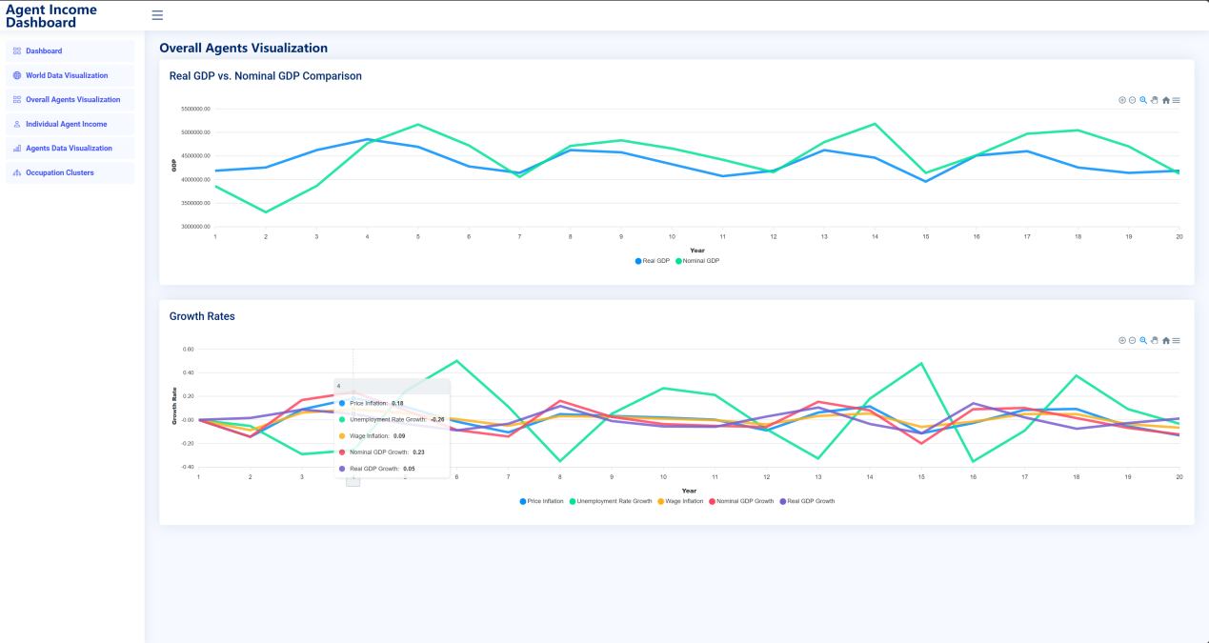

*Fig 1. Setup Page and Agent Income Dashboard Page*

1. Setup Page

The setup page allows users to configure simulation parameters such as the number of agents, simulation duration, city, and start year. These settings determine the content and scope of the predictions.

1. Agent Income Dashboard Page

The agent income dashboard page demonstrates the comparison real GDP vs nominal GDP, and the growth rates of price inflation, unemployment rate growth, wage inflation, nominal GDP growth, and real GDP growth throughout the simulation duration in years.

By putting the mouse pointer on the data point, it can demonstrate the specific value of each data.

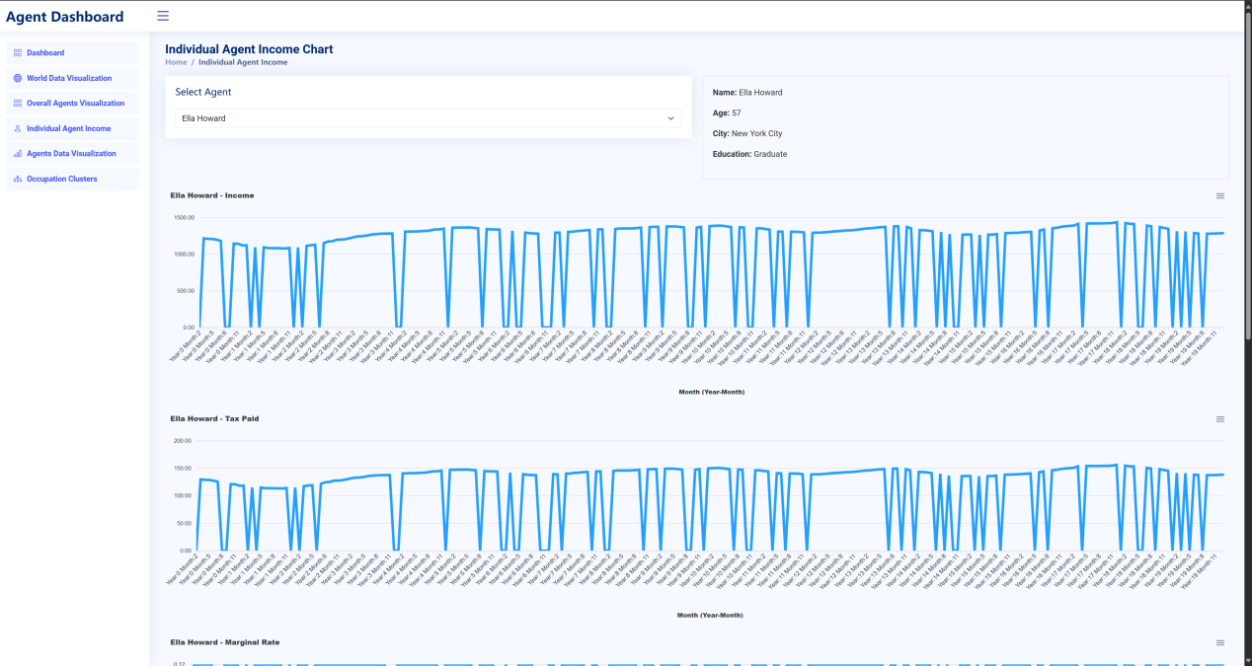

*Fig 2. Individual Agent Income chart*

1. Individual Agent Income Chart Page

The Individual Agent Income Chart page allows users to view detailed financial information for selected agents. Users can choose an agent from the dropdown menu, and the system displays three key metrics: income, tax paid, and marginal tax rate, all visualized through time-series line charts. The charts allow users to observe income patterns, tax obligations, and changes in marginal tax rates over time, providing insight into the financial fluctuations and trends experienced by the selected agent.

By hovering over the chart data points, users can view specific numerical values for each metric.

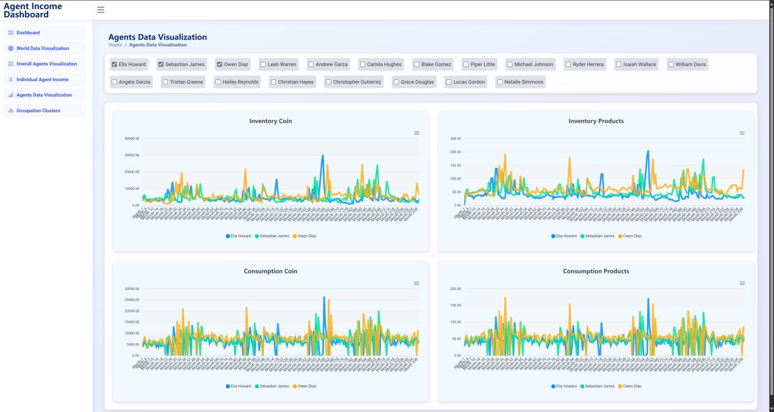

*Fig 3. Agents Data Visualization*

1. Agents Data Visualization Page

The Agents Data Visualization page allows users to compare the economic activities of multiple agents. Users can select agents from a list, and the system will display various metrics, including inventory of coins, inventory of products, consumption of coins, and consumption of products. The charts provide a visual comparison of these metrics over time for the selected agents. By hovering over the chart data points, users can view specific values for detailed analysis.

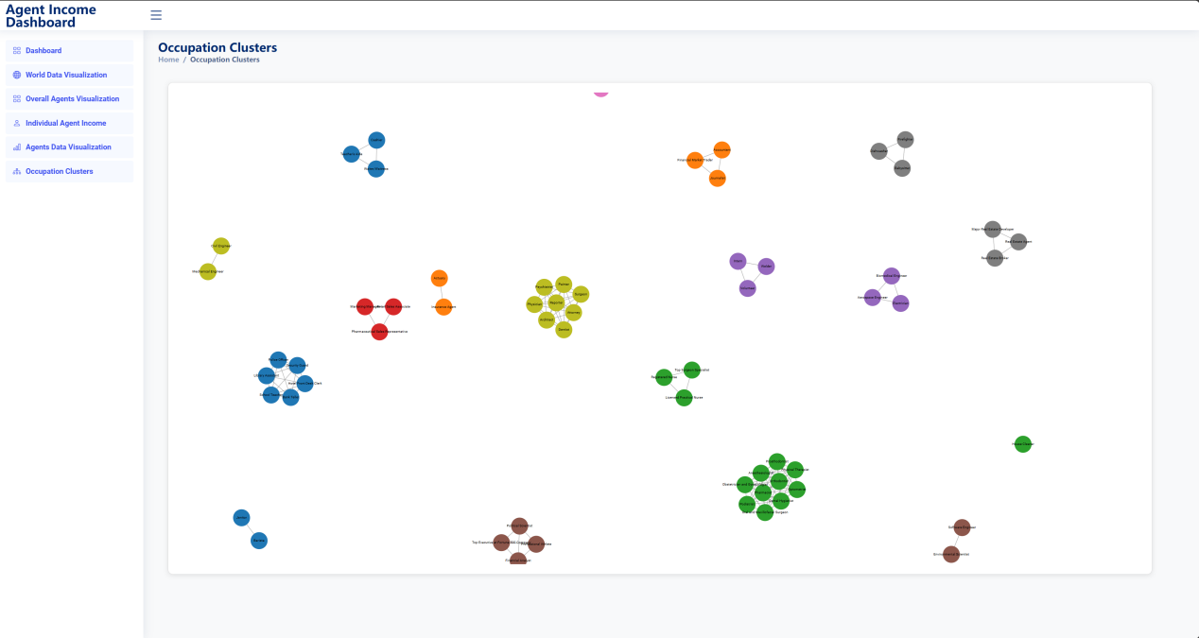

*Fig 4. Occupation Clusters*

1. Occupation Clusters Page

The Occupation Clusters page visualizes various clusters of jobs that are related by skill sets or job characteristics. Each cluster groups similar occupations, representing potential career paths or job transitions for individuals with certain expertise. This clustering allows users to easily identify which job roles are interconnected, offering insights into how agents might move between jobs based on their skills, experience, and the economic environment. The visual representation makes it clear which jobs are closely related, helping in analyzing career progression patterns.

## Overall Design

MacroSimAgent integrates front-end and back-end components in a unified framework that facilitates economic forecasting and data analysis. The overall system design emphasizes smooth communication between the user interface and the computational back-end through well-defined API interfaces.

The front-end consists of a suite of interactive visualization pages that allow users to view economic forecasts across various cities and timeframes, with data on indicators such as GDP growth, inflation, and individual agent metrics. The visualization pages are structured to provide insights into macro-level trends while also offering detailed views of micro-level dynamics.

The back-end performs the heavy computational lifting, using agent-based modeling techniques to simulate economic behaviors and generate outputs. Data is processed into CSV files that capture a range of economic variables at different levels of granularity, ensuring that the results are detailed and comprehensive. The integration of data processing, economic modeling, and visualization generation allows the system to support sophisticated analysis, making it a valuable tool for researchers, policymakers, and educational institutions.

**Back-end Services Collaboration**

## Front-End Construction

**Homepage Design**  
The homepage is designed to be simple and intuitive, with a navigation panel on the left side displaying the five main functional pages: World Data Visualization, Overall Agents Visualization, Individual Agent Income, Agents Data Visualization, and Occupation Clusters. Users can easily navigate through these pages to select different cities and years for economic forecasts. The homepage provides a convenient entry point for users to quickly access various data visualization features, allowing them to seamlessly analyze the required information.

**Query Design**The system includes a straightforward query interface where users can input parameters like city and year to submit a query for economic forecast data. This design helps users interact efficiently with the system, offering personalized prediction results and detailed macroeconomic analysis. The query feature establishes a convenient communication channel between the user and the system, enabling users to quickly obtain customized forecast results based on their specific needs.

# Conclusion

## 5.1 Summary

The MacroSimAgent project set out to advance the field of macroeconomic simulation by developing a sophisticated multi-agent system augmented with large language models (LLMs). By incorporating agent profiling, memory management, and action modeling components, MacroSimAgent enables comprehensive and realistic simulations of economic behaviors at both the macro and micro levels. Through techniques such as Chain of Thought (CoT) prompting and the application of Graph Attention Networks (GATs), the system effectively captures complex economic interactions, including labor market dynamics, consumption trends, taxation impacts, and policy effects.

The project successfully developed an intuitive user interface that simplifies simulation setup and data visualization, providing an accessible platform for users to interact with the system. The backend architecture supports the generation of detailed outputs in CSV format, capturing diverse variables across economic activities and timeframes. These outputs facilitate in-depth analysis for researchers, policymakers, and educational institutions, providing a powerful tool for economic forecasting, policy evaluation, and educational purposes. The integration of cutting-edge AI techniques in macroeconomic modeling marks a significant step forward in improving the accuracy and usability of economic simulations.

## 5.2 Limitation

Despite the significant achievements of the MacroSimAgent project, certain limitations remain. The accuracy and reliability of the simulations are dependent on the quality and comprehensiveness of the input data. The economic indicators and historical trends used may not capture the full complexity of real-world economic conditions, potentially limiting the representativeness of the results. The availability of high-quality data sources is also a challenge, as economic data can often be incomplete, outdated, or subject to biases.

Furthermore, the system's reliance on computationally intensive methods, such as LLMs and GATs, introduces scalability issues. These methods require substantial computational resources, which may affect the system's performance when running large-scale or real-time simulations. This could limit the accessibility of the platform for users who lack high-performance computing infrastructure. Additionally, while the current modeling framework provides a solid foundation for simulating economic behaviors, some aspects of agent interactions—such as the depth of social dynamics, multi-agent cooperation, and the role of cultural or institutional factors—are still simplified. These simplifications may impact the realism of the simulated scenarios, particularly when modeling nuanced social behaviors or cross-occupational skill transfers.

## 5.3 Future Plan

To overcome the limitations identified, future work will prioritize the enhancement of data quality and the expansion of data sources. Collaborations with governmental agencies, international organizations, and research institutions will be sought to access richer datasets, enabling the system to incorporate a broader range of economic indicators and social factors. Efforts will also focus on improving the system's computational efficiency. By optimizing algorithms and leveraging cloud-based solutions, MacroSimAgent can achieve better scalability and reduce resource requirements, making the platform accessible to a wider range of users.

Further development plans include the refinement of the agent modeling framework to simulate more complex social interactions and economic relationships. This will involve expanding the range of agent attributes and introducing additional social and economic factors, such as migration patterns, cultural influences, and intergenerational wealth transfer. Integrating more sophisticated decision-making processes for agents, including reinforcement learning techniques, will also be explored to enhance the adaptability and realism of agent behaviors. Finally, future versions of MacroSimAgent will support seamless integration with external data sources and economic modeling tools through API interfaces, facilitating real-world applications in economic analysis, policy development, and educational programs.

# References

[1] LI N, GAO C, LI Y, et al. Large Language Model-Empowered Agents for Simulating Macroeconomic Activities[J]. 2023.

[2] WEI J, WANG X, SCHUURMANS D, et al. Chain of Thought Prompting Elicits Reasoning in Large Language Models[J].

[3] WANG B, MIN S, DENG X, et al. Towards Understanding Chain-of-Thought Prompting: An Empirical Study of What Matters[J]. 2022.

[4] WANG X, WEI J, SCHUURMANS D, et al. Self-Consistency Improves Chain of Thought Reasoning in Language Models[J].

[5] WU Z, PENG R, HAN X, et al. Smart Agent-Based Modeling: On the Use of Large Language Models in Computer Simulations[J]. 2023.

[6] WITTEK P, RUBIO-CAMPILLO X. Scalable agent-based modelling with cloud HPC resources for social simulations[C/OL]//4th IEEE International Conference on Cloud Computing Technology and Science Proceedings, Taipei, Taiwan. 2012: 355-362. http://dx.doi.org/10.1109/cloudcom.2012.6427498. DOI:10.1109/cloudcom.2012.6427498.

[7] LIU Z, ZHOU J. Graph Attention Networks[M/OL]//Synthesis Lectures on Artificial Intelligence and Machine Learning,Introduction to Graph Neural Networks. 2020: 39-41. http://dx.doi.org/10.1007/978-3-031-01587-8_7. DOI:10.1007/978-3-031-01587-8_7.