**#第一步：卸载自带opencv**

sudo apt-get remove libopencv*

**# 第二步安装Cmake**

sudo apt-get install cmake

**# 第三步 安装依赖项**

sudo apt-get install build-essential \

libavcodec-dev \

libavformat-dev \

libavutil-dev \

libeigen3-dev \

libglew-dev \

libgtk2.0-dev \

libgtk-3-dev \

libjpeg-dev \

libpostproc-dev \

libswscale-dev \

libtbb-dev \

libtiff5-dev \

libv4l-dev \

libxvidcore-dev \

libx264-dev \

qt5-default \

zlib1g-dev \

libavresample-dev \

gstreamer1.0-plugins-bad \

pkg-config

**#第四步 生成可执行文件**

**在opencv文件夹中新建build，打开终端输入下列指令：**

cmake -D BUILD_TIFF=ON -D CMAKE_BUILD_TYPE=RELEASE -D CMAKE_INSTALL_PREFIX=/usr/local -D OPENCV_EXTRA_MODULES_PATH=/home/aaeon/pkg/opencv_contrib-4.5.3/modules -D CUDA_ARCH_BIN='8.7' -D WITH_CUDA=ON -D BUILD_opencv_python3=ON -DBUILD_opencv_python2=OFF -D WITH_V4L=ON -D WITH_QT=OFF -D WITH_OPENGL=ON -D CUDA_FAST_MATH=1 -D WITH_CUBLAS=1 -D OPENCV_GENERATE_PKGCONFIG=1 -D WITH_GTK_2_X=ON -D WITH_GSTREAMER=ON ..

**#第五步 完成编译**

make -j4

**#第六步 完成安装**

sudo make install

**#第七步 opencv环境配置**

sudo gedit /etc/ld.so.conf.d/opencv.conf

**填入如下指令：**

/usr/local/lib

**更新共享连接：**

sudo ldconfig

**配置bash：**

sudo gedit /etc/bash.bashrc

**在文末添加如下指令：**

PKG_CONFIG_PATH=$PKG_CONFIG_PATH:/usr/local/lib/pkgconfig

export PKG_CONFIG_PATH

**#文件末尾追加这些东西**

**执行如下指令使得配置生效：**

source /etc/bash.bashrc

sudo updatedb

**输入如下指令查看opencv版本号：**

pkg-config --modversion opencv4

**第八步 配置cv_bridge**

cd /opt/ros/melodic/share/cv_bridge/cmake

cd /opt/ros/noetic/share/cv_bridge/cmake

sudo gedit cv_bridgeConfig.cmake

安装下面图片，根据实际安装情况进行修改。

需要修改下述两个地方：

1

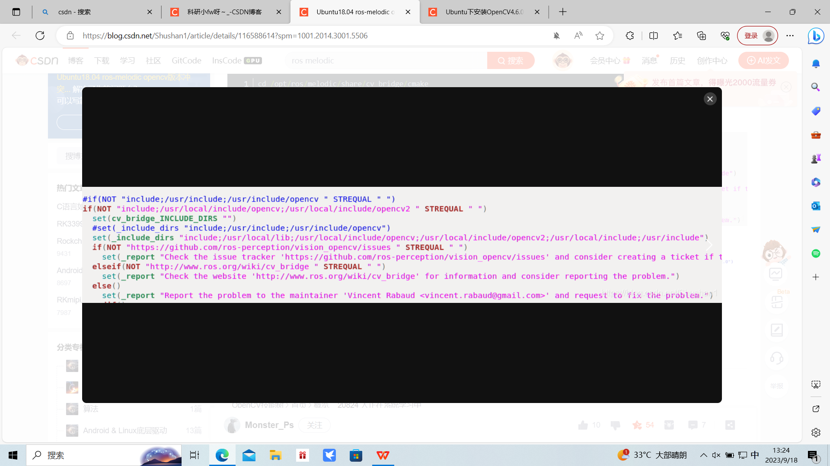

2

