Luna McBride

CSCI 3202

**Assignment 4**

**Part I:**

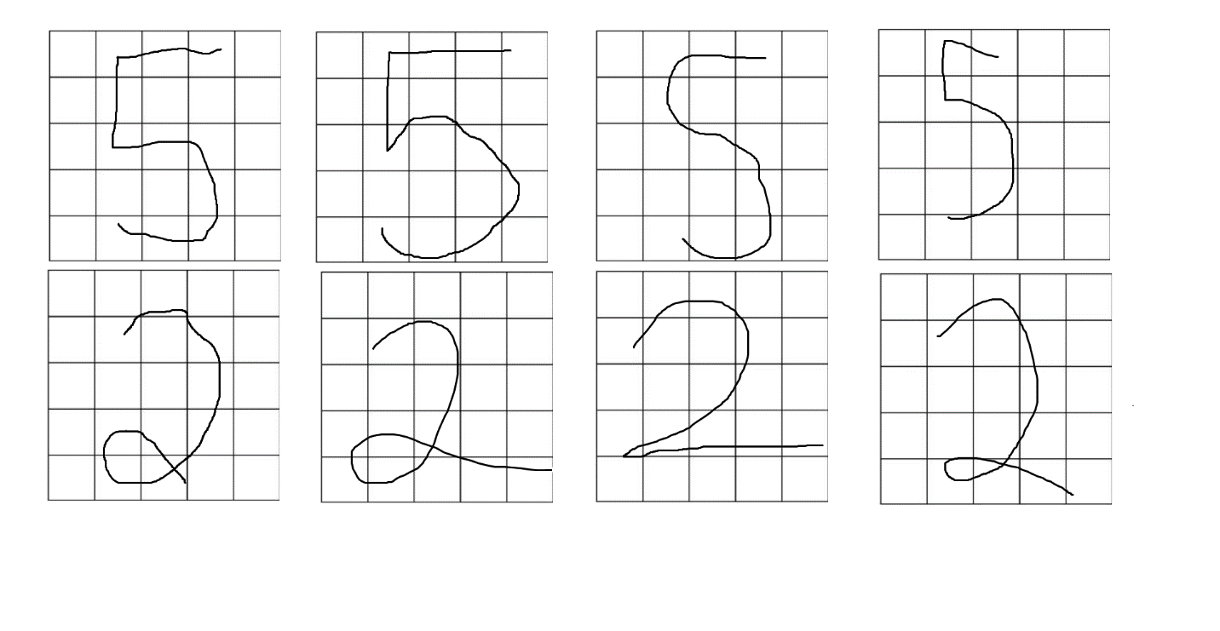

(drawn in paint, so expect some oddities, of course)

**Part II:**

In terms of accuracy, the Hopfield got all of the fives correct. Five has a basic shape to it, so it is understandable why it chose 5. 2, however, was the complete opposite. Most of the 2’s were unknown, with the exception of one that it thought was a 5. It is likely because the main 2 is almost exactly a backwards 5 while I draw mine with the little swirly, which, to a computer that only knows the backward 5 2, is likely really difficult. Also, the grids only are classify if there was a mark in the container with pretty big containers, so further cutting it down might lead to a better result as well.

**Part III:**

This experienced the same results as the previous, just saying 5 instead of unknown. Once again, I feel like it is really likely that the way I draw my 2’s was the main reason neither like to classify the 2’s. The training 2 is a 2 like you would find on a digital clock, which is still a 2, but looks entirely different and fits into the 5x5 quadrant differently. Heck, I added a different 2 as well that was more like the 2 in Word ([0,1,1,1,0,0,0,0,1,1,0,0,1,1,0,0,1,1,0,0,1,1,1,1,1]) and that was understood properly by both methods as a 2, so I think the computer just hates how I draw my 2.

**Part IV:**

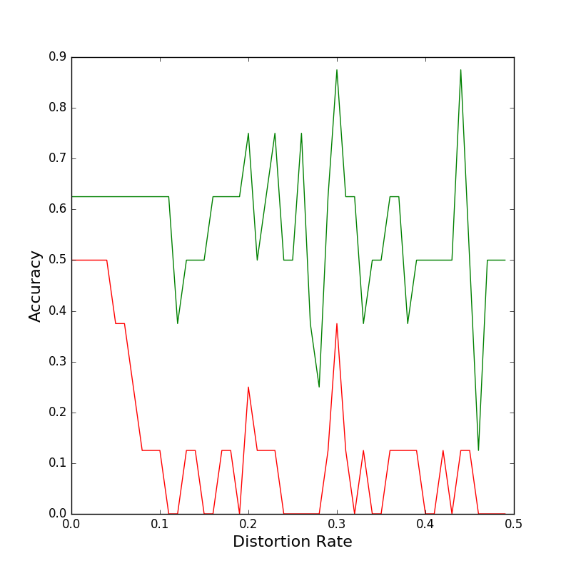

It reads more like a heart monitor than a smooth rate of accuracy, but nonetheless. The Hopfield (red) did a lot poorer than the MLP (green). It could be the issue with the 2’s and the fact that, after this testing, it showed that the MLP sometimes recognizes some of my 2’s sometimes. However, even so the MLP looks to be a lot more suited for the distortion in general.

**Part V**

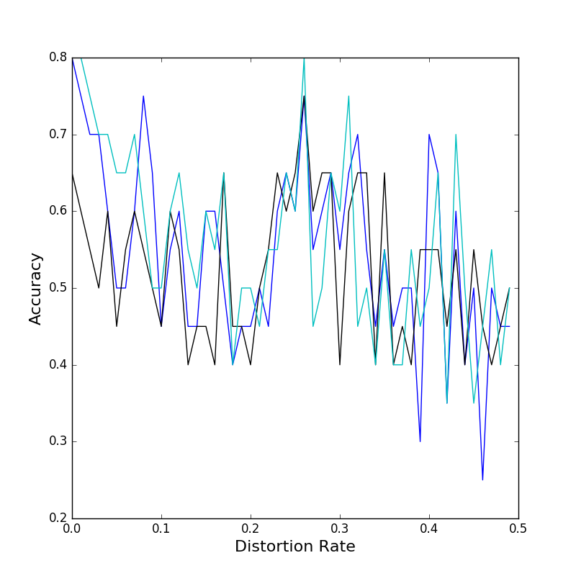

This one was graphed without the other two for less clutter. The order is: 5 layers=blue, 4 layers=black, 2 layers=cyan. The more layers seemed to put the blue at some higher highs and lower lows with the others being a bit more stable in accuracy.

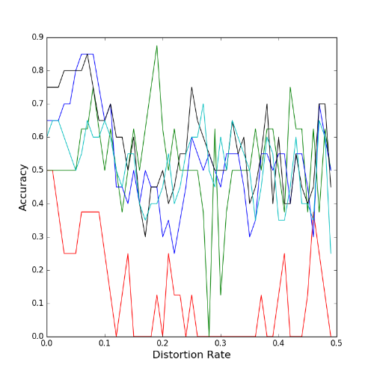

Now with the green single layer, the more layer version is definitely more stable than the single layer’s (green) high highs and low lows, but overall distortion recognition did not improve that much, perhaps due to the different view of 2’s to begin with and the chunks represented being so few (add being counted even at the smallest swipe).