**Analyses Summary**

**Cumulative Viewshed of the Observer**

CVSO means cumulative viewshed of location. To perform a CVSO, observer points were placed in two separate study region, each point separated by 500 meters. ArcGIS uses elevation data for each region, represented by a raster (pixel based) dataset. Each pixel has a numeric value associated with it, representing elevation. ArcGIS calculates, according to each observer point, which location on the landscape (elevation pixel) it can see – this calculation is based on the height of the observer, the height of each pixel, and is limited to a 5 km radius from each pixel.

To give some perspective, the Argolid (region) is about 2500 square kilometers. There are 4012324 possible pixels that could be seen, and 3456361 were visible by some observer. 11261 total observers were used. In Messenia (the second region, 5423273 total pixels could possibly be seen, and at most 4730963 were seen. 16211 observers were used.

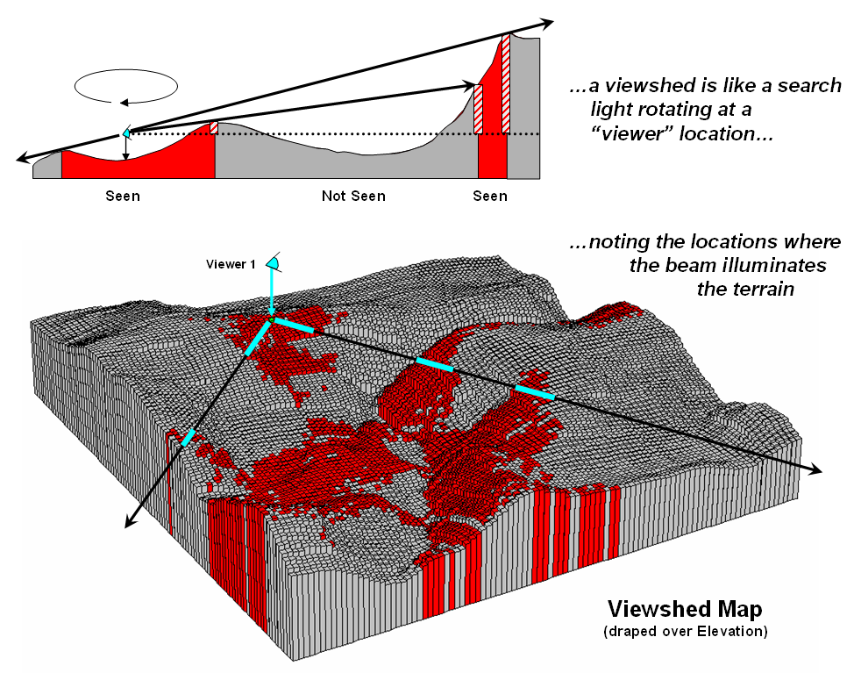

The output produces a viewshed map (see above), in which each pixel has a gridcode associated with it. The gridcode represents how many observers could see that location. Some pixels have a gridcode of 0, meaning there are no instances of visibility.

**Calculating Visibility**

Over the viewshed output (with the grid codes) I placed boundaries of structures, so I could calculate the total number of times each structure could be seen:

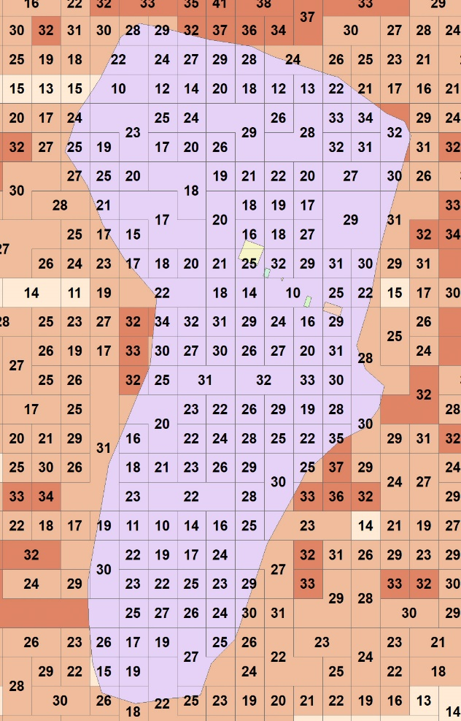

So here, the pixels are represented by the orange layer (which is also underneath the purple). The numbers are the gridcode for each pixel, or the number of times it was seen. The purple boundary, and the small polygons on top of it, are representing boundaries of structures. Each structure is a “place” in my dataset (represented by a place ID). I calculated the total grid code for each place, divided by the number of pixels which comprises each structure: this is represented by **cvso_visbyarea** in the excel tables.

Most of the places in the dataset are represented by a polygon boundary (like above). There are some instances where the boundary of the structure is unknown, and therefore the structure was represented by a single point. In these cases, the grid code was calculated from the single pixel the point fell within:

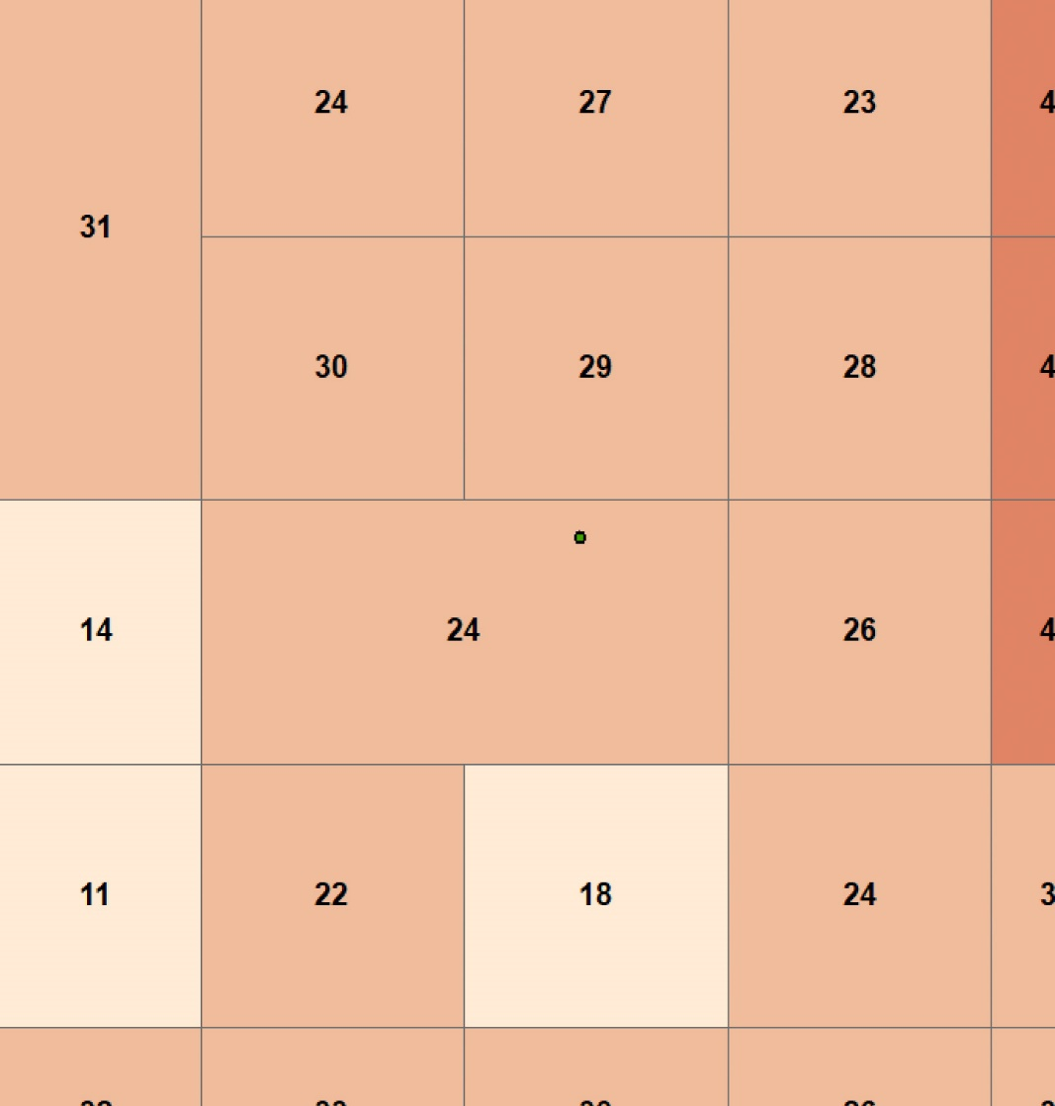

So here, the **cvso_visbyarea** would be 24/1 (24 being the gridcode where the point falls, 1 representing the 1 pixel used to cover its area).

**CVSO_deg_vis** is the total gridcode (the number of times the structure is seen) divided by the number of observer points which could possibly see that structure. The observer points were calculated by making a 5 km boundary around each structure and counting how many observers per 500 m are there. If the place has no boundary (like the example above), I just make a 5 km boundary around the point:

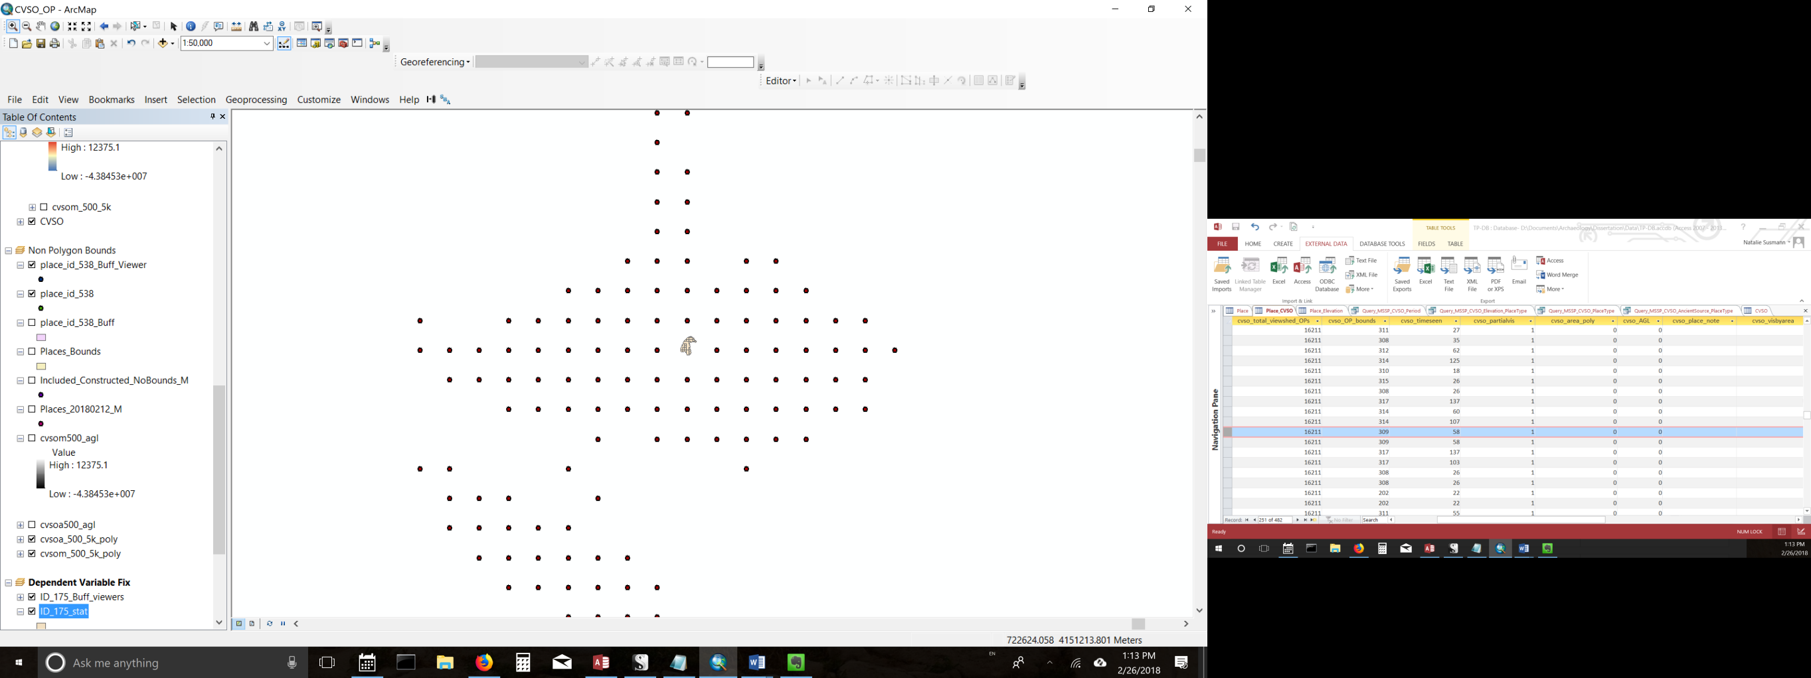 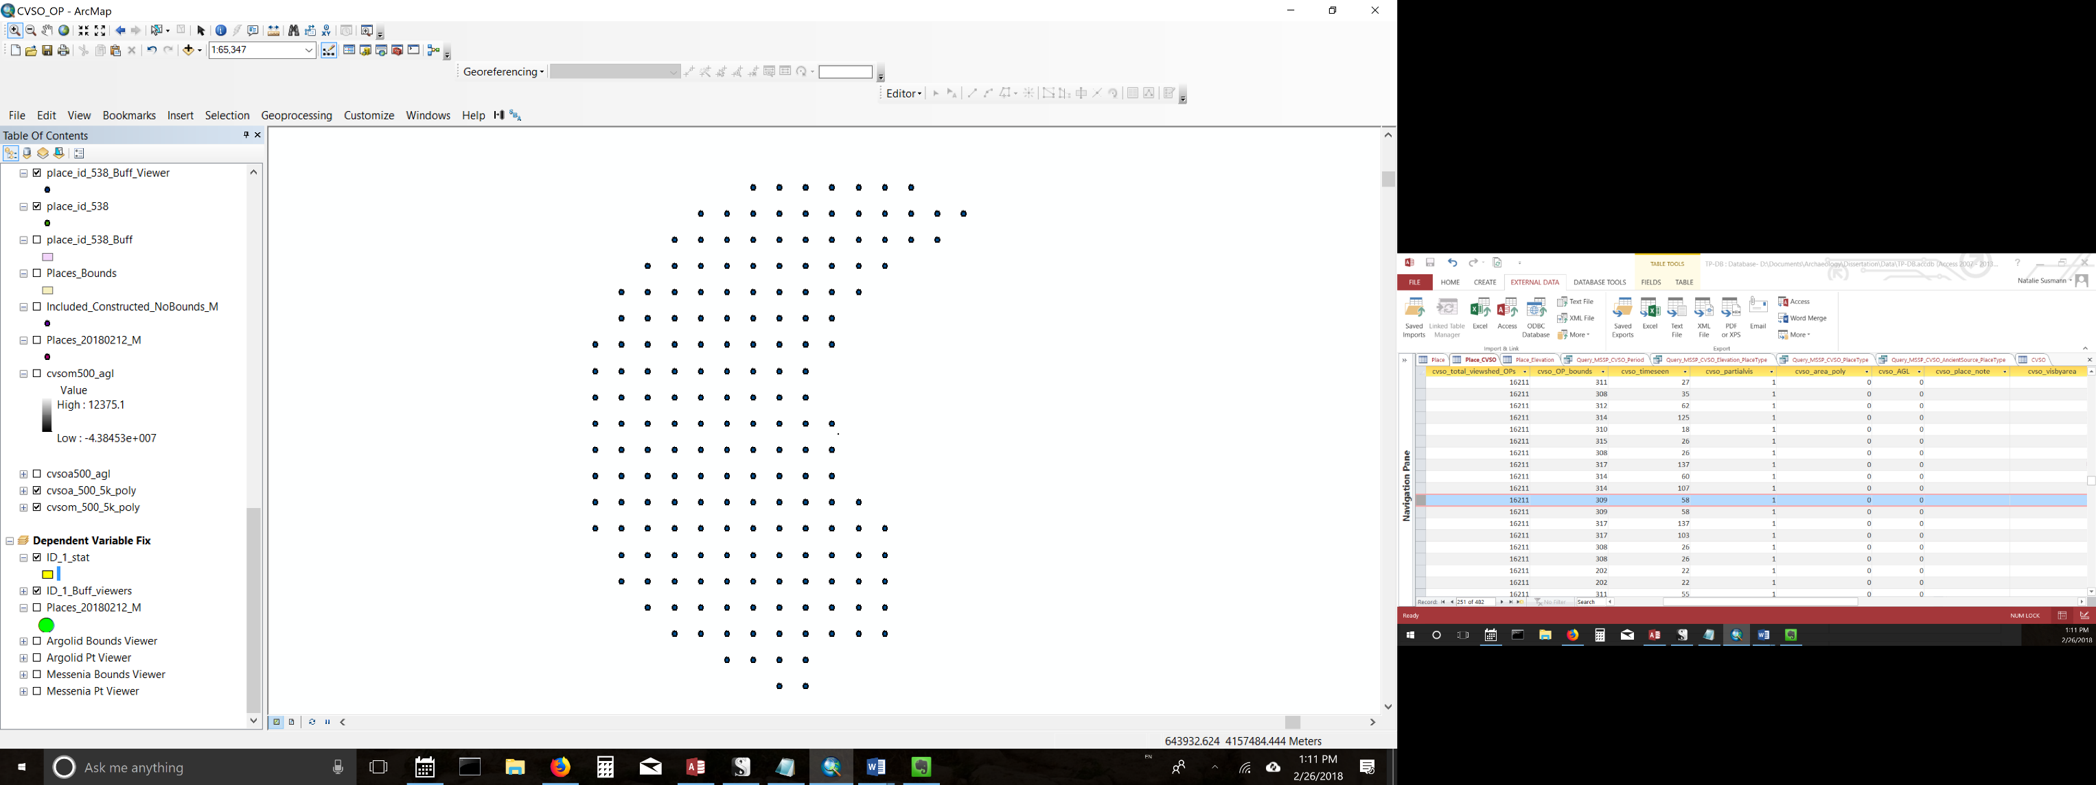

Topography is taken into account with these observer placements – if there is a water body or the area is too steep to stand on, an observer is not placed.

**Regional Comparison:**

**Analysis_id** (present in all of the excel tables) represents the following:

1: Argolid places where polygons were used to represent place boundaries

2: Messenia places where polygons were used to represent place boundaries

3: Argolid places where no boundaries were known, and a point was used to count the grid code.

4: Messenia places where no boundaries were known, and a point was used to count the grid code.

I would like to compare regions (so 1 and 3 versus 2 and 4). However, the CVSO outputs are dependent on whether polygons or points were used to calculate the gridcode. If, for example, a structure has a really large area, its gridcode (visibility) could be significantly higher than the gridcode of a place with only a point representing its location. So this is obviously a crucial detail to consider, though I am a bit lost as to how to handle it statistically.

**Statistical Analyses:**

Each of the bolded points corresponds to a basic type of analysis. The parentheses refer to the excel sheet. The sub points specify the relationship I am interested in, and these correspond to field names.

* **CVSO and Elevation (Query_MSSP_CVSO_Elevation_PlaceType)**
  + CVSO_deg_vis AND Elevation_Mean
  + CVSO_visbyarea AND Elevation_Mean
  + CVSO_visbyarea AND Elevation_Mean AND Place Type 1-5[1]
  + CVSO_deg_vis AND Elevation_Mean AND Place Type 1-5
* **CVSO and Place Type (Query_MSSP_CVSO_PlaceType)**
  + CVSO_deg_vis AND Place Type (1-5)
  + CVSO_visbyarea AND Place Type (1-5)
* **CVSO and Ancient Source (Query_MSSP_CVSO_AncientSource_PlaceType)**
  + CVSO_deg_vis AND ancient_source_id
  + CVSO_visbyarea AND ancient_source_id
  + CVSO_deg_vis AND ancient_source_id AND Place Type 1-5
  + CVSO_visbyarea AND ancient_source_id AND Place Type 1-5

1. The place types are cascading relationships, so I would be interested in seeing the results x5 (so comparing Place Type 1’s, then 2’s, etc.)