RemixBuddy
Engineering Specification v4
Decision document for implementation planning
V1 target: Windows 10/11 x64, VST3 client + local processing service

Document owner | René / Product owner
Decision status | Technical recommendations approved - implementation spec requested by external plugin team
Scope | V1 engineering specification for estimation, staffing and implementation start
Revision | v4 / draft for team review

Purpose. This document removes open technical choices and defines the concrete architecture, interfaces, data contracts, runtime behavior, test strategy and definition of done required for implementation planning.

1. Product decisions
Goal. Define the smallest buildable and testable v1 that gives producers real value without forcing the implementation team to invent missing architecture.

1.1 Mandatory decisions
Decision | Approved v1 choice
Product form | Hybrid product: VST3 plugin client inside the DAW plus a separate local processing service.
Plugin format | V1 supports VST3 only. AU and AAX are explicitly out of scope for v1.
Target platforms | Windows 10/11 x64 only for v1.
Supported DAWs for validation | FL Studio and Ableton Live are the reference hosts for validation.
Processing model | Offline, job-based processing only. No real-time stem separation in v1.
IPC model | Loopback HTTP/JSON on 127.0.0.1:17845 between plugin client and local service.
Repository model | Single monorepo containing plugin, service, shared contracts, test assets and docs.
Plugin client stack | C++17 + JUCE 8 + CMake.
Service stack | Python 3.11 + FastAPI + Uvicorn.
Audio analysis libraries | librosa for BPM/onset analysis, Essentia for key and harmonic features.
Stem model | Demucs v4 (htdemucs) as the single v1 separation model.
Time-stretch engine | Rubber Band Library via service wrapper.
Audio representation | Internal PCM float32, normalized to stereo or mono as loaded, resampled to 44.1 kHz for analysis/stem jobs.
Job execution policy | One heavy job at a time per project session in v1 to minimize GPU/CPU contention and simplify recovery.
Result persistence | All job outputs written to %LOCALAPPDATA%\RemixBuddy\jobs\<job_id>\ and referenced by manifest JSON.
Logging | Structured local JSON logs with daily rotation; no cloud telemetry in v1.

1.2 Out of scope for v1
- AU, AAX, macOS and Linux builds
- Cloud processing, remote inference or online user accounts
- Real-time stem separation during playback
- Tracks longer than 15 minutes
- Multitrack session import (stems in, remix out); v1 accepts a single mixed audio file only
- Automatic arrangement generation and genre intelligence

1.3 Target users and use cases
- Primary user: electronic music producer preparing a remix from a finished mixed track.
- Use case A: load a 3-5 minute pop or dance track, detect BPM/key/sections, export usable vocal and instrumental stems.
- Use case B: identify remix hooks and break sections, then export loop candidates and metadata into a DAW project.
- Use case C: inspect the harmonic and structural profile of a reference track before building a remix arrangement.

2. Non-functional requirements

2.1 Performance
Requirement | Target
UI responsiveness | Plugin UI must remain responsive at all times; any heavy processing is asynchronous.
Service discovery | Plugin must detect service availability in <= 300 ms on startup.
Analysis latency | BPM/key/section analysis for a 5-minute stereo file at 44.1 or 48 kHz must finish in <= 20 s on recommended hardware.
Stem latency (GPU) | 4-stem separation for a 5-minute stereo file must finish in <= 90 s on recommended GPU hardware.
Stem latency (CPU fallback) | 4-stem separation for a 5-minute stereo file may take up to 6 min on CPU-only fallback.
Export latency | Manifest + file export step must complete in <= 10 s after processing finishes.

2.2 Hardware and operating envelope
- Minimum supported hardware: 16 GB RAM, 4-core CPU, Windows 10/11 x64, no GPU required.
- Recommended hardware: 32 GB RAM, 8-core CPU, NVIDIA GPU with >= 8 GB VRAM and CUDA-compatible driver.
- Accepted input duration: 5 s to 15 min. Files above 15 min are rejected in v1 with explicit error code RB-LIMIT-001.
- Accepted channel configurations: mono and stereo only. Files with >2 channels are rejected in v1.
- Accepted sample rates: 44.1 kHz and 48 kHz preferred. Other supported decode rates are resampled internally to 44.1 kHz float32.

2.3 Stability, logging and monitoring
- Crash isolation: the processing service runs in a separate process; service failure must not crash the plugin host.
- Log location: %LOCALAPPDATA%\RemixBuddy\logs\service-YYYYMMDD.jsonl and plugin-YYYYMMDD.log.
- Monitoring model: local only. Health endpoint /health and /metrics are available on loopback; no remote monitoring in v1.
- Retention: keep 14 days of logs or 200 MB total, whichever limit is reached first.

3. Runtime architecture
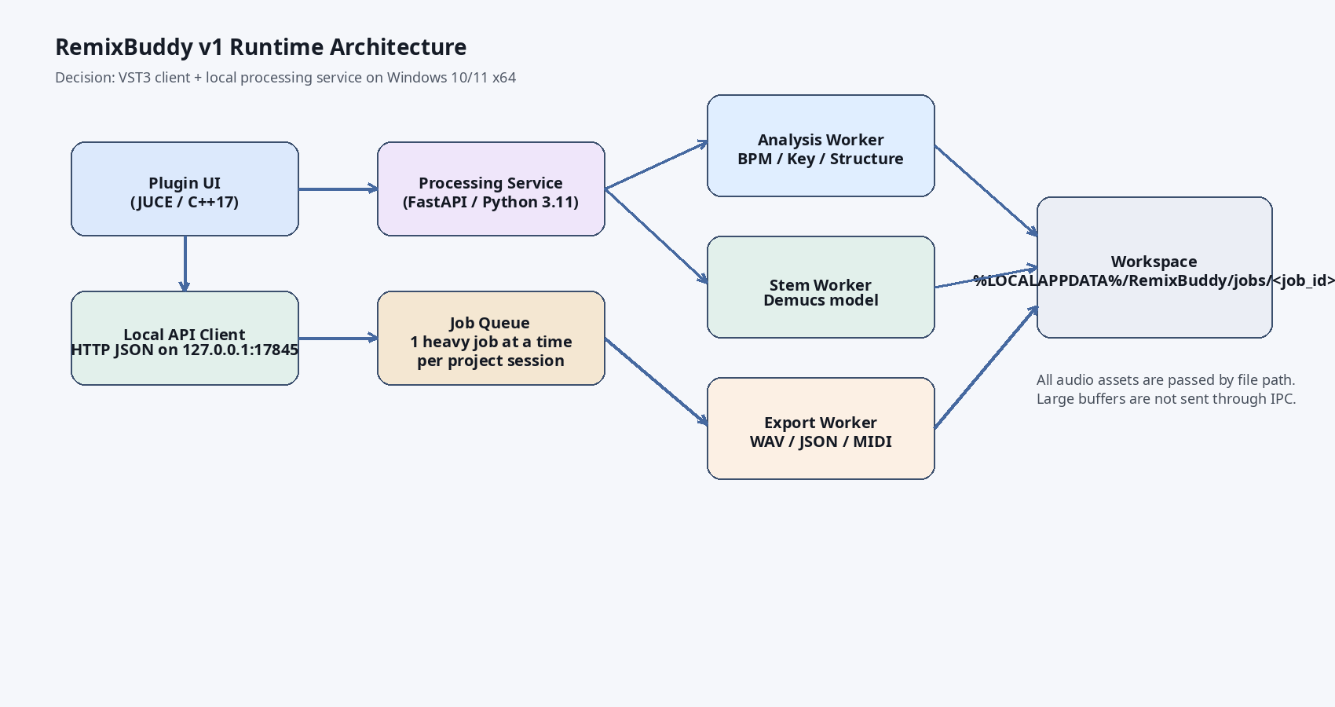
Figure 1. Runtime architecture for v1.
Architecture summary. The plugin is intentionally thin: UI, session state, host integration and orchestration. The local service owns decoding, analysis, model execution, exports and log generation.

3.1 Process model
- Plugin startup: on first UI open, the plugin sends GET http://127.0.0.1:17845/health.
- If service is unavailable, the plugin launches the bundled service executable and retries health check for up to 5 s.
- If health check fails after 5 s, the plugin enters Error state and exposes Retry and Open Logs actions.
- Each processing request creates a job in the service. Jobs are persisted on disk so a completed export remains available after plugin UI closes.

3.2 Concurrency and queueing
- One heavy job at a time per project session in v1. Heavy jobs are analysis and stem separation.
- Queue discipline: FIFO within the active project session.
- Plugin polls job status every 250 ms while a job is running.
- Cancel behavior: plugin can request cancellation; service marks job cancel_requested and worker stops at nearest safe checkpoint.

3.3 Audio memory policy
- Plugin never transfers large audio buffers over IPC.
- Plugin sends file path + options only.
- Service decodes source audio to float32 and writes intermediate assets to the workspace.
- Peak memory target for a 5-minute stereo file on GPU path: <= 10 GB system RAM + model VRAM footprint.

3.4 GPU usage
- GPU is used only by the stem worker.
- Model loading is lazy on first stem job; model remains warm in memory until service shutdown or 20 min idle timeout.
- CPU fallback is automatic when CUDA is unavailable or model initialization fails.
- Plugin UI must display which execution path is active: GPU or CPU fallback.

4. Module architecture and technologies
Module | Implementation choice
Plugin client | C++17, JUCE 8, CMake; renders UI, validates user input, launches service, polls job status, imports results into DAW-facing browser state.
Local service | Python 3.11, FastAPI, Uvicorn; hosts HTTP API, queue, workers, manifests and logging.
Decoder/normalizer | ffmpeg binding or equivalent local decoder through service; decodes WAV/MP3/FLAC to PCM float32.
Analysis worker | librosa for onset/BPM, Essentia for key + harmonic features, custom heuristics for section boundaries.
Stem worker | Demucs htdemucs model only in v1.
Time-stretch worker | Rubber Band Library wrapper via service integration.
Export worker | Writes WAV 24-bit PCM stems, JSON metadata and optional MIDI chord file.

5. Repository, project and build structure
- Repository model: monorepo.
- Rationale: shared contracts, shared versioning and simpler release packaging for a two-person external implementation team.
remixbuddy/
docs/
contracts/
api/
schemas/
plugin/
Source/
Resources/
CMakeLists.txt
service/
app/
api/
workers/
models/
utils/
tests/
requirements.txt
shared/
test_assets/
benchmark_sets/
packaging/
windows/
scripts/
Build system. Plugin uses CMake + JUCE. Service uses Python 3.11 virtual environment with pinned requirements.txt. Releases package the service with the plugin installer and register default workspace/log folders.

6. Data contracts and versioning
Version rule. Every service response includes schema_version and api_version. Breaking contract changes increment major version.

6.1 Core entities
Entity | Fields / constraints
TrackAnalysisRequest | request_id:string (uuid), file_path:string, detect_sections:bool, detect_key:bool, detect_bpm:bool, workspace_id:string
TrackAnalysisResult | job_id:string, schema_version:string, bpm:float, bpm_confidence:float [0..1], key:string, key_confidence:float [0..1], duration_sec:float, sample_rate:int, channels:int, sections:Section[]
Section | label:string enum[intro,verse,chorus,break,drop,other], start_sec:float>=0, end_sec:float>start_sec, confidence:float [0..1]
StemJobRequest | request_id:string, file_path:string, model_id:string='htdemucs', output_format:string='wav24', target_bpm:int|null, key_shift:int|null, workspace_id:string
StemJobResult | job_id:string, stems:StemAsset[], execution_path:string enum[gpu,cpu], processing_sec:float, warnings:string[]
StemAsset | name:string enum[vocals,drums,bass,other], file_path:string, format:string, peak_dbfs:float
ApiError | error_code:string, message:string, details:string|null, retryable:bool

6.2 API / IPC endpoints
Endpoint | Behavior
GET /health | Returns service health, version, gpu_available, active_jobs.
POST /jobs/analyze | Creates analysis job.
POST /jobs/stems | Creates stem separation job.
GET /jobs/{job_id} | Returns status, progress, result paths and warnings.
POST /jobs/{job_id}/cancel | Requests cancellation.
GET /metrics | Local development-only counters for completed, failed and average durations.

6.3 Example request / response
{
"request_id": "1d9219b0-9e1c-49d8-9d13-0d4b6d2b1f10",
"file_path": "D:/Audio/input/my_track.wav",
"workspace_id": "session_2026_03_14_001",
"detect_sections": true,
"detect_key": true,
"detect_bpm": true
}
{
"job_id": "job_an_0001",
"status": "completed",
"schema_version": "1.0.0",
"api_version": "1.0.0",
"bpm": 136.0,
"bpm_confidence": 0.98,
"key": "F minor",
"key_confidence": 0.91,
"duration_sec": 195.2,
"sections": [
{
"label": "intro",
"start_sec": 0.0,
"end_sec": 32.0,
"confidence": 0.88
},
{
"label": "verse",
"start_sec": 32.0,
"end_sec": 64.0,
"confidence": 0.84
}
],
"warnings": []
}

6.4 Error codes
Code | Meaning | Retryable
RB-INPUT-001 | Unsupported file format | No
RB-INPUT-002 | Duration exceeds v1 limit (15 min) | No
RB-SVC-001 | Processing service unavailable after startup timeout | Yes
RB-JOB-001 | Job canceled by user | Yes
RB-JOB-002 | Job timed out | Yes
RB-GPU-001 | GPU unavailable, CPU fallback activated | Yes
RB-STEM-001 | Stem model initialization failed | Yes

7. Request sequence and UX states
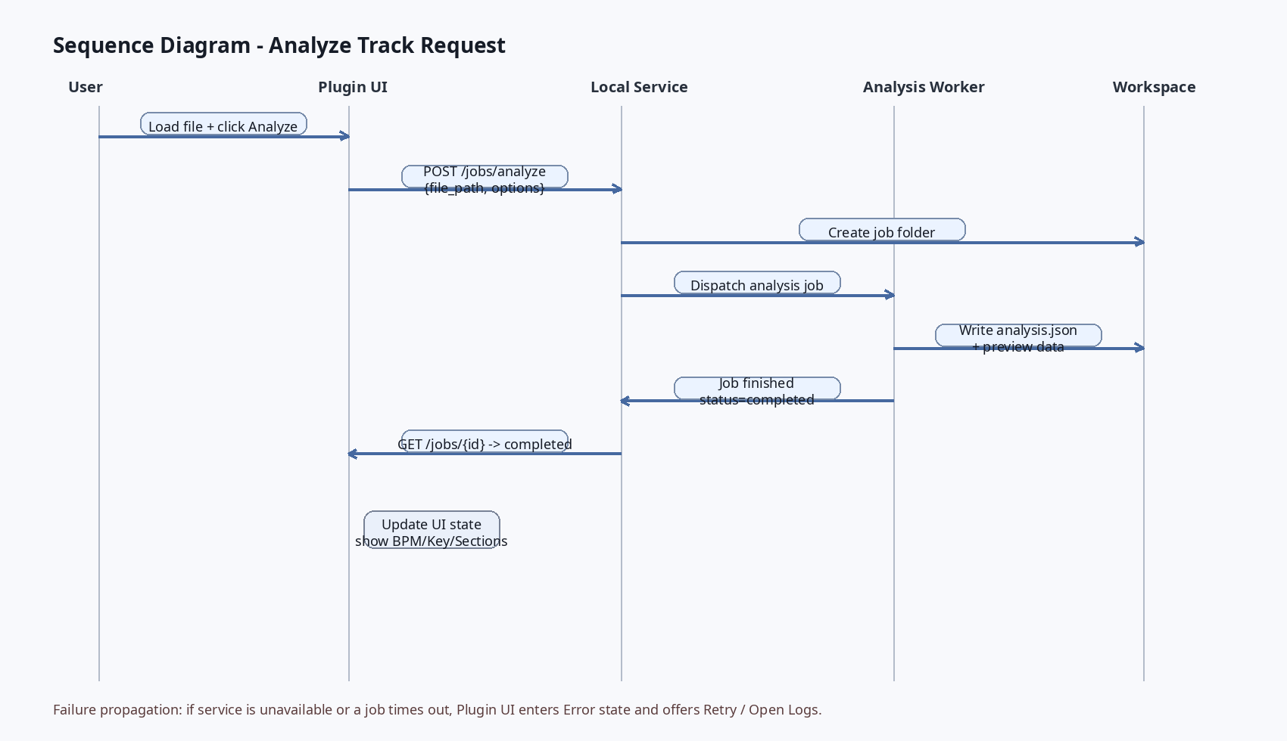
Figure 2. Sequence diagram for Analyze Track.
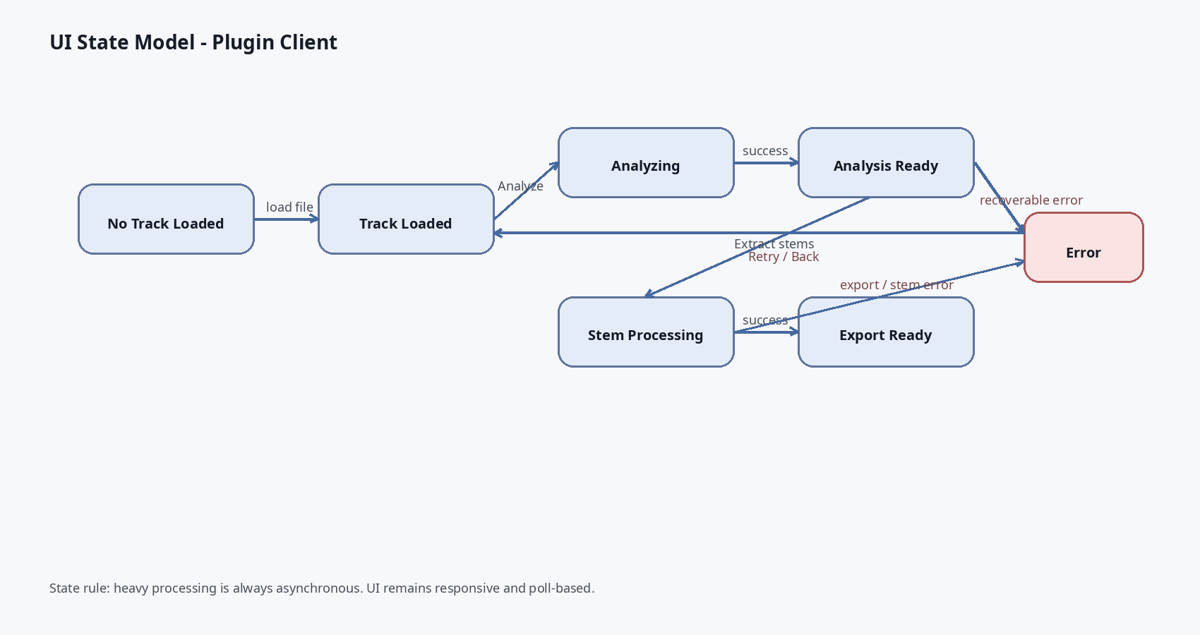
Figure 3. Plugin UI state model.

7.1 Interaction model
- The plugin always starts in No Track Loaded.
- After file load, the user can run Analyze or replace/eject the file.
- Analysis Ready is the only state that unlocks stem extraction controls and remix suggestions.
- Error state always provides Retry and Open Logs actions.

7.2 GUI reference
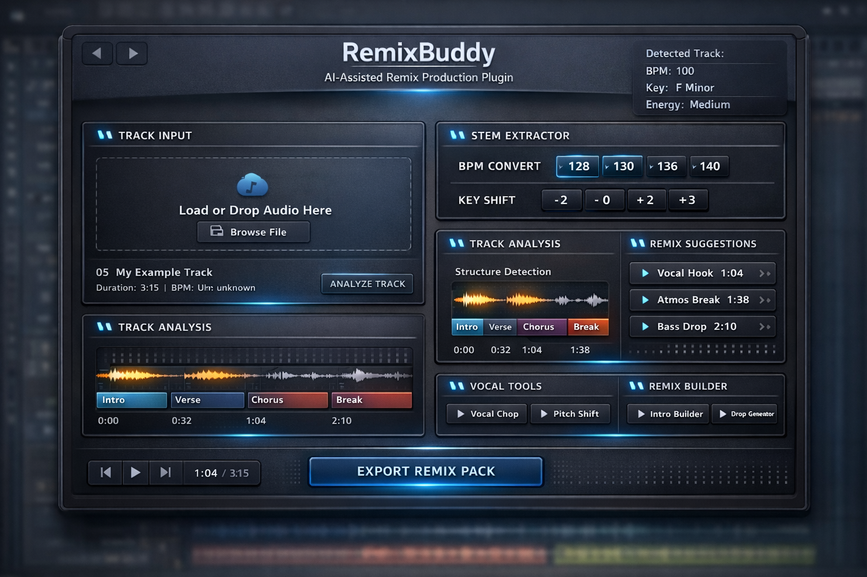
Figure 4. GUI reference mockup for plugin client.

8. User stories and acceptance criteria

US-01 Load and analyze track - As a producer, I want to load a mixed audio file so that I can detect BPM, key and structure.
- Formats: WAV PCM 16/24/32f, MP3, FLAC
- File duration <= 15 min
- Analysis finishes <= 20 s on recommended hardware
- BPM accuracy >= 95% within +/-1 BPM on benchmark set
- Plugin shows file name, duration and analysis status

US-02 Extract stems - As a producer, I want to extract vocal and instrumental stems so that I can start a remix quickly.
- Stem job runs asynchronously
- Vocals, drums, bass and other stems are exported as WAV 24-bit PCM
- GPU path <= 90 s for 5-min benchmark track
- CPU fallback is exposed when GPU is unavailable
- Result manifest lists all exported files

US-03 Export remix pack - As a producer, I want to export a remix pack so that I can continue in my DAW workflow.
- Exports include stems, analysis.json and section markers
- Export writes to workspace and is reachable from plugin UI
- All paths in manifest resolve to existing files
- Export step <= 10 s after processing completion

9. Edge cases and unsupported cases
Case | V1 behavior
3-hour live set | Rejected in v1 via RB-INPUT-002; supported duration cap is 15 min.
Low bitrate MP3 / poor audio quality | Accepted if decodable; service returns warning and lower confidence scores.
Tracks without clear verse/chorus structure | Accepted; sections may return 'other' labels with lower confidence.
BPM drift / tempo changes | Accepted; v1 returns dominant BPM only and flags variable_tempo=true in analysis metadata.
Multilingual vocals | Accepted; stem extraction is language-agnostic; no lyric transcription in v1.
Mono files | Accepted; processed as mono, exported stems keep mono channel count.
Multichannel files >2ch | Rejected in v1.

10. Risks and mitigation
Risk | Mitigation
Stem quality is source-dependent | Use a single validated v1 model only, expose confidence/warnings, allow preview before export, maintain CPU fallback.
GPU initialization failure | Detect at service startup, fall back to CPU automatically, write RB-GPU-001 warning.
Service crash under heavy job | Isolate service process, persist job state to disk, plugin offers Retry and Open Logs.
Host instability due to heavy processing | Keep plugin thin and asynchronous; no model inference in plugin process.
Long job duration on CPU-only systems | Display estimated duration and recommend GPU hardware in docs and UI notice.

11. MVP, priorities and delivery plan

11.1 Scope using MoSCoW
Priority | Items
Must Have | Plugin client, local service, load file, analyze BPM/key/sections, 4-stem separation, export WAV stems + JSON manifest, logging, error handling.
Should Have | Key shift parameter, target BPM parameter, remix suggestion list derived from section analysis.
Could Have | MIDI chord export, cached recent jobs browser.
Won't Have in v1 | Realtime processing, cloud sync, AU/AAX, macOS, arrangement generator.

11.2 Implementation phases
Phase | Content | Dependencies | Effort
Phase A - foundation | Repo setup, contracts, service launcher, health check, logging, workspace management. | Blocker for all later work | M
Phase B - analysis MVP | File load, decoding, BPM/key/section analysis, analysis UI rendering. | Depends on Phase A | M
Phase C - stem MVP | Demucs integration, GPU/CPU path, stem export, manifest export. | Depends on A and B | L
Phase D - polish and validation | Error handling, benchmark runs, host validation in FL/Ableton, installer packaging. | Depends on B and C | M

12. Definition of done
Module | Done when...
Plugin launcher + health check | Service launches from plugin, health check succeeds within 5 s, failure path shows Error state and logs path.
Analysis module | All benchmark files process without crash, BPM accuracy >= 95% within +/-1 BPM, key accuracy >= 90% on internal set, result schema validates.
Stem module | 5-min benchmark finishes <= 90 s on GPU path, exports 4 WAV 24-bit PCM stems, manifest validates, no missing files, median SI-SDR on internal eval set >= 6 dB.
Export module | analysis.json and manifest.json are versioned, every asset path exists, output naming is deterministic.
Installer package | Plugin + service install cleanly on fresh Windows machine and first-run health check passes.

13. Test specification

13.1 Benchmark asset set
- 60 benchmark input files total.
- 20 standard music tracks (licensed internal test set): pop, dance, trance, house, vocal-heavy material.
- 20 synthetic control files: known BPM, known key, known section boundaries.
- 20 edge-case files: mono, noisy MP3, low dynamic range, tempo drift, weak structure.

13.2 Required automated tests
- Contract tests: validate every response against JSON schema.
- Unit tests: queue lifecycle, error mapping, manifest writer, workspace cleanup.
- Integration tests: plugin -> service health check, job creation, result retrieval.
- Benchmark tests: BPM/key accuracy and timing against benchmark asset set.
- Regression tests: compare exported file count, manifest fields and known durations against locked reference outputs.

13.3 Audio-quality evaluation
- Analysis metrics: BPM tolerance +/-1 BPM, key top-1 accuracy target 90% on internal set.
- Stem metrics: median SI-SDR target >= 6 dB on internal eval set, plus human listening review on 10 reference tracks.
- Listening review rule: no major clicks, no silent outputs, no missing lead vocal in exported vocal stem.

14. Open issues deliberately postponed
- AU/AAX/macOS support deferred until v1 Windows VST3 is validated.
- Alternative stem models are deferred until the first stable Demucs-based release exists.
- Realtime and cloud scenarios are deferred to avoid scope explosion during v1.
Implementation note. This document is intentionally prescriptive. Where choices were previously open, v1 decisions are now fixed so an external engineering team can estimate, plan and start implementation without inventing missing architecture.

