**CASA0002 - Urban Simulation Assessment**

Github link:

Words count: 2503

**Part 1: London’s underground resilience**

**I. Topological network**

In this part, I explored the London’s underground network, only take into consideration the infrastructural network, where stations are connected through only one link, regardless of the number of lines connecting the stations.

**I.1. Centrality measures**

The London’s underground network have 438 nodes and 486 edges. In this research, degree centrality, betweenness centrality and closeness centrality are selected to identify the most important nodes in the underground network.

**Degree centrality**

Degree centrality is defined as the number of links incident upon a node (Diestel, 2005). In the context of an underground transportation system, it measures how many subway lines intersect or pass through a particular station. These highly connected stations serve as major hubs or transfer points so they are crucial for the functioning of the underground. In an undirected graph, for a node i, its degree centrality is given by:

$D_{\left(i\right)}= \frac{1}{n−1}\sum_{j=1}^{n}{A_{ij^{'}}}$ (1)

where $A_{ij}$  is the ij-th element of the adjacency matrix A of the graph, and n is the number of vertices in the graph. The first 10 ranked nodes for degree centrality measure can be seen in Table 1.

|  |  |  |
| --- | --- | --- |
|  | **Station Name** | **Value** |
| 1 | King's Cross St. Pancras | 0.016018 |
| 2 | Baker Street | 0.016018 |
| 3 | Oxford Circus | 0.01373 |
| 4 | Green Park | 0.01373 |
| 5 | Bank | 0.01373 |
| 6 | Earl's Court | 0.01373 |
| 7 | Waterloo | 0.01373 |
| 8 | Turnham Green | 0.011442 |
| 9 | Canning Town (DLR) | 0.011442 |
| 10 | Liverpool Street | 0.011442 |

Table 1: The first 10 ranked nodes for degree centrality measure

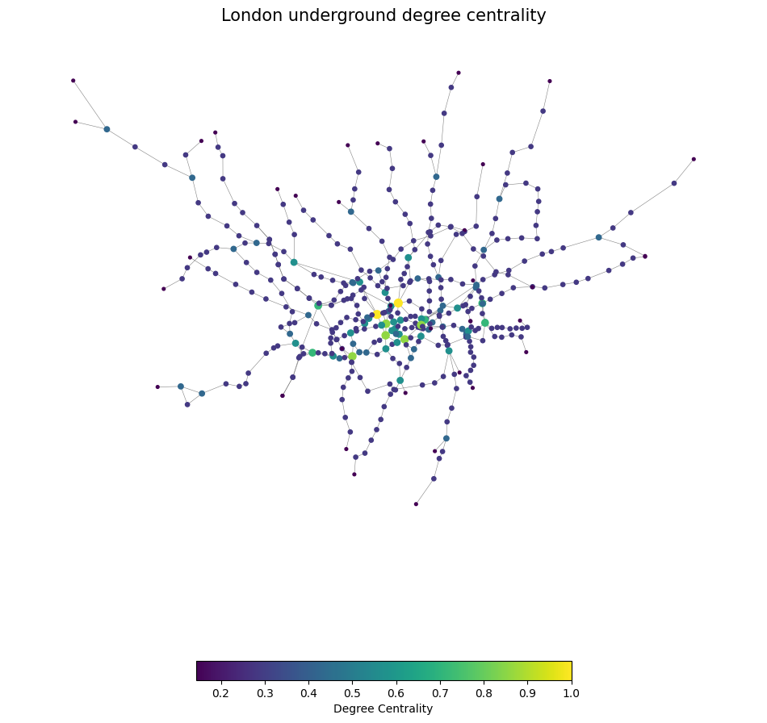

Figure 1: The first 10 ranked nodes for degree centrality measure

**Betweenness centrality**

Betweenness centrality quantifies the number of times a node acts as a bridge along the shortest path between two other nodes (Freeman, 1977). In London underground network, stations with high betweenness centrality lie on many shortest paths connecting different pairs of stations. So they are crucial to the efficiency and robust to the network. According to Brandes, 2011.

$C_{B}\left(v\right)=\sum_{s≠v≠t∈V}{\frac{σ_{st}(v)}{σ_{st}}}$（2）

Where  IMG_256 is total number of shortest paths from node *s* to node *t* and IMG_256 is the number of those paths that pass through *v*. The betweenness may be normalised by dividing through the number of pairs of vertices not including *v*, for undirected graphs is (n-1)(n-2)/2. The first 10 ranked nodes for betweenness centrality measure can be seen in Table 2.

|  |  |  |
| --- | --- | --- |
|  | **Station Name** | **Value** |
| 1 | Baker Street | 36297.77579 |
| 2 | Bethnal Green | 33670.10833 |
| 3 | Finchley Road | 32064.8004 |
| 4 | Bank | 30443.44167 |
| 5 | Green Park | 30442.4381 |
| 6 | Waterloo | 30219.9 |
| 7 | Liverpool Street | 29820.74167 |
| 8 | Westminster | 27623.54167 |
| 9 | Bond Street | 24635.65317 |
| 10 | West Hampstead | 22536.65833 |

Table 2: The first 10 ranked nodes for between centrality measure

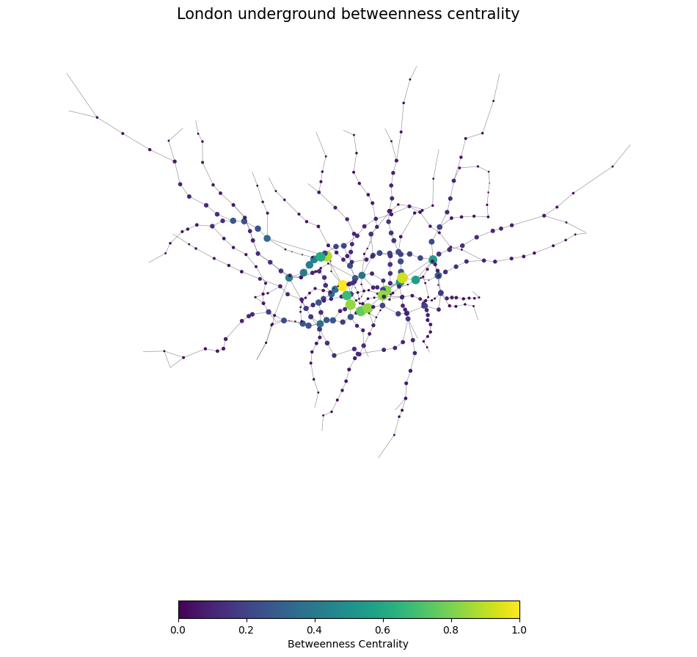



Figure 2: The first 10 ranked nodes for between centrality measure

**Closeness centrality**

Closeness centrality is defined as the reciprocal of the sum of the length of the shortest paths between the node and all other nodes in the graph. In underground network. The stations with high closeness centrality stand for the high convenience and ease of connections between stations. Its normalized form equation is given by Bavelas (1950):

$C\left(x\right)=\frac{N−1}{\sum_{y}{d(y, x)}}$ (3)

Where *N* is the number of nodes in the graph, *d(y, x)* is the [distance](https://en.wikipedia.org/wiki/Distance_(graph_theory)" \o "Distance (graph theory)) (length of the shortest path) between nodes *x* and *y*. The first 10 ranked nodes for closeness centrality measure can be seen in Table 3.

|  |  |  |
| --- | --- | --- |
|  | **Station Name** | **Value** |
| 1 | Green Park | 0.094897 |
| 2 | Bond Street | 0.093737 |
| 3 | Westminster | 0.093197 |
| 4 | Baker Street | 0.0929 |
| 5 | Waterloo | 0.092389 |
| 6 | Bank | 0.092 |
| 7 | Oxford Circus | 0.091614 |
| 8 | Liverpool Street | 0.09001 |
| 9 | Regent's Park | 0.089275 |
| 10 | Finchley Road | 0.089165 |
| 1 | Victoria | 0.089002 |

Table 3: The first 10 ranked nodes for closeness centrality measure

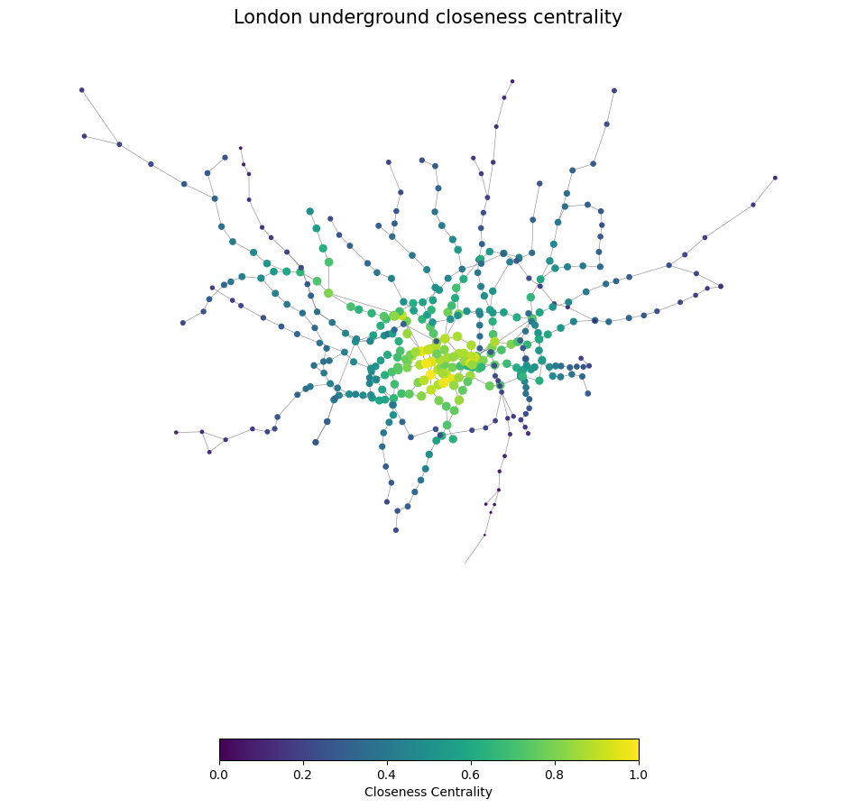



Figure 3: The first 10 ranked nodes for closeness centrality measure

**I.2. Impact measures**

Network efficiency and largest connected component were selected to evaluate the impact of the node removal on the network. Network efficiency is calculated as the average of the reciprocal of the shortest path lengths between all pairs of nodes in the network (Latora, 2001). The largest connected component largest connected component" typically refers to the largest subset of vertices within a graph where every vertex is connected to every other vertex by paths, with no breaks, it reflects the most dense and connected part of the network, typically exhibiting high network connectivity (Newman, 2002). These two measures are not only used in London underground, but also important measures in various fields such as transportation networks, social networks.

**I.3. Node removal**

In the context of an underground transportation network, betweenness centrality is often considered a better reflection of station importance. This is because betweenness centrality captures the extent to which a station serves as a critical intermediary or hub for the flow of passengers between other stations. Removing nodes with high betweenness centrality will have a greater impact on the efficiency of transferring via shortest paths. For ease of viewing, the size of the largest connected component is used in describing the largest connected component divided by the number of nodes N to represent the proportion of the maximum connectivity component in the overall graph in here.

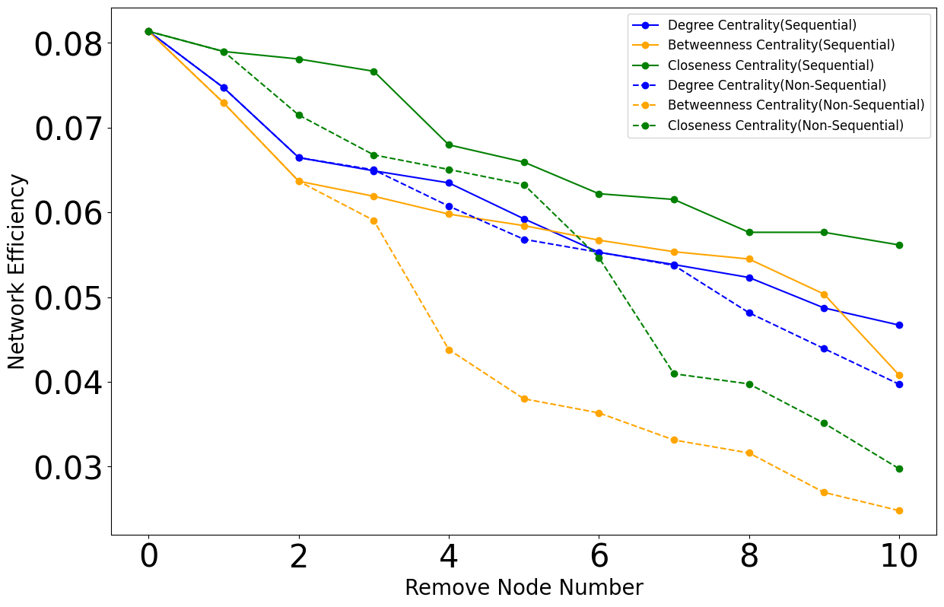

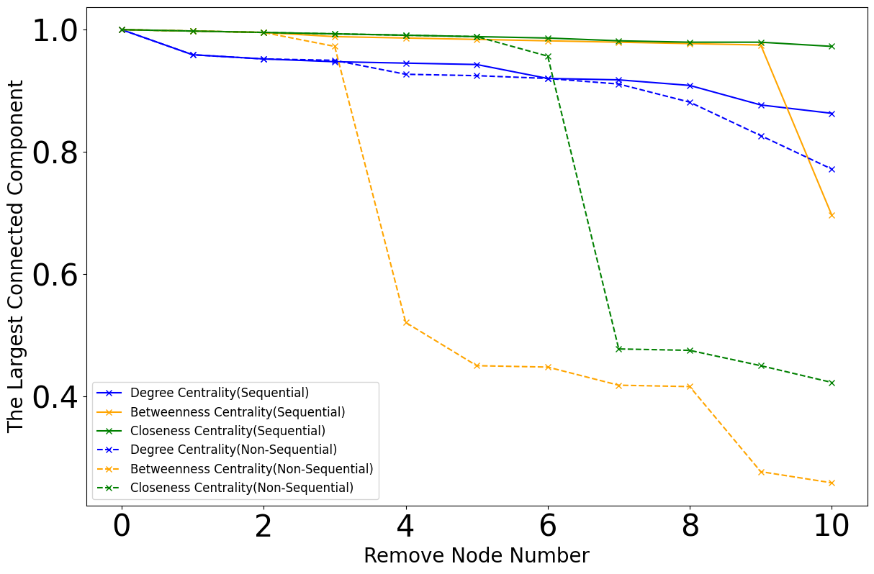

Figure 3: Centrality Measure After Node Removal

In this research, Sequence removal is more effective at studying resilience. After removing each node, the structure of the network changes accordingly. Therefore, sequential removal ensures that each removed node has the maximum impact on its respective centrality measure. As evident from Figure 3, sequential removal leads to a more rapid decline in both network efficiency and the size of the largest connected component.

Both network efficiency and the size of the largest connected component are valuable impact measures for assessing the damage after node removal, but they serve different purposes and provide different insights into the resilience of the network. For the London Underground network, the Largest Connected Component is better suited for assessing the damage after node removal. This is because we can observe from the graph that after sequentially removing the third node, there is a drastic decline in betweenness centrality. This suggests that the network has become more fragmented, with isolated clusters of nodes that are no longer connected to the main network.

**II. Flows: weighted network**

In the second part, I consider the commuting flows, and discuss the impact of the analysis on the number of people moving from one part of the city to another. Figure 4 shows the passenger flows between stations.

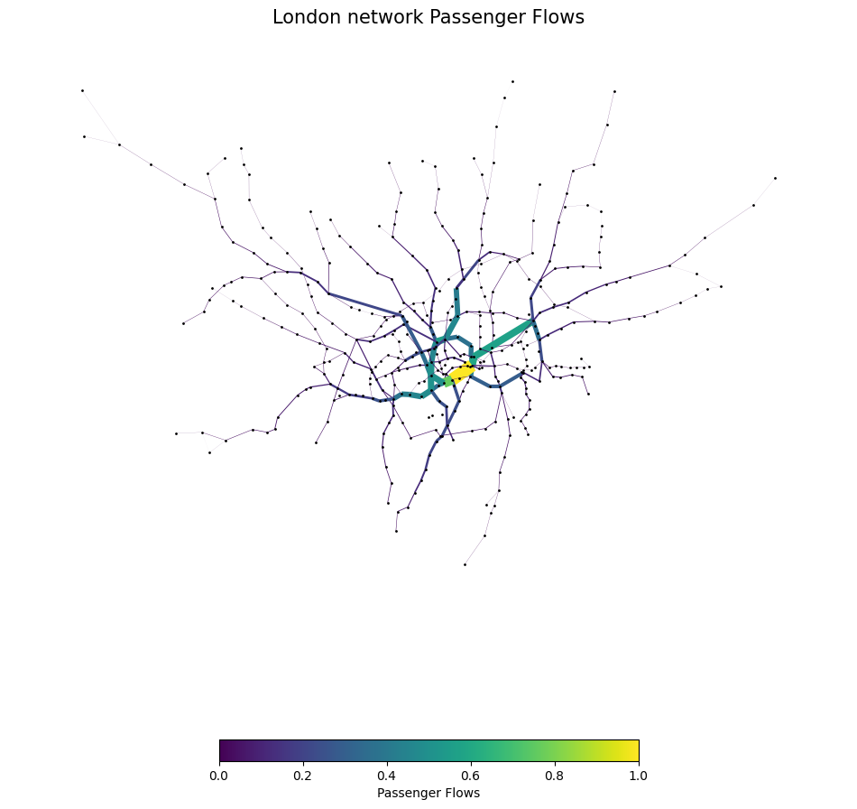



Figure 4: London Network Passenger Flows

**II.1.**

In part Ⅰ, the degree centrality measure, between centrality measure, and closeness centrality were derived. In an unweighted network, these metrics typically presume that all edges carry the same weight, often considered as unit weight. However, in the case of weighted networks, where the edges bear various weights symbolizing flows of connections, it becomes necessary to adjust these metrics to accommodate these weights.

For each node in the network, calculate the sum of the weights of all edges directly connected to it. This sum is the weighted degree centrality of the node. Betweenness centrality for a node in a weighted network is computed by considering its frequency on the weighted shortest paths connecting pairs of nodes. In this context, the term "shortest" refers to paths with the lowest total weight, where lower weights signify stronger or more favorable connections.

While in closeness centrality, the distance metric typically represents the actual distance between nodes (e.g., physical distance on a map). Using the weight attribute "flows" might not be the most appropriate measure for closeness centrality. So I change it to PageRank.

The recomputed ranking of the 10 most important nodes in theses three centrality measure are shown in Table 4, Table 5 and Table 6. It is clear there is no same ones as in I.1.

|  |  |  |
| --- | --- | --- |
|  | **Station name** | **Value** |
| 1 | Green Park | 737778 |
| 2 | Bank and Monument | 663305 |
| 3 | Waterloo | 579966 |
| 4 | Westminster | 480431 |
| 5 | King's Cross St. Pancras | 454853 |
| 6 | Liverpool Street | 409131 |
| 7 | Euston | 387820 |
| 8 | Stratford | 367041 |
| 9 | Oxford Circus | 323524 |
| 10 | Baker Street | 305105 |

Table 4: The First 10 Ranked Nodes For Degree Centrality Measure In Weighted Network

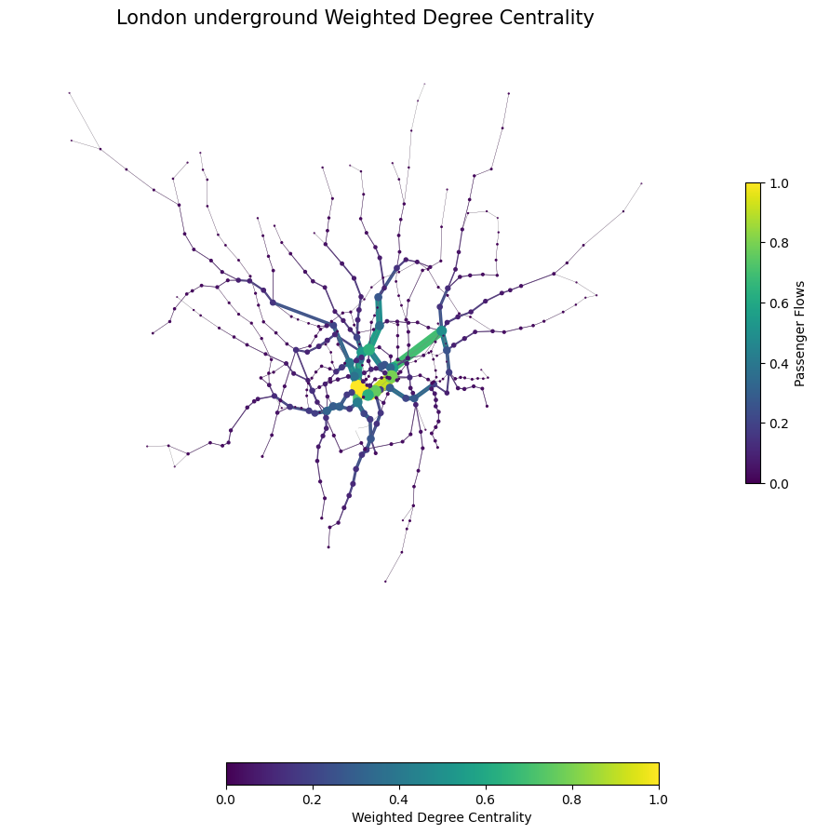



Figure 5: The First 10 Ranked Nodes For Degree Centrality Measure In Weighted Network

|  |  |  |
| --- | --- | --- |
|  | **Station name** | **Value** |
| 1 | West Hampstead | 0.3494 |
| 2 | Gospel Oak | 0.2996 |
| 3 | Finchley Road & Frognal | 0.2887 |
| 4 | Hampstead Heath | 0.2887 |
| 5 | Blackhorse Road | 0.2607 |
| 6 | Upper Holloway | 0.2503 |
| 7 | Crouch Hill | 0.2488 |
| 8 | Harringay Green Lanes | 0.2474 |
| 9 | South Tottenham | 0.2460 |
| 10 | Willesden Junction | 0.2437 |

Table 5: The First 10 Ranked Nodes For Betweenness Centrality Measure In Weighted Network

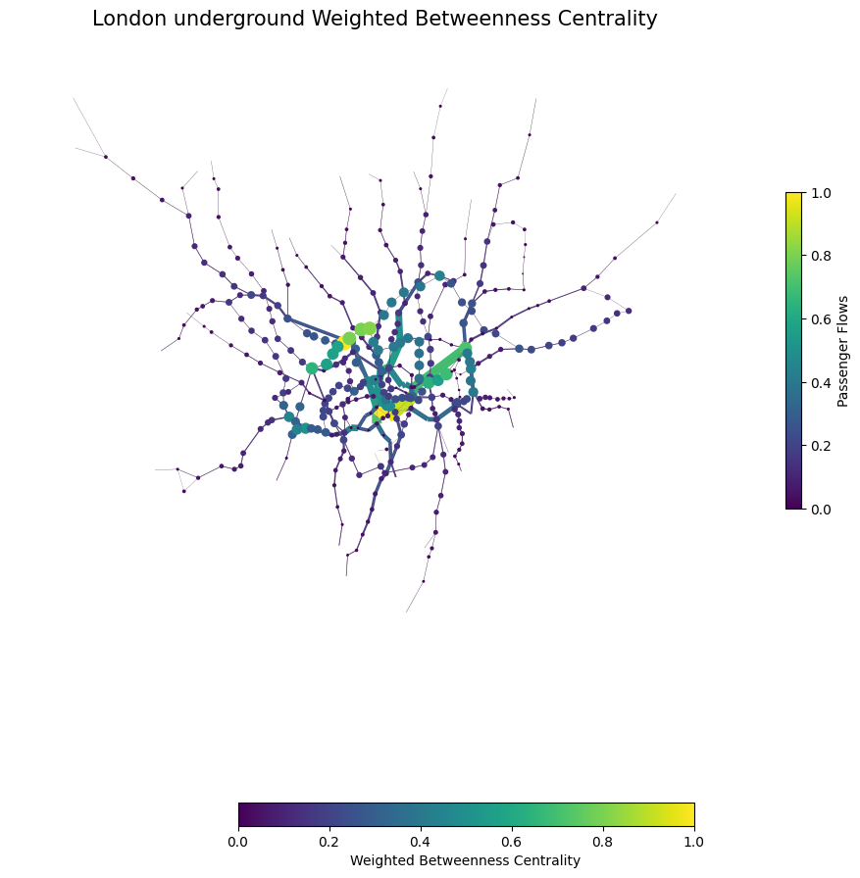



Figure 6: The First 10 Ranked Nodes For Betweenness Centrality Measure In Weighted Network

|  |  |  |
| --- | --- | --- |
|  | **Station name** | **Value** |
| 1 | Stratford | 0.0117 |
| 2 | Bank and Monument | 0.0116 |
| 3 | King's Cross St. Pancras | 0.0103 |
| 4 | Liverpool Street | 0.0097 |
| 5 | Waterloo | 0.0095 |
| 6 | Baker Street | 0.0087 |
| 7 | Green Park | 0.0083 |
| 8 | Euston | 0.0078 |
| 9 | West Ham | 0.0075 |
| 10 | Highbury & Islington | 0.0074 |

Table 6: The First 10 Ranked Nodes For PageRank In Weighted Network

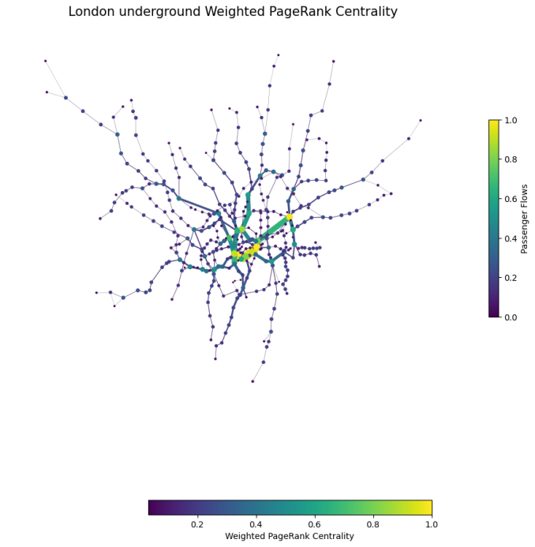



Figure 7: The First 10 Ranked Nodes For PageRank In Weighted Network

**II.2.**

In a weighted network, PageRank offers a method to evaluate the impact of closing a station by incorporating passenger flows. Unlike simply tallying the number of connections, PageRank also incorporates the weight of these connections. It achieves this by iteratively computing the score of each station, treating each station as a node. Initially, all nodes start with the same score. Then, each node redistributes its score among its linked nodes. The final score of each node is determined by aggregating all the scores it receives from other nodes. The PageRank of London underground network is shown in Table 7.

**II.3.**

Table 7, 8,9 show the impact of removing specific station. The removal of Stratford seems to have a substantial impact on network accessibility, even though it may lead to increased efficiency and a reduced path length within the remaining network. This could mean that while the overall efficiency of the network might improve, the connectivity and accessibility for passengers would be substantially reduced, potentially leading to significant disruption.

The substantial decrease in degree centrality efficiency from 0.08 to 4.6459e-06 in the weighted network suggests that the distribution of edge weights has shifted significantly. This shift likely resulted in a concentration of high-weighted connections among a smaller subset of nodes, while other nodes became less connected or even isolated. In weighted networks, the removal of nodes has little effect on The largest connected component. Removing an important node in a weighted network may not always have a drastic effect on the LCC if there are alternative paths with sufficient weights connecting other nodes. The presence of redundant paths or highly weighted edges can mitigate the impact of node removal.

|  |  |  |  |  |
| --- | --- | --- | --- | --- |
|  | Removal Station Name | Network efficiency | The largest connected component | Average Path Length |
| 0 | - | 4.7094e-06 | 1.0 | 644784.3613 |
| 1 | West Hampstead | 4.5345e-06 | 0.9975 | 654003.2875 |
| 2 | Gospel Oak | 4.5406e-06 | 0.9975 | 651593.7863 |
| 3 | Finchley Road & Frognal | 4.5758e-06 | 0.9975 | 650592.5092 |

Table 7: Betweenness Centrality After Node Removal In Weighted Network

|  |  |  |  |  |
| --- | --- | --- | --- | --- |
|  | Removal Station Name | Network efficiency | The largest connected component | Average Path Length |
| 0 | - | 4.7094e-06, | 1.0 | 644784.3613 |
| 1 | Green Park | 4.7634e-06 | 0.9975 | 582903.8081 |
| 2 | Bank and Monument | 4.8346e-06 | 0.9975 | 552247.7867 |
| 3 | Waterloo | 4.7800e-06 | 0.9975 | 592117.9002 |

Table 8: Degree Centrality After Node Removal In Weighted Network

|  |  |  |  |  |
| --- | --- | --- | --- | --- |
|  | Removal Station Name | Network efficiency | The largest connected component | Average Path Length |
| 0 | - | 4.7094e-06 | 1.0 | 644784.3613 |
| 1 | Bank and Monument | 4.7634e-06 | 0.9975 | 582903.8081 |
| 2 | Stratford | 4.6975e-06 | 0.9451 | 495850.3930 |
| 3 | Green Park | 4.8147e-06 | 0.9975 | 665289.92 |

Table 9: PageRank After Node Removal In Weighted Network

**Part 2: Spatial Interaction models**

**III. Models and calibration**

**III.1. Model introduction.**

Wilson (1971) introduced various Spatial Interaction models in his research. The following definitions and formulas for the model are provided based on the practical from the CASA0002 module.

**Unconstrained Spatial Interaction Model**

An Unconstrained Spatial Interaction Model is a theoretical framework in which interactions or flows between distinct spatial units occur without any limitations or restrictions. It can be written as follows:

$$T_{ij}=kO_{i}^{α}D_{j}^{γ}d_{ij}^{−β}$$

*Tij* is interaction flow from origin *i* to destination *j.*

*Oi* denotes the “mass” measure of origin i.

*Dj* denotes the “mass” measure of destination j.

*dij* denotes the distance or transport costs separating locations i and j.

*α* and *γ* are parameters that modify the influence of the "mass" of the origin and destination locations.

β is a distance-decay parameter modifies the influence of distance on the interaction.

k is a constant of proportionality that adjusts the scale of interaction to fit the model to empirical data.

**Singly Constrained Spatial Interaction Model**

The Singly Constrained model includes either a constraint on the supply side (origin) or the demand side (destination).

In Origin-Constrained Model, the total flow from each origin sums to a known total originating from that location.

$$T_{ij}=A_{i}O_{i}D_{j}d_{ij}^{−β}$$

In Destination-Constrained Model, the total flow into each destination sums to a known total for that destination.

$$T_{ij}=O_{i}B_{j}D_{j}d_{ij}^{−β}$$

Tij represents the flow from i to j.

Oi is the total outflow from origin i.

Dj is the attractiveness of destination j.

dij is the distance between i and j.

γ and β are empirically determined parameters.

Ai or Bj are balancing factors to ensure that the model reproduces. The Ai and Bj​ factors are determined through an iterative process.

**Doubly Constrained Spatial Interaction Model**

$$T_{ij}=A_{i}{B_{j}O}_{i}{D_{j}d}_{ij}^{−β}$$

Tij represents the flow from i to j.

Oi is the total outflow from origin i.

Dj is the attractiveness of destination j.

dij is the measure of distance or cost between i and j.

β is a parameter that determines the sensitivity of the flow to distance or cost.

Ai and Bj are balancing factors to ensure that the model reproduces.

$$A_{i}=\frac{1}{\sum_{j}{B_{j}D_{j}D_{ij}^{−β}}} , B_{j}=\frac{1}{\sum_{i}{A_{i}O_{i}D_{ij}^{−β}}}$$

**III.2. Building London flow model**

I explored the Doubly Constrained Spatial Interaction Model. In the real world, traffic flow is subject to certain supply and demand restrictions. The Doubly Constrained Model takes into account both origin and destination constraints, ensuring that flow data do not exceed these real-world limits. It guarantees a balance of flows, preventing any location from exceeding its capacity. Therefore, it can model real-world situations more accurately.

In the experiment, I used both an inverse power law function and a negative exponential function. The Poisson regression model with the inverse power law function yielded an R-squared value of 0.40 and an RMSE of 101.3. Conversely, the Poisson regression model with the negative exponential function produced an R-squared value of 0.49 and an RMSE of 93.4. Therefore, the negative exponential function provides a better fit. The beta of the negative exponential function is 0.0001543.

I further investigated other models and they performed as shown in Table 11：

|  |  |  |  |  |  |  |
| --- | --- | --- | --- | --- | --- | --- |
|  | **Model** | **R2** | **RMSE** | **Alpha** | **Gamma** | **Beta** |
| 0 | uncosim\_pow | 0.246443 | 114.26 | 0.616202 | 0.650897 | -0.815905 |
| 1 | prodsim\_pow | 0.388269 | 102.893 | NaN | 0.768616 | -0.878119 |
| 2 | attrsim\_pow | 0.349942 | 106.012 | 0.745118 | NaN | -0.635148 |
| 3 | doublesim\_pow | 0.407697 | 101.334 | NaN | NaN | -0.909632 |
| 4 | uncosim\_exp | 0.17343 | 120.845 | 0.245243 | 0.34405 | -0.000135 |
| 5 | prodsim\_exp | 0.468066 | 96.263 | NaN | 0.755222 | -0.000153 |
| 6 | attrsim\_exp | 0.39996 | 102.168 | 0.714555 | NaN | -0.0001 |
| 7 | doublesim\_exp | 0.49789 | 93.397 | NaN | NaN | -0.000154 |

Table 11: Spatial Interaction Model Comparison

**IV. Scenarios**

Considering the specific case of Scenarios, I switched to using the destination constrained model. because in the specific case the starting point has not changed, while the attractiveness of the destination has changed. In the following study I recalculated the parameters of the model.

**IV.1.** **S****cenario A**

For Scenario A, Due to the impact of Brexit, the workload of Canary Wharf was reduced from 58772 to 29386. In this circumstance, the destination constraint has changed and the origin has remaned constant. So the origin constraint model is used to compute the new flows. The attractiveness of the destination decreases in this case, while the population of the origin remains constant. If we had used the changed population directly into the original model, it would have resulted in a lower total flow in the system. Whilst in a real world scenario there may be a reduction in population in other parts of London due to the reduction in work at Canary Wharf, for the purposes of this study we have assumed that there is no change in the number of commuter flows in the system. Therefore we need to modify Ai to make sure the number of commuters is conserved.

In the simulated new scenario, there was an increase in traffic between 10,452 stations and a decrease in traffic between 304 stations. The table properties of the changes in traffic between different stations are summarized in Table 11. Due to the fact that the prediction model could only explain 38.83% of the original flow, the primary focus here is on comparing Scenario A to the prediction model. In this scenario, 75% of the station-to-station traffic increases were less than 1, with changes of less than 8%. Upon examining the stations with the most significant changes, it was discovered that this was due to the relatively small initial flow values. Table 13 shows that the largest increase in traffic is from Limehouse to Bank and Monument, reaching 133 people. Table 14 shows that the largest decrease in traffic is from Stratford to Canary Wharf, reaching 978 people.

|  | Original Estimate | Scenario A | Change | Change % |
| --- | --- | --- | --- | --- |
| mean | 84.57 | 86.43 | 1.85 | 7.17 |
| std | 171.55 | 173.58 | 4.02 | 12.20 |
| min | 0 | 1 | 1 | 0.33 |
| 25% | 15 | 17 | 1 | 1.44 |
| 50% | 39 | 40 | 1 | 3.00 |
| 75% | 90 | 91 | 1 | 8.00 |
| max | 4440 | 4480 | 133 | 100.00 |

Table 12: Changes of Scenario A

|  | station\_origin | station\_destination | Original Estimate | Scenario A | Change | Change % |
| --- | --- | --- | --- | --- | --- | --- |
| 1 | Limehouse | Bank and Monument | 1049 | 1182 | 133 | 12.68 |
| 2 | Lewisham | Bank and Monument | 1233 | 1355 | 122 | 9.89 |
| 3 | Woolwich Arsenal | Stratford | 1324 | 1431 | 107 | 8.08 |
| 4 | Woolwich Arsenal | Bank and Monument | 1285 | 1389 | 104 | 8.09 |
| 5 | Lewisham | Stratford | 943 | 1036 | 93 | 9.86 |

Table 13: Top 5 Increased Flows

|  | station\_origin | station\_destination | Original Estimate | Scenario A | Change | Change % |
| --- | --- | --- | --- | --- | --- | --- |
| 1 | Stratford | Canary Wharf | 2428 | 1450 | -978 | -40.28 |
| 2 | Canada Water | Canary Wharf | 1747 | 1053 | -694 | -39.73 |
| 3 | Canning Town | Canary Wharf | 1549 | 937 | -612 | -39.51 |
| 4 | Lewisham | Canary Wharf | 1717 | 1107 | -610 | -35.53 |
| 5 | Woolwich Arsenal | Canary Wharf | 1437 | 912 | -525 | -36.53 |

Table 14: Top 5 Decresed Flows

**IV.2. Scenario B**

Suppose there is a significant increase in the cost of transport. scales it by 1.5 and 2.0 to simulate two scenarios of increased transport costs. This is a 50% increase and then a 100% increase respctively.

In the simulated Scenario B1, there was an increase in traffic between 7034 stations and a decrease in traffic between 40073 stations. The properties of the changes in traffic between different stations are summarized in Table 15. In this scenario, 75% of the station-to-station traffic decreased. This suggests that the majority of inter-site flows will decrease due to increased travel costs, with only a small proportion increasing significantly. Table 16 shows that the largest increase in traffic is from Liverpool Street to Moorgate, reaching 2814 people. Table 17 shows that the largest decrease in traffic is from Waterloo to Canary Wharf, reaching 415 people.

|  | Original Estimate | Scenario B1 | Change | Change % |
| --- | --- | --- | --- | --- |
| mean | 25.11 | 25.10 | -0.00 | -18.13 |
| std | 85.43 | 106.53 | 36.04 | 35.48 |
| min | 0 | 0 | -415 | -100.00 |
| 25% | 2 | 2 | -2 | -33.33 |
| 50% | 7 | 5 | -1 | -16.67 |
| 75% | 20 | 17 | 0 | 0.00 |
| max | 4440 | 6978 | 2814 | 321.74 |

Table 15: Changes of Scenario B1

|  | station\_origin | station\_destination | Original Estimate | Scenario B1 | Change | Change % |
| --- | --- | --- | --- | --- | --- | --- |
| 1 | Liverpool Street | Moorgate | 3065 | 5879 | 2814 | 91.81 |
| 2 | London Bridge | Bank and Monument | 4440 | 6978 | 2538 | 57.16 |
| 3 | Waterloo | Southwark | 2496 | 4584 | 2088 | 83.65 |
| 4 | Canary Wharf | Heron Quays | 1010 | 2860 | 1850 | 183.16 |
| 5 | Liverpool Street | Bank and Monument | 4187 | 6005 | 1818 | 43.42 |

Table 16: Top 5 Decreased Flows

|  | station\_origin | station\_destination | Original Estimate | Scenario B1 | Change | Change % |
| --- | --- | --- | --- | --- | --- | --- |
| 1 | Waterloo | Canary Wharf | 1128 | 713 | -415 | -36.79 |
| 2 | Ilford | Liverpool Street | 1447 | 1057 | -390 | -26.95 |
| 3 | Waterloo | Stratford | 831 | 460 | -371 | -44.64 |
| 4 | Gidea Park | Liverpool Street | 880 | 540 | -340 | -38.63 |
| 5 | Romford | Liverpool Street | 1281 | 945 | -336 | -26.22 |

Table 17: Top 5 Increased Flows

In the simulated Scenario B2, there was an increase in traffic between 5974 stations and a decrease in traffic between 48457 stations. The properties of the changes in traffic between different stations are summarized in Table 18. In this scenario, 75% of the station-to-station traffic decreased more than 1. This suggests that the majority of inter-site flows will decrease due to increased travel costs, with only a small proportion increasing significantly. Table 19 shows that the largest increase in traffic is from Liverpool Street to Moorgate, reaching 6329 people. Table 20 shows that the largest decrease in traffic is from Romford to Liverpool Street, reaching 658 people.

|  | Original Estimate | Scenario B2 | Change | Change % |
| --- | --- | --- | --- | --- |
| mean | 25.11 | 25.09 | -0.01 | -18.13 |
| std | 85.43 | 139.06 | 82.74 | 35.48 |
| min | 0 | 0 | -726 | -100.00 |
| 25% | 2 | 1 | -5 | -33.33 |
| 50% | 7 | 4 | -2 | -16.67 |
| 75% | 20 | 14 | -1 | 0.00 |
| max | 4440 | 9700 | 6329 | 321.74 |

Table 18: Changes of Scenario B2

|  | Station origin | Station destination | Original Estimate | Scenario B2 | changeB2 | changeB2 % |
| --- | --- | --- | --- | --- | --- | --- |
| 1 | Liverpool Street | Moorgate | 3065 | 9394 | 6329 | 91.81 |
| 2 | London Bridge | Bank and Monument | 4440 | 9700 | 5260 | 57.16 |
| 3 | Stratford | Stratford High Street | 700 | 5884 | 5184 | 210.85 |
| 4 | Waterloo | Southwark | 2496 | 7493 | 4997 | 83.65 |
| 5 | Canary Wharf | Heron Quays | 1010 | 5807 | 4797 | 183.16 |

Table 19: Top 5 Increased Flows

|  |  |  |  |  |  |  |
| --- | --- | --- | --- | --- | --- | --- |
|  | Station origin | Station destination | Original Estimate | Scenario B2 | changeB2 | changeB2 % |
| 1 | Romford | Liverpool Street | 1281 | 623 | -658 | -26.22 |
| 2 | Gidea Park | Stratford | 1128 | 469 | -659 | -28.10 |
| 3 | Waterloo | Liverpool Street | 2320 | 1649 | -671 | -10.64 |
| 4 | Ilford | Liverpool Street | 1447 | 727 | -720 | -26.95 |
| 5 | Waterloo | Canary Wharf | 1128 | 402 | -726 | -36.79 |

Table 20: Top 5 Decreased Flows

**IV.3. Discussion**

In Scenario A, only traffic to Canary Wharf decreased, while traffic between other stations experienced moderate growth. In Scenario B, by significantly increasing the cost of transport, the number of stations with traffic changes and the magnitude of those changes increased. Additionally, the increases and decreases were not confined to a single station, but rather occurred across the entire network. Comparing Scenario B1 and Scenario B2, Scenario B2 had a larger cost change, which led to a greater degree of change in flow values and affected a larger number of stations. It is noteworthy that a small number of station pairs experienced even more drastic changes in traffic. So Scenario B2 have more impact in the redistribution of flows.

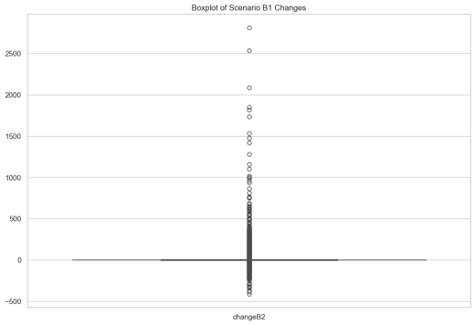 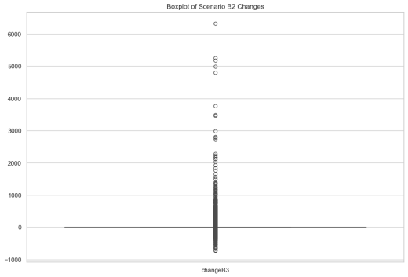

Figure 8: Flow Changes Boxplot between Scenario B1 And Scenario B2

**Reference**

Brandes, U. (2001) A faster algorithm for betweenness centrality. *The Journal of mathematical sociology*. 25 (2), 163–177.

Diestel, Reinhard (2005). *[Graph Theory](https://diestel-graph-theory.com/index.html) (3rd ed.)*. Berlin, New York: Springer-Verlag. pp. 5, 28.

Freeman, L. C. (1977) *A Set of Measures of Centrality Based on Betweenness. Sociometry*. 40 (1), 35–41.

Latora, V. & Marchiori, M. (2001) Efficient behavior of small-world networks. *Physical review letters*. 87 (19), 198701/4-198701–198704.

Newman, M. E. J. (2003) The Structure and Function of Complex Networks. *SIAM review*. 45 (2), 167–256.

Wasserman, S. & Faust, K. (1994) Social network analysis : methods and applications / Stanley Wasserman, Katherine Faust. Cambridge: Cambridge University Press.

Bavelas, A. (1950) Communication Patterns in Task-Oriented Groups. *The Journal of the Acoustical Society of America*. 22 (6), 725–730.

Wilson, A. G. (1971) A Family of Spatial Interaction Models, and Associated Developments. *Environment and planning. A.* 3 (1), 1–32.