**Assignment #2: 3D Scalar Field Visualization**

**Due on October 9th, before midnight**

### **Goals**:

The goals of this assignment include: (1) complete the cut planes for 3D volume data, (2) extract and visualize iso-surfaces from volumetric scalar fields, and (3) perform ray-casting direct volume rendering.

Two 3D volumetric data sets in the format of image data (or uniform structured grid) are provided. A skeleton code in Python is also available to help you get started.

### Requirements of Submission:

You should submit your source code **in a single .zip file** and a writing report **in a separate file** via Canvas before the deadline. Please use the following naming convention to name your zip file:

*Assignment2\_****FirstName\_LastName****.zip, Assignment2\_Report\_****FirstName\_LastName****.pdf (or .docx)*

**Please DO NOT include the data sets in your submissions!!!!**

**Your report (required)** should include your answers to the writing questions **AND** high-quality images captured for the individual visualization tasks listed below for the **two data sets** given. Also, please **specify the parameters** used to produce the corresponding visualization (like the iso-value for the iso-surface and the configuration file for the transfer functions), **especially for the cylinder3D\_L2data set**.

**Important Notice on the Use of ChatGPT in Programming Assignments:**

While the utilization of ChatGPT or similar large language models is permitted for programming assignments, it is not allowed during exams. We urge students to exhaust their understanding and attempt solutions independently before resorting to these tools. Remember: the true value of this course is derived from the challenges you overcome, and the knowledge you gain in the process.

**Transparency is crucia**l: If you choose to use ChatGPT or any other external resources, it is mandatory to clearly indicate so in your assignment report. You will not be penalized if you use ChatGPT. However, if you failed to report it and were caught, it would be considered plagiarism and your score will be zero. Note that it was prohibited to borrow codes from students who already took this course.

### Tasks:

#### **1. Writing questions (20 points)**

**1.1 (10 points)** What are the potential issues and limitations of Marching Cubes?

**1.2 (10 points)** What are the disadvantages/limitations of Raycasting and Splatting, respectively? In your opinion, how will you improve them respectively?

#### **2. 3D slicing (30 points)**

Visualize three axis-aligned cut planes based on the user-specified locations. You can safely assume that these locations are integers corresponding to the indices of the XY, YZ, and XZ planes in the provided data. For example, Z=10 defines an XY plane with all the 3D points (or voxels) that have Z index 10.

You can use the following code to get the dimensions of the image data, dim = [xdim, ydim, zdim]

dim = reader.GetOutput().GetDimensions()

The following code shows how to specify an XY cut plane for a loaded 3D image data

# Create a mapper and assign it to the corresponding reader

xy\_plane\_Colors = vtk.vtkImageMapToColors()

xy\_plane\_Colors.SetInputConnection(reader.GetOutputPort())

xy\_plane\_Colors.SetLookupTable(bwLut)

xy\_plane\_Colors.Update()

Note that bwLut is a black/white look up table that can be setup as follows. You can **re-use the color scale look up tables you created in Assignment 2** here, but this look up table must be setup first before it can be used. A place to set this look up table is when you load the data file (e.g., in the open\_vtk\_file() function).

# Create a black/white lookup table

bwLut = vtk.vtkLookupTable()

**# YOU need to adjust the following range to address the dynamic range issue!**

**bwLut.SetTableRange(0, 2)**

bwLut.SetSaturationRange(0, 0)

bwLut.SetHueRange(0, 0)

bwLut.SetValueRange(0, 1)

bwLut.Build()

# Create an actor for the XY plane

xy\_plane = vtk.vtkImageActor()

xy\_plane.GetMapper().SetInputConnection(xy\_plane\_Colors.GetOutputPort())

xy\_plane.SetDisplayExtent(0, xdim-1, 0, ydim-1, current\_zID, current\_zID)

# Current\_zID is a user-input integer within the range of [0, zdim-1]

# Add the actor to the renderer (ren is a vtkRenderer object)

ren.AddActor(xy\_plane)

Note that two spinboxes are provided for your convenience in setting the custom color range for the cut planes. You can retrieve their values with self.ui\_min\_range.value() and self.ui\_max\_range.value()

The following shows a screenshot of the three selected cut planes for the *FullHead* data.

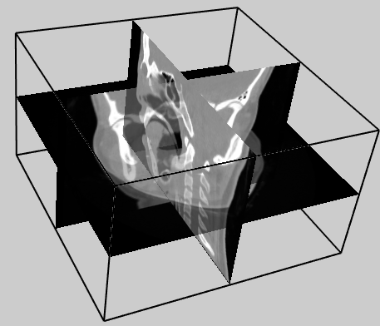

**Figure 1. An example of the 3D cut planes for the Head dataset.**

#### **3. Iso-surface Extraction and Visualization (20 points)**

Extract and visualize an iso-surface based on the user input iso-value. You can use the vtkMarchingCubes() filter to achieve that.

isoSurfExtractor = vtk.vtkMarchingCubes()

Once you create a marching cubes filter, you can use the similar function SetValue(0, iso-value) as you used in Assignment 2 with the contour filter, and pass the iso-value that the user inputs.

To accelerate the rendering of the extracted iso-surface(s), it is recommended to use the vtkStripper to convert the individual triangles in the iso-surface into triangle strip.

isoSurfStripper = vtk.vtkStripper()

isoSurfStripper.SetInputConnection(isoSurfExtractor.GetOutputPort())

isoSurfStripper.Update()

Next, you will pass this stripper object to a vtkPolyDataMapper() mapper. Remember to call the ScalarVisibilityOff() function **IF** you want to specify a color for the surface.

Next, create an actor for the iso-surface so that you can set its color and other materials. If you wish to use the lighting effect, you can use the following functions.

your\_actor.GetProperty().SetDiffuseColor([the color you prefer])

your\_actor.GetProperty().SetSpecular(.3)

your\_actor.GetProperty().SetSpecularPower(20)

You can also specify the transparency of the extracted iso-surfaces, which can be useful when multiple iso-surfaces are shown at the same time.

your\_actor.GetProperty().SetOpacity([your preferred opacity in [0, 1]])

The following shows a screenshot of the iso-surface corresponding to value 500 of the *FullHead* data. This iso-surface represents the skin of a patient.

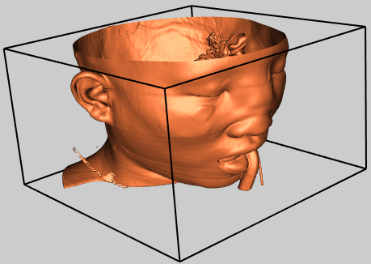

**Figure 2. An iso-surface of the FullHead dataset**

#### **4. DVR-Raycasting (30 points)**

Compute and show the volume rendering using ray-casting. To achieve that, you can use the vtkFixedPointVolumeRayCastMapper() mapper or the vtkSmartVolumeMapper() mapper. The former is the standard raycasting DVR and the latter is the improved DVR. \alpha composition will be used. Note that for DVR, there is no filter needed as no geometry will be extracted from the data. So, you should directly connect the loaded data from the source to ray-casting mapper using the SetInputConnection() function of the mapper.

**To compute the pixel colors, both color and opacity transfer functions need to be set**.

The following shows an example code for the specification of the *color transfer function* for the FullHead data. The vtkColorTransferFunction is used. The AddRGBPoint() function of this class is used to add control points to the color transfer function. This function consists of four parameters, the first one specifies the iso-value and the last three provide the RGB color you want to assign to that value.

# The goal is to assign one color for flesh (between 500 and 1000)

# and another color for bone (1150 and over).

volumeColor = vtk.**vtkColorTransferFunction**()

volumeColor.AddRGBPoint(0, 0.0, 0.0, 0.0)

volumeColor.AddRGBPoint(500, 1.0, 0.5, 0.3)

volumeColor.AddRGBPoint(1000, 1.0, 0.5, 0.3)

volumeColor.AddRGBPoint(1150, 1.0, 1.0, 0.9)

The following shows an example code for the specification of the *opacity transfer function* (which is a 1D function) for the FullHead data. The vtkPiecewiseFunction is used. The AddPoint () function is used to add control points to this 1D function and provide the specific opacity values. Other opacity values for the data between these control points will be interpolated linear as the piecewise function is used here.

volumeScalarOpacity = vtk.**vtkPiecewiseFunction**()

volumeScalarOpacity.AddPoint(0, 0.00)

volumeScalarOpacity.AddPoint(500, 0.15) #Skin is more transparent

volumeScalarOpacity.AddPoint(1000, 0.15)

volumeScalarOpacity.AddPoint(1150, 0.85) #Bone gets the highest opacity

**NOTE that for both the color and opacity functions, the above locations of control points need to be adjusted by the user interactively to achieve the best rendering effect. Also, those scalar values (e.g., 500, 1000, and 1150) are data dependent. You must replace them based of the data range of the loaded data (e.g., for the cylinder3D\_L2 data).**

To facilitate the interactive specification of the above two transfer functions, a “rendering\_config.txt” file is used that has the following format:

#Color

0, 0.0, 0.0, 0.0

500, 1.0, 0.5, 0.3

1000, 1.0, 0.5, 0.3

1150, 1.0, 1.0, 0.9

#Opacity

0, 0.00

500, 0.15

1000, 0.15

1150, 0.85

Each row under the #Color section corresponds to a control point for the color transfer function as explained earlier. The rows under the #Opacity section are similar. During run time, the user can open this rendering\_config.txt file and modify the control points to adjust the volume rendering effect. Once the file is modified and saved, it can be reloaded by pressing the “Load control points” button on the interface (see an example interface later) or uncheck and check the “Show Volume Rendering” checkbox as currently done in the skeleton code.

After you specify the above transfer functions, you need to add them to a vtkVolumeProperty object. The following shows an example of adding the previously defined transfer functions to the volume property object.

volumeProperty = vtk.vtkVolumeProperty()

volumeProperty.SetColor(**volumeColor**)

volumeProperty.SetScalarOpacity(**volumeScalarOpacity**)

volumeProperty.SetGradientOpacity(**volumeGradientOpacity**)

volumeProperty.SetInterpolationTypeToLinear()

If you wish to add illumination (or shading) effect to your volume rendering, you can do something like the following for your volume property object (after the above setting).

volumeProperty.ShadeOn()

volumeProperty.SetAmbient(0.4)

volumeProperty.SetDiffuse(0.6)

volumeProperty.SetSpecular(0.2)

Next, you should create a volume object using vtkVolume and add the ray-casting mapper and the corresponding volume property object to this volume object as follows.

volume = vtk.vtkVolume()

volume.SetMapper(volumeMapper)

volume.SetProperty(volumeProperty)

Finally, add this volume object to your renderer so that it can be rendered. The following provides a screenshot of the raycasting of the *FullHead* data with the above setting (and the rendering\_config.txt file) for your reference.

Note that if you use the **vtkSmartVolumeMapper**(), which is recommended, you may see different (**most likely better**) rendering effect.

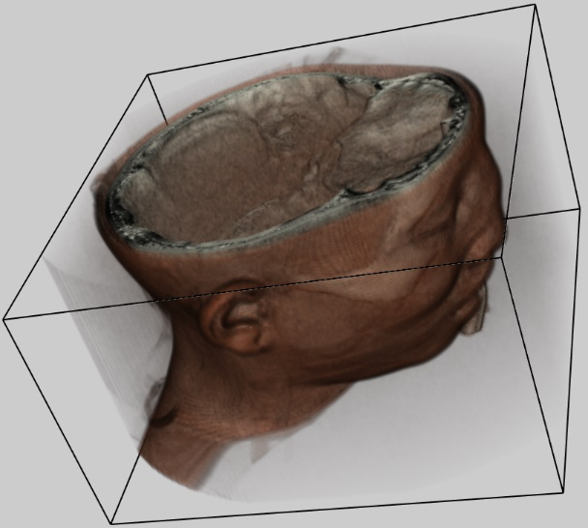

**Figure 3. An example volume rendering of the FullHead dataset**

#### **4.1 Volume Rendering the Cylinder3D data set**

Once the implementation of the raycasting functionality is finished, you need to perform some exploration to effectively visualize important features of the Cylinder data set. For this task, you need to produce **two separate volume renders**, the first render should visualize the vortex core regions of the cylinder, and the second render should reveal the flow regions surrounding the vortex cores. The screenshots of what the correct volume renders should look like are provided below:

Figure 4a

A volume rendering of the lambda_2 field of the cylinder that shows smaller structures.

Figure 4b.

A volume rendering of the lambda_2 field of the cylinder that shows larger structures.

**Figure 4. Two volume renderings using two different sets of transfer functions. The top image shows the tube-like small structures in the data, while the bottom image shows the larger structures.**

Again, you need to play with the transfer function designed via the rendering\_config.txt file to achieve a volume rendering that reveals the characteristics of this data.

#### **5. Graphical interface (GUI)**

Unlike the previous assignment. For this assignment a fully functional interface is provided for you. **Try not to change or rename the ui components as part of the submission will be autograded.**

A skeleton code with a QT GUI is provided for you to get started. The interface of the skeleton program looks like below

Figure 5.

A screenshot of the GUI interface in the skeleton code

**Figure 5. A screenshot of the GUI interface of the skeleton code. Note that please do not change the layout of the interface. You only need to connect the interface with the variables in your code to receive user input parameters.**

**The interface for XY cut plane with the full functionality is provided to you as a reference**. You need to implement the cut plane visualization for the other two planes. The interface for iso-surface extraction and volume rendering is also included in the skeleton code, but they currently do nothing as their respective functions are incomplete. You need to complete these functions as described earlier to see the respective visualization.

Some simple instruction on PyQt and its widgets is provided in assignment 2 and the following small tutorial.

<http://www2.cs.uh.edu/~chengu/Teaching/Fall2020/Assigns/PyQT_PyVTK%20Tutorial.pdf>

A more detailed instruction and reference can be found below

<https://doc.qt.io/qtforpython/contents.html>

**6. Using Paraview to help fine-tune transfer function values (Optional!)**

In the second part of task 4, you need to replace the scalar values in the opacity function to properly display the correct volume render of the cylinder3D data set. To help make this process easier and faster, rather than guessing the correct opacity values for the opacity function and restarting your program each time, you can use Paraview’s intuitive Color Map Editor to quickly find the correct values. **(Note that this is not required but recommended).**

First, load the Cylinder3D dataset into Paraview and click Apply. Then, select “Volume” in the Display/Representation drop down box.

Figure 6.

Paraview interface

Then, select the Edit button to show the Color Map Editor

Figure 7.

Place to select color scheme

In the Color Map Editor panel, you’ll need to drag both the left and right control points down to hide everything (see below).

Figure 8.

Transfer function design interface

Then, you can freely adjust the opacity control points to highlight different portions of the Cylinder dataset.

After adjusting the control points to achieve the correct result (**the correct result should be similar to the Cylinder volume render screenshot before this section**), you can scroll down the Color Map Editor to read the opacity values from the table and paste them into your opacity function code (click on the Gear ⚙️ button if you don’t see the tables):

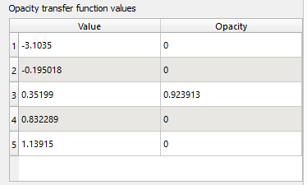

(Note that again, **the above opacity values are wrong**, and you need to adjust the control points to get the correct values that lead to the rendering similar to the reference ones above!!!)