## Stream surfaces: concerns

## 1.2 Line integral convolution in 3D

## 2. Arrow plots in 3D

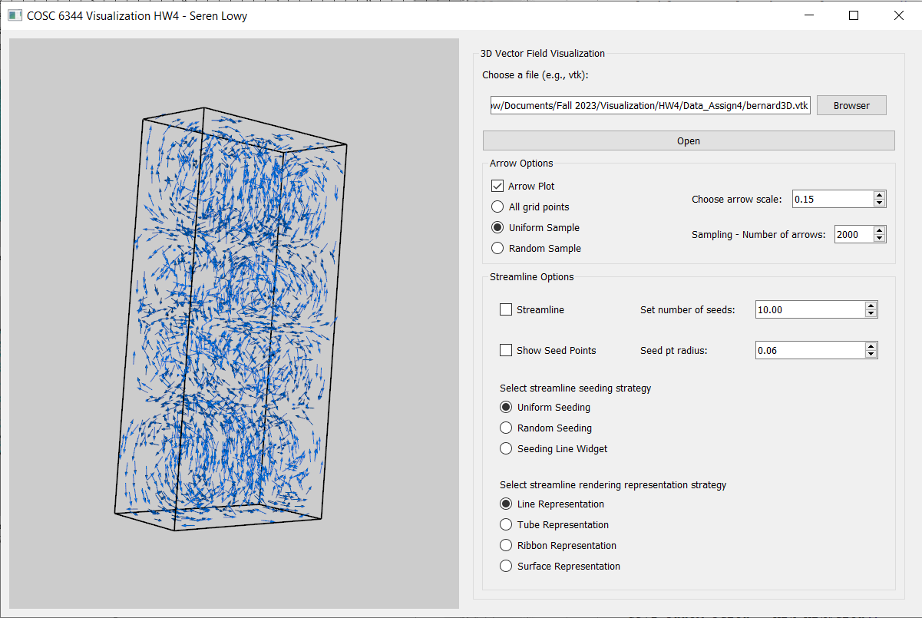

**Dataset: bernard3D.vtk**   
Number of arrows: 2000 | Sampling type: uniform | Arrow scale: 0.15

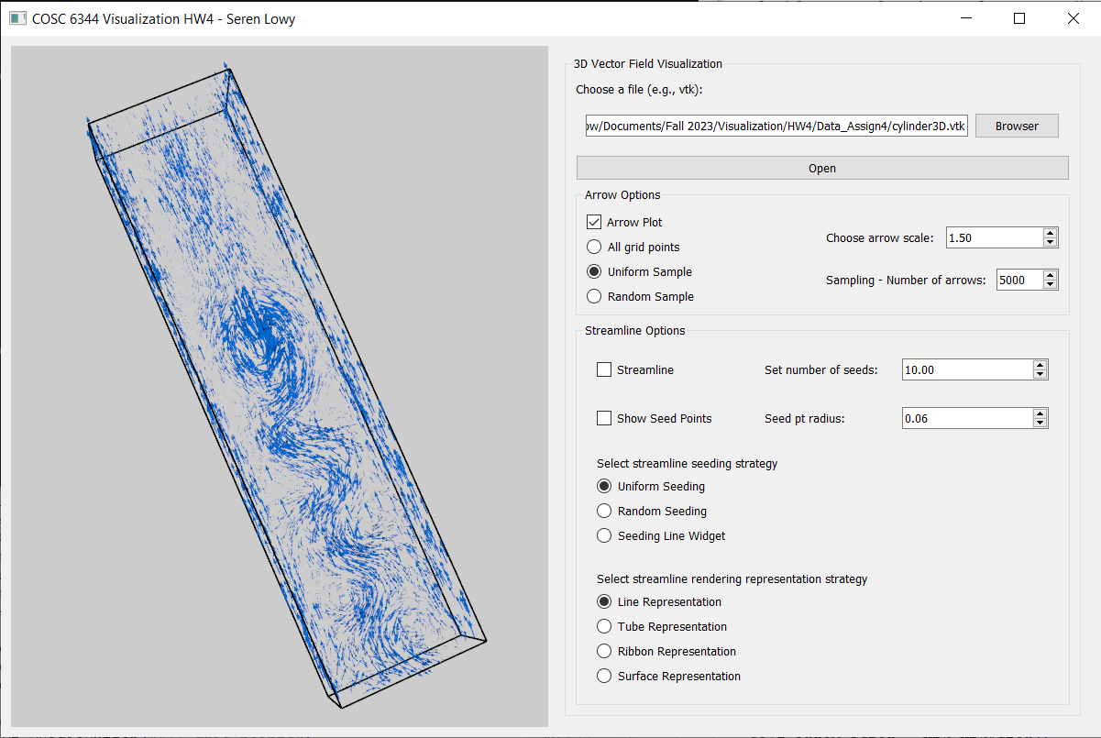

**Dataset: cylinder3D.vtk**Number of arrows: 5000 | Sampling type: uniform | Arrow scale: 1.50

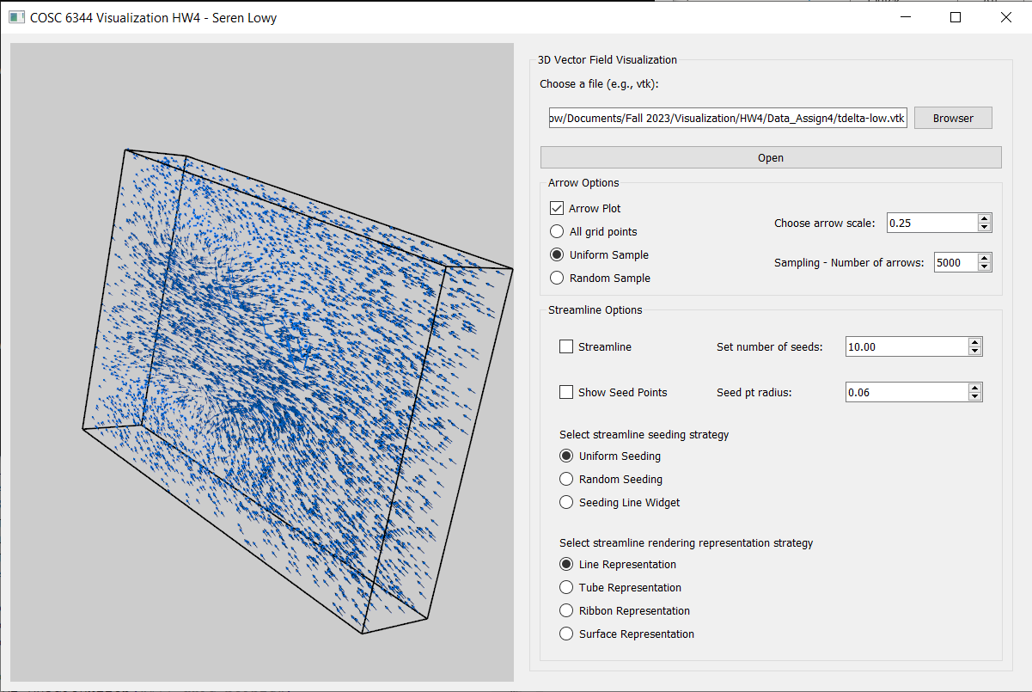

**Dataset: tdelta-low.vtk**Number of arrows: 5000 | Sampling type: uniform | Arrow scale: 0.25

## 3. Streamlines, tubes, and ribbons

## 4. Streamline-type surfaces (streamsurfaces)