- The list can be generated by running the program with generate list = TRUE
- 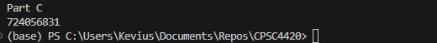
- 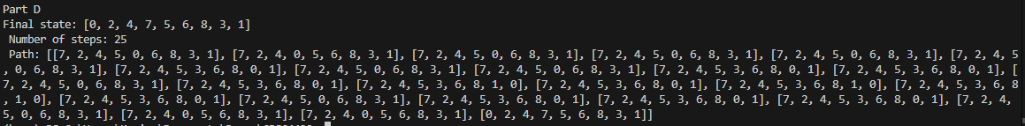
- I couldn't print the list of states because it crashed my computer. The output list of actions is too long so I couldn’t print it
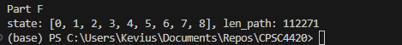
- 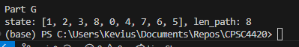
- UCS – It appears that both take the same number of steps and path so UCS must be finding the optimal path without the weights

