Programming Assignment 2
- The Best path is as follows
  - (1,1), A4, -.5, (1,1), A2, -1.5, (3,1), A1, -1, (4,1), A3, -.5, (4,1), A2, 1.5, (4,3), A1, -1, (4,4), A4,(4,4), A1, -1, (5,4), A3, -.5, (5,4), A1, 100, (5,5).
- Terminal out
  - 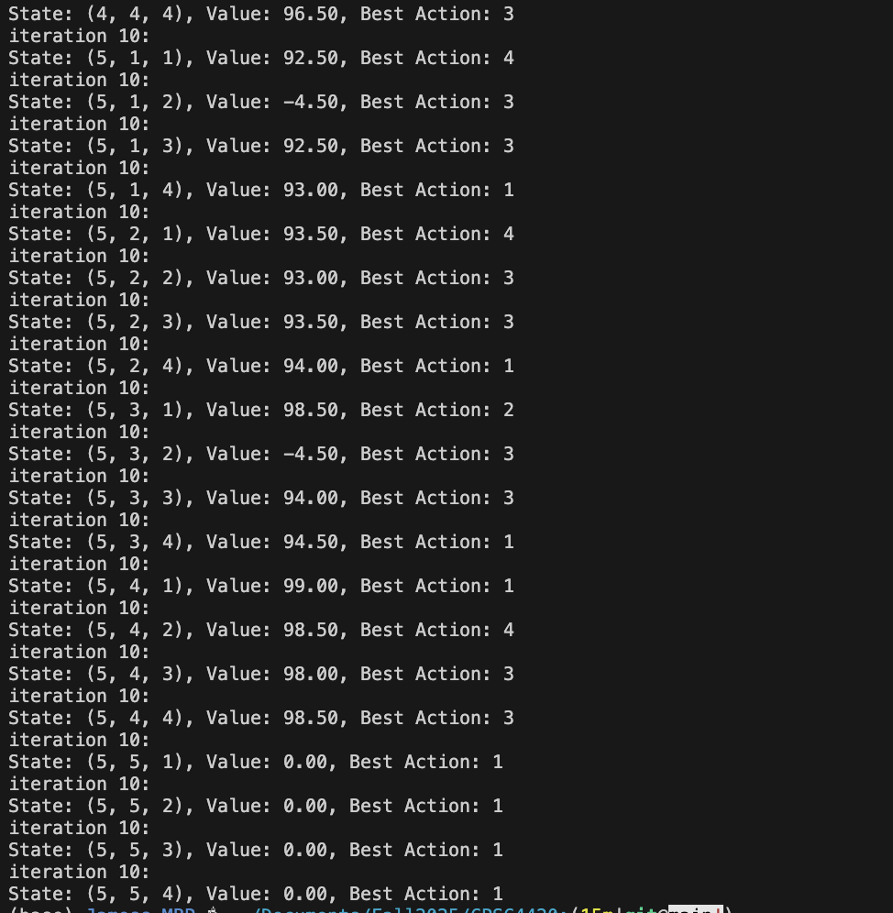
- The path from the MDP is almost the same as mine. The only difference is we do our double movements in a different order.
- The final path is identical to the the 1.0 gamma option which suggests that that path is most optimal.
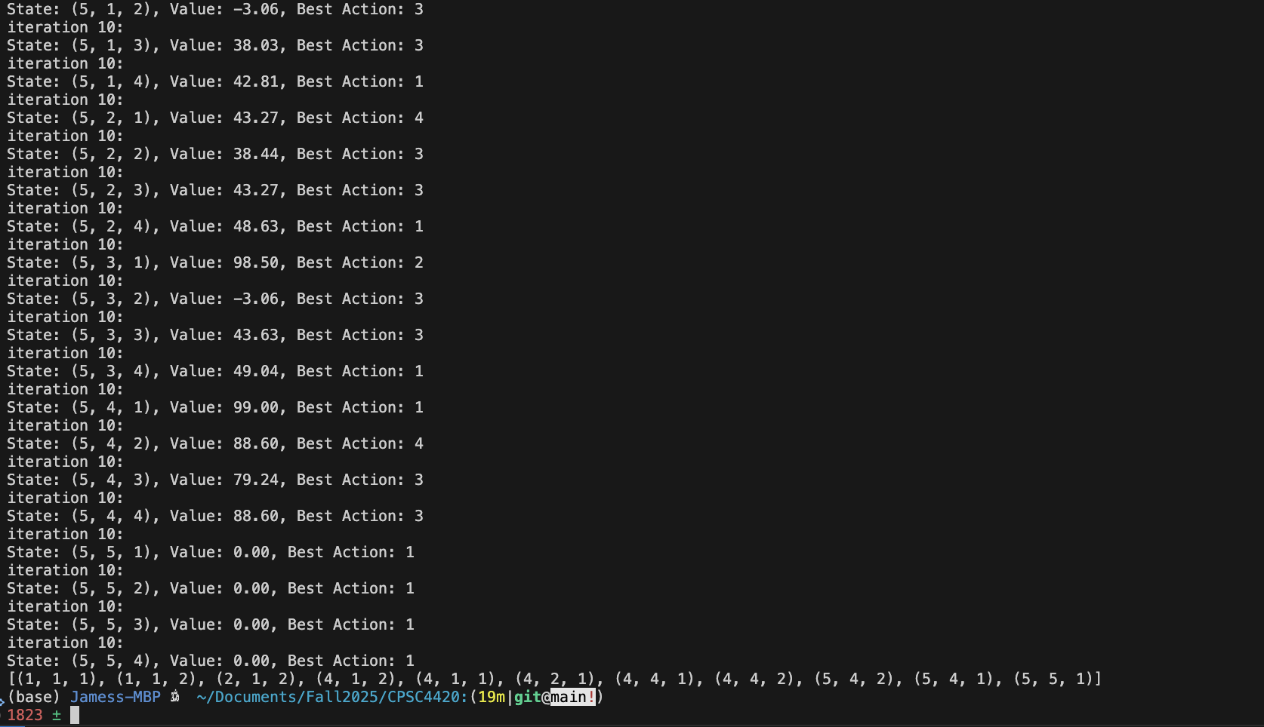
- With a gamma of .1 the agent gets stuck in a loop and never wants to explore. I think it turns because it is the least costly option.
  - 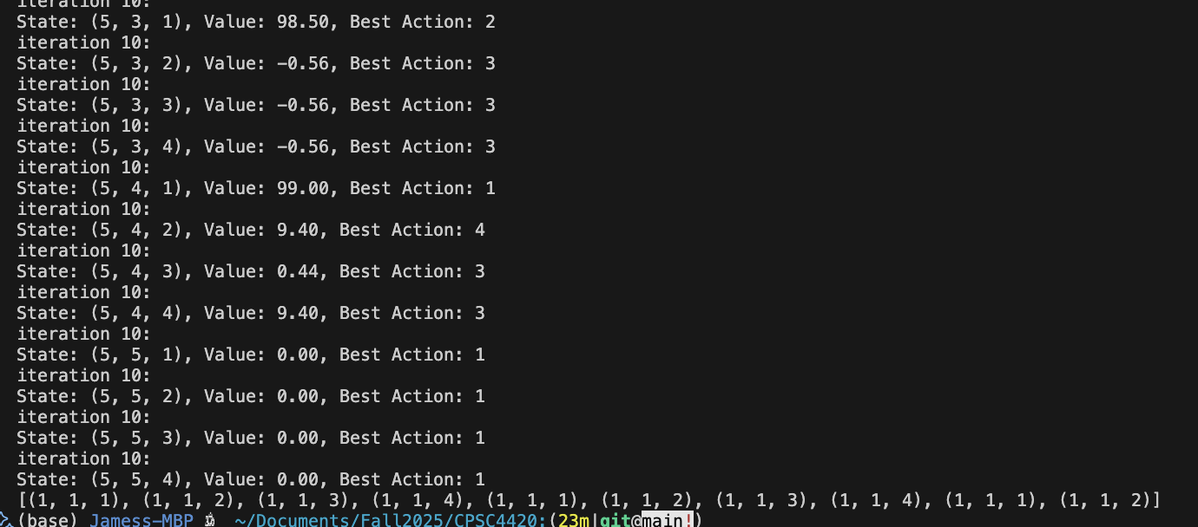
- The final path is the same as parts B and D, because there is not a longer safer path to the goal
  - 