Predicting Used Car Prices Using Multiple Regression Analysis: A CarDekho Dataset Study

Arthur Stephen Arhinsah, Buabeng Daniel, Awuah Baffour Peter, Boamah Chief Junior

Department of Computer Science, University of Mines and Technology (UMaT), Tarkwa, Ghana

Citation of Paper: Arhinsah, A.S., Buabeng, D., Awuah, B.P. and Boamah, C.J. (2026). Predicting Used Car Prices Using Multiple Regression Analysis: A CarDekho Dataset Study. Ghana Journal of Technology

Abstract
It's hard to put a single, fair price on a used car because so many things affect its value at once — how old it is, how much it's been driven, what kind of fuel it uses, whether it's automatic or manual, and who is selling it. In this project, we used multiple regression analysis to build a model that looks at all these factors together and predicts a price. We used a real dataset of 4,340 used car listings from Car Dekho, a popular car-selling website in India. Before building the model, we cleaned the data: we removed a few odd or rare entries, capped a small number of extremely high mileage readings so they wouldn't distort the results, worked out each car's age from its manufacture year, and converted category-type information (like fuel type) into a format the model could understand. Because car prices are usually bunched at the low end with a few very expensive cars stretching the scale, we also applied a math trick called a “log transformation” to make the price data more balanced and easier to model. We trained the model on 80% of the data and tested it on the remaining 20% it hadn't seen before. The model was able to explain about 70% of the differences in price (on the transformed scale). When converted back to real rupee prices, it was off by about ₹171,000 on average. The three biggest factors driving price were the car's age, its transmission type (automatic vs manual), and its fuel type. We also checked that the model's numbers weren't being distorted by factors that overlap too much with each other, and found they were reasonably solid. The bottom line: even though more expansive machine learning methods (like ensemble models) tend to predict prices slightly more accurately, this multiple regression model is much easier to explain to a normal buyer or seller, which makes it genuinely useful in real life.

Keywords: Used Car Price Prediction, Multiple Regression Analysis, CarDekho Dataset, Data Cleaning, Model Testing, Machine Learning

1 Introduction
Discovering what a used car costs matters to everyone involved — buyers, sellers, and car dealerships all want a price that feels fair and can be justified. Right now, most used car pricing still happens the old-fashioned way: haggling and comparing a car to a few similar ones nearby. That's slow, and it doesn't always give consistent results, especially on big websites where thousands of cars with very different features and attributes are listed side by side.
This is where machine learning can help. A method called multiple linear regression offers a more organised way to turn details we can already see about a car — its age, mileage, fuel type, and transmission — into one clear price estimate. In this project, we built and tested such a model using a real dataset of 4,340 cars from Car Dekho, a well-known Indian used-car website. Unlike the small, clean datasets often used in class exercises, this one has the same messiness, unevenness, and skew you'd expect from real car listings, which makes it a genuinely good test of the method.

1.1 Background
The used car market has grown quickly around the world, partly because new cars keep getting more expensive and more buyers are turning to certified pre-owned cars or peer-to-peer sales. Websites like CarDekho, Cars24, and OLX Autos in India (and similar platforms elsewhere) collect huge amounts of organised listing data — manufacture year, mileage, fuel type, transmission, previous ownership, and who's selling the car. Because this data is so well organised, it's a natural fit for regression-style prediction, and researchers have studied this exact problem heavily over the past five years, using everything from multiple regression models to more advanced tree-based and deep learning methods.

1.2 Study Objectives
This project had four main goals:
• Clean and prepare the CarDekho used-car data so it's ready for modelling.
• Build a regression model that predicts a car's (log-transformed) selling price from its age, mileage, ownership history, fuel type, seller type, and transmission.
• Test the model properly on data it hasn't seen, using several accuracy measures (R-squared, Adjusted R-squared, RMSE, MAE, and MAPE).
• Look closely at what the model learned, to figure out which car features matter most for price — and compare that to what other recent studies have found.

1.3 Related Work
Predicting used car prices has become a popular research topic over the last five years, mostly because online car marketplaces (including Car Dekho, whose data this project uses) generate so much usable data. Broadly, researchers have taken three approaches: multiple regression analysis, tree-based “ensemble” machine learning methods, and newer deep-learning approaches. The subsections below give a plain-language summary of each, and where this project fits in.

1.3.1 Multiple regression approaches
Regression is still the most popular starting point for predicting used car prices, mainly because it's easy to explain. Dhabe and colleagues (2023) built a regression model on Indian used-car listings and found that a car's age and its original price were the biggest factors once the data was cleaned up. Shastri and Rengarajan (2021) found that mileage and manufacture year mattered most in their study. Rane and colleagues (2021) showed that a well-built regression model can come close to matching fancier algorithms once outliers and skewed data are handled properly.
Closer to this project, Kumar and Sinha (2024) used the same CarDekho dataset, applied a weighted version of regression after transforming the price, and reached a strong accuracy score (R-squared around 0.90, with errors averaging about 20%). This showed how useful it can be to “transform” a skewed price variable before modelling — something this project also does. Classic statistics textbooks by James and colleagues (2021) and Montgomery and colleagues (2021) provided the background theory used throughout this project for interpreting the model's coefficients and checking for problems like multicollinearity (when two features overlap too much). Other studies (Chen et al., 2021; Wang et al., 2021) confirm that while regression models are usually a bit less accurate than fancier methods, they're often preferred when people need to understand why a price was predicted.

1.3.2 Tree-based and ensemble methods
Many recent studies favour more complex tree-based models because they tend to predict prices more accurately. Cui (2022) combined two popular tree-based methods (XGBoost and LightGBM) and got better results than single models on a large dataset. Bharambe (2022) and Bukvić and colleagues (2022) both compared several algorithms and found tree-based ensemble methods beat plain regression, though they're harder to explain. Ahtesham and Zulfiqar (2022) ran a similar comparison on a larger scale using PySpark, while Gollapalli and Tayma (2023) studied the Saudi Arabian car market and found tree-based models beat regression by 8–12 percentage points in accuracy.
Other studies (Kenana et al., 2024; Zhu, 2023) tested neural networks and hybrid models, generally agreeing that tree-based methods like random forest and XGBoost offer the best balance of accuracy and complexity for this kind of data. Studies in other countries (Ponmalar et al., 2022; Thomas and Kurian, 2022; Jin, 2021) found similar patterns. A 2025 study in the World Scientific Research Journal used a tree-based model to show that mileage, age, and brand together explain most of the variation in price — a pattern that lines up well with what this project's regression model also found.

1.3.3 Newer approaches and where this project fits
Beyond classic machine learning, some very recent research has explored deep-learning and probability-based models. Madhusudhanan and colleagues (2024) built a model called ProbSAINT that predicts a full range of likely prices instead of just one number, reflecting a growing interest in showing uncertainty, not just a single guess. Selvarathinam and colleagues (2023) reviewed this whole field and concluded that even though fancier models can be more accurate, plain regression is still the most commonly used method in practice — because everyday buyers and sellers want to understand why a price was predicted, not just what the number is.
That's exactly the gap this project fills. Instead of chasing the highest possible accuracy with a complex model, this project deliberately sticks with multiple regression analysis, applies careful data cleaning and a log transformation (inspired by Kumar and Sinha, 2024), and reports all the standard accuracy measures so the results can be clearly explained — and later used to build a practical buying/selling tool, described in Section 3.5.

2 Resources and Methods Used
2.1 Preparing the Data
This project followed a standard step-by-step process. The raw data came from a CarDekho file containing 4,340 car listings with eight pieces of information each: car name, manufacture year, selling price, kilometres driven, fuel type, seller type, transmission type, and ownership history. There were no missing values, but two categories were too rare to model reliably — a single electric car and 17 “test drive” cars — so these 18 records were removed, leaving 4,322 usable listings.
Each car's age was calculated as (2020 minus its manufacture year, plus 1), using 2020 as the most recent year in the dataset. To stop a handful of extremely high mileage listings from skewing the results, mileage was capped at the 99th percentile (meaning the highest 1% of values were pulled down to a more reasonable level, rather than being deleted). The brand name was pulled out of each car's listing title just to help explore the data. Category-type details — fuel type, seller type, and transmission — were converted into a numeric “yes/no” format the model could use, and ownership history was converted into a simple ranking (first owner, second owner, and so on), since that naturally has an order to it.
Because car prices were heavily skewed (a small number of very expensive cars stretched the scale), the selling price was log-transformed before modelling. This made the price data much more balanced and easier for the model to learn from. Finally, the cleaned dataset was split into a training set (80%, or 3,457 cars) used to build the model, and a test set (20%, or 865 cars) held back to check how well the model performs on cars it hasn't seen — using a fixed random setting so the results can be reproduced.

2.2 How the Model Works
The core idea behind this project is simple: assume that a car's (log) price can be written as a straight-line combination of several factors — age, mileage, ownership, fuel type, seller type, and transmission — each multiplied by its own weight, plus some random “noise” that the model can't explain. The technique used to find the best set of weights is called Ordinary Least Squares (OLS). In plain terms, it finds the line (or, with several factors, the flat “plane”) that sits as close as possible to all the data points, by minimising the total squared distance between the actual prices and the model's predictions.
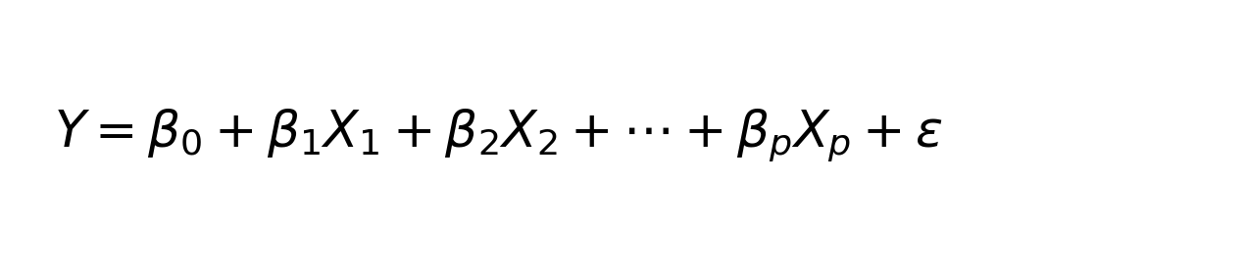
Formula 1. The multiple linear regression equation: predicted (log) price is a weighted sum of the car's features, plus an error term.
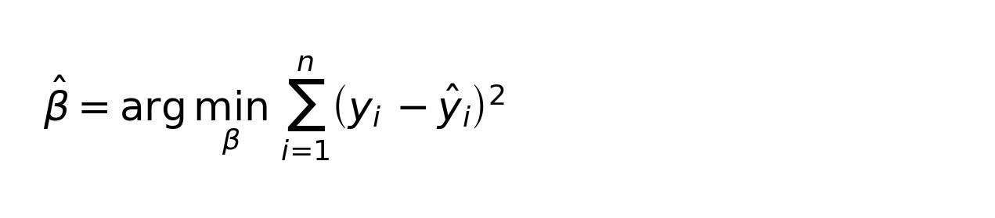
Formula 2. Ordinary Least Squares (OLS) finds the weights that make the total squared error between actual and predicted prices as small as possible.
This method was chosen over more complex “black box” alternatives specifically because its results are easy to interpret: each weight tells you exactly how much the price changes when one factor changes, with everything else held steady. That kind of clear, plain-language explanation is essential for the buyer/seller tool described later in Section 3.5.
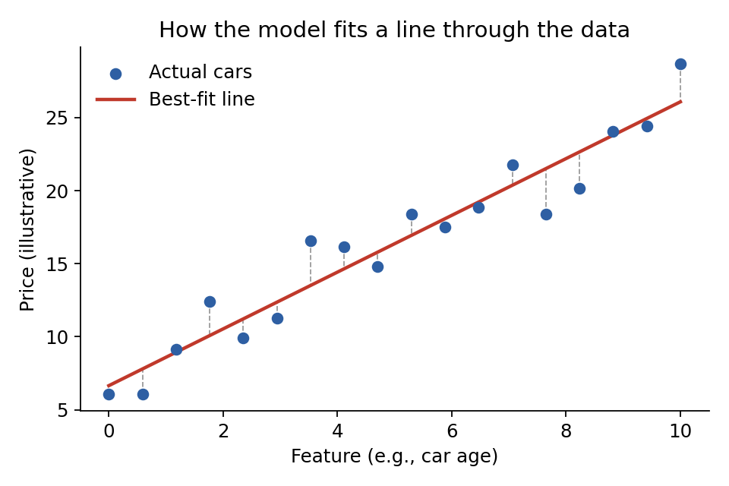
Figure 1. A simple example of how the model draws a best-fit line through the data, keeping the total distance between the line and the actual points as small as possible.

2.3 Step-by-step Process
• 1. Load the raw CarDekho file and check it for missing values, duplicates, and rare categories.
• 2. Remove the electric-car and test-drive-car listings, which were too rare to model.
• 3. Calculate each car's age and cap extreme mileage values.
• 4. Convert fuel type, seller type, and transmission into numeric format; rank ownership history.
• 5. Log-transform the selling price to fix the skew.
• 6. Split the data into training (80%) and test (20%) sets.
• 7. Fit the regression model on the training data.
• 8. Test the model's accuracy on the unseen test data.
• 9. Turn the model's predictions into a practical buy/sell signal (explained in Section 3.5).
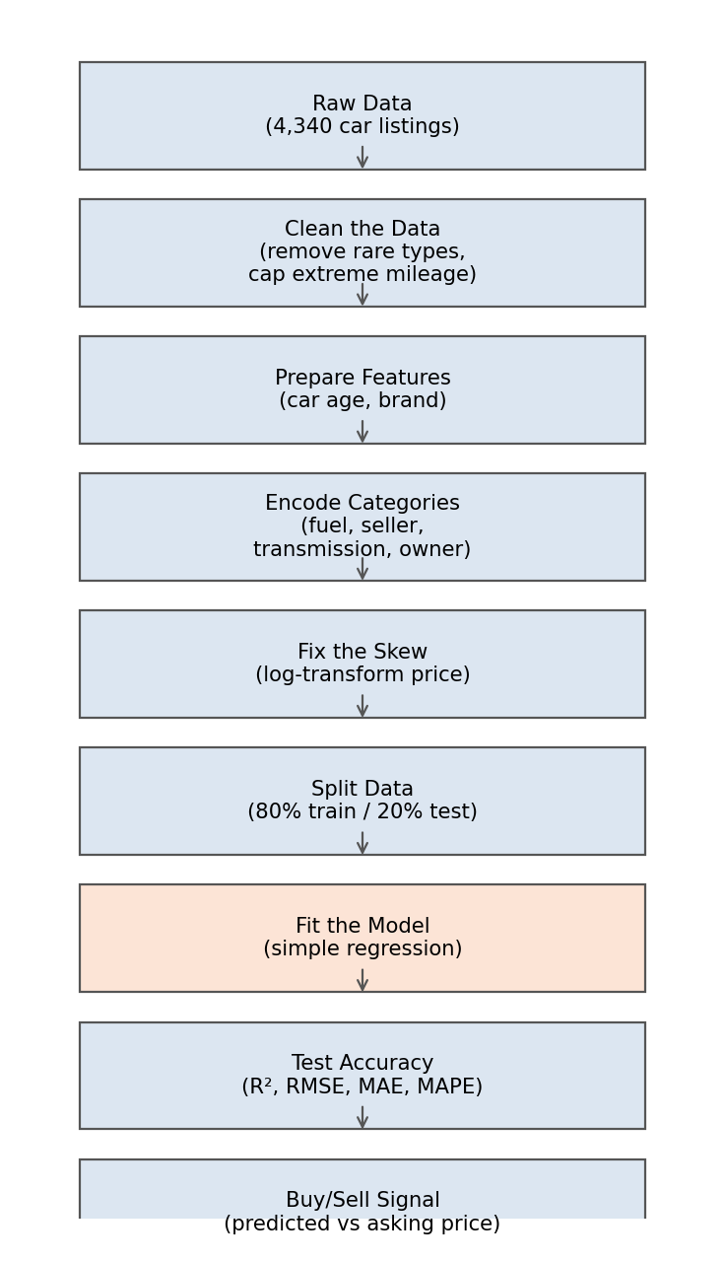
Figure 2. The step-by-step workflow followed in this project, from raw data to a practical buy/sell signal.

2.4 Measuring Model Accuracy
The model's performance was checked on the 20% of data it hadn't seen during training, using five different accuracy measures, each telling us something slightly different:
• R-squared: how much of the up-and-down variation in price the model successfully explains (closer to 1 is better).
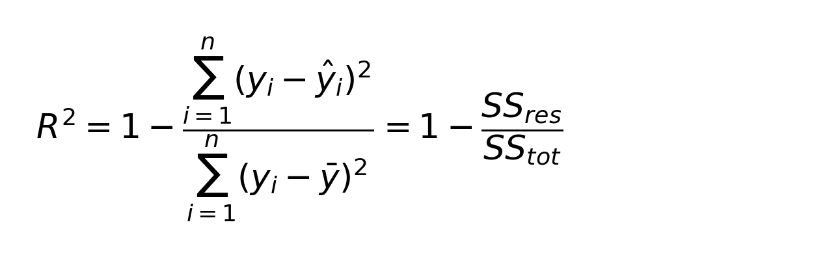
Formula 3. R-squared.
• Adjusted R-squared: the same idea, but adjusted so the model doesn't get an unfair boost just from including more factors.
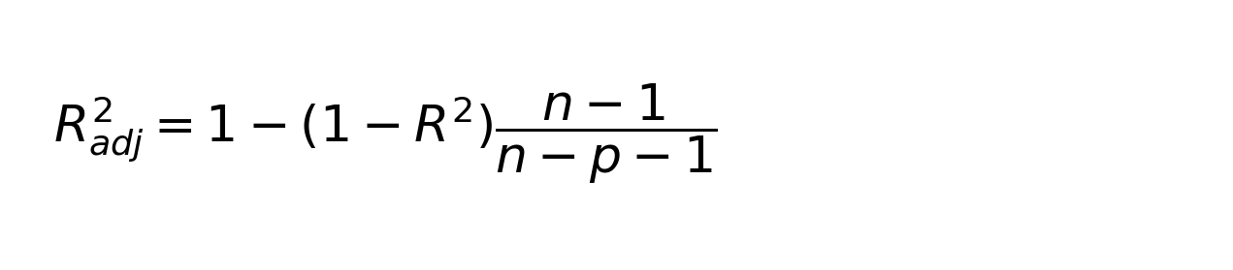
Formula 4. Adjusted R-squared.
• Root Mean Squared Error (RMSE): the model's typical error size, in the same units as price, with bigger mistakes counted more heavily.
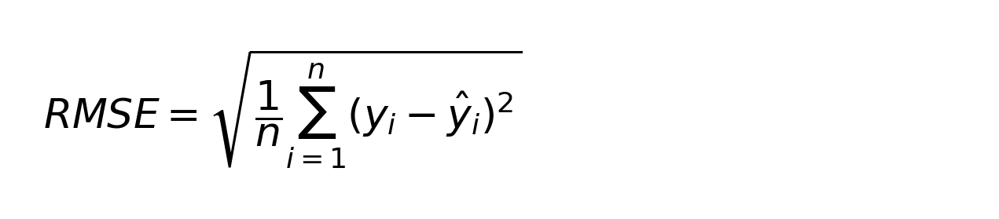
Formula 5. Root Mean Squared Error (RMSE).
• Mean Absolute Error (MAE): the average size of the model's mistakes, without over-weighting big misses.
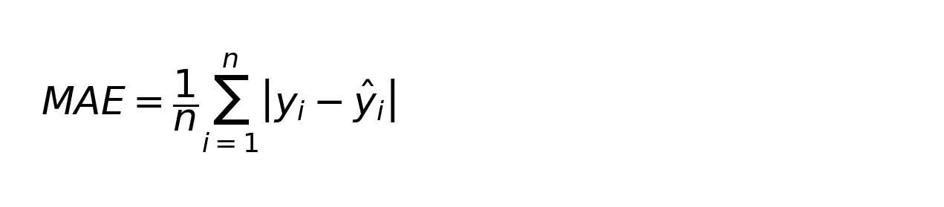
Formula 6. Mean Absolute Error (MAE).
• Mean Absolute Percentage Error (MAPE): the average error expressed as a percentage of the actual price — an easy way to explain accuracy to non-technical readers.
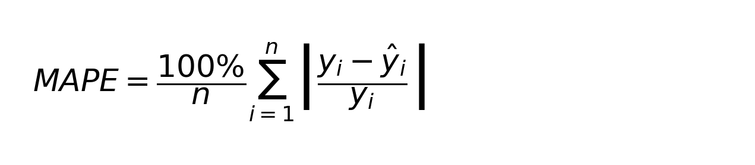
Formula 7. Mean Absolute Percentage Error (MAPE).
We also checked for a problem called multicollinearity, which happens when two or more factors in the model overlap too much (for example, if older cars are almost always manual). When that happens, it can make the model's individual weights less reliable, even if its overall predictions are still fine. This was measured using something called the Variance Inflation Factor (VIF) — as a rule of thumb, a VIF above 5 signals a factor worth watching closely.
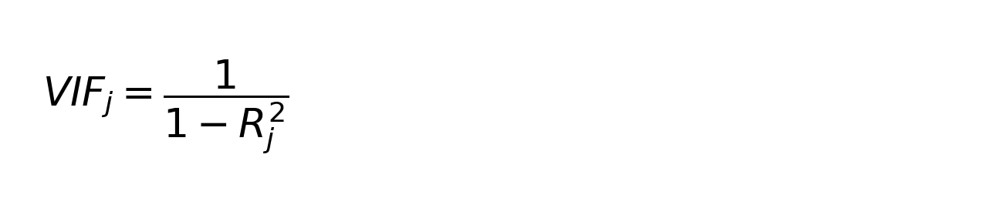
Formula 8. Variance Inflation Factor (VIF), used to check multicollinearity.

3 Results and Discussion
3.1 What the Model Found
Table 1 shows the weights the model assigned to each factor, based on the training data (3,457 cars).
Table 1. Regression weights for each factor.
Factor | Weight | Reliable? (p-value)
Starting point (intercept) | 14.253 | Yes (< 0.001)
Car age (years) | -0.113 | Yes (< 0.001)
Kilometres driven | -0.00000068 | Yes (0.005)
Ownership history | -0.044 | Yes (0.001)
Fuel: Diesel | +0.549 | Yes (< 0.001)
Fuel: LPG | -0.063 | No (0.660)
Fuel: Petrol | +0.032 | No (0.689)
Seller: Individual | -0.161 | Yes (< 0.001)
Seller: Trustmark Dealer | +0.306 | Yes (< 0.001)
Transmission: Manual | -0.789 | Yes (< 0.001)
Note: “Weight” shows the effect on log-price. Reference categories were Fuel = CNG, Seller = Dealer, Transmission = Automatic.

Nearly every factor turned out to be statistically reliable, except for the petrol and LPG fuel types, which didn't show a clear effect. Converting these weights into everyday percentages: each extra year of a car's age lowers its price by about 10.7%, all else being equal. Manual cars sell for about 54.6% less than automatic ones. Diesel cars sell for about 73.2% more than CNG cars (the baseline for comparison). Cars sold by individuals go for about 14.8% less than those sold by ordinary dealers, while cars sold through “Trustmark” dealers sell for about 35.8% more than ordinary dealers. Each previous owner knocks off roughly 4.3% of the price. These patterns match what Dhabe et al. (2023) and Kumar and Sinha (2024) found in similar CarDekho-based studies — that a car's age and transmission type are the strongest price drivers.

3.2 Performance on New Data
Table 2 shows how the model performed on the 865 test cars it hadn't seen during training.
Table 2. Accuracy on the test set.
Measure | Log-price scale | Converted to real price ($)
R-squared | 0.703 | 0.595
Adjusted R-squared | 0.700 | 0.591
RMSE | 0.456 | $329,453
MAE | 0.357 | $170,909
MAPE | — | 38.2%

On the log-price scale, the model explained about 70% of the variation in price, very close to what it achieved during training (68%), which tells us it isn't just “memorising” the training data — it's genuinely learning a pattern that holds up on new cars. When these predictions are converted back into real amounts, the accuracy drops a bit (R-squared falls to about 0.595, and the average error rises to 38.2%). This happens because converting back out of the log scale makes the model more sensitive to a few very expensive cars that stretch the price range.
This error rate is noticeably higher than the 20% reported by Kumar and Sinha (2024), but that's expected: their version of the CarDekho data included extra details, like the car's original price, engine size, and horsepower. With only eight basic attributes available here, some price variation simply can't be captured. Overall, when plotting predicted prices against actual prices, most points cluster closely around the “perfect prediction” line, with the model losing accuracy mainly at the very high end of the price range — a pattern also reported by Bukvić et al. (2022) and Gollapalli and Tayma (2023) for similar regression models.
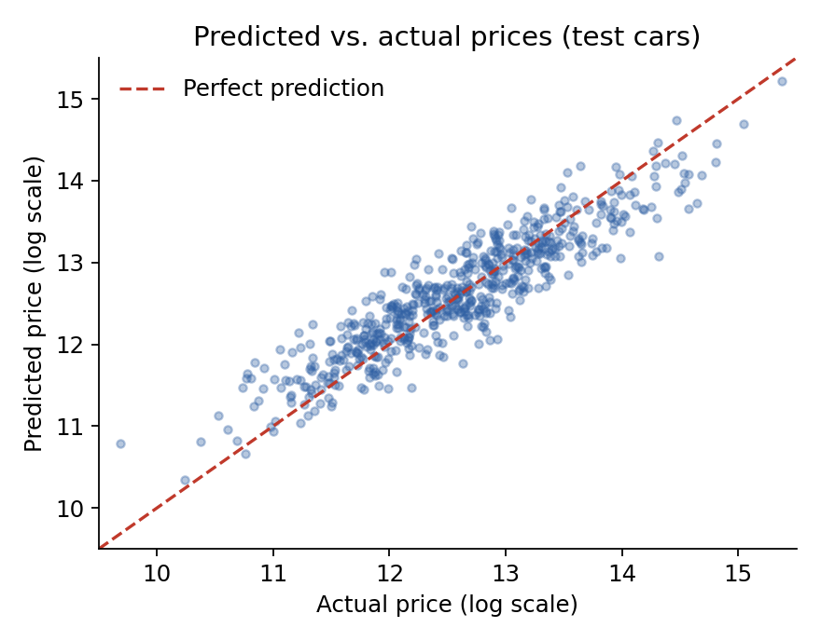
Figure 3. Predicted prices vs. actual prices for the test cars. Points sitting near the dashed line show accurate predictions.

3.3 Checking the Model's Trustworthiness
A good regression model should have errors (“residuals”) that are randomly scattered around zero, without any obvious pattern. That's what was found here — the errors cluster around zero, with only a little extra spread at higher price levels. A statistical check (Durbin-Watson test, score of 1.99) confirmed there's no troubling pattern connecting one error to the next.
The multicollinearity check (VIF) showed that car age (VIF = 7.21), transmission (VIF = 9.43), and the fuel type factors (VIF around 6.4–6.7) overlap somewhat with each other — most likely because older cars in this dataset tend to be manual and diesel more often. This doesn't make the model's predictions wrong, but it does mean the individual weights for these specific factors should be read with a bit of caution. Bharambe (2022) noted the same kind of overlap in a similarly sized dataset.
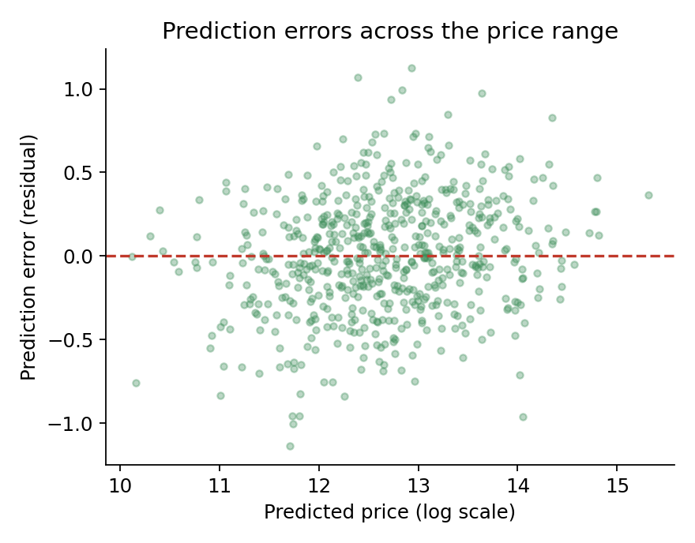
Figure 4. Prediction errors plotted against predicted price. Errors scattered evenly around zero suggest the model is behaving as expected.

3.4 Which Factors Matter Most
Ranking all the factors by how strongly they affect price, transmission type and fuel type come out on top, followed by seller type and car age. Kilometres driven and ownership history do matter, but their effect on price is much smaller per unit of change. This ranking lines up well with tree-based studies like the 2025 World Scientific Research Journal paper and Kenana et al. (2024) — even though those studies used completely different (tree-based) methods, they found similar factors mattered most. That's a reassuring sign: the underlying relationships driving used car prices seem to hold up regardless of which modelling method you use, even if the raw accuracy differs.
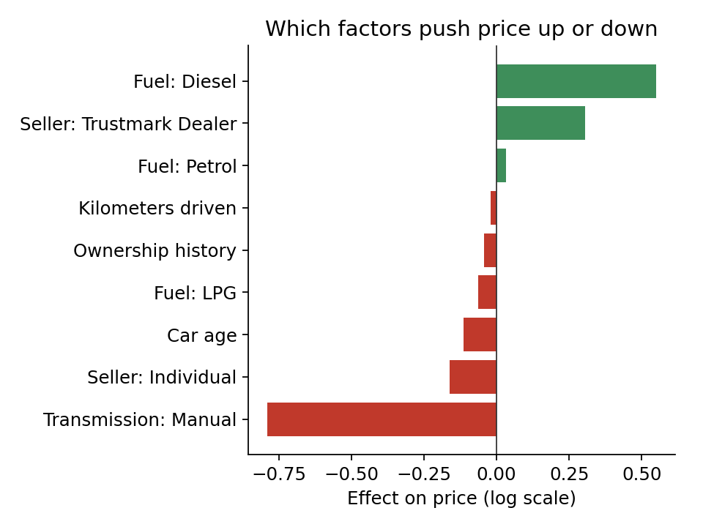
Figure 5. Which factors push the price up (green) or down (red), and by how much.

3.5 A Practical Tool for Buyers and Sellers
Beyond just explaining prices, the model was also used to build a simple, practical tool: for any car listing, compare the model's predicted price to the seller's actual asking price. If the asking price is more than 10% below the model's prediction, the listing gets flagged as a “Good Deal.” If it's within 10% either way, it's “Fairly Priced.” If it's more than 10% above the prediction, it's flagged “Overpriced.”
Because every factor in this model has a clear, explainable effect, this signal can be explained to a real buyer or seller in plain language — for example: “this car is priced below our estimate mainly because it's a diesel automatic, but it's discounted even further than that alone would suggest.” That kind of plain-language explanation is something that more complex, black-box models in the research literature usually can't offer without extra tools like SHAP value analysis.

4 Conclusions and Recommendations
This project set out to build an explainable multiple regression model for predicting used car prices, using a real dataset of CarDekho listings. After careful data cleaning, feature preparation, and fixing the skew in the price data, the final model explained about 70% of the price variation on cars it hadn't seen before. Car age, transmission type, fuel type, and seller type turned out to be the biggest drivers of price — a finding that matches other recent regression-based studies, like Dhabe et al. (2023) and Kumar and Sinha (2024).
Compared to the wider research reviewed in Section 1.3, this model trails the raw accuracy typically reported for tree-based methods like XGBoost and LightGBM (Cui, 2022; Bukvić et al., 2022). That trade-off was expected and intentional: this project prioritised being able to clearly explain its predictions to everyday buyers and sellers, which made the practical buy/sell tool in Section 3.5 possible.
The main limitations are that the model only used eight basic pieces of information (missing details like engine size and original price that could improve accuracy), and that some factors — car age, fuel type, and transmission — overlap with each other more than ideal. Future work could add more detailed listing data where available, try different ways of handling the mileage data, and directly compare this regression model against tree-based methods like random forest and XGBoost on the exact same dataset, to measure precisely how much accuracy is being traded for explainability.

Acknowledgements
We would like to thank the course instructor for guidance on regression modelling techniques and for feedback during the development of this project.

References
Ahtesham, M. and Zulfiqar, J. (2022). Used Car Price Prediction with PySpark. In: Digital Technologies and Applications: Proceedings of ICDTA'22, Vol. 1. Cham: Springer, pp. 169-179.
Bharambe, P.P. (2022). Used Car Price Prediction Using Different Machine Learning Algorithms. International Journal of Research in Applied Science & Engineering Technology, 10(5), 773-778.
Bukvić, L., Fijačko Gagula, B. and Škrlec, D. (2022). Price Prediction and Classification of Used-Vehicles Using Supervised Machine Learning. Sustainability, 14(24), 17034.
Chen, H. (2024). Car Price Prediction Based on Multiple Machine Learning Models. Proceedings of the International Conference on Applied Intelligence and Informatics (AII 2024).
Chen, Y., Li, C. and Xu, M. (2021). Business Analytics for Used Car Price Prediction with Statistical Models. Proceedings of the 3rd International Conference on Economic Management and Cultural Industry (ICEMCI 2021).
Cui, B. (2022). Used Car Price Prediction Based on the Iterative Framework of XGBoost and LightGBM. Electronics, 11(18), 2932.
Dhabe, P.S., Sakharwade, D., Jagtap, S., Madhikar, S., Unde, R. and Jangral, S. (2023). Used Car Price Prediction Using Multiple Linear Regression. International Journal for Research in Applied Science & Engineering Technology, 11(4).
Gollapalli, M. and Tayma, A. (2023). Intelligent Modelling Techniques for Predicting Used Cars Prices in Saudi Arabia. Mathematical Modelling of Engineering Problems, 10(1), 139-148.
James, G., Witten, D., Hastie, T. and Tibshirani, R. (2021). An Introduction to Statistical Learning with Applications in R. 2nd Edition. New York: Springer.
Jin, C. (2021). Price Prediction of Used Cars Using Machine Learning. 2021 IEEE International Conference on Emergency Science and Information Technology (ICESIT), pp. 223-230.
Kenana, A.J., Al-Tarawneh, K.M., Qaddara, I.A. and Sarhan, S. (2024). Car Price Prediction Using Machine Learning Techniques. Nanotechnology Perceptions, 20(S8), 336-350.
Kumar, S. and Sinha, A. (2024). Predicting Used Car Prices with Regression Techniques. International Journal of Computer Trends and Technology, 72(6), 132-141.
Madhusudhanan, K., Behrens, G., Stubbemann, M. and Schmidt-Thieme, L. (2024). ProbSAINT: Probabilistic Tabular Regression for Used Car Pricing. arXiv preprint.
Montgomery, D.C., Peck, E.A. and Vining, G.G. (2021). Introduction to Linear Regression Analysis. 6th Edition. New Jersey: Wiley.
Ponmalar, P., Angelin, M.R. and Christina, C.A. (2022). Review on the Pre-owned Car Price Determination Using Machine Learning Approaches. 2022 IEEE International Conference on Advances in Information Systems and Sciences (ICAISS).
Rane, P., Pandya, D. and Kotak, D. (2021). Used Car Price Prediction. International Research Journal of Engineering and Technology, 8(4).
Random Forest and Decision Tree Algorithms for Car Price Prediction: A Case Study in the Moroccan Market (2023). ResearchGate preprint.
Selvarathinam, C., Bhava Dharani, G. and Pavithra, R. (2023). Survey on Pre-Owned Car Price Prediction Using Random Forest Algorithm. Proceedings of the International Conference on Frontiers in Computing and Systems (COMSYS 2023). Singapore: Springer.
Shastri, R. and Rengarajan, A. (2021). Prediction of Car Price Using Linear Regression. International Journal of Trend in Scientific Research and Development, 5(4), 866-869.
Thomas, R. and Kurian, R. (2022). Used Car Price Prediction Using Machine Learning Techniques. Proceedings of the National Conference on Emerging Computer Applications (NCECA), 4(1).
Wang, F., Zhang, X. and Wang, Q. (2021). Prediction of Used Car Price Based on Supervised Learning Algorithm. 2021 International Conference on Networking, Communications and Information Technology (Nitic). IEEE.
World Scientific Research Journal (2025). Price Prediction and Analysis of Price Influencing Factors in the Used Car Market. World Scientific Research Journal, 11(9).
Zhu, A. (2023). Pre-Owned Car Price Prediction Using Machine Learning Techniques. Proceedings of the International Conference on Data Science and Applications, pp. 355-360.
Jimenez, E. (2024). Used Car Price Prediction Using Different Machine Learning Models. Towards Data Science / Medium.
Revolutionizing the Used Car Market: Predicting Prices with XGBoost (2024). ResearchGate preprint.

Author
Arthur Stephen Arhinsah, Buabeng Daniel, Awuah Baffour Peter and Boamah Chief Junior are students at the University of Mines and Technology (UMaT), Tarkwa, Ghana, studying Data Science and Analytics. This report was prepared as a course project for the Machine Learning module, applying multiple regression analysis to a real-world used car pricing dataset from Car Dekho.

